4.3 Server Load Testing and Database Concurrency Evaluation

4.3.1 Purpose of the Test
SPMS is busiest near evaluation deadlines, when many users open, edit and save performance documents at the same time, so this test checked the requirement for performance efficiency under peak loads (NFR-01). SPMS stores its data in SQLite, a database kept in a single file on the server. In SQLite’s default setup (rollback journal mode, with no waiting time), a save briefly locks the file, and any read or save that arrives at that moment fails with a “database is locked” error. Two settings were changed to prevent this, referred to below as the fix: write-ahead logging (WAL) mode, which lets reading continue during a save, and a 5-second busy timeout, which makes a request wait for its turn instead of failing. The test asked how many users SPMS can serve within 1 second, whether the fix prevents database errors, and whether the database or the processor limits the system.

4.3.2 Test Environment and Method
The test ran on a copy of SPMS, with the same code and settings as the live system and a snapshot of its database, on a cloud server (Table 20).
Table 20. Test Server Hardware and Software
Component | Specification
Processor (CPU) | ARM Neoverse-N1 with 3 cores, so it can work on 3 tasks at the same instant
Memory and storage | 22 GB RAM; 146 GB solid-state drive
Operating system | Ubuntu 22.04.5 LTS
Web server (receives each browser request) | nginx 1.31.1
Application (builds each page) | PHP 8.3.36 with the CodeIgniter 4.7.0 framework; up to 50 PHP workers, each handling one request at a time
Password check at login | bcrypt, using about 61 ms of processor time per login
Database | SQLite 3.53.4 in WAL mode, with a 5-second busy timeout
Load-testing tool (simulates the users) | k6 2.3.0
Note: The load-testing tool ran on the same server and used about 0.1 to 0.2 of the 3 processor cores, so the capacity results are slightly conservative.
The users were simulated with k6, an open-source load-testing tool. Each simulated user logged in, then repeatedly opened the dashboard, opened their own performance document, saved it, opened the notifications page and saved again, pausing 2 to 5 seconds (3.5 seconds on average) after each action. Users were added in nine steps from 25 to 1,000 (before the fix, in smaller steps: 25, 50, 75, 100 and 150 users); each step began with a 30-second login rush, the heaviest load on the processor, followed by 60 seconds of work. The measured rate was about 0.33 requests per second per user: for example, 734 requests ÷ 25 users ÷ 90 seconds in the first step, a count that includes the requests for logging in and automatic redirects.
Response times are reported as 95th percentiles, the time within which 95 of every 100 requests finished, against a 1-second target for page loads and autosaves, the limit for keeping a user’s flow of thought uninterrupted (Nielsen, 1993). Logins were not held to this target, because the password check is deliberately slow. Times cover the whole step, login rush included, unless they are given for the last 30 seconds of a step, once everyone was logged in. The test stopped itself when 95% of pages took longer than 10 seconds or more than 20% of requests failed. The same test was run before and after the fix.

4.3.3 Results
1. Failed requests. Before the fix, requests failed from the first step and reached 20% at 150 users, where the test stopped itself, after 1,415 “database is locked” errors. After the fix, none of the 60,336 requests failed (Figure 1).
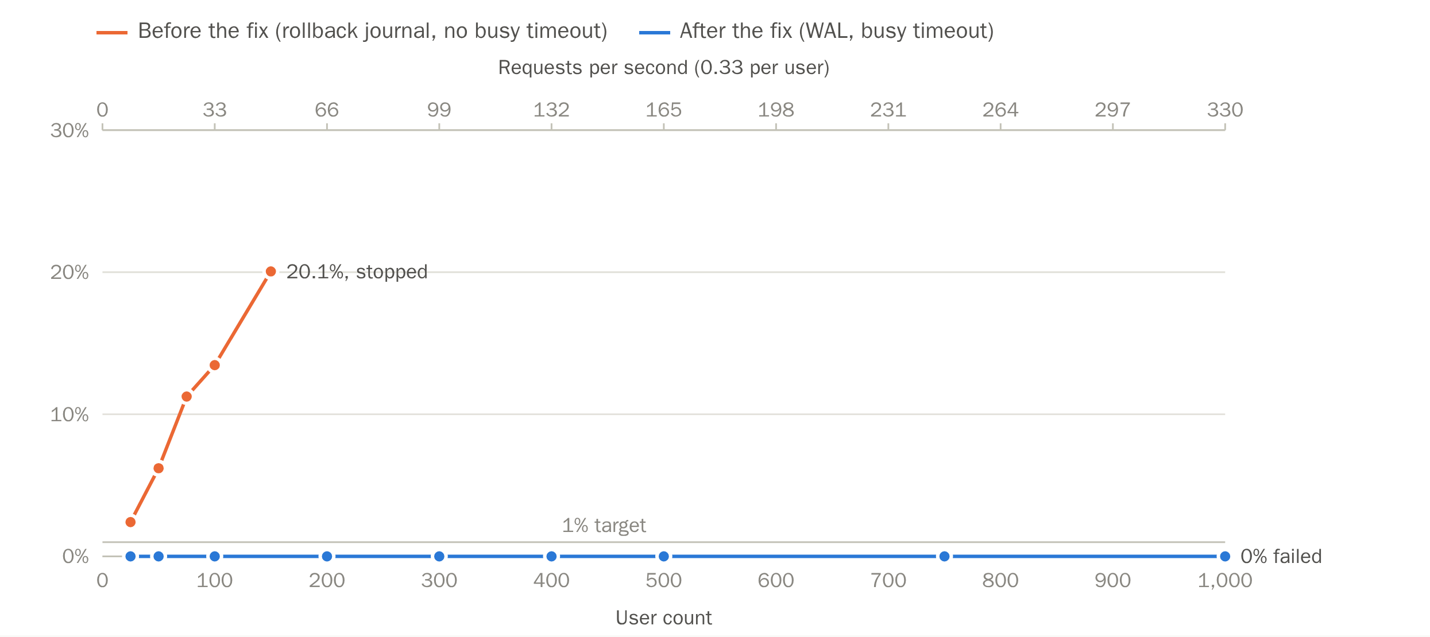
Figure 1. Failed requests before and after the fix. Share of requests that failed at each step; the 1% line is the target.
2. Response time. Response times stayed low while the processor had spare capacity (Figure 2): up to 300 users, with at most 56% of the processor in use, 95% of page loads and autosaves finished within 0.2 seconds. At 400 users the 1-second target still held for the whole step: 95% of pages loaded within 913 ms, including the login rush. At 500 users it held only once the rush was over: 95% of pages took 2.26 seconds over the whole step, but 384 ms in the last 30 seconds, after everyone had logged in. From 750 users all 3 cores were busy and response times rose to several seconds, and 1,000 users was the breaking point. Database time stayed below 0.2 seconds throughout.
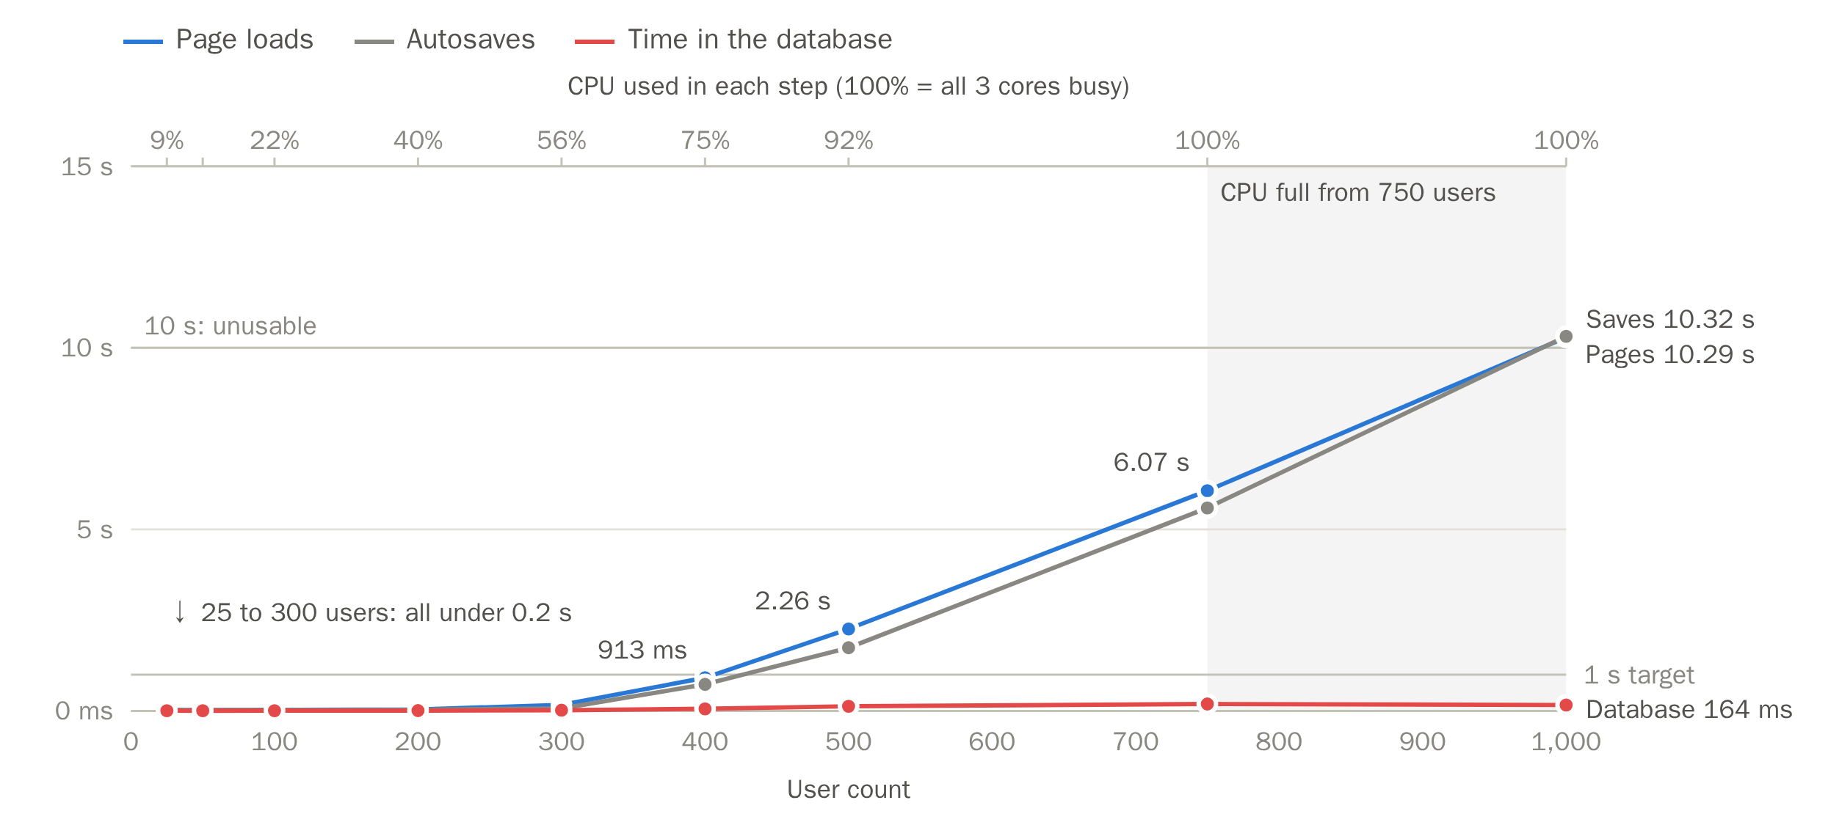
Figure 2. Response time and processor use at each step. 95th-percentile times of page loads, autosaves and database time over each whole step, login rush included. The top axis gives the processor (CPU) use measured in each step, and the shaded area marks the steps where all 3 cores were busy. The 1-second line is the target and the 10-second line the stopping point.
3. Requests handled. The server handled nearly every request asked for up to about 400 users, and at most about 142 requests per second from 500 users; the rest waited in line for a free PHP worker (Figure 3). Repeating the test with fewer and with more PHP workers gave nearly the same results, because the processor was already fully used.
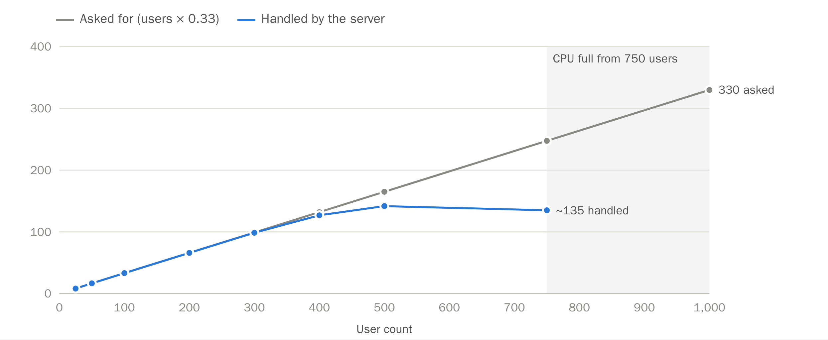
Figure 3. Requests asked for and requests handled per second. The server keeps up until its processor is full; the 1,000-user step stopped early, so its handled rate is not shown.
4. Results at each step. Table 21 lists the measurements at every step after the fix.
Table 21. Load Test Results at Each Step (After the Fix)
Users | Requests handled per second | Page loads (95%) | Autosaves (95%) | Database time (95%) | Processor (CPU) used
25 | 8 | 26 ms | 25 ms | 6.4 ms | 9%
50 | 17 | 27 ms | 25 ms | 6.3 ms | 14%
100 | 33 | 31 ms | 27 ms | 7.7 ms | 22%
200 | 66 | 40 ms | 30 ms | 9.4 ms | 40%
300 | 99 | 169 ms | 71 ms | 20.4 ms | 56%
400 | 127 | 913 ms | 732 ms | 58.2 ms | 75%
500 | 142 | 2.26 s | 1.74 s | 129 ms | 92%
750 | 135 | 6.07 s | 5.59 s | 191 ms | 100%
1,000 | — | 10.29 s | 10.32 s | 164 ms | 100%
Note: Times are for the whole step, login rush included. No request failed at any step. Database time includes any wait for a free processor core. The test stopped itself about 10 seconds into the 1,000-user step, so that step’s handled rate is not shown (—). Bold: the largest step within the 1-second target over the whole step. Once the rush was over (the last 30 seconds of each step), 95% of pages loaded within 90 ms at 400 users and 384 ms at 500 users, so 500 users also met the target then.
5. The database on its own. Tested directly, without building pages, 10 readers and 2 writers sharing a copy of the database failed most attempts before the fix and none after it (Table 22). SQLite alone completed more than 9,000 saves per second, over 230 times the busiest rate SPMS needed during the test (Table 23). Each request needed about 21 ms of processor time against about 0.11 ms for a save, so the processor reaches its limit long before the database does.
Table 22. Reading and Saving at the Same Time (10 Readers and 2 Writers, 3 Seconds)
Database setup | Reads per second | Failed reads | Saves per second | Failed saves
Before the fix: rollback journal, no busy timeout | 14,461 | 65.5% | 0.3 (1 save in 3 s) | 99.99% (8,023 of 8,024)
After the fix: WAL, 5-second busy timeout | 29,388 | 0% | 1,460 | 0%
Note: Failures are shown as a share of all attempts.
Table 23. How Far SQLite Is From Its Limit
Test | Saves per second
SPMS at its busiest during the load test (500 users) | 39
SQLite on its own, one save after another | 9,142 (over 230 times as many)
SQLite on its own, 10 writers saving at the same time | 42,045 (over 1,000 times as many)
Note: Saves of the largest real document (58 KB), without building pages.

4.3.4 Test Scope and Interpretation
The results are a conservative baseline: every step began with a login rush, the simulated users acted far more often than real employees, and the load-testing tool shared the server with SPMS. The number of real employees SPMS can serve at the same time is therefore likely higher than the 400 to 500 users found here (400 with the login rush, 500 once everyone was logged in), although this was not measured directly. The figures apply to this 3-core server; since the processor was the limit, a server with more cores would be expected to handle more requests per second.

References
Nielsen, J. (1993, January 1). Response times: The 3 important limits. Nielsen Norman Group. https://www.nngroup.com/articles/response-times-3-important-limits/

