import pyautogui as pt

import pyperclip as py

from time import sleep

import csv

def wa():

wcord = pt.locateOnScreen("Whatsapp_logo.png", confidence=.85)

if wcord is None:

wcord = pt.locateCenterOnScreen("Whatsapp_logoh.png", confidence=.70)

pt.click(wcord)

def msg_det():

cords = pt.locateCenterOnScreen("Green_dot1.png", confidence=.92)

print(cords)

if cords is None:

cords = (0, 0)

else:

pt.click(cords[0]-99,cords[1])

return cords

def msg_write(msg):

cords= pt.locateOnScreen("message_write.png",confidence=.85)

pt.click(cords)

pt.typewrite(msg)

pt.typewrite("\n", interval=.01)

def msg_reciever():

py.copy("No reply")

global pos

pos=pt.locateOnScreen("message_write.png",confidence=.85)

pt.tripleClick(pos[0],pos[1]-65)

sleep(.6)

pt.rightClick(pos[0],pos[1]-65)

print(pos)

pt.click(pos[0]+34,pos[1]-46)

message=py.paste()

message

print("the message is:",message)

return message

def cords_get():

while (True):

sleep(2)

posxy = pt.position()

print(posxy)

if posxy[0] == 0:

break

def cross():

cross = pt.locateOnScreen("cross.png")

pt.click(cross)

def Continue():

msg_write("Would You Like to Continue?")

while True:

sleep(5)

res = msg_reciever()

print(res)

if res.upper() == "NO REPLY":

cross()

elif not(res.upper()=="YES" or res.upper()=="Y" or res.upper()=="NO" or res.upper()=="N"):

cross()

msg_write("Yes/No?")

else:

return res

flag=0

wa()

while True:

msg_det()

msg=msg_reciever()

if msg.upper()=="START BOT":

msg_write("Welcome to Atlas!")

msg_write("---------------------------------")

lfile = open("Link.csv")

opt = csv.reader(lfile)

for row in opt:

msg_write(row[0])

lfile.close()

msg_write("---------------------------------")

msg_write("Enter Your Option:")

while True:

sleep(15)

option=msg_reciever()

if option.upper()=="NO REPLY":

cross()

continue

else:

if not option.isdigit() or int(option) > 14 or int(option)<0:

option=15

lfile = open("Link.csv")

opt = csv.reader(lfile)

for row in opt:

if option!="12":

if opt.line_num==int(option):

msg_write(row[1])

else:

msg_write("Enter your Feedback:")

msg_write("(No Emoji's)")

sleep(50)

fd=msg_reciever()

if fd=="No reply":

msg_write("FeedBack Not Received!")

break

else:

msg_write("Feedback Received")

f1=open("Feedback.txt","a")

f1.write(fd)

f1.write("\n")

f1.close()

break

lfile.close()

rep=Continue()

if rep[0].upper()=="NO" or rep[0].upper()=="N":

msg_write("Thank You!!")

flag=1

break

elif rep[0].upper()=="YES" or rep[0].upper()=="Y":

msg_write("Enter Your Option:")

continue

else:

cross()

sleep(5)

if flag==1:

break

Output Screen

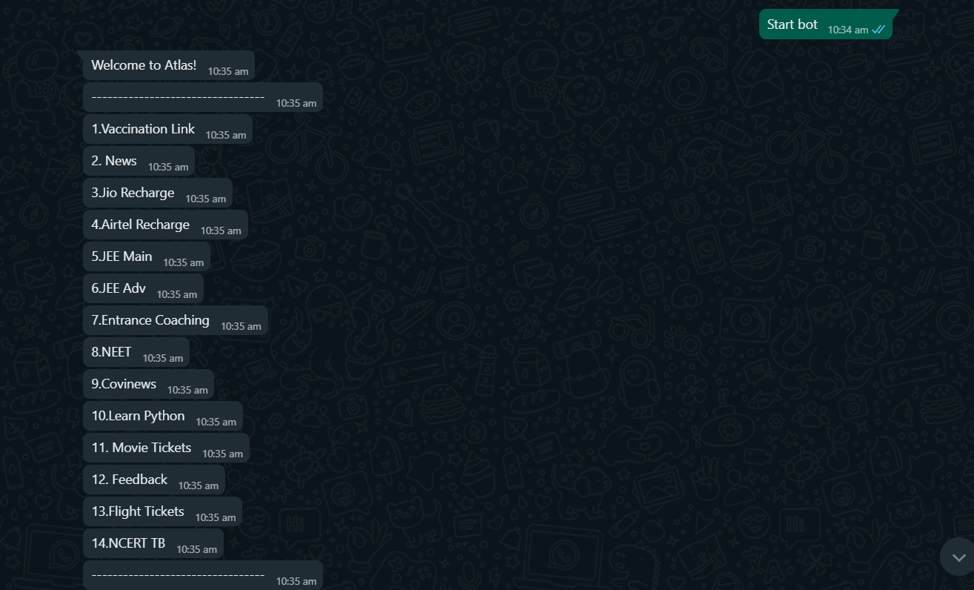

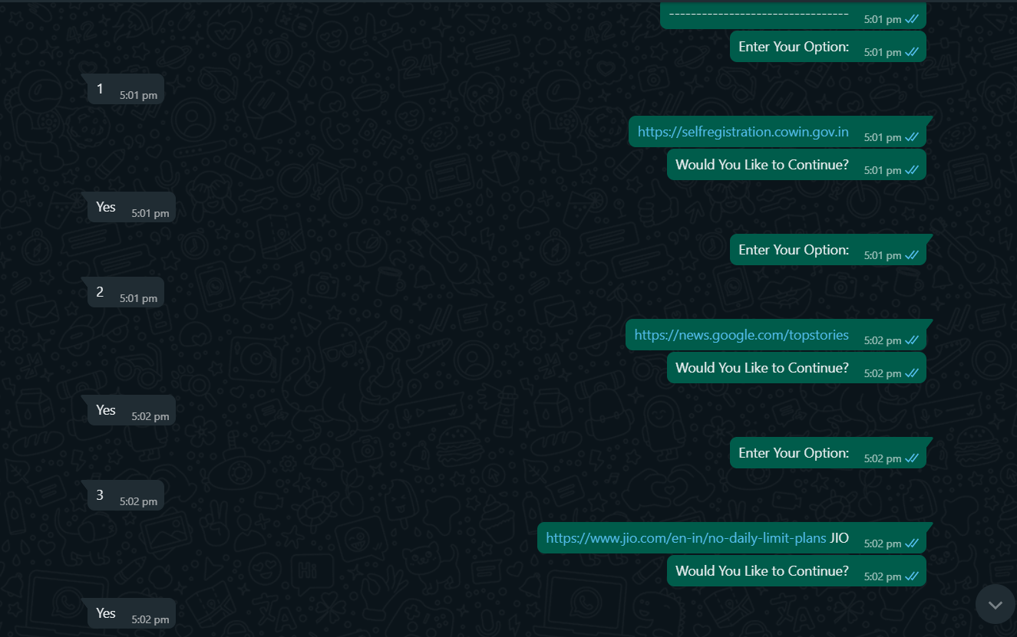

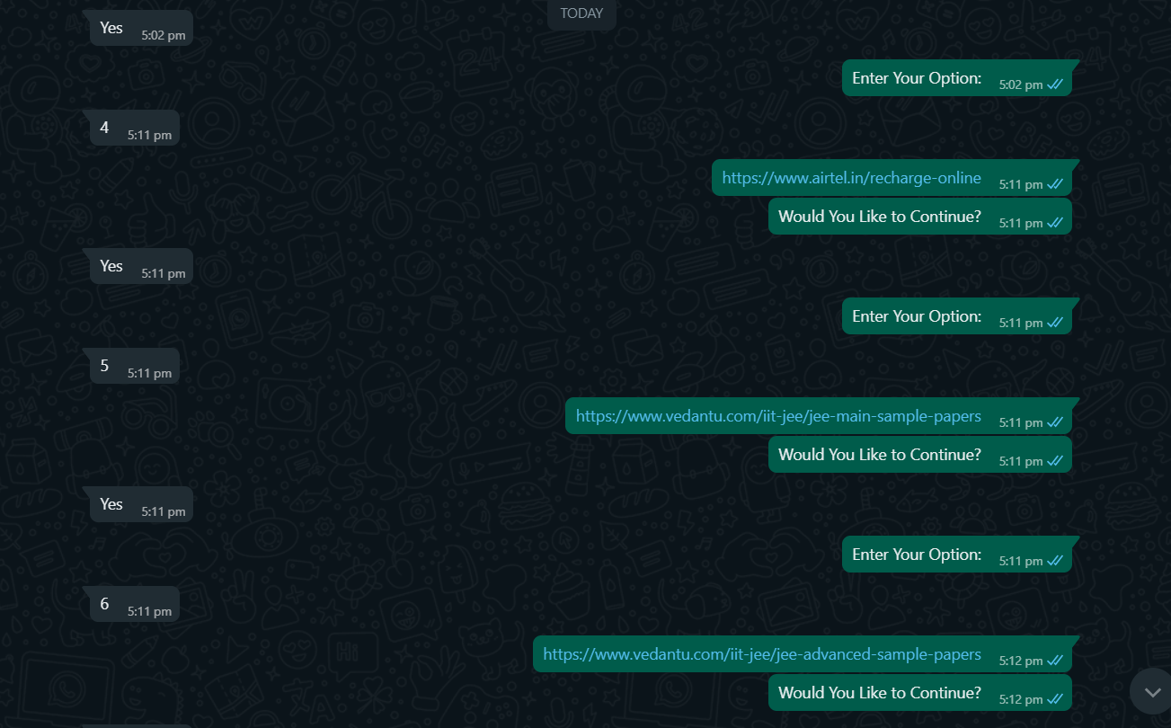

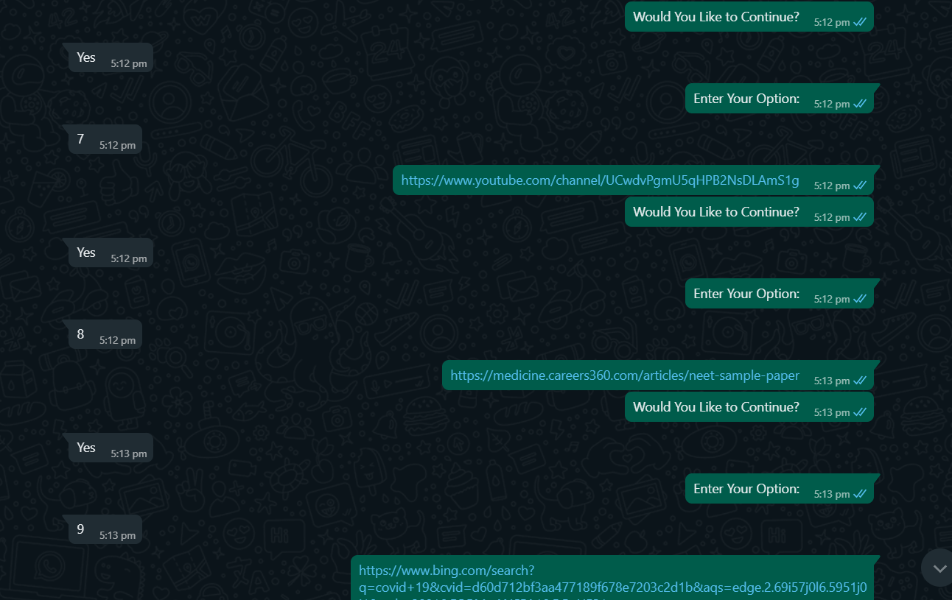

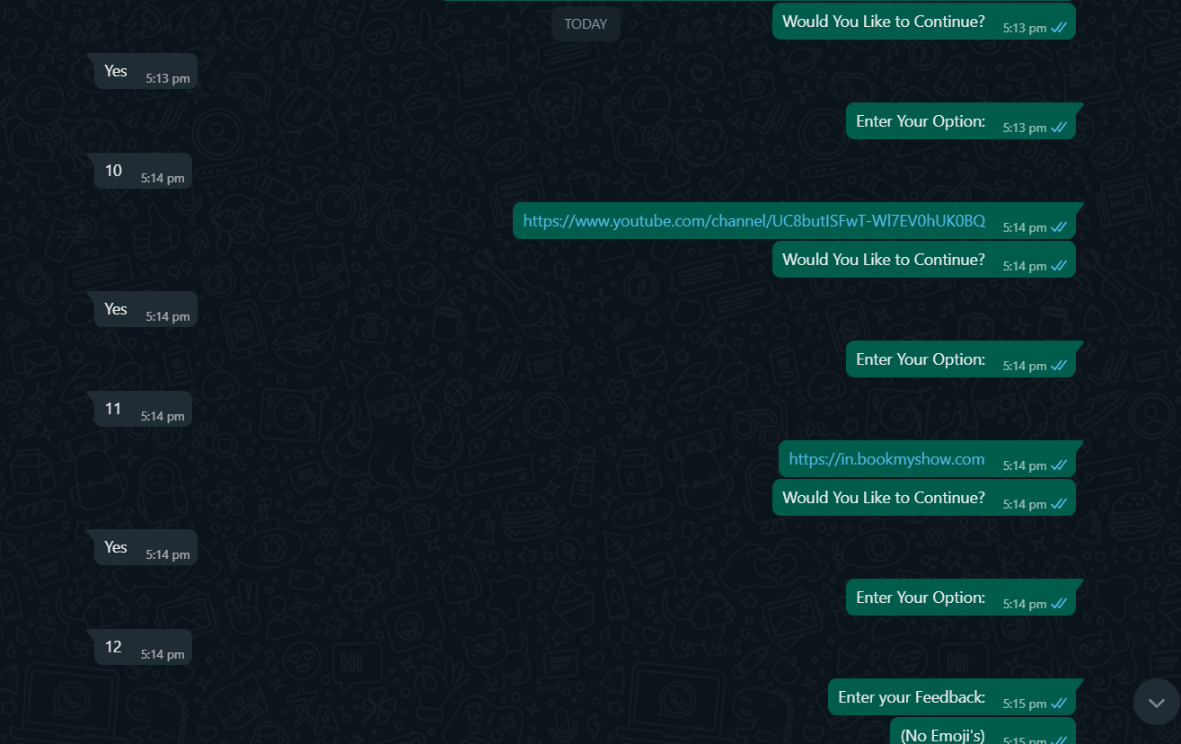

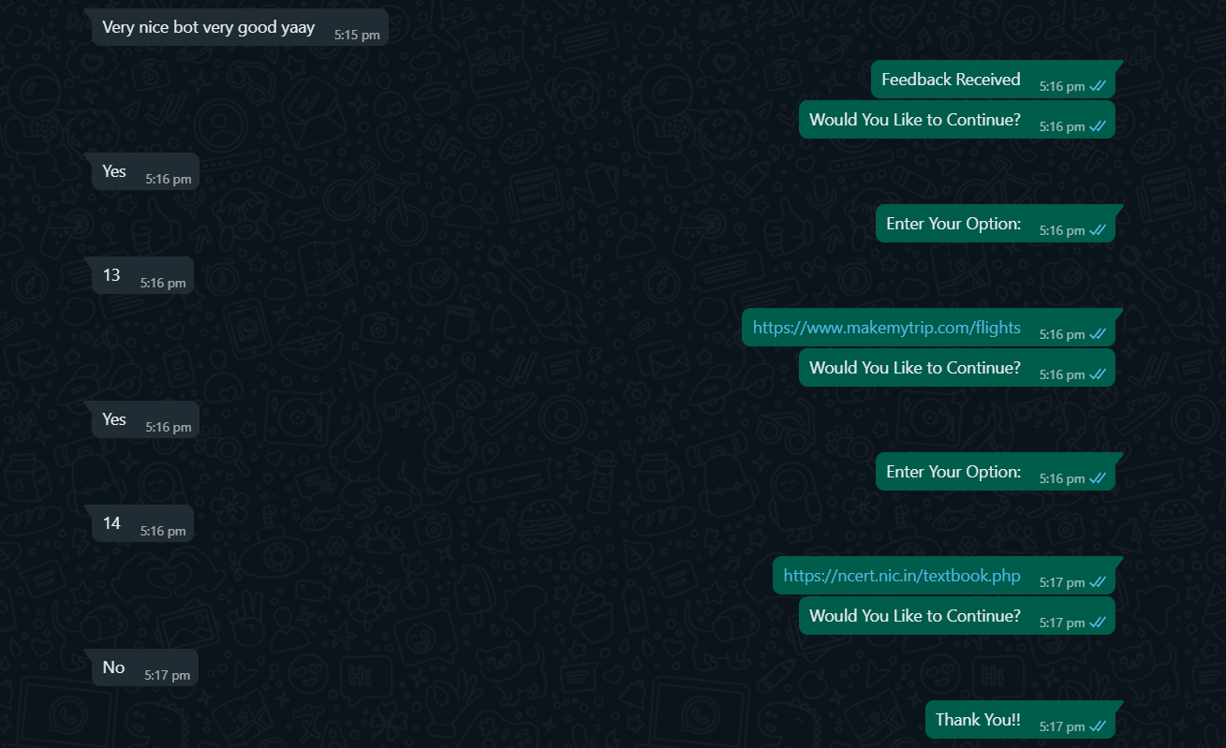

Bibliography

<https://pyautogui.readthedocs.io/en/latest/>

<https://pyperclip.readthedocs.io/en/latest/>

<https://www.youtube.com/>

Human Brain