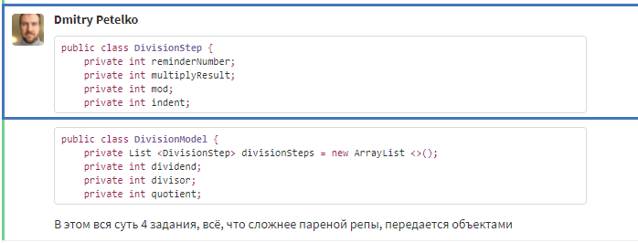

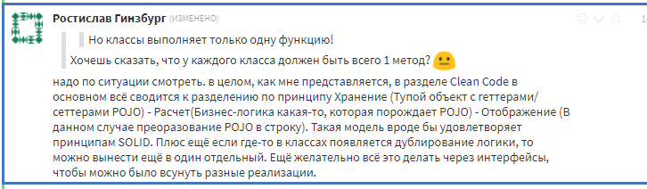

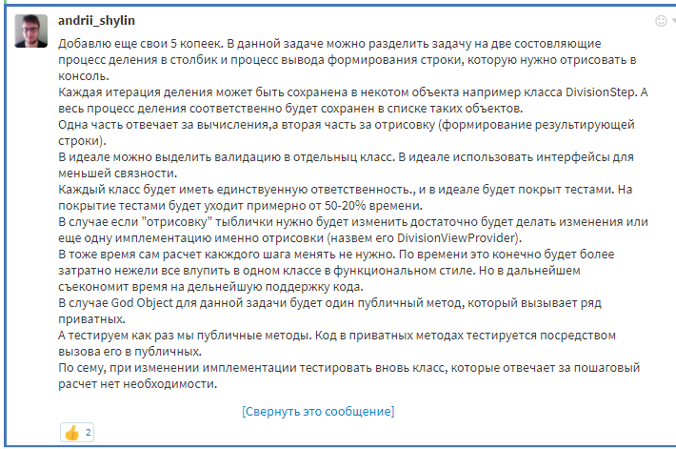

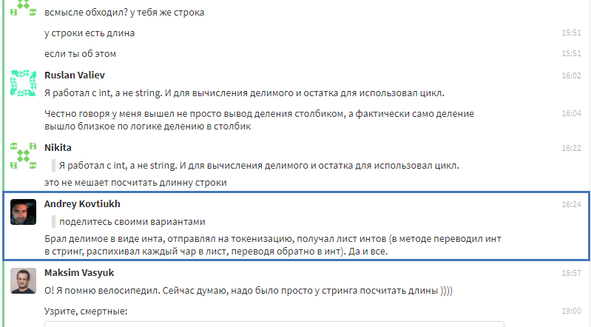

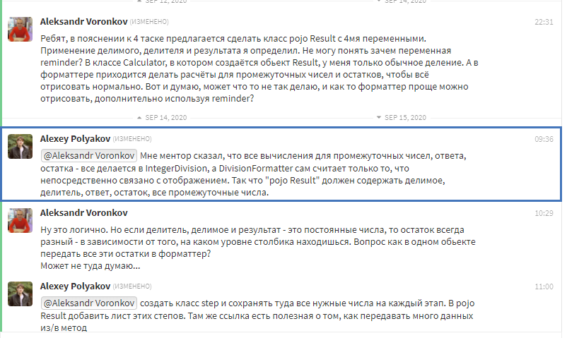





Ссылки:

<https://refactoring.guru/ru/replace-method-with-method-object>

<https://refactoring.guru/ru/introduce-parameter-object>

<https://dzone.com/articles/stateful-or-stateless-classes>

<https://dzone.com/articles/java-8-optional-avoid-null-and>

<https://www.geeksforgeeks.org/custom-arraylist-java/>

dividend – делимое

divisor – делитель

555(divident)|5(divisor)

|--------------------

|111 (quotient)