DBA Troubleshooting Form

The symptoms are ___________________ (what end users complain about?).
I believe the root cause is __________________ (high CPU usage, memory etc.).
If we don’t take action now, the effect will be _________________ (drive gets filled up, replica fails).
I recommend that we:
Take action ________ now to fix it, or
Take action ________ to investigate further, or
Put this in _________’s queue.

Tools to be used in this order:
- Monitoring tool
- sp_WhoIsActive
- sp_BlitzFirst
- sp_BlitzCache
- sp_BlitzIndex
- sp_Blitz

EX:
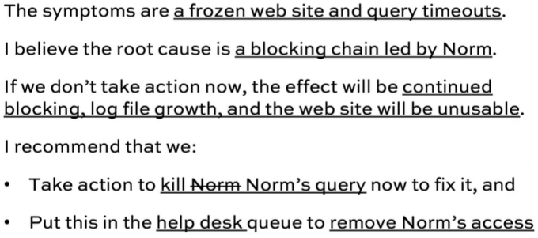 | 