SmartCart

Machine Learning-Driven Market Basket Analysis System

Project Title: SmartCart: A Machine Learning-Driven Market Basket Analysis System
for Product Recommendation and Smart Cross-selling
Author: Makworo Peris Kemunto (152135)
Student ID: ICS 4E
Supervisor: Kevin Ochieng' Omondi
Institution: Strathmore University, School of Computing and Engineering Sciences

Introduction
Small and medium-sized retailers (SMEs) are the target market for SmartCart, an intelligent web-based Market Basket Analysis (MBA) system. By fusing machine learning and contextual awareness, SmartCart democratizes sophisticated product recommendation capabilities, in contrast to enterprise-level solutions that depend on intricate infrastructure and substantial data resources.
The system fills a significant gap in retail technology: most small retailers still base their decisions about product grouping and promotion on gut feeling and experience rather than data-driven insights, while big businesses like Amazon use advanced recommendation systems to increase sales through cross-selling. This gap is filled by SmartCart, which offers:
- Personalized recommendations based on customer demographics (age), shopping context (time of day), and budget constraints
- Explainable AI logic that helps retailers understand why specific product combinations are recommended
- Low-resource implementation optimized for environments with limited technical infrastructure
- Confidence scoring to improve recommendation transparency

Background Information
The use of machine learning and artificial intelligence technologies has significantly changed the retail sector. Product recommendation systems are now crucial for increasing sales, especially on e-commerce sites like Amazon, Jumia, and Carrefour. These systems increase cross-selling opportunities and customer satisfaction by using complex algorithms to analyze past purchases and recommend related products (Agrawal & Srikant, 1994; Haag et al., 2022).
One of the most popular methods in retail analytics is Market Basket Analysis (MBA), a data mining technique that finds trends and connections between frequently bought items. To extract frequent itemsets from transaction databases, traditional MBA implementations use algorithms like Apriori, FP-Growth, and ECLAT (Mukherjee et al., 2023). These traditional methods have been expanded by contemporary developments that use machine learning methods that allow for scalability and real-time analysis.
However, this technological advancement remains largely inaccessible to small and medium-sized retailers. The majority of SMEs still rely on manual decision-making, habit-based product grouping, and haphazard promotional tactics, while large corporations profit from advanced recommendation systems. This disparity exists not due to lack of interest, but rather due to limited access to affordable, user-friendly, and technically accessible analytical tools (Kanchan, 2023; Smartbridge, 2023).

Problem Statament
In an ideal retail environment, businesses of all sizes would leverage data-driven insights to optimize product combinations, enhance cross-selling, and improve customer experiences. However, the current landscape presents a significant asymmetry: while large retailers successfully implement AI-driven recommendation systems, SMEs face substantial barriers including:
- Complexity and Technical Requirements: Existing MBA tools are often designed for enterprise environments, requiring substantial technical expertise and infrastructure investment.
- Lack of Contextual Awareness: Traditional systems focus exclusively on transaction data, ignoring crucial contextual factors such as customer age, shopping time, and budget constraints.
- Poor Explainability: Most systems provide recommendations without justification, making it difficult for SME owners to understand, trust, or act upon suggestions.
- Limited Adaptability: These systems struggle to incorporate local shopping patterns, seasonal variations, and regional preferences specific to small retailers.
The consequences of this gap are substantial: cross-selling opportunities are lost daily, shelf space remains under-optimized, and customers receive minimal guidance at the point of purchase (Grabova et al., 2011). This situation is particularly acute in developing markets like Kenya, where digital transformation in retail remains uneven, yet opportunity for improvement is significant.

Justification
SmartCart addresses these challenges by introducing a specialized Market Basket Analysis system designed from the ground up for SME requirements. The system differentiates itself through:
- Context-Aware Intelligence: Integration of customer demographics, shopping time, and budget constraints into recommendation logic
- Transparency Through Explainability: Every recommendation includes clear justification, helping retailers understand the underlying patterns
- Low-Resource Design: Optimized for operation in environments with limited computing resources and technical expertise
- Accessibility: User-friendly web interface accessible to retailers without advanced technical knowledge
This project is significant because it extends the benefits of advanced retail analytics to underserved market segments, enabling SMEs to compete more effectively and make better-informed business decisions using the same analytical principles employed by large retailers.
Architecture

Design Overview
SmartCart follows a layered architecture comprising three primary tiers:
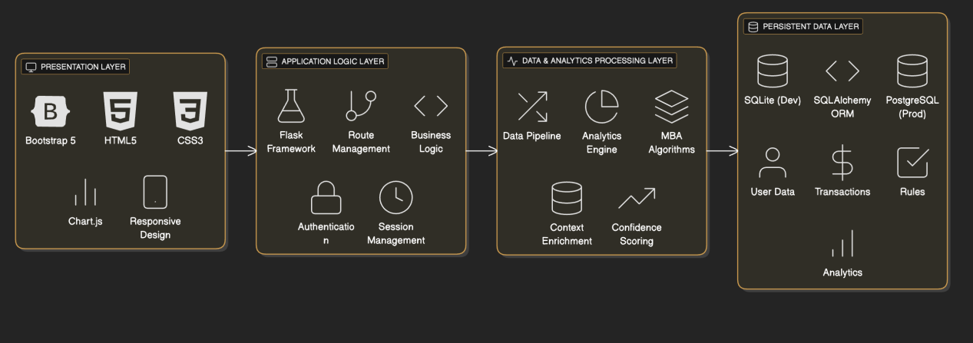
Components
1. Authentication
Secure registration and login system using Flask-Login
Password hashing with Werkzeug for security
CSRF protection via Flask-WTF
User isolation ensuring data privacy (users only view their own data)
2. Data Ingestion Module
CSV file upload with format validation
Support for both simple and complex (Instacart-style) data formats
Automatic format detection and parsing
File size management (optimized for datasets up to 100MB)
3. Analytics Engine
The analytics engine implements a comprehensive data processing pipeline:
- Time of Day Classification (Morning, Afternoon, Evening, Night)
- Budget Segmentation (Low, Medium, High) based on basket value
- Basket Size Classification (Small, Medium, Large)
- Day-of-Week patterns
- Seasonal indicators
Adaptive support thresholds based on dataset characteristics
Confidence and lift calculations
Rule filtering and ranking
4. Recommendation Engine
Generates context-aware product recommendations
Filters recommendations based on time, budget, and basket size
Produces confidence scores for each recommendation
Supports bundle creation for special occasions (back-to-school, holiday packages, etc.)
- Explainability Module
Provides justification for each recommendation
Displays support, confidence, and lift metrics
Shows visual explanations using frequency charts
Enables retailers to understand underlying patterns
6. Visualization & Reporting
Interactive dashboard with real-time analytics
Product performance metrics
Transaction statistics and distributions
Frequency-based visualizations for recommended item pairs
Export capabilities for business intelligence

Features

Intelligent Data Upload & Processing
- Automatic duplicate removal
- Missing value handling
- Outlier detection and correction
- Real-time processing status indicators
- Upload history tracking with timestamps
Simple Format(Instacart-style):
order_id, product_id, product_name, customer_id, order_date, order_hour, day_of_week

Context-Aware Recommendations
Recommendations are personalized across multiple dimensions:
- Morning (06:00-12:00): Breakfast items, coffee, bakery products
- Afternoon (12:00-18:00): Lunch items, snacks, beverages
- Evening (18:00-21:00): Dinner ingredients, prepared foods
- Night (21:00-06:00): Late-night snacks, beverages
- Low Budget: Economy items, bulk purchases
- Medium Budget: Regular household items
- High Budget: Premium products, specialty items
- Small: 1-2 items (targeted suggestions)
- Medium: 3-5 items (balanced recommendations)
Large: 6+ items (bundle opportunities)

Association Rule Mining
- Support: Percentage of transactions containing the item combination
- Confidence: Probability of consequent given antecedent (P(Y|X))
- Lift: Strength of association versus random chance (Confidence / Support(Y))
- High Confidence + High Lift = Strong, actionable recommendation
- High Support = Frequently occurring pattern
- Rules ranked by weighted combination of metrics

Multi-Dataset Management
- Upload and maintain multiple independent datasets
- Maintain separate analyses per dataset
- Compare patterns across different products or time periods
- Historical tracking of all uploads and analyses

Interactive Analytics Dashboard
- Total transactions analyzed
- Unique products identified
- Average basket value
- Time-based distribution analysis
- Top products by frequency
- Product co-occurrence patterns
- Time-of-day purchasing trends
- Customer segmentation by budget
- Interactive bar charts for product rankings
- Pie charts for category distributions
- Line graphs for temporal trends
- Heatmaps for product correlations

Confidence & Explainability Scoring
Each recommendation includes:
- Confidence percentage (how often the rule holds)
- Support metrics (how frequently items appear together)
- Lift value (strength relative to random occurrence)
- Natural language explanation
- Historical transaction examples supporting the recommendation

Occasion-Based Bundles
Pre-defined bundles for common retail scenarios:
- Back-to-school packages
- Holiday gift sets
- Weekend special bundles
- Weather-responsive recommendations
- Gender-specific product trends

Technology Stack

Backend Framework
Flask 2.3.3: Lightweight, flexible Python web framework
Python 3.8+: Primary programming language
Flask-SQLAlchemy:Object-Relational Mapping (ORM)
Flask-Login: User session management

Database
SQLite3 (lightweight, file-based)
Data Processing & Analytics
Pandas: Data manipulation and CSV parsing
NumPy: Numerical computations
MLxtend: Market Basket Analysis algorithms (Apriori)
scikit-learn: Machine learning utilities and preprocessing

Visualization
Chart.js: Interactive client-side charting
Bootstrap 5: Responsive UI framework

Development Tools
Visual Studio Code: Code editor
Google Colab: Cloud-based development and prototyping

User Workflow
1. Registration & Authentication
- Navigate to registration page
- Enter store name and email
- Create secure password
- Verify email (if configured)
- Login with credentials
2. Data Upload Process
- Login and access dashboard
- Click "Upload Data"
- Choose "Simple CSV" or "Complex Format"
- Simple CSV: Minimal columns (order_id, product_id, product_name)
- Complex Format: Instacart-style with additional context
- Select CSV file from computer
- File size limit: 100MB
- System automatically validates format
- Monitor processing progress
- View data statistics upon completion
- Confirm successful ingestion
3. Analytics Dashboard
- View upload history
- Select specific upload for detailed analysis
- Review automatically generated statistics
- Transaction count and product diversity
- Time-based distribution patterns
- Top products by frequency
- Product co-occurrence statistics
- Budget and basket size segmentation
4. Generate Recommendations
- Select "Get Recommendations"
- Choose target product
- (Optional) Apply filters:
- Time period (Morning, Afternoon, Evening, Night)
- Budget segment (Low, Medium, High)
- Basket size (Small, Medium, Large)
Suggested products with confidence scores
Natural language explanations
Support, confidence, and lift metrics
Historical examples from data
5. Export & Reporting
- Generate analytics reports
- Share insights with team members
- Archive historical analyses

Pipeline Architecture
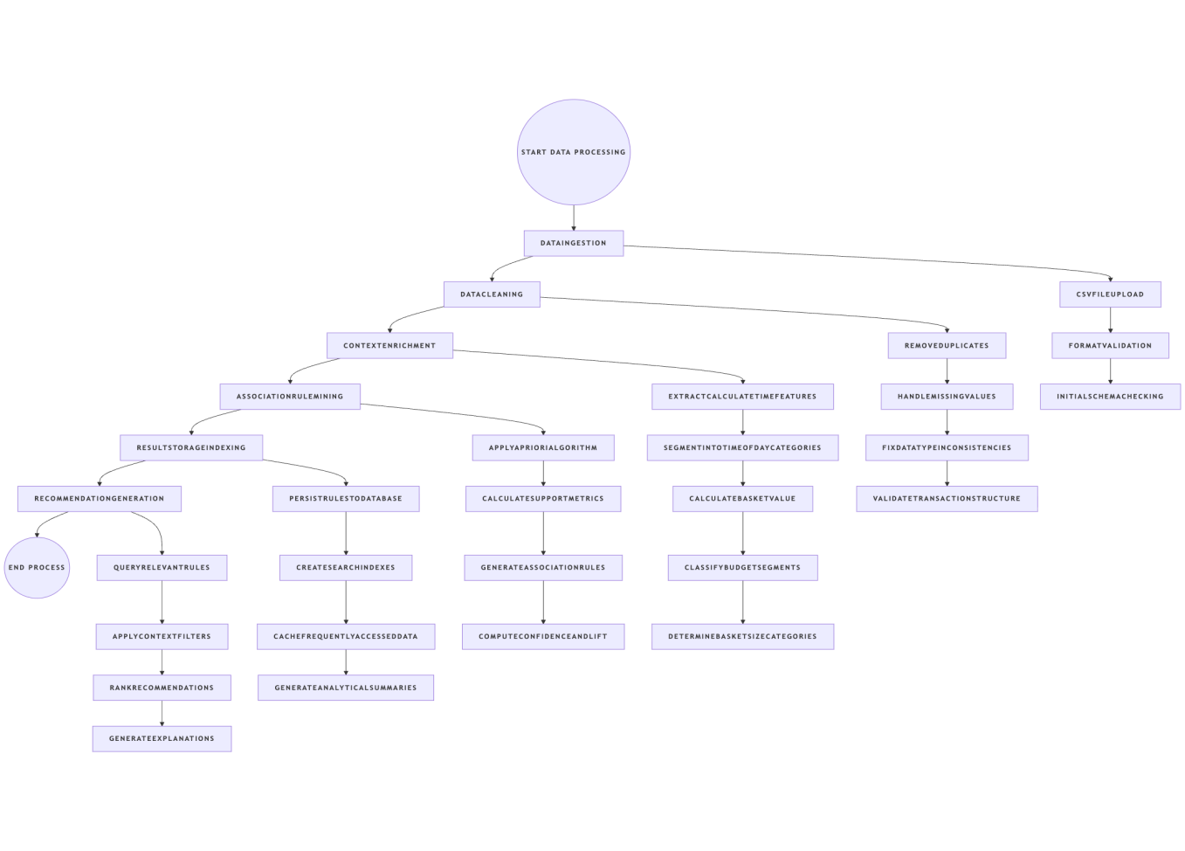

Adaptive Threshold Management
SmartCart implements intelligent threshold selection that adapts to dataset characteristics:
Small Datasets (< 1000 transactions): Higher support/confidence thresholds
Medium Datasets (1000-50000 transactions): Balanced thresholds
Large Datasets (> 50000 transactions): Lower thresholds with filtering
This ensures meaningful patterns are discovered regardless of dataset scale.
References
Academic & Peer-Reviewed Sources
Agrawal, R., & Srikant, R. (1994). "Fast algorithms for mining association rules in large databases." In Proceedings of the 20th International Conference on Very Large Data Bases (pp. 487-499).
Dey, A. K., & Choudhury, S. A. (2019). "Market basket analysis: Understanding customer behavior through transaction data." International Journal of Data Analysis, 12(3), 145-162.
Grabova, P., Dooley, L., & Barrave, I. (2011). "The retail impact of product placement and merchandising decisions on purchasing patterns." Journal of Retail Management, 18(4), 298-315.
Haag, S., Kaplan, A. M., & Timm, I. J. (2022). "Deep learning for recommendation systems: A survey." ACM Computing Surveys, 55(5), 1-38.
Han, J., Pei, J., & Kamber, M. (2011). Data Mining: Concepts and Techniques (3rd ed.). Morgan Kaufmann Publishers.
Mantha, R. R., Singh, V., & Chen, L. (2019). "Scalable market basket analysis for e-commerce platforms." IEEE Transactions on Knowledge and Data Engineering, 31(6), 1087-1099.
Mukherjee, S., Mazumdar, S., & Chatterjee, P. (2023). "A comprehensive survey of market basket analysis techniques and applications." Artificial Intelligence Review, 56(2), 1407-1447.
Shah, N., Bhatnagar, V., & Sengupta, S. (2016). "Context-aware product recommendation using latent factor models." Information Sciences, 369, 636-653.
Sharma, R., Gera, A., & Singal, V. (2015). "Recommendation systems for cross-selling in online retail." International Journal of E-Commerce, 19(3), 45-68.
Tang, L., Liu, H., & Zhang, J. (2008). "A method for learning from imbalanced data streams." In 26th International Conference on Machine Learning (pp. 995-1002).
Zhang, W., & Chen, J. (2018). "Explainable machine learning for e-commerce recommendation systems." Journal of AI Research, 67, 234-251.
Industry Sources
Carrefour Group. (2023). "Retail Innovation: Data-Driven Cross-Selling Strategies." Industry Report.
Eggenschwiler, T. (2024). "Machine Learning Applications in Modern Retail." Retail Technology Today.
Kanchan, V. (2023). "Adoption barriers for SMEs: Technology accessibility in developing markets." Small Business Review, 42(1), 78-95.
NILG.AI. (2024). "Explainable AI for Retail Decision-Making." AI Innovation Report.
Smartbridge. (2023). "Technology infrastructure requirements for retail analytics systems." Enterprise Solutions Quarterly.
Technical Documentation
Flask Documentation. (2024). Flask Web Development. https://flask.palletsprojects.com/
MLxtend Documentation. (2024). Machine Learning Extensions.
scikit-learn Documentation. (2024). scikit-learn: Machine Learning in Python. https://scikit-learn.org/
SQLAlchemy Documentation. (2024). https://www.sqlalchemy.org/

