First
create env
python -m venv venv
activate venv
source /smartcart/venv/bin/activate
pip install -r requirements.txt
python run.py
open port on chrome
http://127.0.0.1:5001
Then
create Account (sign up)
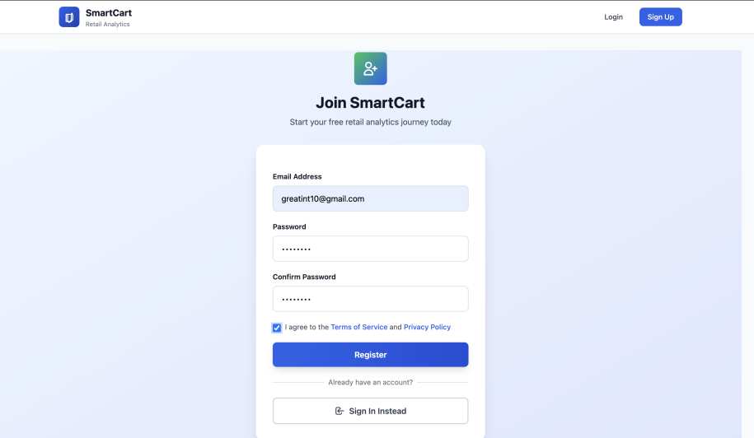

Immediately Go back to login( and login)

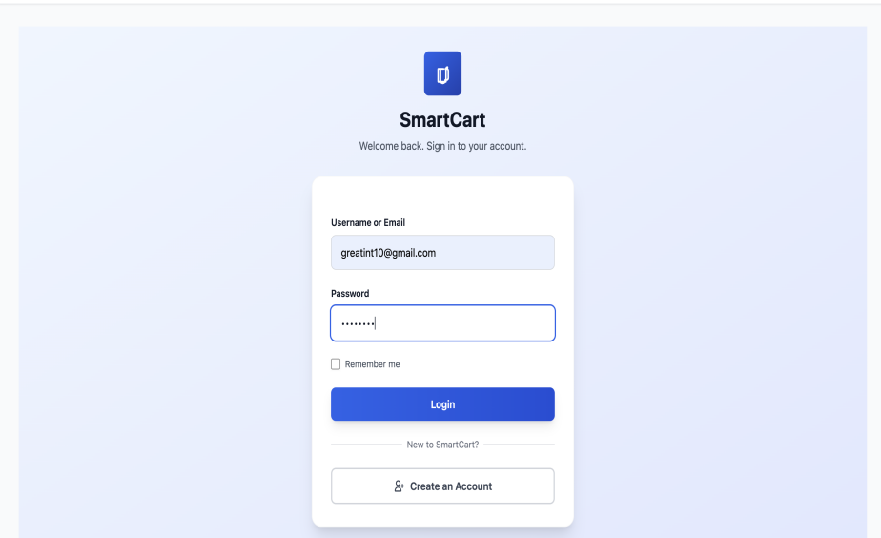

Verify OTP

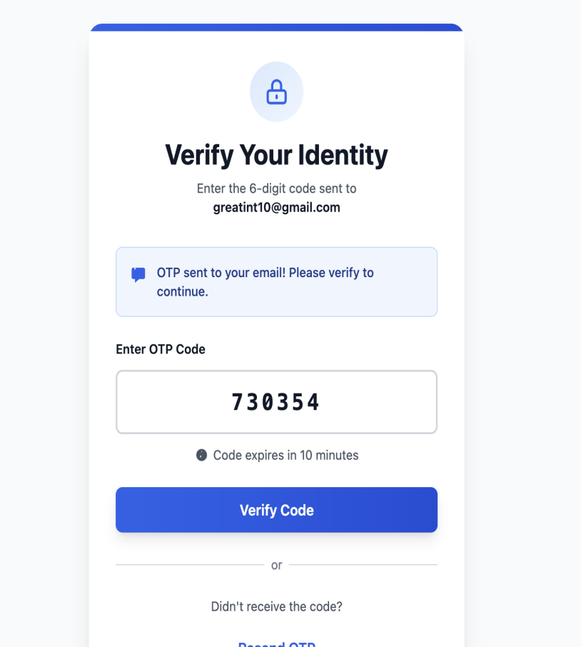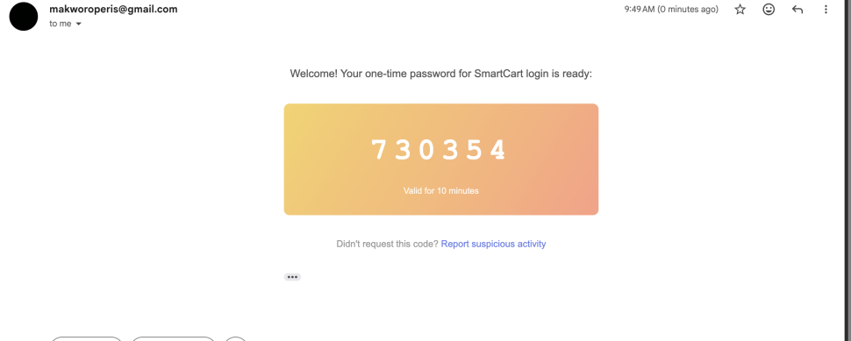

Fill in userData/shop
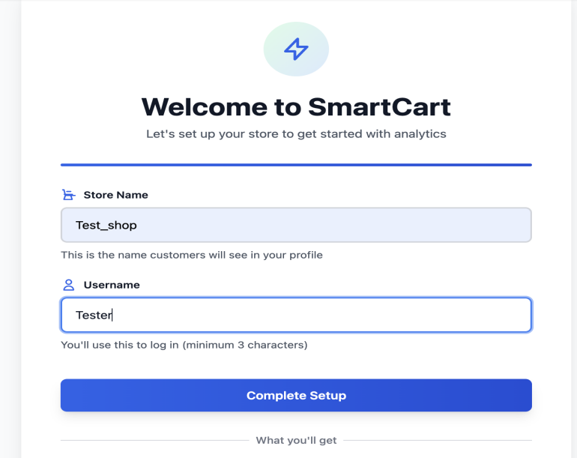

Main Dashboard working
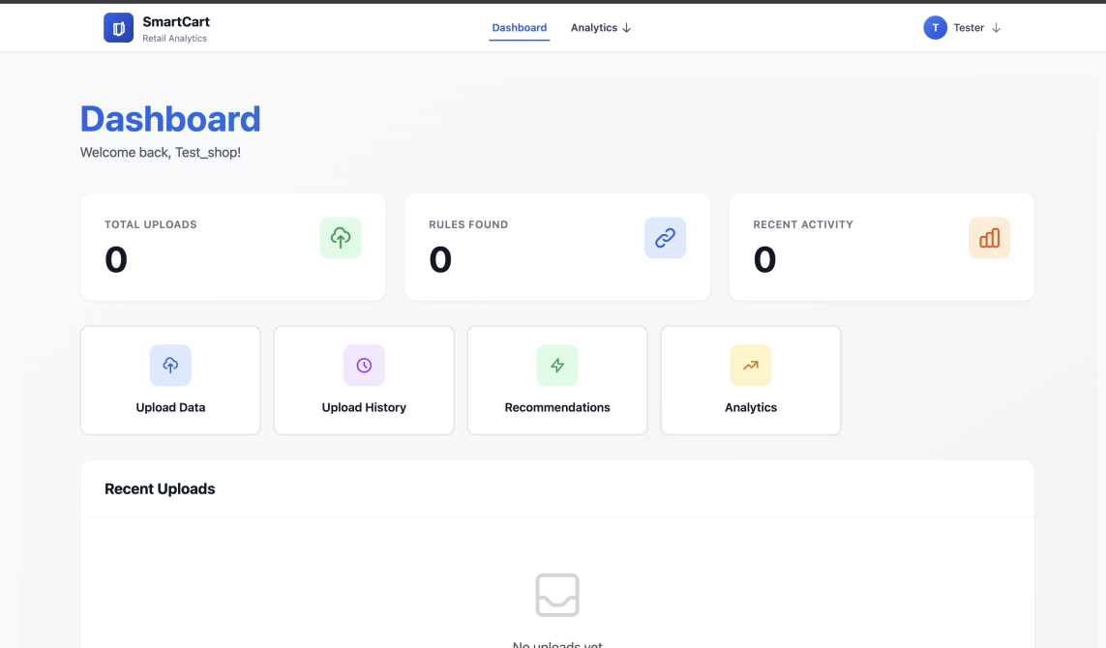

Upload Data
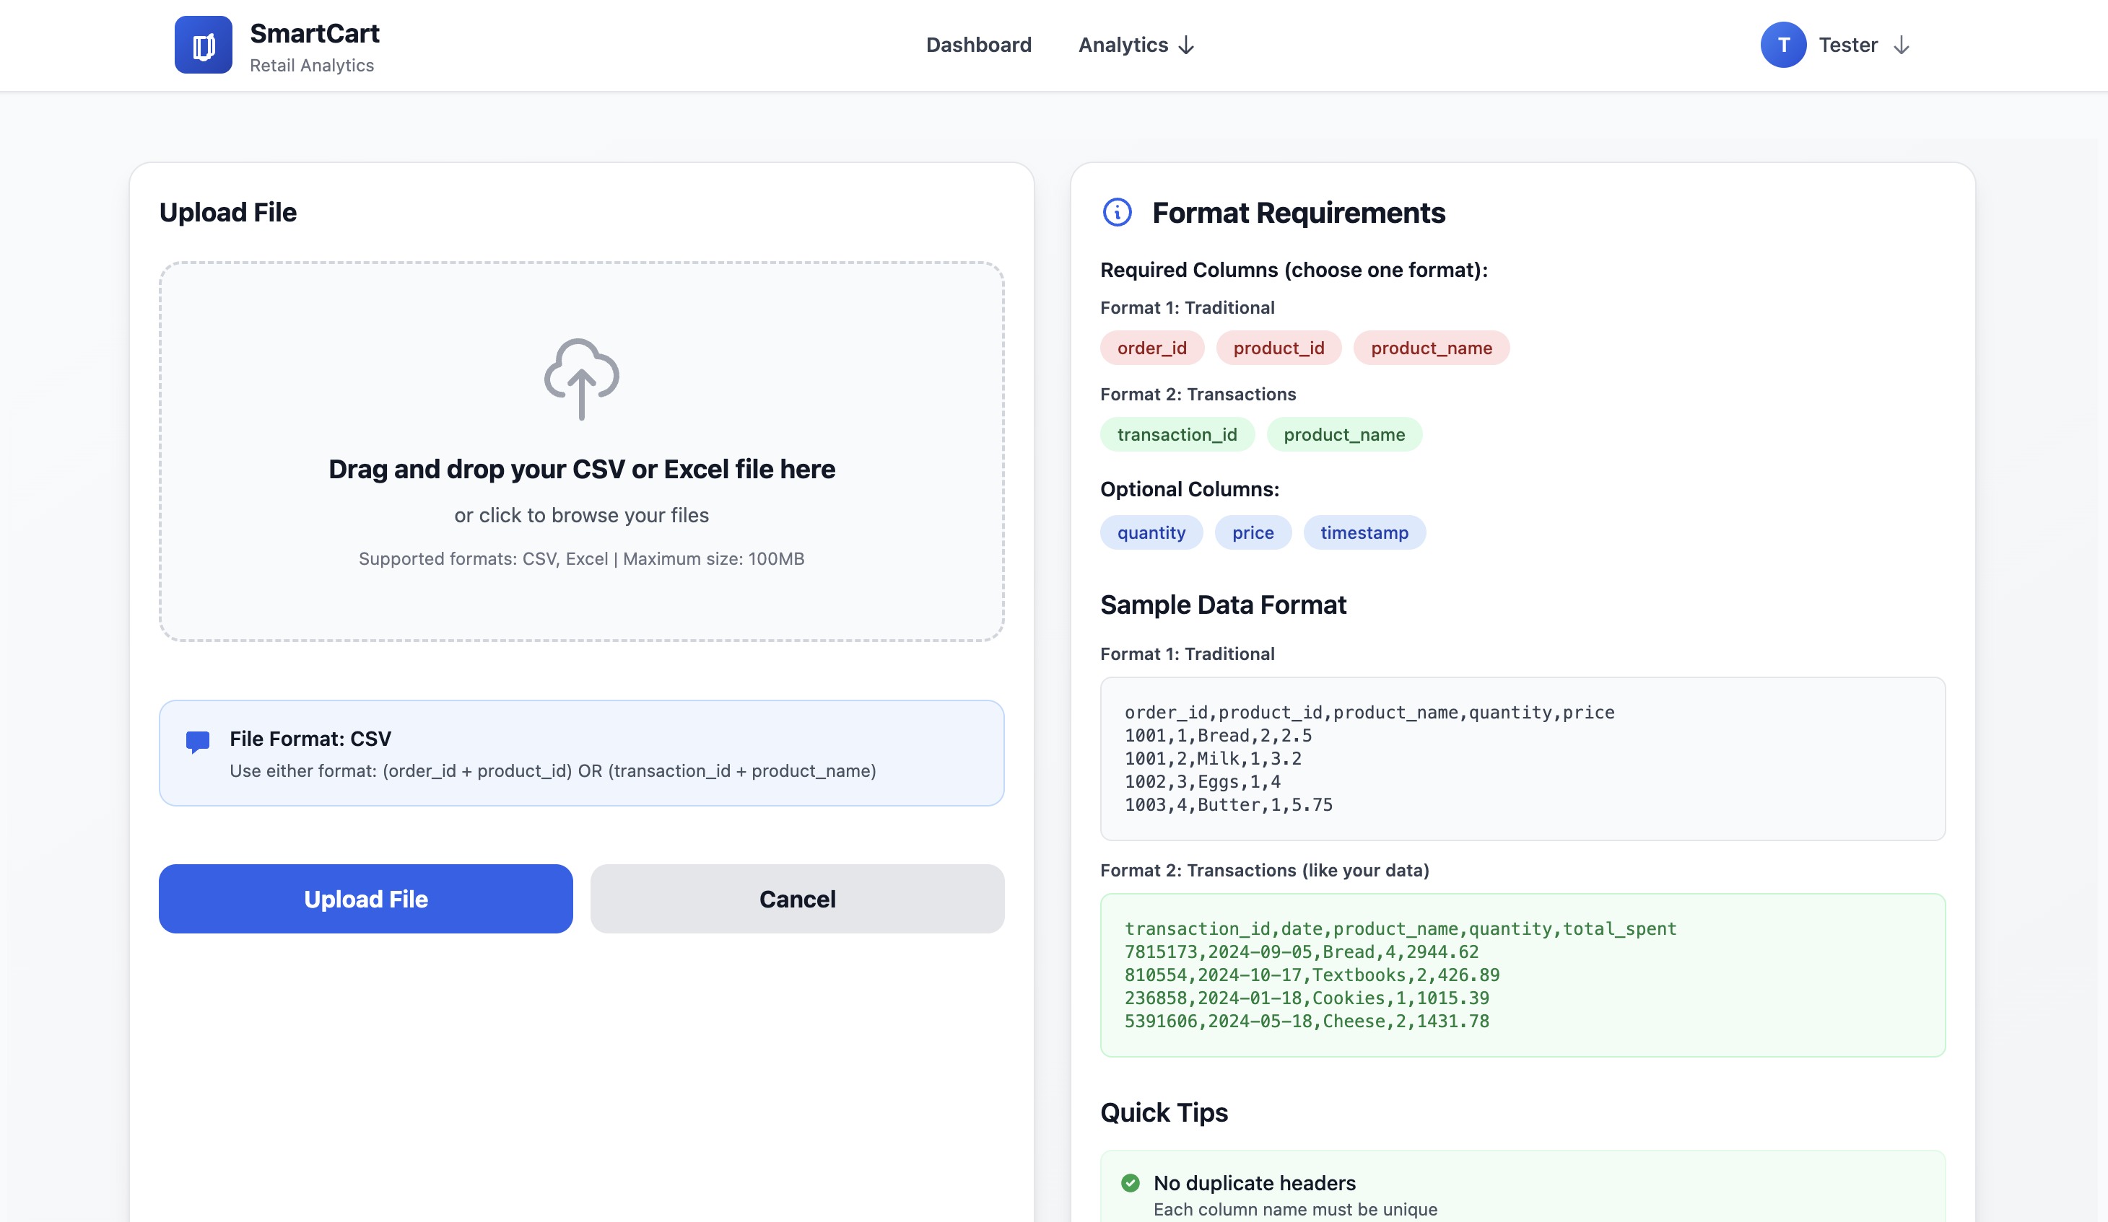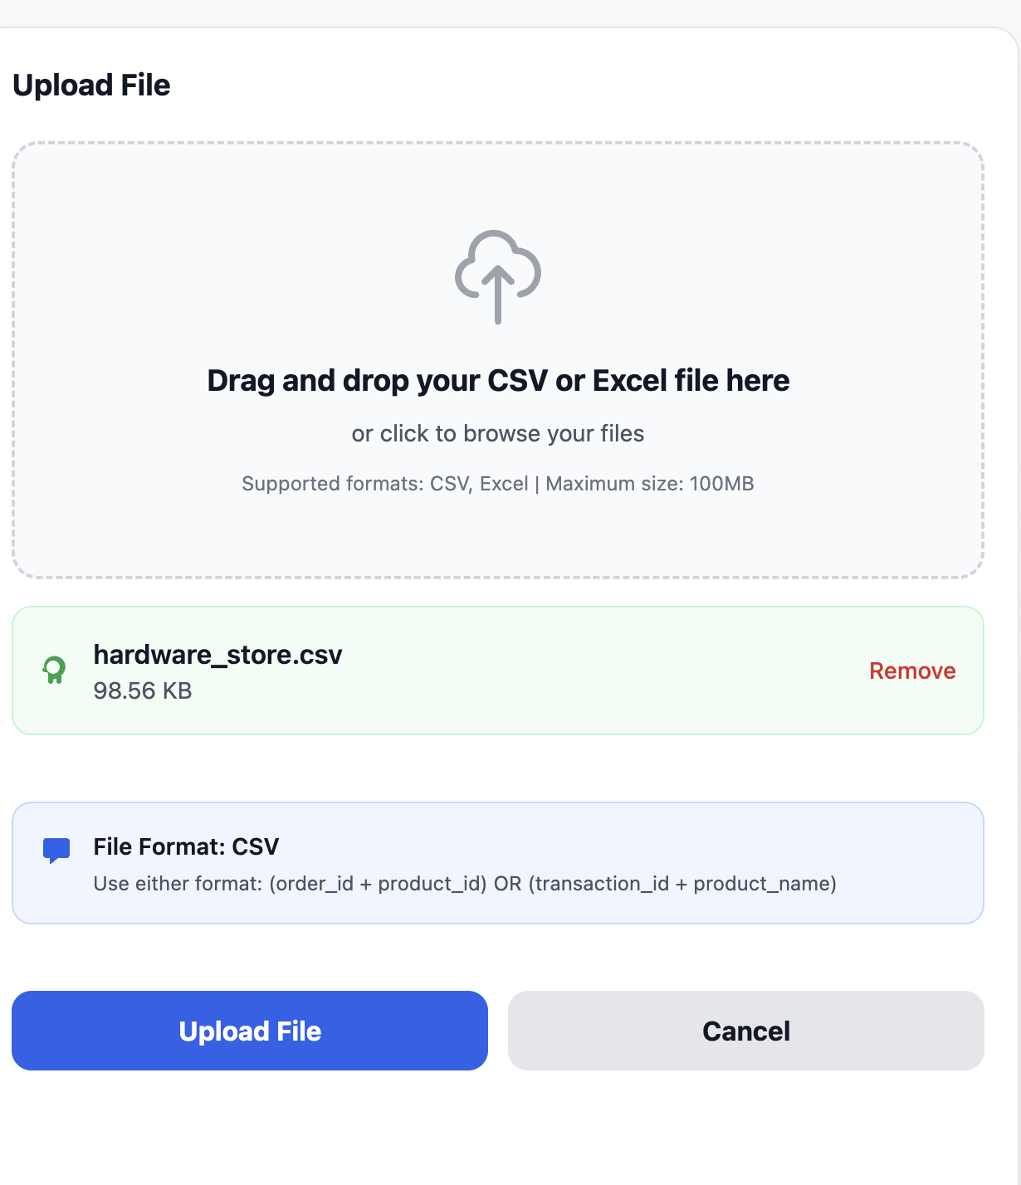

Threashhold updates
SmartCart implements intelligent threshold selection that adapts to dataset characteristics:
Small Datasets (< 1000 transactions): Higher support/confidence thresholds
Medium Datasets (1000-50000 transactions): Balanced thresholds
Large Datasets (> 50000 transactions): Lower thresholds with filtering
This ensures meaningful patterns are discovered regardless of dataset scale.
User allowed to change and modify else leave it alone then submit
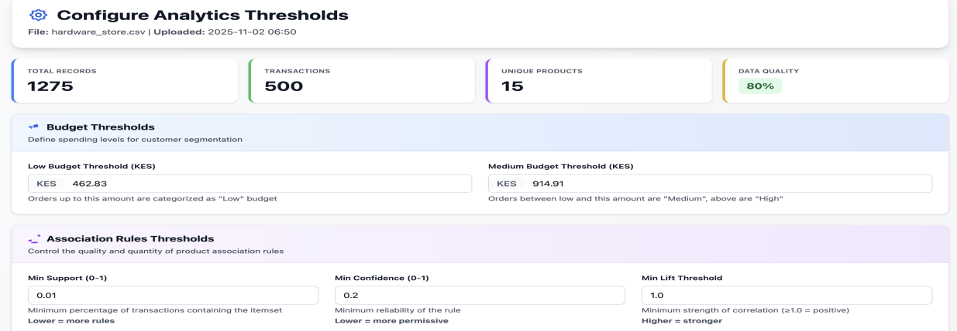
submit
fist analytic report (relation to thresholds)
showing the different distributions
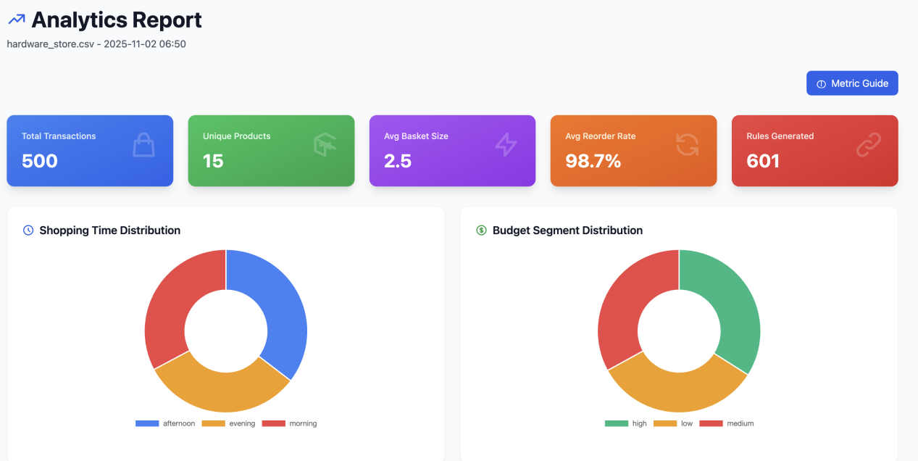

Rule in relation to context and distribution in relation to threshold
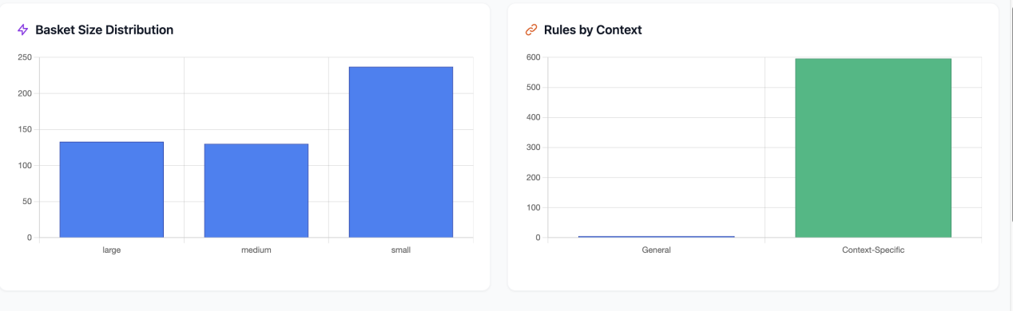

Upload summary
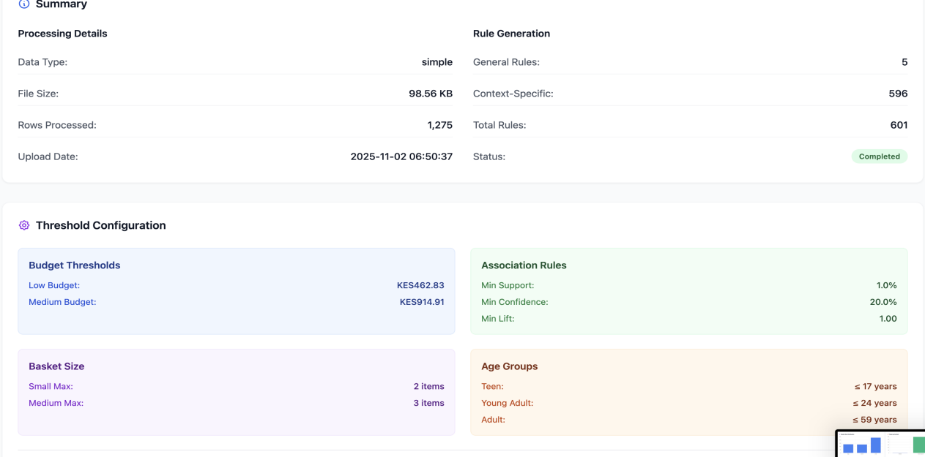

Recommendation based on the threshold
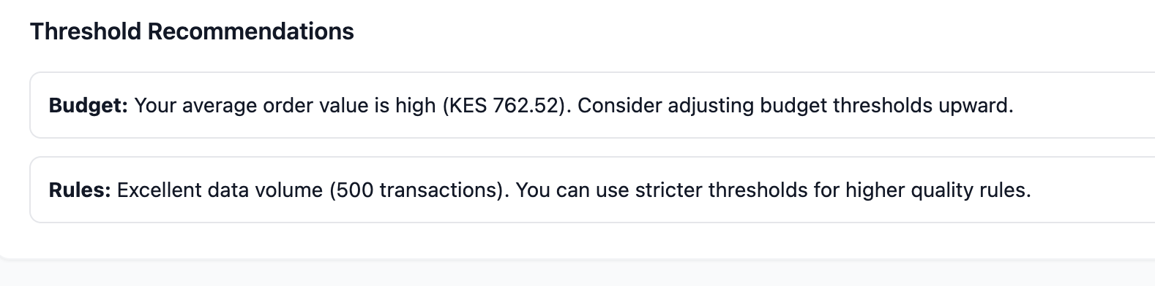

Back to main dashboard
Top 5 strongest are based on the recent uploads
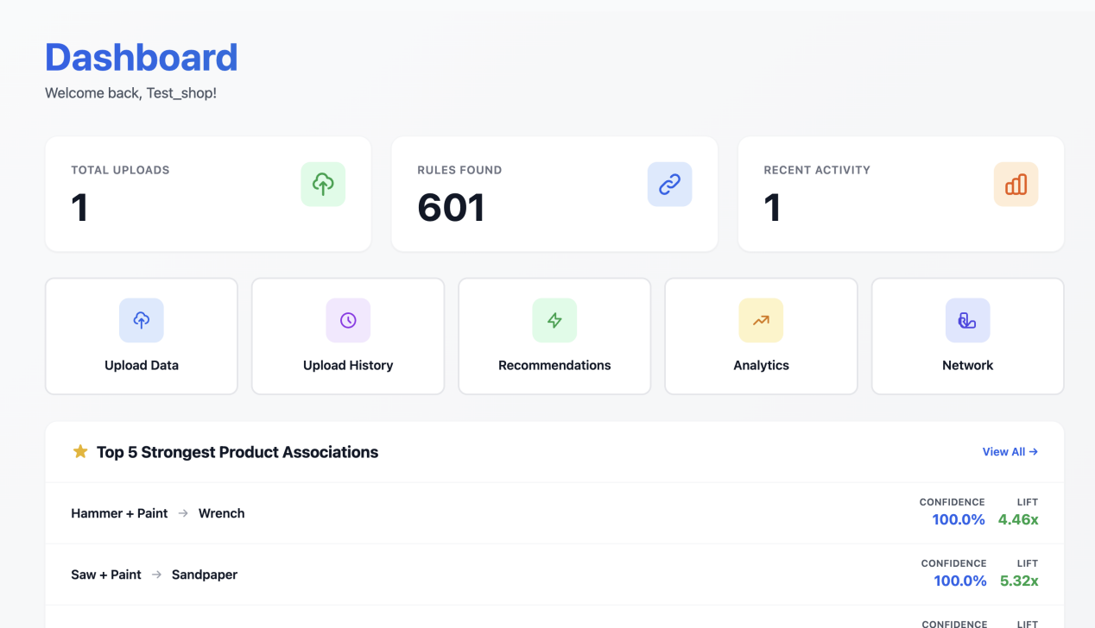

Then recent uploads
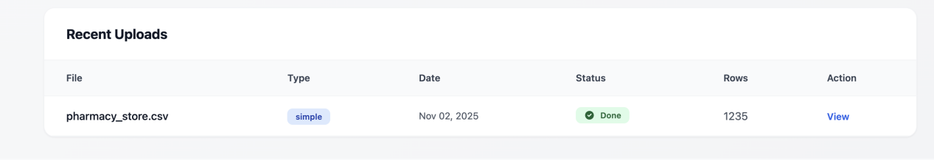

Then
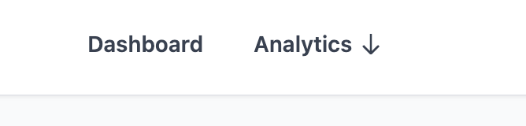
the Recommendations
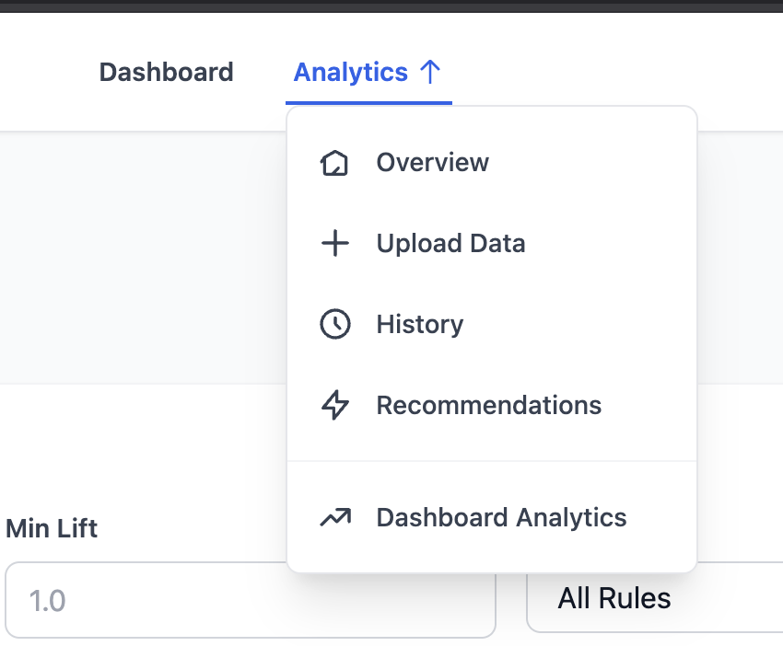

Recommendation based on Top rules in Desc
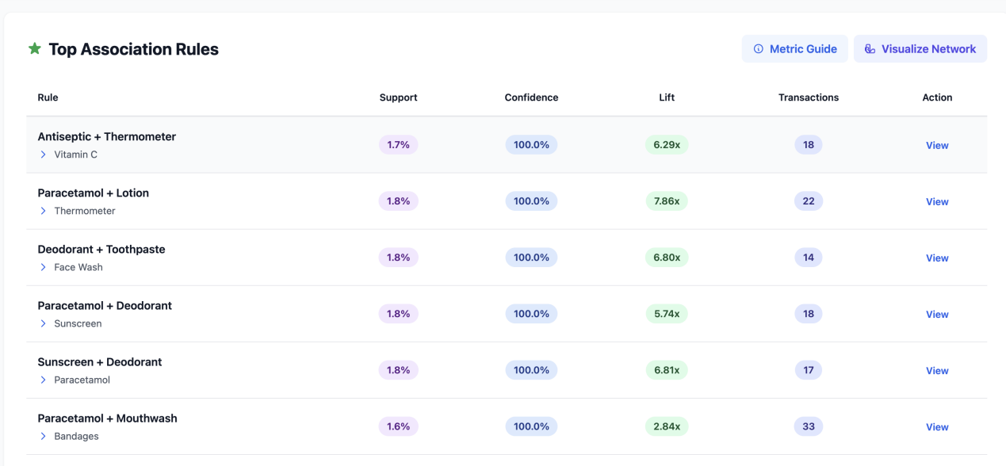
view each
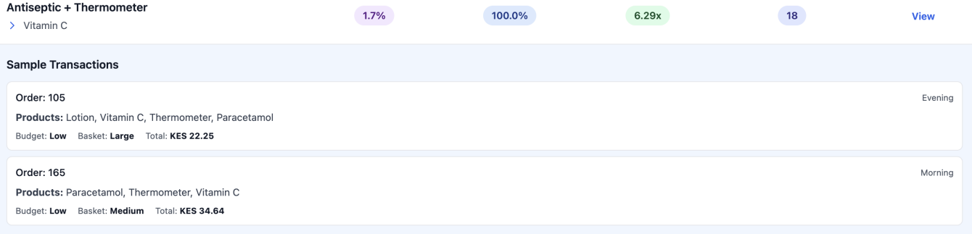

Then
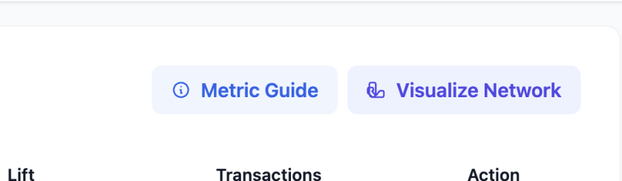
Metric Guide
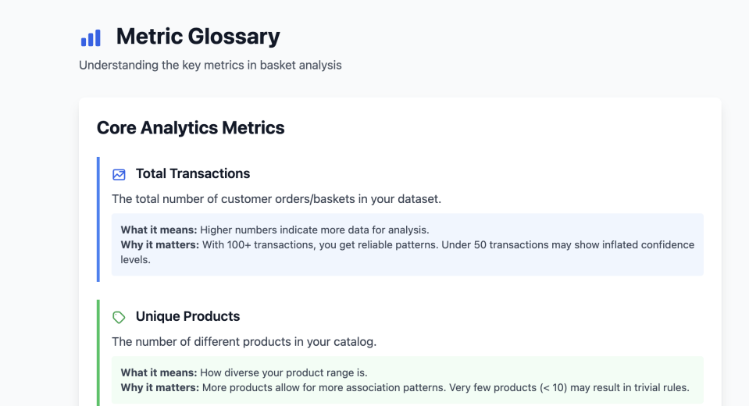
You can visualize Network
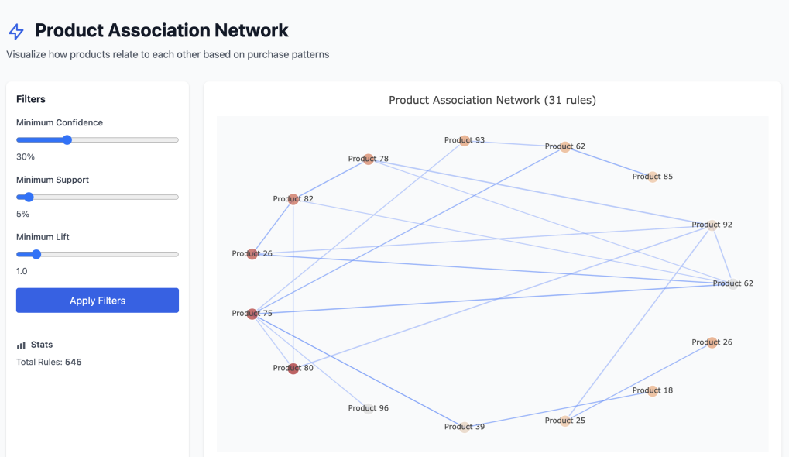
at the end of Recommendation analytic explanations
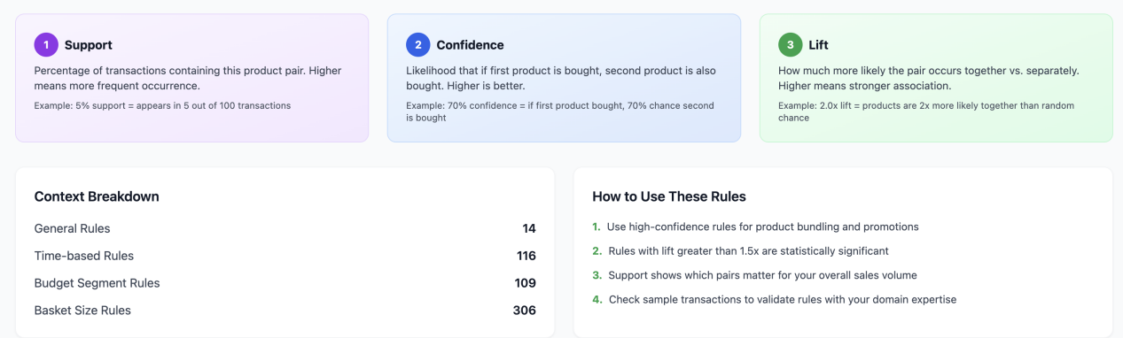

The open retailer Dashboard Analytic


General sales summary
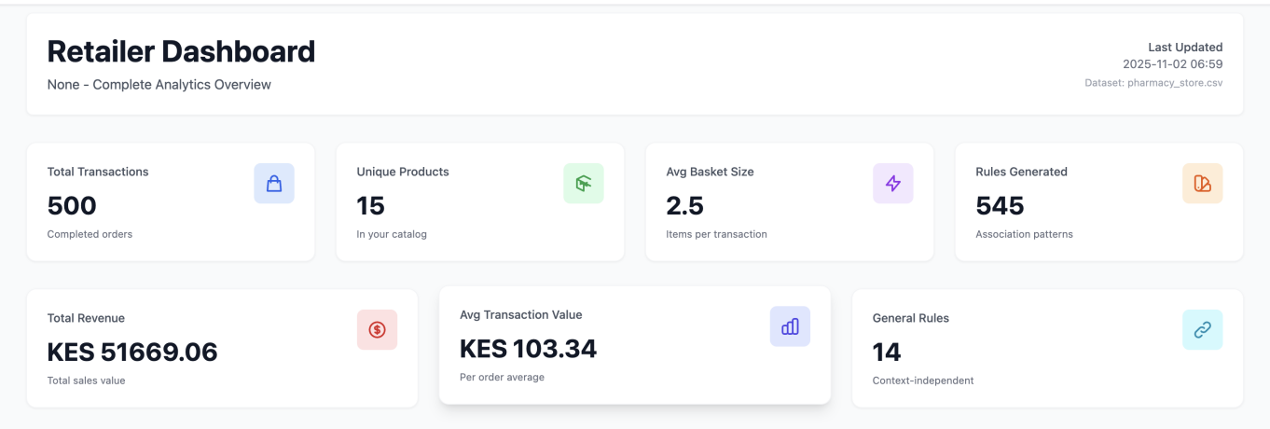

Also shop time and budget distribution better analytic
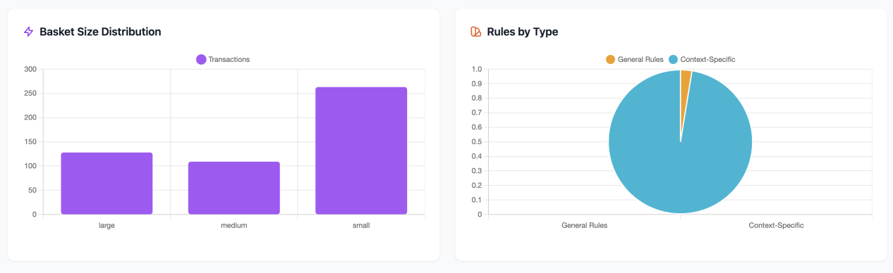

Product association
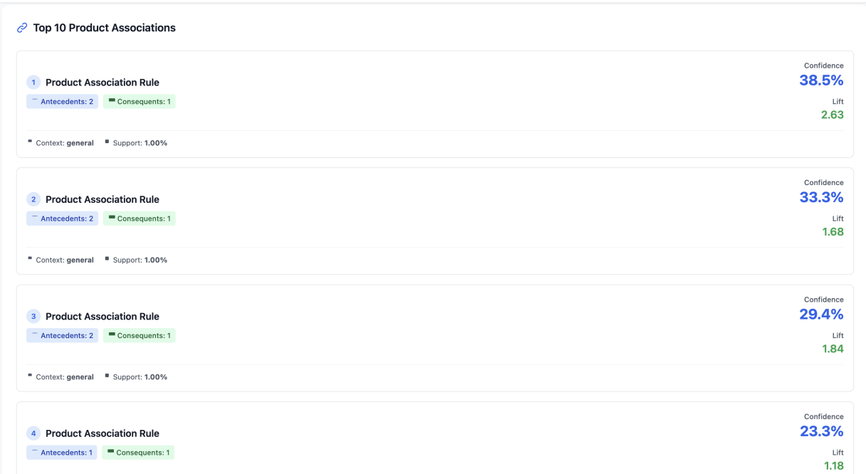

Distribution of the context in the threshold
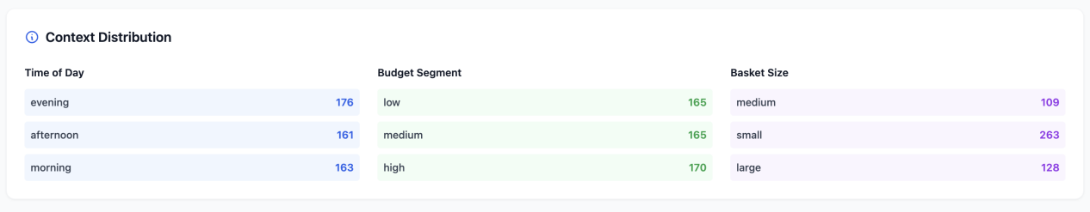
finally history of the uploads
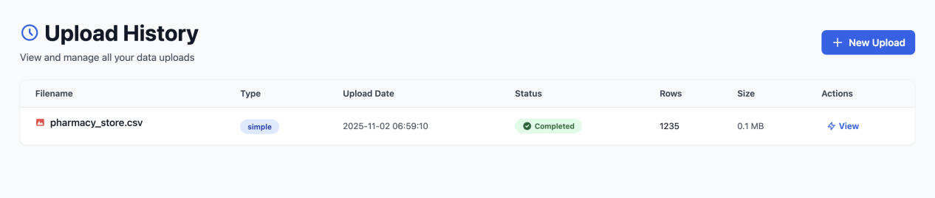

Finally logout
