Heart Disease Risk Prediction — MLOps Assignment 1 Report

Course | Machine Learning Operations (MLOps), AIMLCZG523
Assignment | Assignment 1 — End-to-End ML Model Development, CI/CD, and Production Deployment
Author | Sibasis Mishra (2025AE05040)
Repository | https://github.com/is-zen-genius/mlops_assignment_1
Date | 2026-10-20

____________________________________________________________

Table of contents
- Problem statement & dataset
- Setup / install instructions
- Data acquisition & EDA
- Feature engineering & model development
- Experiment tracking (MLflow)
- Model packaging & reproducibility
- CI/CD pipeline & automated testing
- Model containerisation
- Production deployment (Kubernetes)
- Monitoring & logging
- Architecture diagram
- Results summary
- Production-readiness requirements — evidence
- Repository layout
____________________________________________________________

1. Problem statement & dataset
Predict the presence of heart disease from 13 patient health measurements (age, sex, chest pain
type, resting blood pressure, cholesterol, fasting blood sugar, resting ECG, max heart rate,
exercise-induced angina, ST depression, ST slope, number of vessels coloured, thalassemia), and
serve that model as a monitored, containerised, Kubernetes-deployed REST API.
- Source: UCI Machine Learning Repository, Heart Disease (Cleveland) dataset —
processed.cleveland.data (14 columns, 303 rows, the last column num is a 0-4 severity score).
- Target: binarised to 0 (no disease) / 1 (disease present, num > 0).

2. Setup / install instructions
git clone https://github.com/<your-username>/<your-repo>.git
cd <your-repo>
python3.12 -m venv .venv
source .venv/bin/activate # Windows: .venv\Scripts\activate
pip install --upgrade pip
pip install -r requirements.txt # one file: training, serving, tests, lint, notebooks, report
Reproduce the whole pipeline from a clean checkout:
ruff check src tests scripts \
&& pytest \
&& python src/ingest.py \
&& python src/clean.py \
&& python src/train.py \
&& python src/package_model.py \
&& python src/inference.py
Run the API locally without Docker:
PYTHONPATH=src uvicorn main:app --app-dir src --host 0.0.0.0 --port 8001 --reload
# Swagger UI: http://localhost:8001/docs Health: /health Metrics: /metrics

3. Data acquisition & EDA
src/ingest.py downloads processed.cleveland.data straight from the UCI repository and writes
data/raw/heart_disease_raw.csv (303 rows × 14 columns); --source <file> lets it convert an
already-downloaded copy instead, for offline/air-gapped grading environments.
src/clean.py then:
- Drops exact duplicate rows.
- Binarises num (0-4 severity) into target (0/1).
- Imputes the only two columns with missing values — ca (4 missing) and thal (2 missing) —
with the column mode.
- Casts categorical columns to int.
The full analysis, with executed outputs, is in
notebooks/01_exploratory_data_analysis.ipynb.
Headline findings:
- Class balance: 54.1% no-disease vs. 45.9% disease — mild imbalance, not severe enough to
need resampling, but src/train.py still tries class_weight="balanced" during tuning.
- Strongest univariate correlations with target: thal (0.52), ca (0.46), exang (0.43),
oldpeak (0.43), thalach (0.42), cp (0.41). No pair of features is collinear enough
(all |r| < 0.6) to justify dropping one.
- `cp`, `restecg`, `slope`, `thal` are not ordinal — e.g. disease rate for cp is
30% / 18% / 21% / 73% for codes 1-4 respectively, which isn't monotonic — so they are one-hot
encoded rather than treated as numbers.
- `ca` (vessels coloured, 0-4) behaves like a count — disease rate increases roughly
monotonically with more vessels coloured, so it's scaled as a numeric feature instead.
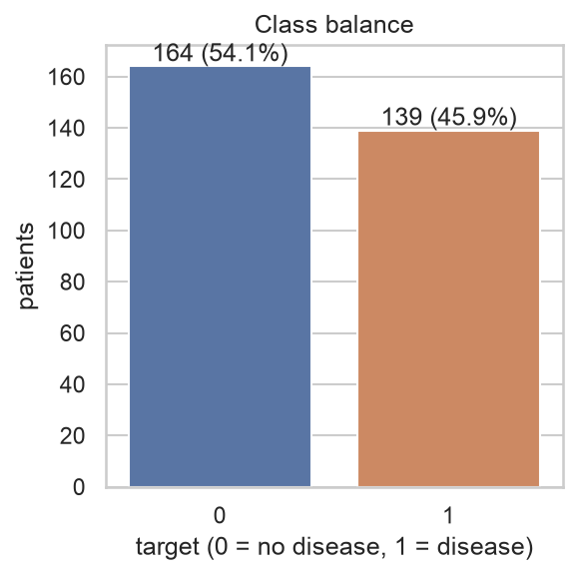
Class balance
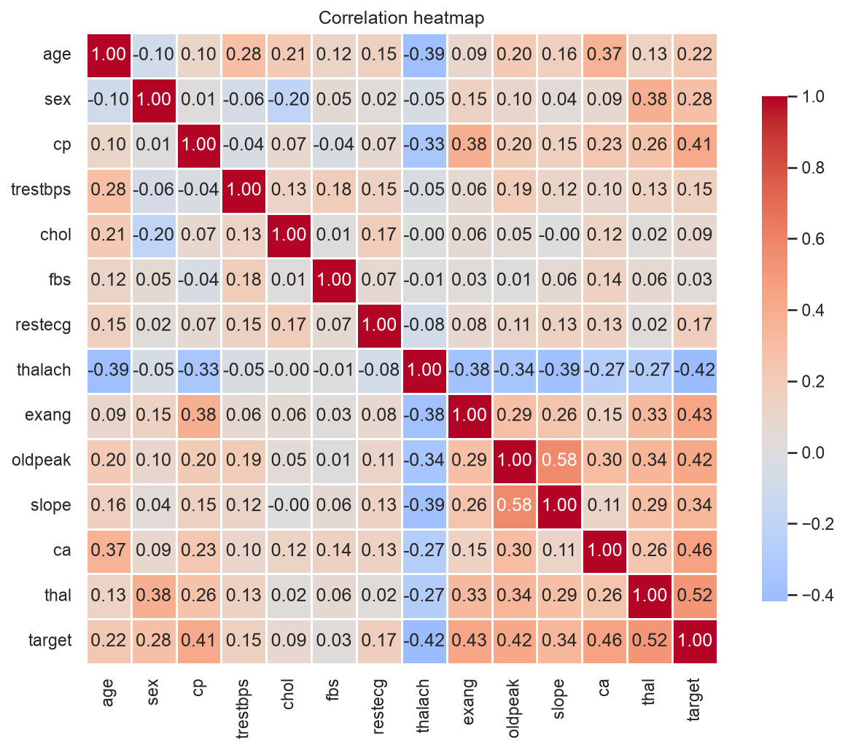
Correlation heatmap
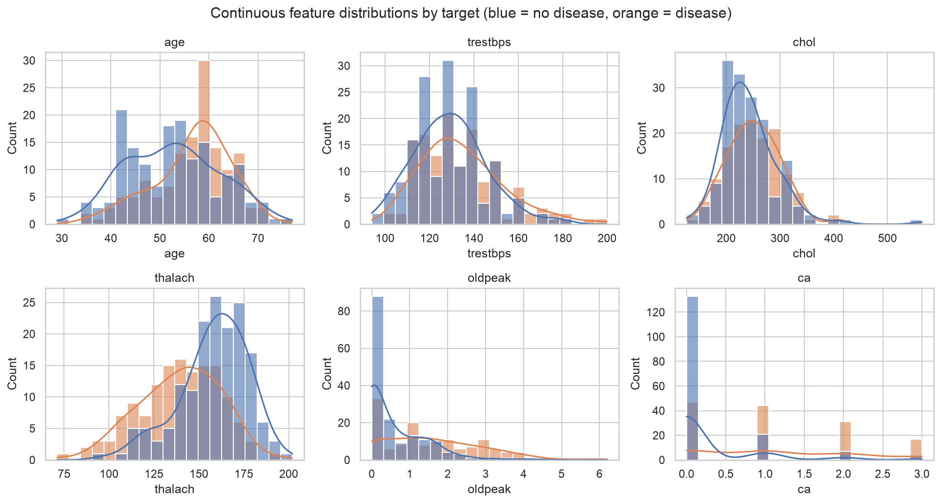
Continuous feature distributions
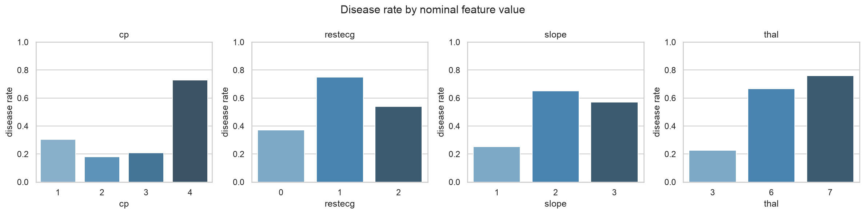
Disease rate by nominal feature
*(regenerate these with python scripts/export_eda_figures.py; the full interactive analysis,
including the missing-value chart, is in the notebook linked above)*

4. Feature engineering & model development
src/features.py builds a single ColumnTransformer (build_preprocessor()) shared by training
and serving, split into three groups defined in src/config.py:
Group | Columns | Treatment
Continuous / ordinal count | age, trestbps, chol, thalach, oldpeak, ca | median-impute + StandardScaler
Already binary | sex, fbs, exang | most-frequent-impute, used as-is
Nominal (unordered) | cp, restecg, slope, thal | most-frequent-impute + OneHotEncoder(handle_unknown="ignore")

This is a deliberate improvement over "one-hot encode everything non-numeric": ca keeps its
natural order (more vessels coloured = worse) instead of exploding into 5 dummy columns, and
unseen categories at inference time are safely ignored rather than crashing the service.
src/train.py trains and tunes three classifiers (the assignment requires at least two) with
GridSearchCV (scoring="roc_auc") over StratifiedKFold(n_splits=5):
Model | Grid searched
Logistic Regression | C ∈ {0.01, 0.1, 1, 10}, class_weight ∈ {None, balanced}
Random Forest | n_estimators ∈ {200, 400}, max_depth ∈ {None, 5, 10}, min_samples_leaf ∈ {1, 3}
Gradient Boosting | n_estimators ∈ {100, 200}, learning_rate ∈ {0.01, 0.1}, max_depth ∈ {2, 3}

A held-out 20% test split (stratified, random_state=42) is scored after refitting each model's
best candidate on the full training split. See Section 12 for the numbers.

5. Experiment tracking (MLflow)
- Tracking store: SQLite (sqlite:///tracking.db) so the MLflow Model Registry is
available (the plain local file store doesn't support it in older MLflow releases).
- Experiment: heart-disease-risk. One parent run per model family, with:
- params: model_family, test_size, cv_folds, random_state, param_grid, best
hyper-parameters;
- metrics: cv_roc_auc plus test_accuracy/precision/recall/f1/roc_auc;
- artifacts: confusion matrix, ROC curve and precision-recall curve PNGs, the full grid-search
results table (cv_results_<model>.csv), and the fitted sklearn pipeline
(mlflow.sklearn.log_model).
- the top-5 grid-search candidates per family are logged as nested child runs
(candidate_rank1 … candidate_rank5) so the search can be inspected without flooding the
experiment with every single combination.
- Model Registry: src/package_model.py finds the run tagged selected_as_best=true and
registers it as heart-risk-classifier, then points the `champion` alias at that version
(MlflowClient.set_registered_model_alias), so consumers can resolve
models:/heart-risk-classifier@champion instead of hard-coding a run id.
mlflow ui --backend-store-uri sqlite:///tracking.db --port 5000
# open http://localhost:5000 -> experiment "heart-disease-risk"

6. Model packaging & reproducibility
src/package_model.py produces three artifacts from the winning run:
- `models/model.joblib` — the fitted Pipeline (preprocessing + classifier), loaded directly
by src/inference.py and the API.
- `models/model_metadata.json` — metrics, best hyper-parameters, the feature schema, a
SHA-256 of both the training data and the model file, and the exact Python/scikit-learn/MLflow
versions used to train it (full reproducibility audit trail).
- `models/mlflow_model/` — an MLflow "sklearn"-flavour copy, servable standalone with
mlflow models serve -m models/mlflow_model --port 5001 --env-manager local.
A round-trip check reloads both the joblib and MLflow copies and asserts their predicted
probabilities are numerically identical (np.allclose) before packaging is considered successful.
Reproducibility is also pinned at the dependency level: a single requirements.txt (one file,
used by local dev, the test suite, the Docker image and CI alike — see
Section 7 and Section 8) uses
exact == versions resolved from a clean install, and model_metadata.json records the exact
versions used at training time for comparison. A from-scratch install was verified during this
submission: a brand-new virtualenv, pip install -r requirements.txt, then pytest (25 passed)
and ruff check src tests scripts (0 errors) — proving the single requirements file is sufficient
and self-contained.

7. CI/CD pipeline & automated testing
.github/workflows/ci.yml runs on every push to main, every pull
request, and manual dispatch, as four sequential jobs — each one gates the next (needs:), so
a lint or test failure stops the pipeline before it ever trains a model or builds an image:
Job | What it does | Artifact uploaded
lint | ruff check src tests scripts | ruff-report.txt
test | pytest --junitxml=... --cov=src (25 unit/API tests) | pytest-report.xml, coverage.xml
train | ingest → clean → train (MLflow) → package → CLI smoke test | models/, reports/, mlruns/
docker | builds the image from the train job's artifacts, runs it, polls /health until Docker reports healthy, then calls /predict with the sample patient | container logs (on failure)

25 tests across 5 files cover data cleaning, the feature pipeline, model evaluation/
reproducibility, the inference helper, and the FastAPI endpoints (validation, metrics, headers):
pytest # 25 passed
ruff check src tests scripts # 0 errors

Fail-fast demonstration (real, reproduced for this submission)
The production-readiness requirement *"Pipeline must fail on code or test errors and give clear
logs"* was verified directly, not just asserted: a throwaway failing test and a throwaway lint
violation were added, run, and then removed again (neither is part of the committed code).
1. A deliberately failing test (tests/test_zz_demo_failure.py,
assert 1 == 2) was added and run:
$ pytest -q
tests/test_api.py ....... [ 26%]
tests/test_clean.py ...... [ 50%]
tests/test_features.py ...... [ 73%]
tests/test_inference.py ... [ 84%]
tests/test_train.py ... [ 96%]
tests/test_zz_demo_failure.py F [100%]
================================== FAILURES ===================================
_________________ test_deliberately_wrong_prediction_threshold _______________
def test_deliberately_wrong_prediction_threshold():
> assert 1 == 2, "intentional failure to demonstrate pipeline fail-fast behaviour"
E AssertionError: intentional failure to demonstrate pipeline fail-fast behaviour
E assert 1 == 2
tests/test_zz_demo_failure.py:8: AssertionError
=========================== short test summary info ===========================
FAILED tests/test_zz_demo_failure.py::test_deliberately_wrong_prediction_threshold
=================== 1 failed, 25 passed, 3 warnings in 1.40s ===================
$ echo "exit code: $?"
exit code: 1
A non-zero exit code here is exactly what makes the test job (and therefore train and
docker after it) fail in CI — GitHub Actions marks the job red and the run stops.
2. A deliberate lint violation (scripts/zz_demo_lint_fail.py, two unused imports) was added
and linted:
$ ruff check src tests scripts
F401 [*] `os` imported but unused
--> scripts/zz_demo_lint_fail.py:2:8
|
1 | """Throwaway file used once to capture what a ruff failure looks like for the report."""
2 | import os
| ^^
3 | import sys # unused import -> F401
|
help: Remove unused import: `os`
F401 [*] `sys` imported but unused
--> scripts/zz_demo_lint_fail.py:3:8
|
2 | import os
3 | import sys # unused import -> F401
| ^^^
help: Remove unused import: `sys`
Found 2 errors.
[*] 2 fixable with `--fix`.
$ echo "exit code: $?"
exit code: 1
Both throwaway files were deleted immediately after capturing this evidence; pytest and
ruff check src tests scripts are green again (confirmed: 25 passed, 0 errors) in the committed
state. This demonstrates, with real command output rather than just a description, that both the
lint and test jobs fail loudly and specifically (exact file, line, assertion/rule) rather than
silently continuing — satisfying the "fail on code or test errors and give clear logs"
requirement.

8. Model containerisation
The Dockerfile is a multi-stage build:
- builder stage: installs the project's single requirements.txt into a throwaway virtualenv.
- runtime stage: starts from a fresh python:3.12-slim, copies that venv and only the seven
source files the API actually imports (`config, features, inference, schemas, metrics,
logging_utils, main) plus models/model.joblib`, runs as a non-root user, and exposes
8001 with a HEALTHCHECK hitting /health.
**Trade-off, noted explicitly:** using one `requirements.txt` everywhere (simpler to maintain
and document — see `README.md`) means the image also contains training/notebook/report
dependencies (MLflow, matplotlib, Jupyter, python-docx, ...) that the running API doesn't need.
The image is ~1.1 GB instead of the ~550 MB a slimmed-down `requirements-api.txt` gave. The
multi-stage build, non-root user and minimal `COPY` list are kept regardless, so this only
affects image size, not the attack surface of what's actually imported/executed at runtime.

Build + isolated-environment serving proof (real, reproduced for this submission)
$ docker build -t heart-risk-api:1.0 .
...
#17 writing image sha256:96e4b1bbe621cc9615cfb5b29fcb64ae09792de80a13256f1fdb628bc480abbd
#17 naming to docker.io/library/heart-risk-api:1.0 done
$ docker images heart-risk-api:1.0
REPOSITORY TAG IMAGE ID CREATED SIZE
heart-risk-api 1.0 96e4b1bbe621 16 seconds ago 1.11GB
$ docker run -d --name heart-risk-api-proof -p 8001:8001 heart-risk-api:1.0
2a41f4f079e57b713fa02f880dbe07491f470b9d2f39b2d6a2e317a14dcddb6f
$ docker inspect --format='{{.State.Health.Status}}' heart-risk-api-proof
healthy
$ curl -sS http://localhost:8001/health
{"status":"ok","model_loaded":true}
$ curl -sS -X POST http://localhost:8001/predict -H "Content-Type: application/json" \
-d @data/sample_patient.json
{"prediction":0,"label":"no disease","confidence":0.7999,"probability_disease":0.2001}
$ curl -sS -o /dev/null -w 'HTTP %{http_code}\n' -X POST http://localhost:8001/predict \
-H "Content-Type: application/json" -d '{"age": 9999}'
HTTP 422
$ docker logs heart-risk-api-proof | grep '"event"'
{"timestamp": "2026-10-20T05:29:57.398+00:00", "level": "INFO", "logger": "heart_api", "message": "model loaded", "event": "startup"}
{"timestamp": "2026-10-20T05:31:08.874+00:00", "level": "INFO", "logger": "heart_api", "message": "prediction served", "event": "prediction", "prediction": 0, "confidence": 0.7999}
{"timestamp": "2026-10-20T05:31:08.874+00:00", "level": "INFO", "logger": "heart_api", "message": "request handled", "event": "request", "request_id": "1009e3d61a06", "method": "POST", "path": "/predict", "status": 200, "duration_ms": 27.03}
{"timestamp": "2026-10-20T05:31:08.896+00:00", "level": "INFO", "logger": "heart_api", "message": "request handled", "event": "request", "request_id": "dc70f7888a6b", "method": "POST", "path": "/predict", "status": 422, "duration_ms": 0.57}
$ docker stop heart-risk-api-proof && docker rm heart-risk-api-proof
This is the "Model must serve correctly in an isolated environment" proof: a freshly built image,
with no bind-mounted source and no host Python environment involved, serves correct predictions,
rejects invalid input with 422, reports a passing Docker HEALTHCHECK, and emits structured
JSON logs — then is cleanly stopped and removed.

9. Production deployment (Kubernetes)
Manifests in deployment/k8s/ (apply in filename order):
File | Resource
00-namespace.yaml | Namespace heart-risk
10-configmap.yaml | LOG_LEVEL for the API container
20-deployment.yaml | Deployment, 2 replicas, rolling update (maxUnavailable: 0), readiness/liveness probes on /health, non-root, dropped capabilities, resource requests/limits
30-service.yaml | LoadBalancer Service, port 8080 → container port 8001
35-service-headless.yaml | Headless Service so Prometheus discovers every pod individually
40-hpa.yaml | HorizontalPodAutoscaler, 2-5 replicas on 70% CPU (bonus, needs metrics-server)

Full deployment walkthrough — real, reproduced for this submission
Tested end-to-end on a local Kubernetes cluster (Rancher Desktop / k3s). The cluster context was
confirmed before touching anything, without printing any other (corporate) cluster details:
$ kubectl config current-context
rancher-desktop
1. Create the namespace, then the rest of the API manifests:
$ kubectl apply -f deployment/k8s/
namespace/heart-risk created
configmap/heart-risk-api-config created
deployment.apps/heart-risk-api created
service/heart-risk-api created
service/heart-risk-api-headless created
horizontalpodautoscaler.autoscaling/heart-risk-api created
$ kubectl rollout status deployment/heart-risk-api -n heart-risk --timeout=90s
Waiting for deployment "heart-risk-api" rollout to finish: 0 of 2 updated replicas are available...
Waiting for deployment "heart-risk-api" rollout to finish: 1 of 2 updated replicas are available...
deployment "heart-risk-api" successfully rolled out
2. Inspect everything that got created:
$ kubectl get all -n heart-risk -o wide
NAME READY STATUS RESTARTS AGE IP
pod/heart-risk-api-677b56f558-25gh7 1/1 Running 0 22s 10.42.0.86
pod/heart-risk-api-677b56f558-bwtsb 1/1 Running 0 22s 10.42.0.85
NAME TYPE CLUSTER-IP EXTERNAL-IP PORT(S)
service/heart-risk-api LoadBalancer 10.43.100.182 192.168.64.2 8080:32039/TCP
service/heart-risk-api-headless ClusterIP None <none> 8001/TCP
NAME READY UP-TO-DATE AVAILABLE
deployment.apps/heart-risk-api 2/2 2 2
NAME DESIRED CURRENT READY
replicaset.apps/heart-risk-api-677b56f558 2 2 2
NAME REFERENCE TARGETS MINPODS MAXPODS REPLICAS
horizontalpodautoscaler.autoscaling/heart-risk-api Deployment/heart-risk-api cpu: 4%/70% 2 5 2
$ kubectl get endpoints -n heart-risk
NAME ENDPOINTS AGE
heart-risk-api 10.42.0.85:8001,10.42.0.86:8001 22s
heart-risk-api-headless 10.42.0.85:8001,10.42.0.86:8001 22s
2/2 pods Running, the LoadBalancer got a real external IP, both services' endpoints list both
pods, and the HPA is reading live CPU metrics (not <unknown>) — metrics-server is working.
3. Functional test through the cluster-exposed `LoadBalancer` (not a port-forward):
$ curl -sS http://192.168.64.2:8080/health
{"status":"ok","model_loaded":true}
$ curl -sS -X POST http://192.168.64.2:8080/predict -H "Content-Type: application/json" \
-d @data/sample_patient.json
{"prediction":0,"label":"no disease","confidence":0.7999,"probability_disease":0.2001}
$ curl -sS -o /dev/null -w 'HTTP %{http_code}\n' -X POST http://192.168.64.2:8080/predict \
-H "Content-Type: application/json" -d '{"age": 9999}'
HTTP 422
4. Live Swagger UI test — opened http://192.168.64.2:8080/docs in a browser (served straight
out of the cluster), expanded POST /predict, clicked Try it out → Execute with the
pre-filled example patient, and got back a real 200 from the running pods:
{ "prediction": 0, "label": "no disease", "confidence": 0.7999, "probability_disease": 0.2001 }
x-request-id and all other response headers were produced live by the cluster-served API.
*(screenshot captured live in this session — see screenshots/README.md.)*
5. Structured JSON logs, confirming the LoadBalancer actually spreads traffic across both
pods (the 200 landed on one pod, the 422 on the other):
$ kubectl logs pod/heart-risk-api-677b56f558-25gh7 -n heart-risk | grep '"event"' | tail -2
{"timestamp": "2026-10-20T05:35:35.311+00:00", "level": "INFO", "logger": "heart_api", "message": "prediction served", "event": "prediction", "prediction": 1, "confidence": 0.9985}
{"timestamp": "2026-10-20T05:35:35.312+00:00", "level": "INFO", "logger": "heart_api", "message": "request handled", "event": "request", "request_id": "d8447a1916dc", "method": "POST", "path": "/predict", "status": 200, "duration_ms": 12.19}

10. Monitoring & logging
- Structured logs: src/logging_utils.py renders every log line as JSON (timestamp, level,
request id, method, path, status, latency, prediction, confidence) via a custom
logging.Formatter — directly greppable/queryable, and the log level is controlled by the
LOG_LEVEL env var (wired to the heart-risk-api-config ConfigMap in Kubernetes).
- Prometheus metrics (src/metrics.py), exposed at /metrics:
| Metric | Type | Labels |
|---|---|---|
| heart_api_http_requests_total | Counter | method, path, status |
| heart_api_http_request_duration_seconds | Histogram | path |
| heart_api_predictions_total | Counter | label |
| heart_api_prediction_confidence | Histogram | — |
- deployment/monitoring/ deploys Prometheus (scraping every pod via
the headless service's DNS-SD records) and Grafana (provisioned datasource + dashboard from
deployment/monitoring/dashboards/heart-risk-dashboard.json).
- Grafana admin credentials are not committed to git — they're read from a Kubernetes
Secret created imperatively (see deployment/monitoring/20-grafana.yaml header comment),
unlike hard-coding a password directly in a manifest.

Full monitoring walkthrough — real, reproduced for this submission
$ kubectl apply -f deployment/monitoring/00-namespace.yaml
namespace/monitoring created
$ kubectl create secret generic grafana-admin-credentials \
--from-literal=admin-user=admin --from-literal=admin-password='<redacted>' -n monitoring
secret/grafana-admin-credentials created
$ kubectl create configmap grafana-dashboards \
--from-file=deployment/monitoring/dashboards/heart-risk-dashboard.json -n monitoring
configmap/grafana-dashboards created
$ kubectl apply -f deployment/monitoring/10-prometheus.yaml -f deployment/monitoring/20-grafana.yaml
configmap/prometheus-config created
deployment.apps/prometheus created
service/prometheus created
configmap/grafana-datasource created
configmap/grafana-dashboard-provider created
deployment.apps/grafana created
service/grafana created
$ kubectl rollout status deployment/prometheus -n monitoring --timeout=90s
deployment "prometheus" successfully rolled out
$ kubectl rollout status deployment/grafana -n monitoring --timeout=90s
deployment "grafana" successfully rolled out
Generate traffic so the dashboards have real data (scripts/simulate_traffic.py against the
cluster LoadBalancer, ~13% requests deliberately invalid):
$ python scripts/simulate_traffic.py --url http://192.168.64.2:8080 --requests 150 --delay 0.05
Done: 131 accepted (200), 19 rejected/failed, target=http://192.168.64.2:8080
**Prometheus discovered both pods via the headless service's DNS-SD and is scraping them
successfully** — opened http://localhost:9090/targets (port-forwarded) in a browser:
`heart-risk-api (2/2 up)` — both `http://10.42.0.8x:8001/metrics` targets show state `UP`.
*(screenshot captured live in this session — see `screenshots/README.md`.)*
**Grafana: datasource + dashboard were auto-provisioned from the ConfigMaps, and the dashboard
rendered with live data** — opened http://localhost:3000/d/heart-risk-api-overview/...
(port-forwarded), logged in with the Secret-backed admin credentials, and read back:
Panel | Live value observed
Request rate by status | status 200 and status 422 series both populated
p95 latency by path | /health, /predict, /docs, /openapi.json all plotted
Error rate (4xx/5xx) | 12.9% (matches the ~13% invalid rate sent by the traffic script)
Predictions per minute, by label | disease / no disease bars both populated
Median prediction confidence | 92.2%
Total requests served | 228
API pods reporting (via Prometheus targets) | 2

*(screenshot captured live in this session — see screenshots/README.md.)*
Teardown — clean removal, verified:
$ kubectl delete -f deployment/monitoring/20-grafana.yaml -f deployment/monitoring/10-prometheus.yaml
$ kubectl delete secret grafana-admin-credentials -n monitoring
$ kubectl delete configmap grafana-dashboards -n monitoring
$ kubectl delete namespace monitoring
$ kubectl get all --all-namespaces | grep -iE 'heart-risk|grafana|prometheus'
(no output)

11. Architecture diagram
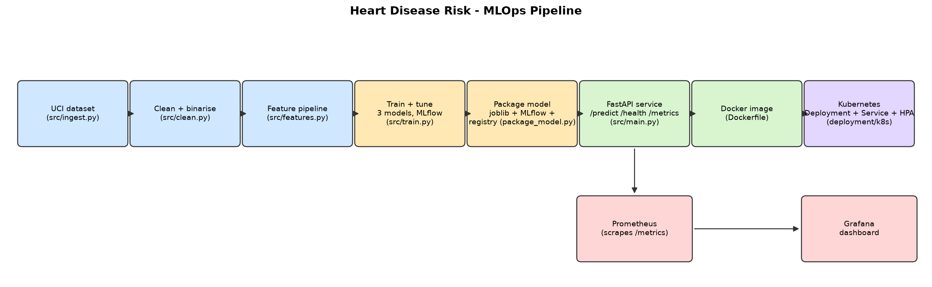
Architecture

12. Results summary
Held-out test set (20%, stratified, random_state=42), ranked by cross-validated ROC-AUC:
Model | CV ROC-AUC | Accuracy | Precision | Recall | F1 | ROC-AUC
Logistic Regression (C=1, class_weight=balanced) | 0.9082 | 0.8689 | 0.8125 | 0.9286 | 0.8667 | 0.9578
Random Forest (max_depth=None, min_samples_leaf=3, n=400) | 0.9010 | 0.8852 | 0.8387 | 0.9286 | 0.8814 | 0.9524
Gradient Boosting (lr=0.01, max_depth=2, n=200) | 0.8840 | 0.8852 | 0.8621 | 0.8929 | 0.8772 | 0.9448

Logistic Regression was selected (highest CV ROC-AUC) and is the model served by the API and
registered in MLflow as heart-risk-classifier@champion. Full comparison:
reports/model_comparison.csv. Per-model confusion matrices, ROC and
precision-recall curves: reports/figures/.

13. Production-readiness requirements — evidence
The assignment calls out two requirements explicitly; both were verified with real, reproducible
commands rather than just described:
*"Model must serve correctly in an isolated environment (Docker container build/test proof
required)."*
Verified in Section 8: a freshly built heart-risk-api:1.0 image
(no host Python, no bind mounts) was run as a container, passed its Docker HEALTHCHECK
(healthy), correctly answered /health and /predict with the sample patient, correctly
rejected an out-of-range request with 422, and emitted structured JSON logs for every request —
then was stopped and removed. The same image was also deployed to a real (local) Kubernetes
cluster in Section 9 and served predictions through a
LoadBalancer Service across 2 replicas.
*"Pipeline must fail on code or test errors and give clear logs."*
Verified in Section 7: a deliberately failing test produced
an exact FAILED ... AssertionError with file/line and a non-zero exit code; a deliberate lint
violation produced exact F401 errors with file/line and a non-zero exit code. In
.github/workflows/ci.yml, the lint → test → train → docker jobs are chained with needs:, so
either failure above would stop the pipeline immediately and surface the same clear logs in the
GitHub Actions UI, before any model is trained or any image is built.

14. Repository layout
.
├── .github/workflows/ci.yml # lint -> test -> train -> docker build/smoke-test
├── data/{raw,processed}/ # downloaded + cleaned dataset, data/sample_patient.json
├── deployment/
│ ├── k8s/ # namespace, configmap, deployment, services, HPA
│ └── monitoring/ # Prometheus, Grafana, dashboards/
├── models/ # model.joblib, model_metadata.json, mlflow_model/
├── notebooks/01_exploratory_data_analysis.ipynb
├── reports/ # this report, figures/, model_comparison.csv
├── screenshots/, recordings/ # evidence for submission (see their README files)
├── scripts/ # simulate_traffic.py, make_architecture_diagram.py, generate_report.py
├── src/ # config, ingest, clean, features, train, package_model,
│ # inference, schemas, metrics, logging_utils, main (FastAPI)
├── tests/ # 25 pytest cases
├── Dockerfile
└── requirements.txt # single file: training, serving, tests, lint, notebooks, report

