EduAssist AI - LLMOps Prompt Evaluation Report

Name: Sibasis Mishra

Roll Number: 2025AE05040

Github URL: https://github.com/is-zen-genius/mlops_assignment_2.git

Prompt versioning, operational benchmarking, and MLflow promotion

Model, access method, and pricing basis

Every call in this report ran locally against Qwen/Qwen2.5-3B-Instruct (ungated, Apache-2.0, ~3B parameters), using that model's own tokenizer for exact token counts. Cost is estimated using the published hosting rate for Qwen/Qwen2.5-7B-Instruct (the smallest Qwen2.5 checkpoint currently listed by hosted providers), sourced from OpenRouter's aggregated pricing API (accessed 2026-11-04): $0.1/1M input tokens and $0.2/1M output tokens, in USD.

Task 1 & 2 - Latency, tokens, and cost (Prompt v1, 5 questions)

Mean latency across the five questions was 28.74s (median 30.00s, std 4.06s, range 21.59-31.61s). The slowest request was Q1 at 31.61s, producing 300 output tokens (hitting the 300-token generation cap); the fastest was Q5 at 21.59s with 213 tokens. Since generation runs locally with greedy decoding, latency is driven almost entirely by output length rather than network variance - longer, less-constrained answers simply take proportionally longer to generate.
Q | Latency (s) | In tok | Out tok | Cost ($)
Q1 | 31.61 | 50 | 300 | 0.000065
Q2 | 30.64 | 49 | 300 | 0.000065
Q3 | 29.85 | 49 | 300 | 0.000065
Q4 | 30.00 | 47 | 300 | 0.000065
Q5 | 21.59 | 48 | 213 | 0.000047
Average cost per request was $0.00006138, projecting to $0.61/month at 10,000 requests. Output tokens dominate cost (4 of 5 requests hit the 300-token cap without naturally stopping), so the highest-leverage cost optimization is shortening responses - e.g. an explicit length/format constraint (as Prompt v2's "concise" instruction attempts) or a lower max-token budget for simple factual questions - rather than reducing input size, caching, or switching models, since input tokens are already a small fraction of spend here.

Task 3 - Prompt comparison and promotion

Prompt Version | Avg Latency (s) | Avg In Tok | Avg Out Tok | Avg Cost ($) | Valid JSON | Rec.?
v1 (Basic) | 29.30 | 48.6 | 282.6 | 0.000061 | 0%
v2 (Structured) | 28.92 | 70.6 | 283.4 | 0.000064 | 0%
v3 (JSON Output) | 15.92 | 104.6 | 155.4 | 0.000042 | 100% | YES
Prompt v3 (JSON Output) is promoted to the MLflow Prompt Registry's `production` alias. EduAssist's product requirement is a strict JSON contract (answer/confidence/key_points); only the JSON-Output prompt was designed to satisfy it, and it achieved a 100% valid-JSON rate under a strict schema check (exact keys, confidence in {high,medium,low}, key_points as a list), versus 0% for the other two, which were never asked to emit JSON at all. This makes JSON validity a hard gate, not one metric among equals - a downstream application cannot safely parse the other versions' output regardless of prose quality. On this question set the winning version was not even a trade-off: it was simultaneously the only contract-compliant prompt and the cheapest ($0.000042 vs $0.000061 and $0.000064) and fastest (15.9s vs 29.3s and 28.9s) of the three, because the JSON constraint

causes generation to stop as soon as the closing brace is emitted instead of continuing to elaborate.

Conclusion

Structuring the output contract (Prompt v3) simultaneously improved reliability, latency, and cost relative to unconstrained prompting on this question set, demonstrating that for production LLM features with a machine-readable contract, enforcing that contract in the prompt is not purely a quality lever but an operational one. The MLflow Prompt Registry made this a reproducible, auditable decision: all three versions are versioned with commit messages, every evaluation run is linked back to the exact prompt version it used, and promotion is a single aliasing operation rather than a code change.

MLflow experiment - runs and metrics
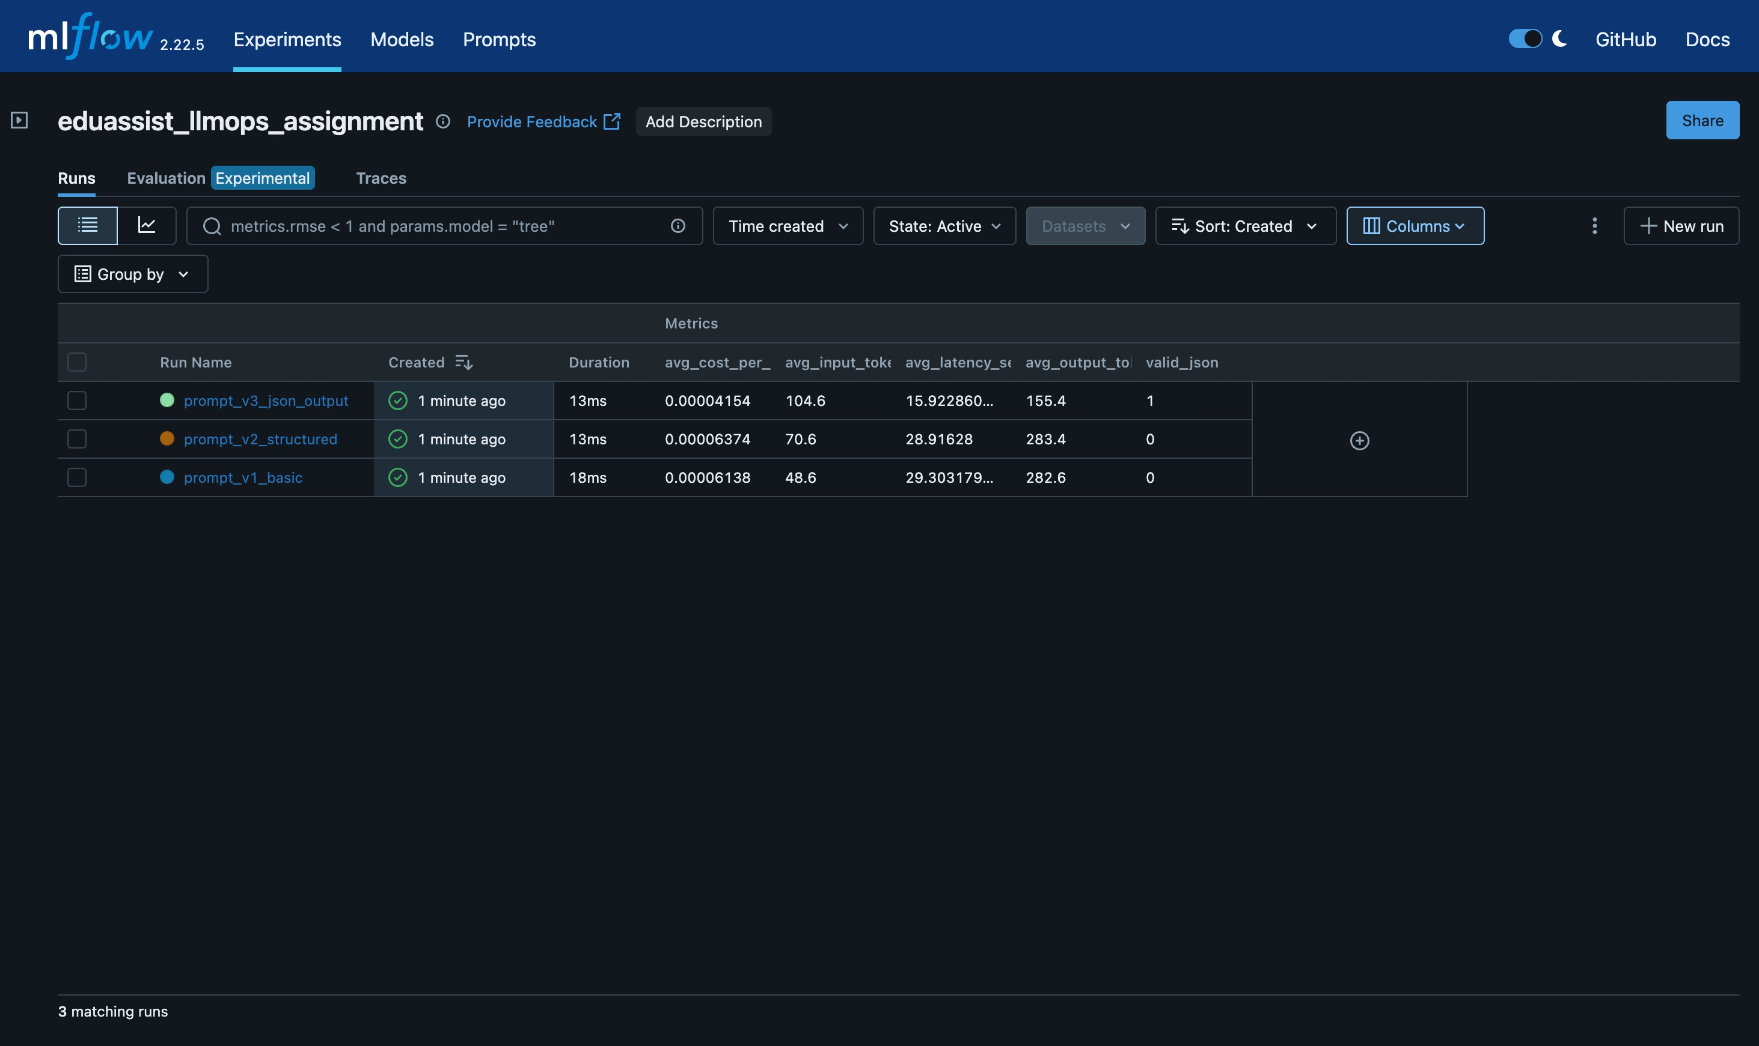

Prompt Registry - v1, v2, v3
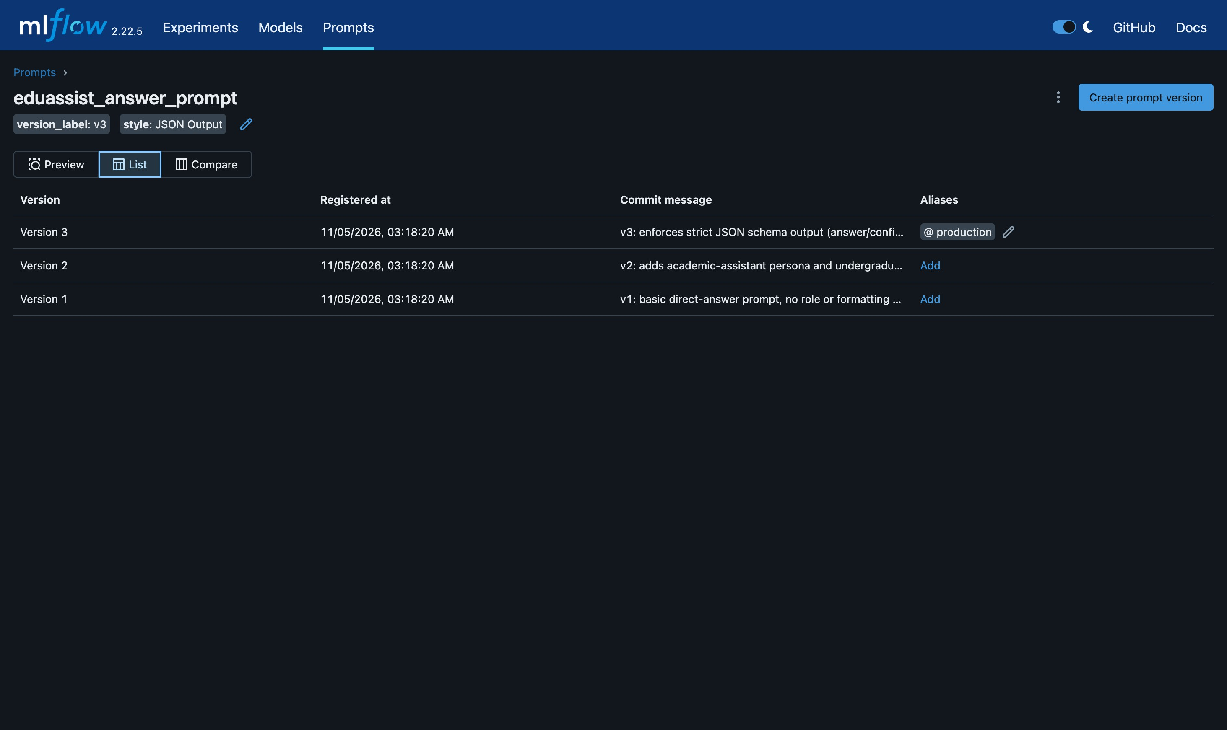

Prompt version detail - production alias
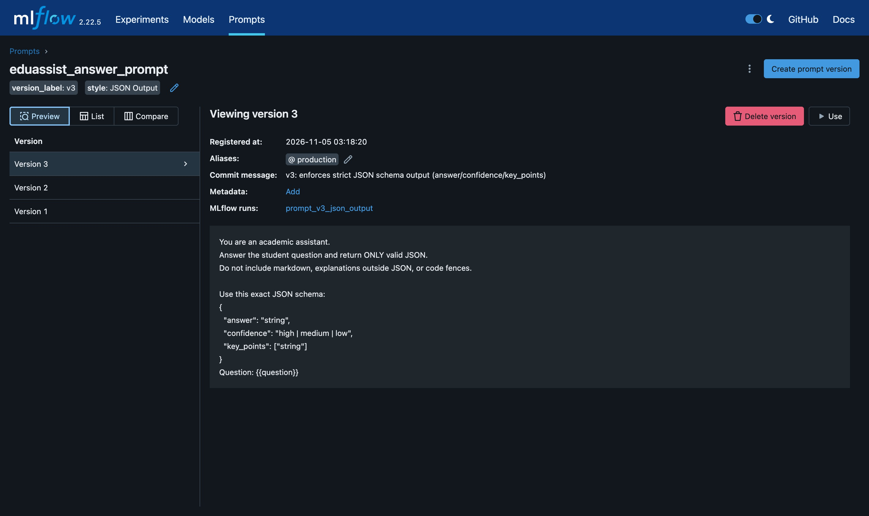

Prompt diff - v2 vs v3
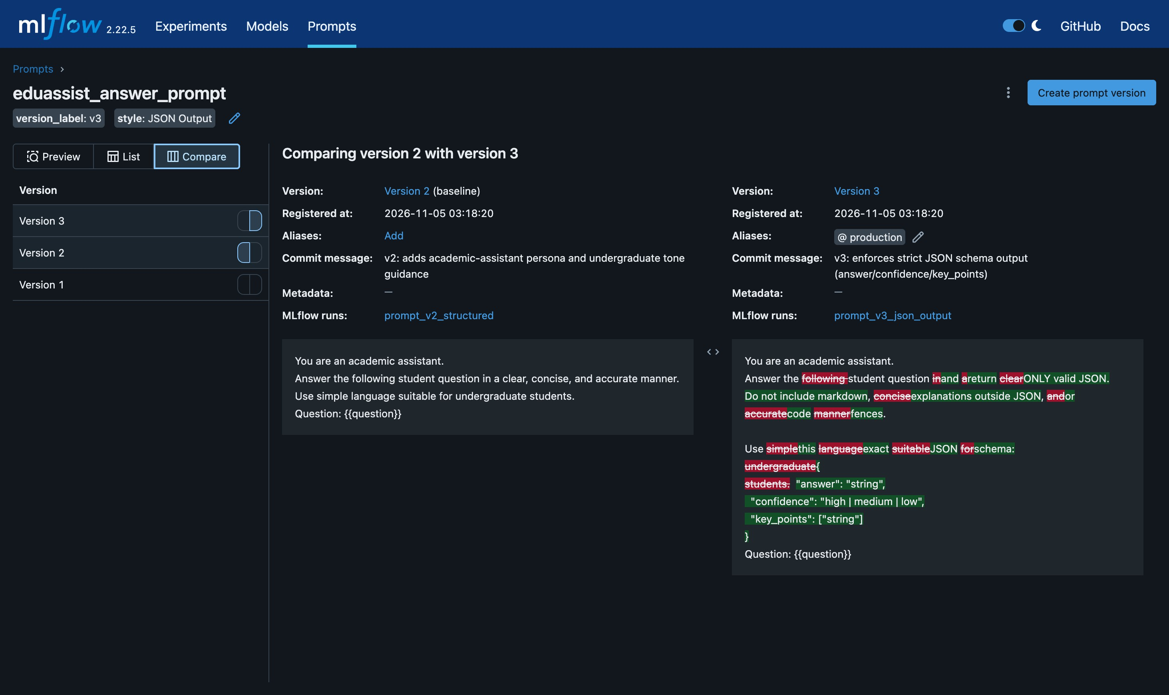

Run detail - v3 parameters and metrics


