**DATA VISUALIZATION**

**Name: Ismail Usmangani Sarigat**

**Student Id: 21088719**

**Module Name: Applied Data Science – 1**

**Assignment -1**

**Table of Contents**

Introduction 3

Discussion 3

Result 4

Conclusion 9

Reference List 10

# Introduction

This paper is discussed the data visualization concept using the python graph plotting library . In addition, the paper also aims to plot the different types of graph plots to get a better understanding as well as make a clear view of the chosen dataset. Moreover, the dataset details and the data description are also included in this paper.

# Discussion

Numpy, Pandas, MatplotLib, Seaborn, and Many More are Just a Few of the Many Python Data Analysis and Visualization Libraries Available. Here, we'll talk about the pandas library, an open-source toolkit providing data processing and analysis that was developed on the base of numpy.

**Analysis**

A Comman Separated Values (CSV) file contains tabular data in a specific format and is a type of plain text document. The comma is used to separate values in the CSV file format, which is a confined text document (VanderPlas *et al,* 2018). Each record in the file represents a log of some kind. One or even more fields, separated by commas, make up each log. When it comes to exchanging spreadsheets and databases, it is the format of choice.



**Figure1: Read file**

(Source: Created by the learner)

If any of the values in the Data Frame object are NULL, the is null() method will replace them with True, and if not, it will produce False.



**Figure1: Check the null value**

(Source: Created by the learner)

The Data Frame's metadata is displayed by calling the info () method. The details include the total number of columns, the number of cells for each column, the memory use, the range index, and thus the type of data in each column's labels (non-null values) (Hammad *et al,* 2021).



**Figure2: Find the information on the dataset**

(Source: Created by the learner)

# Result

This section helps to understand the details of the region-based local authority name using the plot graph.

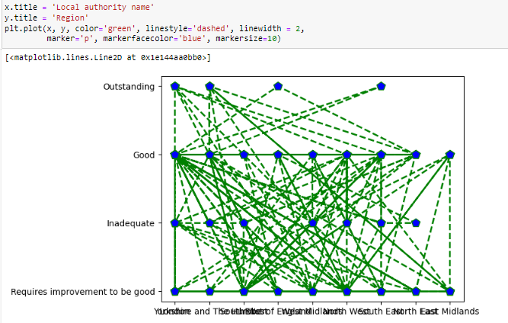

**Figure4: region vs local authority name**

(Source: Created by the learner)

This section provides context for the geographical distribution of children in need of protection.

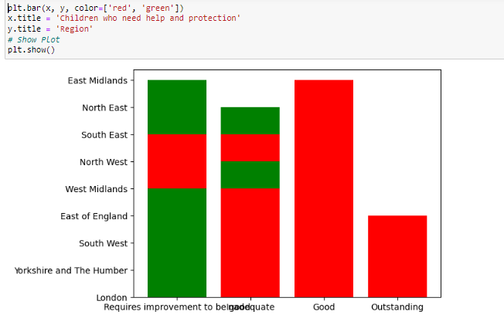

**Figure5: region vs children who need help with protection**

(Source: Created by the learner)

The overall judgment is base d on the inspection date graph plot using the plot style in the python matplotlib library.

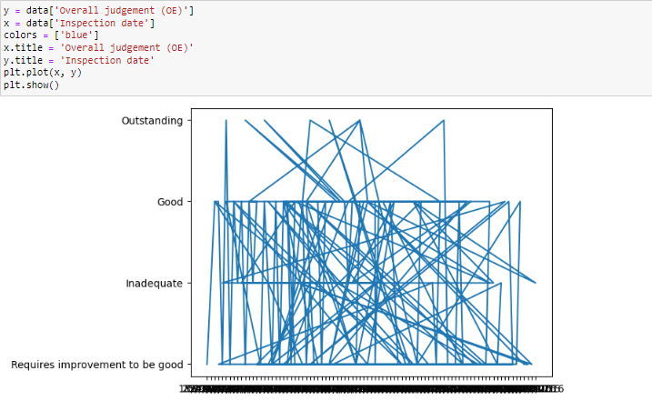

**Figure6: Overall judgment vs inspection date**

(Source: Created by the learner)

This section introduces the details of the inspection date based on the overall judgment using the barh graph in python.

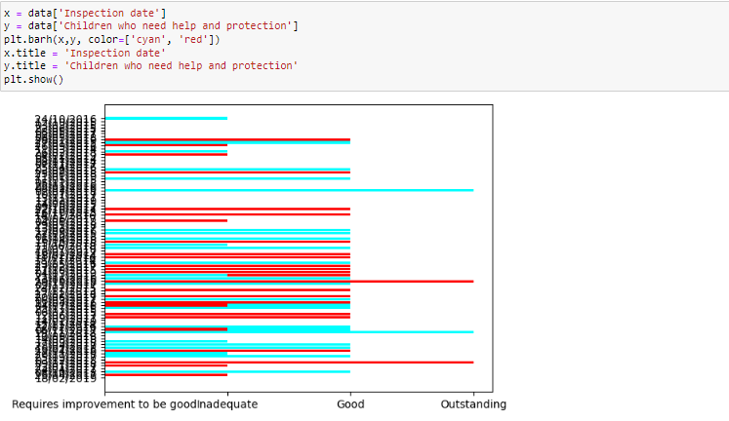

**Figure7:**  **inspection date vs overall judgment**

(Source: Created by the learner)

This section shares the details of the region-based children looked after and achieving performance. Using the bar plot this data plot is plotted.

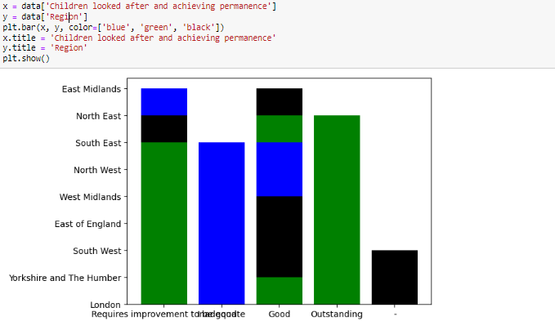

**Figure8: region vs children looked after and achieved performance**

(Source: Created by the learner)

The region versus overall judgment graph plot is plotted in this section using the matplotlib library.

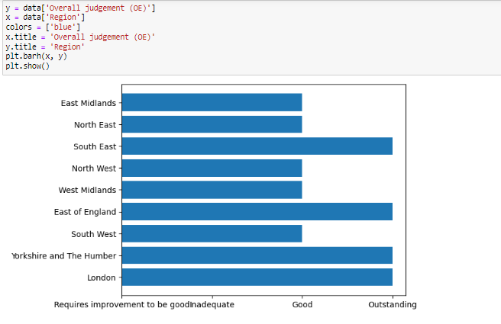

**Figure9: region vs overall judgment**

(Source: Created by the learner)

The Local authority name versus Leadership, management, and governance graph plot is plotted in this section (Nongthombam and Sharma, 2021).

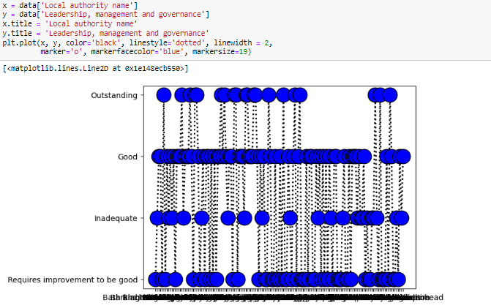

**Figure10: Local authority name vs Leadership, management and governance**

(Source: Created by the learner)

# Conclusion

In this paper, we explore the idea of data visualization with the help of the Graphite package for Python. The study also seeks to plot several forms of graph displays to better understand and provide a concise view of the selected dataset. This publication also includes a detailed description of the information and data about the dataset used.

GitHub Link: https://github.com/is2295/ADS-1_Assignment-1

# Reference List

Hammad, G., Reyt, M., Beliy, N., Baillet, M., Deantoni, M., Lesoinne, A., Muto, V. and Schmidt, C., 2021. pyActigraphy: Open-source python package for actigraphy data visualization and analysis. *PLoS Computational Biology*, *17*(10), p.e1009514.

Nongthombam, K. and Sharma, D., 2021. ” Data Analysis using Python. *International Journal of Engineering Research & Technology (IJERT)*.

VanderPlas, J., Granger, B., Heer, J., Moritz, D., Wongsuphasawat, K., Satyanarayan, A., Lees, E., Timofeev, I., Welsh, B. and Sievert, S., 2018. Altair: interactive statistical visualizations for Python. *Journal of open source software*, *3*(32), p.1057.