Here is what we expect to achieve:

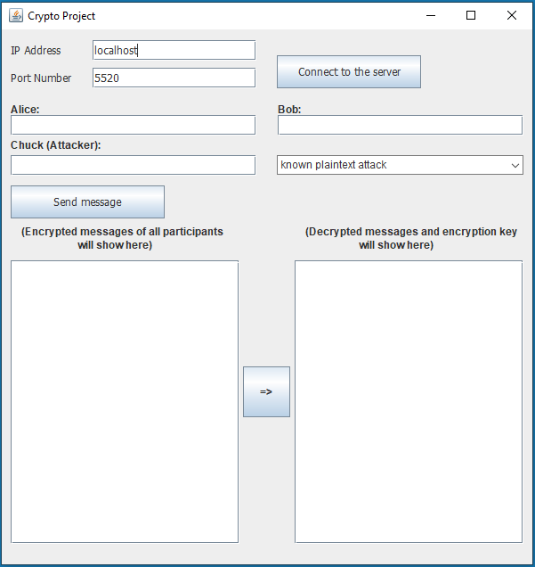

In the UI shown above, when Alice, Bob, or Chuck send messages, the encrypted version of it should show up on the left side where it says “Encrypted messages of all participants will show here”

Once the “=>” button is clicked, on the right side where it says, “Decrypted messages and encryption key will show here”, it will show the decrypted plaintext along with the key. The constraints for this button are:

1. Make sure one of the modes is selected
2. Make sure Chuck has send a message. If Chuck hasn’t sent the message, this functionality shouldn’t work