Deep Vision Pipeline for Brain Tumor MRI Slice Understanding
Final Semester Project Research Paper
Student IDs: 231192, 231200
Course: AI303 Computer Vision
GitHub Repository: https://github.com/isMaaz/CV_Project.git

Abstract
This paper presents an end-to-end deep vision pipeline for brain tumor MRI slice understanding. The project integrates radiometric pre-processing, segmentation, texture and geometric description, and deep recognition. The final model uses a 3D transformer-style architecture to learn local voxel-to-voxel and slice-to-slice dependencies. The held-out test accuracy is 78.12%, with macro precision 84.78%, macro recall 78.12%, and macro F1-score 77.03%.
Keywords: Computer Vision, MRI, Brain Tumor, GLCM, 3D Transformer, Deep Learning

Table of Contents
1. Introduction
2. Literature Review
3. Dataset and Acquisition
4. Pre-processing
5. Segmentation and Masking
6. Texture and Geometric Description
7. Deep Recognition Model
8. Training Protocol
9. Evaluation Methodology
10. Results
11. Discussion
12. Limitations
13. Reproducibility
14. Conclusion
15. References

1. Introduction
Medical image interpretation is a demanding Computer Vision problem because image evidence can be subtle, noisy, and dependent on the imaging modality. In magnetic resonance imaging, brain tumor analysis often requires several processing stages before a reliable decision can be made. Raw slices must be normalized, artifacts must be reduced, regions of interest must be isolated, and both local texture and spatial context must be interpreted.
The objective of this project was to convert the outputs of Assignments 1, 2, and 3 into a high-level deep vision application. Assignment 1 focused on radiometric pre-processing and noise mitigation. Assignment 2 focused on segmentation, morphological cleaning, boundary representation, and convex hull analysis. Assignment 3 focused on GLCM texture descriptors, geometric features, and traditional classification. The final project integrates these components into a single end-to-end system.
The assigned dataset category was brain tumor MRI. The final pipeline treats each useful MRI slice as a labeled sample and uses paired segmentation masks when available. The system exports an annotated dataset, trained model, feature vectors, figures, metrics, and reproducible notebooks. This makes the work suitable for both technical evaluation and GitHub-based submission.

2. Literature Review
Classical Computer Vision pipelines commonly begin with pre-processing and segmentation before recognition. Radiometric correction, denoising, and contrast normalization reduce nuisance variation so that later stages operate on more stable image representations. In MRI, this is important because intensity distributions vary between subjects, sequences, and scanners.
Segmentation is a central task in medical image analysis. Edge-based approaches such as Canny edge detection and intensity-based methods such as Otsu thresholding provide interpretable classical baselines. Morphological operations such as erosion, dilation, opening, and closing are useful for removing isolated artifacts and improving binary masks. Although deep segmentation networks are now common, classical mask generation remains valuable in small-data settings because it is transparent and easy to debug.
Texture analysis is another important tradition in medical imaging. Haralick texture features derived from the Gray-Level Co-occurrence Matrix describe how frequently gray-level pairs occur at specified distances and angles. Energy, entropy, contrast, homogeneity, and correlation are particularly useful for describing local regularity, randomness, and variation. In tumor imaging, these descriptors can capture tissue heterogeneity that may not be obvious from shape alone.
Deep learning changes the recognition stage by learning task-specific representations directly from pixels. Convolutional neural networks are effective for 2D image classification because they build hierarchical features from local receptive fields. Transformers add self-attention, allowing the model to connect spatially separated tokens. In 3D medical imaging, a transformer block can model voxel-to-voxel or slice-to-slice dependencies, which is useful when the appearance of pathology spans multiple neighboring slices.
This project uses the classical stages for interpretability and continuity with earlier assignments, while using a deep 3D transformer-style classifier for the final semantic recognition step. This hybrid design is appropriate for a semester project because it demonstrates both foundational Computer Vision concepts and a modern deep learning component.

3. Dataset and Acquisition
Dataset item | Value
Total samples | 158
No-tumor samples | 80
Tumor samples | 78
Training samples | 107
Validation samples | 19
Test samples | 32
The dataset was acquired through KaggleHub using the brain tumor MRI dataset referenced in the project notebook. The final run selected paired NIfTI MRI volumes and segmentation files. The exported dataset contains PNG slice images, binary masks, overlays, and a manifest CSV describing each sample.
The final annotated dataset contains 158 samples. The labels are balanced: 80 no-tumor slices and 78 tumor slices. The train, validation, and test split sizes are 107, 19, and 32, respectively.
The dataset used for final testing is stored inside the repository under DeepVision Pipeline Output/annotated_dataset. This satisfies the final deliverable requirement that the annotated dataset used for training and testing be included with the project submission.

4. Assignment 1 Integration: Pre-processing
The pre-processing stage follows the Assignment 1 theme of radiometric correction and noise mitigation. Each MRI slice is converted to floating point, normalized using percentile clipping, and rescaled to the range 0 to 1. This reduces the effect of extreme intensity values and creates a stable input range for later operations.
Denoising combines Gaussian filtering, median filtering, and mean filtering. Gaussian smoothing reduces high-frequency acquisition noise. Median filtering suppresses isolated salt-and-pepper artifacts while preserving stronger edges. Mean filtering provides a final local averaging step. These operations connect directly to the original Assignment 1 deliverables, where Gaussian, median, and mean filters were evaluated with visual outputs and image quality metrics.
The final deep model receives pre-processed slices, not raw image values. This matters because deep networks are sensitive to input scale and distribution. Consistent pre-processing makes training more stable and improves reproducibility between Colab runs.

5. Assignment 2 Integration: Segmentation and Masking
The segmentation stage continues the Assignment 2 work. When a paired segmentation volume exists, the pipeline uses the annotated mask directly. This is preferable for the final training/testing dataset because the label source is explicit and reproducible. If masks are not available, the notebook contains a fallback classical segmentation method based on thresholding, Canny edges, morphological closing/opening, hole filling, and connected-component selection.
For each exported sample, the pipeline saves the original pre-processed image, its mask, and an overlay showing the segmented region. The overlays make it possible to visually audit whether the mask is aligned with the anatomical region of interest. This is important because poor masks can damage both handcrafted feature extraction and model interpretation.
The final output folder contains 158 image slices, 158 masks, and 158 overlays. This directly supports the deliverable requiring the final annotated dataset used for training and testing.
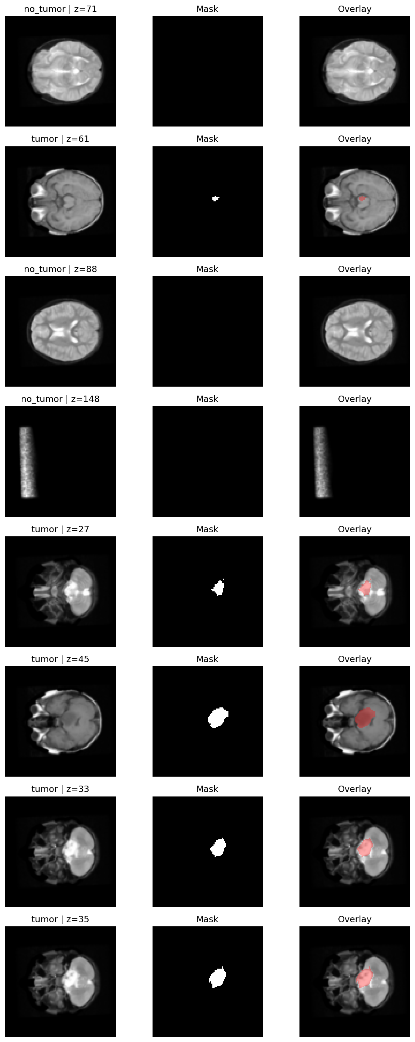
Figure 1. Pre-processing and segmentation preview

6. Assignment 3 Integration: Description
The descriptor stage continues the Assignment 3 feature extraction work. For each masked slice, the pipeline computes GLCM texture features: energy, entropy, contrast, homogeneity, and correlation. It also computes geometric descriptors including area, perimeter, centroid, and circularity.
These descriptors are exported in DeepVision Pipeline Output/features/deep_pipeline_features.csv. They are not the direct input to the final 3D transformer model, but they provide interpretable measurements that connect the final project to the statistical texture and geometry work completed earlier.
The descriptor distribution figure shows strong differences between tumor and no-tumor samples in several features. Tumor masks generally have larger area and perimeter, while no-tumor slices often have empty or near-empty masks. One limitation observed in the exported descriptor table is that circularity can become unstable for tiny masks with perimeter close to zero. This does not affect the deep model because the deep model learns from image tensors, but it should be handled carefully when interpreting handcrafted descriptors.
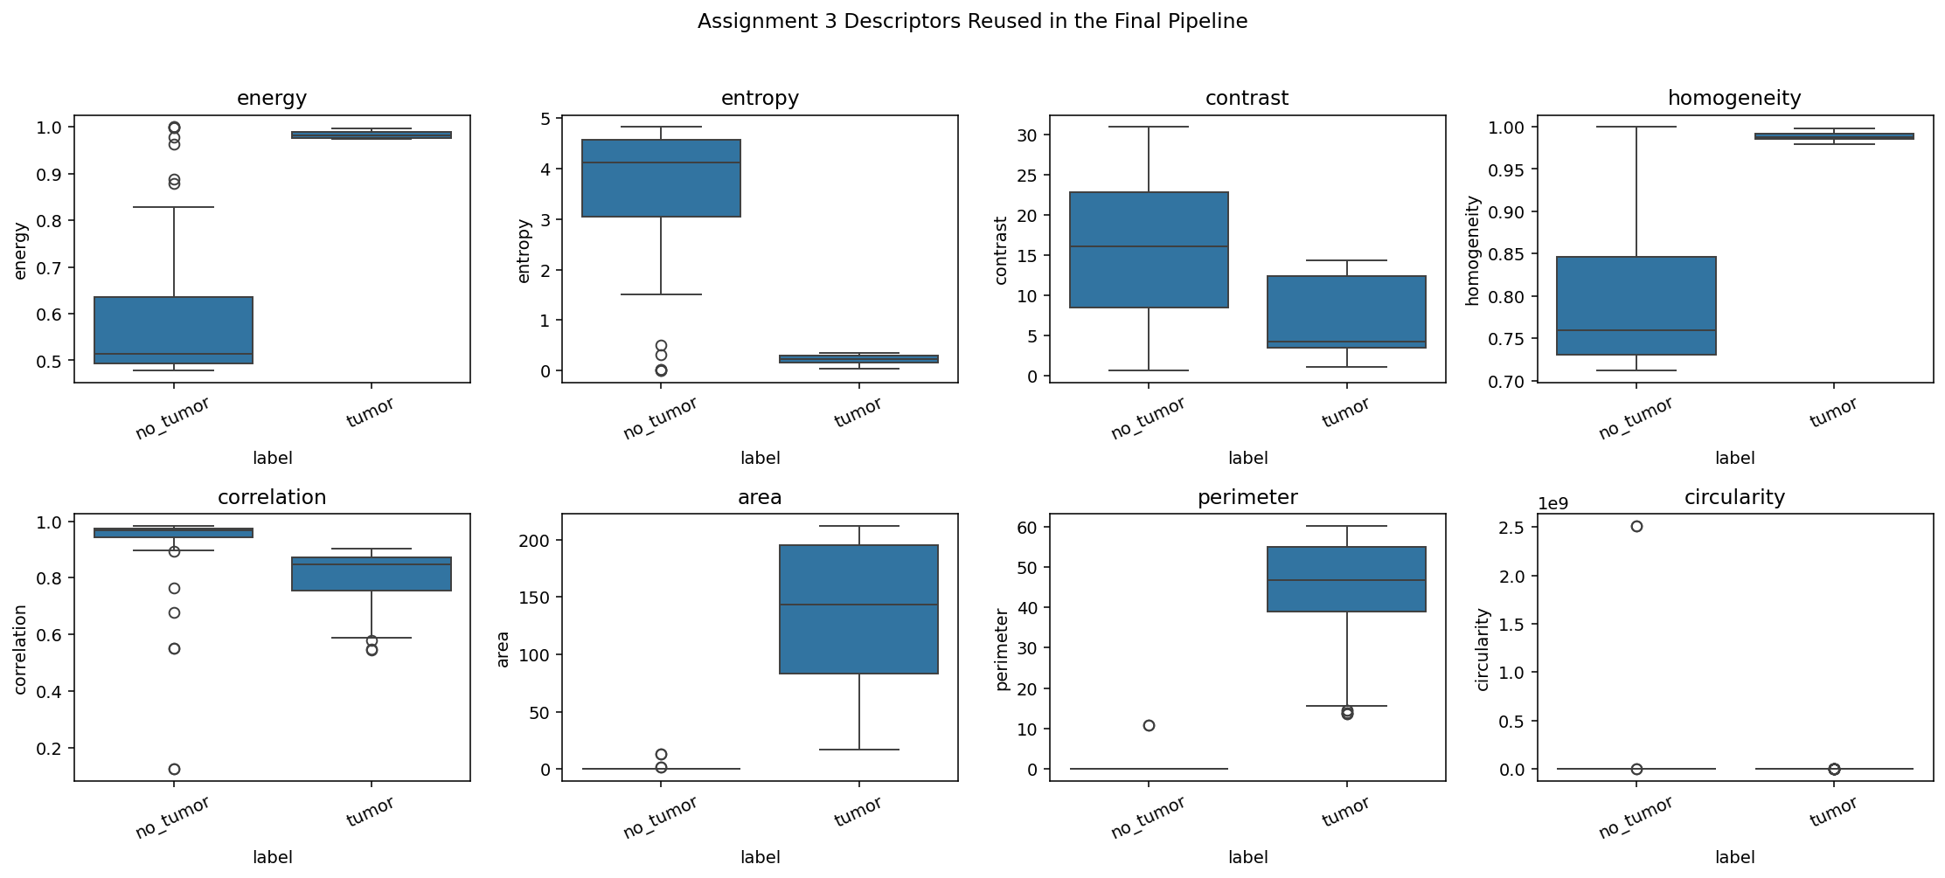
Figure 2. Texture and geometric descriptor distributions

7. Deep Recognition Model
The final recognition stage applies a 3D transformer-style architecture. Instead of classifying one 2D slice alone, the model forms a local context volume using neighboring MRI slices. A small Conv3D feature extractor embeds this context, then the feature map is reshaped into voxel-patch tokens. Transformer encoder blocks with multi-head self-attention then learn dependencies among these tokens.
This design satisfies the selected research challenge: 3D Transformer Integration. The attention block allows the model to relate spatial and slice-wise evidence across the local MRI context, which is more appropriate for volumetric medical imaging than treating every slice as completely independent.
The output layer performs binary classification between no_tumor and tumor. A validation-tuned decision threshold was used instead of a fixed 0.50 cutoff. The selected threshold was 0.5563, which was chosen from the validation set to improve the precision-recall tradeoff.

8. Training Protocol
Training was performed in Google Colab. The model used the exported MRI slice context tensors with labels derived from segmentation masks. The dataset was split into training, validation, and held-out test subsets. The test subset was not used for training or threshold selection.
The final run used 107 training samples, 19 validation samples, and 32 test samples. The test set was balanced with 16 no-tumor and 16 tumor samples.
The final epoch recorded training accuracy of 90.65% and validation accuracy of 47.37%. Training loss decreased to 0.2919, while validation loss was 1.7894. This gap indicates overfitting, which is expected because the final run is based on a limited annotated subset.
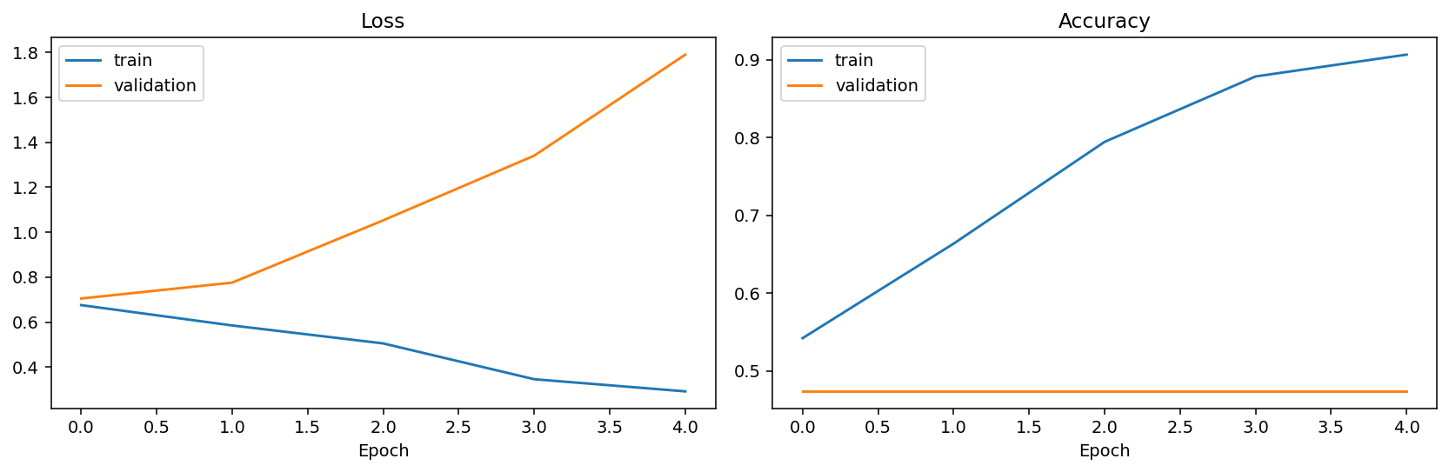
Figure 3. Training and validation curves

9. Evaluation Methodology
Evaluation uses a complete confusion matrix and precision/recall analysis, as required by the final project instructions. The confusion matrix records true no-tumor, false positive, false negative, and true tumor predictions. Precision measures how many predicted tumor cases are actually tumor. Recall measures how many true tumor cases were detected.
Macro precision, macro recall, and macro F1-score were reported to give equal importance to both classes. This is important because medical applications should not hide poor minority-class behavior behind overall accuracy. The final test set was balanced, so accuracy is also meaningful.
The pipeline exports classification_report.csv, metrics_summary.json, test_predictions.csv, confusion_matrix.png, and precision_recall_curve.png. These files make the evaluation reproducible and easy to inspect.

10. Results
The final 3D transformer model achieved 78.12% accuracy on the held-out test set. Macro precision was 84.78%, macro recall was 78.12%, and macro F1-score was 77.03%.
The confusion matrix was: true no-tumor predicted no-tumor = 9, true no-tumor predicted tumor = 7, true tumor predicted no-tumor = 0, and true tumor predicted tumor = 16. This means the model detected every tumor test slice, producing zero false negatives.
The main error mode is false positives: seven no-tumor test slices were predicted as tumor. In a medical screening scenario, this is usually less dangerous than false negatives, but it still reduces specificity and would require follow-up review by a clinician or a stronger model.
Metric | Value
Accuracy | 78.12%
Macro precision | 84.78%
Macro recall | 78.12%
Macro F1-score | 77.03%
Decision threshold | 0.5563
True / Predicted | no_tumor | tumor
no_tumor | 9 | 7
tumor | 0 | 16
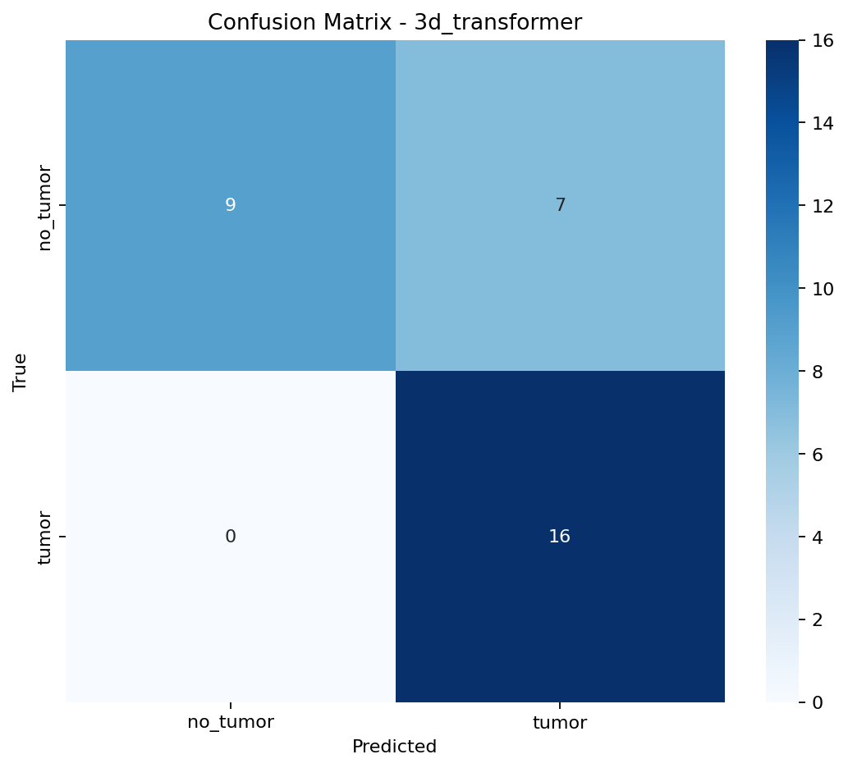
Figure 4. Confusion matrix on held-out test data
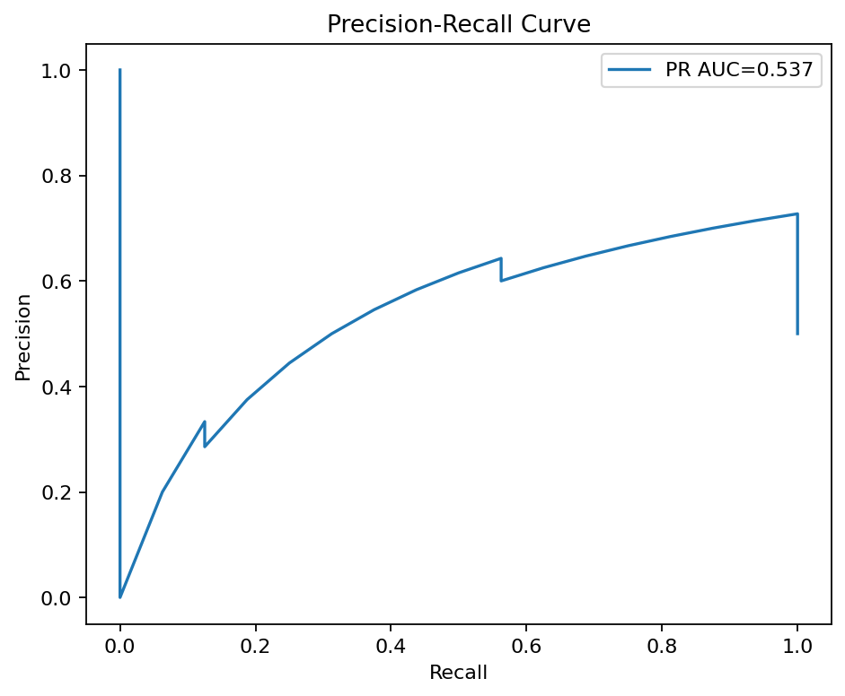
Figure 5. Precision-recall curve
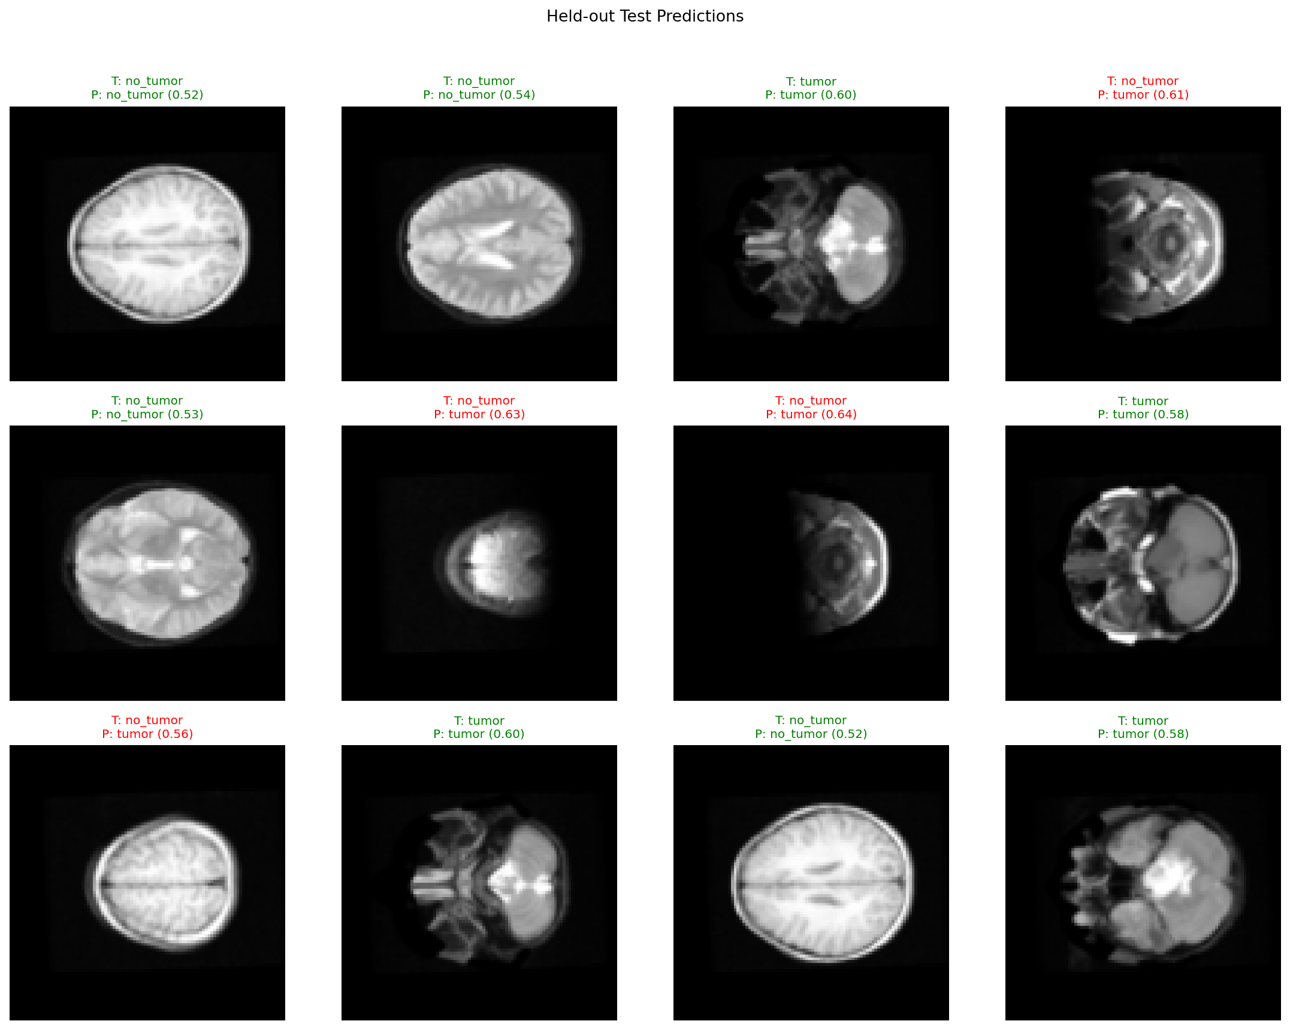
Figure 6. Sample held-out predictions

11. Discussion
The results show that integrating classical Computer Vision stages with a deep model can produce a working high-level application. The tumor class achieved perfect recall on the test set, demonstrating that the model learned features associated with tumor-containing slices. The false positives suggest that bright anatomical structures, boundary artifacts, or slice-context ambiguity can still look tumor-like to the model.
The validation curve shows overfitting. Training accuracy increased strongly, while validation accuracy remained lower. This is likely caused by the small number of subjects and the similarity between neighboring slices. Slice-level datasets can appear large, but adjacent slices from the same subject are correlated. A stronger final system should include more subjects and should split data subject-wise to measure generalization more fairly.
Even with these limitations, the project meets the educational objective: it demonstrates acquisition, pre-processing, segmentation, description, and recognition in one runnable pipeline. The exported artifacts also allow another user to inspect the data, reproduce the figures, and rerun the notebook in Colab.

12. Limitations
The most important limitation is dataset size. The final run contains 158 slices from a limited annotated subset. A larger project should include more subjects, more MRI modalities, and stronger subject-level train/test separation.
The second limitation is that the task is slice-level tumor presence classification, not full 3D lesion segmentation or clinical diagnosis. The system should be viewed as a Computer Vision prototype, not a medical decision system.
The third limitation is descriptor instability for tiny masks. Circularity can be mathematically unstable when perimeter is near zero. Future work should clamp circularity values, ignore tiny masks for shape analysis, or use a more robust perimeter estimate.
The fourth limitation is model overfitting. Regularization, augmentation, transfer learning, and larger data would likely improve validation performance and reduce false positives.

13. Reproducibility and GitHub Submission
The full project has been initialized as a Git repository and pushed to GitHub. The repository contains the original project PDF, assignment notebooks, assignment reports, final Colab notebook, final outputs, trained model, annotated data, figures, and this research paper.
The final notebook is 231192_231200_Final_Deep_Vision_Pipeline_Colab.ipynb. Running it in Google Colab downloads or loads the dataset, builds the annotated slice dataset, trains the 3D transformer model, evaluates it, exports all artifacts, and downloads the final output zip.
The GitHub repository link for submission is https://github.com/isMaaz/CV_Project.git.

14. Conclusion
This semester project successfully integrates the findings from Assignments 1 through 3 into a complete Deep Vision Pipeline. The system starts with acquisition, applies MRI pre-processing, uses segmentation masks, extracts texture and geometric descriptors, and performs semantic recognition with a deep 3D transformer-style model.
The final held-out test accuracy is 78.12%, with 84.78% macro precision, 78.12% macro recall, and 77.03% macro F1-score. The model achieved complete tumor recall on the test split, which is the strongest result of the final run.
Future improvements should focus on subject-level splitting, larger annotated datasets, stronger augmentation, and a dedicated segmentation network. However, as a CLO-5 high-level deep vision application, the submitted system completes the required pipeline and demonstrates both classical and modern Computer Vision techniques.

15. References
Canny, J. (1986). A computational approach to edge detection. IEEE Transactions on Pattern Analysis and Machine Intelligence.
Haralick, R. M., Shanmugam, K., and Dinstein, I. (1973). Textural features for image classification. IEEE Transactions on Systems, Man, and Cybernetics.
Otsu, N. (1979). A threshold selection method from gray-level histograms. IEEE Transactions on Systems, Man, and Cybernetics.
LeCun, Y., Bottou, L., Bengio, Y., and Haffner, P. (1998). Gradient-based learning applied to document recognition. Proceedings of the IEEE.
Ronneberger, O., Fischer, P., and Brox, T. (2015). U-Net: Convolutional networks for biomedical image segmentation. MICCAI.
Vaswani, A. et al. (2017). Attention is all you need. Advances in Neural Information Processing Systems.
Dosovitskiy, A. et al. (2020). An image is worth 16x16 words: Transformers for image recognition at scale.
Menze, B. H. et al. (2015). The multimodal brain tumor image segmentation benchmark (BRATS). IEEE Transactions on Medical Imaging.
KaggleHub dataset used in this project: awansaad6797/cancer-dataset.

