AI303L: Computer Vision Lab
Assignment 2 Report
Segmentation, Morphology, Chain Code, and Convex Hull
Submitted By
Muhammad Maaz Akram | 231192
Muhammad Umar | 231200
BSAI-6-A
Submitted To
Ms. Hina Rashid
Prepared on 18 May 2026

Introduction
In this assignment, we moved from image filtering to image segmentation and shape analysis. The goal was to take MRI slices, create masks, clean those masks using morphology, and then describe the boundary using chain code and convex hull.
This type of work is useful in computer vision because many tasks start by separating an object from the background. After an object is separated, its shape can be studied using boundary and geometry methods.

Dataset Used
The main dataset selected for this work was the BraTS-PEDs dataset from The Cancer Imaging Archive. The full dataset is very large, so it was not practical to download and process the complete collection again and again during the lab work. To make the work manageable, a smaller chunk of the dataset was uploaded to Kaggle and then used inside the code through the KaggleHub API.
So, the original source of the data is TCIA BraTS-PEDs, but the actual files used by the notebook came from the Kaggle dataset named awansaad6797/cancer-dataset. This is why the code contains the KaggleHub download command. It allowed the notebook to work with a smaller and easier-to-handle part of the original dataset.
Dataset Point | Explanation
Original dataset | BraTS-PEDs from The Cancer Imaging Archive
Original dataset link | https://www.cancerimagingarchive.net/collection/brats-peds/
Dataset DOI | 10.7937/dx5c-tj86
Full dataset size | About 457 subjects and around 32.7 GB of image data
Dataset used in code | Kaggle chunk accessed with KaggleHub
Kaggle dataset name | awansaad6797/cancer-dataset
Reason for Kaggle use | The full dataset was large, so a smaller uploaded chunk was used for the assignment.

Objectives
- Create edge maps using Canny and Sobel methods.
- Generate binary masks from the edge results.
- Apply erosion, dilation, opening, and closing.
- Trace the object boundary using Freeman chain code.
- Calculate first difference and shape number.
- Find and display the convex hull using Graham Scan.

Methods
The notebook loaded MRI volumes from the Kaggle dataset chunk and selected center slices. Each slice was normalized between 0 and 1. Then Canny and Sobel edge detection were applied. The edge results were closed using a disk-shaped structure, and the largest connected component was selected as the mask.
The Canny mask was used as the main mask for the next steps. Morphological operations were then applied to show how the mask changes. Closing was used as the cleaned mask for chain code and convex hull because it helps fill small gaps in the boundary.
Step | Simple Explanation
Canny | Finds strong edges in the image.
Sobel | Finds edges by measuring image gradient.
Erosion | Shrinks the white mask area.
Dilation | Expands the white mask area.
Opening | Removes small noisy parts.
Closing | Fills small gaps and connects broken parts.
Chain code | Stores the boundary as direction numbers.
Convex hull | Draws the smallest outer polygon around the boundary.

Algorithm Details
Freeman chain code uses direction numbers from 0 to 7. Each number shows the next movement along the boundary. This gives a compact way to describe the shape of the detected object. The first difference was also calculated so that the shape description depends less on the starting direction.
For the convex hull, boundary points were sampled from the cleaned mask. Graham Scan was then used to find the outer polygon around those points. The convex hull has fewer points than the full chain code because it only keeps the outer shape.

Results
Item | Details
Notebook used | CV_ProjectA2_231192_231200.ipynb
CSV rows | 15
Average chain length | 469.53 steps
Chain length range | 446 to 476 steps
Average hull vertices | 54.00
Hull vertices range | 45 to 60
Saved visual stages | masks, morphology, chain_code, and convex_hull

Label | Slice | Chain Length | Hull Vertices
T1CE_to_SRI_defaced | 76 | 476 | 53
T1CE_to_SRI_defaced | 77 | 476 | 55
T1CE_to_SRI_defaced | 78 | 476 | 58
T1_to_SRI_defaced | 76 | 476 | 56
T1_to_SRI_defaced | 77 | 475 | 60
T1_to_SRI_defaced | 78 | 475 | 55
FL_to_SRI_defaced | 76 | 475 | 59
FL_to_SRI_defaced | 77 | 475 | 53
FL_to_SRI_defaced | 78 | 474 | 55
T2_to_SRI_defaced | 76 | 475 | 57
T2_to_SRI_defaced | 77 | 474 | 57
T2_to_SRI_defaced | 78 | 473 | 55
T1CE_to_SRI_defaced | 76 | 450 | 46
T1CE_to_SRI_defaced | 77 | 447 | 45
T1CE_to_SRI_defaced | 78 | 446 | 46

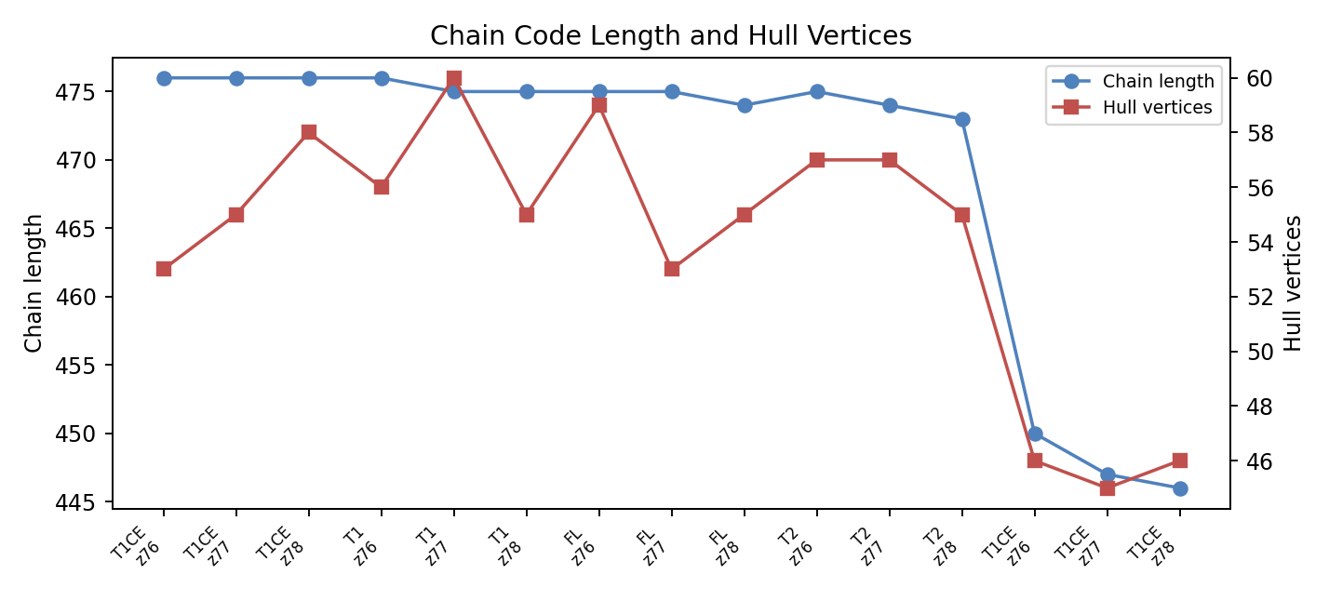
Figure 1. Chain code length and convex hull vertices for processed slices.

Processed Labels
Label | Rows | Average Chain | Average Hull
T1CE_to_SRI_defaced | 6 | 461.8 | 50.5
T1_to_SRI_defaced | 3 | 475.3 | 57.0
FL_to_SRI_defaced | 3 | 474.7 | 55.7
T2_to_SRI_defaced | 3 | 474.0 | 56.3

Visual Results
The visual results are the most useful part of this assignment because they show each step clearly. The mask figure shows how Canny and Sobel detected edges. The morphology figure shows how the mask changed. The chain code and convex hull figures show how the final boundary was represented.
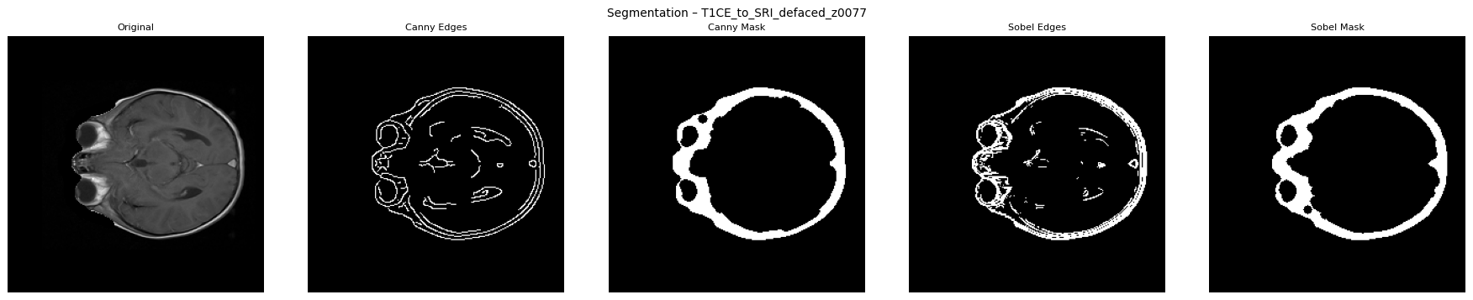
Figure 2. Mask comparison using Canny and Sobel.
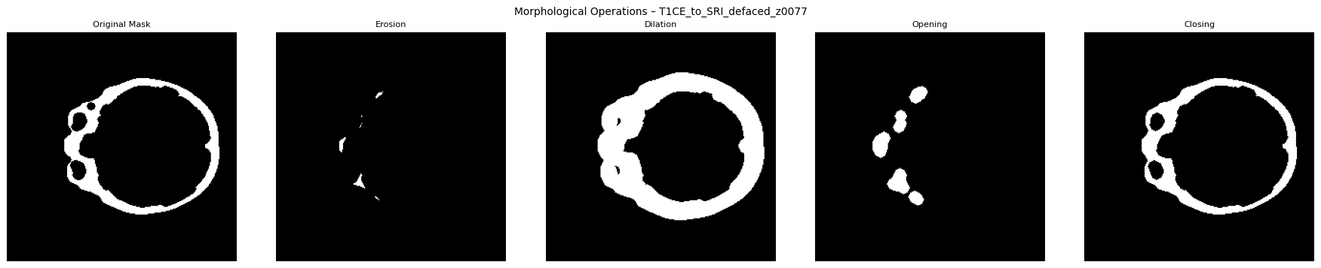
Figure 3. Morphological operations on the mask.
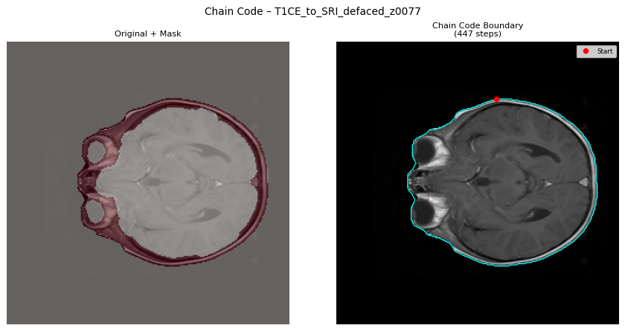
Figure 4. Chain code boundary overlay.
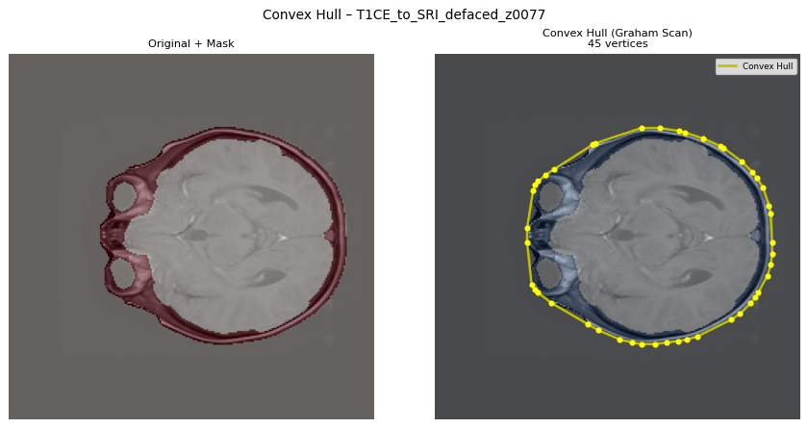
Figure 5. Convex hull overlay using Graham Scan.
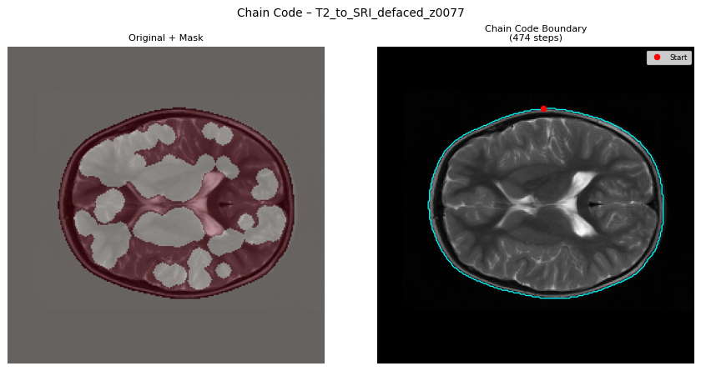
Figure 6. T2 chain code boundary overlay.
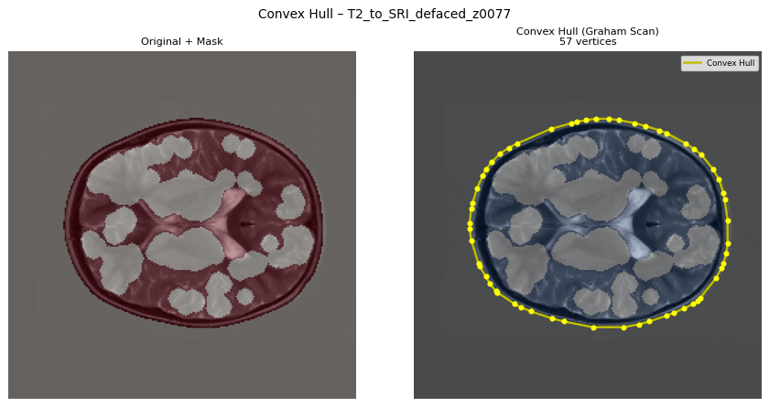
Figure 7. T2 convex hull overlay.

Discussion
Canny gave a cleaner main mask for the next steps, which is why it was used as the primary mask. Sobel was still useful for comparison because it shows gradient-based edges. After edge detection, closing helped connect broken boundaries and made the mask better for chain code extraction.
The chain code values are much longer than the convex hull values because they describe the boundary in more detail. Chain code follows the boundary step by step, while the convex hull only keeps the outer covering shape. This is why the average chain length was about 469.53 steps, while the average hull size was only about 54 vertices.
One thing noticed in the output is that the CSV has 15 rows, but the visual folders have 12 unique images per stage. This can happen when the same subject and slice name appears again and the PNG file gets overwritten. The CSV still keeps the written rows, while the image folder keeps the latest file with that name.

Conclusion
This assignment showed how MRI slices can be converted into masks and then into shape information. The notebook successfully performed edge detection, morphology, chain code extraction, first difference calculation, shape number calculation, and convex hull visualization. The results show that simple computer vision methods can be used to study boundaries and shapes in medical images.

References
- BraTS-PEDs dataset from The Cancer Imaging Archive: https://www.cancerimagingarchive.net/collection/brats-peds/
- Kaggle dataset used in code: awansaad6797/cancer-dataset
- scikit-image documentation for Canny and Sobel edge detection.
- SciPy ndimage documentation for binary morphology.
- Freeman chain code and Graham Scan concepts from computer vision and computational geometry.

