AI303L: Computer Vision Lab
Computer Vision Project Assignment 3 Report
GLCM Texture Features, Geometric Features, and Classification
Air University E-9 Islamabad
Submitted To: Ms. Hina Rashid
Submitted By
Muhammad Maaz Akram 231192
Muhammad Umar 231200
BSAI-6-A
Prepared on 19 May 2026

Introduction
This report is the third milestone of the same main computer vision project. Assignment 1 worked on MRI filtering and image quality checking. Assignment 2 worked on segmentation, morphology, chain code, and convex hull. Assignment 3 continues from those steps and uses the segmented region idea to extract texture and shape features.
The purpose of this assignment is to convert each selected MRI slice into a feature vector. A feature vector is a row of numbers that describes the texture and geometry of the detected region. These numbers are then used to train and test machine learning classifiers.

Dataset Used
The dataset information below was taken from the previous project reports because all three assignments are milestones of the same project.
The main dataset selected for this work was the BraTS-PEDs dataset from The Cancer Imaging Archive. The full dataset is very large, so it was not practical to download and process the complete collection again and again during the lab work. To make the work manageable, a smaller chunk of the dataset was uploaded to Kaggle and then used inside the code through the KaggleHub API.
So, the original source of the data is TCIA BraTS-PEDs, but the actual files used by the notebook came from the Kaggle dataset named awansaad6797/cancer-dataset. This is why the code contains the KaggleHub download command. It allowed the notebook to work with a smaller and easier-to-handle part of the original dataset.
Dataset Point | Explanation
Original dataset | BraTS-PEDs from The Cancer Imaging Archive
Original dataset link | https://www.cancerimagingarchive.net/collection/brats-peds/
Dataset DOI | 10.7937/dx5c-tj86
Full dataset size | About 457 subjects and around 32.7 GB of image data
Dataset used in code | Kaggle chunk accessed with KaggleHub
Kaggle dataset name | awansaad6797/cancer-dataset
Reason for Kaggle use | The full TCIA dataset is large, so a smaller uploaded chunk was used for Colab processing.

Connection With Previous Milestones
Milestone | Main work | How it connects to Assignment 3
Assignment 1 | MRI filtering using Gaussian, mean, and median filters | Prepared clean MRI slices and quality comparison ideas.
Assignment 2 | Segmentation, morphology, chain code, and convex hull | Created the base idea of masks and shape analysis.
Assignment 3 | GLCM, geometric features, and classification | Uses texture and shape features for machine learning classification.

Objectives
- Download and load MRI volumes from the Kaggle dataset chunk.
- Select useful center slices from the NIfTI volumes.
- Create a clean mask using Canny edge detection and morphology.
- Extract GLCM texture features from the masked region.
- Extract geometric features from the detected region.
- Save feature vectors in a CSV file.
- Train Random Forest and SVM classifiers.
- Save plots, reports, confusion matrices, and a zipped output folder.

Complete Assignment 3 Pipeline Diagram
Step | Block | What happens
1 | Dataset | TCIA BraTS-PEDs source, Kaggle chunk used in Colab
2 | Load MRI | Read .nii volumes using NiBabel
3 | Slice selection | Take center slices from each 3D volume
4 | Preprocessing | Normalize intensity values between 0 and 1
5 | Mask creation | Canny edges, closing, connected component selection
6 | Texture features | GLCM energy, entropy, contrast, homogeneity, correlation
7 | Shape features | Area, centroid, perimeter, circularity
8 | Classification | Random Forest and SVM using 8 numeric features
9 | Outputs | CSV files, plots, confusion matrices, zipped output

Feature Vector Diagram
Part | Columns
Identity columns | subject, slice, label
GLCM texture columns | energy, entropy, contrast, homogeneity, correlation
Geometric columns | area, centroid_r, centroid_c, perimeter, circularity
Classifier columns | energy, entropy, contrast, homogeneity, correlation, area, perimeter, circularity

Tools and Libraries
Library | Use in Assignment 3
nibabel | Loads NIfTI MRI volumes.
scikit-image | Canny edges, GLCM features, morphology, and region analysis.
scipy | Connected component labeling and morphology operations.
matplotlib | Saves visual outputs as PNG images.
scikit-learn | StandardScaler, train-test split, Random Forest, SVM, and metrics.
kagglehub | Downloads the Kaggle dataset chunk in Colab.
tqdm | Shows progress while volumes are processed.

Detailed Methodology With Code

1. Installation and Imports
The first cell installs all required packages in Google Colab. The next cells import the libraries used for MRI loading, image processing, feature extraction, plotting, and machine learning.
!pip install nibabel scikit-image scipy matplotlib kagglehub tqdm scikit-learn -q

import numpy as np
import nibabel as nib
from skimage.feature import canny, graycomatrix, graycoprops
from skimage.morphology import disk
from skimage.measure import regionprops
from sklearn.ensemble import RandomForestClassifier
from sklearn.svm import SVC

2. Configuration
The configuration keeps the experiment manageable in Colab. Only a limited number of volumes and center slices are processed.
MAX_VOLUMES = 10
MAX_SLICES = 5
CANNY_SIGMA = 1.5
MORPH_ITER = 2
GLCM_DISTS = [1, 2]
GLCM_ANGLES = [0, np.pi/4, np.pi/2, 3*np.pi/4]
OUT_DIR = Path("output_a3")

3. Dataset Download
The code downloads the smaller Kaggle chunk of the TCIA BraTS-PEDs data. Segmentation files are ignored because this assignment extracts features from image volumes.
path = kagglehub.dataset_download("awansaad6797/cancer-dataset")
all_nii = sorted(f for f in Path(path).rglob("*.nii") if f.is_file())
all_nii = [f for f in all_nii if "seg" not in f.name.lower()]
all_nii = all_nii[:MAX_VOLUMES]

4. Normalisation and Center Slice Selection
Normalisation changes pixel intensity values into a 0 to 1 range. Center slices are selected because they usually contain more useful brain structure than side slices.
def normalise(slc):
mn, mx = slc.min(), slc.max()
if mx > mn:
return ((slc - mn) / (mx - mn + 1e-8)).astype(np.float32)
return np.zeros_like(slc, dtype=np.float32)

def centre_slice_indices(n_slices, max_slices):
if n_slices <= max_slices:
return list(range(n_slices))
start = (n_slices - max_slices) // 2
return list(range(start, start + max_slices))

5. Mask Generation
A mask is created to focus on the useful region. Canny detects edges, closing joins small gaps, and the largest connected component is selected.
def get_clean_mask(slc):
edges = canny(slc, sigma=CANNY_SIGMA)
closed = binary_closing(edges, structure=disk(4))
labeled, n = nd_label(closed)
if n == 0:
return edges.astype(np.uint8)
sizes = [(labeled == i).sum() for i in range(1, n + 1)]
mask = (labeled == (np.argmax(sizes) + 1)).astype(np.uint8)
cleaned = binary_closing(mask, structure=disk(3).astype(bool), iterations=MORPH_ITER)
return cleaned.astype(np.uint8)

6. GLCM Texture Feature Extraction
GLCM means Gray Level Co-occurrence Matrix. It studies how often gray level pairs appear near each other. This tells us about image texture.
GLCM Feature | Meaning in easy English
Energy | Higher value means the texture is more uniform.
Entropy | Higher value means the texture has more variation or randomness.
Contrast | Higher value means stronger dark and bright differences.
Homogeneity | Higher value means nearby pixels are more similar.
Correlation | Shows how related nearby pixel values are.
glcm = graycomatrix(img_uint, distances=GLCM_DISTS, angles=GLCM_ANGLES,
levels=64, symmetric=True, normed=True)
energy = graycoprops(glcm, "energy").mean()
contrast = graycoprops(glcm, "contrast").mean()
homogeneity = graycoprops(glcm, "homogeneity").mean()
correlation = graycoprops(glcm, "correlation").mean()
entropy = -np.sum(glcm_norm * np.log2(glcm_norm + 1e-10))

7. Geometric Feature Extraction
Geometric features describe the shape of the selected mask. These values are useful because different tissues can have different region sizes and boundaries.
Geometric Feature | Meaning in easy English
Area | Number of pixels inside the selected region.
Centroid | Center point of the selected region.
Perimeter | Length of the outer boundary.
Circularity | How close the region is to a circle.
labeled_mask = sk_label(mask)
props = regionprops(labeled_mask)
region = max(props, key=lambda r: r.area)
area = region.area
centroid_r, centroid_c = region.centroid
perimeter = region.perimeter
circularity = (4 * np.pi * area) / (perimeter ** 2 + 1e-8)

8. Classification
The classifier does not use the image directly. It uses the eight selected feature columns. First the values are scaled, then the data is split into training and testing samples.
FEATURE_COLS = ["energy", "entropy", "contrast", "homogeneity",
"correlation", "area", "perimeter", "circularity"]

X_scaled = StandardScaler().fit_transform(X)
X_train, X_test, y_train, y_test = train_test_split(
X_scaled, y, test_size=0.25, random_state=42)

rf = RandomForestClassifier(n_estimators=100, random_state=42)
svm = SVC(kernel="rbf", C=10, gamma="scale", random_state=42)

Notebook Output Details
Notebook file | Code cells | Feature vectors | GLCM images | Geometry images
231192_231200_CV_Project_Assignment3.ipynb | 11 | 50 | 20 | 20

Actual Colab Execution Output
Dataset download output:
Downloading dataset via kagglehub...
Using Colab cache for faster access to the 'cancer-dataset' dataset.
Dataset path: /kaggle/input/cancer-dataset
Using 10 volumes.
Processing output sample:
[T1_to_SRI_defaced_z0079] label=Necrotic energy=0.9266 entropy=0.9999 area=3815.0 circ=0.0398
Total feature vectors: 50
Classifier output:
Feature matrix: (50, 8)
Edema: 10 samples
Enhancing: 15 samples
Necrotic: 15 samples
Other: 10 samples
==================================================
Random Forest Accuracy : 100.00%
SVM (RBF) Accuracy : 92.31%
==================================================
Random Forest Report:
precision recall f1-score support
Edema 1.00 1.00 1.00 4
Enhancing 1.00 1.00 1.00 1
Necrotic 1.00 1.00 1.00 4
Other 1.00 1.00 1.00 4
accuracy 1.00 13
macro avg 1.00 1.00 1.00 13
weighted avg 1.00 1.00 1.00 13
SVM Report:
precision recall f1-score support
Edema 1.00 1.00 1.00 4
Enhancing 0.50 1.00 0.67 1
Necrotic 1.00 0.75 0.86 4
Other 1.00 1.00 1.00 4
accuracy 0.92 13
macro avg 0.88 0.94 0.88 13
weighted avg 0.96 0.92 0.93 13
Accuracy report saved.

Output Files Produced
Output file or folder | Count or value | Explanation
output_a3/feature_vectors.csv | 50 | Main CSV containing all extracted feature rows.
output_a3/glcm_plots | 20 | PNG images showing original slice, mask overlay, and GLCM feature bars.
output_a3/geometry_plots | 20 | PNG images showing mask overlay, centroid, and geometric bars.
classification/confusion_matrices.png | 1 | Confusion matrix image for Random Forest and SVM.
classification/feature_importance.png | 1 | Random Forest feature importance image.
classification/accuracy_report.csv | 1 | CSV file containing classifier accuracy values.

Results

Label Distribution
Label | Samples
Edema | 10
Enhancing | 15
Necrotic | 15
Other | 10

Overall Feature Mean Values
Feature | Mean value
energy | 0.8561
entropy | 1.8533
contrast | 17.8636
homogeneity | 0.8894
correlation | 0.8252
area | 7731.0000
perimeter | 1348.2591
circularity | 0.0515

Class Wise Feature Summary
Label | Samples | Energy | Entropy | Contrast | Homogeneity | Area | Perimeter | Circularity
Edema | 10 | 0.8452 | 2.0548 | 24.5791 | 0.8748 | 8274.10 | 1568.40 | 0.0427
Enhancing | 15 | 0.9173 | 1.1545 | 11.7158 | 0.9307 | 4356.60 | 1093.22 | 0.0457
Necrotic | 15 | 0.8452 | 1.9460 | 19.1197 | 0.8838 | 8426.67 | 1251.27 | 0.0604
Other | 10 | 0.7918 | 2.5609 | 18.4858 | 0.8507 | 11206.00 | 1656.16 | 0.0557

Sample Rows From feature_vectors.csv
Subject | Slice | Label | Energy | Entropy | Contrast | Area | Circularity
T1CE_to_SRI_defaced | 75 | Enhancing | 0.9102 | 1.2359 | 8.6215 | 4667.0 | 0.0519
T1CE_to_SRI_defaced | 76 | Enhancing | 0.9077 | 1.2833 | 10.3888 | 4789.0 | 0.0488
T1CE_to_SRI_defaced | 77 | Enhancing | 0.9105 | 1.2502 | 10.3970 | 4644.0 | 0.0509
T1CE_to_SRI_defaced | 78 | Enhancing | 0.9083 | 1.2836 | 11.3022 | 4780.0 | 0.0536
T1CE_to_SRI_defaced | 79 | Enhancing | 0.9074 | 1.2958 | 11.2555 | 4821.0 | 0.0514
T1_to_SRI_defaced | 75 | Necrotic | 0.7006 | 3.5763 | 30.5813 | 16481.0 | 0.0916
T1_to_SRI_defaced | 76 | Necrotic | 0.7119 | 3.4706 | 29.9363 | 15835.0 | 0.0899
T1_to_SRI_defaced | 77 | Necrotic | 0.6997 | 3.5764 | 27.7948 | 16585.0 | 0.1084
T1_to_SRI_defaced | 78 | Necrotic | 0.7147 | 3.4122 | 28.8830 | 15623.0 | 0.0736
T1_to_SRI_defaced | 79 | Necrotic | 0.6967 | 3.6148 | 30.3756 | 16738.0 | 0.1025

Classifier Results
Classifier | Accuracy percent | Train samples | Test samples
Random Forest | 100.00 | 37 | 13
SVM (RBF) | 92.31 | 37 | 13
Random Forest gave 100.00 percent accuracy on the test set. SVM with RBF kernel gave 92.31 percent accuracy. These values show that the extracted features were useful for this small selected dataset chunk.

Visual Output Gallery
The following figures are actual images generated by the Assignment 3 notebook. Each GLCM figure shows the original slice, the masked region, and the texture feature values. Each geometry figure shows the detected region, centroid, and shape feature values.

Enhancing tissue example
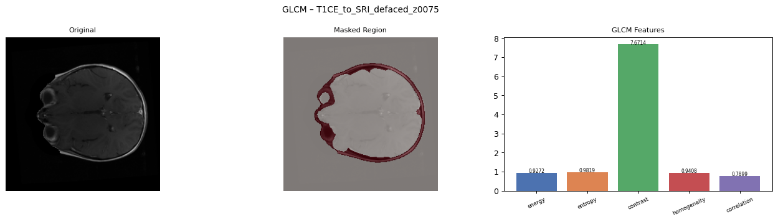 | 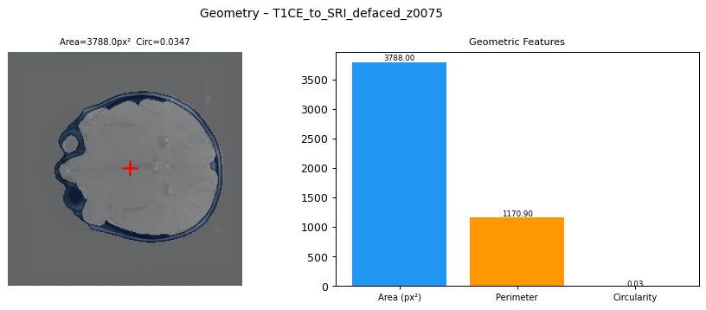
Figure 1: GLCM output for T1CE_to_SRI_defaced, slice 75. | Figure 2: Geometry output for T1CE_to_SRI_defaced, slice 75.

Edema tissue example
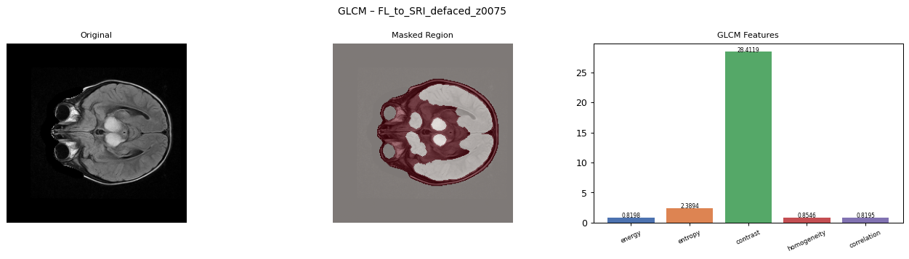 | 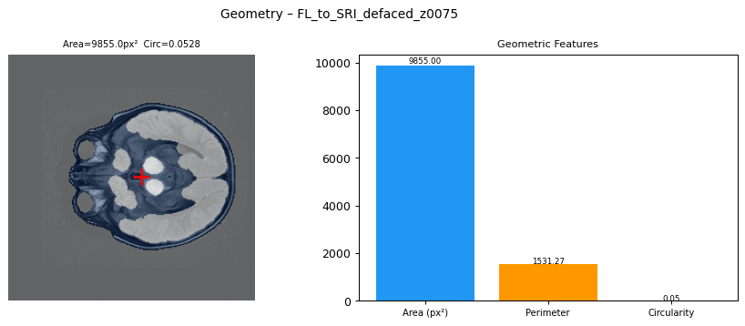
Figure 3: GLCM output for FL_to_SRI_defaced, slice 75. | Figure 4: Geometry output for FL_to_SRI_defaced, slice 75.

Other tissue example
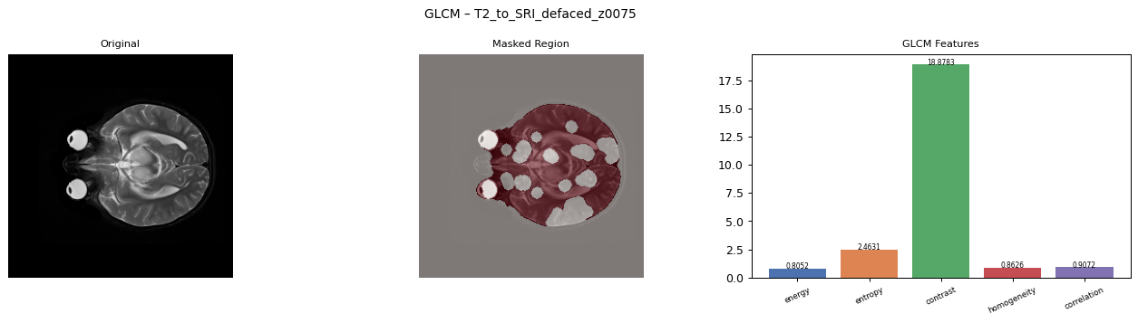 | 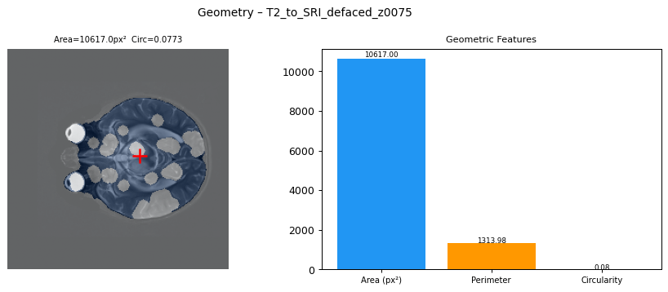
Figure 5: GLCM output for T2_to_SRI_defaced, slice 75. | Figure 6: Geometry output for T2_to_SRI_defaced, slice 75.

Necrotic tissue example
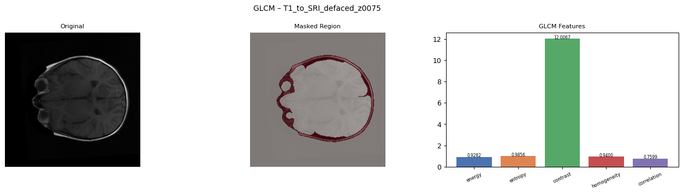 | 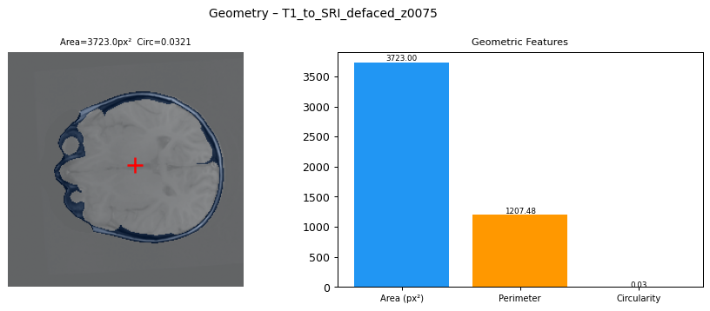
Figure 7: GLCM output for T1_to_SRI_defaced, slice 75. | Figure 8: Geometry output for T1_to_SRI_defaced, slice 75.

Classification Visuals
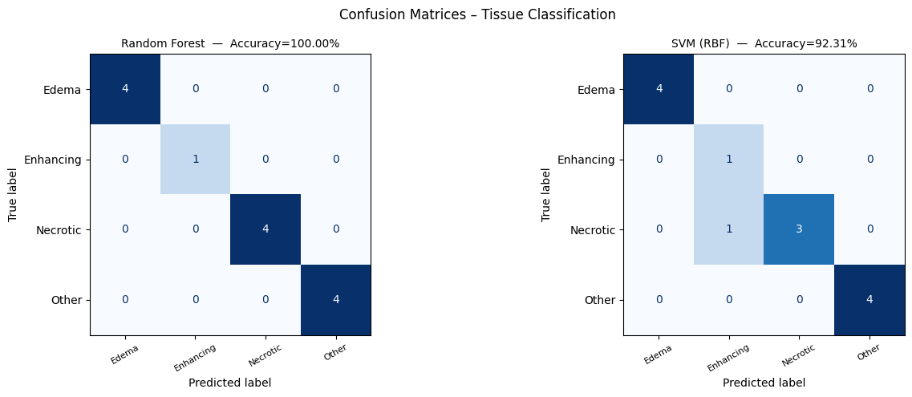
Figure 9: Confusion matrices for Random Forest and SVM.
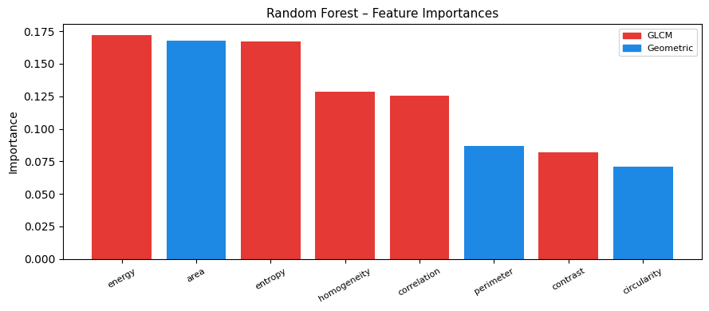
Figure 10: Random Forest feature importance plot.

Complete Images Inserted From content_a3 Folder
This section inserts the actual generated image files from content_a3/output_a3. These are the real notebook output images, included directly in the report.

All GLCM Plot Images From content_a3/output_a3/glcm_plots

Figure 11: GLCM output image from content_a3 - FL_to_SRI_defaced_z0075_glcm.png
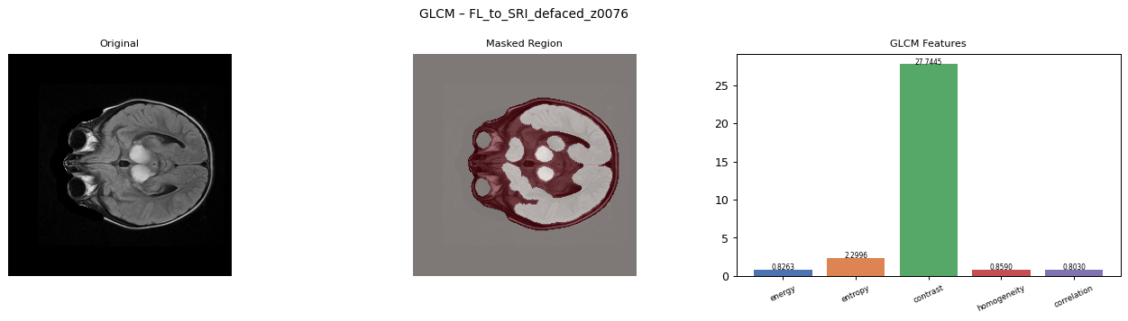
Figure 12: GLCM output image from content_a3 - FL_to_SRI_defaced_z0076_glcm.png
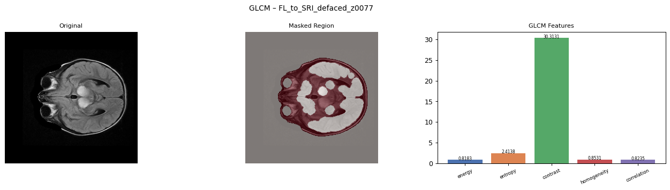
Figure 13: GLCM output image from content_a3 - FL_to_SRI_defaced_z0077_glcm.png
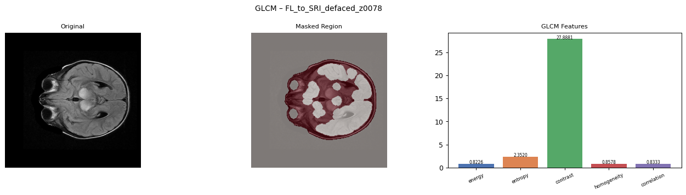
Figure 14: GLCM output image from content_a3 - FL_to_SRI_defaced_z0078_glcm.png
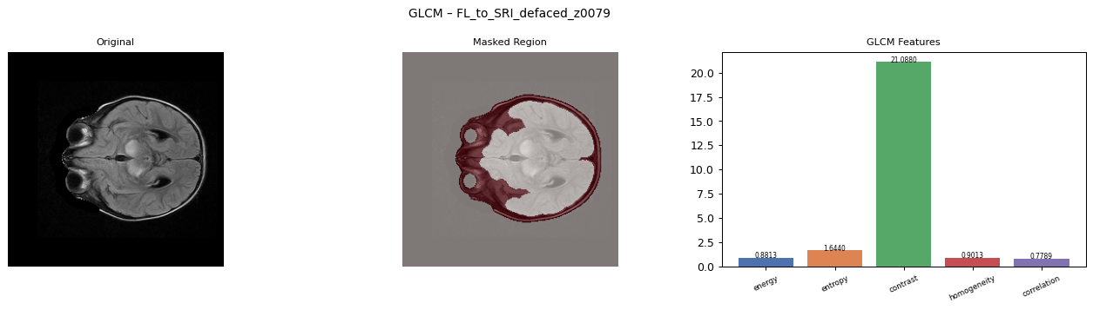
Figure 15: GLCM output image from content_a3 - FL_to_SRI_defaced_z0079_glcm.png

Figure 16: GLCM output image from content_a3 - T1_to_SRI_defaced_z0075_glcm.png
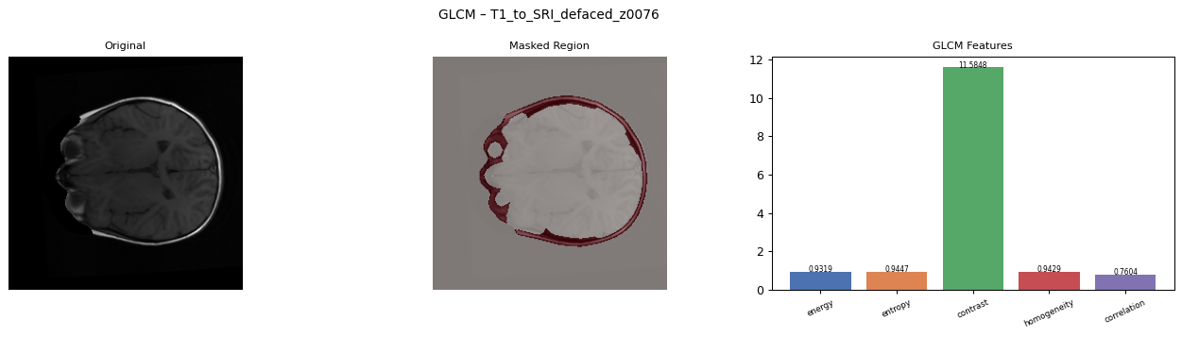
Figure 17: GLCM output image from content_a3 - T1_to_SRI_defaced_z0076_glcm.png
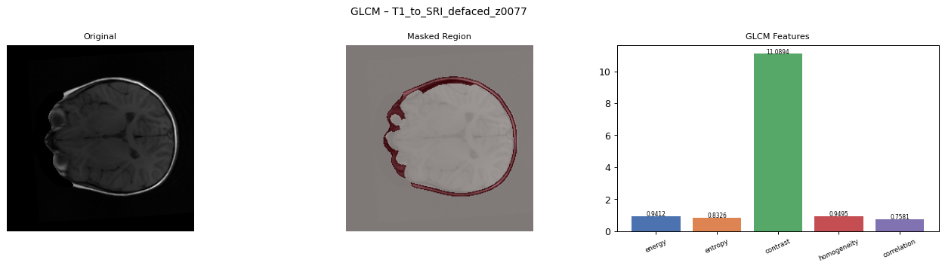
Figure 18: GLCM output image from content_a3 - T1_to_SRI_defaced_z0077_glcm.png
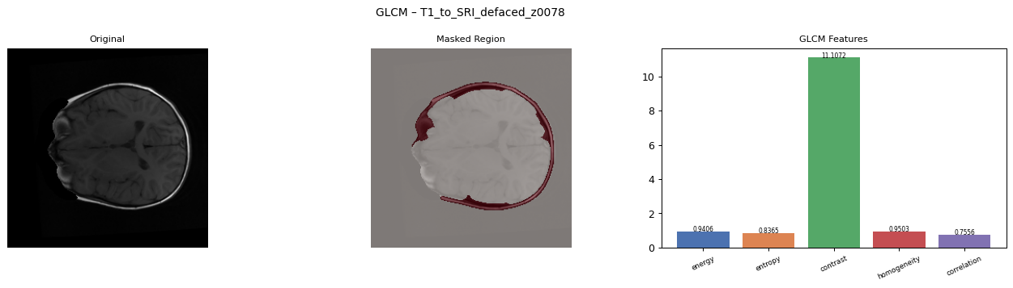
Figure 19: GLCM output image from content_a3 - T1_to_SRI_defaced_z0078_glcm.png
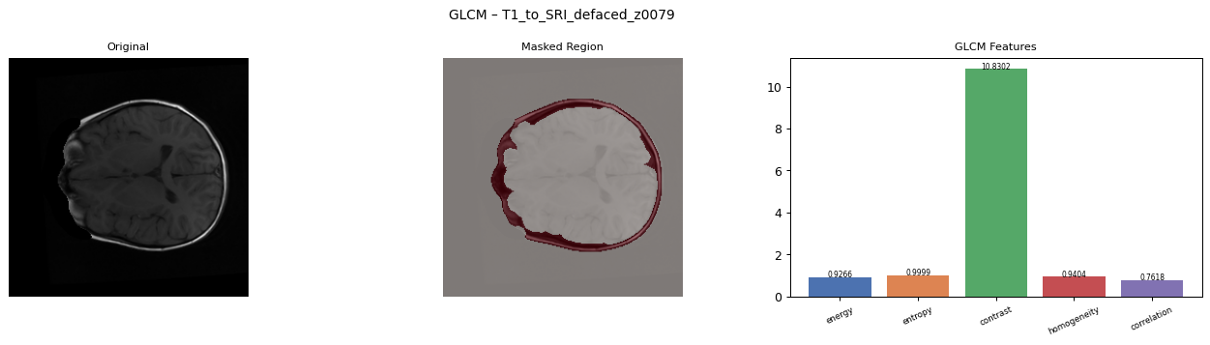
Figure 20: GLCM output image from content_a3 - T1_to_SRI_defaced_z0079_glcm.png

Figure 21: GLCM output image from content_a3 - T1CE_to_SRI_defaced_z0075_glcm.png
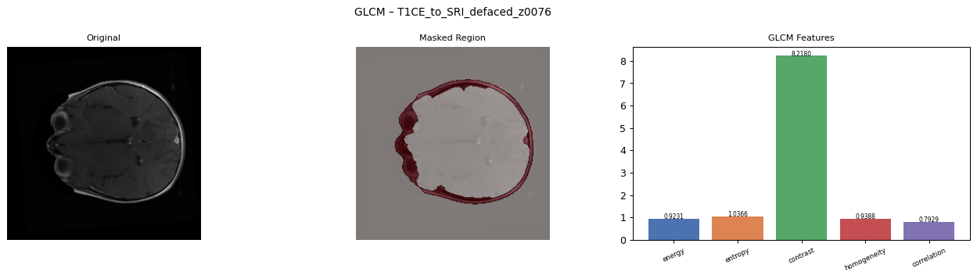
Figure 22: GLCM output image from content_a3 - T1CE_to_SRI_defaced_z0076_glcm.png
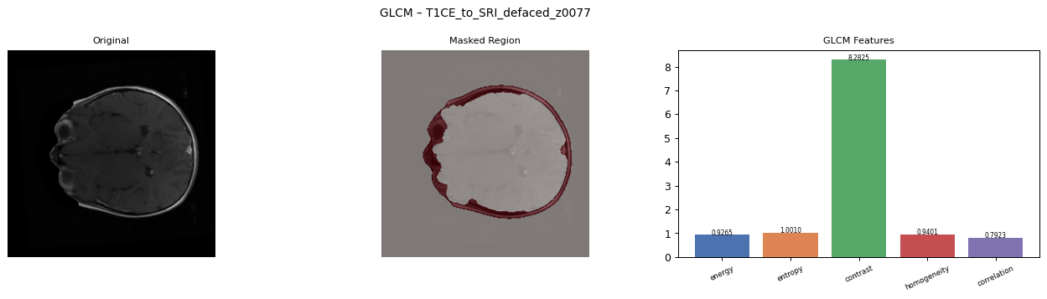
Figure 23: GLCM output image from content_a3 - T1CE_to_SRI_defaced_z0077_glcm.png
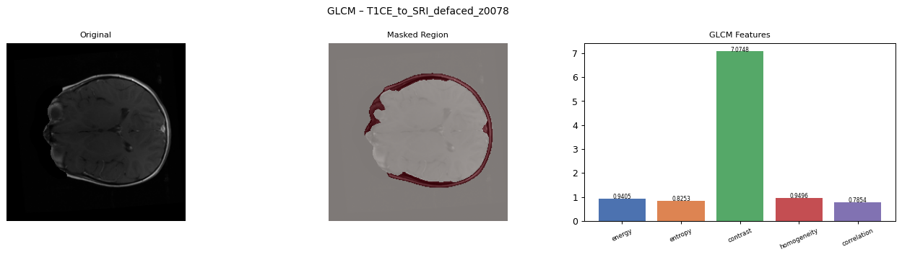
Figure 24: GLCM output image from content_a3 - T1CE_to_SRI_defaced_z0078_glcm.png
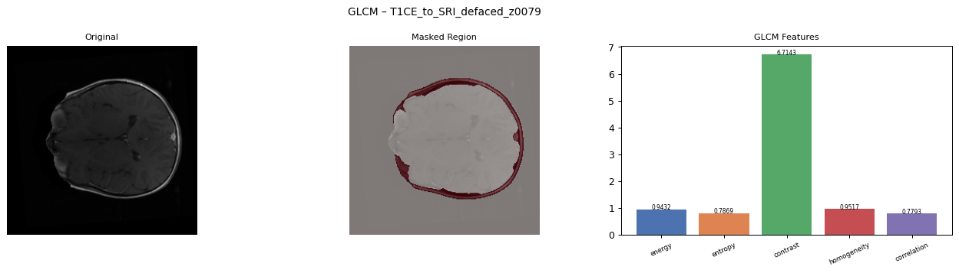
Figure 25: GLCM output image from content_a3 - T1CE_to_SRI_defaced_z0079_glcm.png

Figure 26: GLCM output image from content_a3 - T2_to_SRI_defaced_z0075_glcm.png
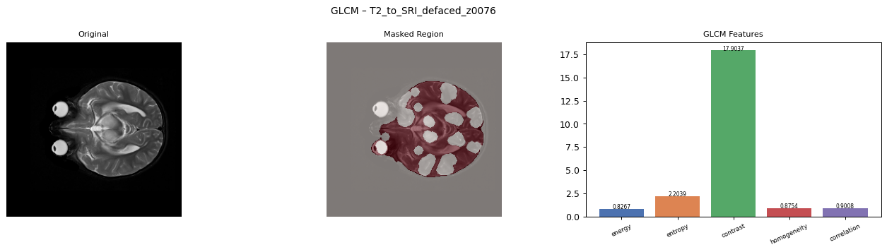
Figure 27: GLCM output image from content_a3 - T2_to_SRI_defaced_z0076_glcm.png
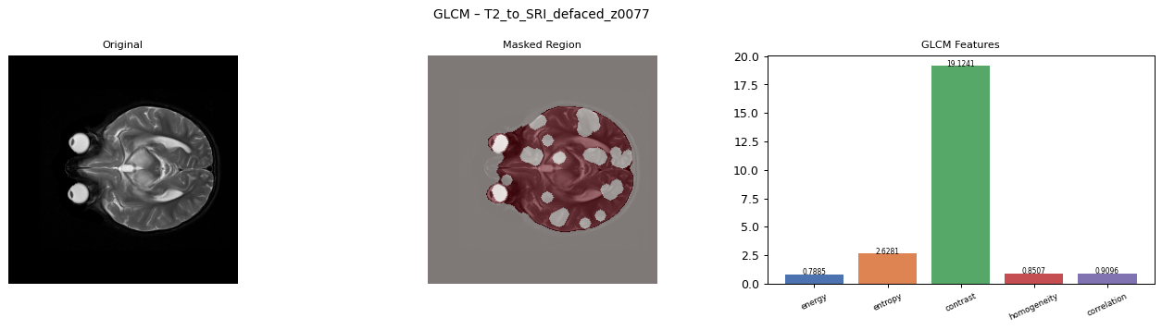
Figure 28: GLCM output image from content_a3 - T2_to_SRI_defaced_z0077_glcm.png
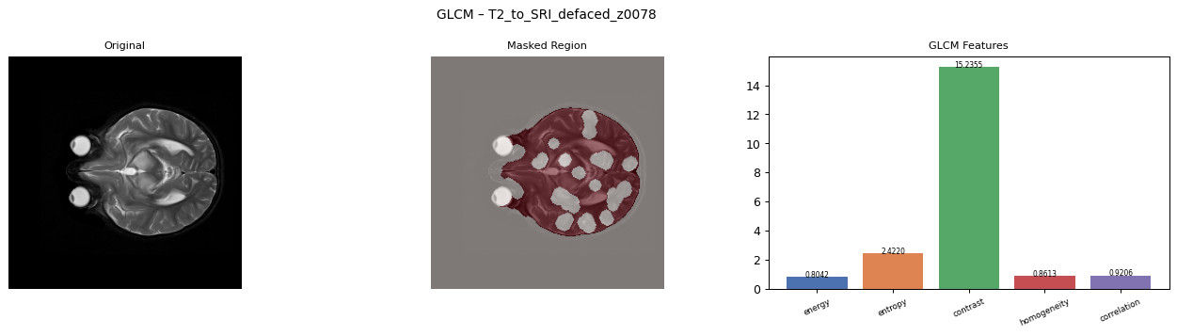
Figure 29: GLCM output image from content_a3 - T2_to_SRI_defaced_z0078_glcm.png
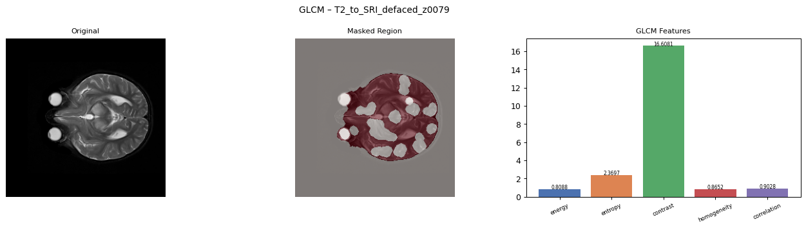
Figure 30: GLCM output image from content_a3 - T2_to_SRI_defaced_z0079_glcm.png

All Geometry Plot Images From content_a3/output_a3/geometry_plots

Figure 31: Geometry output image from content_a3 - FL_to_SRI_defaced_z0075_geometry.png
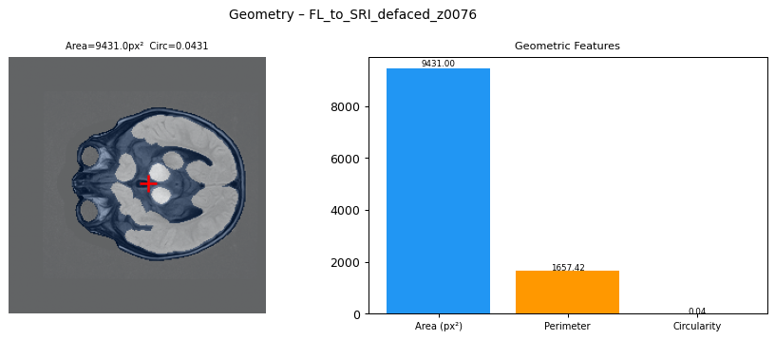
Figure 32: Geometry output image from content_a3 - FL_to_SRI_defaced_z0076_geometry.png
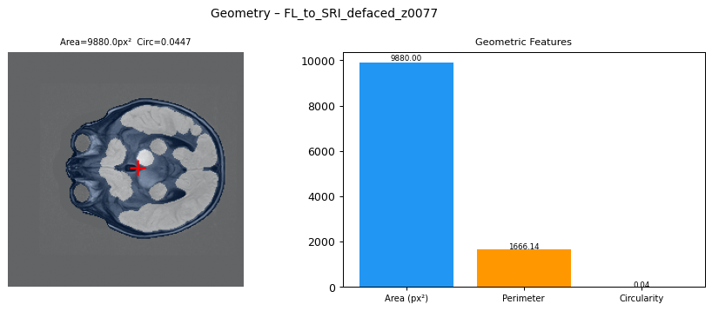
Figure 33: Geometry output image from content_a3 - FL_to_SRI_defaced_z0077_geometry.png
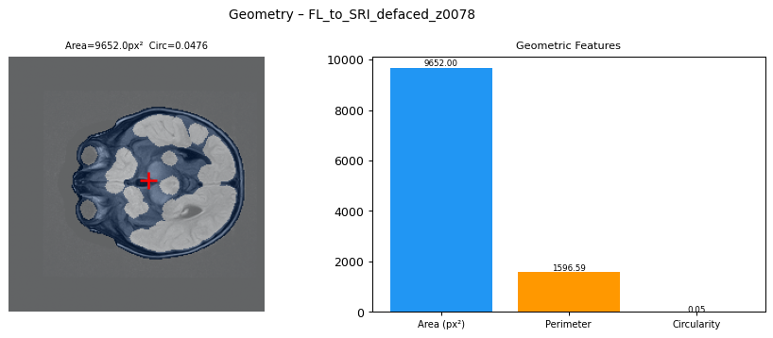
Figure 34: Geometry output image from content_a3 - FL_to_SRI_defaced_z0078_geometry.png
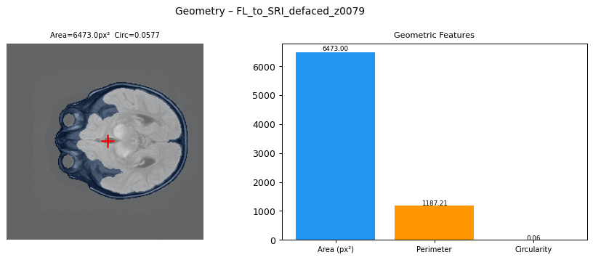
Figure 35: Geometry output image from content_a3 - FL_to_SRI_defaced_z0079_geometry.png

Figure 36: Geometry output image from content_a3 - T1_to_SRI_defaced_z0075_geometry.png
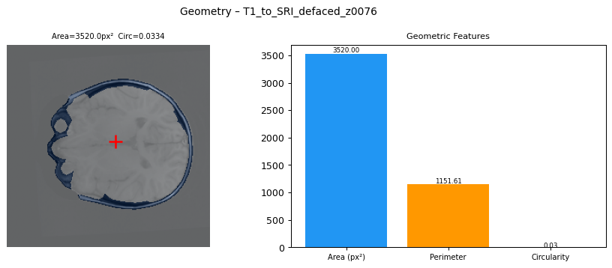
Figure 37: Geometry output image from content_a3 - T1_to_SRI_defaced_z0076_geometry.png
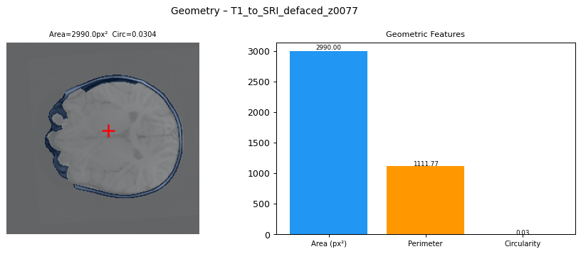
Figure 38: Geometry output image from content_a3 - T1_to_SRI_defaced_z0077_geometry.png
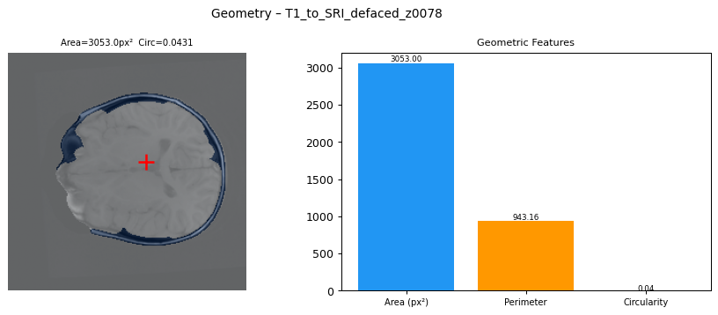
Figure 39: Geometry output image from content_a3 - T1_to_SRI_defaced_z0078_geometry.png
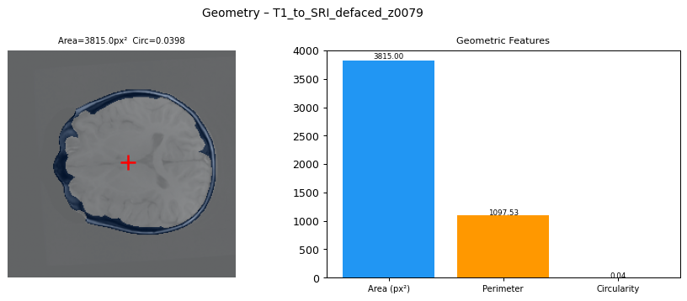
Figure 40: Geometry output image from content_a3 - T1_to_SRI_defaced_z0079_geometry.png

Figure 41: Geometry output image from content_a3 - T1CE_to_SRI_defaced_z0075_geometry.png
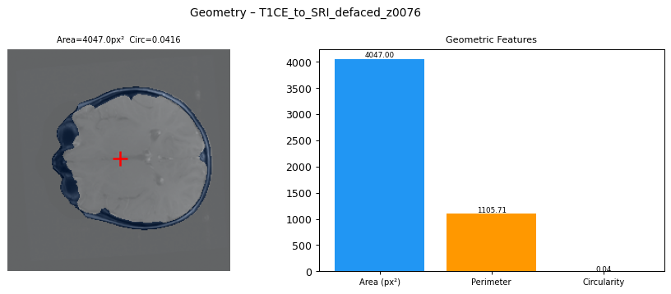
Figure 42: Geometry output image from content_a3 - T1CE_to_SRI_defaced_z0076_geometry.png
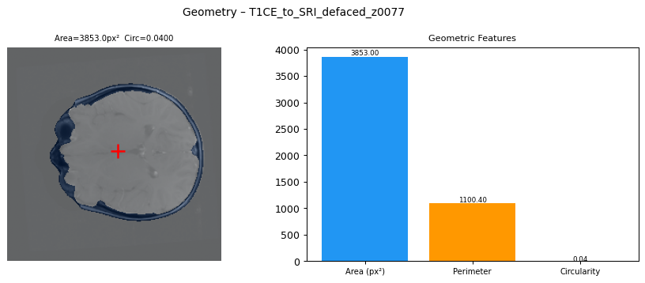
Figure 43: Geometry output image from content_a3 - T1CE_to_SRI_defaced_z0077_geometry.png
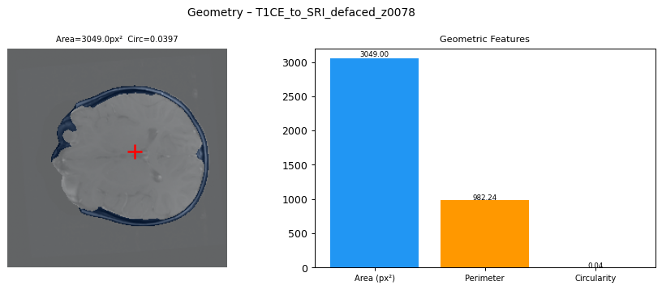
Figure 44: Geometry output image from content_a3 - T1CE_to_SRI_defaced_z0078_geometry.png
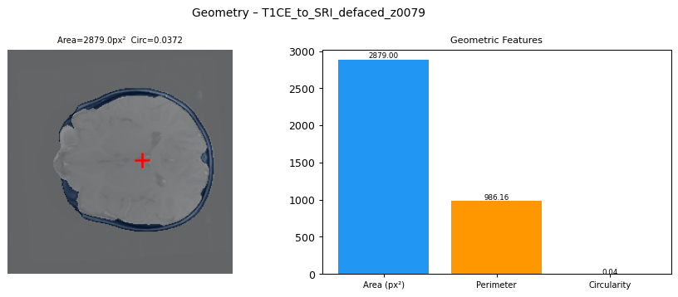
Figure 45: Geometry output image from content_a3 - T1CE_to_SRI_defaced_z0079_geometry.png

Figure 46: Geometry output image from content_a3 - T2_to_SRI_defaced_z0075_geometry.png
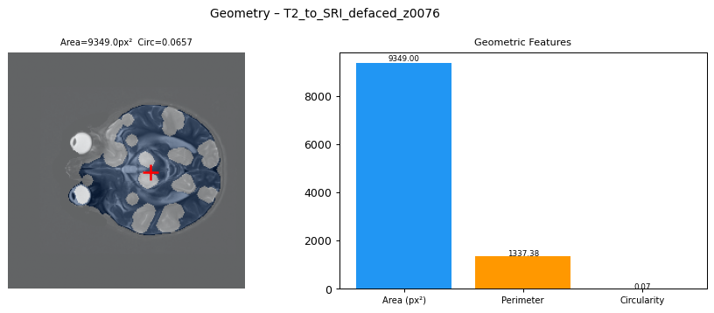
Figure 47: Geometry output image from content_a3 - T2_to_SRI_defaced_z0076_geometry.png
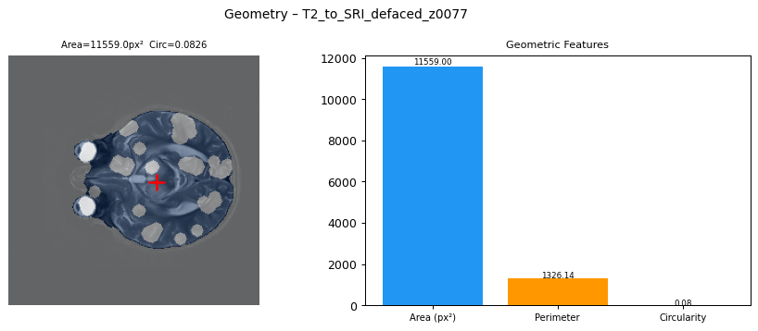
Figure 48: Geometry output image from content_a3 - T2_to_SRI_defaced_z0077_geometry.png
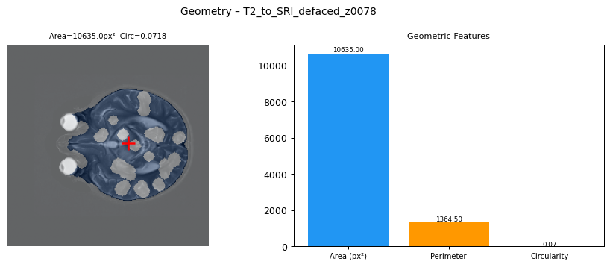
Figure 49: Geometry output image from content_a3 - T2_to_SRI_defaced_z0078_geometry.png
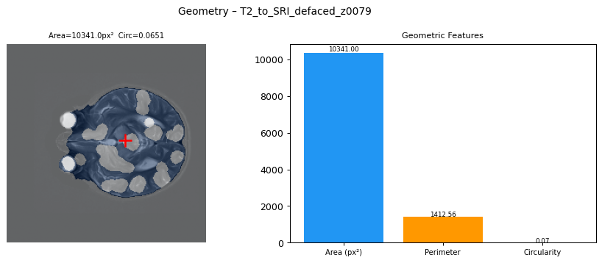
Figure 50: Geometry output image from content_a3 - T2_to_SRI_defaced_z0079_geometry.png

Discussion
The GLCM results show texture differences between the labels. Enhancing samples have high average energy and low average entropy, which means their selected regions are more regular. Edema and Other samples have higher entropy, which means their texture is more varied.
The geometry results also show useful differences. Area and perimeter values change between labels. Other and Edema examples generally have larger selected regions than Enhancing examples. This is why combining GLCM and geometric features gives a better description than using only one type of feature.
The feature importance plot shows which features helped the Random Forest model most. This is important because it tells us which extracted measurements were most useful for classification.

Limitations
- Only a smaller Kaggle chunk of the original TCIA dataset was used.
- Only a limited number of volumes and center slices were processed to keep Colab runtime manageable.
- The labels were inferred from MRI file names, so the experiment is useful for assignment learning but should not be treated as a medical diagnostic system.
- The test set had 13 samples, so the accuracy is a small experiment result and not a final clinical result.

Conclusion
Assignment 3 successfully completed the third milestone of the project. The notebook downloaded MRI data, selected center slices, created clean masks, extracted GLCM texture features, extracted geometric features, saved feature vectors, trained classifiers, and generated visual outputs.
The work connects directly with Assignment 1 and Assignment 2. Filtering helped prepare MRI images, segmentation and morphology helped understand masks and shapes, and this assignment used texture and shape measurements for classification.

