AI303L: Computer Vision Lab
Assignment 1 Report
MRI Filtering and Image Quality Check
Submitted By
Muhammad Maaz Akram | 231192
Muhammad Umar | 231200
BSAI-6-A
Submitted To
Ms. Hina Rashid
Prepared on 18 May 2026

Introduction
In this assignment, we worked on MRI brain images and applied basic image filtering techniques. The main purpose was to see how different filters change the image and how much detail they preserve. This is an important step in computer vision because medical images usually need some preprocessing before further tasks like segmentation or classification.
Three filters were tested: Gaussian filter, mean filter, and median filter. After applying each filter, the results were compared with the original normalized image using PSNR and SSIM. The output images were also saved so that the results could be checked visually.

Dataset Used
The main dataset selected for this work was the BraTS-PEDs dataset from The Cancer Imaging Archive. The full dataset is very large, so it was not practical to download and process the complete collection again and again during the lab work. To make the work manageable, a smaller chunk of the dataset was uploaded to Kaggle and then used inside the code through the KaggleHub API.
So, the original source of the data is TCIA BraTS-PEDs, but the actual files used by the notebook came from the Kaggle dataset named awansaad6797/cancer-dataset. This is why the code contains the KaggleHub download command. It allowed the notebook to work with a smaller and easier-to-handle part of the original dataset.
Dataset Point | Explanation
Original dataset | BraTS-PEDs from The Cancer Imaging Archive
Original dataset link | https://www.cancerimagingarchive.net/collection/brats-peds/
Dataset DOI | 10.7937/dx5c-tj86
Full dataset size | About 457 subjects and around 32.7 GB of image data
Dataset used in code | Kaggle chunk accessed with KaggleHub
Kaggle dataset name | awansaad6797/cancer-dataset
Reason for Kaggle use | The full dataset was large, so a smaller uploaded chunk was used for the assignment.

Objectives
- Load MRI volumes from the Kaggle dataset chunk.
- Select useful center slices from each volume.
- Normalize the image intensity values.
- Apply Gaussian, mean, and median filters.
- Save original, filtered, and comparison images.
- Use PSNR and SSIM to compare the filters.

Methods
The notebook first downloaded the dataset using KaggleHub. Then it searched for MRI files and loaded them with NiBabel. If a volume had four dimensions, the first channel was used. For every volume, center slices were selected because they usually contain more useful brain information than slices near the edges.
Each slice was normalized between 0 and 1. This made the image values consistent before filtering. After that, three filters were applied. The Gaussian filter used sigma 1.0, while the mean and median filters used a 3 by 3 window.
Filter | What It Does | Parameter Used
Gaussian | Smooths the image using weighted nearby pixels. | Sigma = 1.0
Mean | Replaces each pixel with the average of nearby pixels. | 3 by 3 window
Median | Replaces each pixel with the middle value of nearby pixels. | 3 by 3 window

Evaluation Metrics
PSNR was used to measure how close the filtered image was to the original image. A higher PSNR means less difference from the original image. SSIM was used to check how much structure was preserved. A higher SSIM means the important image structure is more similar to the original.

Results
Item | Details
Notebook used | CV_Project_Milestone_1.ipynb
Total metric rows | 4,800
Unique labels in metrics | 13
Saved comparison images | 56

Filter | Rows | Mean PSNR | PSNR Range | Mean SSIM | SSIM Range
Gaussian | 1,600 | 31.5317 | 26.7367 to 37.4594 | 0.9484 | 0.8720 to 0.9793
Mean | 1,600 | 32.1203 | 27.0110 to 38.4006 | 0.9515 | 0.8614 to 0.9846
Median | 1,600 | 34.6233 | 28.8928 to 41.1842 | 0.9639 | 0.8712 to 0.9922

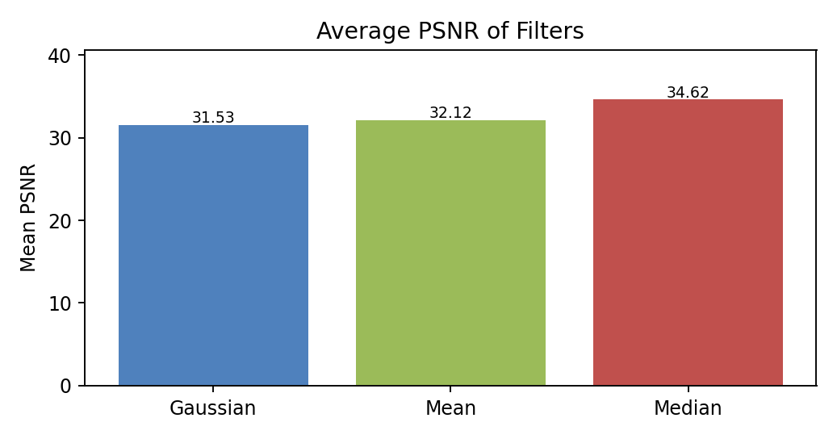
Figure 1. Average PSNR for the three filters.
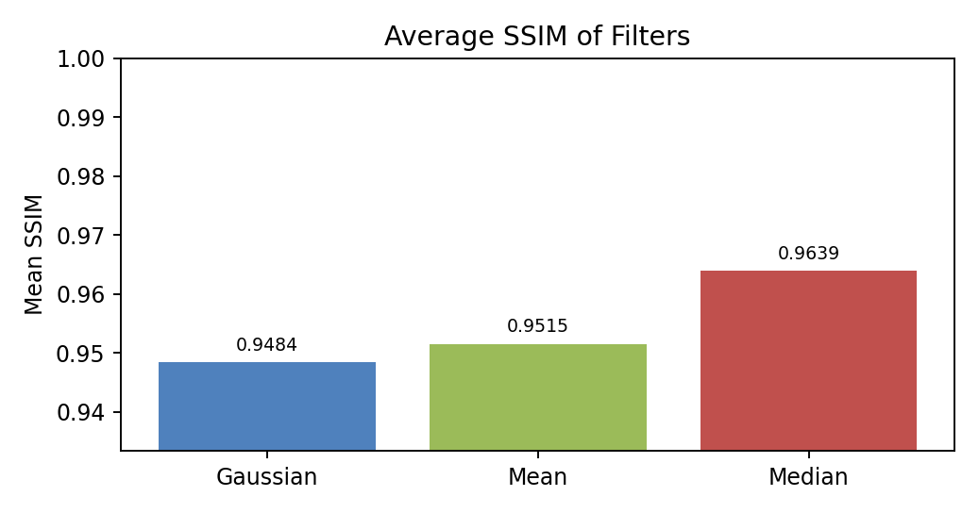
Figure 2. Average SSIM for the three filters.

Processed Labels
Label | Rows | Average PSNR | Average SSIM
T1CE_to_SRI_defaced | 1140 | 33.589 | 0.9591
FL_to_SRI_defaced | 1140 | 31.559 | 0.9393
T1_to_SRI_defaced | 1020 | 33.290 | 0.9691
T2_to_SRI_defaced | 960 | 32.172 | 0.9469
BraTS-PED-00195-000-t1n | 60 | 35.083 | 0.9823
BraTS-PED-00195-000-t2w | 60 | 38.356 | 0.9777
sub002_t1ce_defaced | 60 | 33.314 | 0.9516
sub002_t1_defaced | 60 | 32.843 | 0.9686
sub002_fl_defaced | 60 | 32.339 | 0.9604
sub002_t2_defaced | 60 | 32.589 | 0.9623
BraTS-PED-00201-000-t1n | 60 | 33.660 | 0.9782
BraTS-PED-00201-000-t2w | 60 | 32.993 | 0.9593
BraTS-PED-00203-000-t2w | 60 | 30.996 | 0.9342

Visual Results
The following images are taken directly from the output folder. Each figure shows the original slice and the filtered versions. These figures make it easier to see the difference between the filters instead of only looking at numbers.
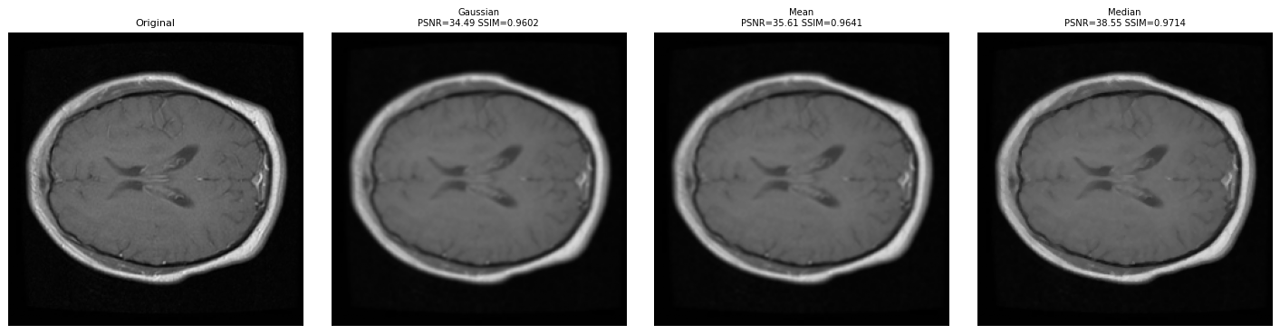
Figure 3. T1CE slice comparison.
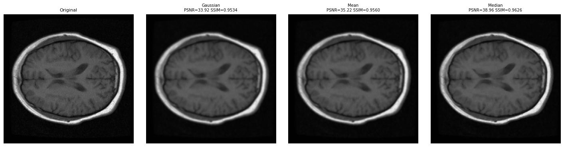
Figure 4. T1 slice comparison.
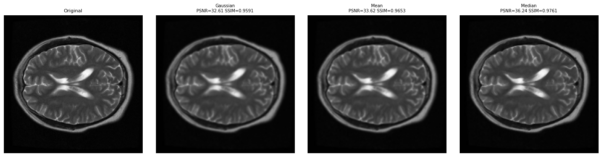
Figure 5. T2 slice comparison.
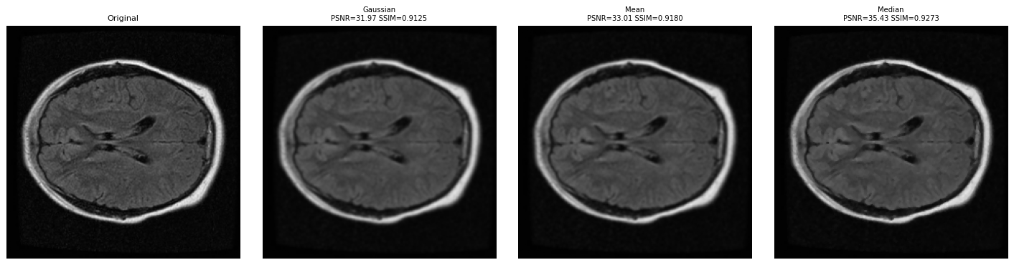
Figure 6. FLAIR slice comparison.
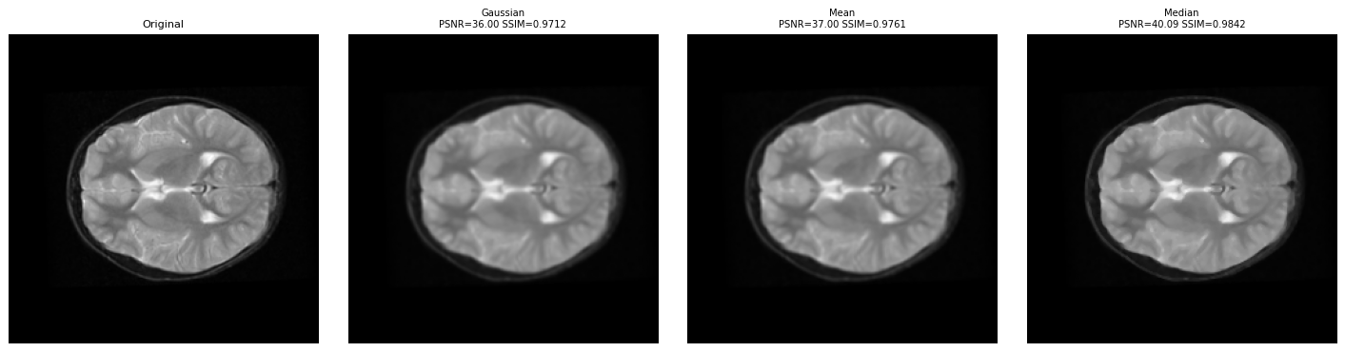
Figure 7. BraTS-PED T2-weighted slice comparison.

Discussion
From the results, the median filter performed the best overall. It gave the highest average PSNR and SSIM values. This means it changed the image less and preserved the structure better than the other two filters. This also makes sense visually, because median filtering removes small noise while keeping edges sharper.
The mean filter also smoothed the images, but it blurred some details because it simply averages nearby pixels. The Gaussian filter gave smoother results, but in this experiment it had lower average PSNR and SSIM than the median filter.
It is important to note that PSNR and SSIM compare the filtered image with the original image. So, a higher value means the image stayed closer to the original. It does not automatically mean that the filtered image is always better for medical diagnosis.

Conclusion
This assignment showed how basic filters affect MRI images. The notebook successfully loaded the dataset chunk, selected slices, normalized them, applied three filters, saved the outputs, and calculated PSNR and SSIM. Based on both the numbers and the visual results, the median filter was the best option in this experiment.

References
- BraTS-PEDs dataset from The Cancer Imaging Archive: https://www.cancerimagingarchive.net/collection/brats-peds/
- Kaggle dataset used in code: awansaad6797/cancer-dataset
- SciPy ndimage documentation for image filters.
- scikit-image documentation for PSNR and SSIM.

