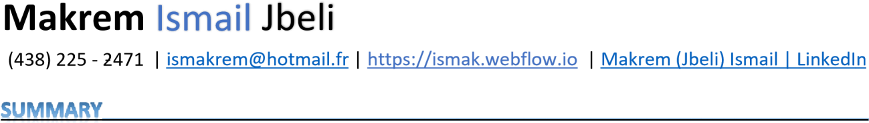

Highly motivated professional offering proficiency in Web Development combined with strong mathematical and analytical thinking skills. Fast learner and committed to continuous, self-directed learning. Well-coordinated and decisive programmer with profound knowledge in problem-solving, and performance optimization. A SOLID history of success in developing and maintaining best practices for successful Full-stack and high-volume e-commerce applications. Great interest in working in the AI industry.



# Web Developer Jan 2022

## Amir Food-Chain

* Developed and maintained the web platform using Figma, ReactJS, Stripe, Tailwind CSS, and Netlify
* Implemented user authentication with Firebase to secure the website
* Utilized Firebase as a database to store the menu items and customer information
* Designed and implemented the website's user interface and interactions with ReactJS and Tailwind
* Integrated payment functionality using Stripe to enable secure and convenient online transactions
* Deployed the website on Netlify to ensure seamless and efficient performance for users

# Programmer-Analyst Jan 2022

## Freelancer

* Developed full stack mobile applications based on clean architecture using Android studio featuring Kotlin, SQLite, and Dagger-Hilt DI
* Built several web applications using OOP MVC PHP
* Optimized the communication protocols between the server and the web applications
* Optimized the overall reliability and efficiency of each project

# Programmer-Analyst Intern Nov 2022

## Rahma Auto Luxury

* Conducted research and analyzed market trends to identify potential customer
* Utilized Figma for design and wireframing
* Developed and maintained the website using HTML, CSS, JavaScript, and Tailwind CSS
* Integrated payment methods using Stripe
* Deployed and hosted the website on Netlify
* Conducted regular testing and debugging to ensure website functionality and performance
* Implemented search engine optimization (SEO) strategies to improve website ranking

# Software Engineer Intern May 2019

## Tunisian Company of Electricity and Gas

* Monitored and maintained IT infrastructure including networks, servers, and the cloud services
* Designed user friendly graphic interface that fits the company standards
* Improved the database architecture and optimized the information storage with SQL/SQLite
* Reviewed the code written by my teammates and offered different suggestions



Angular HTML5 C++ Wordpress

ReactJs CSS3/TailWind JAVA Webflow NextJS JavaScript/Typescript Kotlin GitHub



**Programmer Analyst**  **2020-2023**  ***CDI College***

# Computer Engineering 2015-2019

## Mediterranean Institute of Technology (Tunisia)



# Modern Full stack Android Application

* Followed The Clean architecture guidelines to build a SOLID scalable and testable Kotlin Application
* Designed responsive screens using jetpack compose declarative User Interface
* Implemented Dependency injection with Dagger-Hilt and local cashing with Room Library

# School Management System

* Implemented OOP PHP MVC for back-end
* Managed the project responsiveness using JS/AJAX
* Used Bootstrap templates to design the front-end

# Car Repair Website

* Developed a user-friendly and responsive landing page using HTML, CSS3, and Bootstrap.
* Implemented a responsive design using Bootstrap, ensuring optimal viewing on various devices.
* Incorporated a functional contact form to capture leads and inquiries.
* Optimized the page for search engines with descriptive page titles and meta descriptions.