Abdul Munim Zahid

Data Visualization

Project 1 January 17th, 2018

Visualizing the Integrated Postsecondary Education Data System (IPEDS) which is available via the National Center for Education Statistics. As an international student myself, who not so long ago had to choose a university, I was curious to look at the data behind the American universities. We will use this data sets to look at some of the interesting facts about Universities in the Unites States and answer some questions.

I have wondered for a long time why some universities have a very high number of international students (non-resident alien) compared to some universities where the enrollment of international student is almost negligible.

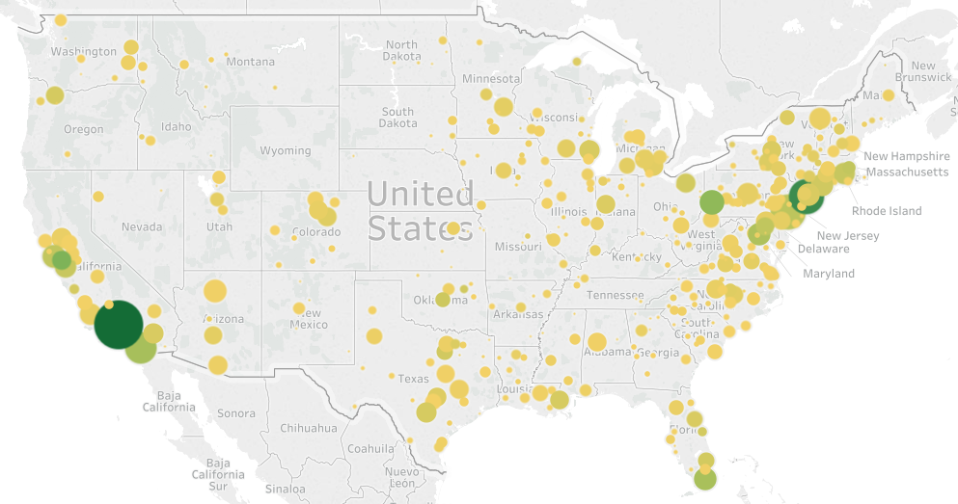

In this graph, intensity of the green color shows the percentage of foreign students enrolled whereas the size of the dot shows the total number of students enrolled. Greener shades indicate more foreign students and larger dots indicate higher enrollment.

Immediately from the graph it is clear there’s positive linear relationship with the size (i.e. total number of enrolled students) of the university and the percent of enrolled students which are non-resident alien. So, International students tend to go to bigger universities. I always suspected that International students generally go to universities which are in famous cities/areas in pop culture. Los Angeles in California, New York area, Chicago and Miami-Dade are some of the most famous parts of United States and according to my hypothesis they should have large international student population. However, according to our data, a clear outlier here is Chicago. Which shows another aspect of foreign student’s university preference; Security is a big concern. Especially when you are moving to a new place!Furthermore, we can see from our map that International students prefer to live near beaches/sea (eg.: Miami, California, New York Area).

When I realized I will visualize university data, I immediately knew I wanted to see how the tuition of a university varies with respect to the total student enrollment in the university. My initial guess was that as students (demand) increase, the tuition fee(cost) increases.

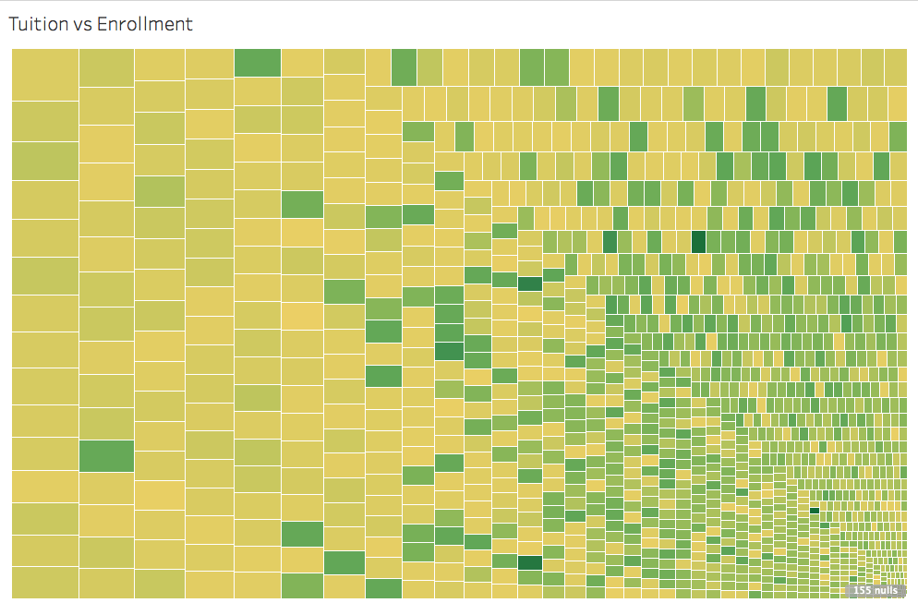

Here’s a tree map of the cost of tuition in a university vs the size of the university. This visualization shocked me in two distinct ways. Not only was I totally wrong to think that increased demand would increase the cost of university education (normal business rules do not apply to universities!), the inverse of that; universities which are very small in size aren’t that much more expensive. In fact, there are many universities which are around 20 times smaller than the largest universities in the states and have around the same tuition costs as them. The tuition fee is actually directly proportional to three main factors; location (eg: New York University costs more than University of Florida), Status (Eg: big names like Vanderbilt University, Wheaton College costs more) and the category (eg: State University vs Private University).

Lastly, I was curious to see what makes a university more prestigious and attractive to students. Or what variable directly and positively effects the enrollment in a university. While I suspected that the universities which offer advanced degrees will be more desirable to students, the preciseness of the data shocked me.

Here’s a pie chart of the amount of students enrolled vs the level of education that the university provides.

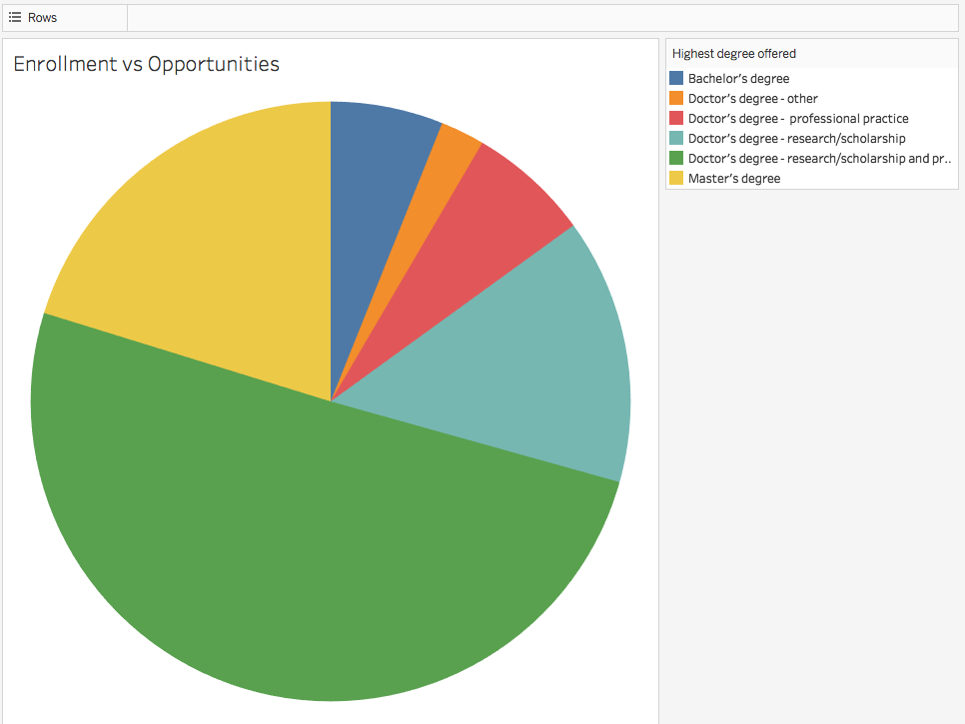

The dark green color represents the students enrolled in a university which offers doctor’s degree along with research/ scholarship AND professional practice. This was unexpected. A university which offers a PhD along with research/scholarship, professional experience and opportunities had almost triple the number of enrolled students when compared to a university which just offered a PhD. This shows that students prefer professional experience and having a good graduate level program can massively increase the popularity of the university.