Supplementary Material
Supplementary results for the ZhiRun edge-cloud fertigation system. These tables and figures are excluded from the main-manuscript table/figure count and preserve the full robustness and iteration records.

Appendix A. Runtime decision and execution algorithm
The following ordered procedure defines the boundary between model inference and physical execution.
A1. Trigger. Start a decision cycle from the daily 12:00 scheduler or an authenticated manual request. Record trigger source, crop, date, area and current device identifier.
A2. Snapshot validation. Reject automatic execution if the timestamp is stale or a critical soil field is missing or invalid.
A3. Optional-context recovery. Substitute only current regional weather fallback values and mark their source.
A4. Policy inference. Construct the validated feature vector, infer targets and apply all operational bounds.
A5. Execution gate. Require an executable decision, an enabled execution path, an online edge device, a current command and no active fault.
A6. Fertilizer dosing. Stop each N/P/K channel on its own incremental flow target; stop all outputs on any safety fault.
A7. Outlet transfer. Release the outlet only after every requested fertilizer channel has completed and log the terminal state.

Appendix B. Reproducibility manifest
B1. Configuration files define crop calendars, nutrient budgets, hardware mappings and sensor payloads.
B2. NASA POWER weather data, source metadata, the training script, fitted model and metrics are retained in the repository.
B3. Ablation, iteration, controller simulation, figure and document scripts rebuild the reported results.
B4. Training uses 2015-2022, validation uses 2023 and independent testing uses 2024-2025. Production seed is 42; repeated runs use 11, 23, 37, 53 and 71; controller simulation uses 20260908.
B5. Repository revision identifiers should be included in the final data-availability statement.

Appendix C. Sensor and actuator semantics
C1. Soil moisture, pH and measured N/P/K are direct critical inputs from one soil probe; missing or invalid values block automatic execution.
C2. Air and soil environment values are logged when available; tipping-bucket rain requires site calibration and debounce handling.
C3. Forecast rain, radiation, ET0 and accumulated weather features are server-derived context, not local sensor readings.
C4. IDLE, DOSING, OUTLET_TRANSFER, COMPLETE and FAULT/STOPPED define mutually constrained relay states.
C5. Relay-on is an electrical command; delivered volume is incremental flow since the work-order baseline divided by calibrated pulses per litre.
Supplementary Table S1. Optional-weather masking stress test on the independent test set.
Stress test | Fields replaced | Decision agreement | Changed decisions | Agreement with teacher
Optional-weather masking | wind, rain_today, rain_next_2d | 0.8526 | 1,061 / 7,200 | 0.7975

Supplementary Table S2. Large-sample controller safety simulation using the production state machine.
Scenario group | n | Primary outcome | Observed result
Random normal work orders | 10,000 | Completed without safety timeout | 9,920 (99.2%)
Random normal work orders | 10,000 | Outlet-fertilizer overlap | 0 (0.0%)
Random normal work orders | 10,000 | Premature nutrient stop | 0 (0.0%)
Random normal work orders | 10,000 | All outputs OFF at terminal state | 10,000 (100%)
Single-channel no-flow fault | 2,000 | Fault detected and all outputs OFF | 2,000 (100%)
Emergency stop during dosing | 2,000 | Fault detected and all outputs OFF | 2,000 (100%)

Supplementary Table S3. Feature ablation and transparent soil-moisture reference on the independent test set.
Method | Removed or rule | Water MAE | Water R2 | N R2 | P2O5 R2 | K2O R2 | Decision accuracy
Full ExtraTrees policy | None | 0.4599 | 0.9805 | 0.9230 | 0.9254 | 0.9576 | 0.9317
No weather features | 15 weather variables | 4.8725 | 0.4138 | 0.6070 | 0.6457 | 0.5731 | 0.8003
No soil features | 9 soil variables | 2.9602 | 0.8352 | 0.8517 | 0.8704 | 0.9001 | 0.5932
No crop-stage features | 11 crop/stage/budget variables | 0.4620 | 0.9807 | 0.8806 | 0.8914 | 0.8850 | 0.9250
Soil-moisture threshold + mean dose | Measured trigger only; no fertilizer | 4.7158 | 0.1417 | -0.0695 | -0.0570 | -0.0320 | 0.8194

Supplementary Table S4. Sensitivity of irrigation-event classification to the model-output threshold.
Model threshold (m3 mu-1) | TN | FP | FN | TP | Precision | Recall | F1 | Specificity
0.1 | 3,645 | 1,361 | 0 | 2,194 | 0.6172 | 1.0000 | 0.7633 | 0.7281
0.5 | 4,514 | 492 | 0 | 2,194 | 0.8168 | 1.0000 | 0.8992 | 0.9017
1.0 | 4,749 | 257 | 0 | 2,194 | 0.8951 | 1.0000 | 0.9447 | 0.9487
2.0 | 4,884 | 122 | 0 | 2,194 | 0.9473 | 1.0000 | 0.9729 | 0.9756

Supplementary Table S5. Repeated learning-curve results on the fixed 2023 validation set.
Training fraction | Rows | Runs | Decision accuracy | Water MAE | Water R2 | Nutrient macro R2
10% | 2,880 | 5 | 0.8666 +/- 0.0037 | 0.7593 +/- 0.0175 | 0.9730 +/- 0.0016 | 0.8591 +/- 0.0130
25% | 7,200 | 5 | 0.8969 +/- 0.0039 | 0.5310 +/- 0.0056 | 0.9822 +/- 0.0009 | 0.9184 +/- 0.0032
50% | 14,400 | 5 | 0.9231 +/- 0.0069 | 0.3990 +/- 0.0135 | 0.9871 +/- 0.0007 | 0.9475 +/- 0.0019
75% | 21,600 | 5 | 0.9357 +/- 0.0053 | 0.3639 +/- 0.0074 | 0.9880 +/- 0.0006 | 0.9604 +/- 0.0024
100% | 28,800 | 5 | 0.9332 +/- 0.0044 | 0.3463 +/- 0.0167 | 0.9890 +/- 0.0011 | 0.9649 +/- 0.0012

Supplementary Table S6. ExtraTrees parameter-sensitivity iterations.
Trees | Minimum leaf | Water MAE | Water R2 | Nutrient macro R2 | Decision accuracy
100 | 1 | 0.3052 | 0.9904 | 0.9698 | 0.9372
100 | 2 | 0.3242 | 0.9888 | 0.9641 | 0.9381
100 | 4 | 0.3443 | 0.9885 | 0.9561 | 0.9278
200 | 1 | 0.3126 | 0.9902 | 0.9697 | 0.9408
200 | 2 | 0.3295 | 0.9896 | 0.9660 | 0.9347
200 | 4 | 0.3474 | 0.9886 | 0.9577 | 0.9358
350 | 1 | 0.3267 | 0.9898 | 0.9680 | 0.9394
350 | 2 | 0.3390 | 0.9893 | 0.9661 | 0.9311
350 | 4 | 0.3529 | 0.9883 | 0.9569 | 0.9386
500 | 1 | 0.3307 | 0.9897 | 0.9684 | 0.9344
500 | 2 | 0.3335 | 0.9896 | 0.9667 | 0.9358
500 | 4 | 0.3550 | 0.9886 | 0.9565 | 0.9378

Supplementary Table S7. Complete learning-curve iteration log for 25 model fits.
Training fraction | Seed | Rows | Water MAE | Water R2 | Nutrient macro R2 | Decision accuracy
10% | 11 | 2,880 | 0.7520 | 0.9739 | 0.8515 | 0.8681
10% | 23 | 2,880 | 0.7562 | 0.9724 | 0.8410 | 0.8697
10% | 37 | 2,880 | 0.7854 | 0.9741 | 0.8693 | 0.8608
10% | 53 | 2,880 | 0.7647 | 0.9705 | 0.8610 | 0.8692
10% | 71 | 2,880 | 0.7382 | 0.9742 | 0.8728 | 0.8650
25% | 11 | 7,200 | 0.5244 | 0.9824 | 0.9142 | 0.9014
25% | 23 | 7,200 | 0.5302 | 0.9829 | 0.9177 | 0.8925
25% | 37 | 7,200 | 0.5324 | 0.9828 | 0.9230 | 0.8967
25% | 53 | 7,200 | 0.5285 | 0.9822 | 0.9174 | 0.8936
25% | 71 | 7,200 | 0.5394 | 0.9808 | 0.9194 | 0.9003
50% | 11 | 14,400 | 0.3890 | 0.9873 | 0.9475 | 0.9308
50% | 23 | 14,400 | 0.3883 | 0.9881 | 0.9503 | 0.9233
50% | 37 | 14,400 | 0.4199 | 0.9863 | 0.9455 | 0.9122
50% | 53 | 14,400 | 0.3927 | 0.9867 | 0.9462 | 0.9228
50% | 71 | 14,400 | 0.4049 | 0.9873 | 0.9483 | 0.9264
75% | 11 | 21,600 | 0.3731 | 0.9871 | 0.9562 | 0.9272
75% | 23 | 21,600 | 0.3617 | 0.9881 | 0.9609 | 0.9386
75% | 37 | 21,600 | 0.3605 | 0.9881 | 0.9619 | 0.9397
75% | 53 | 21,600 | 0.3547 | 0.9888 | 0.9616 | 0.9339
75% | 71 | 21,600 | 0.3695 | 0.9877 | 0.9615 | 0.9392
100% | 11 | 28,800 | 0.3363 | 0.9898 | 0.9666 | 0.9358
100% | 23 | 28,800 | 0.3527 | 0.9888 | 0.9645 | 0.9308
100% | 37 | 28,800 | 0.3507 | 0.9889 | 0.9637 | 0.9311
100% | 53 | 28,800 | 0.3241 | 0.9902 | 0.9656 | 0.9394
100% | 71 | 28,800 | 0.3679 | 0.9873 | 0.9642 | 0.9286

Supplementary Figures
Supplementary Figure S1. Controller Monte Carlo safety evaluation across 14,000 reproducible scenarios. Normal completion excludes the 80 deliberately bounded safety timeouts; every terminal state turned all outputs off.
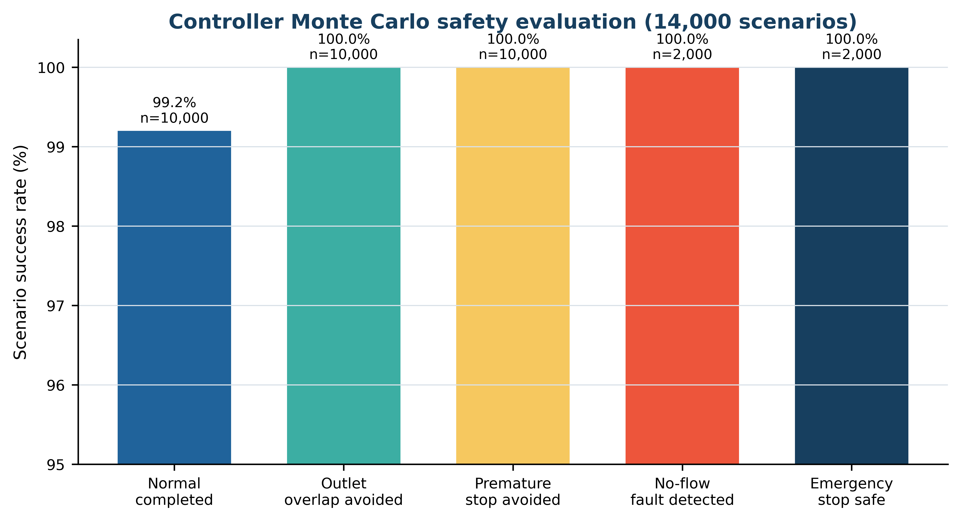
Supplementary Figure S2. Feature ablation and transparent-reference comparison. Bars show irrigation decision accuracy on the independent test years; labels are generated teacher-policy outcomes, not field treatment outcomes.
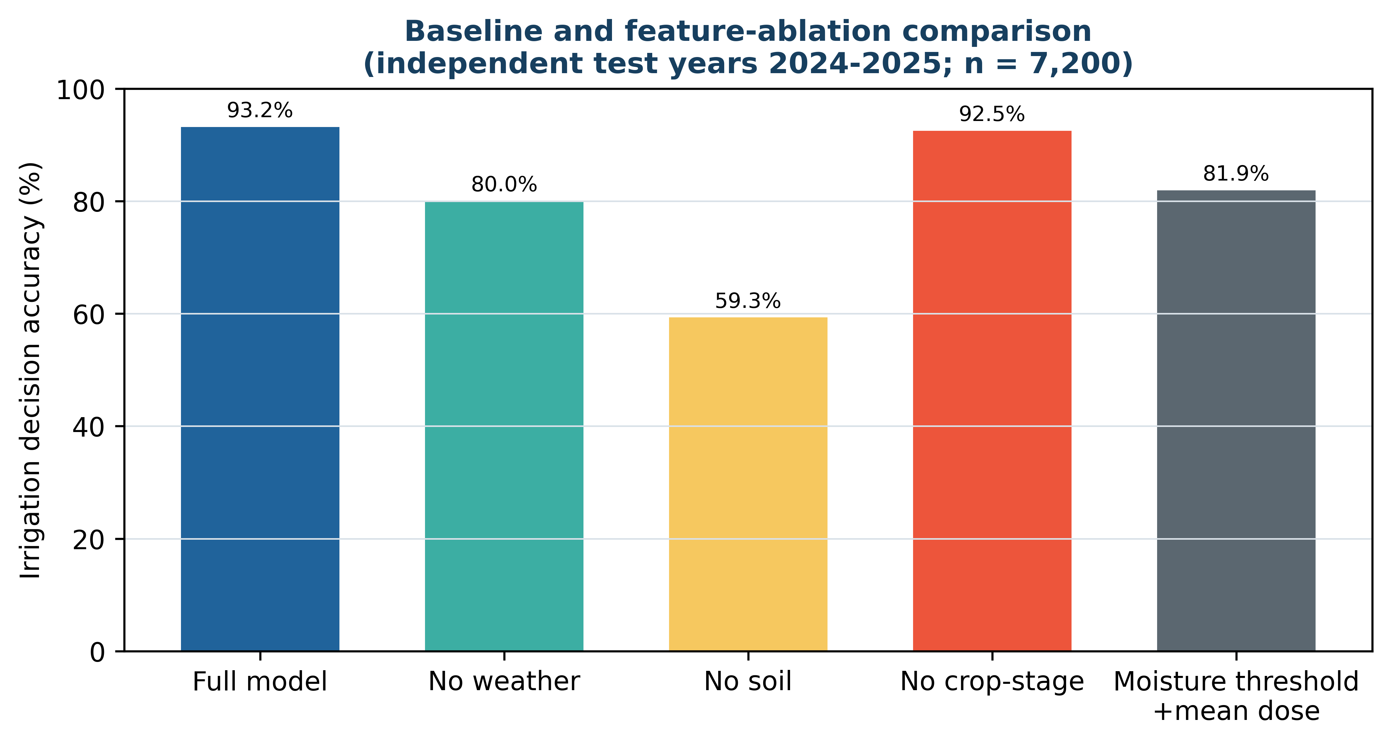
Supplementary Figure S3. Repeated learning curves over five training fractions and five random seeds. Error bars show one standard deviation; all iteration evaluations use the fixed 2023 teacher-policy validation set.
