3TP3 Lab 1

Yuyiing Lai 400268588

**Question 1:**

Result plot:

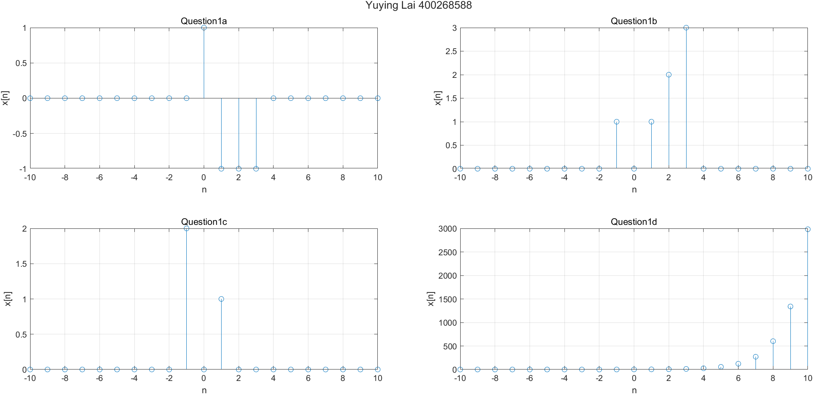

Using these two functions from SimpleFunctions.m to generate unit step and unit impulse function.

In the main matlab file, this block is used to generate required discrete time function.

Using step() to generate discrete time plot. Here is the example of one subplot. Please refer to the **appendix** for completed code.

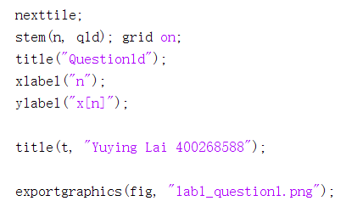

**Question 2:**

Read table and insert new column to calculate sum of lab, exam, and final. Remove the maximum mark row in temporary table d for future use.

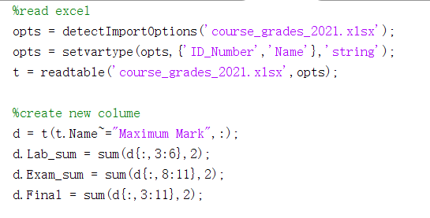

For question a to c, using max() to find the corresponding maximum mark and the index of the student. Note that for question 2b, it will not include the midterm mark in the total exam mark.

Result of question a to c will be:

For question d, use [] to combine original table t and new row.

The new table will be:

**Question 3:**

Read image and extract the matrixs of rgb channel of the image.

Multiply factor to red channel and green channel.

Combine matrix into new 1050x1680x3 matrix. Export the matrix into new picture.

Original picture and re_img comparison:

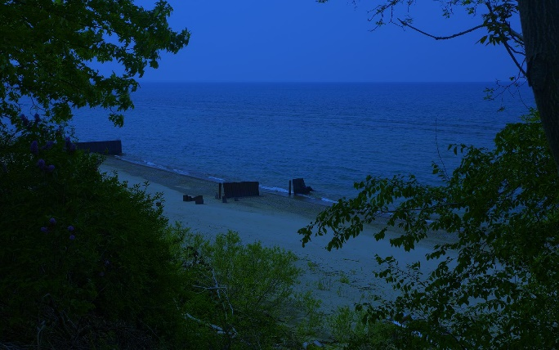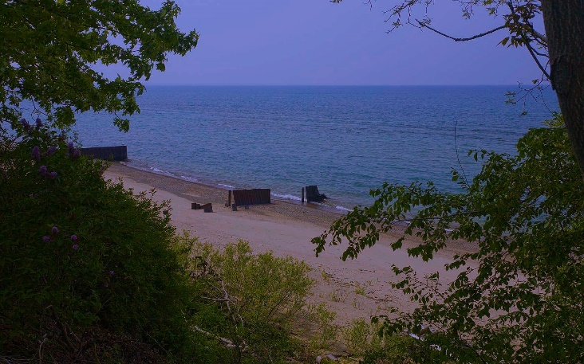

**Code:**

**Q1:**

%question 1

n = -10:10;

f=SimpleFunctions();

% function

q1a = f.unitstep(n) - 2 .* f.unitstep(n - 1) + f.unitstep(n - 4);

q1b = (n + 2) .* f.unitstep(n + 2) - 2 .* f.unitstep(n) - n .* f.unitstep(n - 4);

q1c = f.delta(n + 1) - f.delta(n) + f.unitstep(n + 1) - f.unitstep(n - 2);

q1d = exp(0.8 .* n) .* f.unitstep(n + 1) + f.unitstep(n);

% create figure

fig = figure('units', 'normalized', 'outerposition', [0, 0.08, 1, 0.9], 'Name',...

'Question 1');

t = tiledlayout(2, 2);

nexttile;

stem(n, q1a); grid on;

title("Question1a");

xlabel("n");

ylabel("x[n]");

nexttile;

stem(n, q1b); grid on;

title( "Question1b");

xlabel("n");

ylabel("x[n]");

nexttile;

stem(n, q1c); grid on;

title( "Question1c");

xlabel("n");

ylabel("x[n]");

nexttile;

stem(n, q1d); grid on;

title("Question1d");

xlabel("n");

ylabel("x[n]");

title(t, "Yuying Lai 400268588");

exportgraphics(fig, "lab1_question1.png");

**Q2:**

%read excel

opts = detectImportOptions('course_grades_2021.xlsx');

opts = setvartype(opts,{'ID_Number','Name'},'string');

t = readtable('course_grades_2021.xlsx',opts);

%create new colume

d = t(t.Name~="Maximum Mark",:);

d.Lab_sum = sum(d{:,3:6},2);

d.Exam_sum = sum(d{:,8:11},2);

d.Final = sum(d{:,3:11},2);

% Q2a

[maxlab,maxlabidx] = max(d.Lab_sum);

best_stu_lab = d(maxlabidx,:);

disp(best_stu_lab.Name+' get highest lab mark:'+maxlab);

% Q2b

[maxexam,maxexamidx] = max(d.Exam_sum);

best_stu_exam = d(maxexamidx,:);

disp(best_stu_exam.Name+' get highest exam mark:'+maxexam);

% Q2c

[maxfinal,maxfinalidx] = max(d.Final);

best_stu_final = d(maxfinalidx,:);

disp(best_stu_final.Name+' get highest final mark:'+maxfinal);

% Q2d

newrow = {'Yuying Lai','400268588',6,7,8,9,17,6,7,8,9};

t = [t;newrow];

**Q3:**

% read img

img = imread('ee3tp3picture2021.jpg');

img_r = img(:,:,1);

img_g = img(:,:,2);

img_b = img(:,:,3);

% refine rgb

img_r = img_r.*3;

img_g = img_g.*1.3;

% export

re_img = cat(3,img_r,img_g, img_b);

imshow(re_img);

imwrite(re_img,'my_fixed_image.jpg');