Elec Eng 3tp3 Lab 4

Laiy24 Yuying Lai 400268588

Part 1:

Playing the wav file, we can hear there is a signal remain in the same pitch. It is not possible to tell the shape of the signal only by human ears.

The signal if the first 5 sec is:

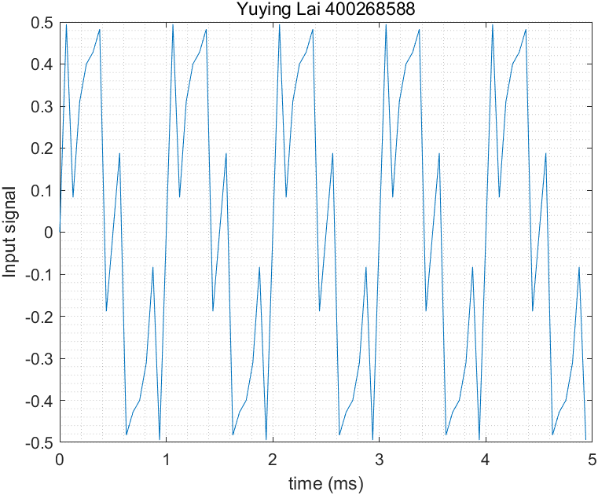

% Read in the signal from the audio filee

[signal,Fs] = audioread("tones2021.wav");

L = length(signal);

T = 1/Fs;

t = [0:L-1]*T;

% plot

t_plot = 5;

msec_per_sec = 1000;

numSample = t_plot*Fs/msec_per_sec;

plot(msec_per_sec*t(1:numSample), signal(1:numSample));

title("Yuying Lai 400268588");

xlabel("time (ms)");

ylabel("Input signal");

grid('minor');

exportgraphics(gcf, 'Part1Q1.png');

We can see a same pattern repeat every 1 ms which is 1000Hz, and during each patternWe can say there is at least 2 sin wave to made up this complicate wave. However, it is not possible to tell the exact number of sin wave and their frequency only by reading using human eyes. Therefore, we need to do Fourier transformation on this signal.

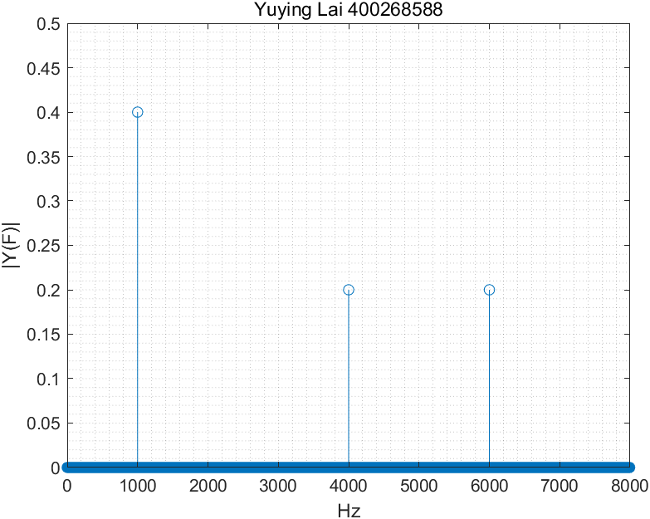

% Read in the signal from the audio filee

[signal,Fs] = audioread("tones2021.wav");

L = length(signal);

T = 1/Fs;

t = [0:L-1]*T;

% plot

t_plot = 5;

msec_per_sec = 1000;

numSample = t_plot*Fs/msec_per_sec;

result = fft(signal)/L;

f = linspace(0,1,L/2+1)*Fs/2;

stem(f,2*abs(result(1:L/2+1)));

title("Yuying Lai 400268588");

xlabel("Hz");

ylabel("|Y(F)|");

axis([0 Fs/2 0 .5]);

grid('minor');

exportgraphics(gcf, 'Part1Q2.png');

After Fourier Transformation, we see there is three frequencies have high y value. It means the input signal is made by these 3 frequency 1000Hz, 4000Hz, and 6000Hz. The y value in this port will be the amplitude of sin wave at corresponding frequency.

The completed formula will be

$$y=0.4\sin\left(2π*1000t\right)+0.2\sin\left(2π*4000t\right)+0.2sin⁡(2π*6000t)$$

If we manually generate a wave using this formula, we will get the exact same wave as the input.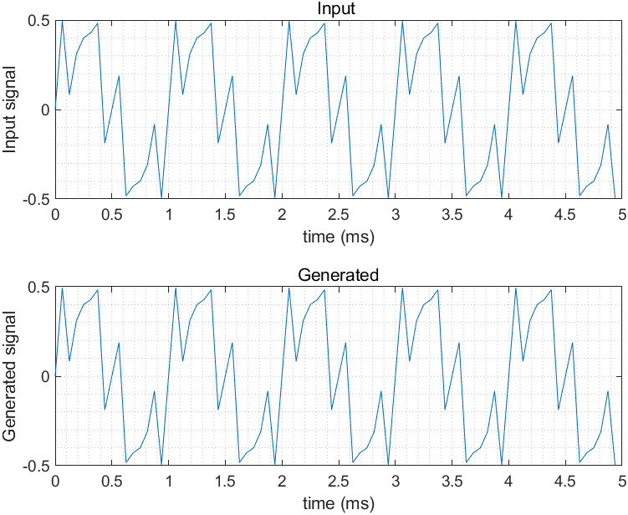

Therefore, Fourier Transformation can be used to determine the amplitude and frequency of each sin wave that made up the result wave.

% Read in the signal from the audio filee

[signal,Fs] = audioread("tones2021.wav");

L = length(signal);

T = 1/Fs;

t = [0:L-1]*T;

% plot

t_plot = 5;

msec_per_sec = 1000;

numSample = t_plot*Fs/msec_per_sec;

sin1 = 0.4*sin(2*pi*1000*t);

sin2 = 0.2*sin(2*pi*4000*t);

sin3 = 0.2*sin(2*pi*6000*t);

result = sin1+sin2+sin3;

title(t, 'Yuying Lai 400268588');

tiledlayout('flow');

nexttile;

plot(msec_per_sec*t(1:numSample), signal(1:numSample));

title("Input ");xlabel("time (ms)");ylabel("Input signal");

grid('minor');

nexttile;

plot(msec_per_sec*t(1:numSample), result(1:numSample));

title("Generated");xlabel("time (ms)");ylabel("Generated signal");

grid('minor');

exportgraphics(gcf, 'Part1Q3.png');

Part 2:

The original wav file contains too much frequency wave, and it is not possible to determine its pitch or tone only by human ears.

Plot for 40 seconds are: To make sure the four max frequencies are visible, an amplitude of 1000 will be times to the FFT result.

To decode this, we will use Fourier Transformation to get 4 frequencies with highest FFT value in each second. Then we will match the 4 frequencies to see which letter it represents. After we decoded 40 second, we will get “**TO BE OR NOT TO BE THAT IS THE QUESTION.”**

% Read in the signal from the audio filee

[signal,Fs] = audioread("SecretMessage2021.wav");

L = length(signal);

T = 1/Fs;

t = [0:L-1]*T;

resultF = zeros(40,4);

result = "";

sample_second = L/40;

f = linspace(0,1,sample_second/2)*Fs/2;

title(t, 'Yuying Lai 400268588');

tiledlayout('flow');

second = 0;

% plot

for i = sample_second:sample_second:L

Y = fft(signal(i-sample_second+1:i))/L ;

% extract the highest 4

[A,B] = maxk(abs(Y(1:sample_second/2)),4);

resultF(second+1,:) = B-1;

second = second+1;

%plot

nexttile;

stem(f,1000*abs(Y(1:sample_second/2)));

title("Plot");

xlabel("Hz");

ylabel("|Y(F)|");

axis([0 Fs/2 0 .5]);

grid('minor');

end

exportgraphics(gcf, 'Part2Spe.png');

% sort

resultF = sort(resultF,2);

for i = 1:40

if resultF(i, :) == [1000, 2000, 3000, 4000]

result = strcat(result, "A");

elseif resultF(i, :) == [1000, 2000, 3000, 5000]

result = strcat(result, "B");

elseif resultF(i, :) == [1000, 2000, 3000, 6000]

result = strcat(result, "C");

elseif resultF(i, :) == [1000, 2000, 3000, 7000]

result = strcat(result, "D");

elseif resultF(i, :) == [1000, 2000, 4000, 5000]

result = strcat(result, "E");

elseif resultF(i, :) == [1000, 2000, 4000, 6000]

result = strcat(result, "F");

elseif resultF(i, :) == [1000, 2000, 4000, 7000]

result = strcat(result, "G");

elseif resultF(i, :) == [1000, 2000, 5000, 6000]

result = strcat(result, "H");

elseif resultF(i, :) == [1000, 2000, 5000, 7000]

result = strcat(result, "I");

elseif resultF(i, :) == [1000, 2000, 6000, 7000]

result = strcat(result, "J");

elseif resultF(i, :) == [1000, 3000, 4000, 5000]

result = strcat(result, "K");

elseif resultF(i, :) == [1000, 3000, 4000, 6000]

result = strcat(result, "L");

elseif resultF(i, :) == [1000, 3000, 4000, 7000]

result = strcat(result, "M");

elseif resultF(i, :) == [1000, 3000, 5000, 6000]

result = strcat(result, "N");

elseif resultF(i, :) == [1000, 3000, 5000, 7000]

result = strcat(result, "O");

elseif resultF(i, :) == [1000, 3000, 6000, 7000]

result = strcat(result, "P");

elseif resultF(i, :) == [1000, 4000, 5000, 6000]

result = strcat(result, "Q");

elseif resultF(i, :) == [1000, 4000, 5000, 7000]

result = strcat(result, "R");

elseif resultF(i, :) == [1000, 4000, 6000, 7000]

result = strcat(result, "S");

elseif resultF(i, :) == [1000, 5000, 6000, 7000]

result = strcat(result, "T");

elseif resultF(i, :) == [2000, 3000, 4000, 5000]

result = strcat(result, "U");

elseif resultF(i, :) == [2000, 3000, 4000, 6000]

result = strcat(result, "V");

elseif resultF(i, :) == [2000, 3000, 4000, 7000]

result = strcat(result, "W");

elseif resultF(i, :) == [2000, 3000, 5000, 6000]

result = strcat(result, "X");

elseif resultF(i, :) == [2000, 3000, 5000, 7000]

result = strcat(result, "Y");

elseif resultF(i, :) == [2000, 3000, 6000, 7000]

result = strcat(result, "Z");

elseif resultF(i, :) == [2000, 4000, 5000, 6000]

result = strcat(result, " ");

elseif resultF(i, :) == [2000, 4000, 5000, 7000]

result = strcat(result, ".");

end

end

% Display message

result