Mental Health in the Technology Industry
Analysis of survey data from employees in the technology industry
Isabella Castellano (Author)

IU Luddy School of Informatics, Computing, & Engineering Undergraduate in Bioinformatics
Indianapolis, Indiana
isacaste@iu.edu

Abstract— The purpose of this project is to see how certain attributes affect the mental health of employees in the workplace within the IT field. Our approach will utilize decision trees due to all the data being categorical. The end goal of our study is to show whether the lack of mental health resources provided by employers and positive attitudes toward bettering the employees is true or not.
Index Terms— mental health, IT, workplace

Introduction
We will be analyzing a survey-based data set regarding mental health status among technology-based employees. Our dataset is made up of mostly categorical data with the attributes being different questions about attitudes & settings regarding mental health in the workplace. We will be utilizing R programming to create different decision trees to predict what the outcome with be based on different attributes.
This data set was ideal for us because of its vast size and complexity as well as pertaining to topics that are of interest to us. We wanted to work with something that we found interesting and related to the health care field. It explores topics that we value such as mental health and the stigma around it. It also relates to the field we hope to work in some day. This dataset also provides insight as to what may be in store day-to-day in our future careers.
After deciding on what dataset to use, our next steps were to create a hypothesis we could work with and that we were equally curious about. We then needed to clean the data to be fit for mining. This involved different approaches such as deleting attributes and so on. Next, we needed to find the appropriate approach to performing our analysis. With our collaboration and the help of our professor we decided on creating decision trees. We then could begin diving into our analysis by creating some preliminary conclusions and taking steps to finalize our finished project.

Decision Tree
In R, a decision tree is an algorithm for classification and regression tasks, represented graphically with nodes for decisions based on input variables. Through recursive splitting, it divides the dataset into subsets, minimizing impurity or maximizing information gain at each step. Terminal nodes, or leaf nodes, provide final predictions. Implemented through packages like "rpart" or "tree," decision trees offer options for pruning to combat overfitting. Using functions like `rpart()` or `tree()`, we can build and fine-tune decision tree models, enabling accurate predictions on new data.

Objective
Analyzation of data statistics is both essential to interpreting information and obtaining a better understanding of given data or to implement strategies for an issue if necessary. Our objective is to use R to observe any correlation between the negative consequences of reaching out about mental health, mental health resources not being available, the willingness of employees to seek out help for their own mental health and other factors. If we were applying this to a real-world situation, our observations could help to create change or implementation that may be needed in the workplace. According to Mitravinda, there are an “alarming number of people living with mental illnesses”. When it comes to mental health in the workplace, survey data is an excellent resource to gauge the state of workers and to possibly improve the wellbeing of employees. The dataset we will be working with is a survey of mental health from employees that work mostly in the technology industry. This dataset was created by Open Sourcing Mental Illness to measure attitudes towards mental health within the tech workplace.

Dataset Information
The data that we will be analyzing has many different attributes and will come from a set that is surveying individuals working in the tech industry and their background regarding their mental health. In the data set there are 27 attributes with 1259 entries. There is demographic data including age, gender, and the location of where the applicant is from. There are many yes /no questions that are included in the survey such as “Do you have a family history of mental illness?” or sometimes/often/never questions such as “Does mental illness interfere with your work?”. These questions ask dynamic questions that can’t be answered by a Boolean value. There were some columns that contained inconsistent, missing values that needed to be handled.

Hypothesis
Our hypothesis surrounds the idea that the attributes about mental illness will affect if it interferes with the employee’s work. Our null hypothesis is that a lack of resources and poor treatment of employees who speak out about mental health does not negatively impact the mental wellness of employees. Our alternate hypothesis is that a lack of resources and poor treatment of employees who speak out about mental health do negatively impact the mental wellness of employees. The attribute, “work_interfere”, asks if mental health interferes with the employee’s work with answers being never, rarely, sometimes, and often. This will be our determining factor in our analyzation. For the null hypothesis to be true, most of the answers from the trees would need to be never & rarely. For the alternative hypothesis to be true most of the answers from the trees would need to be mostly sometimes & often. This is what we are basing our hypothesis on. Given the high pressure of working in the tech industry, as well as a stigma around mental health, these may result in worsened states for employees. Working long hours while having to meet deadlines and not being provided with any resources for mental health could prevent employees from reaching out for help. According to Kendra Cherry MSeD, having social support in the workplace is important to maintain a strong and healthy mental attitude among employees. This may be significantly worse with lack of resources or seeing backlash for those who speak out about it for. Given all this information we stand by our presumption that these key factors could play a key role in the impact on the wellbeing of employees.

Data Set
The original dataset contained 27 attributes and we decided to keep 14 as we felt they were the most relevant to achieving our objective. The attribute “work_interfere” will be our root node for the decision trees. We will see how the other workplace attributes affect the employee’s mental health. Listed below are each attribute and their answer options in parentheses.

Attributes
work_interfere: If you have a mental health condition, do you feel that it interferes with your work? (never, rarely, sometimes, often)
family_history: Do you have a family history of mental illness? (no, yes)
treatment: Have you sought treatment for a mental health condition? (no, yes)
benefits: Does your employer provide mental health benefits? (no, yes, don’t know)
care_options: Do you know the options for mental health care your employer provides? (no, yes, not sure)
wellness_program: Has your employer ever discussed mental health as part of an employee wellness program? (no, yes, don’t know)
seek_help: Does your employer provide resources to learn more about mental health issues and how to seek help? (no, yes, don’t know)
anonymity: Is your anonymity protected if you choose to take advantage of mental health or substance abuse treatment resources? (no, yes, don’t know)
leave: How easy is it for you to take medical leave for a mental health condition? (very difficult, somewhat difficult, somewhat easy, very easy, don’t know)
mental_health_consequence: Do you think that discussing a mental health issue with your employer would have negative consequences? (no, yes, maybe)
coworkers: Would you be willing to discuss a mental health issue with your coworkers? (no, yes, some of them)
supervisor: Would you be willing to discuss a mental health issue with your direct supervisor(s)? (no, yes, some of them)
mental_health_interview: Would you bring up a mental health issue with a potential employer in an interview? (no, yes, maybe)
mental_vs_physical: Do you feel that your employer takes mental health as seriously as physical health? (no, yes, don’t know)
obs_consequence: Have you heard of or observed negative consequences for coworkers with mental health conditions in your workplace? (no, yes)

Methodology
Our first task was to get rid of attributes we felt wouldn’t contribute to our goal findings. We did this by creating a vector of attributes that would be excluded from the dataset. After this we were left with strictly categorical data. From here we took our altered dataset and used the na.omit() function to delete all missing values. After this we were still left with 995 entries, meaning there were only 264 out of 1259 entries with missing values.
The data mining technique that was utilized was a decision tree model. The reasoning behind this is because of all the categorical data attributes, which our professor had recommended would be a good idea because they make up most of our attributes. Many of them have values such as yes, no, don’t know, sometimes, and others like this. Utilizing a decision tree model will allow us to observe which attributes affect the root node the most.
For all the trees we made the attribute “work_interfere” the root node and added other attributes to the formula. As previously mentioned, this attribute will be our determining factor in seeing how the other attributes affect the mental state of employees int he workplace. Using the table() function for this attribute we can see how many of each answer there is. The answer “sometimes” has the most entries followed by “never”, “rarely”, and “often” having the least number of p entries. In an ideal workplace the answers would mostly be never or rarely.
Continuing with our analysis we intend to explore more into how other combinations of other attributes affect the attribute “work_interfere”. With this we can uncover potential correlations into factors explaining how these mental health challenges in the workplace occur. We aim to develop a comprehensive understanding of how the complex dynamic of mental health plays a role in the workplace.

Preliminary Analysis
After completing some basic analysis of our data set, we focused on understanding the frequency and severity of work interference due to mental health issues. Our initial examination revealed that 46%, a significant portion, of respondents reported that mental health sometimes affects their work, indicating a prevalent issue deserving attention. Through the table() function, we scrutinized the distribution of responses for this attribute, observing variations in the extent to which mental health impacts work duties among respondents. This finding underscores the complexity of the relationship between mental health and work performance, motivating further investigation into the contributing factors and potential interventions.
Delving deeper into the data, we utilized the “work_interfere” attribute as the root node in our decision tree model, given its direct relevance to our research question. This preliminary insight serves as a foundation for exploring additional attributes and their interactions with “work_interference”, with the aim of explaining underlying patterns and informing targeted interventions. The first decision tree we were able to produce had the following formula: “family_history + treatment + remote_work + mental_vs_physical + obs_consequence + care_options”. Below is an image of the tree. The combination of the attributes was simply random, just to test out the code with the data. Our tree was not yet ideal, but we experimented with the seed number, test, and training data to determine what needed to be changed to achieve a more ideal tree. We also planned to experiment with other attributes and produce multiple trees and see how they interact with each other.
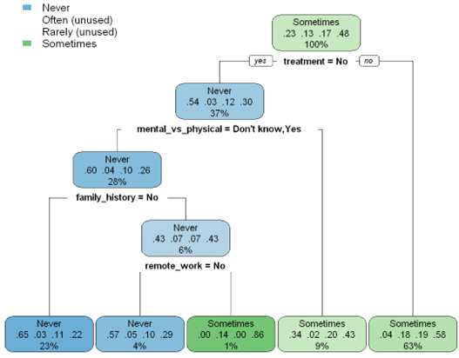
Aside from just looking at our dataset, it is also important to do some preliminary research regarding the topic of mental health in the workplace. Declining mental health status is something all kinds of careers are facing, which is why we chose this topic. According to the Bureau of Labor Statistics, “over one-third of US workers are experiencing symptoms related to depression or anxiety.” This seems to be a very pressing matter; stressful mental conditions would make working more difficult than normal and may result in poor performance. Being able to gauge the conditions from the perspective of employees can provide insight to help create a better environment and mental conditions for employees. From this data a plan can be developed to implement outreach and resources for employees to utilize and create healthy working conditions.

Results
After creating 10 trees that we felt were sufficient to analyze we were able to calculate what values were most present in the trees. Each tree uses the root node “work_interfere” and determines the most significant attributes found in relation to whether someone finds their mental health status interfering with their work. Each tree section contains a table for the final answers for “work_interfere” with the values “never & rarely” and “sometimes & often” being grouped together. The group with the highest percentage is underlined.

Tree 1
The first decision tree model was created with a formula “family_history + treatment + remote_work + mental_vs_physical + obs_consequence + care_options”, which analyzes each attribute to find what creates a higher instance with the root node “work_interfere”. Once the plot is created, we can visualize that if someone does not receive treatment, there is a higher likelihood that someone participates in remote work more than 50% of the time, is aware of care options offered, and that their employer does not take mental health as seriously as physical health.
Answers |  | Total
Never | 28% | 36%
Rarely | 8%
Sometimes | 65 | 65%
Often | 0%

Tree 2
The second decision tree was formed around the formula “work_interfere ~ family_history + obs_consequence + care_options + mental_health_consequence” which is analyzing the same root node.
Answers |  | Total
Never | 19% | 19%
Rarely | 0%
Sometimes | 82 | 82%
Often | 0%

Tree 3
The third decision tree was created with the following formula “obs_consequence + mental_health_consequence + leave + wellness_program + family_history + seek_help”. This tree utilized a few more attributes, and the most significant ones would include seeking help and mental health consequences.
Answers |  | Total
Never | 7% | 7%
Rarely | 0%
Sometimes | 88% | 93%
Often | 5%

Tree 4
The fourth tree utilized this formula “obs_consequence + mental_health_consequence + leave + wellness_program + family_history + seek_help”. This tree introduces the wellness program attribute which asks the respondents if they are offered a wellness program through their employer.
Answers |  | Total
Never | 10% | 13%
Rarely | 3%
Sometimes | 87% | 87%
Often | 0%

Tree 5
The fifth tree utilized the formula of “benefits + seek_help + leave + anonymity + supervisor + mental_vs_physical + family_history” which introduces the attributes of benefits and if they would feel comfortable speaking to their supervisor about their mental health.
Answers |  | Total
Never | 28% | 31%
Rarely | 3%
Sometimes | 70% | 70%
Often | 0%

Tree 6, 6.1 & 6.2
These trees all had the same formula, “help + leave + anonymity + supervisor + mental_vs_physical + family_history” but had different seed numbers. Tree 6 seed was 144, while tree 6.1 had the seed 1334, and tree 6.2 had the seed 144444.

Tree 6
Answers |  | Total
Never | 20% | 20%
Rarely | 0%
Sometimes | 81% | 81%
Often | 0%

Tree 6.1
Answers |  | Total
Never | 18% | 18%
Rarely | 0%
Sometimes | 78% | 81%
Often | 3%

Tree 6.2
Answers |  | Total
Never | 29% | 29%
Rarely | 0%
Sometimes | 72% | 72%
Often | %

Tree 7 & 7.1
These trees both had the same formula, which was every attribute. We were curious to see how the tree would turn out by just plugging everything in. The difference between these trees is their seed numbers, like trees 6-6.2. However, we ran tree 7.1 without a seed number, as it is not required. This tree is the most comprehensive as it automatically created the splits and removed the redundant nodes to show an accurate display of how often the mental health of employees interfered with their work and includes an answer choice for each option in “work_interfere”.

Tree 7
Answers |  | Total
Never | 29% | 32%
Rarely | 3%
Sometimes | 66% | 69%
Often | 3%

Tree 7.1
Answers |  | Total
Never | 22% | 31%
Rarely | 9%
Sometimes | 62% | 69%
Often | 7%

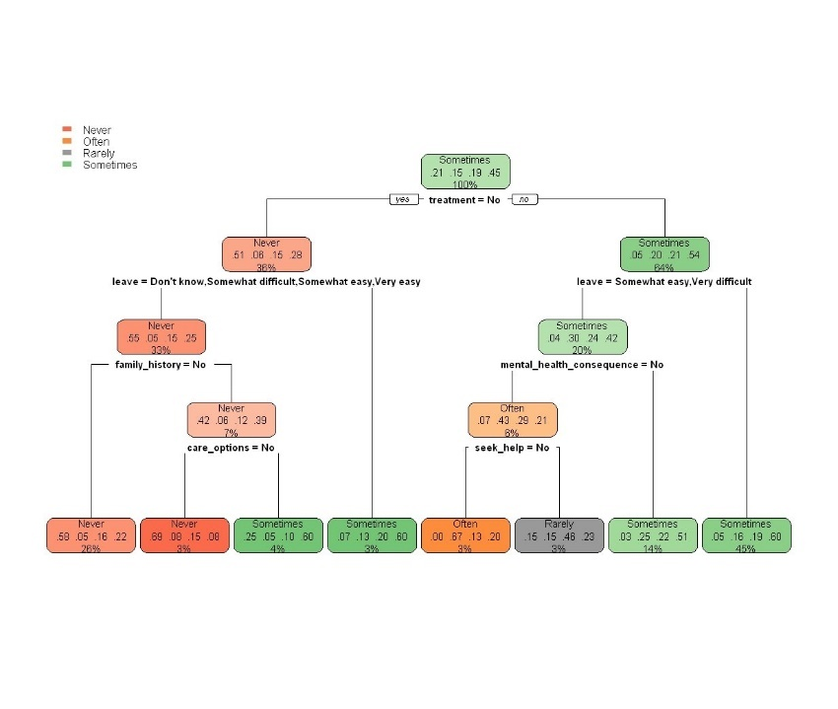

Issues Encountered
Our main issue with the trees was not being able to get all four answers for the attribute “work_interfere”. We typically could get two to three out of the four answers. We delegated this by changing the seed number and formulas. The seed number is simply to save the randomization of the order that the choices the tree will make, running the code without a seed number will allow R to create its own randomness. Because of all these factors, there was a significant amount of time spent experimenting with, without the numbers, and changing each formula. Also, because the seed number is technically not necessary, we also ran each created without the seed number.
We also debated on forcing the attribute the tree would split on and possibly trying to create a multi-way split. However, our results were not as sufficient as using a binary split, only achieving one to two out of the four answers for “work_interfere”. In retrospect a binary split is typically the most sufficient for decision trees.

Final Analysis
The most conclusive and informative decision tree that was formed through our analysis would be trees 7 and 7.1 because they utilized all available attributes and all values from “work_attribute”. This formulated the most precise analysis of the important attributes from the dataset.
After our analysis from the tables, we can see the grouping of sometimes and often always was most of the answers. Because of this, we fail to reject the null hypothesis. There is sufficient evidence to suggest that attributes such as lack of resources for mental health or a family history of mental illness negatively impact the mental health of employees in the IT workforce. This means that our initial thoughts about the data were correct.

Conclusion
Going forward, we would suggest that employers in the technology industry, or any industry, should promote more advances toward bettering their employee's mental health. Employers should start by taking surveys from employees to gauge their needs and respond accordingly. This may include offering benefits, care plans, off-the-clock therapy, and harbor a more accepting attitude toward speaking up about mental health issues.

References
Cherry, K. (2023, March 3). A social support system is imperative for Health and well-being. Verywell Mind.
https://www.verywellmind.com/social-support-for-psychological-health-4119970
The impacts of poor mental health in business. Berkeley Exec Ed. (n.d.). https://executive.berkeley.edu/thought-leadership/blog/impacts-poor-mental-health-business
Joye, F. (n.d.). Why mental health in the tech industry needs to be addressed now. The CEO Magazine. https://www.theceomagazine.com/opinion/mental-health-tech-industry/
Make 2021 the Year of mental health. Lyra Health. (n.d.). https://www.lyrahealth.com/2021-mental-health-report/
Mitravinda, K. M., Nair, D. S., & Srinivasa, G. (2023). Mental health in tech: Analysis of workplace risk factors and impact of COVID-19. SN computer science. https://www.ncbi.nlm.nih.gov/pmc/articles/PMC9907184/
Open Sourcing Mental Illness, L. (2016, November 3). Mental Health in Tech Survey. Kaggle. Esther, K. (2016, November 3). Mental Health in Tech Survey. Kaggle. https://www.kaggle.com/datasets/osmi/mental-health-in-tech-survey

