Test Case Plan
Todo Application Functional Testing
Student Name | Noor El-din Al salihi
Assignment | Module 4.2 Assignment - Test Plan Discussion
Project | Todo Application Test Plan
Course | CSD380-340A DevOps (2267-DD)
Description | Functional test cases based on the Todo Business Requirements document.
Date | 2026/06/24
Application URL | https://buwebdev.github.io/todo/
Business Requirements Covered
Requirement | Requirement Summary
Req 1 | View a list of to-do task items
Req 2 | Create a new to-do task item
Req 3 | Edit a todo task item
Req 4 | Delete a todo task item
Req 5 | For invalid URLs, provide users with a custom 404 error page
Req 6 | Prevent users from submitting a task form without entering a todo item
Req 7 | Prevent users from submitting the edit form without entering a todo item
Req 8 | Provide users with a view for mobile devices
Req 9 | Provide users with a view for tablet devices
Req 10 | Allow users to visit the website through https://buwebdev.github.io/todo/
Table of Contents
Test 1 - Website URL Access and Page Reload - Req 10
Test 2 - View Todo List and Create New Todo Item - Req 1, Req 2, Req 6
Test 3 - Edit Todo Item and Validate Empty Edit Form - Req 3, Req 7
Test 4 - Delete Todo Item - Req 4
Test 5 - Invalid URL and Responsive Device Views - Req 5, Req 8, Req 9

Test 1 - Website URL Access and Page Reload
Business Requirements: Req 10
Description: Verify that users can access the Todo application through the standard URL and that the page reloads correctly.
Test Objective: Confirm the Todo website loads and refreshes without visible browser or application errors.
Developer |  | Noor El-din Al salihi |  | Date tested | 2026/06/24
Peer tester |  | Colton Stone |  | Date tested | 2026/06/28
Step | Action |  | Expected Results |  | Developer Pass/Fail | Tester Pass/Fail
1 | Open a modern browser such as Chrome, Edge, or Firefox. |  | The browser opens and is ready for navigation. |  | Yes | Yes
2 | Visit https://buwebdev.github.io/todo/. |  | The Todo landing page loads through the standard URL. |  | Yes | Yes
3 | Confirm that the page title, task list area, and add-task controls are visible. |  | The main Todo interface displays without missing page content. |  | Yes | Yes
4 | Refresh the browser window. |  | The page reloads successfully. |  | Yes | Yes
5 | Confirm the Todo page still displays correctly after a refresh. |  | The application remains usable, and no 404 or browser error is shown. |  | Yes | Yes
Peer Tester Screenshot: To be added by the peer tester during the discussion review.
Comments: Encounter zero issues with this test. The page displays as it should after refreshing.

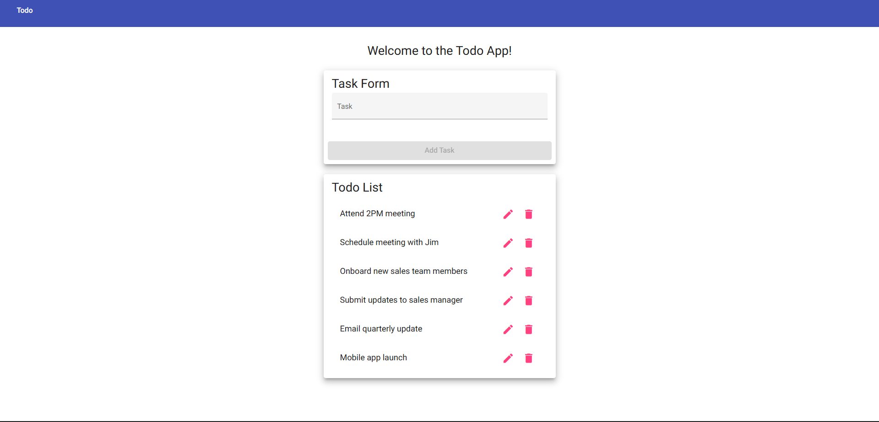

Test 2 - View Todo List and Create New Todo Item
Business Requirements: Req 1, Req 2, Req 6
Description: Verify that the user can view todo task items, create a new task item, and is prevented from submitting a blank new-task form.
Test Objective: Confirm list viewing, task creation, and create-form validation work as expected.
Developer |  | Noor El-din Al salihi |  | Date tested | 2026/06/24
Peer tester |  | Colton Stone |  | Date tested | 2026/06/28
Step | Action |  | Expected Results |  | Developer Pass/Fail | Tester Pass/Fail
1 | Visit https://buwebdev.github.io/todo/. |  | The Todo application landing page loads. |  | Yes | Yes
2 | Review the task list area on the page. |  | Existing Todo items or an empty list state are visible to the user. |  | Yes | Yes
3 | Enter a clear Todo item, such as "Complete Module 4 test plan," in the new task field and submit it. |  | The new todo item is added to the list. |  | Yes | Yes
4 | Clear the new task field and attempt to submit the form with no todo item entered. |  | The application prevents blank submissions and does not add an empty item. |  | Yes | No
5 | Confirm the previously created todo item still appears in the list. |  | The created item remains visible, and the task list is still usable. |  | Yes | No
Peer Tester Screenshot: To be added by the peer tester during the discussion review.
Comments: Am able to add a new task easily. However the new addition does not remain after refreshing.

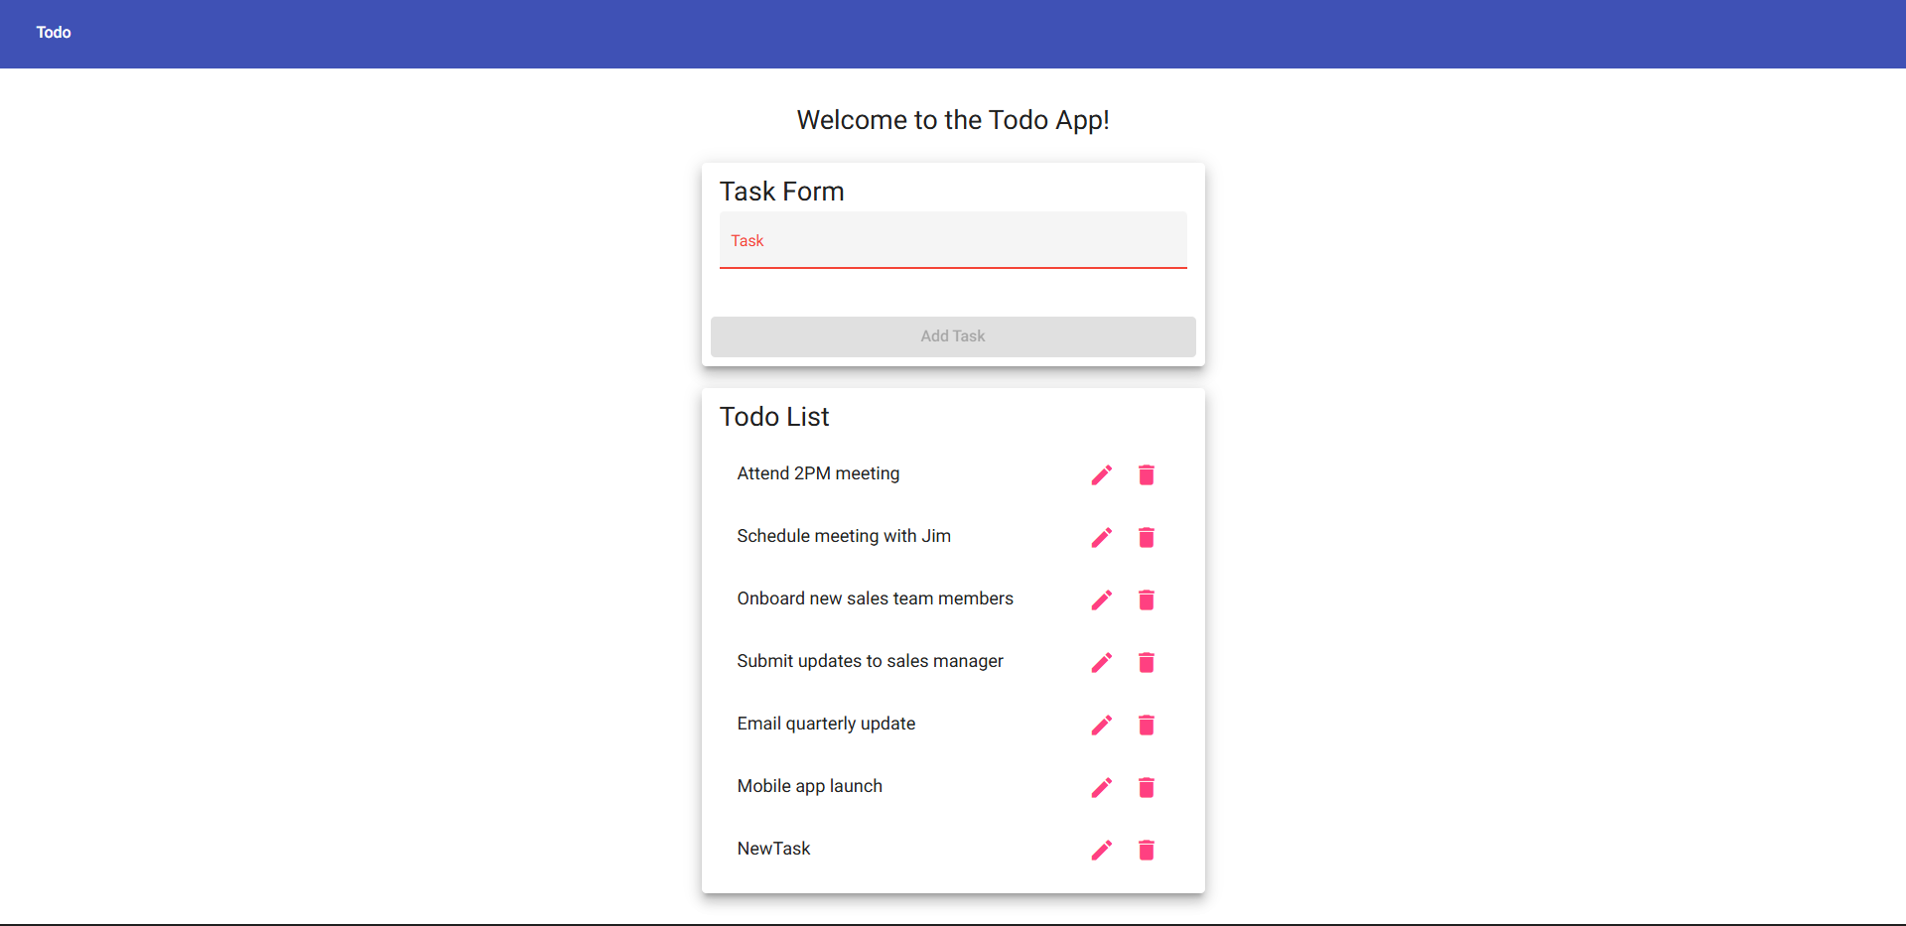

Test 3 - Edit Todo Item and Validate Empty Edit Form
Business Requirements: Req 3, Req 7
Description: Verify that a user can edit an existing todo item and cannot save an edited item when the todo value is blank.
Test Objective: Confirm that edit functionality and edit-form input validation operate correctly.
Developer |  | Noor El-din Al salihi |  | Date tested | 2026/06/24
Peer tester |  | Colton Stone |  | Date tested | 2026/06/28
Step | Action |  | Expected Results |  | Developer Pass/Fail | Tester Pass/Fail
1 | Create or locate an existing todo item in the list. |  | A Todo item is available for editing. |  | Yes | Yes
2 | Select the edit option for the todo item. |  | The edit task view or edit controls open for the selected item. |  | Yes | Yes
3 | Change the item text to "Complete functional testing" and save the update. |  | The todo item displays the updated text in the list. |  | Yes | Yes
4 | Open the same item for editing again, remove all text from the edit field, and attempt to save. |  | The application prevents the blank edit from being submitted. |  | Yes | Yes
5 | Return to the task list and confirm that the valid updated text is still present. |  | The application keeps the last valid to-do item value. |  | Yes | No
Peer Tester Screenshot: To be added by the peer tester during the discussion review.
Comments: Webpage allows me to edit the existing tasks. And does have a filter in place to prevent submitting an empty input field.

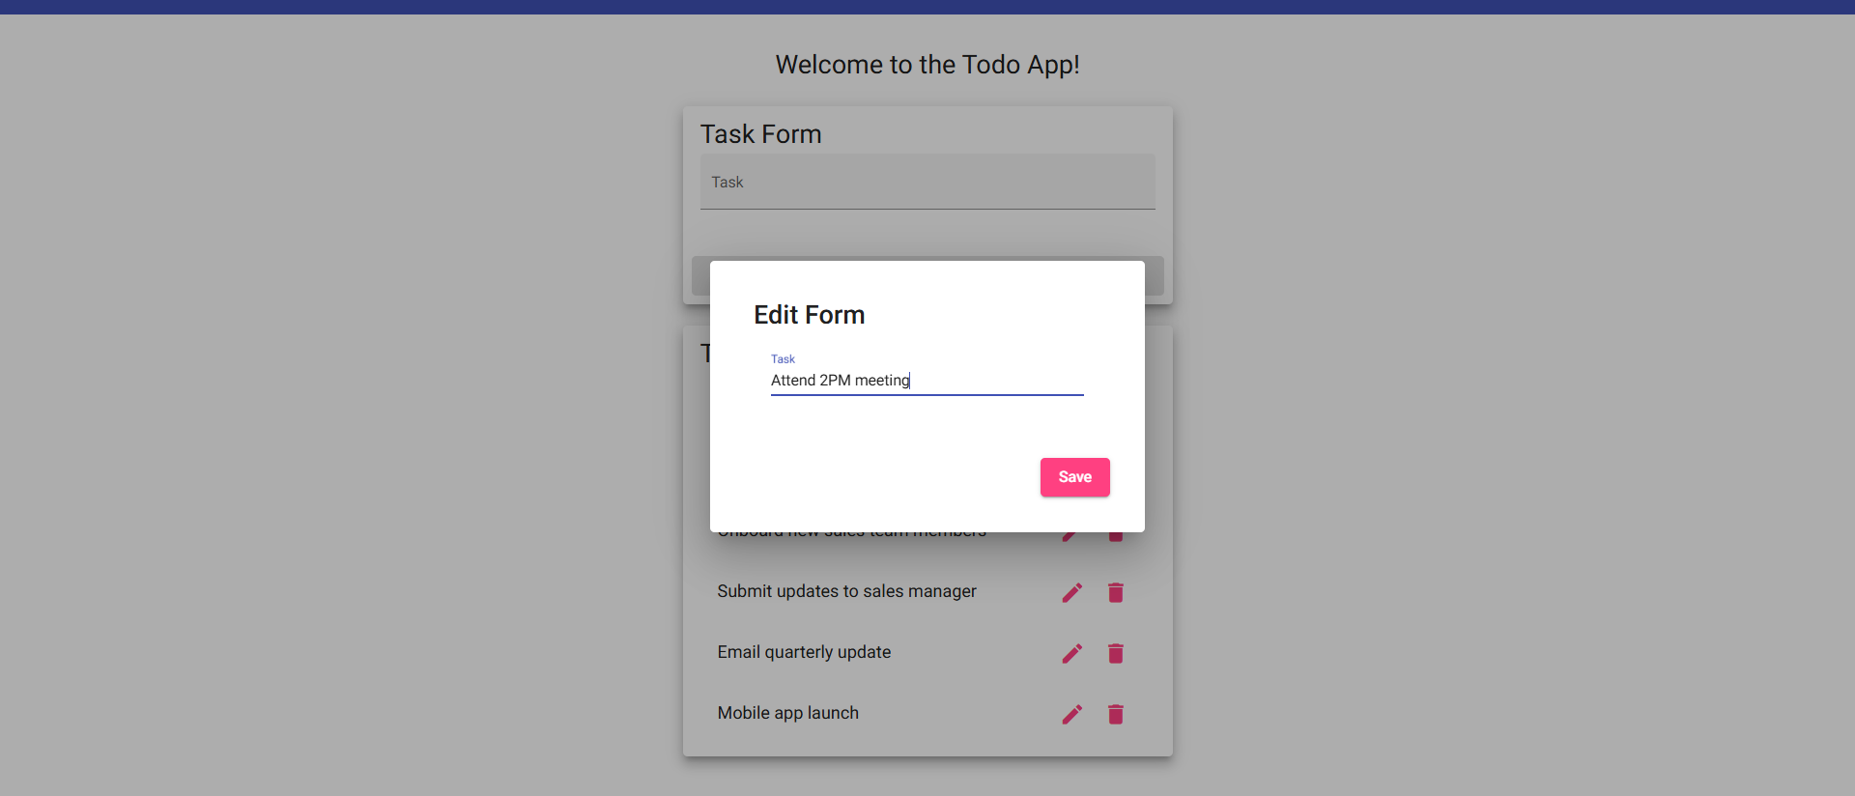

Test 4 - Delete Todo Item
Business Requirements: Req 4
Description: Verify that a user can delete a todo task item from the Todo application.
Test Objective: Confirm that the delete function removes the selected item from the task list.
Developer |  | Noor El-din Al salihi |  | Date tested | 2026/06/24
Peer tester |  | Colton Stone |  | Date tested | 2026/06/28
Step | Action |  | Expected Results |  | Developer Pass/Fail | Tester Pass/Fail
1 | Visit https://buwebdev.github.io/todo/. |  | The Todo application loads correctly. |  | Yes | Yes
2 | Create a test item named "Delete test item" if one is not already available. |  | A known test item appears in the task list. |  | Yes | Yes
3 | Select the delete option for "Delete test item." |  | The application processes the delete request. |  | Yes | Yes
4 | Confirm the item no longer appears in the todo list. |  | The deleted todo item is removed from the list. |  | Yes | Yes
5 | Refresh the page and review the list again. |  | The deleted item does not reappear after the page reloads. |  | Yes | Yes
Peer Tester Screenshot: To be added by the peer tester during the discussion review.
Comments: I am able to delete tasks without issues. The page however does not reflect the deletion after refreshing.
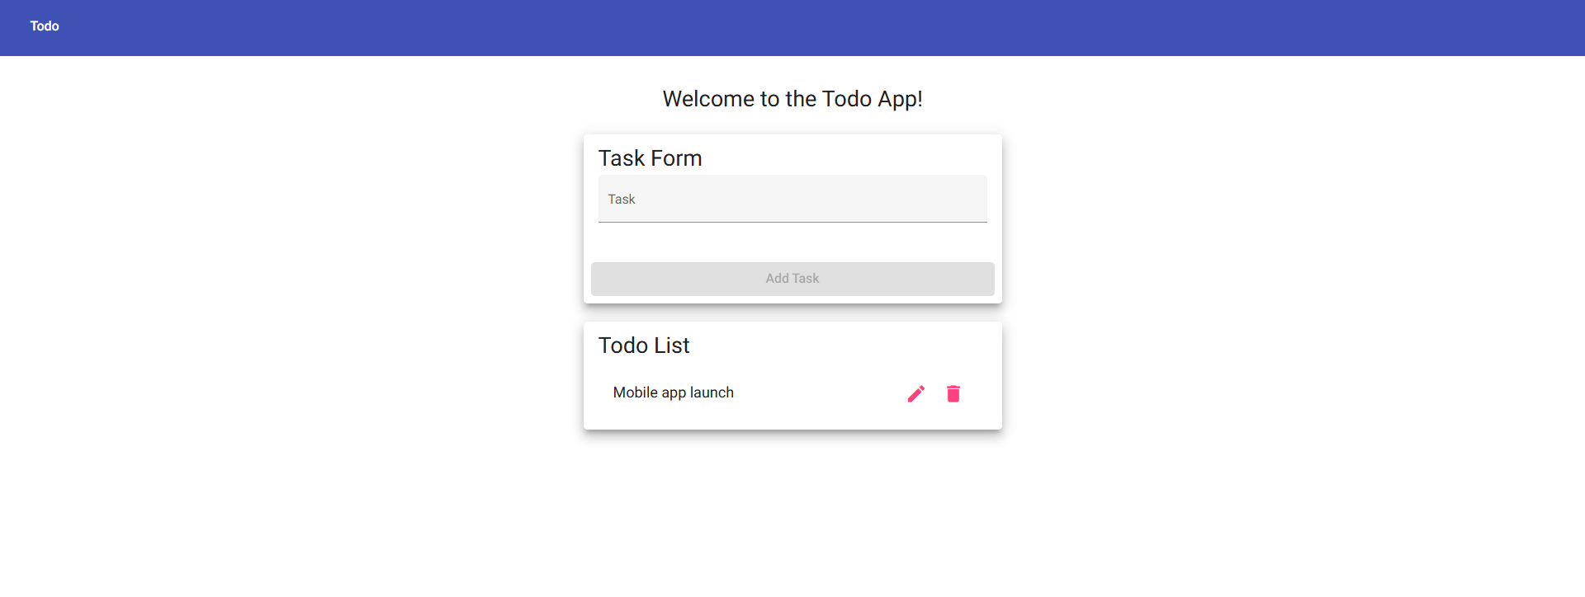

Test 5 - Invalid URL and Responsive Device Views
Business Requirements: Req 5, Req 8, Req 9
Description: Verify that invalid application URLs display a custom 404 page and that the Todo application remains usable on mobile and tablet viewport sizes.
Test Objective: Confirm error handling and responsive views for common device classes.
Developer |  | Noor El-din Al salihi |  | Date tested | 2026/06/24
Peer tester |  | Colton Stone |  | Date tested | 2026/06/28
Step | Action |  | Expected Results |  | Developer Pass/Fail | Tester Pass/Fail
1 | Navigate to an invalid application path, such as https://buwebdev.github.io/todo/invalid-test-page. |  | A custom 404 error page displays instead of a generic browser error or broken page. |  | Yes | Yes
2 | Return to https://buwebdev.github.io/todo/. |  | The normal Todo application page loads again. |  | Yes | Yes
3 | Use browser developer tools to view the page at a mobile width, such as 390 x 844. |  | The Todo page adapts to the mobile viewport while keeping key controls visible. |  | Yes | Yes
4 | Create, edit, or delete a small test task while in the mobile viewport. |  | The main Todo controls work without horizontal scrolling or hidden buttons. |  | Yes | Yes
5 | Change the viewport to a tablet size, such as 768 x 1024, and review the page layout. |  | The Todo page adapts to the tablet viewport, and the task list and controls remain usable. |  | Yes | Yes
6 | Create, edit, or delete a small test task while in the tablet viewport. |  | The main Todo controls work correctly at the tablet width, with no overlapping or hidden buttons. |  | Yes | Yes
Peer Tester Screenshot: To be added by the peer tester during the discussion review.
Comments: The page does display a custom 404 Github page when an invalid URL is entered. And then displays the standard page as normal once the correct URL is entered.
Source Note: The test cases were written to match the Todo Business Requirements and the Todo application URL supplied in Module 4.2 assignment instructions.

