Project: Todo Application
Course: CSD-380 Software Quality Assurance
Description: Functional Test Plan for Todo Web Application
Date: 2026/06/23
To complete the test case plan, fill out the information for Project, Course, Description and Date in the header below.
.
TABLE OF CONTENTS

TC‑01 Verify Website Loads .................................................... 2
TC‑02 Create New Todo Item .................................................. 2
TC‑03 Complete Todo Item ...................................................... 3
TC‑04 Delete a Completed Task .............................................. 3
TC‑05 Filter Tasks .................................................................... 4

For each test, the developer should: provide a test description, a test objective, the developer name and date tested. For each step, fill out the actions to be taken and describe the expected results, and indicate yes or no for each step depending upon the result. The peer tester should provide their name, date tested, indicate yes or no for each step depending upon the result, and a screenshot (thumbnail) of the result.

Test 1  Verify Website Loads | <DESCRIPTION>
1 | Open https://buwebdev.github.io/todo/ | Expected result completed successfully. | Yes
2 | Confirm page loads | Expected result completed successfully. | Yes | Yes
3 | Refresh browser | Expected result completed successfully. | Yes | Yes
4 | Confirm page reloads | Expected result completed successfully. | Yes | Yes
5 | Verify no errors displayed | Expected result completed successfully. | Yes | Yes
Comments | The website came up without any visible issues. I had the same result after refreshing it.
Date tested: 2026/06/23
Peer tester: Colton Stone
Date tested: 2026/06/28

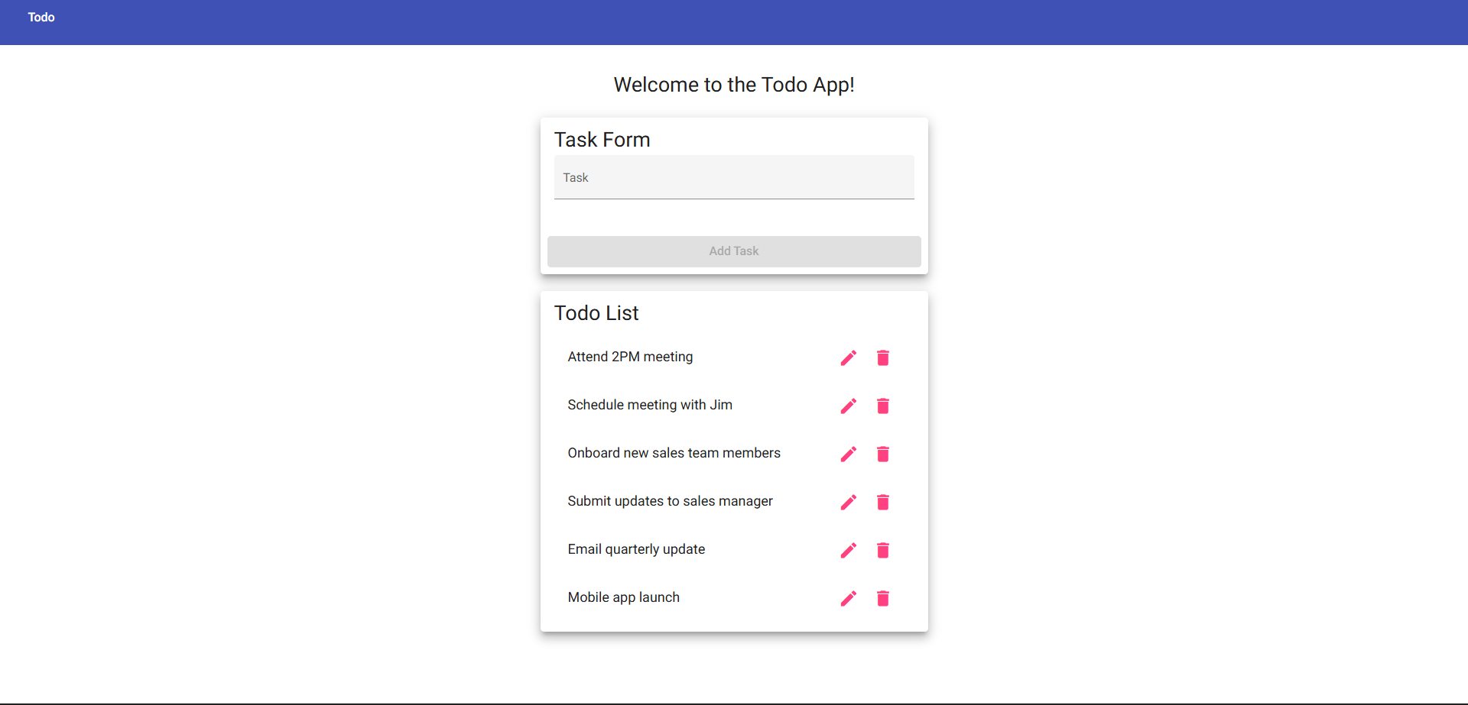

Date tested: 2026/06/23
Peer tester: Colton Stone
Date tested: 2026/06/28

Test 2  Create New Todo Item | <DESCRIPTION>
1 | Enter 'Buy groceries' | Expected result completed successfully. | Yes
2 | Click Add | Expected result completed successfully. | Yes | Yes
3 | Verify task appears | Expected result completed successfully. | Yes | Yes
4 | Refresh page | Expected result completed successfully. | Yes | Yes
5 | Verify task remains or behaves as designed | Expected result completed successfully. | Yes | No
Comments | I was able to enter the specified task and submit without issue. However, it does not stay on the page after I refresh it.
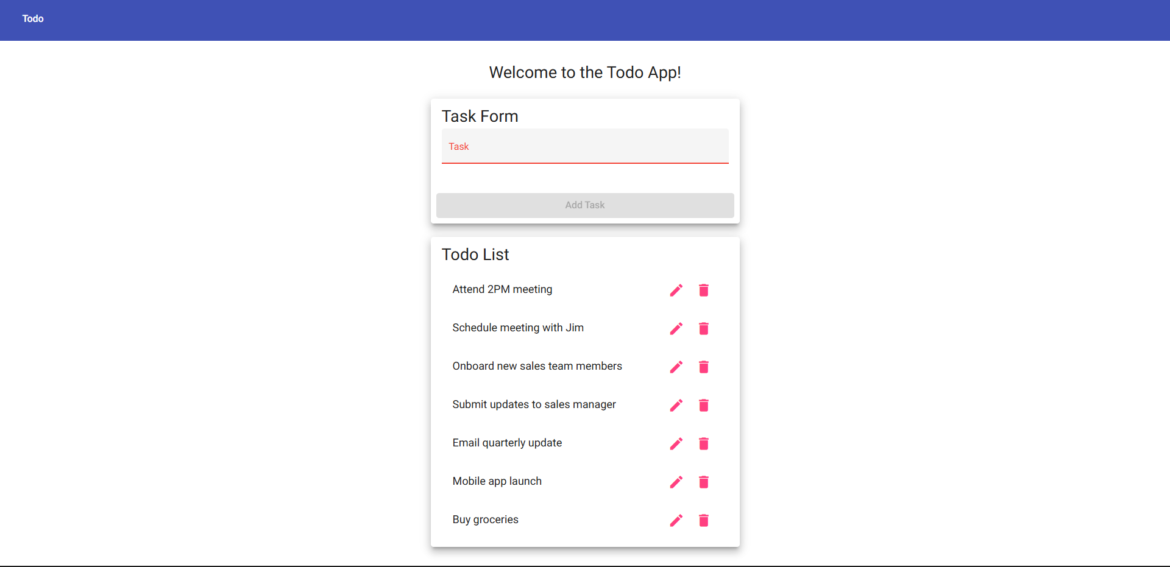

Test 3  Complete Todo Item | <DESCRIPTION>
1 | Create task if needed | Expected result completed successfully. | Yes
2 | Click checkbox | Expected result completed successfully. | Yes
3 | Verify completed style | Expected result completed successfully. | Yes
4 | Refresh page | Expected result completed successfully. | Yes
5 | Verify completed status | Expected result completed successfully. | No
Comments | This task was able to be submitted without problems. However like with the previous test, changes made to the page do not remain after refreshing.

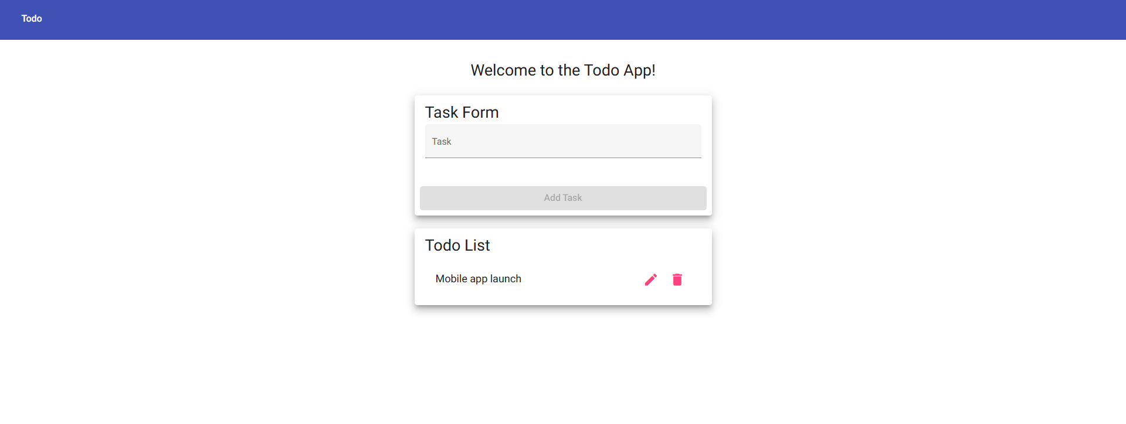

Date tested: 2026/06/23
Peer tester: Colton Stone
Date tested: 2026/06/28

Test 4
Description: Delete a completed task
Test Objective: Verify users can remove completed tasks.
Developer: Will Cotton
Date tested: 2026/06/23
Peer tester: Colton Stone
Date tested: 2026/06/28
Step | Action | Expected Results | Developer Pass/Fail | Tester Pass/Fail
1 | Open Todo app | Application loads. | Yes | Yes
2 | Complete a task | Task marked complete. | Yes | Yes
3 | Delete completed task | Task removed. | Yes | Yes
4 | Refresh page | Deleted task remains removed. | Yes | Yes
5 | Verify list | Only remaining tasks displayed. | Yes | No
Comments: The delete function works as it should. There is no difficulty in quickly removing any unwanted tasks after you add them.

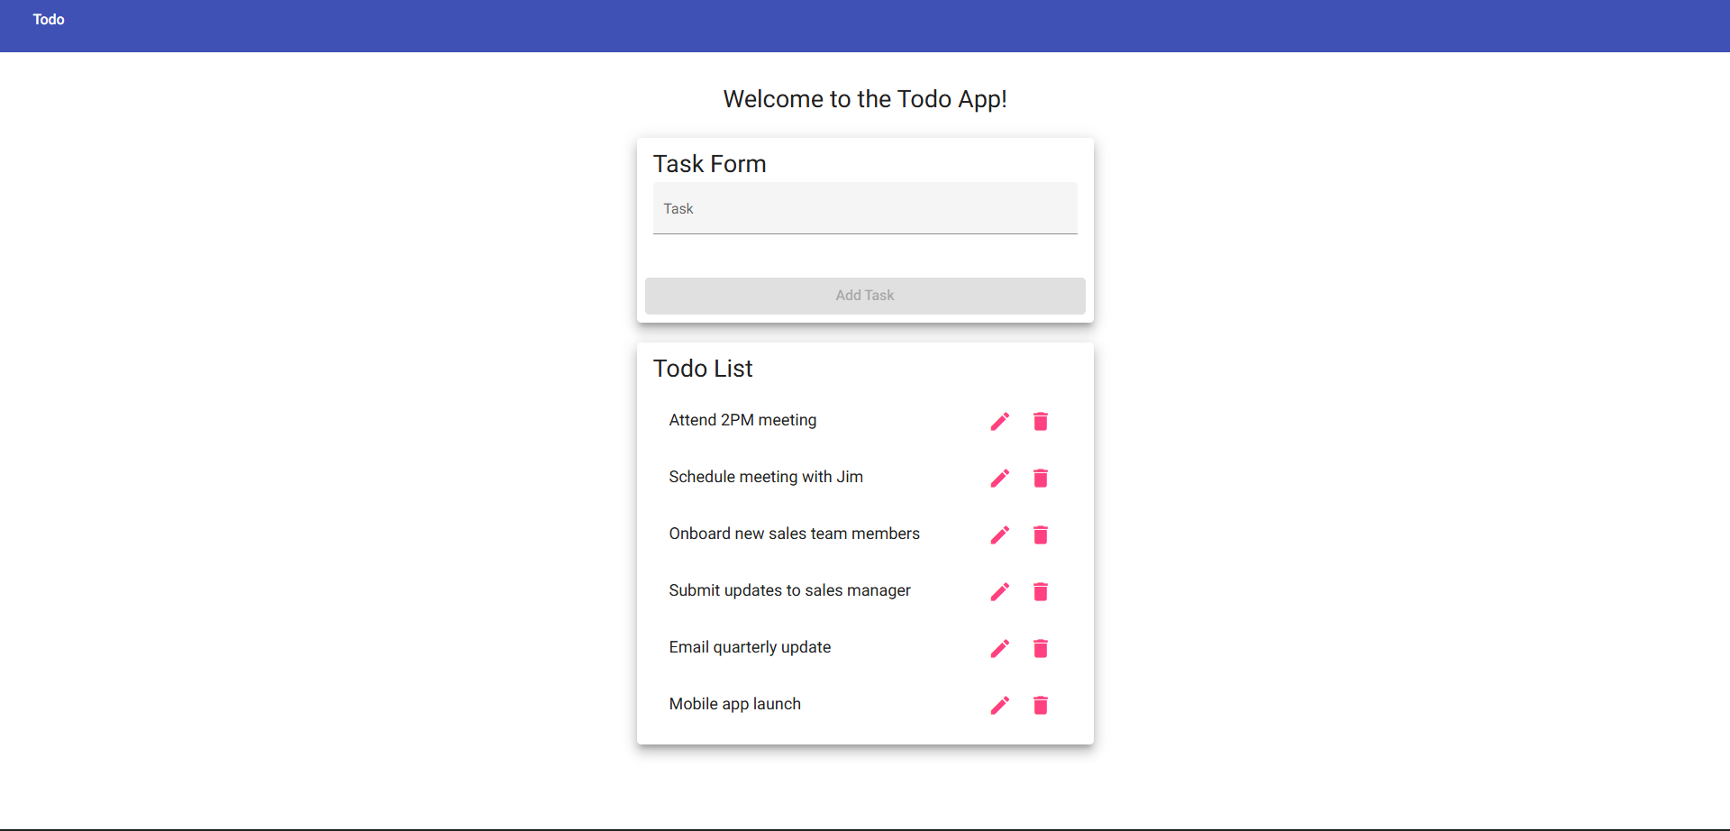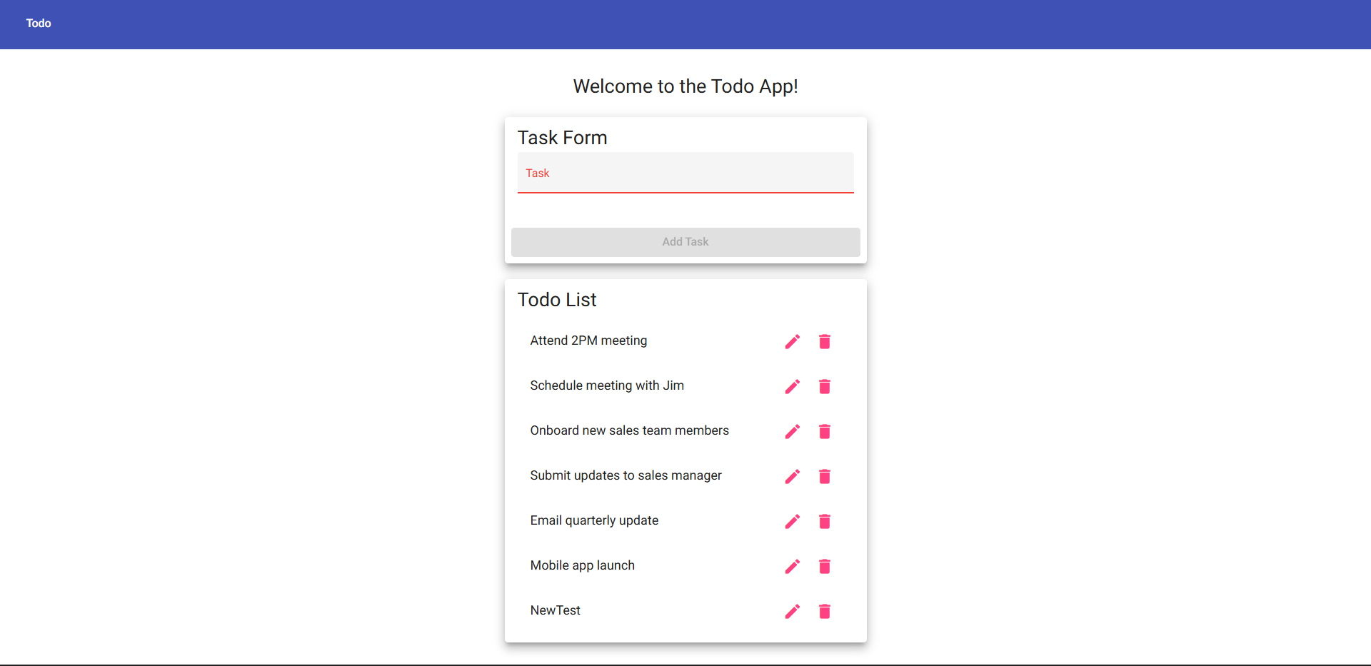

Test 5
Description: Filter tasks
Test Objective: Verify task filters display the correct items.
Developer: Will Cotton
Date tested: 2026/06/23
Peer tester: Colton Stone
Date tested: 2026/06/28
Step | Action | Expected Results | Developer Pass/Fail | Tester Pass/Fail
1 | Create active and completed tasks | Tasks created. | Yes | No
2 | Select Active filter | Only active tasks display. | Yes | No
3 | Select Completed filter | Only completed tasks display. | Yes | No
4 | Select All filter | All tasks display. | Yes | No
5 | Refresh page | Filter behavior remains correct. | Yes | No
Comments: I was not able to complete this test because I do not know how to use this filter feature that the developer is speaking about

