GitHub URL:
https://github.com/isa99sv/csd-430#

GitHub Repo:
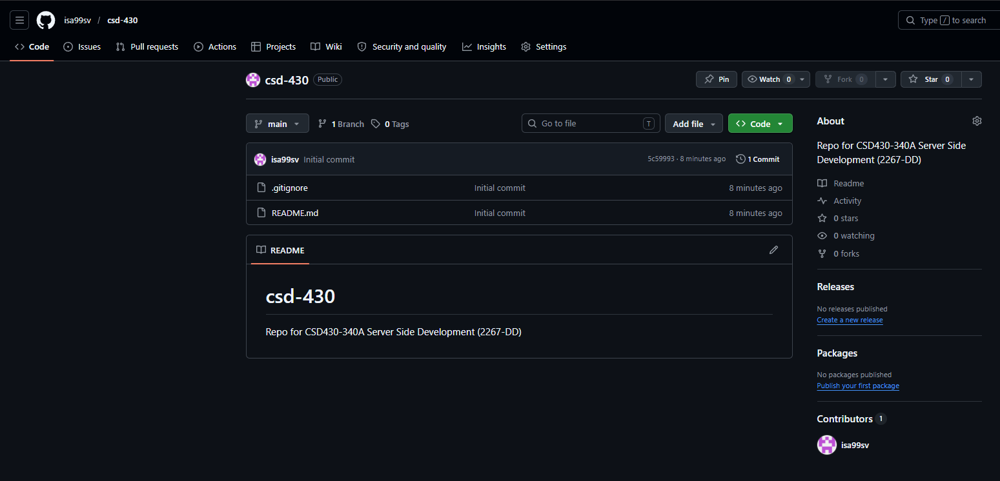

Local Directory:
