1. Set up project properties.
2. Set publish location to your local folder.
3. Set Update location to “Panasonic Web Portal URL” (need check with Sonny). Here is my testing web server, DDM is the folder that contains “setup.exe”, “DriverDownloader.application”, “Application Files” folder, etc.

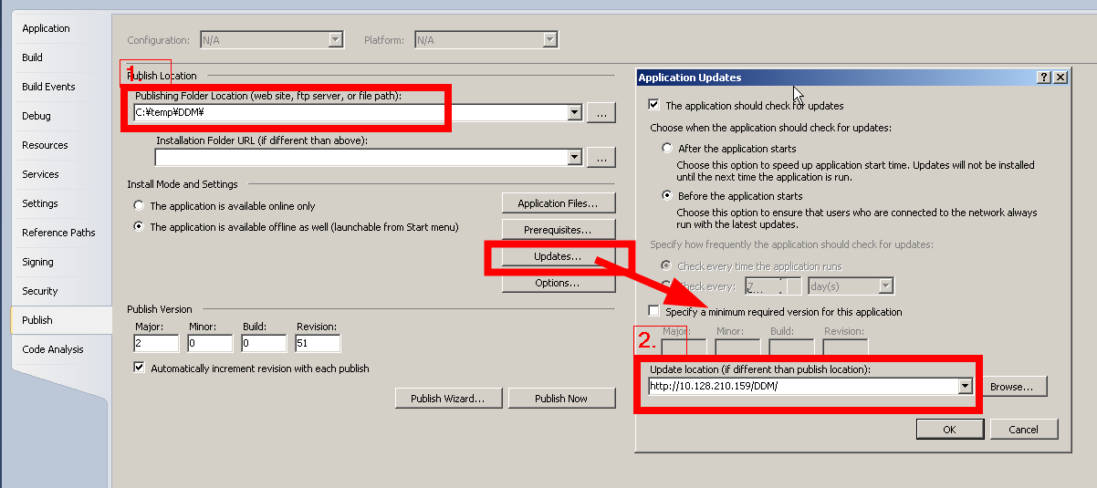

1. When new version is developed, publish this new version.

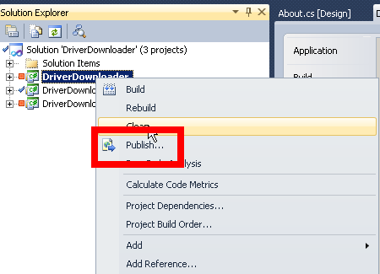

Make sure the installation path is also correct. The installation path shall be the same with the update path.

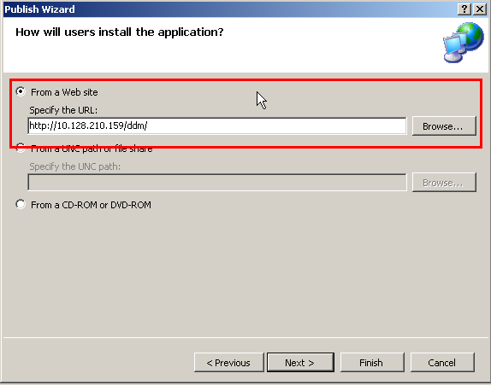

1. Zip the contents in your local publish folder and send to Soony.

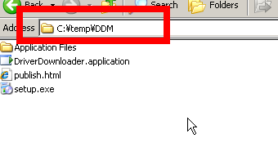

1. Ask Soony to overwrite the previous zip package. Below is the sample of my testing web server.

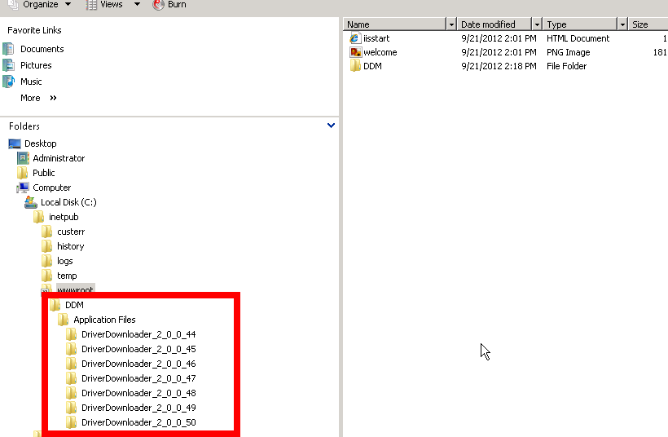

1. Soony only needs put a link on the web that links to the “setup.exe” file in the zip package. Following screen shows the case of my testing web server.

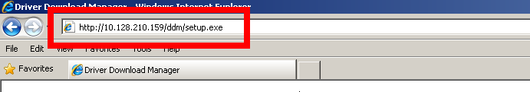

1. Customer will get notified whenever a new version is available on the web site.