**IMAGE VALIDATION ISSUE LIST**

**March 19, 2013**

**Image Collection Validation Software:**

1. **Registry verification: The registry feature is not working correctly. When you upload a registry file into the Web Administration page and then run the Client Validation Tool it doesn’t check if the key exists. Instead it reports that the registry file (not key) doesn’t exists on the desktop.**

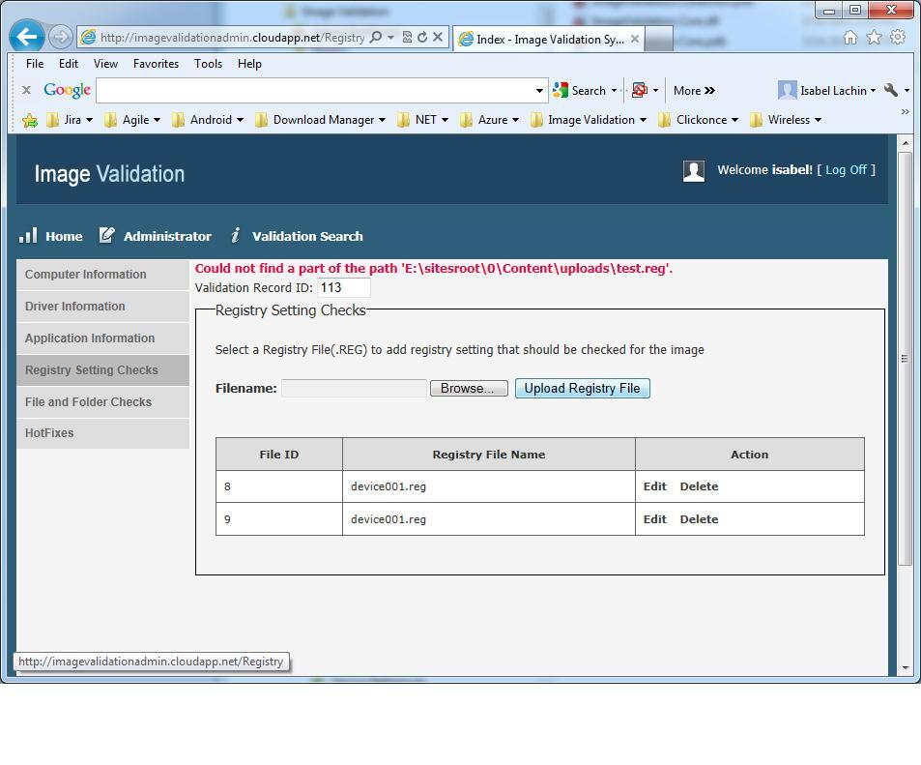

1. **The records are added only one time. We noticed only one record can be added at a time. Not unless we delete the already added record, another record does not get added to the list on the Administration page. Even selecting either or both Primary records does not trigger it to add more records.**

**To reproduce: Add a new record via Client. Navigate to the newly created record in the Browser and look for the matching ID. Go back to Client and add a new record. Notice the ID does not change and verify Browser did not add a new record neither.**

1. **Application Validation is not working correctly. All the versions should be matching but it does not evaluate correctly on the Application Validation. All applications come up as a Mismatch.**

**Image Collection Validation Client:**

1. **Please remove empty sections.**

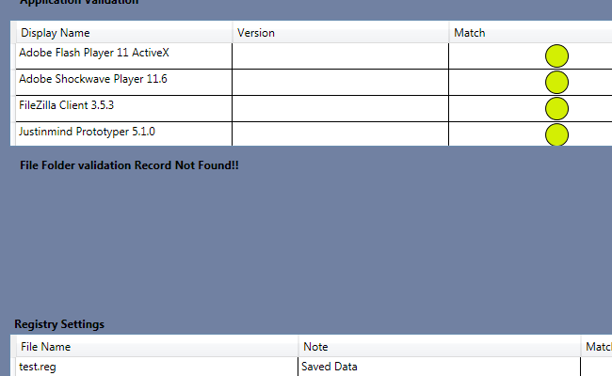

**2. Please add a new icon on top of each section so users don't have to scroll through all items to find a red icon. If all green-> show green. If a mismatch -> show yellow. If any red found -> show red.**

**3. Registry Settings should show the records/entries rather than just the file name.**

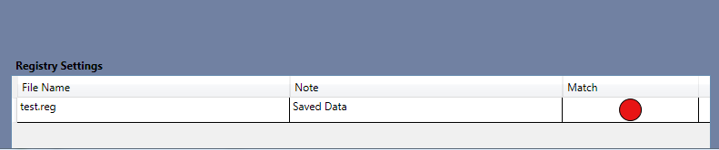

**4. Download links are missing from all grids. Please refer to this image from the original Spec.**

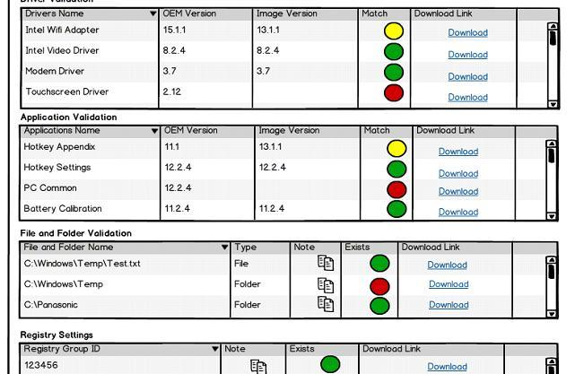

**Image Validation Web Admin:**

**1. Missing "Delete" for registries. Here's the original image:**

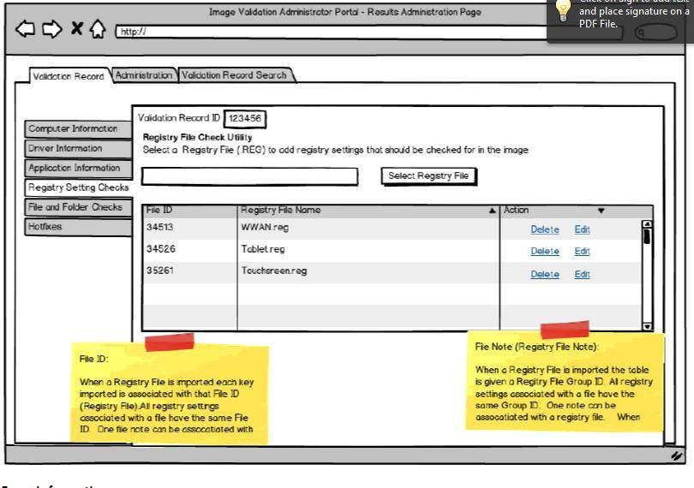

**File and Folder**

**1. Allow for folder selection. Currently it only allows you to choose a file. Allowing for multiple file download at a time would be a valid option.**

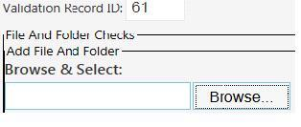

**2. Even when a file is chosen it doesn’t save the full path in display only the file name.**

**3. The drive should be set to C:\ and after submitting a file it shows up as D:\ this will cause problems during validation**

**SSL Development to secure sites**