**IMAGE VALIDATION ISSUE LIST**

Updated: **March 21, 2013**

**Image Collection Validation Software:**

1. **Registry verification: The registry feature is not working correctly. When you upload a registry file into the Web Administration page and then run the Client Validation Tool it doesn’t check if the key exists. Instead it reports that the registry file (not key) doesn’t exists on the desktop. Resolved (Matching issues). Please elaborate more on last sentence.**

**Pana: It should compare each values and not the file or filename. If you click edit on the .reg file, it will display the values contained in the .reg file. These values are the ones that need to be verified as existing inside the host registry.**

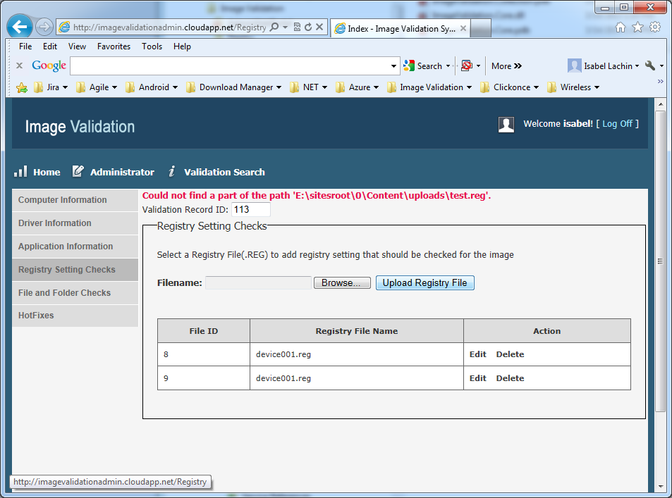

1. **The records are added only one time. We noticed only one record can be added at a time. Not unless we delete the already added record, another record does not get added to the list on the Administration page. Even selecting either or both Primary records does not trigger it to add more records.**

**To reproduce: Add a new record via Client. Navigate to the newly created record in the Browser and look for the matching ID. Go back to Client and add a new record. Notice the ID does not change and verify Browser did not add a new record neither. : One system has maximum two records in azure database means if you have run collection tool multi time from same system then always 2nd record will update and return same ID of the validation.**

1. **Application Validation is not working correctly. All the versions should be matching but it does not evaluate correctly on the Application Validation. All applications come up as a Mismatch. -Resolved**

**Image Collection Validation Client:**

1. **Please remove empty sections. In-Progress**

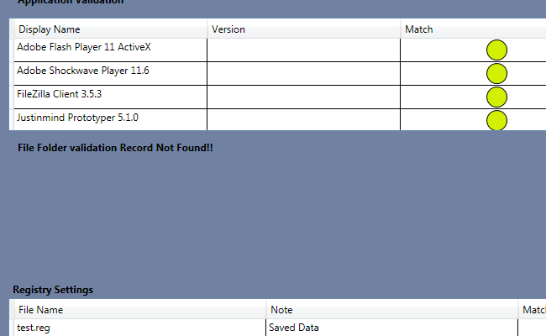

1. **Please add a new icon on top of each section so users don't have to scroll through all items to find a red icon. If all green-> show green. If a mismatch -> show yellow. If any red found -> show red. Resolved (New Request).**

**Pana: The icon above registry should indicate red if internal is red. See latest image below.**

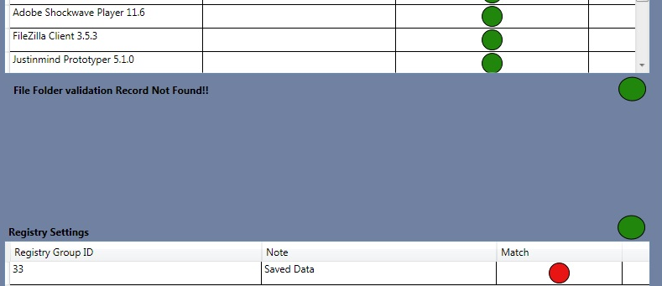

**3. Registry Settings should show the records/entries rather than just the file name. Resolved**

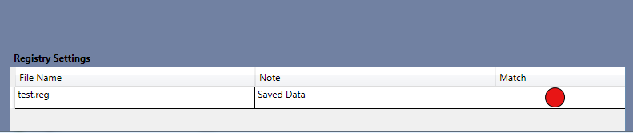

**Pana: The registries still show the file name. See image above.**

1. **Download links are missing from all grids. Please refer to this image from the original Spec. Please provide more information on what needs to be downloaded. Also, how you plan to bind the fields “OEM Version” and “Image Version”.**

**Pana: We consider this issue to be closed. Please leave the download link in place and we will configure here.**

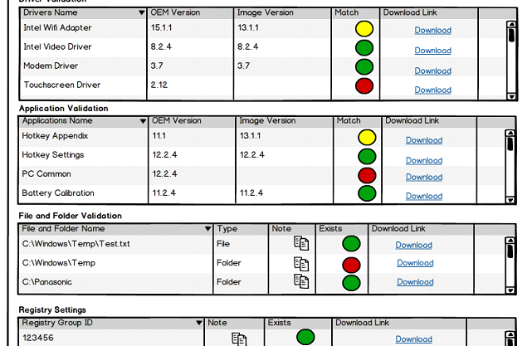

**Image Validation Web Admin:**

**1. Missing "Delete" for registries. Here's the original image: Resolved**

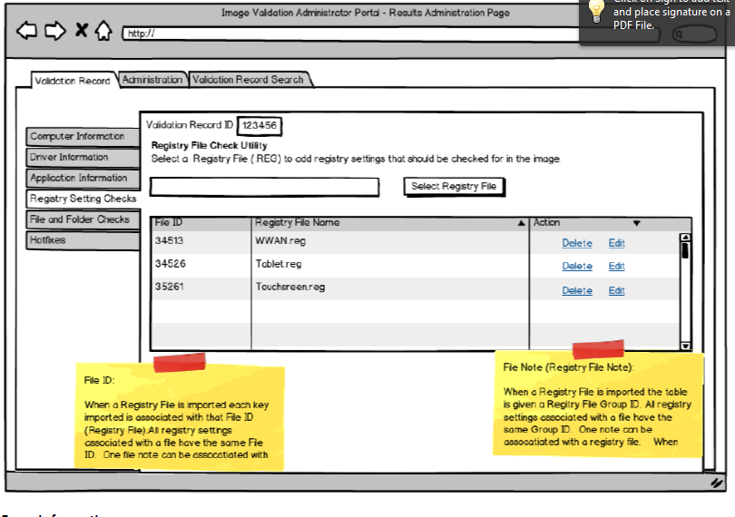

**File and Folder**

**1. Allow for folder selection. Currently it only allows you to choose a file. Allowing for multiple file download at a time would be a valid option. Resolved**

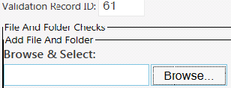

**2. Even when a file is chosen it doesn’t save the full path in display only the file name. Resolved**

**3. The drive should be set to C:\ and after submitting a file it shows up as D:\ this will cause problems during validation. Resolved**

**Note:** Now you can upload a file from using browse button or also enter manually in textbox if you upload file using browse then path will make eg. C:\windows\system32\+filename.