Question 1: Increase the skip window. Looking at the training error and the closest words, does the model seem to get better or worse? Explain why. (3 marks)
Answer: As we increase the skip_window from 1 to 10, the Average Loss increases. First of all, what is a skip_window? Skip_window is a parameter that describes how many words to consider to the left and to the right of the target word. It is also known that the words closest to the target word contribute to its meaning/context. According to the original word2vec code, the word is only trained on the context which is present in the sentence. Therefore, we can see that the skip_window of size 1 better captures the context/meaning of the word compared to the skip_window of size 10, better trains the model, and since we are dealing with the skip-gram models it better predicts source context-words from the target words. Additionally, the skip-gram architecture weighs nearby context words more heavily than more distant context words.
Additionally, here is my understanding of why NCE loss value would increase when skip_window increases. Let’s take a look at the NCE loss below:
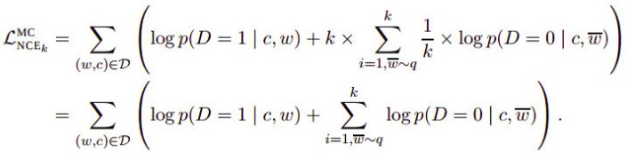
Let w be the target word, c be the context/correct output, and be some noise word from the distribution q with w and c coming from some dictionary D. Now, as per what we said above, the words closest to the target word w would have the highest probability and those that are far from the target word would have low probability. As we know, the log of a very small number results in a big number and log of a very big number results in a small number. Now, as we increase the skip_window hyperparamter, more and more irrelevant words receive low probability resulting in the above sum for the NCE loss to get big.
Question 2: Research and explain NCE loss. (3 marks)
Answer: First, let us formulate the problem/issue in order to understand why we need the NCE. Neural probabilistic language models are traditionally trained using the maximum likelihood (ML) principle to maximize the probability of the next word (for "target") given the previous words h (for "history") in terms of a softmax function,
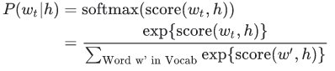

where score(,h) computes the compatibility of word with the context h (a dot product is commonly used). We train this model by maximizing its log-likelihood on the training set, i.e. by maximizing
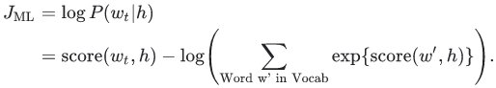
This yields a properly normalized probabilistic model for language modeling. However this is very expensive, because we need to compute and normalize each probability using the score for all other V words in the current context h, at every training step.
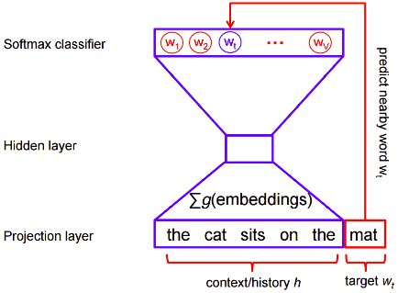

On the other hand, for feature learning in word2vec we do not need a full probabilistic model. The CBOW (Continuous Bag-of-Words model) and skip-gram models are instead trained using a binary classification objective (logistic regression) to discriminate the real target words from k imaginary (noise) words , in the same context. We illustrate this below for a CBOW model. For skip-gram the direction is simply inverted.
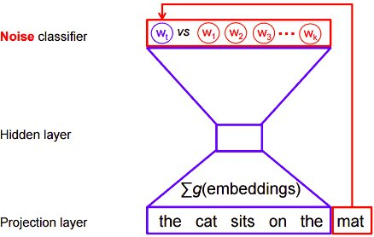

Mathematically, the objective (for each example) is to maximize
where is the binary logistic regression probability under the model of seeing the word w in the context h in the dataset D, calculated in terms of the learned embedding vectors θ. In practice we approximate the expectation by drawing k contrastive words from the noise distribution (i.e. we compute a Monte Carlo average).
This objective is maximized when the model assigns high probabilities to the real words, and low probabilities to noise words. Technically, this is called Negative Sampling, and there is good mathematical motivation for using this loss function: The updates it proposes approximate the updates of the softmax function in the limit. But computationally it is especially appealing because computing the loss function now scales only with the number of noise words that we select (k), and not all words in the vocabulary (V). This makes it much faster to train.
The goal is to make an update to the embedding parameters θ to improve (in this case, maximize) this objective function. We do this by deriving the gradient of the loss with respect to the embedding parameters θ, i.e. . We then perform an update to the embeddings by taking a small step in the direction of the gradient. When this process is repeated over the entire training set, this has the effect of 'moving' the embedding vectors around for each word until the model is successful at discriminating real words from noise words.
With the base idea formulated, we can now move to a similar loss function, NCE (Noise-Contrastive Estimation). As we can see from above, Maximum Likelihood approach with softmax distributions is very expensive. Another alternative for this would be NCE. The basice idea behind the NCE is the following - convert a multinomial classification problem (as it is the problem of predicting the next word) to a binary classification problem. That is, instead of using softmax to estimate a true probability distribution of the output word, a binary logistic regression (binary classification) is used instead.
For each training sample, the enhanced (optimized) classifier is fed a true pair (a center word and another word that appears in its context) and a number of k randomly corrupted pairs(consisting of the center word and a randomly chosen word from the vocabulary). By learning to distinguish the true pairs from corrupted ones, the classifier will ultimately learn the word vectors.
This is important: instead of predicting the next word (the "standard" training technique), the optimized classifier simply predicts whether a pair of words is good or bad.
Word2Vec slightly customizes the process and calls it negative sampling. In Word2Vec, the words for the negative samples (used for the corrupted pairs) are drawn from a specially designed distribution, which favours less frequent words to be drawn more often.
Let’s get mathematical! So, in short, NCE is selecting a sample from the true distribution which consist of the true class and some other nosy class labels. Then taking the softmax over it.
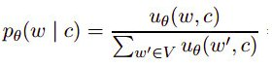

In NCE , We try to get rid of the expensive cost function. More specially the normalizing part. (Denominator). In the process of making the sofmax soft in terms of the computational cost, we introduce sampling methods to mimic the true distribution and get the desired results. Here we try to sample the label from true distribution (Model Distribution) and some other words from noise distribution. What is this noise distribution ? We normally take a Unigram distribution for words Since it's a natural distribution.
The entire structure of the NCE loss function is based upon the premise of sampling words from true distribution and noise distribution:
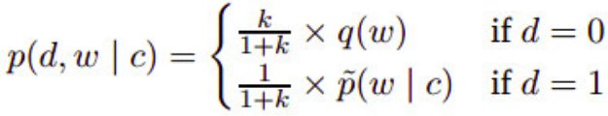
D=1 part : This is indicating the that a single sample is drawn from the true distribution .
D=0 part : This is indicating the k number of samples are drown from noise distribution (Unigram Distribution)
Here the basic Idea is to train logistic regression classifier which can separate the samples obtained from true distribution and sampled obtained from noise distribution. Remember When we are talking about the samples obtained from the true distribution we are talking about only one sample which is the true class obtained from the model distribution.
With conditional probability we can write above equation as:
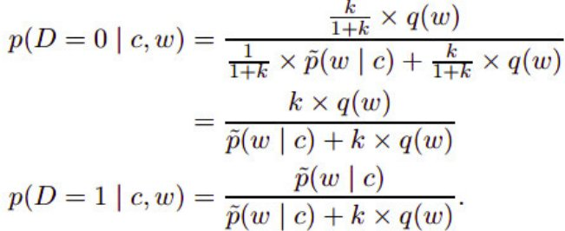

We need to understand the above two equations.
Eq. 1: Probability of given sample came from noise.
Eq. 2: Probability of given sample came from the model distribution.
Still we have that heavy function to calculate . Which is the probability of the correct word given the context (This is heavy normalized soft max). Now we are to remove the heavywith an unnormalized probability term.
Here we take the unnormalized probability (score) of the word given the context from our model ( term in the following equation):
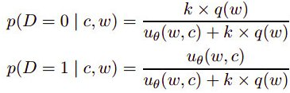

Simply the term above is the exp(score(w, c)) (score of the last layer). Now, how do we transform the above into the cost function? Well, we do the following.
Let’s take one case where the probability of the given sample come from the model distribution (D = 1 case):
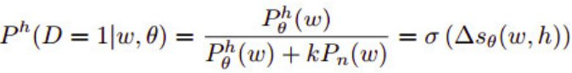
So, what is the delta term? Difference in the scores of word w under the model and the (scaled-because of the log term) noise distribution. The scaling factor k in front of accounts for the fact that noise samples are k times more frequent than data samples. We can take this term as follows:
First term is the unnormalized score or the term . And the next term is the log probability of word sampling from the noise distribution. We can easily reconstruct the original equation with this:
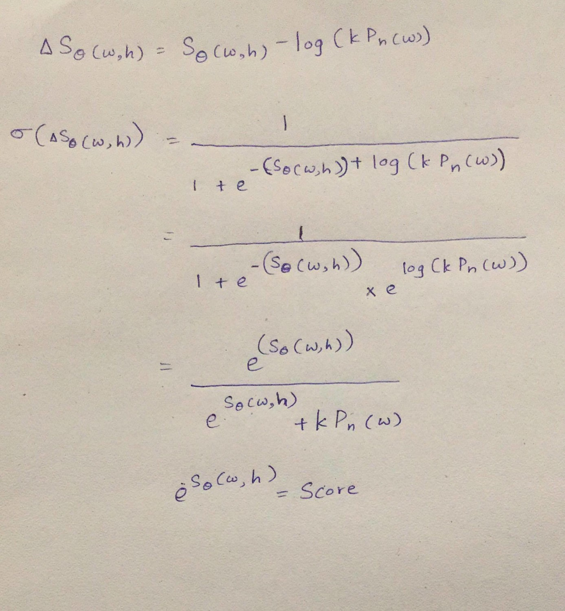
Therefore, we can reach an important insight - In order to maximize the probability of a word comes from the true distribution we need to maximize the part . Which means we train our classifier to discriminate words that belong to real distribution and words that belong to noisy distribution. (Here the real distribution means our model .)
By combining the above two we will write the new cost function as:
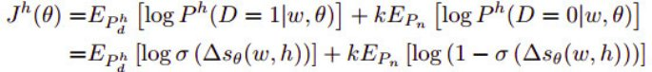
In the above equation what is the second term which is corresponding to the D=0 case. If you work it with like above you will realize it is simply : sigmoid(-x) = 1-sigmoid(x). This is more like a binary classifier! In practice, the loss function looks like the following:
In practice we use this cost function as follows:
- Taking the target word as the word that belong to model distribution .
- Sampling K noise sample words from the unigram distribution and substituting it to the second part of the equation when training .
Two important things:
- The sum over k noise samples instead of a sum over the entire vocabulary, making the NCE training time linear in the number of noise samples and independent of the vocabulary size. As we increase the number of noise samples k, this estimate approaches the likelihood gradient of the normalized model, allowing us to trade off computation cost against the accuracy .
- Sample softmax is all about selecting a sample of the given number and try to get the softmax loss. Here the main objective is to make the result of the sampled softmax equal to our true softmax. So algorithm basically concentrate lot on selecting the those samples from the given distribution. On other hand NCE loss is more of selecting noise samples and try to mimic the true softmax. It will take only one true class and a K noise classes.
Question 3: Why replace rare words with UNK rather than keeping them? (2 marks)
Answer: First of all, what is UNK? UNK - "unknown token" - is used to replace the rare words in our vocabulary. If we keep rare words they would appear less frequently in the training set and thus it would be difficult to learn a good representation, resulting in poor performance. Thus our model does not know of any rare words. It is a crude form of smoothing because the model assumes that the token UNK will never actually occur in real data or better yet it ignores these n-grams altogether. The problem that smoothing is trying to solve is data sparsity. This technique is probably the simplest way to deal with it.
Question 4: If you run the model more than once the t-SNE plot looks different each time. Why? (2 marks)
Answer: t-SNE stands for t-Distributed Stochastic Neighbor Embedding. Stochasticity implies that the model is non-deterministic meaning we won't get exactly the same output each time we run it (though the results are likely to be similar). t-SNE is a heuristic. Like most heuristics, it might behave quite differently according to small changes. The core characteristic here is: only local-convergence is guaranteed! Lastly, t-SNE has a cost function non-convex (i.e. with different initializations we can get different results), meaning it has multiple local minima and is therefore much more difficult to optimize which further contributes to the above.
Question 5: What happens to accuracy if you set vocabulary_size to 500? Explain why. (3 marks)
Answer: As we decrease the vocabulary_size to 500, NCE loss decreases. Continuing from question 1, we need to take a look at the NCE loss value:
What we are concerned with the summation over . As we decrease the dictionary size, we decrease the various target words and their corresponding neighbours/context words and therefore decreasing the overall summation and loss. In short, smaller dictionary ensures that the words the closest context to the target word stay in the training of the model.
Question 6: You may see antonyms like “less” and “more” next to each other in the t-SNE. How does that make sense rather than them being at opposite ends of the plot? (2 marks)
Answer: Let’s start with a Word2Vec. Word2Vec would give a higher similary if the two words have a similar context. E.g. Isaac would get _____ depressed if he finds a job. The blank could be filled by both less and more hence similarity would be higher. Additionally, words with the similar context would have higher cosine similarity. The concept is called Paradigmatic relations.
Let’s briefly take a look at how t-SNE works:
- The algorithms starts by calculating the probability of similarity of points in high-dimensional space and calculating the probability of similarity of points in the corresponding low-dimensional space. The similarity of points is calculated as the conditional probability that a point A would choose point B as its neighbor if neighbors were picked in proportion to their probability density under a Gaussian (normal distribution) centered at A.
- It then tries to minimize the difference between these conditional probabilities (or similarities) in higher-dimensional and lower-dimensional space for a perfect representation of data points in lower-dimensional space.
- To measure the minimization of the sum of difference of conditional probability t-SNE minimizes the sum of Kullback-Leibler divergence of overall data points using a gradient descent method.
Note Kullback-Leibler divergence or KL divergence is is a measure of how one probability distribution diverges from a second, expected probability distribution.
In simpler terms, t-Distributed stochastic neighbor embedding (t-SNE) minimizes the divergence between two distributions: a distribution that measures pairwise similarities of the input objects and a distribution that measures pairwise similarities of the corresponding low-dimensional points in the embedding.
In this way, t-SNE maps the multi-dimensional data to a lower dimensional space and attempts to find patterns in the data by identifying observed clusters based on similarity of data points with multiple features.
Therefore, combining information from word2vec and t-sne, antonyms such as “less” and “more” have similar contextual meaning and therefore would appear together on the t-sne plot. Words with the similar context would appear together even if they are antonyms.
You only need to submit the answers to the questions, not the Jupyter notebook. Words with the similar context would appear together even if they are antonyms.

