Isaac Okolie
Data Analyst
PREPARED BY
A Descriptive Analytics Insights Report
ZIKFLIX’s Consumer usage and Preference Analysis (2021-2025)
zikflix

TABLE OF CONTENTS

- Introducution

- Executive Summary (FIRE)

- Tasks

- Conclusion.

INTRODUCTION
Zik-Flix is a pan-African streaming platform focused on Nollywood and regional storytelling. Using five years of event-level data (2021–2025) covering users, content metadata, and viewing events, this brief describes a descriptive analytics project to surface viewer preferences, regional patterns, device behavior, and monetization signals.

Expected Deliverables (What Client Gets):
- A clear visualization of Total Watch Hours across the platform
- Analysis of Average Watch Time per User
- Calculation and presentation of Completion Rate
- A chart highlighting Top Genres by Watch Hours
- A geographic visualization showing Region/Country with highest usage
- Analysis of Content Consumption by Age Group
- Breakdown of Most Used Devices by Age Range
- Visualization of User Distribution by Gender
- Analysis of Subscription Tier Distribution (%)
- An interactive Tableau dashboard showing Monthly Active Users (MAU) over time

Expected Outcomes (What Happens If Actions)
- Total Watch Hours: Provides a clear measure of overall user engagement on the platform
- Average Watch Time per User: Helps assess depth of user engagement and content stickiness
- Completion Rate: Identifies content retention levels and areas where users drop off
- Top Genres by Watch Hours: Guides content investment toward the most engaging genres
- Region with Highest Usage: Supports targeted expansion and regional marketing strategies
- Content Consumption by Age Group: Helps define and target the platform’s core audience segments
- Most Used Devices by Age Range: Informs optimization of user experience across devices
- Gender Distribution: Supports inclusive content and marketing strategy decisions
- Subscription Tier Distribution (%): Helps evaluate monetization performance and conversion opportunities
- Monthly Active Users (MAU): Enables tracking of platform growth and effectiveness of user acquisition strategies
This report is not only a data review—it is a strategic roadmap for transforming the Company into a smarter, more precise entertainment Platform.

EXECUTIVE SUMMARY
- Problem Statement
The streaming platform faces the challenge of understanding user behavior, content performance, and engagement patterns across diverse markets and demographics. Despite accumulating large volumes of user activity data, the platform lacks a centralized and structured analytical view to effectively measure key performance indicators such as user growth, watch time, content completion, and subscription distribution.

- Objectives
- To measure Total Watch Hours to assess the overall level of user engagement on the platform.
- To determine the Average Watch Time per User to understand how deeply users interact with available content.
- To calculate the Completion Rate to evaluate content retention and identify potential drop-off points.
- To identify Top Genres by Watch Hours in order to guide content investment and programming strategy.
- To examine regional usage patterns to determine the countries with the highest platform engagement.
- To analyze content consumption by age group to define key audience segments and viewing preferences.
- To evaluate device usage by age range to understand how different user groups access the platform.
- To assess gender distribution to gain insights into audience diversity and engagement balance.
- To analyze subscription tier distribution to evaluate monetization performance and identify opportunities for user conversion.
- To analyze Monthly Active Users (MAU) in order to evaluate platform growth and user retention trends over time.

Value Proposition
This Tableau-driven report delivers:
• Data-backed insights that reveal user engagement patterns and content performance across the platform.
• Audience segmentation by age, gender, and region to enable targeted content and marketing strategies.
• Clear visibility into device usage behavior to support mobile-first optimization and product decisions.
• Content consumption trends that guide strategic investment in high-performing genres.
• Subscription tier analysis to identify monetization opportunities and improve user conversion.
• Actionable recommendations to enhance user retention, improve completion rates, and drive platform growth.
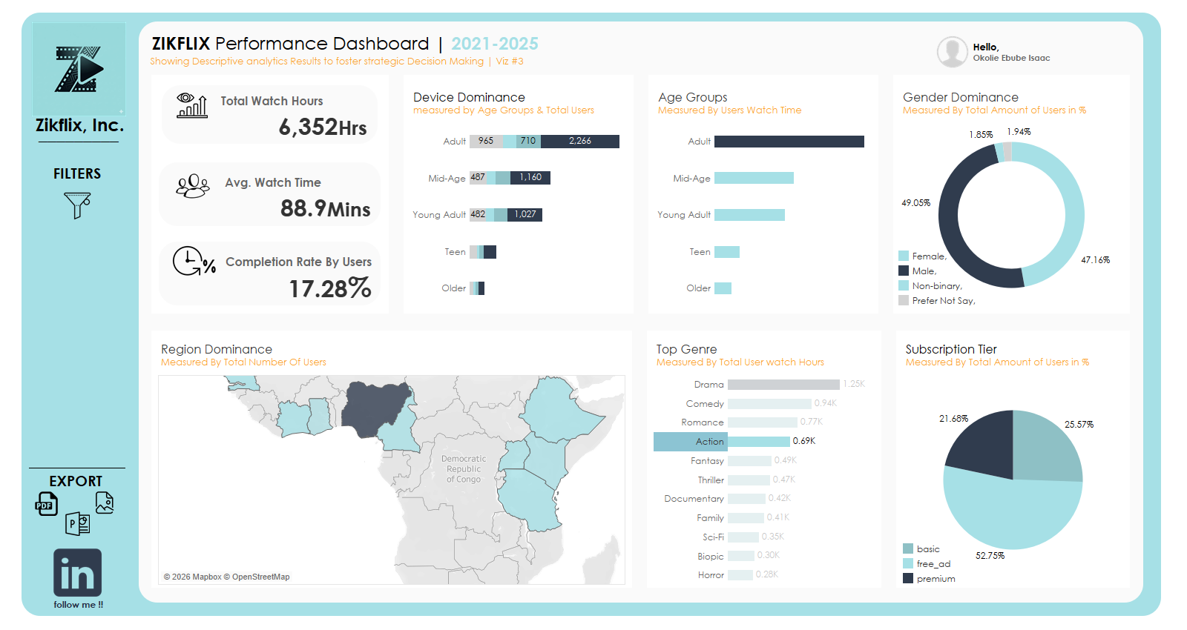
Through the FIRE (Facts, Insights, Recommendations, and Executive Summary) method,
this report transforms complex streaming data into clear, actionable intelligence for executives, enabling informed decision-making, improved user experience, and sustainable growth across the African market.
A Consumer usage and Preference Tracking Dashboard

TASKS

Task 1: Measure Total Watch Hours to assess the overall level of user engagement

Total Watch Hours
ZikFlix recorded a total of 6,352 watch hours, demonstrating a strong level of overall platform engagement. This indicates that users are not only accessing the platform but are also spending meaningful time, consuming content.
The volume of watch hours confirms that the platform has successfully captured user attention, making it a viable digital entertainment platform within its target market.

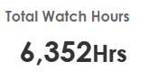

Task 2: Determine the Average Watch Time per User to understand how deeply users interact with available content.

Average Watch Time per User
The average watch time per user is approximately 88.9 minutes, indicating that users typically spend over an hour per session on the platform.
This suggests a relatively high level of user engagement per session, showing that once users begin watching content, they tend to remain engaged for a significant duration. However, this should be evaluated alongside completion rate to fully understand retention quality.
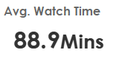
Task 3: Calculate the Completion Rate to evaluate content retention and identify potential drop-off points.

Completion Rate
The platform’s completion rate stands at 17.28%, indicating that a relatively small proportion of viewing sessions result in full content consumption.
This suggests that while users are engaging with content, many do not complete what they start, pointing to potential issues such as content length, relevance, pacing, or recommendation effectiveness.
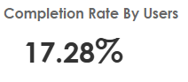

Task 4: Identify Top Genres by Watch Hours in order to guide content investment and programming strategy.

Top Genres by Watch Hours
The analysis shows that Drama, Comedy, and Romance are the top-performing genres, with Drama leading significantly at approximately 1.25K watch hours.
This indicates a strong user preference for emotionally engaging and story-driven content, which aligns with the strengths of Nollywood and African storytelling traditions.
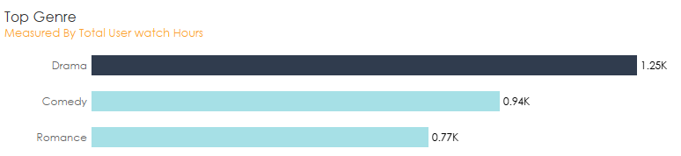

Task 5: Examine regional usage patterns to determine the countries with the highest platform engagement.

Region with Highest Usage
Geographic analysis reveals that Nigeria has the highest user concentration and engagement on the platform, followed by other African countries such as Ghana, Kenya, and Ethiopia.
This confirms that Nigeria serves as the primary market for Zik-Flix, likely due to cultural alignment with Nollywood content and higher platform awareness.
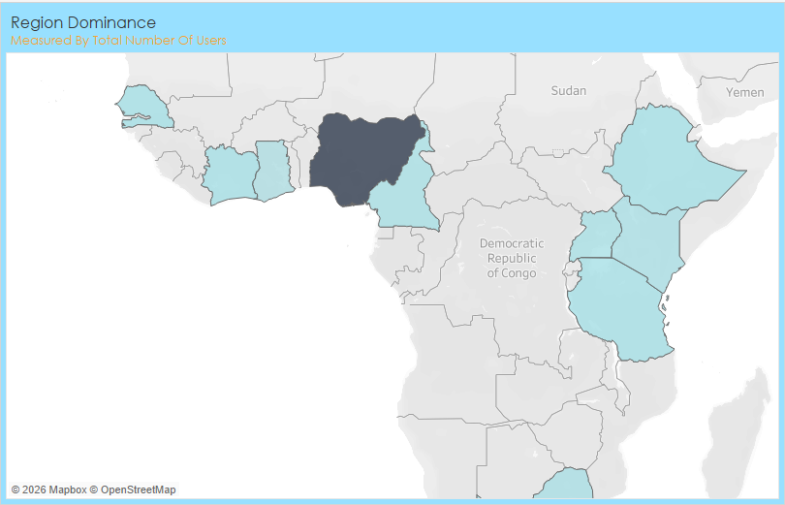

Task 6: Analyze content consumption by age group to define key audience segments and viewing preferences.

Content Consumption by Age Group
Adults represent the largest share of content consumption, followed closely by Young Adults and Mid-Age users.
This indicates that Zik-Flix’s core audience consists of mature, digitally active individuals who are likely to have consistent viewing habits and higher content appreciation.
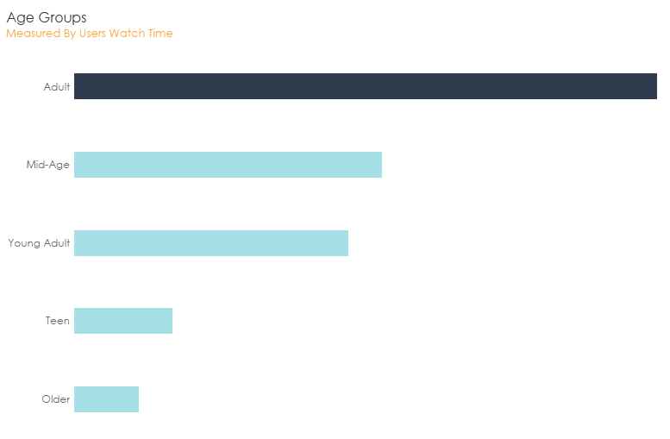

Task 7: Evaluate device usage by age range to understand how different user groups access the platform.

Most Used Devices by Age Range
Mobile phones are the most used devices across all age groups, significantly outperforming Smart TVs and Tablets.
This highlights that Zik-Flix is primarily consumed as a mobile-first platform, reflecting broader digital consumption trends across Africa, where mobile accessibility is dominant.
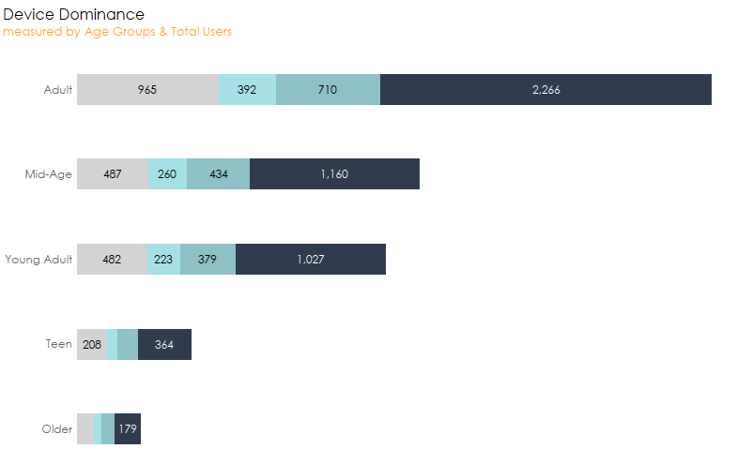

Task 8: Assess gender distribution to gain insights into audience diversity and engagement balance.

Gender Distribution
The gender distribution is relatively balanced, with Male users slightly leading, followed closely by Female users, while other gender categories represent a small fraction.
This suggests that the platform appeals broadly across genders, making it suitable for inclusive content strategies.

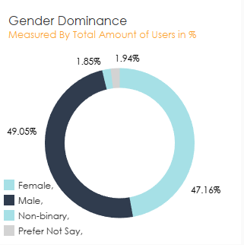

Task 9: Analyze subscription tier distribution to evaluate monetization performance and identify opportunities for user conversion.

Subscription Tier Distribution
The majority of users (approximately 52.75%) are on the free (ad-supported) tier, while Basic and Premium users make up smaller portions.
This indicates that the platform’s growth is largely driven by accessibility, but also highlights an opportunity to improve monetization by converting free users into paying subscribers.
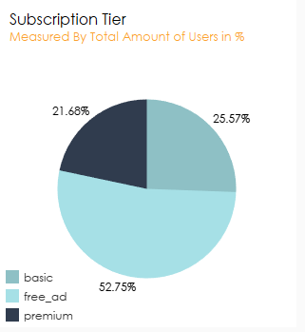

Strategic Recommendations

1. Optimize for Mobile-First Experience
Given that mobile phones dominate usage across all age groups, Zik-Flix should prioritize mobile optimization by improving streaming quality on low bandwidth, enhancing user interface design, and introducing features such as offline downloads.
This will improve accessibility, user satisfaction, and overall engagement across its largest user base.

2. Invest in High-Performing Content Genres
With Drama, Comedy, and Romance emerging as top-performing genres, Zik-Flix should allocate more resources toward producing and acquiring content within these categories.
This will ensure alignment with user preferences, increase watch hours, and strengthen audience retention.

3. Improve Content Completion Rate
The relatively low completion rate (17.28%) indicates a need to improve content retention. Zik-Flix should consider producing shorter, more engaging content, optimizing recommendation algorithms, and enhancing the “Continue Watching” feature.
These actions will encourage users to complete content and increase overall engagement quality.

4. Target Core Audience Segments
Since Adults and Young Adults contribute the most to watch time, Zik-Flix should tailor its content and marketing strategies to meet the preferences of these groups.
Targeted campaigns and personalized content recommendations will help deepen engagement within these key segments.

5. Enhance Monetization Strategy
With over half of users on the free (ad-supported) tier, there is a strong opportunity to increase revenue by encouraging upgrades to paid plans.
Zik-Flix can introduce premium-exclusive content, offer limited-time subscription discounts, and strategically manage ad frequency to incentivize conversion.

6. Expand into High-Potential Regions
While Nigeria remains the dominant market, other countries such as Ghana, Kenya, and Ethiopia show promising engagement levels.
Zik-Flix should expand its presence in these regions through localized content, regional partnerships, and targeted marketing initiatives.

7. Leverage Data for Continuous Improvement
Zik-Flix should adopt a data-driven culture by continuously monitoring KPIs such as MAU, watch hours, and completion rate to guide decision-making.
Regular analysis will enable the platform to quickly adapt to user behavior trends and maintain competitive advantage.

EXECUTIVE SUMMARY & CONCLUTION
Zik-Flix, a leading pan-African streaming platform, has leveraged comprehensive data analytics to gain actionable insights into user behavior, content performance, and regional engagement.
Key Findings:
- User Engagement: The platform maintains a stable user base with steady Monthly Active Users, indicating consistent engagement.
- Content Preferences: Drama, Comedy, and Romance genres lead in watch hours, guiding content investment.
- Device Usage: Mobile devices are the primary access point, emphasizing the need for a mobile-first strategy.
- Completion Rate: A 17.28% completion rate highlights an opportunity to enhance content retention.
- Geographic Focus: Nigeria is the dominant market, with potential growth in other regions like Ghana and Kenya.
- Subscription Insights: Over half of the user base is on the free tier, signaling an opportunity to boost paid conversions.
Strategic Recommendations:
- Enhance Mobile Experience: Prioritize mobile optimization to cater to the largest user segment.
- Focus on High-Performing Genres: Allocate resources to Drama, Comedy, and Romance to maximize engagement.
- Boost Content Completion: Implement strategies like shorter content and improved recommendations to increase completion rates.
- Expand Regional Presence: Leverage insights to grow in emerging markets beyond Nigeria.
- Enhance Monetization: Develop strategies to convert free users to paid subscribers, increasing revenue.

Conclusion
This data-driven approach empowers Zik-Flix to make informed decisions, enhance user engagement, and achieve sustainable growth across the African market.

