EOD Estimator – SOP
1. Purpose
This utility connects to PostgreSQL store databases, reads recent POSLOG batch timestamps, and reports:
- Average POSLOG time of day (excluding weekends, if applicable).
- Latest POSLOG date/time – Checks if EOD is done
- DB version
2. Prerequisites
- Java 8 or higher installed.
- Maven installed.
- Network access from the machine to the target PostgreSQL store databases.
- Valid database credentials configured in DbDetailsBuilder.
- PostgreSQL JDBC driver declared in pom.xml.
3. Input Preparation
- Open input.txt in the project root.
- Add store codes, one per line, in the format:
  - Two-letter country code followed by 3 or 4 digits.
  - Examples:
    - DK121
    - CA1094
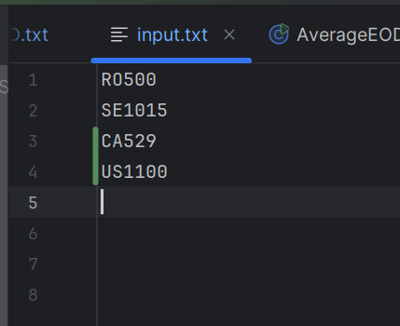
- Save the file.
4. Running the Utility
4.1 Build
From the project root:
Run: mvn clean package
4.2 Execute
Run the main class:
AverageEod.java – To calculate the average EOD time of individual stores.
EodCheck.java – To check if the EOD is complete for the particular stores.
Version.java – To check the DB version of the respective stores.
The program will:
- Read each store code from input.txt.
- Connect to each store's PostgreSQL database.
- Compute and record POSLOG timing information.
5. Output
After the run completes, open
- AverageTimings.txt in the project root for AverageEod.java
- TodaysEOD.txt for EodCheck.java
- Versioncheck.txt for Version.java

The output will be as follows,
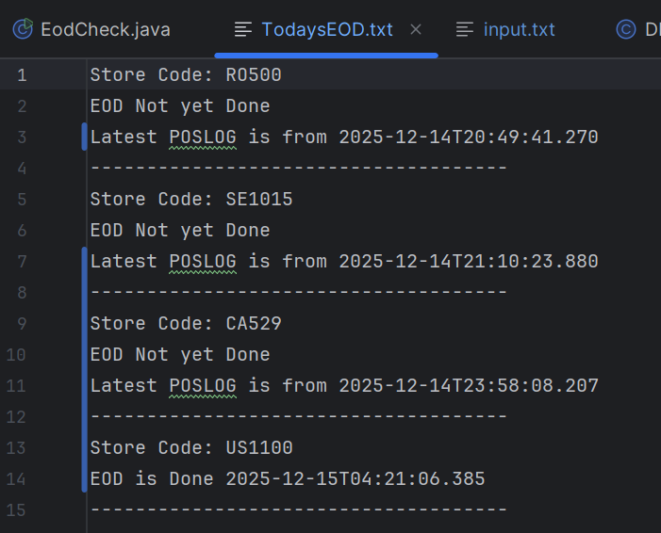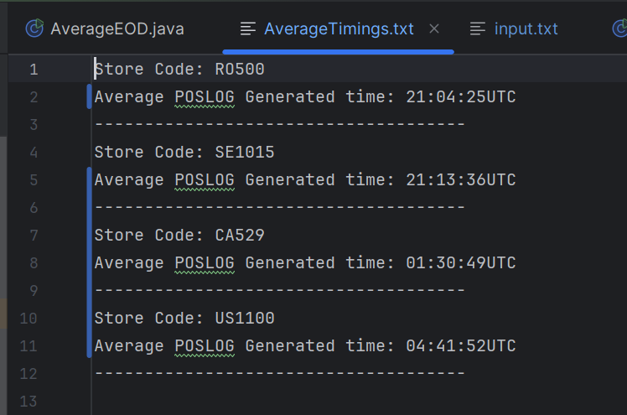

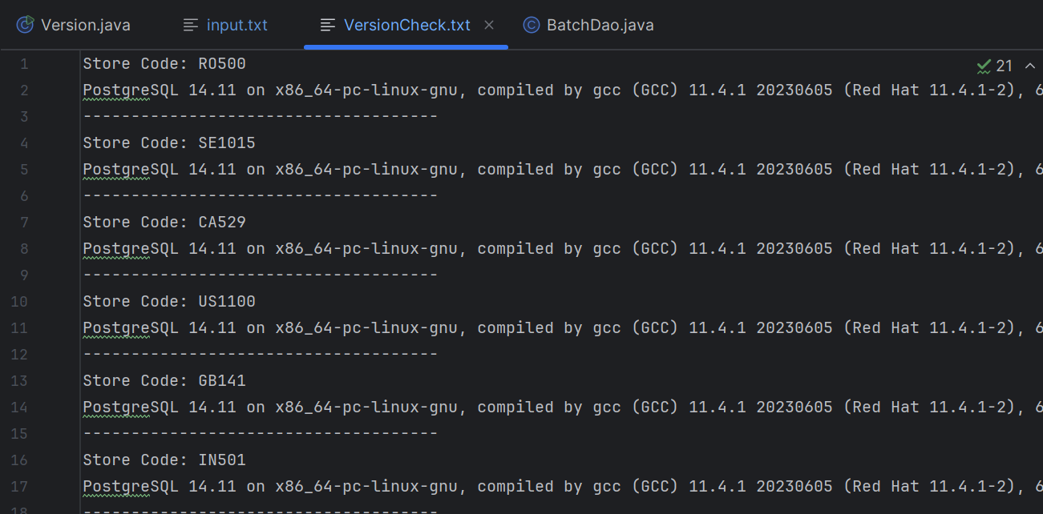

  - Average POSLOG Generated time: approximate time of day(UST) when POSLOG is generated for that store.
  - Latest POSLOG: timestamp of the most recent POSLOG, used to verify that the store is up-to-date.
Configuration Changes
- To change database credentials or host naming rules, edit DbDetailsBuilder.
- To change how many POSLOG records are used for the average, adjust the LIMIT in the SQL query in BatchDao.
- To change weekend/weekday logic or add holidays, adjust the Hashset in the BatchDao within the getAveragePoslogTimestamp() method.

NOTE
PIP: PROD IPOS - Verify PIP
For these CTasks, after running the Version.java class attach the VersionCheck.txt file as proof in the work notes before closing.

