**Climate Change and Conflict in Vulnerable Countries**

Isaac Menninga, Quest University Canada

PHYS 3009, Nov. 2015

**Abstract:**

Climate change will impact weather systems worldwide. The IPCC has already documented significant changes to global surface temperature, sea level, and glacier and ice sheet area. These effects will have significant impacts on humans. Countries which lack essential infrastructure and technologies will be impacted most severely. In these countries, studies have suggested a link between changes in climate and the frequency of violence and conflict. By analyzing data on conflict and climate in 19 sample countries, this study examines that relationship. The analysis found no significant correlation between conflict and climate change, but that result is likely due to experimental error, as many studies have found that the correlation exists.

**Introduction:**

Climate change will have significant impacts in all areas of life. These impacts will take the form of shifts in the way natural systems operate, for instance, an increase in the mean global temperature, or the increased frequency of severe weather events. Changes such as these are already occurring, and are well documented. The mean global surface temperature has increased over the last one hundred years. Glaciers, and ice sheets have been receding since at least 1950. These changes are summarized in the IPCC’s periodic reviews of evidence on climate change (IPCC). An overwhelming consensus exists among scientists; that the Earth’s global climate is rapidly changing as a result of human burning of fossil fuels. A vast area of research, in multiple countries, using a variety of measurement techniques, investigating different micro and macro effects of climate change have found the same thing: climate change is real and human caused, and will have disastrous consequences.

The long term effects of climate change are predicted using environmental models. As computing power continues to increase, the models have become more accurate and complex. These climate models help us understand the long term effects that climate change will have. Sea level rise, rising temperature, extreme weather patterns, disruptions in ocean currents, and decreased snow-pack are all effects that are beginning to be felt, and will continue to worsen. Environmental models predict that these effects will increase into the future. Long term changes in the Earth’s climate will bring about changes for all individuals across the world. Weather changes will disrupt and destroy crop yield, sea level rise threatens to drown habitable land, and rising temperature and dryness will increase drought frequency.

Although climate change is likely to affect global climate systems, the impacts of climate change may not be evenly distributed across the globe. Poorer countries, lacking essential infrastructure and resources for disaster response, will feel the impacts of climate change early, and severely (Barnett and Adger). Changes in the environment will make food and shelter more scarce. Weather extremity may force millions of people to migrate to stabler climate (Nordas). In general terms, climate change will affect the availability of essential resources. Such pressures are predicted to increase rates of conflict and violence as a result of clashes over resource distribution (Hsiang).

However, predictions about conflict and violence are imprecise and inaccurate. Determining what causes a conflict event is difficult, but to speak to the nature of conflict and violence in general is impossible. Many causes of conflict are hypothesized in social science literature. They range from ideological differences, to resource scarcity, to oppressive governance. It is generally accepted, however, that the propensity of an individual to take drastic action, to become violent, can be accentuated by extreme circumstances (Anderson).

This study examines past and predicted climate data for 19 countries in Africa compared with data on conflict occurrence in the same countries. The data on conflicts is taken from the Armed Conflict Location and Event Data project, which defines a conflict as a single altercation between two or more parties, where force is used. The data on climate for each country is taken from the United Nations Development Programme, which contains data on the frequency of extreme weather events such as heavy rainfall, heat, or cold, as well as data on precipitation and temperature. This study will specifically examine the relationship between the frequency of conflict, and each climate variable listed above. The goal is to more accurately determine the relationship between climate change and conflict. Based on other research on the subject, there is a predicted correlation between extremely ‘hot’ days, and deviations from normal rainfall with conflict occurrence.

**Methods:**

Climate change was measured in terms of its effects on the frequency of extreme weather events. The variables used were: the frequency of extreme hot days, the frequency of extreme cold days, the proportion of monthly rainfall falling during heavy events, and temperature, expressed as anomalies from the standard climate period 1970-1999 (detailed definitions found in UNDP documentation). The climate model used is the csiro_mk_3_0 model developed by *The Centre for Australian Weather and Climate Research*, and is a model reviewed and accepted by the IPCC.

The data’s distribution was determined to not be normal, so linear regression was not performed. Instead, the data was analyzed using both Spearman’s rank correlation and Pearson correlation test. Each test was performed to compare one climate variable, to the frequency of conflict. Each variable represented a year of weather or conflict. These two tests were performed separately for each of the 19 countries. The results were then averaged among the countries to determine the correlation for the group as a whole.

**Results:**

The results from the Pearson test gave insignificant p-values, which means that the null hypothesis that the variables are not correlated can’t be rejected. The table below shows the mean value of the results for each statistical test.

|  |  |  |  |  |
| --- | --- | --- | --- | --- |
|  | **Pearson coefficient** | **Pearson p-value** | **Spearman coefficient** | **Spearman p-value** |
| Precipitation | 0.015 | 0.638 | -0.032 | 0.341 |
| Heavy rain | 0.043 | 0.577 | 0.150 | 0.235 |
| ‘Cold’ days | -0.107 | 0.466 | -0.262 | 0.291 |
| ‘Hot’ days | 0.146 | 0.338 | 0.257 | 0.328 |

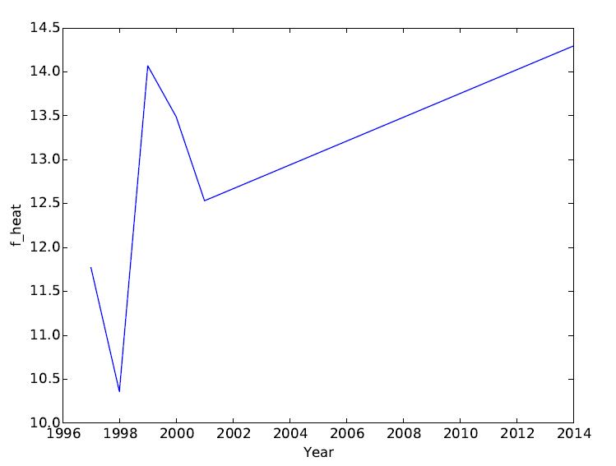

This plot shows the frequency of ‘hot’ days over time. Shows a consistent rise in the frequency of hot days

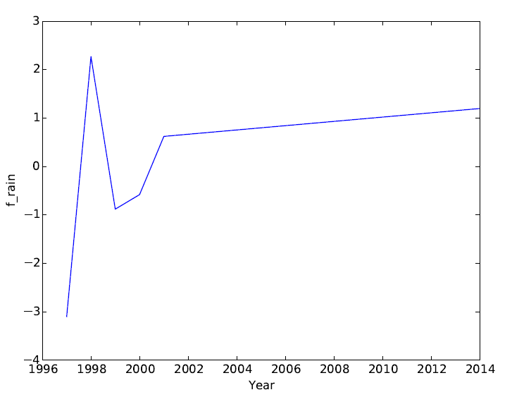

This plot shows the frequency of heavy rainfall events over time. Shows a trend towards more numerous, significant rainfall events.

**Discussion:**

The results suggest no correlation between the frequency of extremely hot days and conflict. These results are inconsistent with other research in on the subject. Heat has been demonstrated, in a laboratory setting, to make individuals more prone to aggression and frustration, which can lead to conflict (Anderson). A review of quantitative studies on climate change and conflict found strong evidence that some effects of climate change are correlated with the occurrence of conflict (Hsiang). This suggests that the method in this study could be improved. The data on climate could be improved. The data only had annual values for each variable, which meant it was necessary to condense the conflict data to the same time step. This likely caused the analysis to miss many small fluctuations that could affect conflict.

Models of climate change suggest that the frequency of ‘hot’ days, and the proportion of rainfall that falls during heavy events will increase into the future. These models forecast more severe heat, more severe weather, and thus more severe living conditions for people living in developing countries. Climate change will likely influence displacement of peoples due to the expected reduction in crop yield, sea level rise, or extreme weather (Reuveny). These effects may cause large areas of land to be largely uninhabitable. Another source of error is that this study does not include a way to measure, analyze or take migration into account during the data analysis.

Other possible causes of conflict are not influenced by climate, such as ideology or historical tensions. These other factors skew the certainty of these statistical tests, as they likely account for some of the conflicts that occurred. Other extreme climate variables have been examined for their correlation as well, such as fresh water supply or oil dependency. Such studies have found a positive correlation between the effects of climate change and the frequency of violent conflict (Nordas).

Such results suggest the need to alter the way we think about climate change solutions. Solutions must step beyond the developed world. The areas that may struggle the most, that may be at the highest risk *will not* be countries which have significant existing infrastructure. While, in the Western world, it is easy for policymakers to dismiss climate change as a distant threat (Nordas), in these vulnerable countries it will not be so easy to dismiss. The effects are being felt. Many studies analyze current crisis in the developing world in the context of climate change. Migration and displacement is a prevalent, current issue. Such population shifts, as well as general population growth will cause more competition for resources, and more pressure for people to take drastic action to secure those resources (Reuveny).

While the findings of studies like this are disputed, and sometimes inconclusive or conflicting (Hsiang), the problem does not stem from data analysis. It stems from insufficient, quality regional data on climate, and insufficient data on conflicts. While climate data is widely available, it does not disaggregate rates of change, or extremities at a regional level (Nordas). Data on conflicts is not comprehensive, and is rarely accurate. It is only possible to analyze conflicts known by news organizations, or governments. Conflicts which go unnoticed or unreported on an international level are not well documented. This lack of data makes it more difficult to have comprehensive, scientific studies on the relationship (Nordas).

The effects of climate change are widely accepted as serious. Governments around the world need to take significant action to curb the burning of fossil fuels. In large developed countries, solutions need to better understand the impact on more vulnerable countries. The true costs of climate change are uncertain. Policymakers dismiss mitigation efforts because of the immediate cost they have, economically and otherwise (Reuveny). This tension usually results in a passive approach to climate change; a “wait and see” mentality (Reuveny). Such a mindset is more extreme when the effects are felt by others, in other countries first. In the context of this research, it may be incredibly difficult to motivate action on climate change in developing countries.

Nonetheless, climate change will be the driving force for many crises. If significant action is not taken, the effects on the developing world will continue to worsen. Such changes have the potential to create disastrous human rights concerns. Displacement and conflict are predicted to increase into the future. Politicians and diplomats cannot afford to fall behind research on climate change. The most effective mitigation and adaption strategies will necessarily be based in existing, scientific research. The ability of institutions, governments and NGOs to combat climate change will depend on their ability to acknowledge and incorporate research into actions.

**References**

IPCC. Stocker, T.F., D. Qin, G.-K. Plattner, L.V. Alexander, S.K. Allen, N.L. Bindoff, F.-M. Bréon, J.A. Church, U. Cubasch, S. Emori, P. Forster, P. Friedlingstein, N. Gillett, J.M. Gregory, D.L. Hartmann, E. Jansen, B. Kirtman, R. Knutti, K. Krishna Kumar, P. Lemke, J. Marotzke, V. Masson-Delmotte, G.A. Meehl, I.I. Mokhov, S. Piao, V. Ramaswamy, D. Randall, M. Rhein, M. Rojas, C. Sabine, D. Shindell, L.D. Talley, D.G. Vaughan and S.-P. Xie, 2013: Technical Summary. In: Climate Change 2013: The Physical Science Basis. Contribution of Working Group I to the Fifth Assessment Report of the Intergovernmental Panel on Climate Change [Stocker, T.F., D. Qin, G.-K. Plattner, M. Tignor, S.K. Allen, J. Boschung, A. Nauels, Y. Xia, V. Bex and P.M. Midgley (eds.)]. Cambridge University Press, Cambridge, United Kingdom and New York, NY, USA.

Barnett, Jon, and W. Neil Adger. “Climate Change, Human Security and Violent Conflict.” Political Geography 26.6 (2007): 639–655. ScienceDirect. Web. 2 Nov. 2015. Climate Change and Conflict.

Hendrix, Cullen S., and Idean Salehyan. “Climate Change, Rainfall, and Social Conflict in Africa.” Journal of Peace Research 49.1 (2012): 35–50. jpr.sagepub.com. Web. 2 Nov. 2015.

Hsiang, Solomon M., Marshall Burke, and Edward Miguel. “Quantifying the Influence of Climate on Human Conflict.” Science 341.6151 (2013): 1235367. www.sciencemag.org. Web. 18 Nov. 2015.

Nordås, Ragnhild, and Nils Petter Gleditsch. “Climate Change and Conflict.” Political Geography 26.6 (2007): 627–638. ScienceDirect. Web. 2 Nov. 2015. Climate Change and Conflict.

Reuveny, Rafael. “Climate Change-Induced Migration and Violent Conflict.” Political Geography 26.6 (2007): 656–673. ScienceDirect. Web. 18 Nov. 2015. Climate Change and Conflict.

Anderson, Craig A. “Climate Change and Violence.” The Encyclopedia of Peace Psychology. Blackwell Publishing Ltd, 2011. Wiley Online Library. Web. 18 Nov. 2015.