Creación de la bbdd y los esquemas
/*
=============================================================
Create Database and Schemas
=============================================================
Script Purpose:
This script creates a new database named 'DataWarehouse' after checking if it already exists.
If the database exists, it is dropped and recreated. Additionally, the script sets up three schemas
within the database: 'bronze', 'silver', and 'gold'.

WARNING:
Running this script will drop the entire 'DataWarehouse' database if it exists.
All data in the database will be permanently deleted. Proceed with caution
and ensure you have proper backups before running this script.
*/

USE master;
GO

-- Drop and recreate the 'DataWarehouse' database
IF EXISTS (SELECT 1 FROM sys.databases WHERE name = 'DataWarehouse')
BEGIN
ALTER DATABASE DataWarehouse SET SINGLE_USER WITH ROLLBACK IMMEDIATE;
DROP DATABASE DataWarehouse;
END;
GO

-- Create the 'DataWarehouse' database
CREATE DATABASE DataWarehouse;
GO

USE DataWarehouse;
GO

-- Create Schemas
CREATE SCHEMA bronze;
GO

CREATE SCHEMA silver;
GO

CREATE SCHEMA gold;
GO

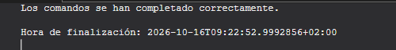

Creación de la capa de bronce

Crear las tablas Bronze
Creación de las tablas y comprobación de los campos creados
USE DataWarehouse;
GO

-- ===============================================================================
-- 7.1 CREAR LAS 6 TABLAS EN BRONZE
-- ===============================================================================
IF OBJECT_ID('bronze.crm_cust_info', 'U') IS NOT NULL
DROP TABLE bronze.crm_cust_info;
GO
CREATE TABLE bronze.crm_cust_info (
cst_id INT,
cst_key NVARCHAR(50),
cst_firstname NVARCHAR(50),
cst_lastname NVARCHAR(50),
cst_marital_status NVARCHAR(50),
cst_gndr NVARCHAR(50),
cst_create_date DATE
);
GO

IF OBJECT_ID('bronze.crm_prd_info', 'U') IS NOT NULL
DROP TABLE bronze.crm_prd_info;
GO
CREATE TABLE bronze.crm_prd_info (
prd_id INT,
prd_key NVARCHAR(50),
prd_nm NVARCHAR(50),
prd_cost INT,
prd_line NVARCHAR(50),
prd_start_dt DATETIME,
prd_end_dt DATETIME
);
GO

IF OBJECT_ID('bronze.crm_sales_details', 'U') IS NOT NULL
DROP TABLE bronze.crm_sales_details;
GO
CREATE TABLE bronze.crm_sales_details (
sls_ord_num NVARCHAR(50),
sls_prd_key NVARCHAR(50),
sls_cust_id INT,
sls_order_dt INT,
sls_ship_dt INT,
sls_due_dt INT,
sls_sales INT,
sls_quantity INT,
sls_price INT
);
GO

IF OBJECT_ID('bronze.erp_loc_a101', 'U') IS NOT NULL
DROP TABLE bronze.erp_loc_a101;
GO
CREATE TABLE bronze.erp_loc_a101 (
cid NVARCHAR(50),
cntry NVARCHAR(50)
);
GO

IF OBJECT_ID('bronze.erp_cust_az12', 'U') IS NOT NULL
DROP TABLE bronze.erp_cust_az12;
GO
CREATE TABLE bronze.erp_cust_az12 (
cid NVARCHAR(50),
bdate DATE,
gen NVARCHAR(50)
);
GO

IF OBJECT_ID('bronze.erp_px_cat_g1v2', 'U') IS NOT NULL
DROP TABLE bronze.erp_px_cat_g1v2;
GO
CREATE TABLE bronze.erp_px_cat_g1v2 (
id NVARCHAR(50),
cat NVARCHAR(50),
subcat NVARCHAR(50),
maintenance NVARCHAR(50)
);
GO

-- ===============================================================================
-- 7.4 CREAR EL PROCEDIMIENTO ALMACENADO DE CARGA (bronze.load_bronze)
-- ===============================================================================
CREATE OR ALTER PROCEDURE bronze.load_bronze AS
BEGIN
DECLARE @start_time DATETIME, @end_time DATETIME, @batch_start_time DATETIME, @batch_end_time DATETIME;
BEGIN TRY
SET @batch_start_time = GETDATE();
PRINT '================================================';
PRINT 'Loading Bronze Layer';
PRINT '================================================';

PRINT '------------------------------------------------';
PRINT 'Loading CRM Tables';
PRINT '------------------------------------------------';

SET @start_time = GETDATE();
PRINT '>> Truncating Table: bronze.crm_cust_info';
TRUNCATE TABLE bronze.crm_cust_info;
PRINT '>> Inserting Data Into: bronze.crm_cust_info';
BULK INSERT bronze.crm_cust_info
FROM 'C:\sql\dwh_project\datasets\source_crm\cust_info.csv'
WITH (
FIRSTROW = 2,
FIELDTERMINATOR = ',',
TABLOCK
);
SET @end_time = GETDATE();
PRINT '>> Load Duration: ' + CAST(DATEDIFF(second, @start_time, @end_time) AS NVARCHAR) + ' seconds';
PRINT '>> -------------';

SET @start_time = GETDATE();
PRINT '>> Truncating Table: bronze.crm_prd_info';
TRUNCATE TABLE bronze.crm_prd_info;
PRINT '>> Inserting Data Into: bronze.crm_prd_info';
BULK INSERT bronze.crm_prd_info
FROM 'C:\sql\dwh_project\datasets\source_crm\prd_info.csv'
WITH (
FIRSTROW = 2,
FIELDTERMINATOR = ',',
TABLOCK
);
SET @end_time = GETDATE();
PRINT '>> Load Duration: ' + CAST(DATEDIFF(second, @start_time, @end_time) AS NVARCHAR) + ' seconds';
PRINT '>> -------------';

SET @start_time = GETDATE();
PRINT '>> Truncating Table: bronze.crm_sales_details';
TRUNCATE TABLE bronze.crm_sales_details;
PRINT '>> Inserting Data Into: bronze.crm_sales_details';
BULK INSERT bronze.crm_sales_details
FROM 'C:\sql\dwh_project\datasets\source_crm\sales_details.csv'
WITH (
FIRSTROW = 2,
FIELDTERMINATOR = ',',
TABLOCK
);
SET @end_time = GETDATE();
PRINT '>> Load Duration: ' + CAST(DATEDIFF(second, @start_time, @end_time) AS NVARCHAR) + ' seconds';
PRINT '>> -------------';

PRINT '------------------------------------------------';
PRINT 'Loading ERP Tables';
PRINT '------------------------------------------------';

SET @start_time = GETDATE();
PRINT '>> Truncating Table: bronze.erp_loc_a101';
TRUNCATE TABLE bronze.erp_loc_a101;
PRINT '>> Inserting Data Into: bronze.erp_loc_a101';
BULK INSERT bronze.erp_loc_a101
FROM 'C:\sql\dwh_project\datasets\source_erp\loc_a101.csv'
WITH (
FIRSTROW = 2,
FIELDTERMINATOR = ',',
TABLOCK
);
SET @end_time = GETDATE();
PRINT '>> Load Duration: ' + CAST(DATEDIFF(second, @start_time, @end_time) AS NVARCHAR) + ' seconds';
PRINT '>> -------------';

SET @start_time = GETDATE();
PRINT '>> Truncating Table: bronze.erp_cust_az12';
TRUNCATE TABLE bronze.erp_cust_az12;
PRINT '>> Inserting Data Into: bronze.erp_cust_az12';
BULK INSERT bronze.erp_cust_az12
FROM 'C:\sql\dwh_project\datasets\source_erp\cust_az12.csv'
WITH (
FIRSTROW = 2,
FIELDTERMINATOR = ',',
TABLOCK
);
SET @end_time = GETDATE();
PRINT '>> Load Duration: ' + CAST(DATEDIFF(second, @start_time, @end_time) AS NVARCHAR) + ' seconds';
PRINT '>> -------------';

SET @start_time = GETDATE();
PRINT '>> Truncating Table: bronze.erp_px_cat_g1v2';
TRUNCATE TABLE bronze.erp_px_cat_g1v2;
PRINT '>> Inserting Data Into: bronze.erp_px_cat_g1v2';
BULK INSERT bronze.erp_px_cat_g1v2
FROM 'C:\sql\dwh_project\datasets\source_erp\px_cat_g1v2.csv'
WITH (
FIRSTROW = 2,
FIELDTERMINATOR = ',',
TABLOCK
);
SET @end_time = GETDATE();
PRINT '>> Load Duration: ' + CAST(DATEDIFF(second, @start_time, @end_time) AS NVARCHAR) + ' seconds';
PRINT '>> -------------';

SET @batch_end_time = GETDATE();
PRINT '==========================================';
PRINT 'Loading Bronze Layer is Completed';
PRINT ' - Total Load Duration: ' + CAST(DATEDIFF(SECOND, @batch_start_time, @batch_end_time) AS NVARCHAR) + ' seconds';
PRINT '==========================================';
END TRY
BEGIN CATCH
PRINT '==========================================';
PRINT 'ERROR OCCURED DURING LOADING BRONZE LAYER';
PRINT 'Error Message: ' + ERROR_MESSAGE();
PRINT 'Error Number: ' + CAST (ERROR_NUMBER() AS NVARCHAR);
PRINT 'Error State: ' + CAST (ERROR_STATE() AS NVARCHAR);
PRINT '==========================================';
END CATCH
END;
GO

-- ===============================================================================
-- EJECUTAR LA CARGA Y COMPROBAR FILAS
-- ===============================================================================
EXEC bronze.load_bronze;
GO

SELECT 'crm_cust_info' AS tabla, COUNT(*) AS filas FROM bronze.crm_cust_info UNION ALL
SELECT 'crm_prd_info', COUNT(*) FROM bronze.crm_prd_info UNION ALL
SELECT 'crm_sales_details', COUNT(*) FROM bronze.crm_sales_details UNION ALL
SELECT 'erp_cust_az12', COUNT(*) FROM bronze.erp_cust_az12 UNION ALL
SELECT 'erp_loc_a101', COUNT(*) FROM bronze.erp_loc_a101 UNION ALL
SELECT 'erp_px_cat_g1v2', COUNT(*) FROM bronze.erp_px_cat_g1v2;

Salida
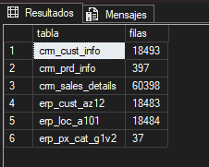

Carga de datos y revisión de ellos
-- ¿Llegaron todas las filas?
SELECT COUNT(*) AS filas FROM bronze.crm_cust_info; -- Esperado: 18494

-- ¿Cada valor está en su columna? Revisa visualmente las primeras filas
SELECT TOP 10 * FROM bronze.crm_cust_info;

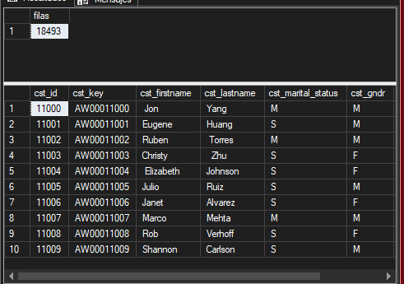

Capa silver

Crear tablas silver
/*
===============================================================================
DDL Script: Create Silver Tables
===============================================================================
Script Purpose:
This script creates tables in the 'silver' schema, dropping existing tables
if they already exist.
Run this script to re-define the DDL structure of 'bronze' Tables
===============================================================================
*/

IF OBJECT_ID('silver.crm_cust_info', 'U') IS NOT NULL
DROP TABLE silver.crm_cust_info;
GO

CREATE TABLE silver.crm_cust_info (
cst_id INT,
cst_key NVARCHAR(50),
cst_firstname NVARCHAR(50),
cst_lastname NVARCHAR(50),
cst_marital_status NVARCHAR(50),
cst_gndr NVARCHAR(50),
cst_create_date DATE,
dwh_create_date DATETIME2 DEFAULT GETDATE()
);
GO

IF OBJECT_ID('silver.crm_prd_info', 'U') IS NOT NULL
DROP TABLE silver.crm_prd_info;
GO

CREATE TABLE silver.crm_prd_info (
prd_id INT,
cat_id NVARCHAR(50),
prd_key NVARCHAR(50),
prd_nm NVARCHAR(50),
prd_cost INT,
prd_line NVARCHAR(50),
prd_start_dt DATE,
prd_end_dt DATE,
dwh_create_date DATETIME2 DEFAULT GETDATE()
);
GO

IF OBJECT_ID('silver.crm_sales_details', 'U') IS NOT NULL
DROP TABLE silver.crm_sales_details;
GO

CREATE TABLE silver.crm_sales_details (
sls_ord_num NVARCHAR(50),
sls_prd_key NVARCHAR(50),
sls_cust_id INT,
sls_order_dt DATE,
sls_ship_dt DATE,
sls_due_dt DATE,
sls_sales INT,
sls_quantity INT,
sls_price INT,
dwh_create_date DATETIME2 DEFAULT GETDATE()
);
GO

IF OBJECT_ID('silver.erp_loc_a101', 'U') IS NOT NULL
DROP TABLE silver.erp_loc_a101;
GO

CREATE TABLE silver.erp_loc_a101 (
cid NVARCHAR(50),
cntry NVARCHAR(50),
dwh_create_date DATETIME2 DEFAULT GETDATE()
);
GO

IF OBJECT_ID('silver.erp_cust_az12', 'U') IS NOT NULL
DROP TABLE silver.erp_cust_az12;
GO

CREATE TABLE silver.erp_cust_az12 (
cid NVARCHAR(50),
bdate DATE,
gen NVARCHAR(50),
dwh_create_date DATETIME2 DEFAULT GETDATE()
);
GO

IF OBJECT_ID('silver.erp_px_cat_g1v2', 'U') IS NOT NULL
DROP TABLE silver.erp_px_cat_g1v2;
GO

CREATE TABLE silver.erp_px_cat_g1v2 (
id NVARCHAR(50),
cat NVARCHAR(50),
subcat NVARCHAR(50),
maintenance NVARCHAR(50),
dwh_create_date DATETIME2 DEFAULT GETDATE()
);
GO

Salida
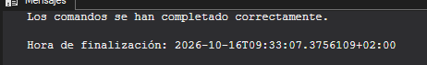

Clientes del crm
SELECT cst_id, COUNT(*) AS repeticiones
FROM bronze.crm_cust_info
GROUP BY cst_id
HAVING COUNT(*) > 1 OR cst_id IS NULL;

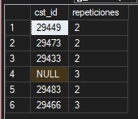

Datos sin duplicados
SELECT * FROM bronze.crm_cust_info WHERE cst_id = 29466 ORDER BY cst_create_date;

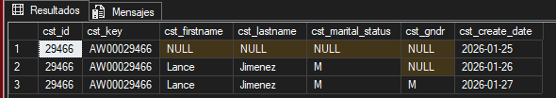

Creamos las reglas para los clientes

-- Espacios sobrantes en los textos
SELECT cst_firstname FROM bronze.crm_cust_info WHERE cst_firstname != TRIM(cst_firstname); -- 15 filas
SELECT cst_lastname FROM bronze.crm_cust_info WHERE cst_lastname != TRIM(cst_lastname); -- 17 filas

-- Valores distintos en columnas de baja cardinalidad
SELECT DISTINCT cst_marital_status FROM bronze.crm_cust_info; -- M, S, NULL
SELECT DISTINCT cst_gndr FROM bronze.crm_cust_info; -- M, F, NULL

Salida
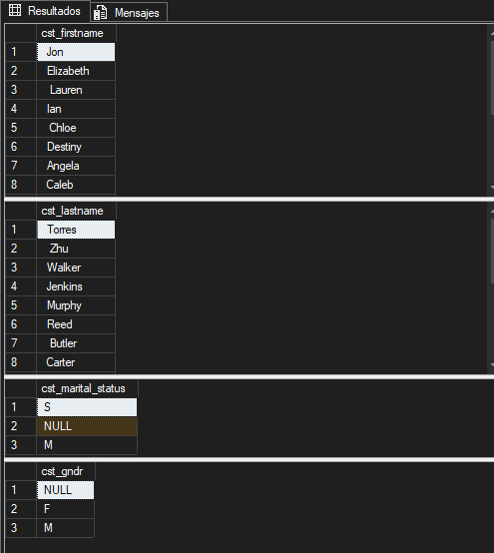

Trasformado
-- Extracto de scripts/silver/proc_load_silver.sql
TRUNCATE TABLE silver.crm_cust_info;
INSERT INTO silver.crm_cust_info (
cst_id,
cst_key,
cst_firstname,
cst_lastname,
cst_marital_status,
cst_gndr,
cst_create_date
)
SELECT
cst_id,
cst_key,
TRIM(cst_firstname) AS cst_firstname,
TRIM(cst_lastname) AS cst_lastname,
CASE
WHEN UPPER(TRIM(cst_marital_status)) = 'S' THEN 'Single'
WHEN UPPER(TRIM(cst_marital_status)) = 'M' THEN 'Married'
ELSE 'n/a'
END AS cst_marital_status, -- Normalize marital status values to readable format
CASE
WHEN UPPER(TRIM(cst_gndr)) = 'F' THEN 'Female'
WHEN UPPER(TRIM(cst_gndr)) = 'M' THEN 'Male'
ELSE 'n/a'
END AS cst_gndr, -- Normalize gender values to readable format
cst_create_date
FROM (
SELECT
*,
ROW_NUMBER() OVER (PARTITION BY cst_id ORDER BY cst_create_date DESC) AS flag_last
FROM bronze.crm_cust_info
WHERE cst_id IS NOT NULL
) t
WHERE flag_last = 1; -- Select the most recent record per customer

Salida

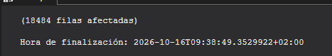

Productos del crm
SELECT prd_key,
SUBSTRING(prd_key, 1, 5) AS parte_categoria,
SUBSTRING(prd_key, 7, LEN(prd_key)) AS parte_producto
FROM bronze.crm_prd_info;

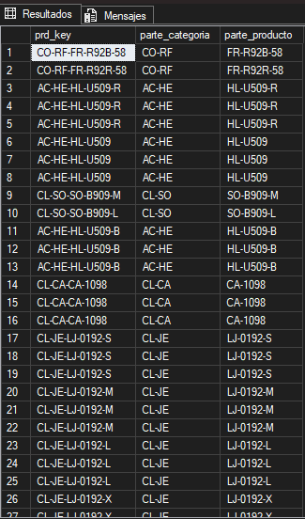

Separar las claves para la unión
-- Costes nulos o negativos
SELECT prd_id, prd_nm, prd_cost
FROM bronze.crm_prd_info
WHERE prd_cost IS NULL OR prd_cost < 0; -- 2 productos sin coste

-- Valores de la línea de producto (fíjate en el espacio final)
SELECT DISTINCT '[' + prd_line + ']' AS prd_line FROM bronze.crm_prd_info;
-- [M ], [R ], [S ], [T ], NULL

-- Fechas de fin anteriores a la de inicio
SELECT prd_key, prd_nm, prd_start_dt, prd_end_dt
FROM bronze.crm_prd_info
WHERE prd_end_dt < prd_start_dt; -- 200 filas

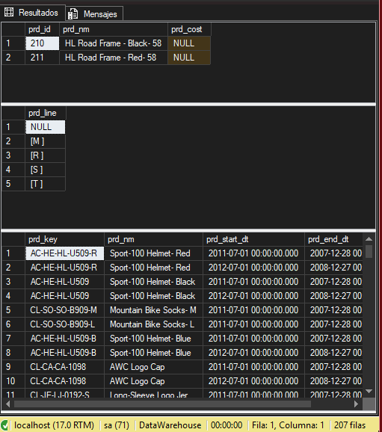

Crm ventas

SELECT sls_order_dt, COUNT(*) AS filas
FROM bronze.crm_sales_details
WHERE sls_order_dt <= 0 OR LEN(sls_order_dt) != 8
GROUP BY sls_order_dt;

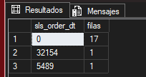

Detención de los datos incoherentes
SELECT sls_ord_num, sls_sales, sls_quantity, sls_price
FROM bronze.crm_sales_details
WHERE sls_sales != sls_quantity * sls_price
OR sls_sales IS NULL OR sls_quantity IS NULL OR sls_price IS NULL
OR sls_sales <= 0 OR sls_quantity <= 0 OR sls_price <= 0
ORDER BY sls_sales, sls_quantity, sls_price;

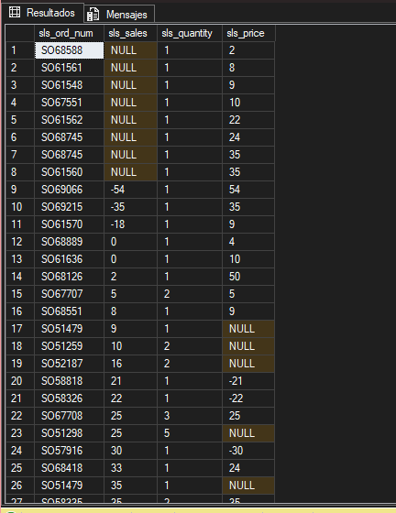

Transformación

-- Extracto de scripts/silver/proc_load_silver.sql
TRUNCATE TABLE silver.crm_sales_details;
INSERT INTO silver.crm_sales_details (
sls_ord_num,
sls_prd_key,
sls_cust_id,
sls_order_dt,
sls_ship_dt,
sls_due_dt,
sls_sales,
sls_quantity,
sls_price
)
SELECT
sls_ord_num,
sls_prd_key,
sls_cust_id,
CASE
WHEN sls_order_dt = 0 OR LEN(sls_order_dt) != 8 THEN NULL
ELSE CAST(CAST(sls_order_dt AS VARCHAR) AS DATE)
END AS sls_order_dt,
CASE
WHEN sls_ship_dt = 0 OR LEN(sls_ship_dt) != 8 THEN NULL
ELSE CAST(CAST(sls_ship_dt AS VARCHAR) AS DATE)
END AS sls_ship_dt,
CASE
WHEN sls_due_dt = 0 OR LEN(sls_due_dt) != 8 THEN NULL
ELSE CAST(CAST(sls_due_dt AS VARCHAR) AS DATE)
END AS sls_due_dt,
CASE
WHEN sls_sales IS NULL OR sls_sales <= 0 OR sls_sales != sls_quantity * ABS(sls_price)
THEN sls_quantity * ABS(sls_price)
ELSE sls_sales
END AS sls_sales, -- Recalculate sales if original value is missing or incorrect
sls_quantity,
CASE
WHEN sls_price IS NULL OR sls_price <= 0
THEN sls_sales / NULLIF(sls_quantity, 0)
ELSE sls_price -- Derive price if original value is invalid
END AS sls_price
FROM bronze.crm_sales_details;

Salida
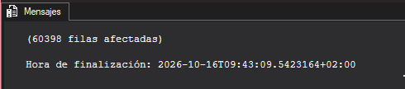

datos demográficos del ERP

-- La clave no casa con el CRM
SELECT TOP 5 cid FROM bronze.erp_cust_az12; -- NASAW00011000 ...

-- Fechas de nacimiento fuera de rango
SELECT bdate FROM bronze.erp_cust_az12
WHERE bdate < '1924-01-01' OR bdate > GETDATE(); -- Hay cumpleaños en 2042, 2050... e incluso 9999

-- Valores de género sin estandarizar
SELECT DISTINCT '[' + gen + ']' AS gen FROM bronze.erp_cust_az12;
-- [Male], [Female], [M], [F], [ ], NULL

Salida
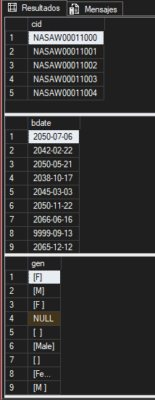

Trasformado
-- Extracto de scripts/silver/proc_load_silver.sql
TRUNCATE TABLE silver.erp_cust_az12;
INSERT INTO silver.erp_cust_az12 (
cid,
bdate,
gen
)
SELECT
CASE
WHEN cid LIKE 'NAS%' THEN SUBSTRING(cid, 4, LEN(cid)) -- Remove 'NAS' prefix if present
ELSE cid
END AS cid,
CASE
WHEN bdate > GETDATE() THEN NULL
ELSE bdate
END AS bdate, -- Set future birthdates to NULL
CASE
WHEN UPPER(TRIM(gen)) IN ('F', 'FEMALE') THEN 'Female'
WHEN UPPER(TRIM(gen)) IN ('M', 'MALE') THEN 'Male'
ELSE 'n/a'
END AS gen -- Normalize gender values and handle unknown cases
FROM bronze.erp_cust_az12;

Salida
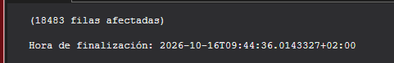

Integración en el crm

SELECT cid FROM silver.erp_cust_az12
WHERE cid NOT IN (SELECT cst_key FROM silver.crm_cust_info); -- 0 filas

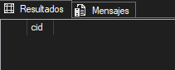

País del cliente
Detección y trasformado
SELECT DISTINCT cntry FROM bronze.erp_loc_a101 ORDER BY cntry;

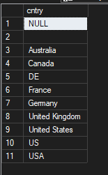

-- Extracto de scripts/silver/proc_load_silver.sql
TRUNCATE TABLE silver.erp_loc_a101;
INSERT INTO silver.erp_loc_a101 (
cid,
cntry
)
SELECT
REPLACE(cid, '-', '') AS cid,
CASE
WHEN TRIM(cntry) = 'DE' THEN 'Germany'
WHEN TRIM(cntry) IN ('US', 'USA') THEN 'United States'
WHEN TRIM(cntry) = '' OR cntry IS NULL THEN 'n/a'
ELSE TRIM(cntry)
END AS cntry -- Normalize and Handle missing or blank country codes
FROM bronze.erp_loc_a101;

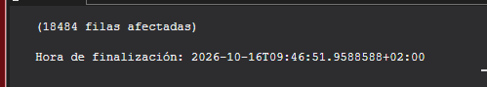

SELECT cntry, COUNT(*) FROM silver.erp_loc_a101 GROUP BY cntry

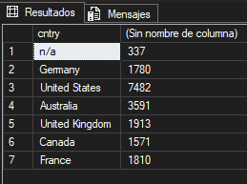

Categorías de productos
Detección
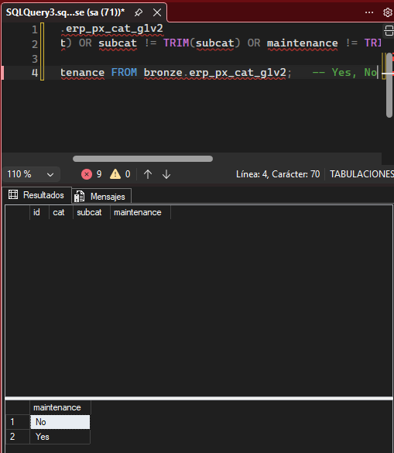

Trasformado
-- Extracto de scripts/silver/proc_load_silver.sql
TRUNCATE TABLE silver.erp_px_cat_g1v2;
INSERT INTO silver.erp_px_cat_g1v2 (
id,
cat,
subcat,
maintenance
)
SELECT
id,
cat,
subcat,
maintenance
FROM bronze.erp_px_cat_g1v2;

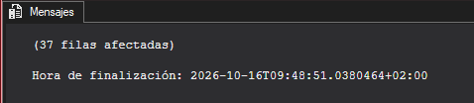

Comprobación de la integración
SELECT DISTINCT cat_id
FROM silver.crm_prd_info
WHERE cat_id NOT IN (SELECT id FROM silver.erp_px_cat_g1v2); -- CO_PE

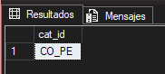

Automatización del proyecto

/*
===============================================================================
Stored Procedure: Load Silver Layer (Bronze -> Silver)
===============================================================================
Script Purpose:
This stored procedure performs the ETL (Extract, Transform, Load) process to
populate the 'silver' schema tables from the 'bronze' schema.
Actions Performed:
- Truncates Silver tables.
- Inserts transformed and cleansed data from Bronze into Silver tables.

Parameters:
None.
This stored procedure does not accept any parameters or return any values.

Usage Example:
EXEC Silver.load_silver;
===============================================================================
*/

CREATE OR ALTER PROCEDURE silver.load_silver AS
BEGIN
DECLARE @start_time DATETIME, @end_time DATETIME, @batch_start_time DATETIME, @batch_end_time DATETIME;
BEGIN TRY
SET @batch_start_time = GETDATE();
PRINT '================================================';
PRINT 'Loading Silver Layer';
PRINT '================================================';

PRINT '------------------------------------------------';
PRINT 'Loading CRM Tables';
PRINT '------------------------------------------------';

-- Loading silver.crm_cust_info
SET @start_time = GETDATE();
PRINT '>> Truncating Table: silver.crm_cust_info';
TRUNCATE TABLE silver.crm_cust_info;
PRINT '>> Inserting Data Into: silver.crm_cust_info';
INSERT INTO silver.crm_cust_info (
cst_id,
cst_key,
cst_firstname,
cst_lastname,
cst_marital_status,
cst_gndr,
cst_create_date
)
SELECT
cst_id,
cst_key,
TRIM(cst_firstname) AS cst_firstname,
TRIM(cst_lastname) AS cst_lastname,
CASE
WHEN UPPER(TRIM(cst_marital_status)) = 'S' THEN 'Single'
WHEN UPPER(TRIM(cst_marital_status)) = 'M' THEN 'Married'
ELSE 'n/a'
END AS cst_marital_status, -- Normalize marital status values to readable format
CASE
WHEN UPPER(TRIM(cst_gndr)) = 'F' THEN 'Female'
WHEN UPPER(TRIM(cst_gndr)) = 'M' THEN 'Male'
ELSE 'n/a'
END AS cst_gndr, -- Normalize gender values to readable format
cst_create_date
FROM (
SELECT
*,
ROW_NUMBER() OVER (PARTITION BY cst_id ORDER BY cst_create_date DESC) AS flag_last
FROM bronze.crm_cust_info
WHERE cst_id IS NOT NULL
) t
WHERE flag_last = 1; -- Select the most recent record per customer
SET @end_time = GETDATE();
PRINT '>> Load Duration: ' + CAST(DATEDIFF(SECOND, @start_time, @end_time) AS NVARCHAR) + ' seconds';
PRINT '>> -------------';

-- Loading silver.crm_prd_info
SET @start_time = GETDATE();
PRINT '>> Truncating Table: silver.crm_prd_info';
TRUNCATE TABLE silver.crm_prd_info;
PRINT '>> Inserting Data Into: silver.crm_prd_info';
INSERT INTO silver.crm_prd_info (
prd_id,
cat_id,
prd_key,
prd_nm,
prd_cost,
prd_line,
prd_start_dt,
prd_end_dt
)
SELECT
prd_id,
REPLACE(SUBSTRING(prd_key, 1, 5), '-', '_') AS cat_id, -- Extract category ID
SUBSTRING(prd_key, 7, LEN(prd_key)) AS prd_key, -- Extract product key
prd_nm,
ISNULL(prd_cost, 0) AS prd_cost,
CASE
WHEN UPPER(TRIM(prd_line)) = 'M' THEN 'Mountain'
WHEN UPPER(TRIM(prd_line)) = 'R' THEN 'Road'
WHEN UPPER(TRIM(prd_line)) = 'S' THEN 'Other Sales'
WHEN UPPER(TRIM(prd_line)) = 'T' THEN 'Touring'
ELSE 'n/a'
END AS prd_line, -- Map product line codes to descriptive values
CAST(prd_start_dt AS DATE) AS prd_start_dt,
CAST(
LEAD(prd_start_dt) OVER (PARTITION BY prd_key ORDER BY prd_start_dt) - 1
AS DATE
) AS prd_end_dt -- Calculate end date as one day before the next start date
FROM bronze.crm_prd_info;
SET @end_time = GETDATE();
PRINT '>> Load Duration: ' + CAST(DATEDIFF(SECOND, @start_time, @end_time) AS NVARCHAR) + ' seconds';
PRINT '>> -------------';

-- Loading crm_sales_details
SET @start_time = GETDATE();
PRINT '>> Truncating Table: silver.crm_sales_details';
TRUNCATE TABLE silver.crm_sales_details;
PRINT '>> Inserting Data Into: silver.crm_sales_details';
INSERT INTO silver.crm_sales_details (
sls_ord_num,
sls_prd_key,
sls_cust_id,
sls_order_dt,
sls_ship_dt,
sls_due_dt,
sls_sales,
sls_quantity,
sls_price
)
SELECT
sls_ord_num,
sls_prd_key,
sls_cust_id,
CASE
WHEN sls_order_dt = 0 OR LEN(sls_order_dt) != 8 THEN NULL
ELSE CAST(CAST(sls_order_dt AS VARCHAR) AS DATE)
END AS sls_order_dt,
CASE
WHEN sls_ship_dt = 0 OR LEN(sls_ship_dt) != 8 THEN NULL
ELSE CAST(CAST(sls_ship_dt AS VARCHAR) AS DATE)
END AS sls_ship_dt,
CASE
WHEN sls_due_dt = 0 OR LEN(sls_due_dt) != 8 THEN NULL
ELSE CAST(CAST(sls_due_dt AS VARCHAR) AS DATE)
END AS sls_due_dt,
CASE
WHEN sls_sales IS NULL OR sls_sales <= 0 OR sls_sales != sls_quantity * ABS(sls_price)
THEN sls_quantity * ABS(sls_price)
ELSE sls_sales
END AS sls_sales, -- Recalculate sales if original value is missing or incorrect
sls_quantity,
CASE
WHEN sls_price IS NULL OR sls_price <= 0
THEN sls_sales / NULLIF(sls_quantity, 0)
ELSE sls_price -- Derive price if original value is invalid
END AS sls_price
FROM bronze.crm_sales_details;
SET @end_time = GETDATE();
PRINT '>> Load Duration: ' + CAST(DATEDIFF(SECOND, @start_time, @end_time) AS NVARCHAR) + ' seconds';
PRINT '>> -------------';

-- Loading erp_cust_az12
SET @start_time = GETDATE();
PRINT '>> Truncating Table: silver.erp_cust_az12';
TRUNCATE TABLE silver.erp_cust_az12;
PRINT '>> Inserting Data Into: silver.erp_cust_az12';
INSERT INTO silver.erp_cust_az12 (
cid,
bdate,
gen
)
SELECT
CASE
WHEN cid LIKE 'NAS%' THEN SUBSTRING(cid, 4, LEN(cid)) -- Remove 'NAS' prefix if present
ELSE cid
END AS cid,
CASE
WHEN bdate > GETDATE() THEN NULL
ELSE bdate
END AS bdate, -- Set future birthdates to NULL
CASE
WHEN UPPER(TRIM(gen)) IN ('F', 'FEMALE') THEN 'Female'
WHEN UPPER(TRIM(gen)) IN ('M', 'MALE') THEN 'Male'
ELSE 'n/a'
END AS gen -- Normalize gender values and handle unknown cases
FROM bronze.erp_cust_az12;
SET @end_time = GETDATE();
PRINT '>> Load Duration: ' + CAST(DATEDIFF(SECOND, @start_time, @end_time) AS NVARCHAR) + ' seconds';
PRINT '>> -------------';

PRINT '------------------------------------------------';
PRINT 'Loading ERP Tables';
PRINT '------------------------------------------------';

-- Loading erp_loc_a101
SET @start_time = GETDATE();
PRINT '>> Truncating Table: silver.erp_loc_a101';
TRUNCATE TABLE silver.erp_loc_a101;
PRINT '>> Inserting Data Into: silver.erp_loc_a101';
INSERT INTO silver.erp_loc_a101 (
cid,
cntry
)
SELECT
REPLACE(cid, '-', '') AS cid,
CASE
WHEN TRIM(cntry) = 'DE' THEN 'Germany'
WHEN TRIM(cntry) IN ('US', 'USA') THEN 'United States'
WHEN TRIM(cntry) = '' OR cntry IS NULL THEN 'n/a'
ELSE TRIM(cntry)
END AS cntry -- Normalize and Handle missing or blank country codes
FROM bronze.erp_loc_a101;
SET @end_time = GETDATE();
PRINT '>> Load Duration: ' + CAST(DATEDIFF(SECOND, @start_time, @end_time) AS NVARCHAR) + ' seconds';
PRINT '>> -------------';

-- Loading erp_px_cat_g1v2
SET @start_time = GETDATE();
PRINT '>> Truncating Table: silver.erp_px_cat_g1v2';
TRUNCATE TABLE silver.erp_px_cat_g1v2;
PRINT '>> Inserting Data Into: silver.erp_px_cat_g1v2';
INSERT INTO silver.erp_px_cat_g1v2 (
id,
cat,
subcat,
maintenance
)
SELECT
id,
cat,
subcat,
maintenance
FROM bronze.erp_px_cat_g1v2;
SET @end_time = GETDATE();
PRINT '>> Load Duration: ' + CAST(DATEDIFF(SECOND, @start_time, @end_time) AS NVARCHAR) + ' seconds';
PRINT '>> -------------';

SET @batch_end_time = GETDATE();
PRINT '=========================================='
PRINT 'Loading Silver Layer is Completed';
PRINT ' - Total Load Duration: ' + CAST(DATEDIFF(SECOND, @batch_start_time, @batch_end_time) AS NVARCHAR) + ' seconds';
PRINT '=========================================='

END TRY
BEGIN CATCH
PRINT '=========================================='
PRINT 'ERROR OCCURED DURING LOADING BRONZE LAYER'
PRINT 'Error Message' + ERROR_MESSAGE();
PRINT 'Error Message' + CAST (ERROR_NUMBER() AS NVARCHAR);
PRINT 'Error Message' + CAST (ERROR_STATE() AS NVARCHAR);
PRINT '=========================================='
END CATCH
END

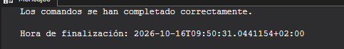
Ejecutamos el procedimiento
EXEC silver.load_silver;

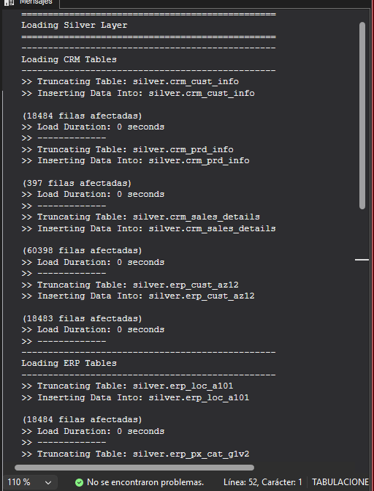

Validamos los resultados
/*
===============================================================================
Quality Checks
===============================================================================
Script Purpose:
This script performs various quality checks for data consistency, accuracy,
and standardization across the 'silver' layer. It includes checks for:
- Null or duplicate primary keys.
- Unwanted spaces in string fields.
- Data standardization and consistency.
- Invalid date ranges and orders.
- Data consistency between related fields.

Usage Notes:
- Run these checks after data loading Silver Layer.
- Investigate and resolve any discrepancies found during the checks.
===============================================================================
*/

-- ====================================================================
-- Checking 'silver.crm_cust_info'
-- ====================================================================
-- Check for NULLs or Duplicates in Primary Key
-- Expectation: No Results
SELECT
cst_id,
COUNT(*)
FROM silver.crm_cust_info
GROUP BY cst_id
HAVING COUNT(*) > 1 OR cst_id IS NULL;

-- Check for Unwanted Spaces
-- Expectation: No Results
SELECT
cst_key
FROM silver.crm_cust_info
WHERE cst_key != TRIM(cst_key);

-- Data Standardization & Consistency
SELECT DISTINCT
cst_marital_status
FROM silver.crm_cust_info;

-- ====================================================================
-- Checking 'silver.crm_prd_info'
-- ====================================================================
-- Check for NULLs or Duplicates in Primary Key
-- Expectation: No Results
SELECT
prd_id,
COUNT(*)
FROM silver.crm_prd_info
GROUP BY prd_id
HAVING COUNT(*) > 1 OR prd_id IS NULL;

-- Check for Unwanted Spaces
-- Expectation: No Results
SELECT
prd_nm
FROM silver.crm_prd_info
WHERE prd_nm != TRIM(prd_nm);

-- Check for NULLs or Negative Values in Cost
-- Expectation: No Results
SELECT
prd_cost
FROM silver.crm_prd_info
WHERE prd_cost < 0 OR prd_cost IS NULL;

-- Data Standardization & Consistency
SELECT DISTINCT
prd_line
FROM silver.crm_prd_info;

-- Check for Invalid Date Orders (Start Date > End Date)
-- Expectation: No Results
SELECT
*
FROM silver.crm_prd_info
WHERE prd_end_dt < prd_start_dt;

-- ====================================================================
-- Checking 'silver.crm_sales_details'
-- ====================================================================
-- Check for Invalid Dates
-- Expectation: No Invalid Dates
SELECT
NULLIF(sls_due_dt, 0) AS sls_due_dt
FROM bronze.crm_sales_details
WHERE sls_due_dt <= 0
OR LEN(sls_due_dt) != 8
OR sls_due_dt > 20500101
OR sls_due_dt < 19000101;

-- Check for Invalid Date Orders (Order Date > Shipping/Due Dates)
-- Expectation: No Results
SELECT
*
FROM silver.crm_sales_details
WHERE sls_order_dt > sls_ship_dt
OR sls_order_dt > sls_due_dt;

-- Check Data Consistency: Sales = Quantity * Price
-- Expectation: No Results
SELECT DISTINCT
sls_sales,
sls_quantity,
sls_price
FROM silver.crm_sales_details
WHERE sls_sales != sls_quantity * sls_price
OR sls_sales IS NULL
OR sls_quantity IS NULL
OR sls_price IS NULL
OR sls_sales <= 0
OR sls_quantity <= 0
OR sls_price <= 0
ORDER BY sls_sales, sls_quantity, sls_price;

-- ====================================================================
-- Checking 'silver.erp_cust_az12'
-- ====================================================================
-- Identify Out-of-Range Dates
-- Expectation: Birthdates between 1924-01-01 and Today
SELECT DISTINCT
bdate
FROM silver.erp_cust_az12
WHERE bdate < '1924-01-01'
OR bdate > GETDATE();

-- Data Standardization & Consistency
SELECT DISTINCT
gen
FROM silver.erp_cust_az12;

-- ====================================================================
-- Checking 'silver.erp_loc_a101'
-- ====================================================================
-- Data Standardization & Consistency
SELECT DISTINCT
cntry
FROM silver.erp_loc_a101
ORDER BY cntry;

-- ====================================================================
-- Checking 'silver.erp_px_cat_g1v2'
-- ====================================================================
-- Check for Unwanted Spaces
-- Expectation: No Results
SELECT
*
FROM silver.erp_px_cat_g1v2
WHERE cat != TRIM(cat)
OR subcat != TRIM(subcat)
OR maintenance != TRIM(maintenance);

-- Data Standardization & Consistency
SELECT DISTINCT
maintenance
FROM silver.erp_px_cat_g1v2;

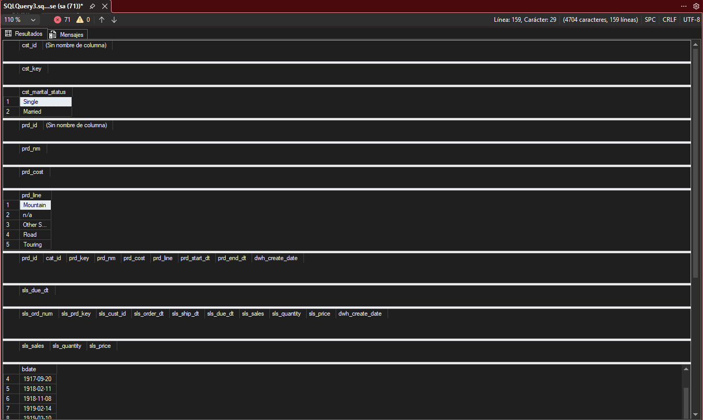
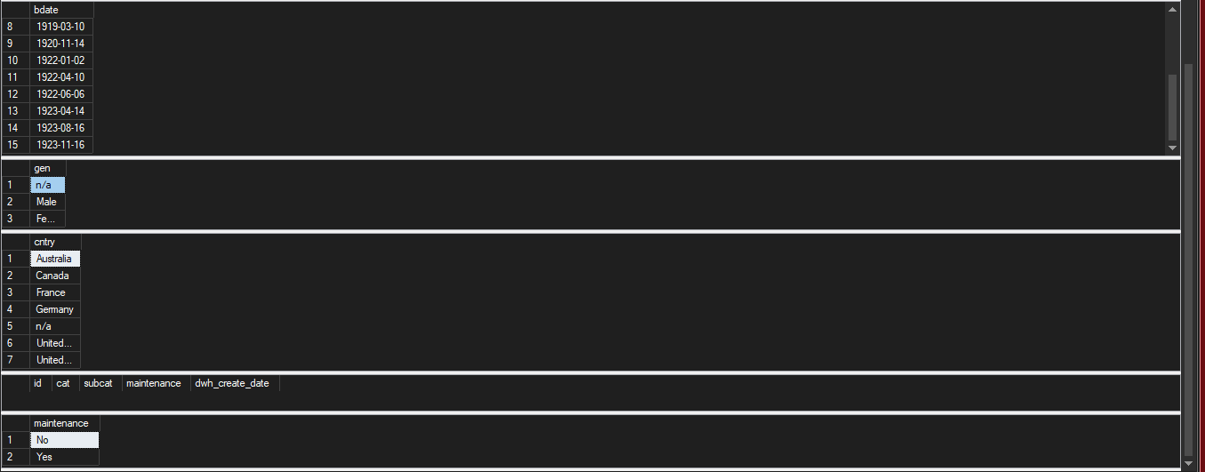

Capa gold modelo estrella

SELECT DISTINCT
ci.cst_gndr AS genero_crm,
ca.gen AS genero_erp
FROM silver.crm_cust_info ci
LEFT JOIN silver.erp_cust_az12 ca ON ci.cst_key = ca.cid
ORDER BY 1, 2;

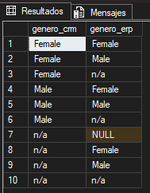

Solución de los nulls
/*
===============================================================================
DDL Script: Create Gold Views
===============================================================================
Script Purpose:
This script creates views for the Gold layer in the data warehouse.
The Gold layer represents the final dimension and fact tables (Star Schema)

Each view performs transformations and combines data from the Silver layer
to produce a clean, enriched, and business-ready dataset.

Usage:
- These views can be queried directly for analytics and reporting.
===============================================================================
*/

-- =============================================================================
-- Create Dimension: gold.dim_customers
-- =============================================================================
IF OBJECT_ID('gold.dim_customers', 'V') IS NOT NULL
DROP VIEW gold.dim_customers;
GO

CREATE VIEW gold.dim_customers AS
SELECT
ROW_NUMBER() OVER (ORDER BY cst_id) AS customer_key, -- Surrogate key
ci.cst_id AS customer_id,
ci.cst_key AS customer_number,
ci.cst_firstname AS first_name,
ci.cst_lastname AS last_name,
la.cntry AS country,
ci.cst_marital_status AS marital_status,
CASE
WHEN ci.cst_gndr != 'n/a' THEN ci.cst_gndr -- CRM is the primary source for gender
ELSE COALESCE(ca.gen, 'n/a') -- Fallback to ERP data
END AS gender,
ca.bdate AS birthdate,
ci.cst_create_date AS create_date
FROM silver.crm_cust_info ci
LEFT JOIN silver.erp_cust_az12 ca
ON ci.cst_key = ca.cid
LEFT JOIN silver.erp_loc_a101 la
ON ci.cst_key = la.cid;
GO

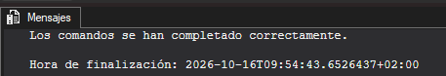

Capa gold de los porductos
-- =============================================================================
-- Create Dimension: gold.dim_products
-- =============================================================================
IF OBJECT_ID('gold.dim_products', 'V') IS NOT NULL
DROP VIEW gold.dim_products;
GO

CREATE VIEW gold.dim_products AS
SELECT
ROW_NUMBER() OVER (ORDER BY pn.prd_start_dt, pn.prd_key) AS product_key, -- Surrogate key
pn.prd_id AS product_id,
pn.prd_key AS product_number,
pn.prd_nm AS product_name,
pn.cat_id AS category_id,
pc.cat AS category,
pc.subcat AS subcategory,
pc.maintenance AS maintenance,
pn.prd_cost AS cost,
pn.prd_line AS product_line,
pn.prd_start_dt AS start_date
FROM silver.crm_prd_info pn
LEFT JOIN silver.erp_px_cat_g1v2 pc
ON pn.cat_id = pc.id
WHERE pn.prd_end_dt IS NULL; -- Filter out all historical data
GO

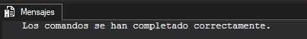

Capa gold de los productos
-- =============================================================================
-- Create Fact Table: gold.fact_sales
-- =============================================================================
IF OBJECT_ID('gold.fact_sales', 'V') IS NOT NULL
DROP VIEW gold.fact_sales;
GO

CREATE VIEW gold.fact_sales AS
SELECT
sd.sls_ord_num AS order_number,
pr.product_key AS product_key,
cu.customer_key AS customer_key,
sd.sls_order_dt AS order_date,
sd.sls_ship_dt AS shipping_date,
sd.sls_due_dt AS due_date,
sd.sls_sales AS sales_amount,
sd.sls_quantity AS quantity,
sd.sls_price AS price
FROM silver.crm_sales_details sd
LEFT JOIN gold.dim_products pr
ON sd.sls_prd_key = pr.product_number
LEFT JOIN gold.dim_customers cu
ON sd.sls_cust_id = cu.customer_id;
GO

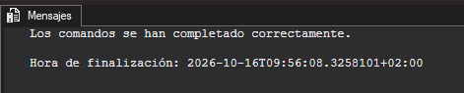
Validar el modelo
/*
===============================================================================
Quality Checks
===============================================================================
Script Purpose:
This script performs quality checks to validate the integrity, consistency,
and accuracy of the Gold Layer. These checks ensure:
- Uniqueness of surrogate keys in dimension tables.
- Referential integrity between fact and dimension tables.
- Validation of relationships in the data model for analytical purposes.

Usage Notes:
- Investigate and resolve any discrepancies found during the checks.
===============================================================================
*/

-- ====================================================================
-- Checking 'gold.dim_customers'
-- ====================================================================
-- Check for Uniqueness of Customer Key in gold.dim_customers
-- Expectation: No results
SELECT
customer_key,
COUNT(*) AS duplicate_count
FROM gold.dim_customers
GROUP BY customer_key
HAVING COUNT(*) > 1;

-- ====================================================================
-- Checking 'gold.product_key'
-- ====================================================================
-- Check for Uniqueness of Product Key in gold.dim_products
-- Expectation: No results
SELECT
product_key,
COUNT(*) AS duplicate_count
FROM gold.dim_products
GROUP BY product_key
HAVING COUNT(*) > 1;

-- ====================================================================
-- Checking 'gold.fact_sales'
-- ====================================================================
-- Check the data model connectivity between fact and dimensions
SELECT *
FROM gold.fact_sales f
LEFT JOIN gold.dim_customers c
ON c.customer_key = f.customer_key
LEFT JOIN gold.dim_products p
ON p.product_key = f.product_key
WHERE p.product_key IS NULL OR c.customer_key IS NULL

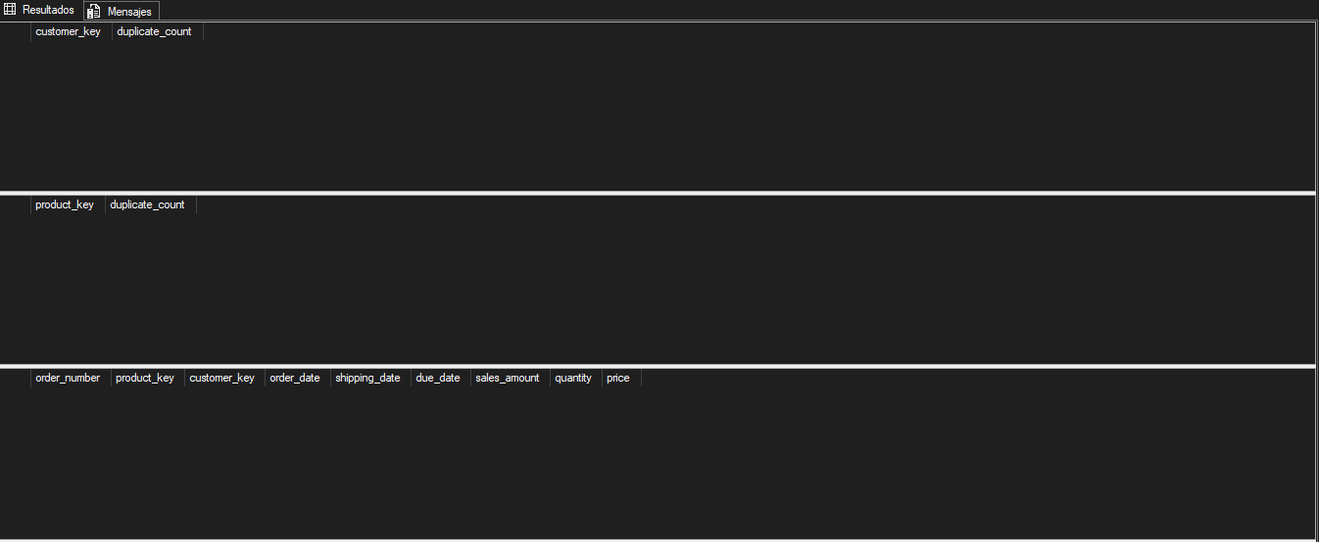

Comprobación de duplicados o perdida de datos

SELECT
(SELECT COUNT(*) FROM silver.crm_sales_details) AS filas_silver, -- 60.398
(SELECT COUNT(*) FROM gold.fact_sales) AS filas_gold; -- 60.398

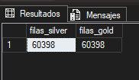

Orquestar la carga
USE DataWarehouse;
GO

EXEC bronze.load_bronze; -- 1. Fuentes → Bronze
EXEC silver.load_silver; -- 2. Bronze → Silver
-- 3. Gold no se carga: son vistas y reflejan Silver al instante

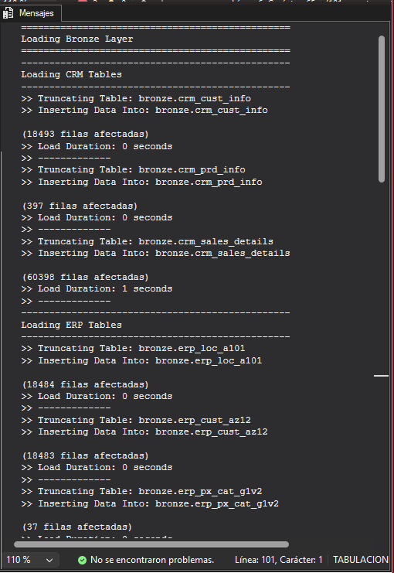
Crear el trabajo con t-sql
/* ============================================================
scripts/job_carga_diaria.sql
Crea el trabajo de SQL Server Agent que recarga el DWH cada día.
Requisitos: SQL Server Agent arrancado y permisos de lectura
sobre C:\sql\dwh_project\datasets para NT SERVICE\SQLSERVERAGENT (ver 10.2).
Antes, aplica en los dos procedimientos el cambio del CATCH (ver abajo).
============================================================ */
USE msdb;
GO

-- Si el trabajo ya existe, lo eliminamos para poder recrearlo
IF EXISTS (SELECT 1 FROM dbo.sysjobs WHERE name = N'DWH - Carga diaria')
EXEC dbo.sp_delete_job @job_name = N'DWH - Carga diaria';
GO

-- 1. El trabajo
EXEC dbo.sp_add_job
@job_name = N'DWH - Carga diaria',
@description = N'Recarga completa de las capas Bronze y Silver del DataWarehouse',
@enabled = 1;

-- 2. Paso 1: Bronze. Si termina bien, pasa al siguiente; si falla, el trabajo se detiene con error
EXEC dbo.sp_add_jobstep
@job_name = N'DWH - Carga diaria',
@step_name = N'1 - Cargar Bronze',
@subsystem = N'TSQL',
@database_name = N'DataWarehouse',
@command = N'EXEC bronze.load_bronze;',
@on_success_action = 3, -- 3 = ir al siguiente paso
@on_fail_action = 2; -- 2 = terminar el trabajo con error

-- 3. Paso 2: Silver. Solo se ejecuta si Bronze terminó bien
EXEC dbo.sp_add_jobstep
@job_name = N'DWH - Carga diaria',
@step_name = N'2 - Cargar Silver',
@subsystem = N'TSQL',
@database_name = N'DataWarehouse',
@command = N'EXEC silver.load_silver;',
@on_success_action = 1, -- 1 = terminar el trabajo con éxito
@on_fail_action = 2;

-- 4. Programación: todos los días a las 06:00
EXEC dbo.sp_add_schedule
@schedule_name = N'Diario 06:00',
@freq_type = 4, -- 4 = diario
@freq_interval = 1, -- cada 1 día
@active_start_time = 060000; -- formato HHMMSS

EXEC dbo.sp_attach_schedule
@job_name = N'DWH - Carga diaria',
@schedule_name = N'Diario 06:00';

-- 5. Asignar el trabajo a este servidor
EXEC dbo.sp_add_jobserver
@job_name = N'DWH - Carga diaria',
@server_name = N'(local)';
GO

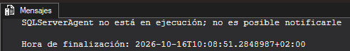

Exploración de la capa golg

Indicadores principales

SELECT
SUM(sales_amount) AS ventas_totales,
SUM(quantity) AS unidades_vendidas,
COUNT(DISTINCT order_number) AS pedidos,
COUNT(DISTINCT customer_key) AS clientes_con_compras
FROM gold.fact_sales;

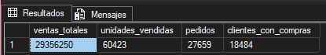

Rendimiento por categorías
SELECT
p.category,
SUM(f.sales_amount) AS ventas,
CAST(100.0 * SUM(f.sales_amount) / SUM(SUM(f.sales_amount)) OVER () AS DECIMAL(5,2)) AS pct_total
FROM gold.fact_sales f
JOIN gold.dim_products p ON f.product_key = p.product_key
GROUP BY p.category
ORDER BY ventas DESC;

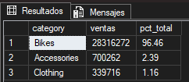

Comportamiento de los clientes
SELECT
c.country,
COUNT(DISTINCT c.customer_key) AS clientes,
SUM(f.sales_amount) AS ventas
FROM gold.fact_sales f
JOIN gold.dim_customers c ON f.customer_key = c.customer_key
GROUP BY c.country
ORDER BY ventas DESC;

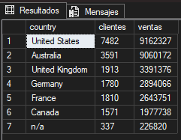

Ventas por año

SELECT
YEAR(order_date) AS anio,
SUM(sales_amount) AS ventas,
COUNT(DISTINCT customer_key) AS clientes
FROM gold.fact_sales
WHERE order_date IS NOT NULL
GROUP BY YEAR(order_date)
ORDER BY anio;

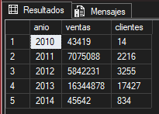

Top 5
SELECT TOP 5
p.product_name,
p.subcategory,
SUM(f.sales_amount) AS ventas
FROM gold.fact_sales f
JOIN gold.dim_products p ON f.product_key = p.product_key
GROUP BY p.product_name, p.subcategory
ORDER BY ventas DESC;

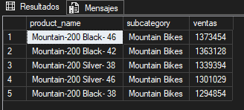

Perfil cliente

SELECT
gender,
marital_status,
COUNT(*) AS clientes
FROM gold.dim_customers
GROUP BY gender, marital_status
ORDER BY gender, marital_status;

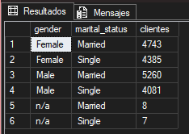

Pregunta de finanzas

SELECT COUNT(*) AS lineas_incoherentes
FROM gold.fact_sales
WHERE sales_amount IS NULL
OR sales_amount <= 0
OR sales_amount != quantity * price;

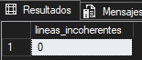

Ejercicio propuestos
Ejercicio 1

SELECT cst_id FROM silver.crm_cust_info
WHERE cst_firstname != TRIM(cst_firstname) OR cst_lastname != TRIM(cst_lastname);

SELECT DISTINCT cst_gndr FROM silver.crm_cust_info;
SELECT COUNT(*) AS ventas_fecha_nula
FROM silver.crm_sales_details
WHERE sls_order_dt IS NULL;

SELECT cid FROM silver.erp_cust_az12 WHERE cid NOT IN (SELECT cst_key FROM silver.crm_cust_info);
SELECT cid FROM silver.erp_loc_a101 WHERE cid NOT IN (SELECT cst_key FROM silver.crm_cust_info);

SELECT DISTINCT cat_id FROM silver.crm_prd_info
WHERE cat_id NOT IN (SELECT id FROM silver.erp_px_cat_g1v2);

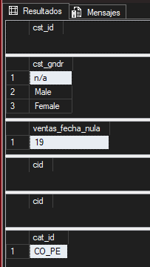

SELECT product_id, product_number, product_name, category_id
FROM gold.dim_products
WHERE category IS NULL;

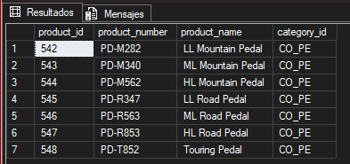

Ejercicio 2

IF OBJECT_ID('dbo.dwh_load_log', 'U') IS NOT NULL
DROP TABLE dbo.dwh_load_log;
GO

CREATE TABLE dbo.dwh_load_log (
log_id INT IDENTITY(1,1) PRIMARY KEY,
layer NVARCHAR(50),
table_name NVARCHAR(100),
rows_loaded INT,
start_time DATETIME,
end_time DATETIME,
status NVARCHAR(50),
error_message NVARCHAR(MAX)
);
GO

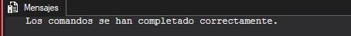

Ejercicio 3
SELECT
c.country,
SUM(f.sales_amount) AS ventas_totales,
COUNT(DISTINCT f.order_number) AS total_pedidos,
SUM(f.sales_amount) / NULLIF(COUNT(DISTINCT f.order_number), 0) AS ticket_medio
FROM gold.fact_sales f
JOIN gold.dim_customers c ON f.customer_key = c.customer_key
GROUP BY c.country
ORDER BY ticket_medio DESC;

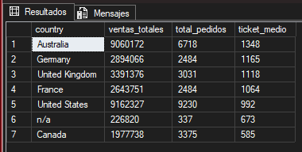

Ejercicio 4
IF OBJECT_ID('gold.report_customers', 'V') IS NOT NULL
DROP VIEW gold.report_customers;
GO

CREATE VIEW gold.report_customers AS
WITH customer_aggregates AS (
SELECT
c.customer_key,
c.customer_id,
c.customer_number,
c.first_name,
c.last_name,
c.country,
c.marital_status,
c.gender,
DATEDIFF(YEAR, c.birthdate, GETDATE()) AS age,
MIN(f.order_date) AS first_order_date,
MAX(f.order_date) AS last_order_date,
COUNT(DISTINCT f.order_number) AS total_orders,
SUM(f.sales_amount) AS total_sales
FROM gold.dim_customers c
LEFT JOIN gold.fact_sales f ON c.customer_key = f.customer_key
GROUP BY c.customer_key, c.customer_id, c.customer_number, c.first_name, c.last_name, c.country, c.marital_status, c.gender, c.birthdate
)
SELECT
customer_key,
customer_id,
customer_number,
first_name,
last_name,
country,
marital_status,
gender,
age,
first_order_date,
last_order_date,
total_orders,
ISNULL(total_sales, 0) AS total_sales,
DATEDIFF(MONTH, first_order_date, GETDATE()) AS customer_tenure_months,
CASE
WHEN ISNULL(total_sales, 0) > 5000 AND DATEDIFF(MONTH, first_order_date, GETDATE()) > 12 THEN 'VIP'
WHEN ISNULL(total_sales, 0) > 5000 OR DATEDIFF(MONTH, first_order_date, GETDATE()) > 12 THEN 'Regular'
ELSE 'New'
END AS customer_segment
FROM customer_aggregates;
GO

