Coap
Isaac Ntambu Kanda

Background
The main concept of this lab is for us to build a Coap message that will later be used to communicate to the coap.me broker via a UDP connection on port 5683.

Implementation

Message Header
The implementation started by first designing the structure of a coap message, having the version, message type, TKL(token length), method, message ID, token, options and payload. This was done using enums as shown in figure 1.

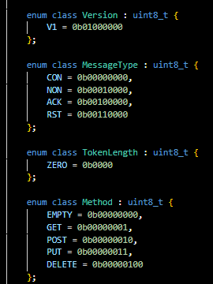
Figure 1: Implementation of the message parts using enums.

Coap client
The Coap client was responsible for making the connection to the coap.me broker this also included sending and receiving the data the coap.me broker sent back. The CoapClient class contained the DNS to the broker and port number which play a very vital roll in getting everything to work.

Connecting to broker
The client was able to create a UDP socket by using the “SOCKET_DGRAM” on port 5683 as shown in the figure below.
Figure 2: creating a socket.
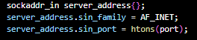
Figure 3: connecting the port.

Send Message
As stated before, the client class also had to be able to send a coap message to the broker and this how it was done as shown below. Our SendMessage function takes in a message instance, and from that instance we collet the message vector by using the get function and store it in a uint8_t vector as shown in the image, and with the help of the socket function send, the message was sent to coap.me broker.
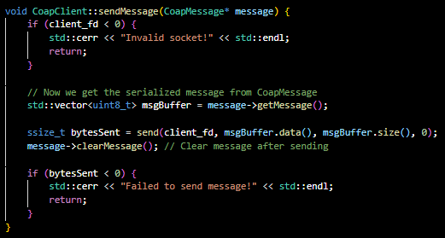

Receive Message
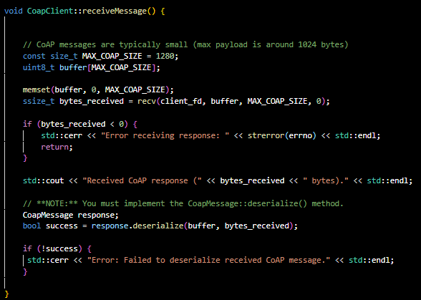

When coap.me responds, the client class receives the message and saves it inside an array and the bytes inside a ssize_t instance, which are later sent into the CoapMessage instance to be deserialized and extract the data.

Coap Message
One of default constructors CoapMessage takes in the method, path, and payload as inputs. This constructor helps us in building the building the actual message as shown in the figure below.
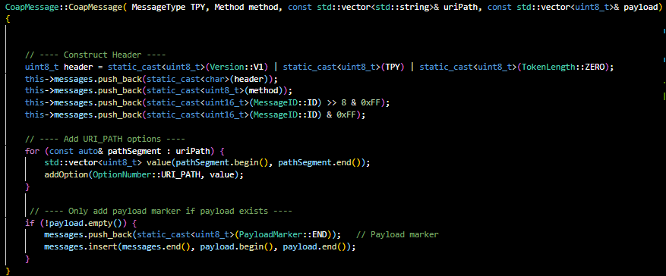

The CoapMessage class also contains a function to deserialize the response received from the coap.me server and finds the payload with the help of the payload marker and later prints it out.
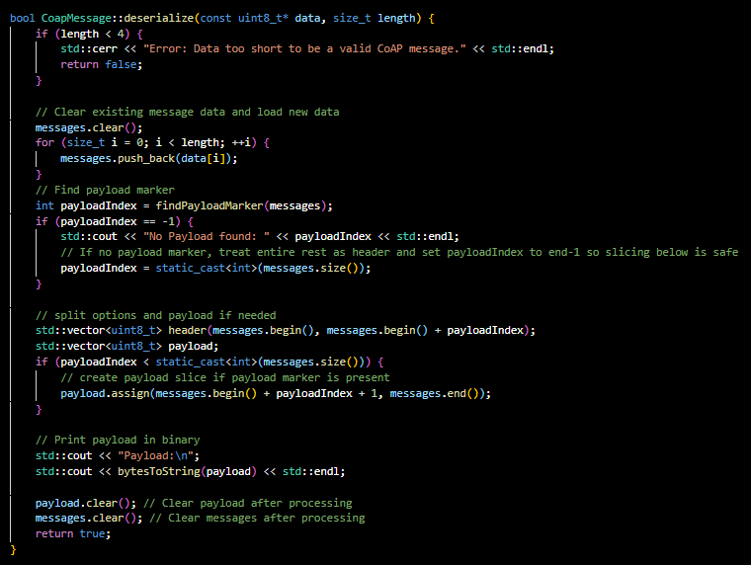

Lastly a function that helps us build the option structure and later sends it also inside the message vector.
