**Group Project Proposal Revision   
CIS 560: Database System Concepts**   
Jacob Koelzer Kaden O’Hare Isaac Peterson

**Introduction:**

This program is a tool for football fans or analysts to view a variety of stats pertaining to a season which includes game, team, and player stats. The user can choose between these types of stats in the GUI. There is a search option to find a specific player or team. A game can be found easier by filtering on the date.

Clicking on a player displays the stats for that player over the entire season. The total stats for a team can be viewed in a similar fashion. There’s also a button to view the top players over the entire season in terms of touchdowns, which can be filtered on total, passing, rushing, and receiving.

**Technical Description:**

The user interface is a windows forms desktop app with its logic layer written in C#. The backend database was made in Microsoft SQL Server Management Studio. The library System.Data.sqlclient was used to connect to the database.

**Database Design:**  
   
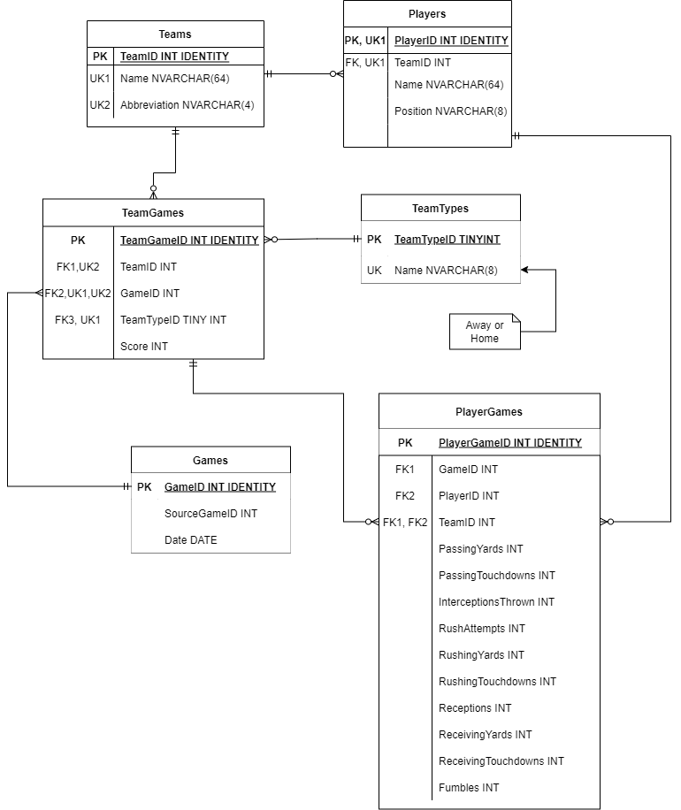

**System Design:**

(UML and Sequence)

**System Features and Usage:**

(Example scenarios with screenshots) Strengths and limitations

**Report Queries:**

**Summary And Discussion:**

* Completeness
* The database design had minimal changes from the proposal. None of the relationships were changed, but there were some changes to the columns. The biggest change was taking out all the defensive stats from the PlayerGame table and adding more offensive stats. This was done due to difficulty in finding per game defensive stats data for each player. Abbreviation was added to the Team table and SourceGameID to the Game table in order to get a connection to the staging tables. Location in team was taken out as well as FirstName and LastName in Player to combine into just Name. Finally, location was removed from the Game table as this was redundant.
* What we learned and what would change
* There are a ton of improvements that could be made on this program. The most obvious is adding defensive stats and players. Also, right now top players can only be listed in terms of touchdowns, but this could also be done on every stat. Expansions such as fantasy points as well as a game predictor based on advanced stats could be added. Due to the abundance of information and data from the NFL, there’s basically unlimited possibilities.