PRAVDHAN STORE
Complete Product, Frontend, Backend, Database, Architecture, Security, Testing, Audit & Release Documentation
Comprehensive Technical History and System Architecture — From Initial Development to Final Release Readiness
DOCUMENT CONTROL & REPOSITORY METADATA
Repository | isaacabnywork-ai/Pravardhan-Store (Product Name: Pravdhan Store)
Evaluation Branch | feature/batch-11.17-independent-final-acceptance
Synchronized HEAD | a28736f793ece9be405921da013e47aabd89fd10 (parent benchmark: 4921fff712307e31554f8dc481db9b11888770be)
Storefront Target | https://pravdhan-store.vercel.app
Operating Hub | Dark Store Hub #01, Sector 14, Model Town, Gurugram (Pincodes: 122001, 122002, 122003, 122018)
Documentation Scope | Part A (What We Have Built, Verified at HEAD) + Part B (What We Still Need to Build & Achieve)
Documentation Date | November 12, 2026
Architectural Note: Part A records strictly source-verified and test-verified architecture at HEAD a28736f. Part B clearly separates open launch blockers, future roadmaps, and proposed target architectures (all diagrams marked PROPOSED FUTURE ARCHITECTURE — NOT YET IMPLEMENTED).

Table of Contents

(Word native TOC field included above; right-click and select Update Field if page numbers do not auto-refresh on open.)
• Document Control & Evidence Standard
PART A — WHAT WE HAVE BUILT: Complete Historical, Architectural, Engineering, Security, Audit & Release Record
• 1. Project Overview and Original Vision
• 2. Repository Structure & Dual-Track Git History
• 3. Complete Technology Stack Inventory
• 4. Complete Frontend Architecture & Storefront Documentation
• 5. Backend Module Architecture & Complete API Surface (79 Route Handlers)
• 6. Database Architecture: Prisma Schema (25 Models, 14 Enums) & 6 SQL Migrations
• 7. Order Lifecycle, Checkout Idempotency, Financial Ledgers & Inventory
• 8. Security Architecture, RBAC, Cryptography & Durable OTP Outbox
• 9. Infrastructure Pipelines, Migration Runner, Analytics & Operational Modules
• 10. Complete Chronology, Batch Evolution & Independent Audit History
• 11. Verification, Automated Testing & Report Reconciliation Audit
• 12. Frontend Design Freeze Audit, GitHub Sync & Part A Evidence Summary
PART B — WHAT WE STILL NEED TO BUILD AND ACHIEVE: Target Future Architecture, Pre-Launch Blockers, Product Roadmaps & Scaling Strategy
• 13. Where Pravdhan Store Stands Today vs. Full Commercial Vision
• 14. Immediate P0 Security, Concurrency & Code-Hygiene Closure
• 15. Live Payments, Expired Checkout Cleanup & Persistent Wallet Ledger Roadmap
• 16. Dark Store Packer, Rider GPS Telemetry & Procurement/FEFO Roadmaps
• 17. Omnichannel Messaging, CRM/Loyalty, Native Android & Multi-Store Scaling
• 18. Six-Gate Pre-Launch Playbook, Open-Work Register & Status Matrix
• 19. Technical Appendices & Final Acceptance Sign-Off

Document Control & Evidence Standard
This specification constitutes the exhaustive historical, architectural, operational, security, financial, testing, audit, and roadmap technical reference for Pravdhan Store (Git repository: isaacabnywork-ai/Pravardhan-Store). Every technical statement in Part A is derived strictly from direct repository inspection against synchronized HEAD commit a28736f793ece9be405921da013e47aabd89fd10 (parent milestone commit 4921fff712307e31554f8dc481db9b11888770be) on branch feature/batch-11.17-independent-final-acceptance, as well as the full git history beginning at initial commit f423dbe355c381796625e886f7cf139668695808 (October 19, 2026).
Attribute | Verified Specification
Product Name | Pravdhan Store (Official storefront branding; repo slug: Pravardhan-Store)
Repository & Remote | https://github.com/isaacabnywork-ai/Pravardhan-Store.git
Active Branch & HEAD | feature/batch-11.17-independent-final-acceptance @ a28736f793ece9be405921da013e47aabd89fd10
Synchronized Benchmark Commit | 4921fff712307e31554f8dc481db9b11888770be (Batch 11.17 reconciled release report -> a28736f)
Frontend Freeze Baseline | 8edc2cddf84a7257931e591a12b31e8fbfb84ac2 (Batch 10.1; 4 UI files modified post-freeze for security/idempotency)
Production Storefront URL | https://pravdhan-store.vercel.app (hosting target; requires prod env secrets & infra configuration)
Target Fulfillment Hub | Dark Store Hub #01, Sector 14, Model Town, Gurugram (Pincodes: 122001, 122002, 122003, 122018)
Documentation Date | November 12, 2026
Release Acceptance Verdict | RELEASE READY WITH CONDITIONS (Code core verified; pre-launch infra, live PSP, CMS auth & E2E conditions open)

Evidence Classification Taxonomy
To eliminate ambiguity between implemented source code, test-proven invariants, unmerged feature experiments, historical report prose, and future roadmap requirements, every major capability claim in this document uses one of seven explicit classifications:
Classification Label | Definition & Verification Standard
Implemented and source-verified | Directly inspected and confirmed in TypeScript, SQL, Prisma schema, or Next.js routes at HEAD a28736f.
Implemented and test-verified | Verified both in source code AND by identifiable automated tests executed in this environment or documented DB runs.
Reported but not independently verified | Stated in historical Batch reports (e.g., live cloud DB stress runs or live production deployment metrics) without local runtime reproduction.
Partially implemented | Scaffolding, UI, or partial route logic exists on HEAD, but end-to-end production behavior is incomplete (e.g., Razorpay simulated UI modal, webhook optional sig check, in-memory CMS/FCM).
Pending operational configuration | Production-capable code exists and fails closed until secrets, vendor credentials, or paid hosting tiers are provisioned (e.g., MSG91, Vercel Pro cron, S3/Cloudinary, Sentry).
Not implemented | Absent from HEAD runtime and schema (though partial prototypes may exist on unmerged local branches such as feature/batch-4..8).
Historical issue corrected | Defect documented in earlier audits (Batch 8.1..11.15) whose code fix was verified directly in subsequent migrations or modules on HEAD.

PART A — WHAT WE HAVE BUILT
Complete Historical, Architectural, Engineering, Security, Audit & Release Record
Evidence-Verified State of Pravdhan Store from Initial Commit (Oct 19, 2026) through Batch 11.17 (Nov 12, 2026)

1. Project Overview and Original Vision
Pravdhan Store was conceived as a hyper-local quick-commerce grocery platform serving dense urban residential neighborhoods out of dedicated neighborhood micro-fulfillment dark stores, promising 12–15 minute doorstep delivery of daily essentials, fresh dairy, staples, beverages, snacks, and household goods. Unlike conventional scheduled-slot online grocers that pick from regional warehouses for next-day or multi-hour windows, Pravdhan Store centers inventory, picking, rider dispatch, and cash settlement inside a hyper-local Dark Store Hub.
Dimension | Conventional Online Grocery | Pravdhan Store Quick-Commerce Vision
Fulfillment Node | Large regional warehouse or supermarket partner | Hyper-local Dark Store Hub (#01 Model Town, Sector 14, Gurugram)
Service Radius / Area | Entire city via milk-run vans | Strict pincode geofence (122001, 122002, 122003, 122018) with <=15 min ETA
Order Economic Constraints | High minimum order value; free or flat slot delivery | Low friction: ₹100 min order (10000 paise) in seeded Hub #01, configurable deliveryFee/freeThreshold
Picking & Dispatch Cadence | Batch wave picking hours before slot | Real-time PLACED -> CONFIRMED -> PREPARING -> READY_FOR_PICKUP -> OUT_FOR_DELIVERY -> DELIVERED
Financial & Trust Controls | Manual reconciliation next day | Integer-paise server-authoritative totals, COD rider CashCollection ledger, Refund ledger, idempotent retries

1.1 Dark Store Hub #01 Operational Profile
Seed scripts (prisma/seed.ts) and serviceability configuration anchor initial operations at Dark Store Hub #01 in Sector 14, Model Town, Gurugram across four primary pincodes: 122001, 122002, 122003, and 122018. In README.md (original V1 specification), early configuration documented scheduled 2-hour delivery slots alongside instant express targets, ₹100 minimum order value, ₹0 default delivery fee, and seeded demo shortcuts. Across subsequent hardening phases through Batch 11.17, customer-facing slot/mock behaviors were streamlined to express checkout while backend transactional integrity, OTP cryptographic hardening, and financial ledgers became the central engineering focus.
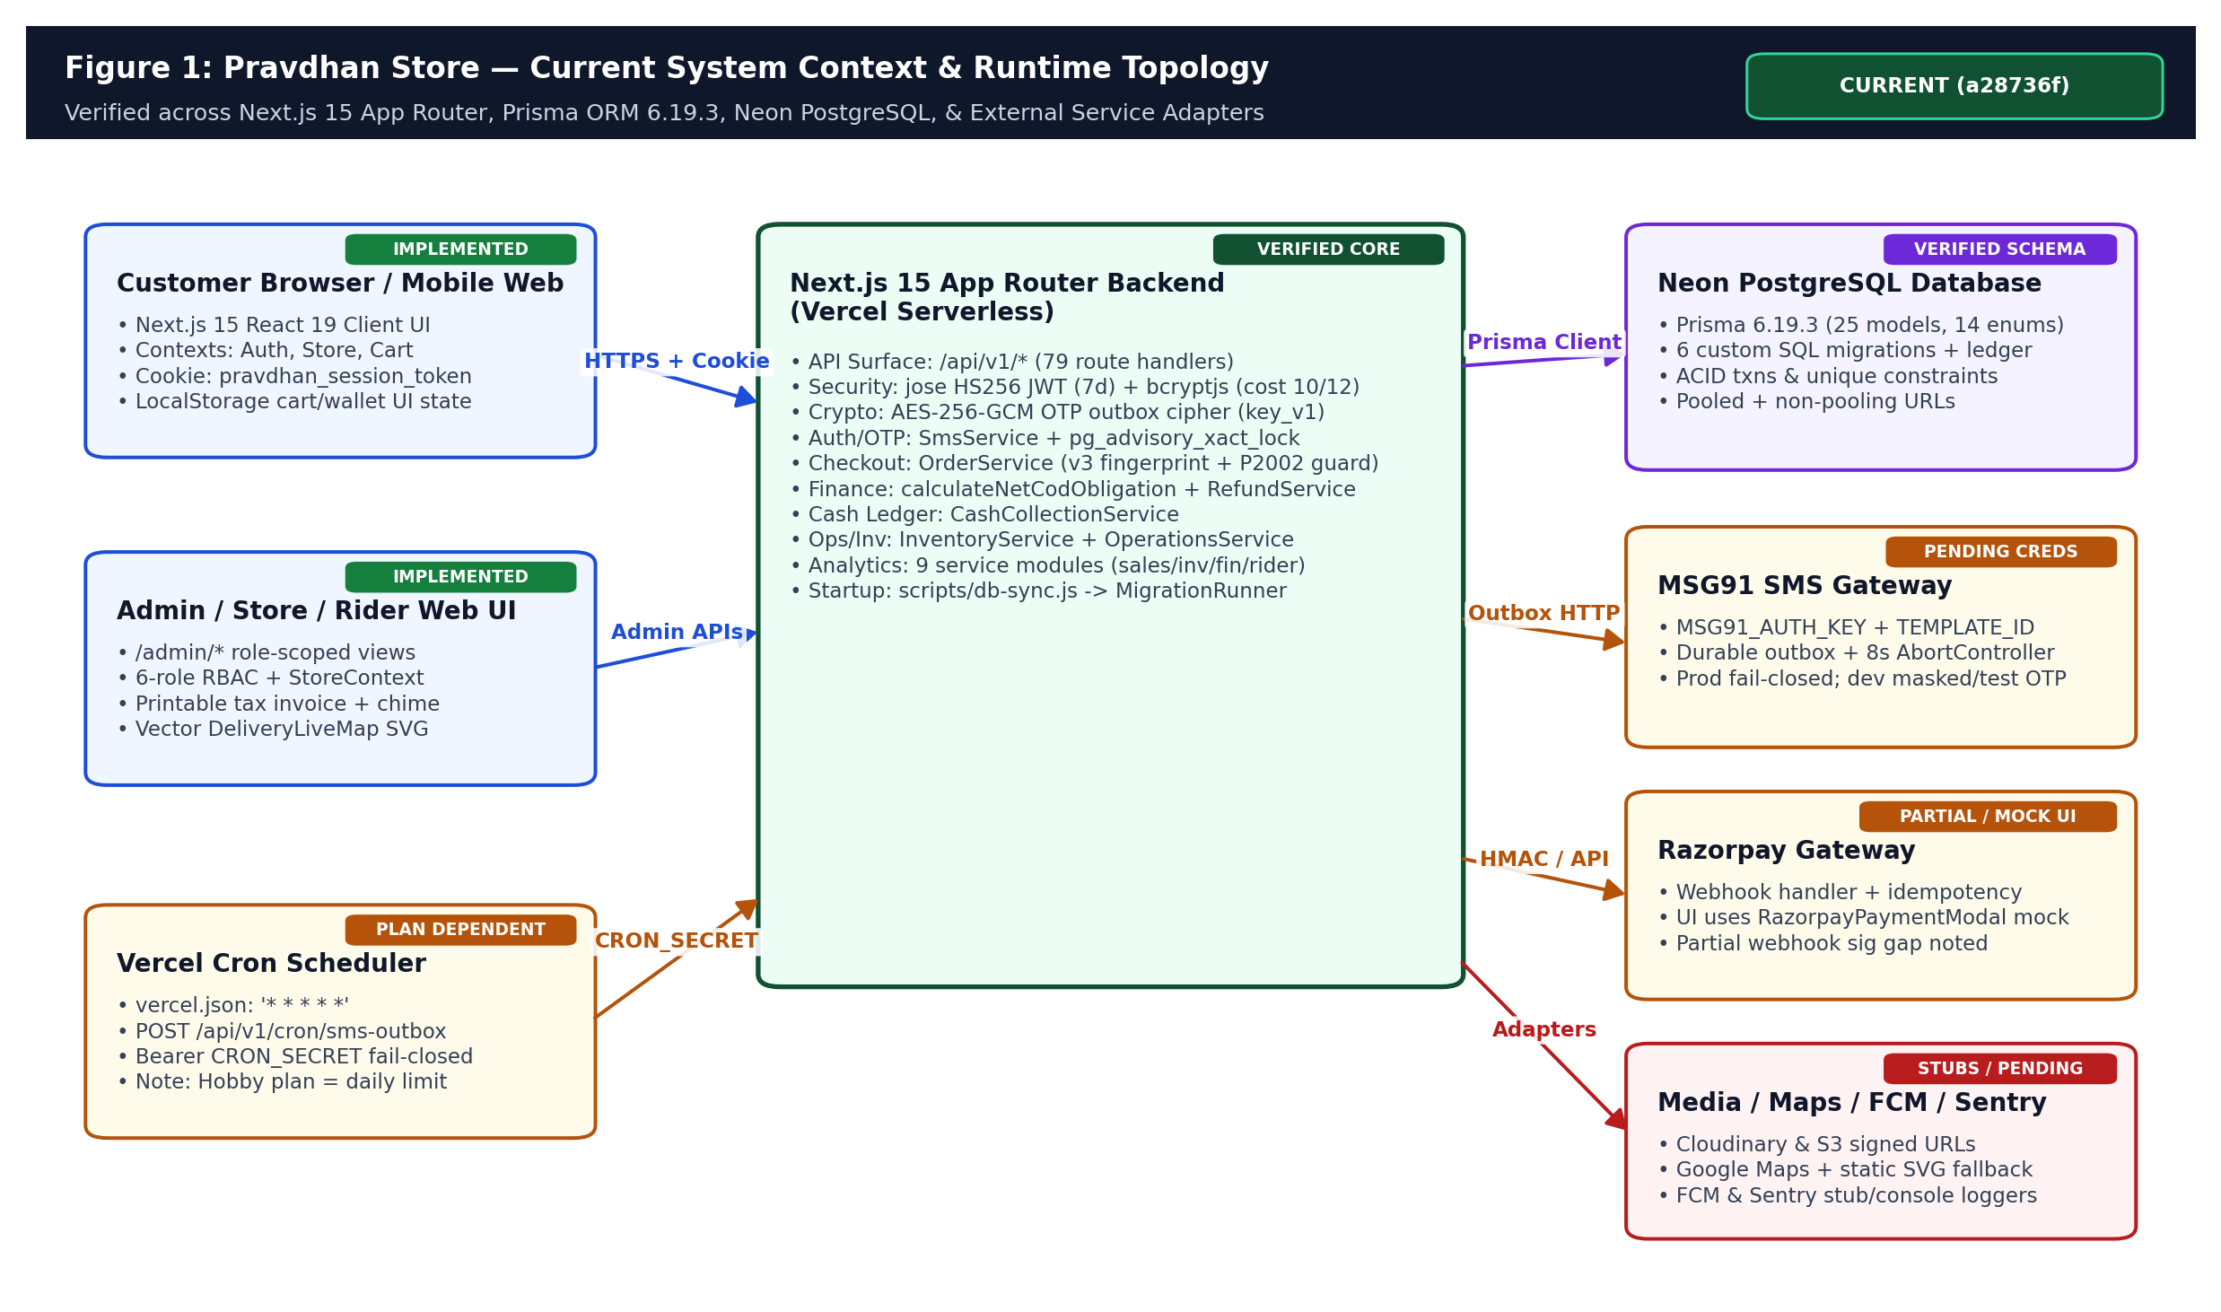
Figure 1: Pravdhan Store current runtime system context across web clients, Next.js 15 App Router backend, Neon PostgreSQL, and external service adapters.

2. Repository Structure & Dual-Track Git History
Critical Historical Discovery: Two Distinct Development Tracks in Local Git
Inspection of all 39 local git branches reveals two divergent tracks branching off main (commit 3783371, Nov 3, 2026). An unmerged local prototype track (feature/phase-1-security-hardening through feature/batch-8-analytics-business-intelligence, commits 309cb6c..3884170) implemented extensive schemas for PurchaseOrders, FEFO InventoryBatch, Wallet, RiderEarning, LoyaltyAccount, and Referrals — NONE of which were ever merged into origin or HEAD. Instead, origin progressed sequentially from 3783371 -> 878898b -> Batch 8 -> Batch 9 -> Batch 10 (8edc2cd) -> Batch 11.1..11.17 -> a28736f.

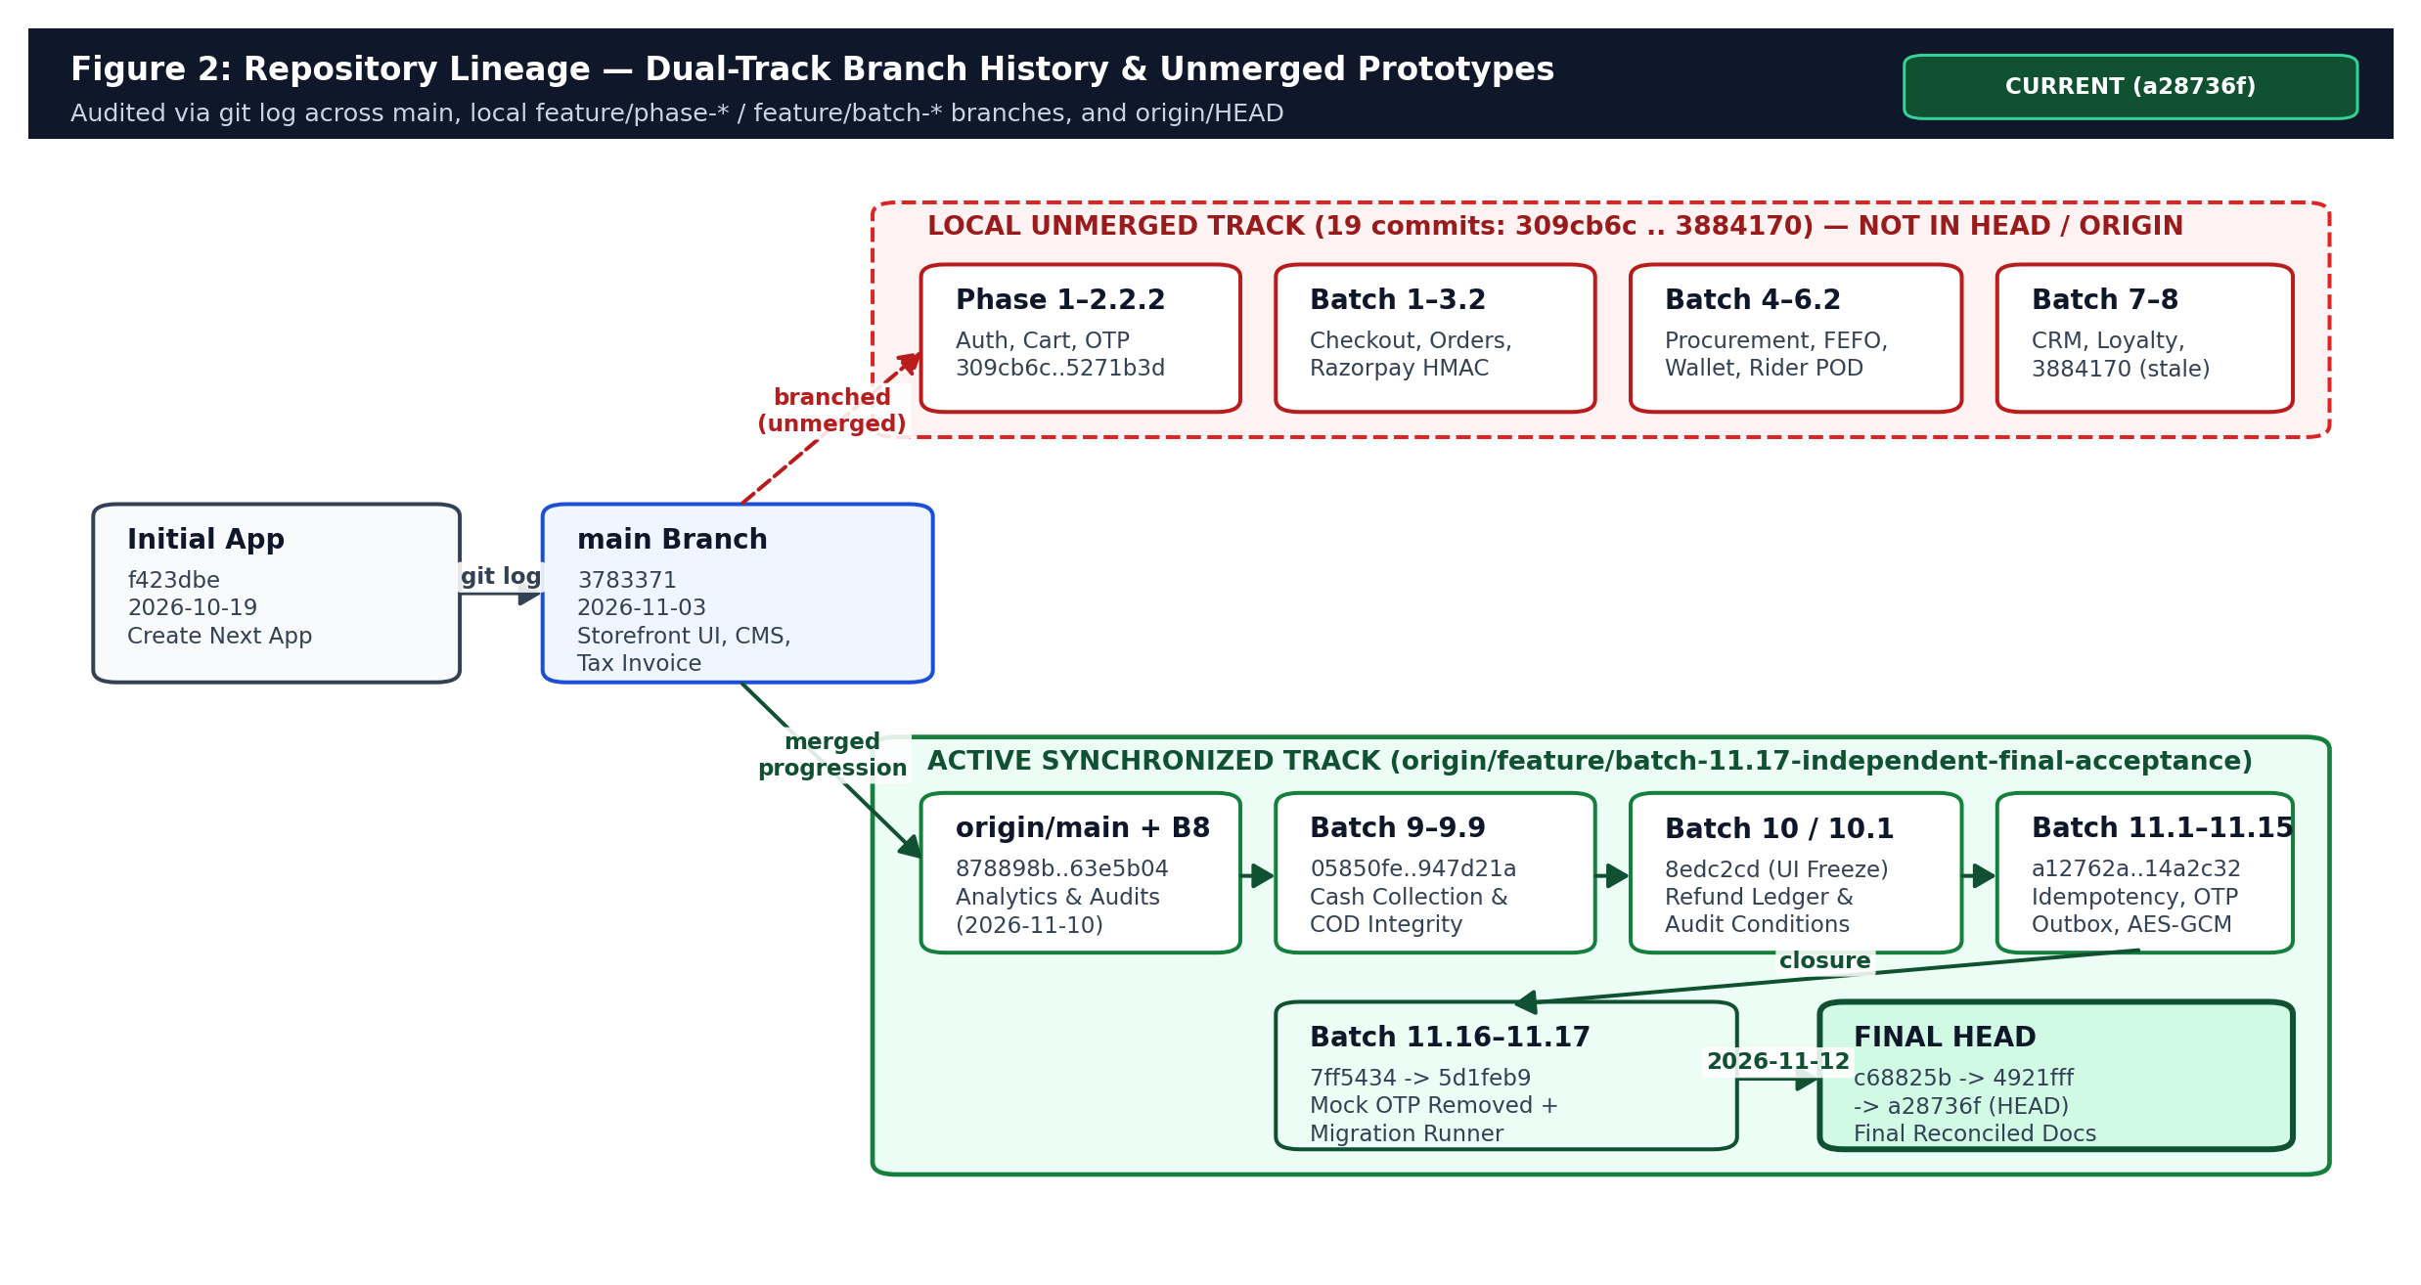
Figure 2: Dual-track git history showing unmerged local Batch 1-8 prototypes versus the synchronized origin Batch 8-11.17 production-hardening track.
Understanding this split prevents a critical onboarding misconception: a new engineer seeing local branches like feature/batch-5-pravdhan-money-wallet or feature/batch-4-inventory-procurement might assume Wallet, Supplier, or FEFO tables exist in production schema.prisma. Direct inspection confirms HEAD contains 25 models and 14 enums without Wallet, PurchaseOrder, Supplier, Loyalty, or Referral tables. Those unmerged prototypes provide architectural inspiration for Part B, not active HEAD features.

3. Complete Technology Stack Inventory
Every technology version below is verified directly from package.json, next.config.ts, vercel.json, and prisma/schema.prisma.
Layer | Technology / Library | Verified Purpose | Actual Implementation Status (HEAD a28736f)
Full-Stack Framework | Next.js ^15.3.9 (App Router), React ^19.0.0, TypeScript ^5 | SSR/RSC storefront, admin views, /api/v1/* Route Handlers | Implemented and source-verified (121 Next App/API files)
Styling & UI Icons | Tailwind CSS ^3.4.1, lucide-react ^1.59.0, clsx, tailwind-merge | Responsive storefront, mobile nav, admin dashboards, print styles | Implemented and source-verified
Database & ORM | PostgreSQL (Neon), Prisma ^6.19.3 + custom MigrationRunner | Relational persistence (25 models, 14 enums, 6 SQL migrations) | Implemented and source-verified; npx prisma validate passes
Schema Validation | Zod ^4.6.7 | API DTO schemas, env validation, canonical order fingerprint inputs | Implemented and source-verified
Auth & Cryptography | jose ^6.2.13 (HS256 JWT), bcryptjs ^3.0.3, Node crypto AES-256-GCM | 7d HTTP-only & Bearer JWT, OTP/password hashes, outbox encryption | Implemented and test-verified
Payment Gateway | Razorpay (webhooks + RazorpayPaymentModal mock UI) | Prepaid UPI/Card capture and refund webhook ingestion | Partially implemented (UI uses simulated Test Mode modal; /pay lacks HMAC; webhook sig conditional)
SMS / OTP Delivery | MSG91 REST v5 API via SmsService + SmsDeliveryJob outbox | OTP delivery with pg_advisory_xact_lock, 3x retry, fencing token | Pending operational configuration (fails closed without creds in prod)
Media & Storage | StorageService (AWS S3 / Cloudinary presigned config adapters) | Proof-of-Delivery & product image uploads | Pending operational configuration (fails closed in prod without keys)
Maps & Push & APM | GoogleMapsService + SVG DeliveryLiveMap, FcmService, Sentry stub | Serviceability/ETA estimation, vector tracking map, push logs | Partially implemented / Stubs (FcmService uses in-memory Map; Sentry logs to console)
Testing & Tooling | tsx ^4.23.15, Node assert scripts, Python HTTP test scripts, ESLint ^9 | Unit/mock suites (13 files), SQL/Prisma suites (11 files), lint | Implemented (18/18 npm test pass; lint exits 0 with warnings; no Playwright/Vitest)
Hosting & Cron | Vercel Serverless + vercel.json cron (* * * * * -> /api/v1/cron/sms-outbox) | Storefront/API deployment and automated outbox recovery | Pending operational configuration (requires Vercel Pro for 1-min cron frequency)

4. Complete Frontend Architecture & Storefront Documentation
The frontend spans 41 page/layout files under src/app/ and 18 UI component files under src/components/, orchestrated around five React Context providers in src/lib/context/: ThemeContext, AuthContext, StoreContext, CartContext, and CmsContext.
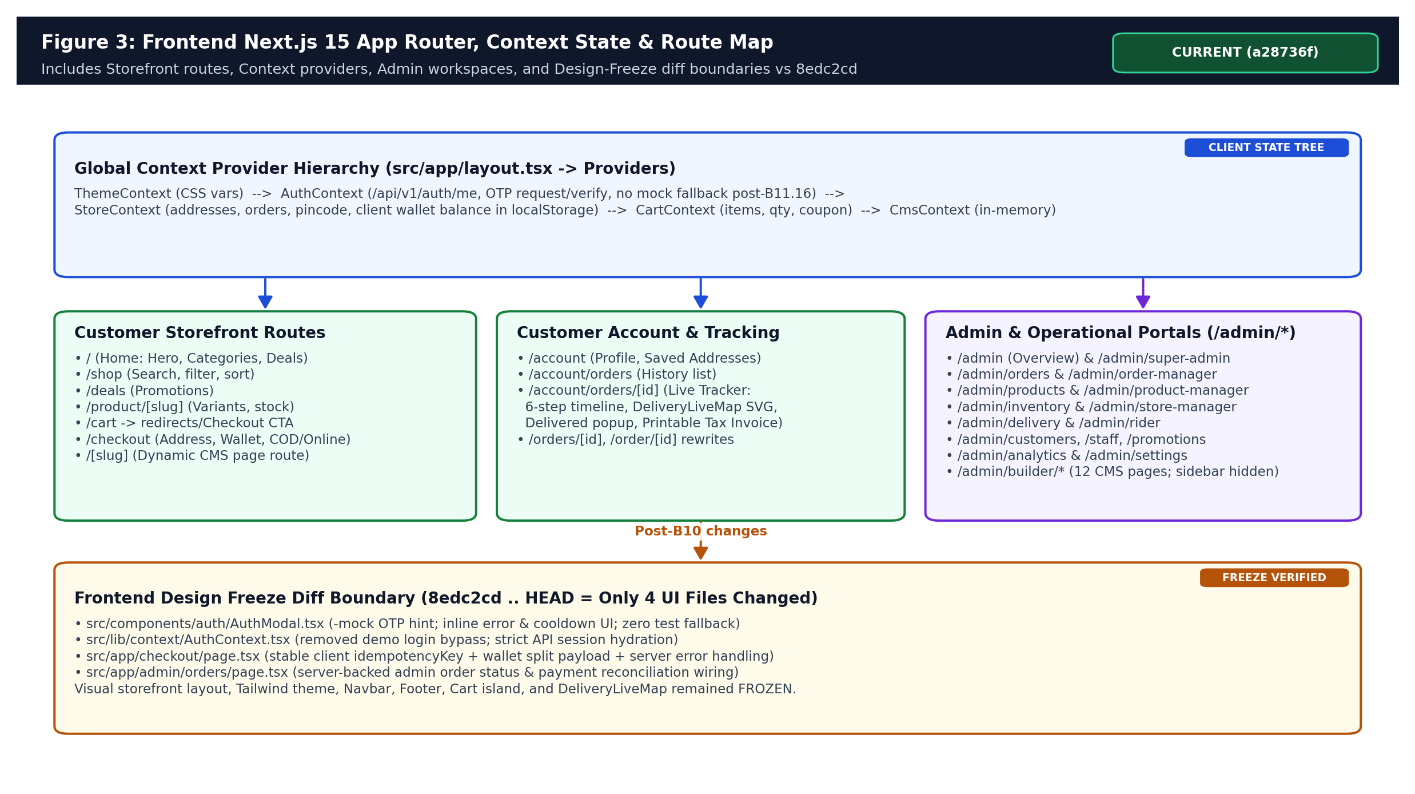
Figure 3: Frontend Next.js 15 App Router structure, React Context provider hierarchy, and post-Batch 10.1 Design Freeze diff boundary.

4.1 Customer Storefront Routes & Product Discovery
- Home (/ - src/app/page.tsx): Renders hero banner carousel (HeroBannerCarousel.tsx), category explorer (ExploreCategoriesGrid.tsx), promotional deal showcases (OfferDealsShowcase.tsx), and announcement/popup modals.
- Shop & Filtering (/shop): Paginated product catalog backed by /api/v1/products & CatalogService with category slug, subcategory slug, brand, search query, sort order, and featured/popular filters.
- Deals (/deals) & Product Details (/product/[slug]): Displays variants (weight/pack size), MRP vs selling price in formatted INR (integer paise / 100), stock availability, and add-to-cart controls.
- Navigation & Sticky Cart: Desktop Navbar with SearchBar and LocationConfirmModal (validating Hub #01 pincodes via /api/v1/serviceability), paired with MobileBottomNav and FloatingCart island (#105132); /cart and View Cart flow routes users cleanly toward /checkout.
- Dynamic CMS Catch-All (/[slug]): Renders page definitions served from CmsContext/CmsService (note: CMS sidebar links were hidden from admin in commit 2e109e4 and CMS persistence remains in-memory).

4.2 Customer Cart, Checkout Flow & Reconciliation
Cart management combines client-side responsiveness in CartContext (items, quantities, applied coupon) with server persistence endpoints (/api/v1/cart, /api/v1/cart/items, /api/v1/cart/coupons). At /checkout (src/app/checkout/page.tsx), the client collects:
- Delivery Address: Saved Address selection via /api/v1/me/addresses or inline street, landmark, city, state, pincode, and phone.
- Coupon & Tip: Optional couponCode validated server-side via Coupon model plus optional deliveryTip.
- Wallet Toggle & Payment Method: Supports Pravdhan Money balance deduction combined with COD, UPI, CARD, or NET_BANKING.
- Idempotent Submission: Generates a deterministic/stable client idempotencyKey and POSTs to /api/v1/orders. The backend ignores client-submitted prices, recomputes every line item from live ProductVariant.price and Store fee thresholds, decrements inventory atomically, and returns the authoritative Order object.

4.3 Customer Authentication & Post-Batch 11.16 Hardening
Customer authentication (AuthModal.tsx + AuthContext.tsx) enforces Indian 10-digit/E.164 phone OTP verification backed by /api/v1/auth/otp/request and /api/v1/auth/otp/verify (with compatibility aliases /api/v1/auth/send-otp and /api/v1/auth/verify-otp). Historically, README.md and early development allowed demo test-OTP hints (123456) and client bypass fallbacks. In Batches 11.16 and 11.17 (commits 7ff5434, 5d1feb9), both AuthModal.tsx and AuthContext.tsx were stripped of mock OTP fallbacks, displaying server cooldowns and rate-limit errors inline while establishing HTTP-only cookie pravdhan_session_token sessions via /api/v1/auth/me.

4.4 Pravdhan Money Wallet (Frontend vs Backend Reality)
Wallet Implementation Classification: Partially Implemented
While Checkout displays wallet balance application and /api/v1/orders splits Order payments into Payment(WALLET, PAID) plus remaining Payment(COD|UPI, PENDING), there is NO dedicated Wallet or WalletTransaction table in prisma/schema.prisma on HEAD. Customer client state relies on StoreContext localStorage, while /api/v1/admin/customers/[id]/wallet records manual credits/debits solely in AuditLog (entity: 'USER_WALLET').

4.5 Customer Order History, 6-Stage Tracking & Printable Tax Invoice
Under /account/orders and /account/orders/[id] (plus Next.js rewrites /orders/:id and /order/:id), customers inspect full receipts, live status updates, and DeliveryLiveMap.tsx. OrderTrackingPage merges localStorage cross-tab updates with /api/v1/orders/[id] API hydration so page reloads do not 404. While the database OrderStatus enum has 9 states, the customer tracker maps progression onto 6 visual milestones (PLACED -> CONFIRMED -> PREPARING -> READY_FOR_PICKUP -> OUT_FOR_DELIVERY -> DELIVERED), renders a static SVG DeliveryLiveMap hub-to-home route, shows a delivery celebration popup, and renders a print-optimized Tax Invoice template (commit 3783371).

4.6 Admin Dashboard & Role-Scoped Workspaces (/admin/*)
Admin Route | Target Operational Persona | Core Capabilities Verified in Code
/admin & /admin/super-admin | SUPER_ADMIN | KPI summary dashboard (Rule A collected revenue, today orders, low stock count), RoleSwitcherModal, Diagnostics (/admin/diagnostics)
/admin/orders & /admin/order-manager | ORDER_MANAGER | Paginated order search, manual OrderStatus progression, cancellation, and refund visibility
/admin/products & /admin/product-manager | PRODUCT_MANAGER | Product & variant CRUD, category assignment, Cloudinary signed upload signature generation
/admin/inventory & /admin/store-manager | STORE_MANAGER | Store inventory listing, low-stock filter (qty <= 5), atomic stock adjustments (RESTOCK/DAMAGE/EXPIRY) with movement audit
/admin/delivery & /admin/rider | DELIVERY_STAFF / Ops | Dispatch queue, rider assignment, pickup/deliver OTP verification, CashCollection recording & settlement
/admin/customers, /staff, /promotions | Admin Ops | Customer CRM list, AuditLog wallet adjustments, Staff CRUD & role assignment, Coupon inspection
/admin/analytics & /admin/settings | Management | Sales, financial reconciliation, inventory valuation, rider KPIs, JSON/CSV report exports
/admin/builder/* (12 routes) | Legacy CMS | Visual page/header/footer/menu/theme builder routes still present on disk but removed from sidebar nav (commit 2e109e4)

5. Backend Module Architecture & Complete API Surface (79 Route Handlers)
The backend follows a modular domain-service architecture under src/modules/ (analytics, auth, cart, catalog, cms, customer, inventory, notifications, operations, orders, payments) supported by shared utilities in src/lib/ (auth, prisma, errors, api-response, security/crypto, services/sms, services/migration-runner, validation/*). Every API endpoint under src/app/api/v1/ wraps handlers in standardized error serialization (apiSuccess / apiError) handling AppError subclasses (ValidationError 400, UnauthorizedError 401, ForbiddenError 403, NotFoundError 404, ConflictError 409).
Domain Group | Endpoint Prefixes (Count = 79 Route Files Total) | Primary Backing Services & Auth Guard
Auth & Session (8) | /api/v1/auth/{login,logout,me,session,otp/request,otp/verify,send-otp,verify-otp} | auth.ts, SmsService | Public OTP/login; session checked on /me & /session
Public Storefront & Geo (7) | /api/v1/{health,serviceability,categories,categories/[slug],products,products/[slug],notifications/devices} | CatalogService, GoogleMapsService, FcmService | Public reads; /devices requires auth
Customer Profile & Cart (9) | /api/v1/me, /me/addresses(/[id]), /me/notifications(/[id]/read), /cart, /cart/items(/[id]), /cart/coupons | CustomerService, CartService, NotificationService | Authenticated customer/guest session
Orders & Payments (5) | /api/v1/orders, /orders/[id], /orders/[id]/cancel, /orders/[id]/pay, /webhooks/razorpay | OrderService | Customer ownership check on /orders & /cancel; HMAC webhook (optional if sig omitted); /pay lacks sig verify
Store & Rider Ops (8) | /api/v1/store/orders(/[id]/{pick,ready}), /api/v1/rider/{me,assignments(/[id]/{accept,pickup,deliver,fail})} | OperationsService | requireRole(STORE_MANAGER/DELIVERY_STAFF/SUPER_ADMIN) + validateStoreScope
Admin Operations & BI (27) | /api/v1/admin/{dashboard,diagnostics,orders(/[id]/status),products(/[id]),categories,inventory(/adjustments,/low-stock,/movements),staff(/[id]),customers(/[id]/wallet),dispatch/{queue,assignments},cash-collections,uploads/signature,reports/*,analytics/*} | Operations, Catalog, Inventory, CashCollection, Analytics, Cloudinary | requireRole + granular Permissions
Cron & Background (1) | /api/v1/cron/sms-outbox (POST & GET) | SmsService.recoverPendingJobs(workerId, 25) | Fail-closed Bearer CRON_SECRET
Legacy CMS (14) | /api/v1/cms/{pages(/[id](/draft,/publish,/revisions/[revisionId]/restore)),header,footer,menus,media,popups,redirects,sections,settings,templates,theme} | CmsService (in-memory) | SECURITY GAP: session?.role || 'SUPER_ADMIN' fallback allows unauthenticated writes

6. Database Architecture: Prisma Schema (25 Models, 14 Enums) & 6 SQL Migrations
Database connectivity uses POSTGRES_PRISMA_URL for runtime pooled connections and POSTGRES_URL_NON_POOLING as directUrl for schema operations. Strictly adhering to quick-commerce accounting hygiene, EVERY monetary column across ProductVariant, Order, Payment, Refund, Coupon, Store, and CashCollection is stored as an exact integer in Indian paise (1 INR = 100 paise).
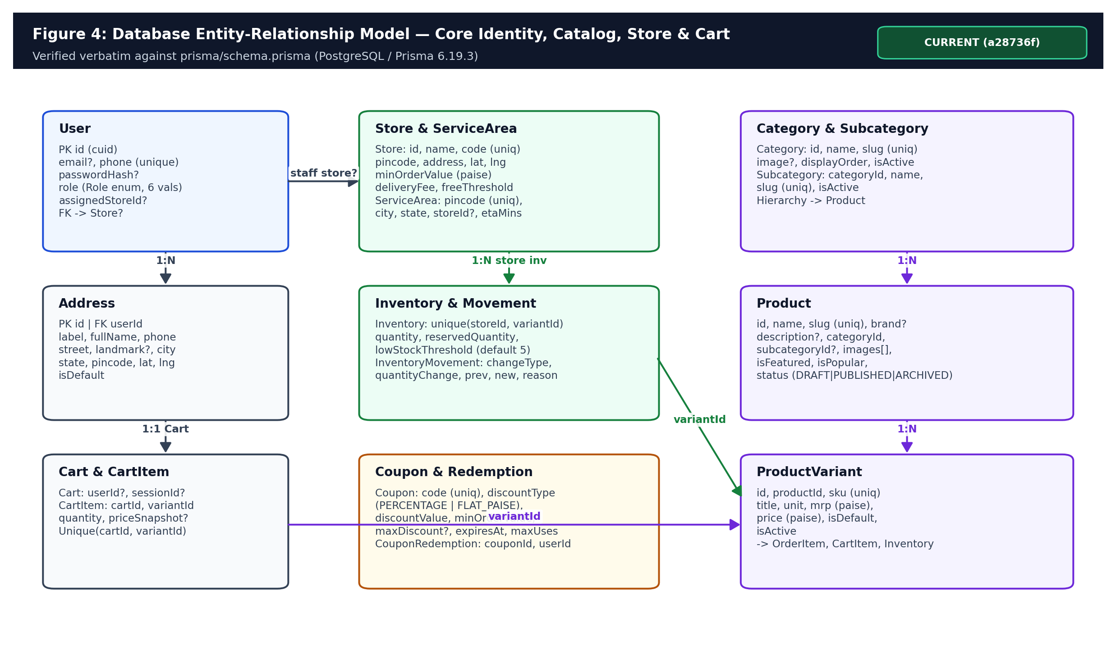
Figure 4: Entity-Relationship model for Identity (User, Address), Store & ServiceArea, Catalog (Category, Product, ProductVariant), Cart, Inventory, and Coupons.
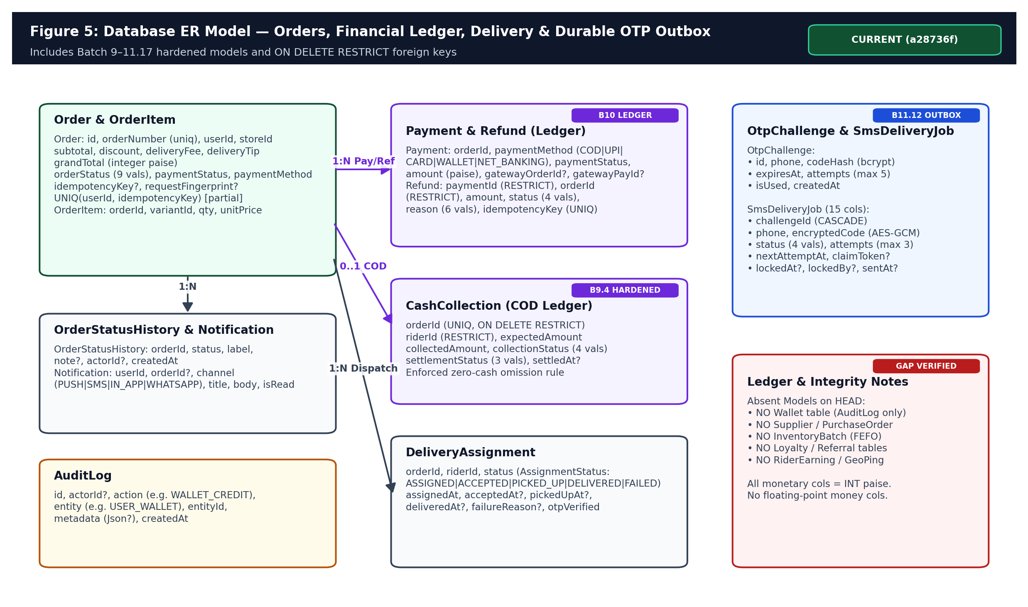
Figure 5: Entity-Relationship model for Orders, Split Payments, Immutable Refund & CashCollection Ledgers, DeliveryAssignment, AuditLog, and Durable OTP Outbox.
Migration File (Authoritative Sequence) | Batch | Schema Mutations & Integrity Invariants Enforced
20261110_batch9_cash_collection.sql | Batch 9 | Created CashCollectionStatus & SettlementStatus enums, cash_collections table, indexes, FKs (initially ON DELETE CASCADE on orderId).
20261110_batch9_4_cash_collection_remediation.sql | Batch 9.4 | Pre-flight duplicate orderId abort guard; switched orderId FK to ON DELETE RESTRICT; added unique index cash_collections_orderId_key.
20261110_batch10_refund_ledger.sql | Batch 10 | Created RefundStatus & RefundReason enums, refunds table, unique idempotencyKey index, and ON DELETE RESTRICT FKs to orders & payments.
20261112_batch11_2_order_idempotency.sql | Batch 11.2 | Added orders.idempotencyKey + unique partial index orders_userId_idempotencyKey_key (WHERE idempotencyKey IS NOT NULL).
20261112_batch11_3_request_fingerprint.sql | Batch 11.3 | Added orders.requestFingerprint + partial lookup index for tamper detection across idempotent retries.
20261112_batch11_12_sms_outbox.sql | Batch 11.12 | Created SmsDeliveryStatus enum & 15-column sms_delivery_jobs durable outbox with claimToken, lockedAt/lockedBy & FK ON DELETE CASCADE to otp_challenges.

7. Order Lifecycle, Checkout Idempotency, Financial Ledgers & Inventory

7.1 End-to-End Checkout & Fingerprint v3 Idempotency
OrderService.createOrder (src/modules/orders/service.ts) is the most rigorously hardened transactional boundary in the codebase. Before touching inventory or orders, OrderPayload validation computes a SHA-256 canonical payload hash via computeRequestFingerprint (version 3, src/lib/validation/order.ts) using unambiguous length-prefixed framing over sorted items, normalized delivery fields, delivery method, paymentMethod, useWallet flag, and walletAmountPaise.
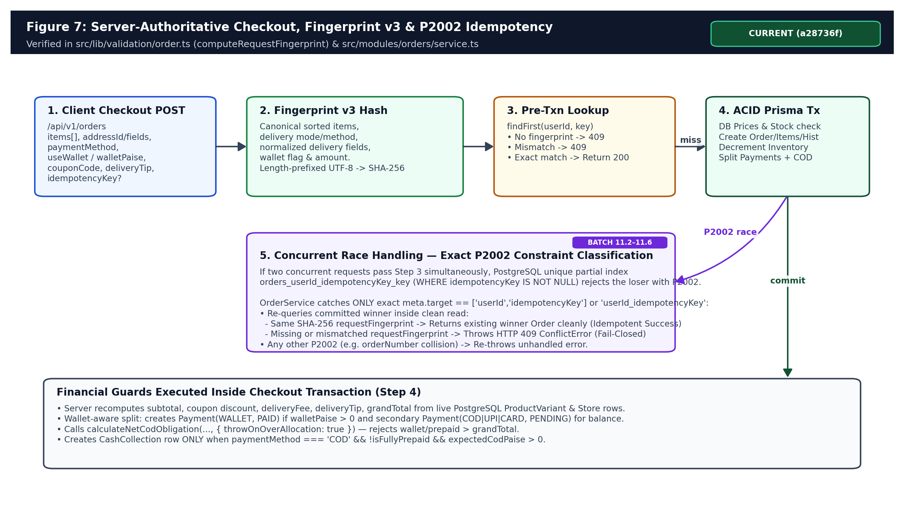
Figure 7: Server-authoritative checkout flow illustrating Fingerprint v3 hashing, pre-transaction cache hit, ACID transaction, and P2002 exact constraint collision recovery.
If two concurrent identical POST /api/v1/orders calls race past pre-transaction lookup, PostgreSQL enforces unique partial index orders_userId_idempotencyKey_key and aborts the losing transaction with Prisma error code P2002. Batch 11.4 hardened the catch block to inspect err.meta.target strictly for ['userId', 'idempotencyKey'] or 'userId_idempotencyKey', query the winning row, fail closed if existingOrder.requestFingerprint is missing or mismatches (HTTP 409 ConflictError), and otherwise return the committed Order cleanly.

7.2 Nine-State Order Lifecycle & Known State-Transition Gap
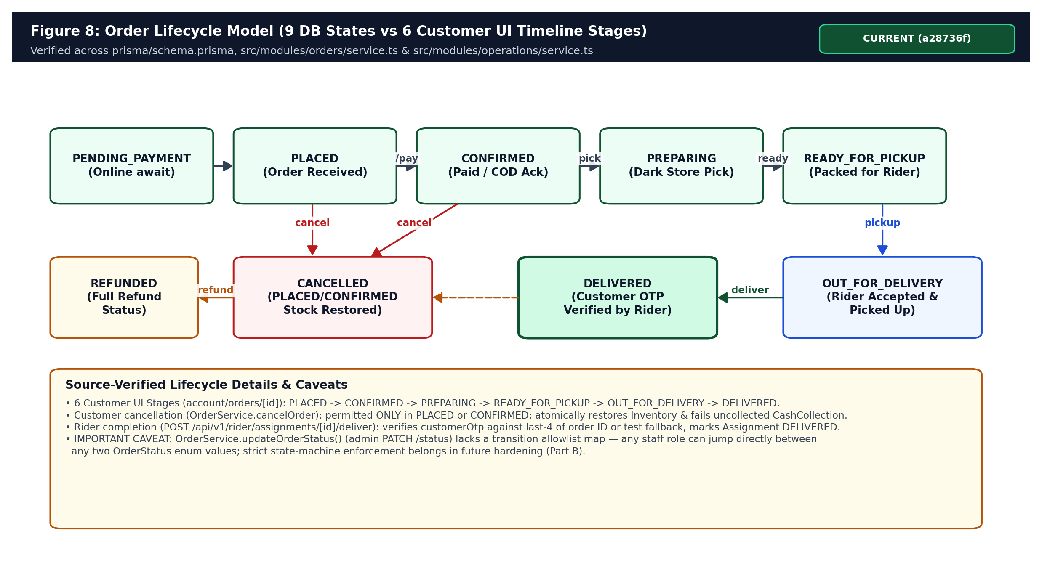
Figure 8: Order lifecycle across 9 PostgreSQL OrderStatus states, 6 storefront timeline stages, cancellation stock restoration, and admin transition caveat.

7.3 Split Payments, Wallet-COD Reconciliation & Refund Ledger
Batch 9.6, Batch 9.8, Batch 9.9, and Batch 10 established an explicit, mathematically verified financial reconciliation engine inside src/modules/operations/financial-reconciliation-helper.ts. For any order, calculateNetCodObligation deduplicates non-COD PAID Payment rows by payment ID, sums strictly PROCESSED Refund amounts against each payment (ignoring PENDING and FAILED refunds), computes netApplied = max(0, min(amount, amount - processedRefunds)), and asserts expectedCodPaise = grandTotal - totalNetApplied.
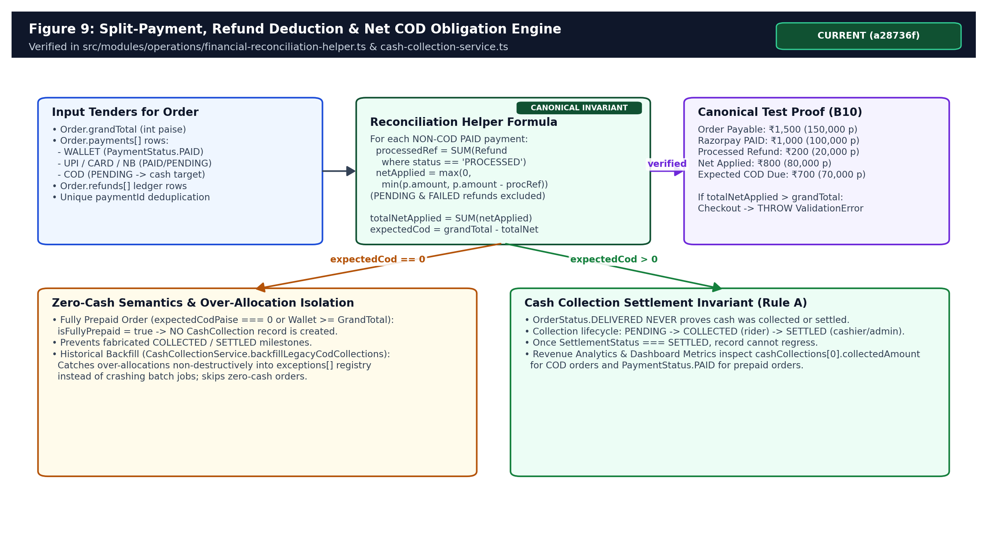
Figure 9: Canonical multi-tender split payment, partial refund deduction, zero-cash order omission, and COD settlement invariant (Rule A).
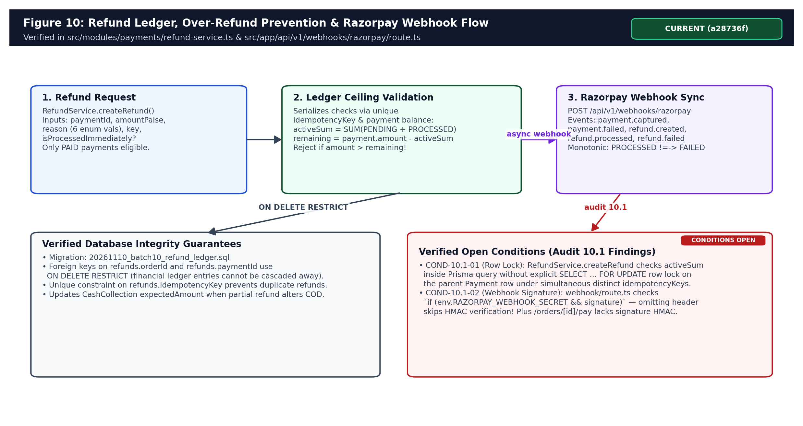
Figure 10: Refund ledger creation, idempotency protection, Razorpay webhook handler, and open Audit 10.1 conditions (COND-10.1-01/02).
Payment Verification & Webhook Gaps Confirmed in Source Code
Three payment security gaps exist at HEAD and are tracked for Part B resolution: (1) RazorpayPaymentModal.tsx simulates a Test Mode modal emitting pay_test_* IDs without loading Razorpay live Checkout.js; (2) POST /api/v1/orders/[id]/pay and OrderService.confirmPayment accept gatewayPaymentId without validating Razorpay HMAC signature or order ownership; (3) POST /api/v1/webhooks/razorpay wraps HMAC verification inside `if (env.RAZORPAY_WEBHOOK_SECRET && signature)`—allowing header omission to bypass signature validation (COND-10.1-02).

7.4 Store Inventory, Reservation Decrement & Audit Movements
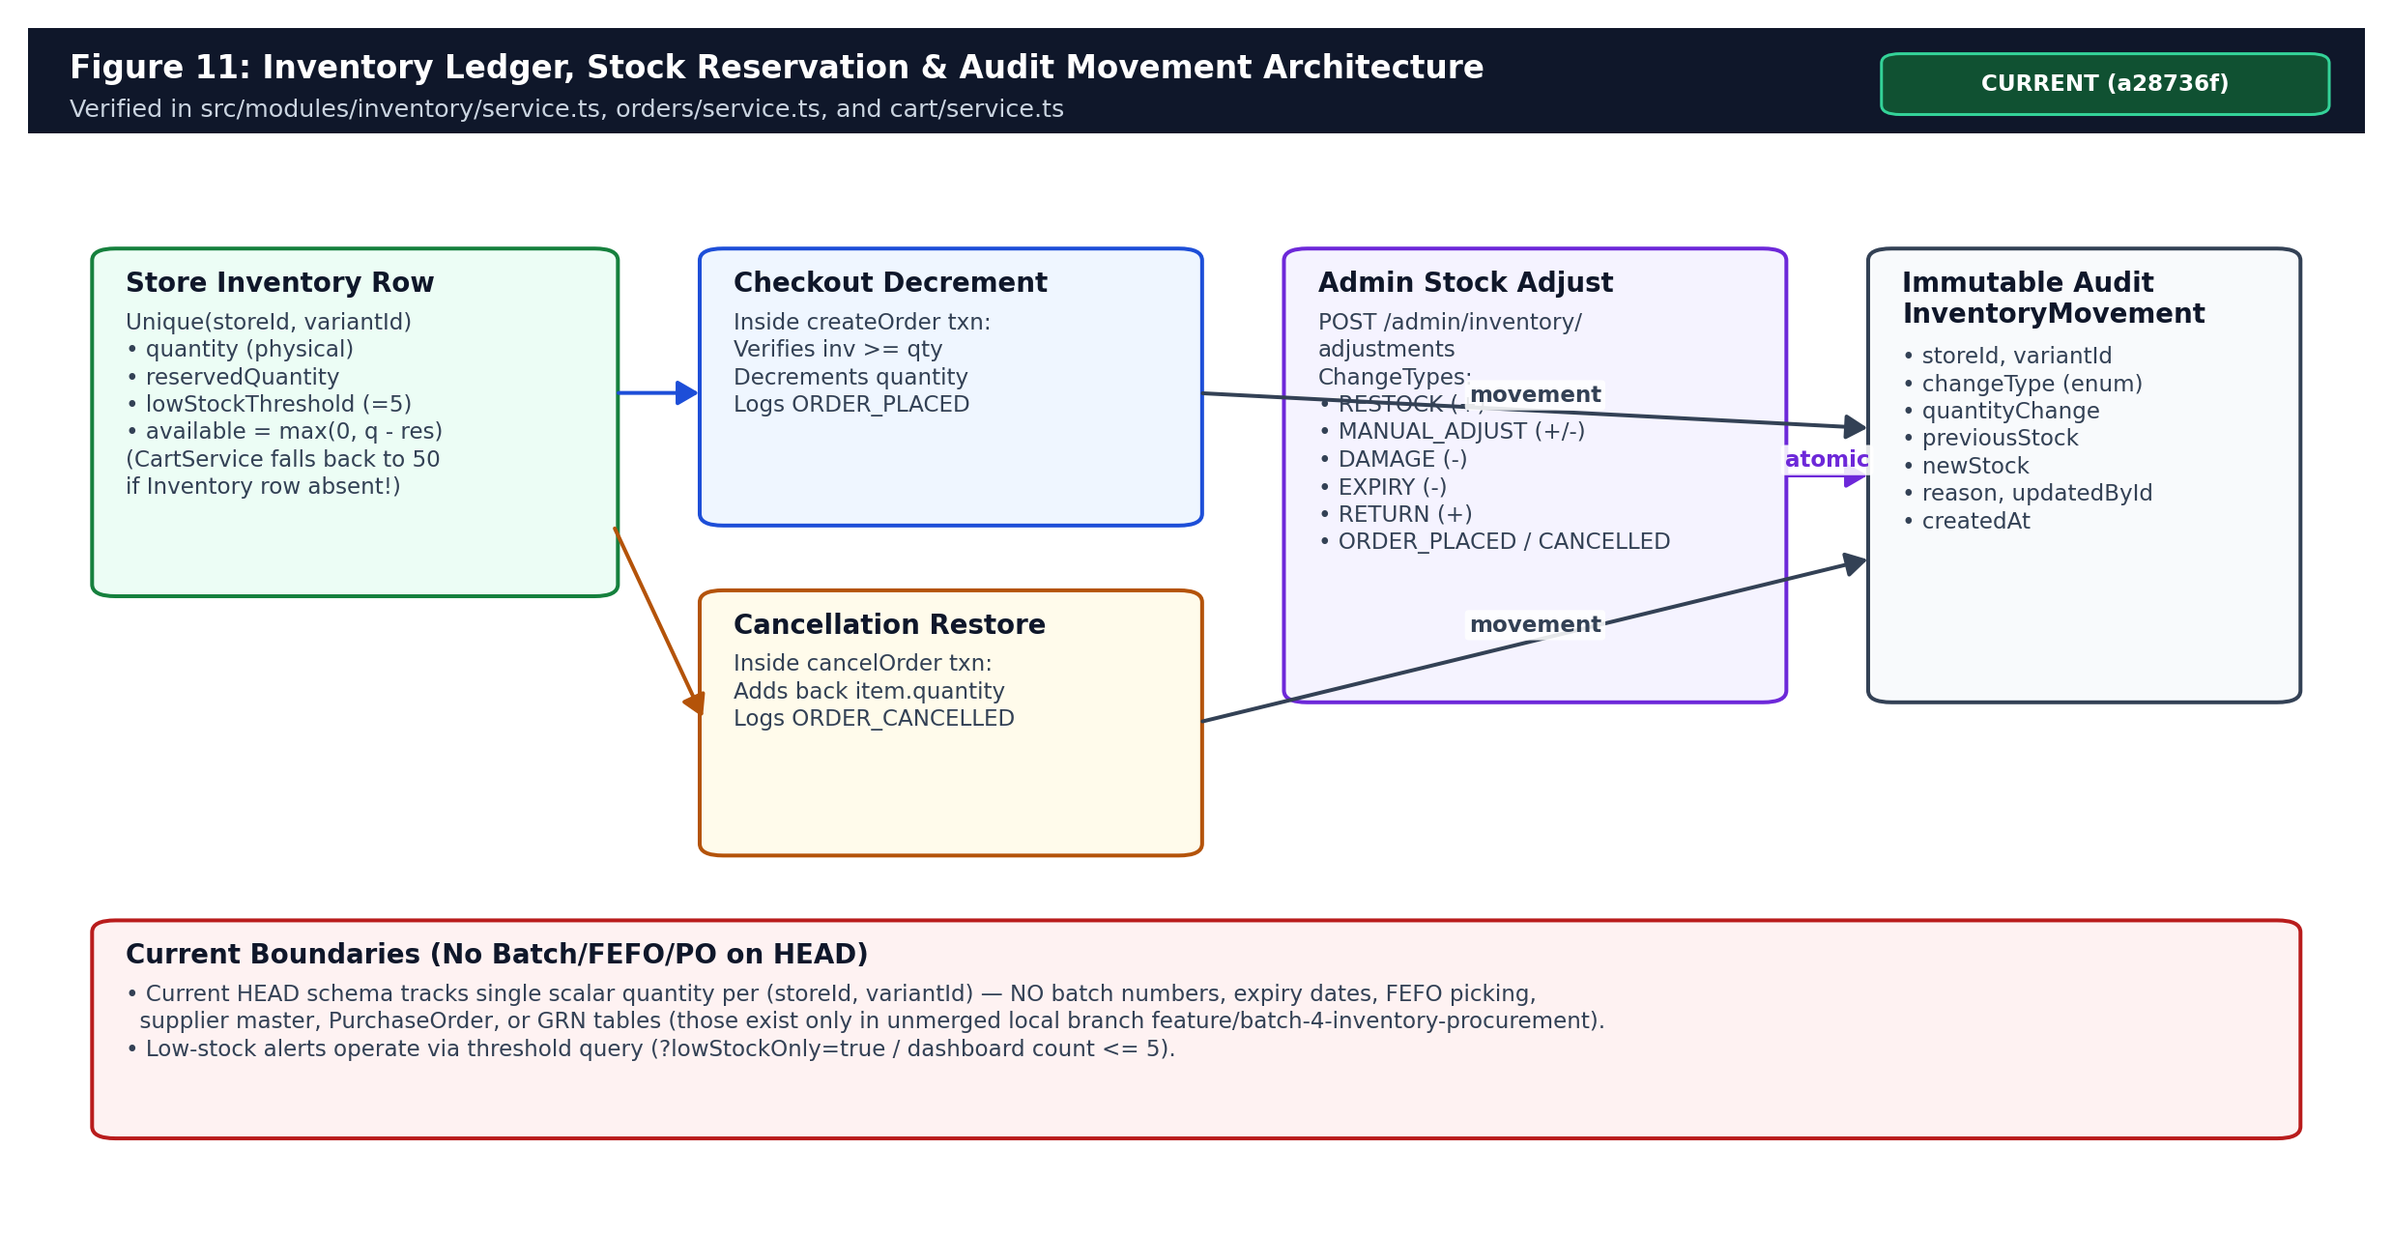
Figure 11: Real-time inventory decrement on checkout, atomic restoration on cancellation, admin adjustment types, and immutable InventoryMovement audit log.

8. Security Architecture, RBAC, Cryptography & Durable OTP Outbox

8.1 Authentication Session Model & 6-Role RBAC Enforcement
Session authentication (src/lib/auth.ts) signs HS256 JWT tokens via jose with 7-day expiration, read either from HTTP-only cookie pravdhan_session_token or an Authorization: Bearer <token> header (enabling future mobile clients). Staff passwords hash via bcryptjs (cost factor 12). Production startup in src/lib/validation/env.ts fails closed if AUTH_SECRET retains its default fallback value outside the Next.js build phase. Authorization in src/modules/auth/permissions.ts maps 6 Role values onto 13 granular Permission enums and enforces store-level boundaries via validateStoreScope(session, targetStoreId) for non-SUPER_ADMIN staff.
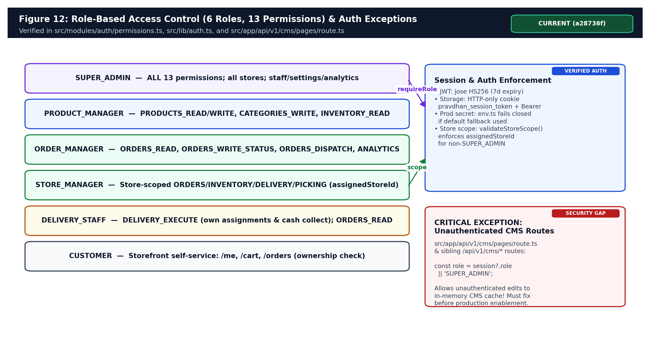
Figure 12: Role-Based Access Control (6 Roles, 13 Permissions), Store-Scope Isolation, and the confirmed CMS fallback security exception.
Confirmed Security Finding: Unauthenticated CMS Route Super-Admin Fallback
Although admin sidebar links to /admin/builder/* were hidden in commit 2e109e4, src/app/api/v1/cms/pages/route.ts (line 22) and sibling CMS handlers still contain `const role = session?.role || 'SUPER_ADMIN';`. Because GET/POST/PUT routes remain deployed under /api/v1/cms/*, an unauthenticated request defaults to SUPER_ADMIN against the in-memory CmsService store. Closing or authenticating all 14 CMS routes is marked Priority P0 in Part B.

8.2 Durable OTP Request Rate Limiting, AES-256-GCM Cipher & Fencing Tokens
OTP delivery (src/lib/services/sms.ts & src/lib/security/crypto.ts) underwent seven consecutive hardening batches (Batch 11.4 through 11.17). Inside requestOtp, Postgres acquires a transaction-scoped advisory lock pg_advisory_xact_lock(hashtext(e164)) before evaluating a rolling 10-minute cap (>= 4 challenges rejected) and active 60-second resend cooldown (isUsed: false). An OTP challenge stores bcrypt(otp, 10) on OtpChallenge alongside an AES-256-GCM ciphertext (version:ivHex:authTagHex:encryptedHex) inside SmsDeliveryJob using OTP_ENCRYPTION_KEY_V1 (or rotated OTP_ENCRYPTION_KEY_V<N>, 64-char hex or 32-byte UTF-8).
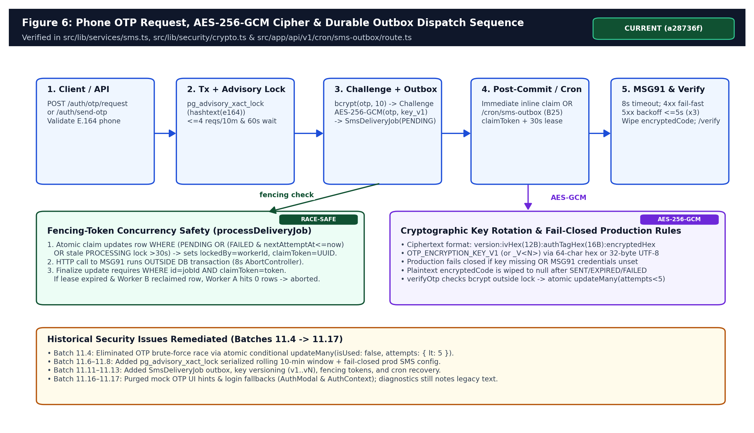
Figure 6: End-to-end OTP generation, PostgreSQL advisory locking, AES-256-GCM encryption, claimToken 30-second fencing lease, and plaintext wipe lifecycle.
- Post-Commit & Cron Dispatch: Inline processDeliveryJob and cron /api/v1/cron/sms-outbox (limit 25; direct recoverPendingJobs default 10) atomically claim eligible jobs with a fresh UUID claimToken and 30-second stale lease.
- External HTTP Isolation: MSG91 REST v5 call executes outside DB transactions with an 8-second AbortController timeout; 4xx carrier rejections fail fast and mark the challenge isUsed=true; 5xx failures schedule exponential backoff min(1000 * 2^(attempts-1), 5000) ms up to 3 attempts.
- Zero-Plaintext Wipe & Atomic Verify: Upon delivery, expiry, or terminal failure, encryptedCode is wiped to null. Verification hashes outside locks and consumes atomically via updateMany({ where: { id, isUsed: false, attempts: { lt: 5 }, expiresAt: { gt: now } }, data: { isUsed: true } }).

9. Infrastructure Pipelines, Migration Runner, Analytics & Operational Modules

9.1 Custom Runtime Migration Runner & Build Pipeline
Instead of running prisma migrate deploy, package.json binds npm run build to node scripts/db-sync.js && next build. When POSTGRES_PRISMA_URL points to a non-local database, scripts/db-sync.js executes MigrationRunner (src/lib/services/migration-runner.ts) and then runs npx tsx prisma/seed.ts. MigrationRunner acquires pg_advisory_xact_lock(hashtext('pravdhan_app_migrations_lock')), maintains an _app_migrations ledger with SHA-256 file checksums, enforces AUTHORITATIVE_MIGRATION_SEQUENCE across the 6 SQL files, splits DO $$ ... $$ PL/pgSQL blocks safely, and aborts via auditDrift() if any historical migration file is modified.
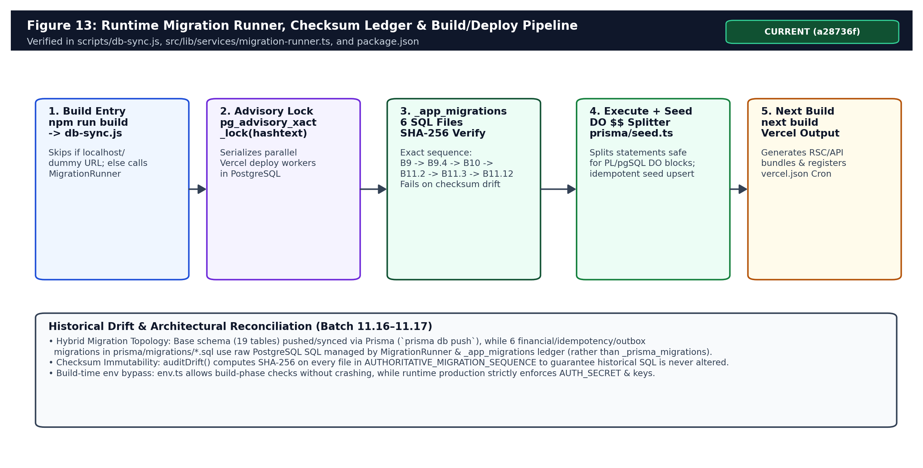
Figure 13: Build-time database synchronization pipeline combining MigrationRunner, _app_migrations SHA-256 ledger, prisma/seed.ts, and Next.js build.

9.2 Vercel Cron, Push Notifications, Observability & Diagnostics Nuances
Subsystem | Verified Source Implementation | Operational / Production Nuance
SMS Outbox Cron | vercel.json (`* * * * *`) -> /api/v1/cron/sms-outbox checking `Bearer ${CRON_SECRET}` (401 fail-closed) | 1-minute schedule requires Vercel Pro plan; Hobby plan restricts crons to daily intervals.
Diagnostics Health | src/modules/operations/diagnostics-service.ts -> /api/v1/admin/diagnostics | Still logs stale message `'Falling back to test OTP 123456.'` at line 79 despite Batch 11.16/11.17 mock removal; checks `MSG91_TEMPLATE_ID`.
Push Notifications | src/lib/services/fcm.ts + Notification model in PostgreSQL | Device tokens live ONLY in a volatile `inMemoryTokens` JS Map (lost on cold start); FCM cloud dispatch logs `[FCM:Cloud]` without Google OAuth2 HTTP v1 call.
Media & POD Storage | src/lib/services/storage.ts + cloudinary.ts | StorageService fails closed in prod without S3/Cloudinary keys; DeliveryAssignment has no persisted photo URL field on HEAD.
Maps & Location | src/lib/services/google-maps.ts + DeliveryLiveMap.tsx | Static SVG DeliveryLiveMap renders vector hub-to-home graphics; GoogleMapsService falls back gracefully if key absent.
Analytics & BI (9 Modules) | src/modules/analytics/*.ts (sales, financial, inventory, delivery, customer, procurement, export) | Rule A revenue honors cashCollections / PAID payments; ProcurementAnalyticsService explicitly outputs `status: 'NOT_CONFIGURED'`.
Sentry Telemetry | src/lib/monitoring/sentry.ts | Wrapper functions record structured error context to stdout/console when Sentry SDK/DSN is inactive.

9.3 Environment Variables & Validation Schema Discrepancy
Inspection of .env.example, src/lib/validation/env.ts, src/lib/services/sms.ts, and src/lib/security/crypto.ts reveals minor naming and schema drift: (1) prisma/schema.prisma binds POSTGRES_PRISMA_URL and POSTGRES_URL_NON_POOLING whereas .env.example lists DATABASE_URL and DIRECT_URL; (2) sms.ts reads MSG91_AUTH_KEY and MSG91_TEMPLATE_ID (referred to as MSG91_FLOW_ID in older operational notes); (3) serverEnvSchema in validation/env.ts does not declare OTP_ENCRYPTION_KEY_V1 or CRON_SECRET even though runtime crypto/cron code fails closed without them in production.

10. Complete Chronology, Batch Evolution & Independent Audit History
Between October 19, 2026 and November 12, 2026, Pravdhan Store progressed from a static storefront scaffold to a strictly audited transactional commerce backend. Every milestone batch and independent audit report stored in the repository (72 markdown files, 7,276 lines) was reviewed against git commits and source code.
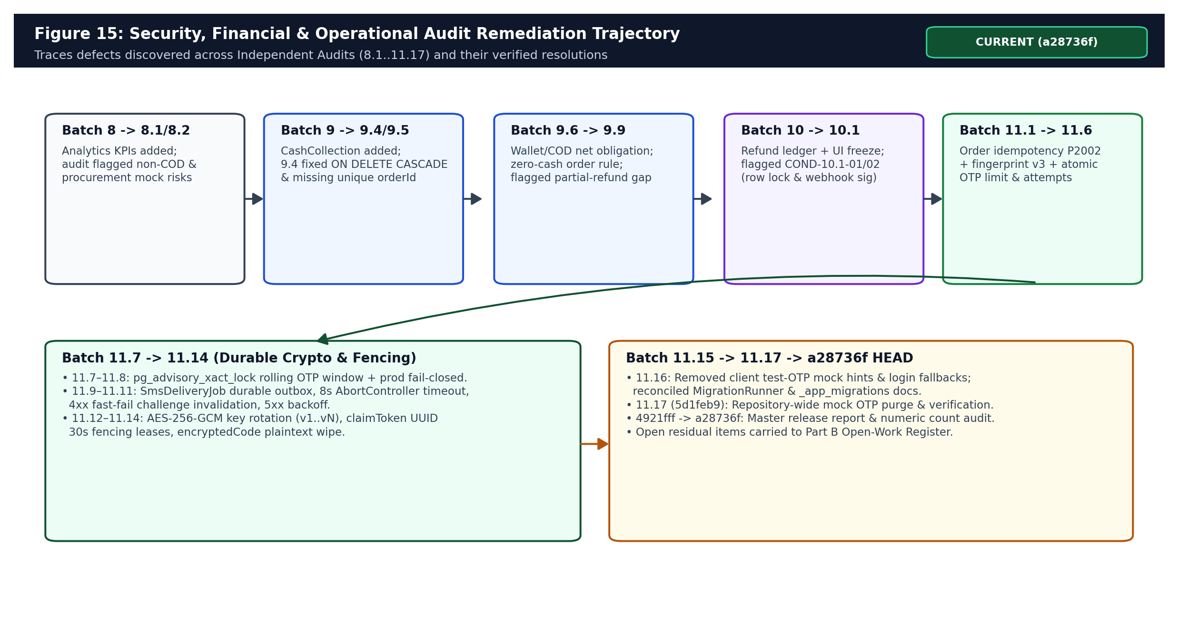
Figure 15: Sequential engineering and independent audit remediation evolution from Batch 8 through Batch 11.17 (HEAD a28736f).
Milestone / Batch | Exact Commit SHA(s) & Date | Engineering Additions & Independent Audit Verdict
Initial V1 & Storefront | f423dbe .. 3783371 (Oct 19 - Nov 3) | Next.js storefront UI, Cart, Checkout, CMS Website Builder (50edc60), sidebar CMS removal (2e109e4), Live SVG map (363f724), Printable Tax Invoice (3783371).
Unmerged Track (Local Only) | 309cb6c .. 3884170 (19 commits) | Prototype Batch 1–8 branches exploring Supplier/PO/GRN/FEFO, Wallet ledger, Rider POD, CRM/Loyalty. NEVER merged into HEAD.
Batch 8 / 8.1 / 8.2 | 878898b, 036b859, 63e5b04 (Nov 10) | 9 analytics modules added on origin track; Audits 8.1 & 8.2 verified analytics contracts and flagged missing procurement data.
Batch 9 – 9.5 | 05850fe .. 7a8cd7c (Nov 10) | CashCollection table introduced; Audit 9.3/9.4 fixed ON DELETE CASCADE -> RESTRICT and enforced unique orderId constraint.
Batch 9.6 – 9.9 | 3f445bb .. 947d21a (Nov 10) | Wallet + non-COD deduction, zero-cash order omission rule, backfill exception isolation; Audit 9.9 ACCEPTANCE WITH CONDITIONS (COND-9.9-01 partial refunds).
Batch 10 & 10.1 | 8edc2cd, 56e75e7 (Nov 10/12) | Refund ledger + netApplied calculation + Razorpay webhooks + UI Freeze baseline; Audit 10.1 ACCEPTANCE WITH CONDITIONS (COND-10.1-01 Payment lock, COND-10.1-02 webhook sig).
Batch 11.1 – 11.6 | a12762a .. 7aa16af (Nov 12) | PostgreSQL Order idempotency (P2002 exact target match), Fingerprint v3, atomic OTP attempts (<5), pg_advisory_xact_lock OTP window.
Batch 11.7 – 11.14 | 844486a .. 2700469 (Nov 12) | Prod OTP fail-closed, SmsDeliveryJob durable outbox, 8s timeout, 4xx fast-fail, AES-256-GCM cipher + key rotation (v1..vN), claimToken 30s fencing leases.
Batch 11.15 – 11.17 & Closure | 14a2c32 -> 5d1feb9 -> 4921fff -> a28736f (Nov 12) | Purged client mock OTP fallbacks (AuthModal/AuthContext), reconciled MigrationRunner docs, synchronized GitHub, corrected test/key naming (HEAD a28736f).

11. Verification, Automated Testing & Report Reconciliation Audit
The repository contains 24 automated test files under tests/ (7,142 total lines) plus 3 manual Python HTTP verification scripts in scripts/ (303 lines). Direct CLI execution in this workspace immediately prior to document generation established exact empirical baselines and revealed specific numeric/prose inaccuracies in historical report tables.
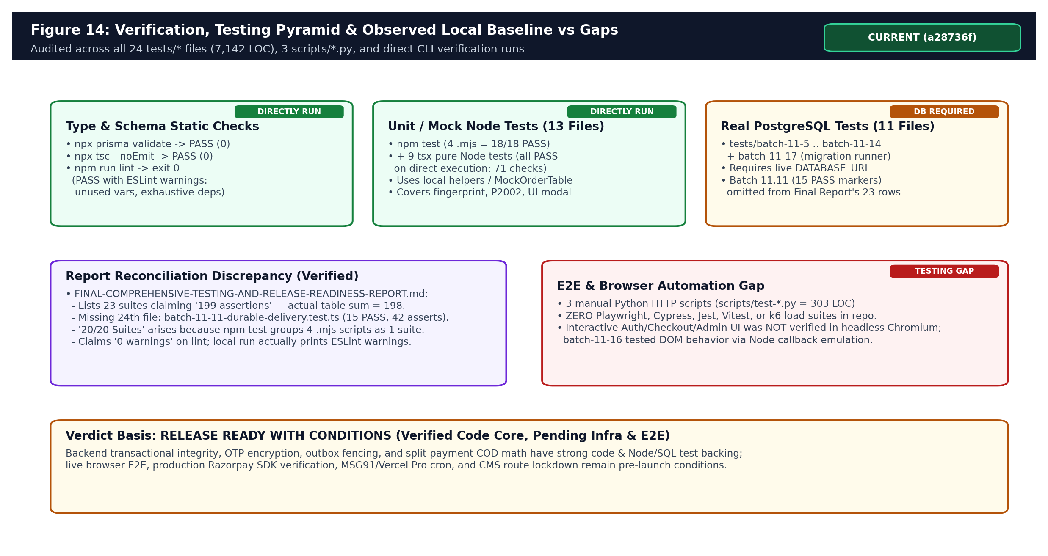
Figure 14: Observed local test verification pyramid, test-suite taxonomy (13 mock/unit vs 11 Prisma/SQL suites), report discrepancies, and Playwright E2E gap.
Verification Command / Scope | Observed Result in Workspace | Scope Notes & Report Reconciliation
npx prisma validate | PASS (exit 0) | Confirmed prisma/schema.prisma (25 models, 14 enums) is syntactically & relationally valid.
npx tsc --noEmit | PASS (exit 0) | Zero TypeScript compiler errors across entire Next.js/Prisma codebase.
npm run lint | EXIT 0 (WITH WARNINGS) | Zero fatal ESLint errors, BUT emits `@typescript-eslint/no-unused-vars` & `react-hooks/exhaustive-deps` warnings (correcting final report's `'0 warnings'` claim).
npm test (4 .mjs suites) | PASS (18/18 assertions) | analytics (5/5), batch-9-hardening (3/3), batch-9-remediation (5/5), batch-9-4-remediation (5/5).
9 Pure Node suites via npx tsx | PASS (all 9 scripts passed) | batch-9-6 (8), 9-8 (4), 10 (5), 11-functional-integration (7), 11-1 (10), 11-2 (12), 11-3 (8), 11-4 (10), 11-16 (7). Uses mocks/local helpers (MockOrderTable, DOM callback stubs).
11 Real PostgreSQL suites (batch-11-5..14, 11-17) | NOT RE-RUN (Requires live PostgreSQL) | Require active DATABASE_URL / PostgreSQL 16 engine; reported passing in Batch 11.15-11.17 historical reports (Reported but not independently verified locally).
Missing Row Reconciliation | 24 files on disk vs 23 in Final Report | FINAL-COMPREHENSIVE-TESTING-AND-RELEASE-READINESS-REPORT.md sums 23 rows to 198 (claims '199') and omits tests/batch-11-11-durable-delivery.test.ts (580 LOC, 15 PASS markers, 42 asserts).
Browser / Playwright E2E | NOT IMPLEMENTED | No Playwright, Cypress, Jest, or Vitest runner in package.json; AuthModal test batch-11-16 uses Node callback emulation.

12. Frontend Design Freeze Audit, GitHub Sync & Part A Evidence Summary
Comparing active HEAD a28736f against the Batch 10.1 Design Freeze baseline 8edc2cd via git diff --stat 8edc2cd..HEAD -- src/components src/app src/styles src/lib/context proves strictly 6 files changed (+424 / -181 lines): 4 UI files (src/app/admin/orders/page.tsx, src/app/checkout/page.tsx, src/components/auth/AuthModal.tsx, src/lib/context/AuthContext.tsx) touched exclusively to enforce idempotency and remove test OTP fallbacks, plus 2 API routes (cron/sms-outbox, orders). All visual layouts, Tailwind design tokens, Navbar, Footer, DeliveryLiveMap, and FloatingCart remain untouched. All commits through a28736f are synchronized to origin/feature/batch-11.17-independent-final-acceptance.
Domain / Capability | Part A Classification at HEAD (a28736f) | Key Technical Fact
Storefront Catalog, Search & Cart UI | Implemented and source-verified | Next.js 15 RSC/client flows with Hub #01 pincode gating.
Order Idempotency & Fingerprint v3 | Implemented and test-verified | Canonical SHA-256 + partial unique index + P2002 exact target 409 guard.
Multi-Tender Reconciliation & Refund Ledger | Implemented and test-verified | Integer paise math, PROCESSED refund deduction, zero-cash COD rule.
Phone OTP Auth, AES-GCM Cipher & Outbox | Implemented and test-verified | pg_advisory_xact_lock, key versioning, 30s claimToken fencing, mock UI purged.
Custom SQL Migration Runner | Implemented and source-verified | 6 sequential SQL migrations tracked with SHA-256 in _app_migrations.
Live Razorpay Gateway & Webhook Sig | Partially implemented | Modal simulates pay_test_*; /pay lacks HMAC verify; webhook sig optional if omitted.
Pravdhan Money Wallet Ledger | Partially implemented | Checkout creates Payment(WALLET, PAID); no Wallet DB table (AuditLog + localStorage).
CMS / Website Builder Endpoints | Partially implemented (Security Gap) | Removed from Admin sidebar, but /api/v1/cms/* defaults unauthenticated calls to SUPER_ADMIN.
Push (FCM), Sentry, Procurement, Loyalty | Stubs / Not implemented | FCM uses in-memory Map; Sentry logs console; Procurement reports NOT_CONFIGURED.
Overall System Release Verdict | RELEASE READY WITH CONDITIONS | Requires P0 security/PSP fixes & live infra provisioning detailed in Part B.

PART B — WHAT WE STILL NEED TO BUILD AND ACHIEVE
Target Future Architecture, Pre-Launch Blockers, Product Roadmaps & Scaling Strategy
All diagrams and architectures in Part B represent PROPOSED FUTURE STATE — NOT YET IMPLEMENTED on HEAD a28736f

13. Where Pravdhan Store Stands Today vs. Full Commercial Vision
Part A demonstrated that Pravdhan Store possesses an unusually disciplined transactional backend core: atomic inventory decrement, v3 SHA-256 request fingerprinting, P2002 constraint idempotency, integer-paise financial ledgers for COD cash collection and refunds, advisory-locked OTP throttling, AES-256-GCM outbox encryption with 30-second fencing tokens, and an immutable migration checksum ledger. Simultaneously, strict source verification identified concrete gaps between a verified backend foundation and a live, high-volume quick-commerce grocery business operating 12–15 minute deliveries in Gurugram.
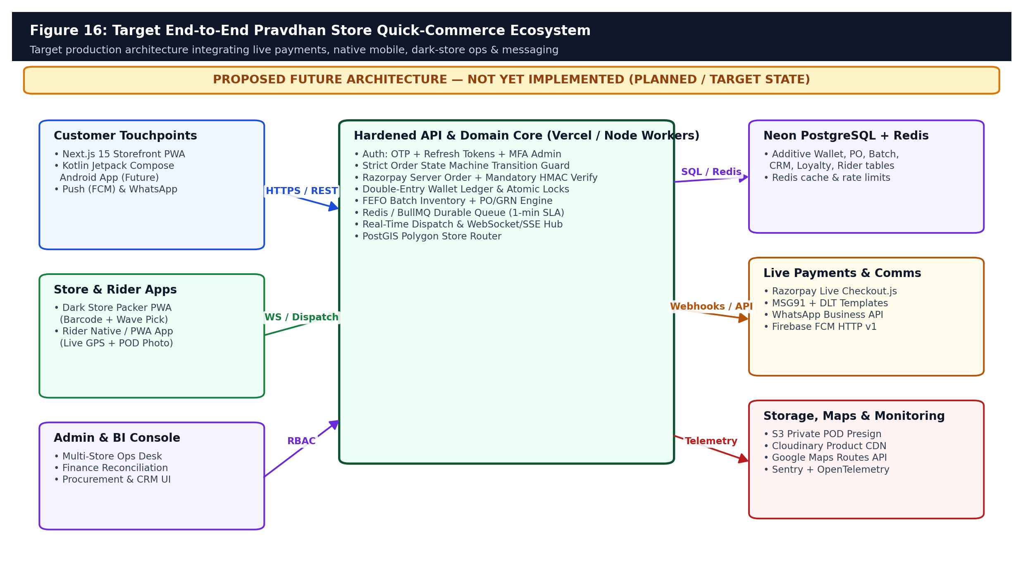
Figure 16: PROPOSED FUTURE ARCHITECTURE — Target Pravdhan Store multi-channel quick-commerce ecosystem integrating live PSPs, native apps, Redis workers & FEFO warehouse ops.

14. Immediate P0 Security, Concurrency & Code-Hygiene Closure
Open Gap ID | Exact Current Defect / Risk Location | Required Remediation Before Live Traffic
SEC-01 (P0) | src/app/api/v1/cms/pages/route.ts & sibling /api/v1/cms/* routes default `session?.role || 'SUPER_ADMIN'` | Replace fallback with strict `requireRole(request, ['SUPER_ADMIN'])`, or disable/404 unauthenticated CMS write endpoints cleanly.
PAY-01 (P0) | src/components/checkout/RazorpayPaymentModal.tsx simulates `pay_test_*`; /api/v1/orders/[id]/pay lacks HMAC verify | Integrate live Razorpay Checkout.js SDK, generate server `razorpay_order_id`, verify `HMAC-SHA256(order_id|payment_id)` & enforce `order.userId === session.userId`.
PAY-02 / COND-10.1-02 (P0) | src/app/api/v1/webhooks/razorpay/route.ts checks `if (env.RAZORPAY_WEBHOOK_SECRET && signature)` | Fail closed with HTTP 401 whenever `x-razorpay-signature` or `RAZORPAY_WEBHOOK_SECRET` is missing outside explicit local dev mocks.
FIN-01 / COND-10.1-01 (P1) | RefundService.createRefund reads existing refunds without PostgreSQL row lock on parent Payment | Execute `SELECT id FROM payments WHERE id = $1 FOR UPDATE` inside Prisma interactive transaction before validating refundable ceiling.
ORD-01 (P1) | OrderService.updateOrderStatus permits arbitrary jumps between any two OrderStatus values | Enforce an explicit `ALLOWED_ORDER_TRANSITIONS` state machine map rejecting illegal regressions (e.g., DELIVERED -> PREPARING).
OPS-01 (P1) | src/modules/operations/diagnostics-service.ts line 79 still emits `'Falling back to test OTP 123456.'` | Update diagnostics copy to reflect Batch 11.17 fail-closed OTP delivery and add OTP_ENCRYPTION_KEY_V1 + CRON_SECRET to serverEnvSchema.

15. Live Payments, Expired Checkout Cleanup & Persistent Wallet Ledger Roadmap
Closing simulated checkout payments and promoting Pravdhan Money Wallet from localStorage + AuditLog to an ACID PostgreSQL ledger are top commercial priorities.
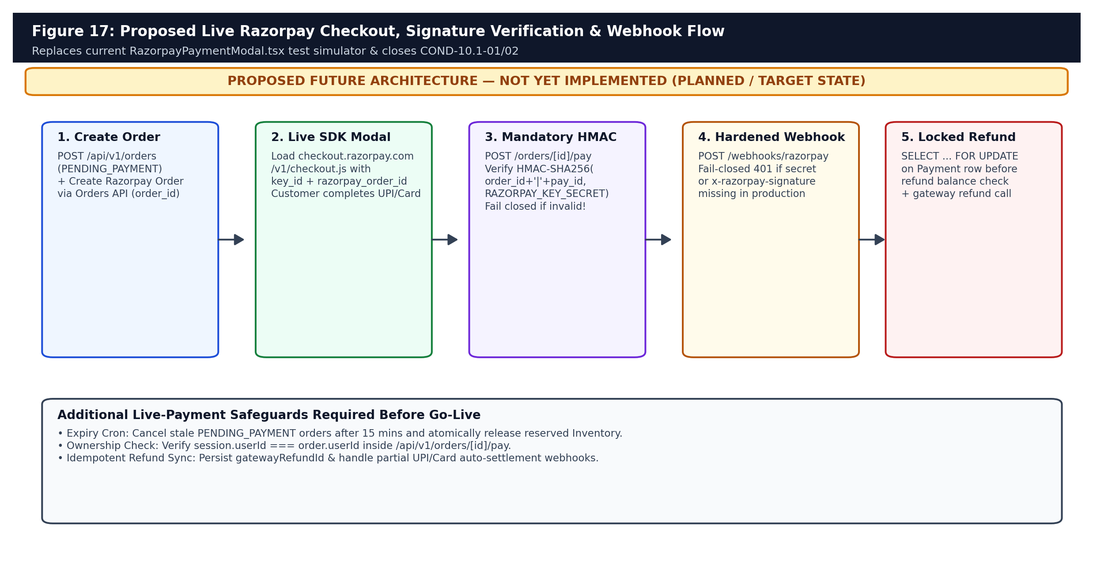
Figure 17: PROPOSED FUTURE ARCHITECTURE — End-to-end live Razorpay Orders API, Checkout.js client SDK, mandatory HMAC verification, and locked refunds.
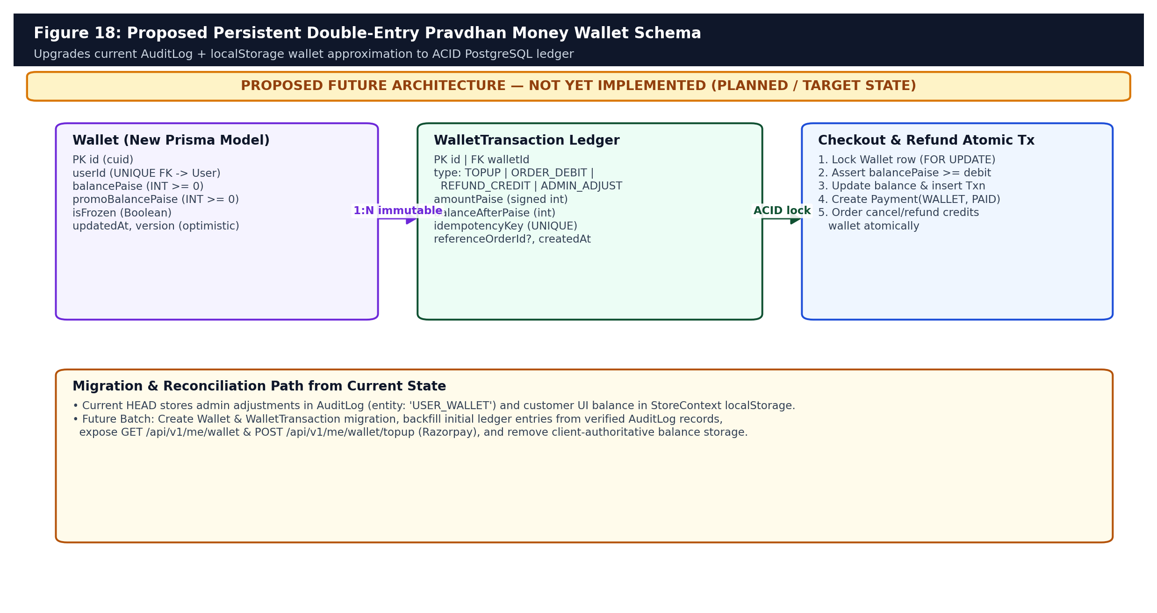
Figure 18: PROPOSED FUTURE ARCHITECTURE — Persistent double-entry Wallet and WalletTransaction ledger replacing AuditLog/localStorage balances.
- Aborted Payment Inventory Release: Introduce a cron sweeper cancelling PENDING_PAYMENT orders older than 15 minutes and atomically restoring Inventory quantities.
- Customer Wallet Ledger: Add Wallet (userId unique, balancePaise >= 0) and WalletTransaction (idempotencyKey unique) models, backfill initial balances from AuditLog(entity='USER_WALLET'), and debit atomically with SELECT FOR UPDATE inside OrderService.createOrder.

16. Dark Store Packer, Rider GPS Telemetry & Procurement/FEFO Roadmaps
True 12–15 minute grocery fulfillment requires sub-3-minute shelf picking, automated rider assignment, verifiable Proof-of-Delivery, and batch/expiry replenishment — capabilities absent from current HEAD.
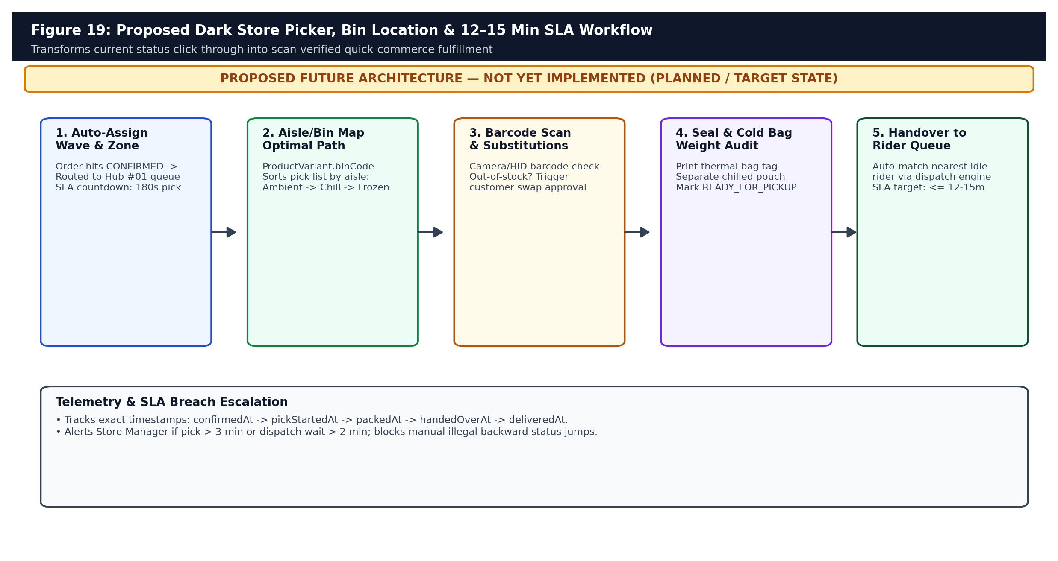
Figure 19: PROPOSED FUTURE ARCHITECTURE — Dark Store hub packer workflow with aisle/bin routing, barcode scan validation, substitution approval, and 180-second pick SLA.
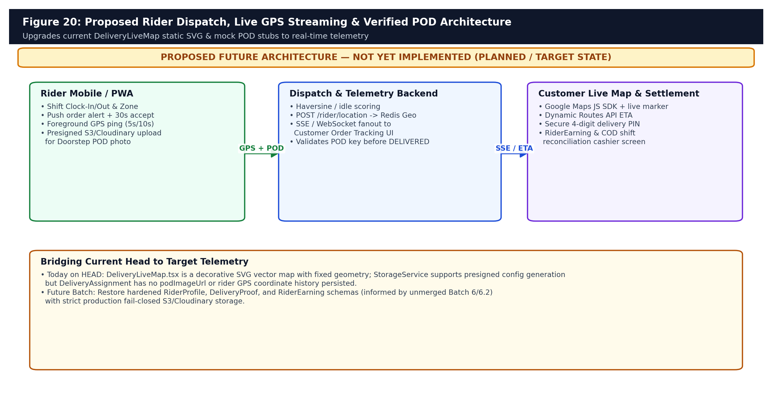
Figure 20: PROPOSED FUTURE ARCHITECTURE — Automated rider dispatch, Redis Geo + SSE live GPS streaming, Google Maps Routes ETA, and mandatory S3/Cloudinary POD upload.
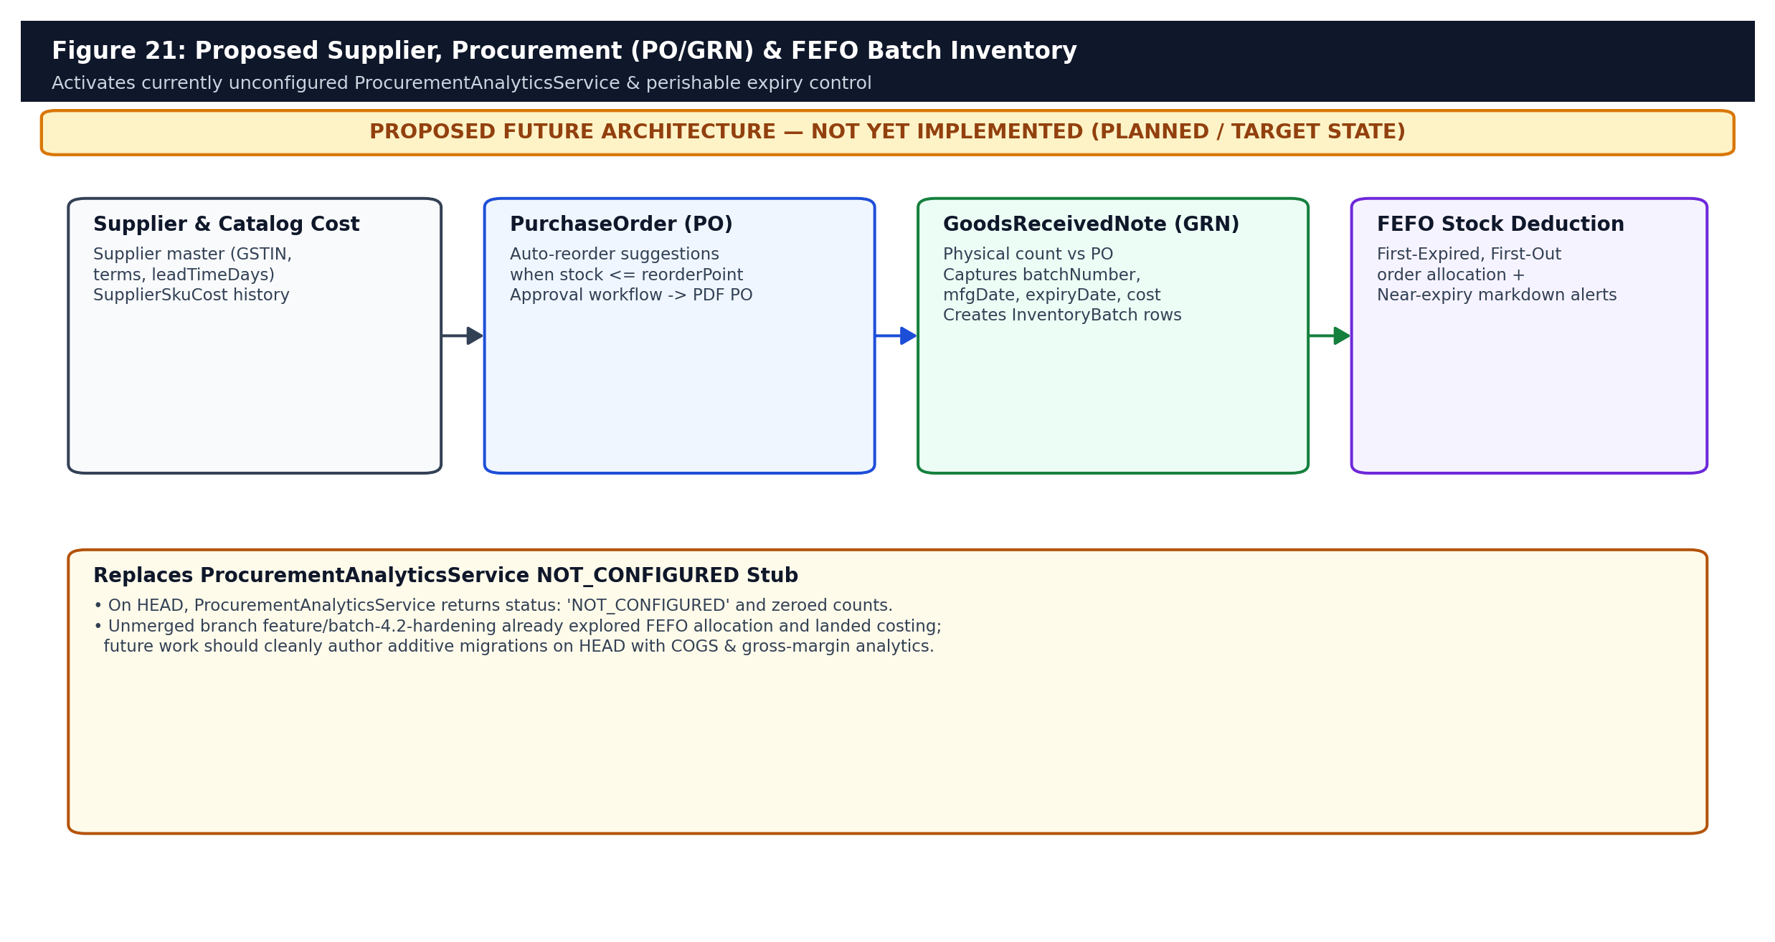
Figure 21: PROPOSED FUTURE ARCHITECTURE — Supplier master, Purchase Orders, Goods Received Notes (GRN), and FEFO expiry-batch allocation activating ProcurementAnalyticsService.

17. Omnichannel Messaging, CRM/Loyalty, Native Android & Multi-Store Scaling
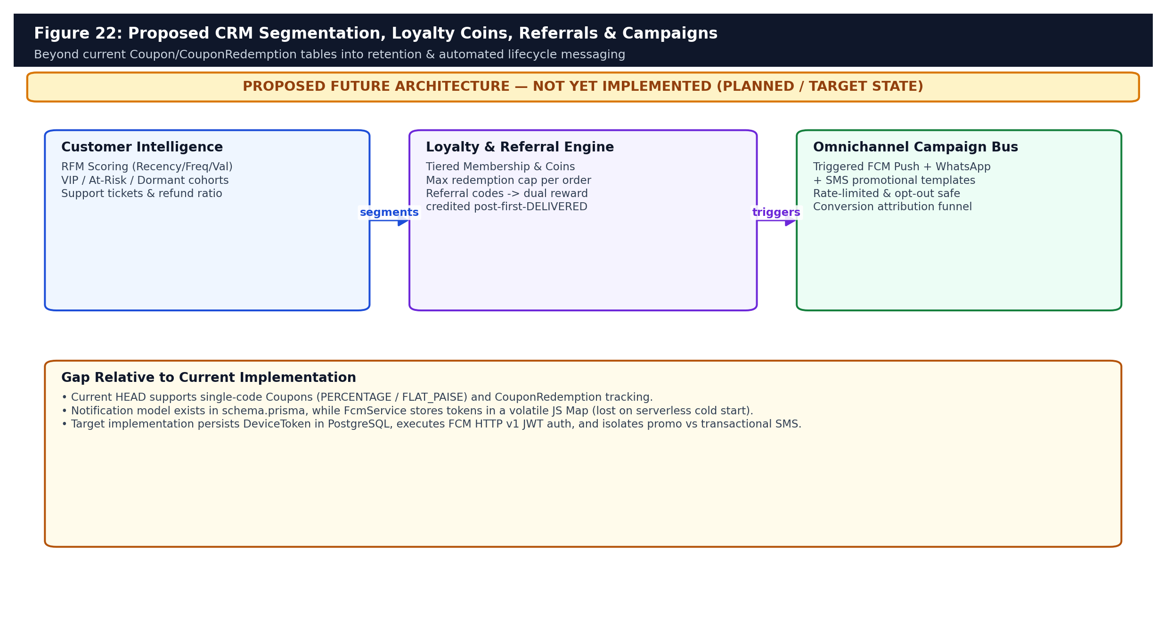
Figure 22: PROPOSED FUTURE ARCHITECTURE — Customer RFM segmentation, Loyalty Coins/Tiers, Referral attribution, and persistent FCM/WhatsApp campaign engine.
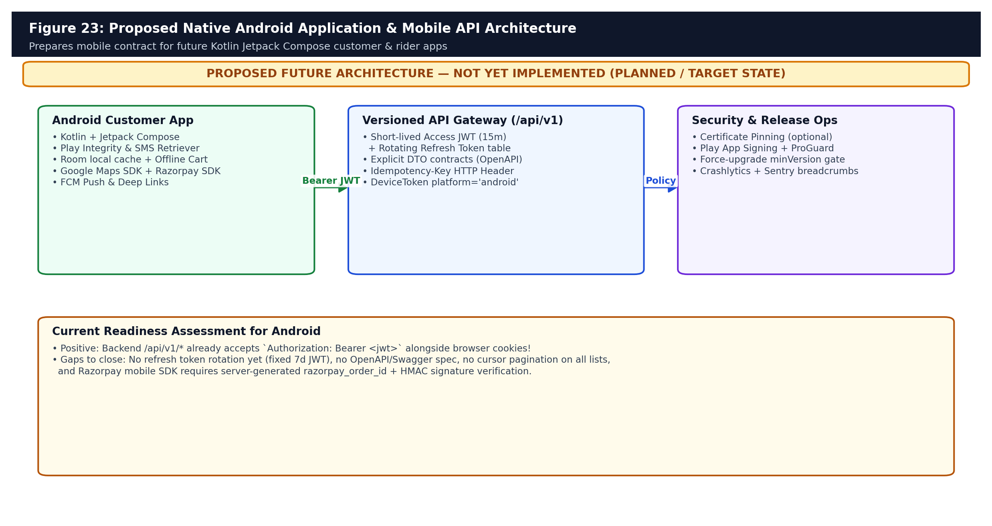
Figure 23: PROPOSED FUTURE ARCHITECTURE — Native Kotlin Jetpack Compose Android application architecture with refresh token rotation, OpenAPI contracts & Play Integrity.
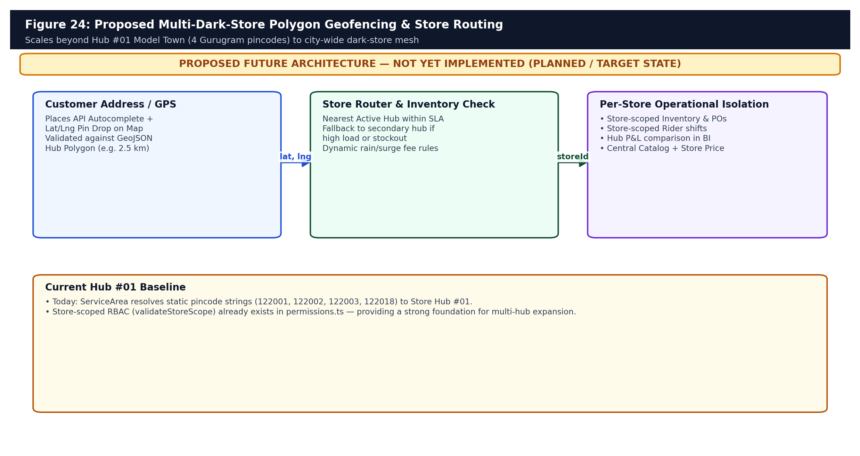
Figure 24: PROPOSED FUTURE ARCHITECTURE — Multi-Dark-Store GeoJSON polygon geofencing and fallback hub routing beyond Hub #01 Model Town.
- Push & Messaging Persistence: Migrate FcmService from in-memory Map to a PostgreSQL DeviceToken table, wire Firebase Service Account OAuth2 JWT signing for HTTP v1 delivery, register India DLT Sender ID/Templates for MSG91, and integrate WhatsApp transactional order alerts.
- Storefront Conversion Upgrades: Add infinite scroll/cursor pagination on /shop, Redis hot-catalog caching, cart substitution preferences, and real Playwright browser E2E testing across Checkout, OTP, and Admin.

18. Six-Gate Pre-Launch Playbook, Open-Work Register & Status Matrix
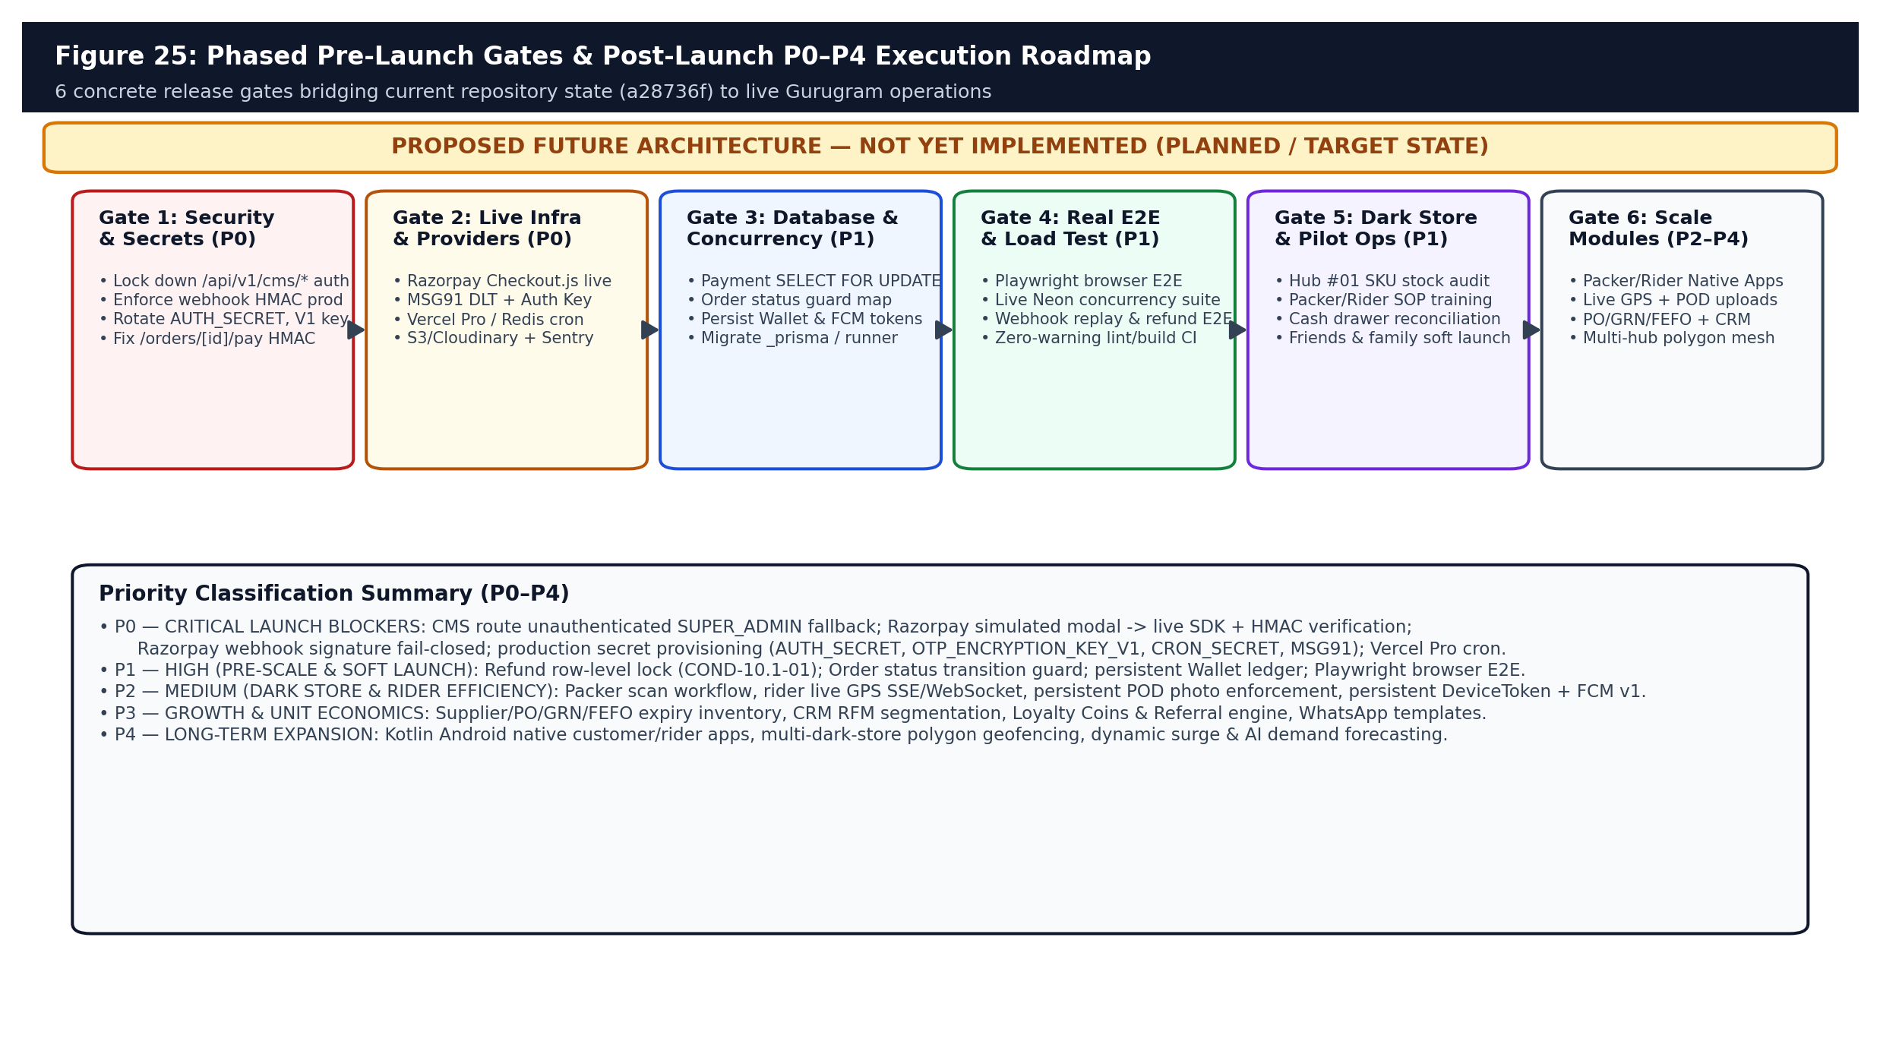
Figure 25: PROPOSED FUTURE ARCHITECTURE — Phased 6-Gate operational launch readiness path and P0-P4 priority classification.

18.1 Master Open-Work Register (Prioritized P0–P4)
Work ID | Priority | Capability / Deliverable | Target Subsystem & Dependencies
OW-01 | P0 | Lock down `/api/v1/cms/*` unauthenticated `SUPER_ADMIN` fallback | src/app/api/v1/cms/** (all 14 routes)
OW-02 | P0 | Replace Razorpay Test Simulator modal with live Checkout.js + HMAC verify | RazorpayPaymentModal.tsx, /orders/[id]/pay, OrderService
OW-03 | P0 | Enforce fail-closed Razorpay webhook signature check (COND-10.1-02) | src/app/api/v1/webhooks/razorpay/route.ts
OW-04 | P0 | Provision prod secrets (`AUTH_SECRET`, `OTP_ENCRYPTION_KEY_V1`, `CRON_SECRET`, `MSG91_*`) & Vercel Pro cron | Vercel Env, MSG91 DLT, vercel.json (`* * * * *`)
OW-05 | P1 | Add `SELECT FOR UPDATE` lock on Payment during Refund creation (COND-10.1-01) | src/modules/payments/refund-service.ts
OW-06 | P1 | Enforce strict OrderStatus transition graph + PENDING_PAYMENT expiry cron | src/modules/orders/service.ts + new cron job
OW-07 | P1 | Persist `Wallet` & `WalletTransaction` ledger in PostgreSQL + backfill AuditLog | prisma/schema.prisma + new migration + OrderService
OW-08 | P1 | Execute Playwright browser E2E + live Neon PostgreSQL CI pipeline + fix lint warnings | Playwright suite, .github/workflows, ESLint cleanup
OW-09 | P2 | Persist `DeviceToken` table & live Firebase FCM HTTP v1 dispatch | src/lib/services/fcm.ts + schema migration
OW-10 | P2 | Dark Store Picker bin map, barcode scan & SLA timers; Rider live GPS SSE + S3 POD | Store/Rider apps, DeliveryLiveMap.tsx, StorageService
OW-11 | P3 | Supplier, Purchase Order, GRN & FEFO InventoryBatch engine (replacing stub) | New schema + ProcurementAnalyticsService
OW-12 | P3 | CRM RFM cohorts, Loyalty Coins, Referral rewards & WhatsApp alerts | CustomerService, NotificationService, Promotions
OW-13 | P4 | Kotlin Android customer/rider apps, refresh token rotation, multi-hub GeoJSON routing | Mobile BFF + PostGIS/ServiceArea polygon router

18.2 Master Feature Status Matrix (Vision vs. Unmerged Branches vs. HEAD vs. Future)
Feature / Domain | V1 Original Plan / Docs | Unmerged Local Branches | Current HEAD (a28736f) | Remaining Build Needed
Storefront & Catalog | Express + 2h slots | Phase 2 catalog integration | Implemented (Hub #01 express) | Cursor paging, Redis cache, real geo
OTP Auth & Crypto | Demo OTP 123456 | Phase 2.2 / 2.2.2 | Implemented (AES-GCM, outbox, no mock) | Provision live MSG91 + DLT + Vercel Pro
Checkout Idempotency | Basic checkout | Batch 1-2 | Implemented & test-verified (v3 + P2002) | Expire abandoned PENDING_PAYMENT orders
Razorpay Payments | Live gateway checkout | Batch 3/3.2 HMAC | Partially implemented (Mock UI, webhook sig gap) | Live SDK, /pay HMAC, fail-closed webhook
Pravdhan Money Wallet | Full wallet topup/debit | Batch 5/5.2 ledger | Partially implemented (Payment split + AuditLog) | PostgreSQL Wallet & WalletTransaction tables
Refunds & COD Ledger | COD & Refund handling | Batch 2.3/5.2 | Implemented & test-verified (CashCollection + Refund) | Add Payment FOR UPDATE row lock
Delivery & POD / GPS | Live rider map + POD | Batch 6/6.2 POD/earning | Partially implemented (SVG map, OTP deliver) | Live GPS SSE, S3/Cloudinary POD URL, RiderEarning
Procurement & FEFO | Store restock + COGS | Batch 4/4.2 PO/GRN/FEFO | Not implemented (`NOT_CONFIGURED` report) | Full Supplier/PO/GRN/InventoryBatch build
CRM, Loyalty, Push | Coins, referrals, FCM | Batch 7/7.2 CRM/loyalty | Partially implemented (Coupons only; FCM Map stub) | Persistent tokens, FCM v1, Loyalty & WhatsApp
Native Android App | Future Kotlin app | Not started | Not implemented (Bearer JWT ready) | Refresh tokens, OpenAPI spec, Kotlin app

18.3 Future Architecture Decision Register & Long-Term Multi-City Vision
ADR ID | Decision Topic | Recommended Direction & Rationale
ADR-F01 | Unmerged Branch Handling | Do NOT blindly merge legacy feature/batch-1..8 (309cb6c..3884170) due to schema drift; cherry-pick domain ideas cleanly atop HEAD's hardened ledger patterns.
ADR-F02 | Migration Convergence | Maintain MigrationRunner + `_app_migrations` cleanly or formalize an explicit baseline reconciliation before introducing Wallet/PO migrations.
ADR-F03 | Async Outbox Scaling | Replace 1-minute Vercel Cron polling with event-driven Redis/QStash/BullMQ queues once daily volume exceeds ~500 OTPs/day.
ADR-F04 | Storefront vs Mobile API | Standardize `/api/v1/*` with OpenAPI Zod generation and rotating refresh tokens before Android beta launch.

Long-Term Vision: Once Gates 1–5 stabilize Hub #01 (Model Town, Gurugram) across real Razorpay/MSG91 traffic and Playwright verification, Gate 6 transforms Pravdhan Store into a replicable multi-dark-store quick-commerce operating system—pairing hyper-local polygon serviceability, automated PO/FEFO perishable replenishment, sub-15-minute wave picking and rider telemetry, and a native Android consumer application.

19. Technical Appendices & Final Acceptance Sign-Off

Appendix A: Repository Metrics & Verification Snapshot
- prisma/schema.prisma: 679 lines, 25 models, 14 enums, 6 sequential SQL migrations tracked in AUTHORITATIVE_MIGRATION_SEQUENCE.
- API Surface: 79 Route Handlers under src/app/api/v1/ across 8 functional domains (including 14 CMS routes requiring lockdown).
- Frontend Tree: 41 page/layout files under src/app/ and 18 UI component files under src/components/.
- Test & Documentation Corpus: 24 automated test files under tests/ (7,142 LOC), 3 Python HTTP scripts (303 LOC), 72 markdown files (7,276 LOC).
- Independent Workspace Runs (Nov 12, 2026): npx prisma validate PASS; npx tsc --noEmit PASS; npm test 18/18 PASS; 9 pure Node tsx scripts PASS; npm run lint exits 0 with ESLint warnings.
Final Technical Acceptance Statement (November 12, 2026)
Synchronized repository state HEAD a28736f on feature/batch-11.17-independent-final-acceptance achieves RELEASE READY WITH CONDITIONS: its backend order idempotency, OTP cryptographic outbox, and financial reconciliation core are verified and clean, while commercial launch requires closing the P0 CMS authorization fallback, integrating live Razorpay Checkout.js + strict HMAC signature verification, provisioning production environment credentials/Vercel Pro cron, and completing Playwright browser E2E testing.

