# 

# 

# 

# 

# 

# 

# 

# 

# 

# 

# CSC 431 Medication Monitor Software Requirements Specification (SRS)

**Team #1**

|  |  |
| --- | --- |
| Grace (Tianjiao) Gu | Developer |
| Isaac Attuah | Developer |
| Jin Curia | Scrum Master |

# Version History

|  |  |  |  |
| --- | --- | --- | --- |
| Version | Date | Author(s) | Change Comments |
| 1 | 2/22/21 | Jin Curia,  Isaac Attuah,  Grace Gu | * First draft |
| 2 | 3/3/21 | Jin Curia,  Isaac Attuah,  Grace Gu | * Second draft |
| 3 | 3/9/21 | Isaac Attuah,  Grace Gu,  Jin Curia | * Added UML class diagram. * Changed names of functional & non-functional requirements. |

# Table of Contents

1. [**CSC 431  
     
   Medication Monitor  
     
     
   Software Requirements Specification (SRS)**](#_heading=h.zf3o7lrbhi7b) **1**
2. **Version History** **1**
3. **Table of Contents** **2**
4. **Table of Tables** **4**
5. **Table of Figures** **5**
6. **System Requirements** **7**
7. Functional Requirements 7
8. Registering an account 7
9. Logging into an account 7
10. Updating personal information 7
11. Register medications 8
12. View medication information 8
13. Count medications 9
14. Identify medications 9
15. Set alerts 9
16. Non-Functional Requirements 10
17. Secure patient information 10
18. Fast image segmentation 10
19. Alert patient without delays 10
20. Requirement Title 11
21. System Constraints 11
22. Tool Constraints 11
23. Mobile Application Framework Constraint 11
24. Language Constraints 11
25. React Framework 11
26. Platform Constraints 11
27. Mobile Phone Service Platform 11
28. Hardware Constraints 12
29. Requirement Title 12
30. Network Constraints 13
31. Requirement Title 13
32. Deployment Constraints 13
33. Requirement Title 13
34. Transition & Support Constraints 13
35. Requirement Title 13
36. Budget & Schedule Constraints 13
37. Requirement Title 13
38. Miscellaneous Constraints 14
39. Requirement Title 14
40. Requirements Modeling 15
41. User and System 15
42. Class Diagram 16
43. Evolutionary Requirements 17
44. Functional Requirements 17
45. Requirement Title 17
46. Non-Functional Requirements 17
47. Requirement Title 17

# Table of Tables

<Generate table here>

# Table of Figures

<Generate table here>

# System Requirements

#### Functional Requirements

*< List all functional requirements in the following example format >*

##### Registering an account

|  |  |
| --- | --- |
| Title | Registering an account |
| Description | Users can register an account to store their information. |
| Priority | Mandatory: 0 |
| Precondition(s) | None. |
| Basic Flow | * User opens application * User clicks Create Account * User enters information into the account creation form * User exits application to verify their account |
| Postconditions(s) | User is sent a verification email or SMS. |
| Use Case Diagram | <Link or number, if present> |

##### Logging into an account

|  |  |
| --- | --- |
| Title | Logging into an account |
| Description | Users can log into existing accounts using the account’s registration information. |
| Priority | Mandatory: 0 |
| Precondition(s) | User account exists in the account database. |
| Basic Flow | * User opens application * User enters phone number or email associated to account * User presses login button * User sees their full name displayed and enters their password * User presses login button again |
| Postconditions(s) | User is directed to the user dashboard. |
| Use Case Diagram | <Link or number, if present> |

##### 

##### Updating personal information

|  |  |
| --- | --- |
| Title | Updating personal information |
| Description | New users and existing users can update their personal information manually or by using an automated camera smart-feature. |
| Priority | Mandatory: 0 |
| Precondition(s) | User is logged into an account and has internet access. |
| Basic Flow | * User views personal information on their dashboard, empty or non-empty. * User presses update information button. * The system opens their camera application. Else user enters information manually. * User presents their ID or prescription label to the application. * The application records the information. * User presses “confirm”. User is now back at dashboard. |
| Postconditions(s) | User personal information is updated or remains the same. |
| Use Case Diagram | <Link or number, if present> |

##### Register medications

|  |  |
| --- | --- |
| Title | Register medications medication |
| Description | Users can register their medications manually or by using an automated camera smart-feature. |
| Priority | Mandatory: 0 |
| Precondition(s) | User is logged into an account and has internet access. |
| Basic Flow | * User is viewing their dashboard. * User selects “Medications” . * User selects Add medication. * The system opens their camera application. * User shows medication label or the medication itself. * The system records this information. * User presses “confirm”. User returns to medication list. |
| Postconditions(s) | User’s medication list is updated. |
| Use Case Diagram | <Link or number, if present> |

##### View medication information

|  |  |
| --- | --- |
| Title | View medication information |
| Description | Users can view detailed information about their medication, dose, dose quantity, refill quantity, date filled, directions, side effects, drug interactions, all simultaneously. |
| Priority | Mandatory: 0 |
| Precondition(s) | * User is logged in. * User’s medication list is non-empty. |
| Basic Flow | * User is viewing their medication list. * User targets a specific medication and presses “view information” * The system returns a summary of their user-specific medication information. * User selects non-user-specific medication information. * The system displays a summary of the medication, interactions, and side effects, etc. |
| Postconditions(s) | None. |
| Use Case Diagram | <Link or number, if present> |

##### Count medications

|  |  |
| --- | --- |
| Title | Count medications |
| Description | Users can identify and count medications using their camera. |
| Priority | Mandatory: 0 |
| Precondition(s) | User is logged in and has internet access. |
| Basic Flow | * User selects the Identification/Counter tool from the Tools menu. * The system opens the camera. * User targets the medication collection with camera. * The system counts and returns a list of medication names, quantities, and total quantity. * User can select update medication quantity or exit. |
| Postconditions(s) | User can view their dose scheduler in its own pane on the User Dashboard. |
| Use Case Diagram | <Link or number, if present> |

##### Identify medications

|  |  |
| --- | --- |
| Title | Identify medications |
| Description | Users can identify unknown medication(s) using their camera. |
| Priority | Mandatory: 0 |
| Precondition(s) | User is logged in and has internet access. |
| Basic Flow | * User opens Pill Identification tool. * The system opens the camera. * User targets the collection. * The system |
| Postconditions(s) | None. |
| Use Case Diagram | <Link or number, if present> |

##### Set alerts

|  |  |
| --- | --- |
| Title | Dose reminder |
| Description | Users can schedule their doses and receive reminders as alerts from the application. |
| Priority | Mandatory: 0 |
| Precondition(s) | User has a non-empty medication list. |
| Basic Flow | * User opens dose schedule. * System returns summary of schedule and pending alerts. * User selects adjust schedule. * System returns a menu for the user to include / exclude medications, and pre-constructed schedule suggestions. |
| Postconditions(s) | Schedule is updated in the system with the changes. |
| Use Case Diagram | <Link or number, if present> |

#### Non-Functional Requirements

*< List all non-functional requirements in the following example format >*

##### Secure patient information

|  |  |
| --- | --- |
| Title | Secure patient information |
| Description | Personal and medication information for users should be encrypted due to the sensitivity of the data. |
| Priority | Mandatory: 0 |
| Applicable FR(s) | * Registering/Logging in account. * Update personal information |

##### Fast image segmentation

|  |  |
| --- | --- |
| Title | Fast image segmentation |
| Description | The user’s device should complete image segmentation within 5 seconds. Fast is defined as between 0-5 seconds. |
| Priority | Important: 1 |
| Applicable FR(s) | * Smart-count/Smart-identifier * Update personal information |

##### Alert patient without delays

|  |  |
| --- | --- |
| Title | Alert patient without delays |
| Description | The dose alerts should be in sync with the user device system clock. No time delays at all. |
| Priority | Mandatory: 0 |
| Applicable FR(s) | * Dose reminder |

### System Constraints

#### Tool Constraints

**References:**

* https://nodejs.org/en/

##### Mobile Application Framework Constraint

|  |  |
| --- | --- |
| Title | Mobile Application Framework Constraint |
| Description | Our application will use Node.js for launching both the frontend and backend of the app. |
| Priority | Mandatory: 0 |

#### Language Constraints

**References:**

* <https://reactnative.dev/>

##### React Framework

|  |  |
| --- | --- |
| Title | React Native Framework |
| Description | JavaScript is required for using both Node.js and React Native. The frontend and backend will both be compiled as JavaScript. |
| Priority | Mandatory: 0 |

#### Platform Constraints

*< List all platform constraints in the following example format >*

##### Mobile Phone Service Platform

|  |  |
| --- | --- |
| Title | Mobile Phone Service Platform |
| Description | Node.js and React Native combined allows us to deploy the application for iOS and Android platforms simultaneously. |
| Priority | Mandatory: 0 |

#### Hardware Constraints

*< List all hardware constraints in the following example format >*

##### Requirement Title

|  |  |
| --- | --- |
| Title | <Insert title> |
| Description | <A one or two sentence description> |
| Priority | <Priority from 0 (highest) – 5 (lowest)> |

#### Network Constraints

*< List all network constraints in the following example format >*

##### Requirement Title

|  |  |
| --- | --- |
| Title | <Insert title> |
| Description | <A one or two sentence description> |
| Priority | <Priority from 0 (highest) – 5 (lowest)> |

#### Deployment Constraints

*< List all deployment constraints in the following example format >*

##### Requirement Title

|  |  |
| --- | --- |
| Title | <Insert title> |
| Description | <A one or two sentence description> |
| Priority | <Priority from 0 (highest) – 5 (lowest)> |

#### Transition & Support Constraints

*< List all transition & support constraints in the following example format >*

##### Requirement Title

|  |  |
| --- | --- |
| Title | <Insert title> |
| Description | <A one or two sentence description> |
| Priority | <Priority from 0 (highest) – 5 (lowest)> |

#### Budget & Schedule Constraints

*< List all budget & schedule constraints in the following example format >*

##### Requirement Title

|  |  |
| --- | --- |
| Title | <Insert title> |
| Description | <A one or two sentence description> |
| Priority | <Priority from 0 (highest) – 5 (lowest)> |

#### Miscellaneous Constraints

*< List all miscellaneous constraints in the following example format >*

##### Requirement Title

|  |  |
| --- | --- |
| Title | <Insert title> |
| Description | <A one or two sentence description> |
| Priority | <Priority from 0 (highest) – 5 (lowest)> |

### Requirements Modeling

*< List all Use-case diagrams for the functional requirements in the following format>*

##### User and System

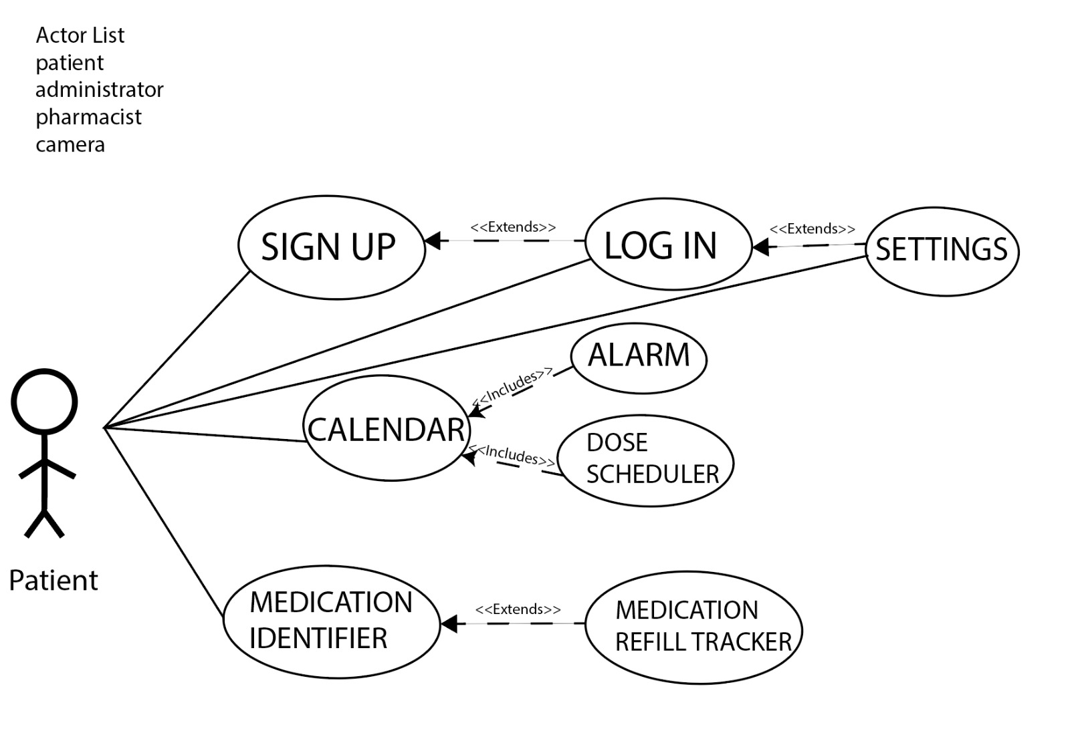

##### Class Diagram

### 

### Evolutionary Requirements

#### Functional Requirements

*< List all functional requirements in the following example format >*

##### Requirement Title

|  |  |
| --- | --- |
| Title | <Insert title> |
| Description | <A one or two sentence description> |
| Priority | <Priority from 0 (highest) – 5 (lowest)> |
| Precondition(s) | <What needs to happen before> |
| Postconditions(s) | <What happens as a result> |
| Use Case Diagram | <Link or number, if present> |

#### Non-Functional Requirements

*< List all non-functional requirements in the following example format >*

##### Requirement Title

|  |  |
| --- | --- |
| Title | <Insert title> |
| Description | <A one or two sentence description> |
| Priority | <Priority from 0 (highest) – 5 (lowest)> |
| Applicable FR(s) | <Which functional requirement(s) is this applicable to?> |

# 