**MCA372 – Unix Programming**

**Task for Lab 18 – 03.09.2020**

**Submitted by,**

**Ambily Francis**

**1947204**

**iNODE**

Execute the following:

1. Suppose there exist a file name with some special character in it. For example:  “christ*

* Try to remove it normally using rm command, you will not be able to remove it.

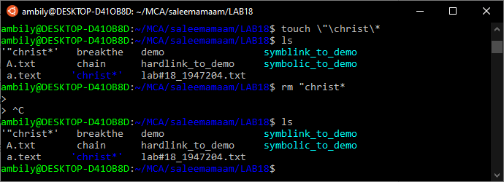

it’s not removing “christ*

* However using the inode number of this file you can remove it.

removing a file name “christ* using inode command

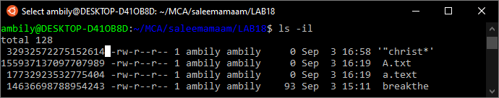

inode of “christ* is 32932572275152614

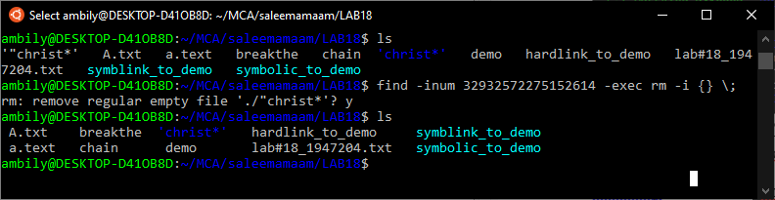

1. Stat command to display different information about file

Stat command is used to display file statistics that also displays inode number of a file

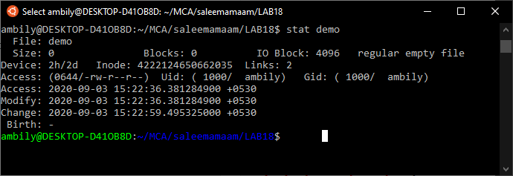

s

1. Ls -i and Df -I usage

df –i – this command is used to see how many inodes are used and free on mounted file systems.( df -i command displays the inode information of the file system. The flag -i is used for displaying Inode information.)

ls –i – is used to display the filename along with the inode number

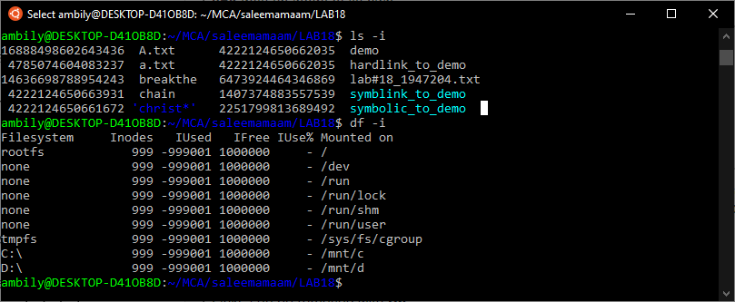

1. Create Soft link, Hard link for a file and demonstrate inode number

hard link we can create by using ln ,so in this case we have a file named demo we are creating a hardlink and softlink/symbolic link (for creating a soft we need to use ln –s command) for this demo file

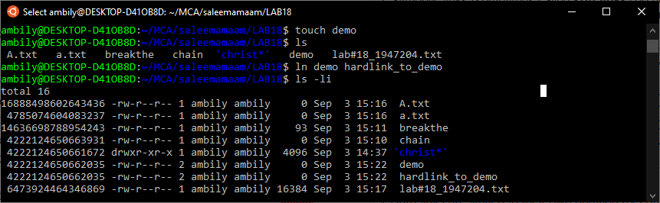

After creating hardlink we can observe that both file having same inode number and file permission,(which we are getting by ls –li command)

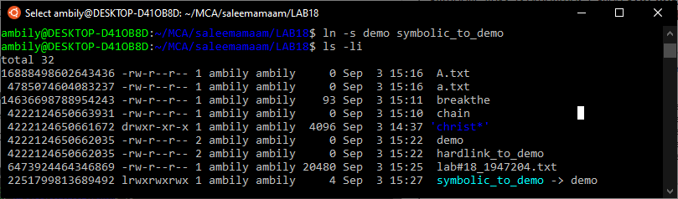

But in the case of softlink,it will create separate inode number.

1. Diffrentiate inode number for a.text and A.txt

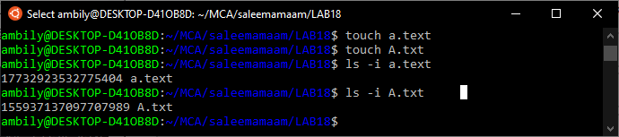

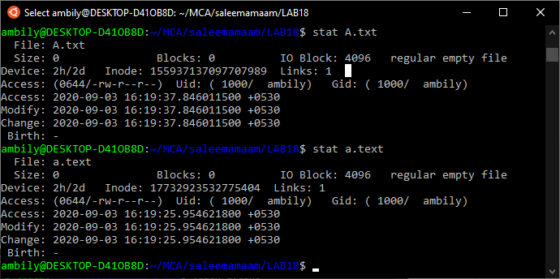

here both files will be assigned with different inode numbers ,since we know that inode number is a unique identification no. assigned to the particular file.As a difference here we can see a.text having a inode number of 17 digit but in the case of A.txt it’s 18 digit.