SCREENSHOTS.

REGISTRY TERMINAL
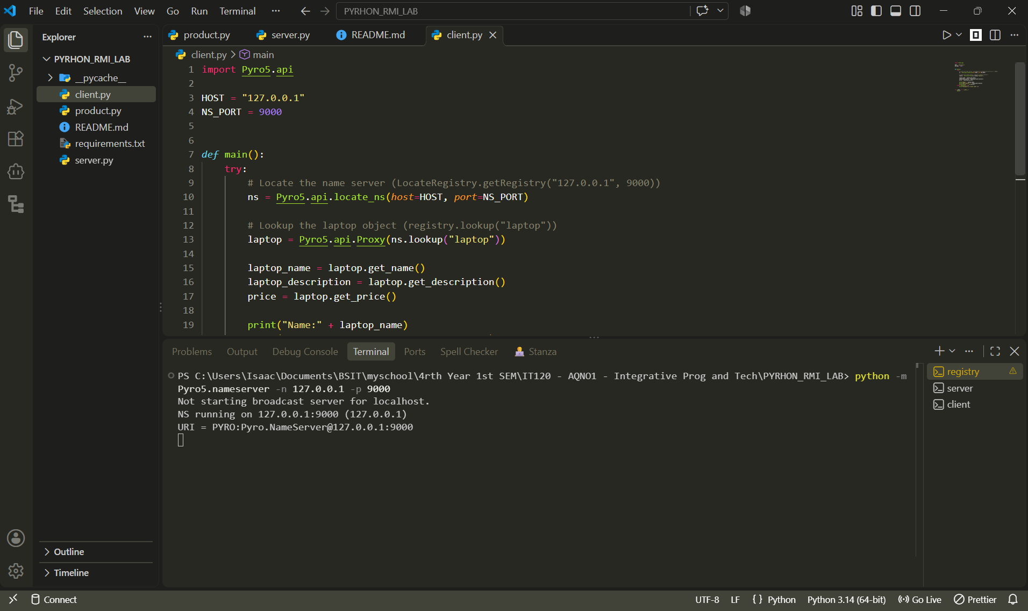

SERVER TERMINAL
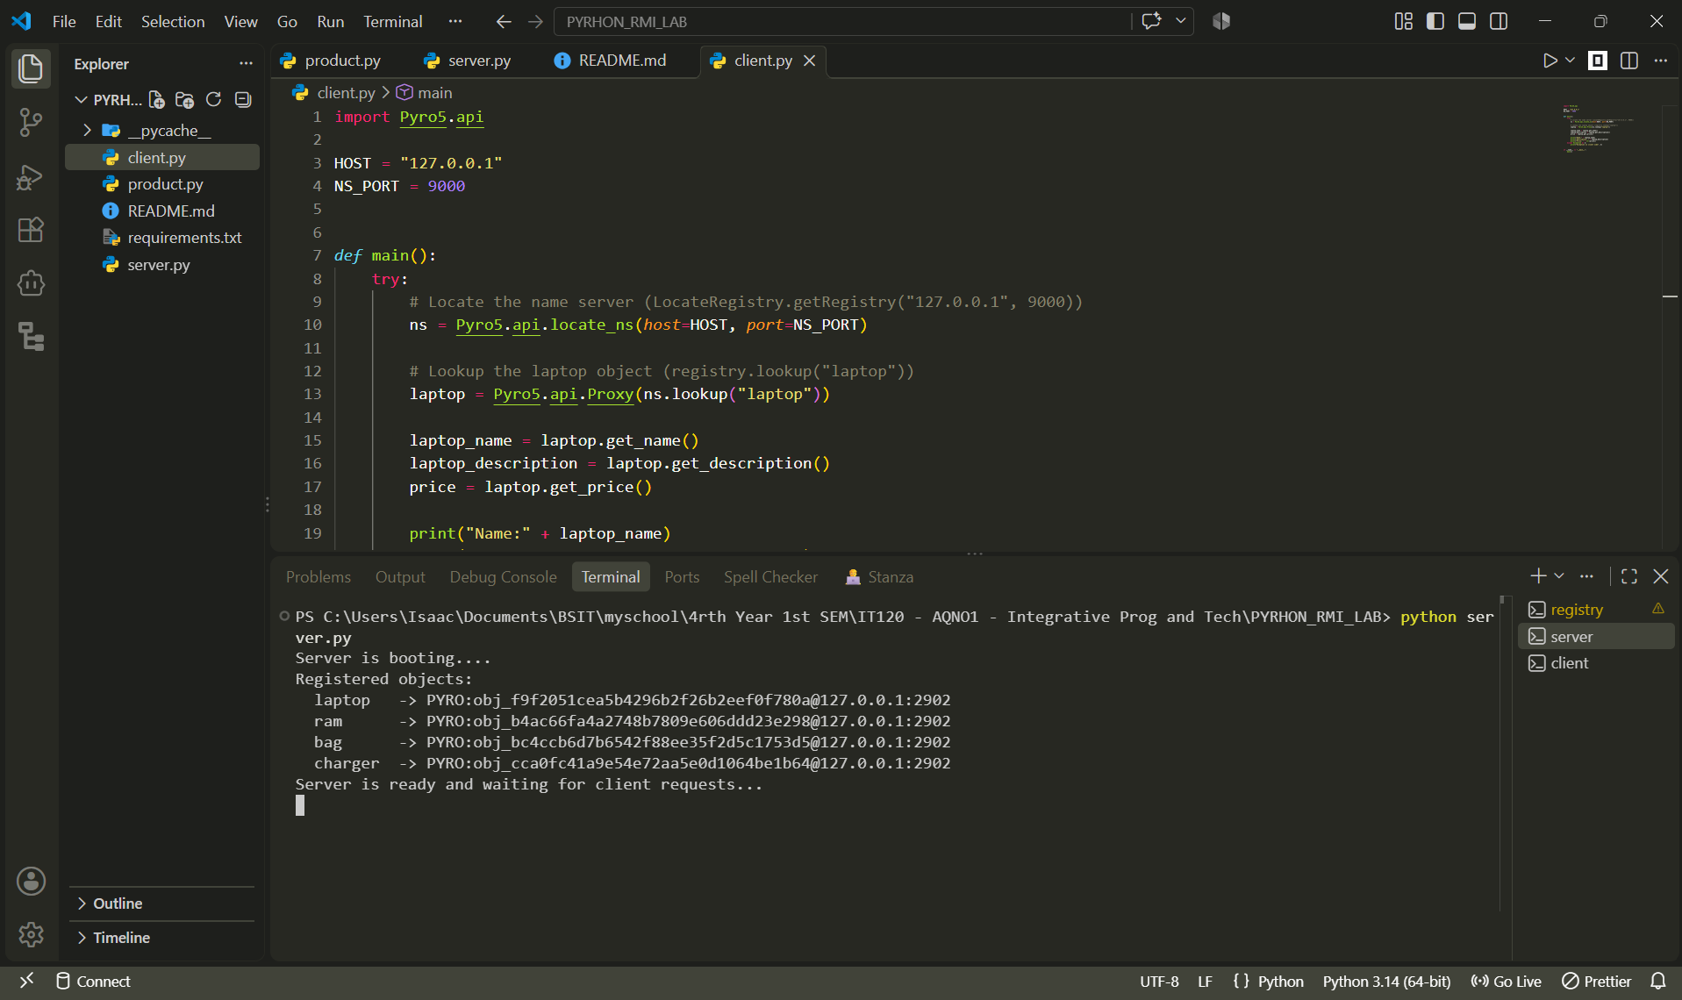

CLIENT TERMINAL
