Weather Trend Forecasting Report

PM Accelerator Mission
By making industry-leading tools and education available to individuals from all backgrounds, we level the playing field for future PM leaders. This is the PM Accelerator motto, as we grant aspiring and experienced PMs what they need most – Access. We introduce you to industry leaders, surround you with the right PM ecosystem, and discover the new world of AI product management skills.

Project Summary
Objective: Forecast city-level weather trends from the Global Weather Repository using daily aggregation built from last_updated.
Primary target in this notebook: daily mean temperature for Bandar Seri Begawan.
Approach: leakage-safe daily preprocessing, exploratory time-series diagnostics, baseline forecasting, ARIMA, recursive XGBoost, model comparison, anomaly review, and outlier treatment rationale.

Basic Requirements:
• Data cleaning & preprocessing: Handled timestamp parsing, daily aggregation, train-only gap repair, missing-value review, outlier review, and an explicit normalization decision.
• Use last_updated for time series analysis: Used last_updated as the timestamp, then aggregated to one row per city per day.
• EDA: trends, correlations, patterns: Included daily temperature diagnostics, secondary precipitation diagnostics, and multivariate exploratory analysis.
• Temperature and precipitation visualizations: Included dedicated sections for both temperature and precipitation.
• Forecasting model + evaluation: Compared moving average, ARIMA candidates, and recursive XGBoost using MAE and RMSE; used AIC/BIC for ARIMA candidate comparison.

Temperature Exploratory Data Analysis Visualisations & Diagnostics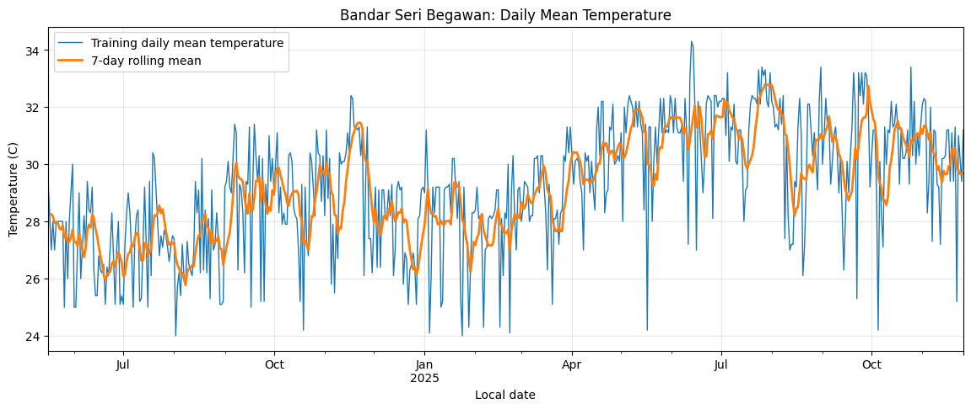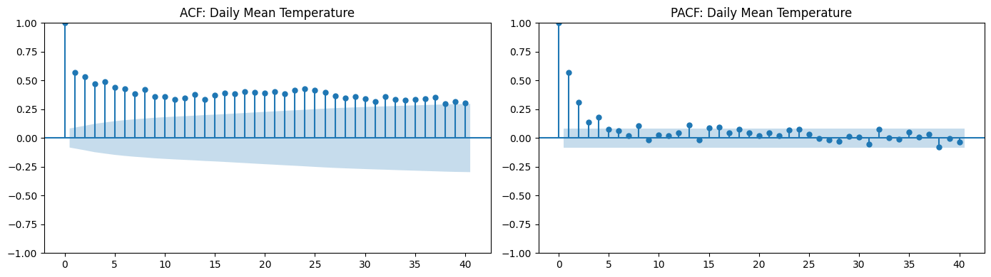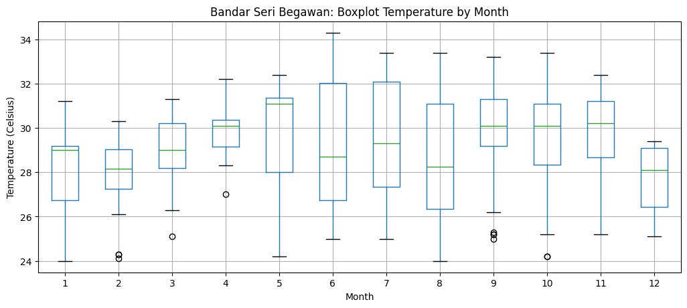

Precipitation Exploratory Data Analysis Visualisations & Diagnostics

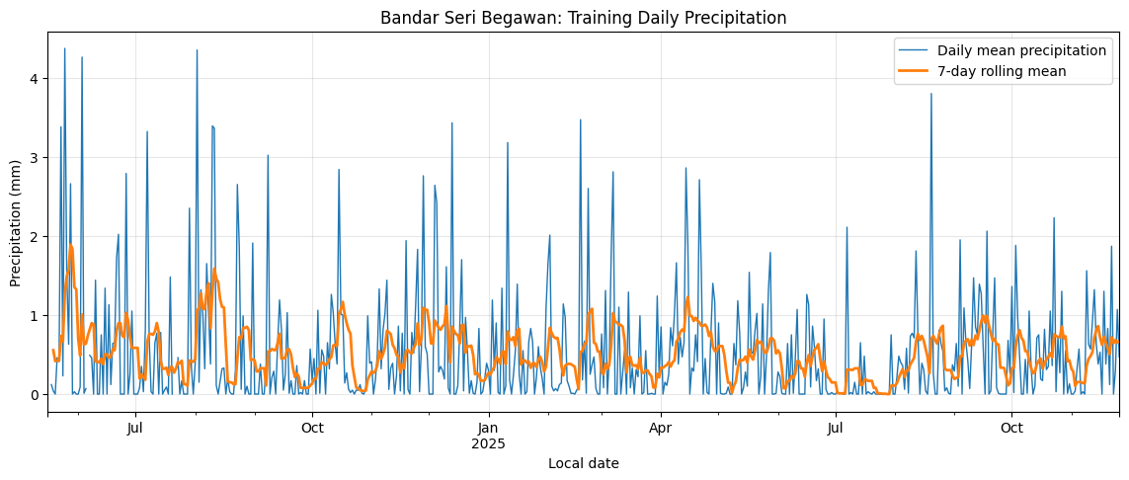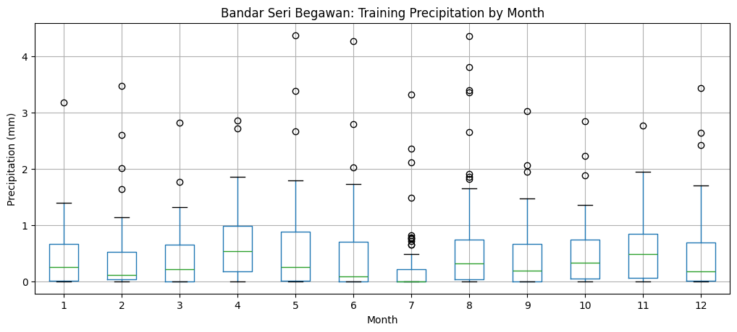
My rationale for choosing Bandar Seri Begawan was that it is my hometown – thus the most interesting for my analysis.

Advanced Requirements — Explicit Mapping
Advanced items completed in this notebook:
• Anomaly detection: Implemented model-based outlier detection from ARIMA residuals.
• Multiple forecasting models: Built and compared moving average, several ARIMA variants, and several recursive XGBoost variants.
• Ensemble: Created XGBoost ensembles and compared them against single-model forecasts.
• Feature importance: Ranked training-only XGBoost features by gain and used feature selection explicitly.
Advanced items not claimed here: climate analysis across regions, environmental impact / air-quality study, spatial analysis, and broad geographical-pattern analysis.
The figure below shows the feature importance that fed into the feature selection process for XGBoost models:
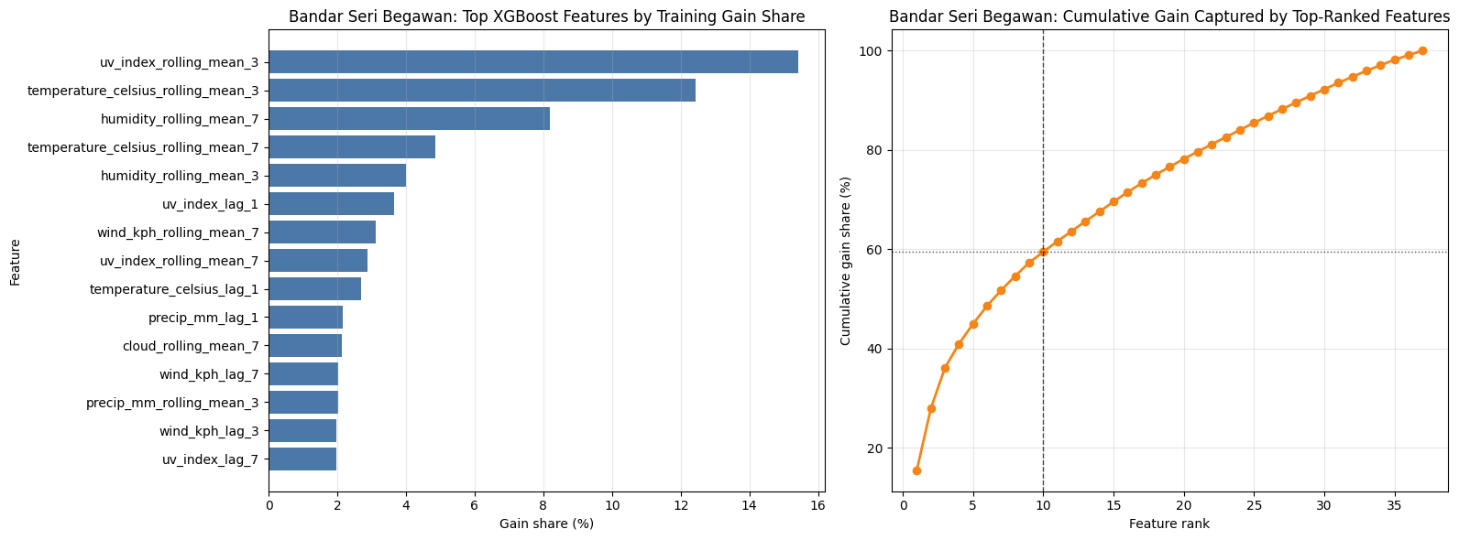
The table and figures below show the outliers we detected with the best performing model, ARIMA(1,1,1), based on median absolute deviation. The data points are separated into whether they were in our test or train dataset – our ARIMA(1,1,1) model here was trained only on the training dataset.
local_date | split | actual | predicted | residual | absolute_residual | residual_score
2025-05-17 | train | 24.20 | 31.025338 | -6.825338 | 6.825338 | -5.174921
2025-10-05 | train | 24.20 | 30.417900 | -6.217900 | 6.217900 | -4.734442
2026-01-18 | test | 24.10 | 30.125963 | -6.025963 | 6.025963 | -4.595261
2025-09-22 | train | 25.30 | 30.773397 | -5.473397 | 5.473397 | -4.194571
2025-11-22 | train | 25.20 | 30.585087 | -5.385087 | 5.385087 | -4.130534
2026-01-30 | test | 25.30 | 30.125963 | -4.825963 | 4.825963 | -3.725090
2025-06-16 | train | 27.00 | 31.670108 | -4.670108 | 4.670108 | -3.612072
2025-08-09 | train | 27.40 | 32.002893 | -4.602893 | 4.602893 | -3.563332
2025-08-20 | train | 26.10 | 30.660486 | -4.560486 | 4.560486 | -3.532581
2024-05-17 | train | 28.25 | 32.805231 | -4.555231 | 4.555231 | -3.528771
2024-10-19 | train | 24.20 | 28.745088 | -4.545088 | 4.545088 | -3.521415

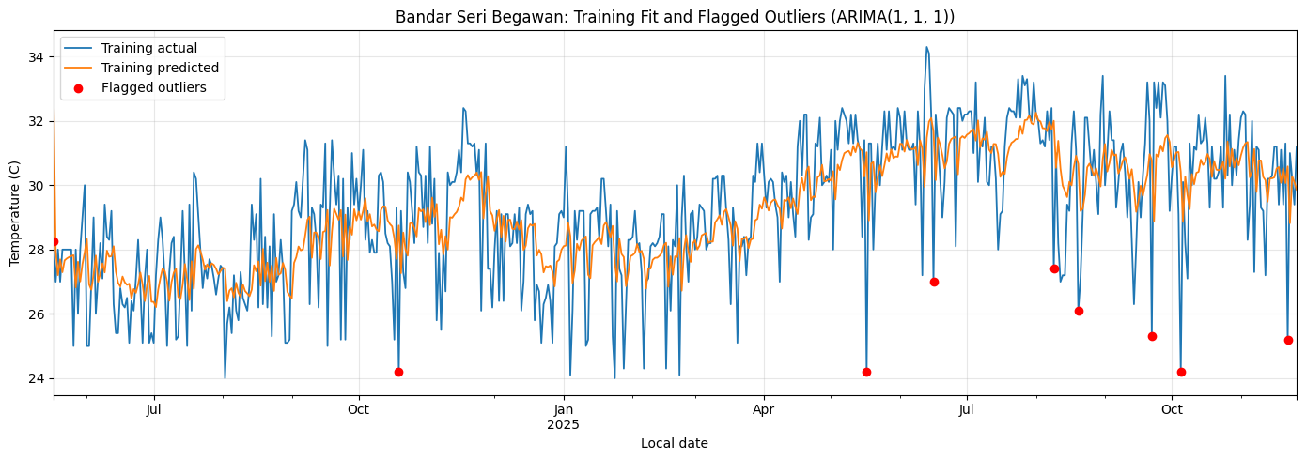

Key Results
ARIMA family models performed best on the holdout window; ARIMA(1,1,1) was selected as the final model.
XGBoost did not materially outperform the stronger linear time-series baselines on this city-series setup.
Outliers were retained and reported transparently rather than overwritten.

The table below shows the comparisons between the finalized models. Details are in the notebook.
Model | model_type | MAE | RMSE | AIC | BIC | n_features
ARIMA(1, 1, 1) | ARIMA | 1.205654 | 1.637954 | 2153.899295 | 2166.866990 | -
ARIMA(0, 1, 1) | ARIMA | 1.218489 | 1.626706 | 2165.550161 | 2174.195291 | -
7-day moving average | Recursive baseline | 1.239592 | 1.619948 | - | - | -
ARIMA(1, 1, 0) | ARIMA | 1.312714 | 1.772746 | 2254.613697 | 2263.262415 | -
XGBoost exog lag1+lag3+lag7+roll3 | Gradient boosted trees | 1.680241 | 2.045387 | - | - | 31
XGBoost ensemble (top 3) | Gradient boosted trees ensemble | 1.775431 | 2.176961 | - | - | -

The figure below is for readability – looking at the first 7 test days in our train-test split, and how our top models are performing in relation to each other, as well as the actual observed temperatures during those days.
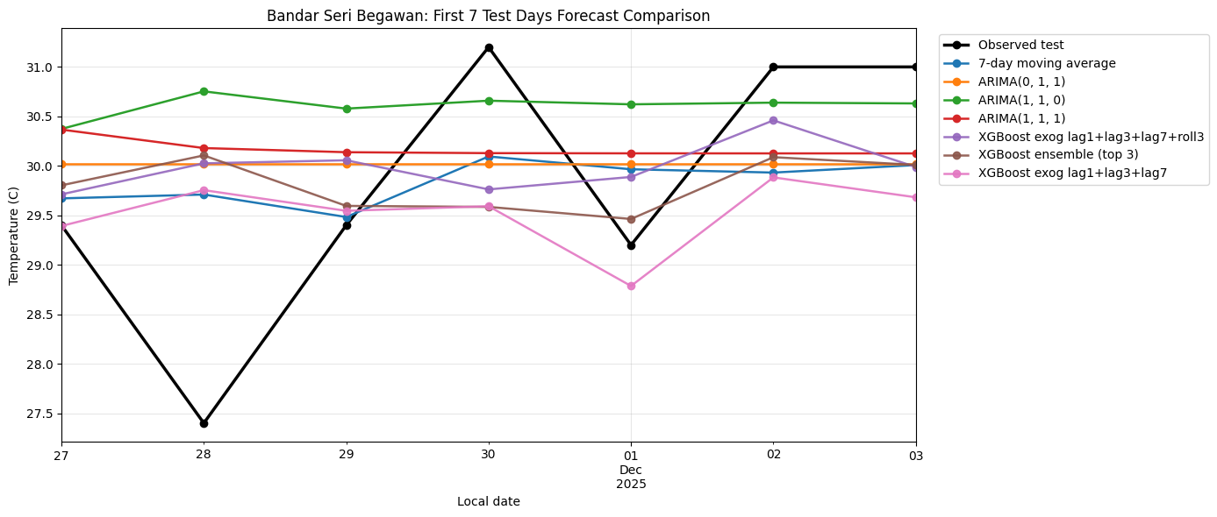

Repository Contents
notebook_DS.ipynb - full analysis and modeling workflow
README.md - project overview, setup, and results summary
requirements.txt - installable dependencies
Weather_Forecasting_Report_Template.pdf - concise submission artifacts

How to Run
1. Create a Python 3.11+ environment.
2. Install dependencies from requirements.txt.
3. Open notebook_DS.ipynb and run all cells in order.
4. Export the notebook or use the attached report/deck for submission packaging.

