The University of Iowa
FY25 Annual Economic Development Report
Ranked as a top-200 “best global universities” and #46 “best public university” accompanied by 35 consecutive years with one of the nation’s “best academic hospitals” including three disciplines ranked in the nation’s top 50, the University of Iowa stresses bringing “learning and discovery into the service of the people of the state of Iowa, the nation and the world” as a central mission. Translation of research and knowledge generated by University of Iowa faculty, staff and students is a central means through which this mission is accomplished. Those actions subsequently produce a positive impact on the economy of Iowa. The University’s 2022-2027 strategic plan calls to “Accelerate entrepreneurship and support broader economic development through innovative engagement and partnerships with industry and community organizations.” This strategy is implemented by:

- Creating increased opportunities for entrepreneurial education, new venture creation, technology transfer, with a specific focus in medtech innovation, and
- Connecting faculty, staff, and students to organizations and subject matter experts to solve unmet needs in social, health, technical, and business.

A robust strategy incenting economic development, on a campus like the University of Iowa, is key to transforming ideas into impact benefiting Iowans and beyond.

Consequently, this report provides a description of the UI’s key initiatives in the economic development space— the work of the Chief Innovation Officer, who oversees Protostudios, UI Research Park, Translational Research Incubator, UI Ventures, and MADE; UI Research Foundation; John Pappajohn Entrepreneurial Center (JPEC); UI Pharmaceuticals, and other activities.

I. Organizing to Support Economic Development

The Chief Innovation Officer, who reports to the Vice President for External Relations with a dotted-line report to the University President, oversees and coordinates the economic development activities for faculty, staff and graduate students at the University of Iowa. The Chief Innovation Officer oversees: Protostudios, UI Research Park, Translational Research Incubator, UI Ventures, and MADE.

In FY24, several broad themes served as the central organizing principles of the Office of Innovation, including:

Establishing the Medical Innovation Hub. With the support of an $8 million grant from the Governor’s office, the Office of Innovation will open the Medical Innovation Hub located adjacent to the UI’s Hospitals & Clinics and healthcare campus. The Hub will become the gathering place for healthcare innovators and industry. There they can access unique equipment, resources and expertise while also commingling with other innovative faculty, staff and graduate students. A key success factor in similar spaces elsewhere is proximity to the “day jobs” of those clinicians, researchers, and graduate students eager to take advantage of this offering. Creating an innovation Hub within the healthcare complex is a major cultural breakthrough that will reduce the bottleneck of faculty seeking start-up company wet lab space while propelling nascent entrepreneurs forward. Construction on the Medical Innovation Hub is targeted to be completed in FY26 with a scheduled Grand Opening in winter/spring 2026.

Seeding Interest in Translational Activities with Next Generation. The Iowa Innovation Leadership Fellows program continues with its third cohort in FY24. The FY24 cohort consists of 11 competitively selected graduate students, post-doctoral researchers, and trainees from medicine, engineering, and public health to teach the significance of translational research outcomes, how to go about solving unmet needs and gaining exposure and connections to industry experts. They learn about the programs available to support entrepreneurial activities and commercialization efforts on campus. They interact with UI faculty, alumni, and entrepreneurs with experience in commercializing academic research. The Fellows offer the Office of Innovation unique insights to help shape communications with academic departments, identify opportunities to engage with those departments, and encourage their colleagues to consider translational activities when appropriate.

Extending the UI Innovation Support Structure Across Iowa. The Nurse Innovators program, which is designed to encourage nurses to bring forward solutions to unmet needs, continued into its second year which saw the number of direct engagement of nurses expand to over 1,000 surfacing 29 projects. The program began to receive regional and national attention as it graduated its first 2 nurses and expanded into a Critical Access Hospital in Davis County. Through the program, the Office of Innovation guides and assists nurses with concept development, providing them an outlet and agency to solve challenges they face in their clinical practice. This project intends to work with nurses throughout the State of Iowa and across a variety of nursing professions, exposing underserved healthcare communities and workers to the support that the Office of Innovation can extend to innovators outside the university. Besides empowering nurses with tools and resources to solve unmet needs in clinical practice, the program aims to impact job satisfaction, retention and nurse recruitment as well as an economic impact when these inventions reach the healthcare marketplace.

Mobilizing an External Network. The Office of Innovation is exposing UI start-ups and entrepreneurially minded faculty, staff and students to skills and connections drawn from a network of contacts in the healthcare innovation and venture capital space. The network of individuals able to assess start-ups potential, offer strategic and experiential assistance, and connect them to essential talent not resident to Iowa.

Deploying a Concierge Service to Support UI Faculty Innovations. Under the direction of UI Ventures, the Office of Innovation established a comprehensive suite of services to assist UI faculty looking to engage the commercialization process. This service has and will continue to connect entrepreneurial faculty and companies with strategic support from medtech venture capital and industry knowledge, FDA guidance, intellectual property or clinical study guidance and reimbursement strategies.

Application of Innovation Funding Programs. Encouraging proof of concept and translational projects is a key building block in the Economic Development pipeline. UI Ventures continued to deploy innovation funding to promising medical innovations in FY24. The program reviewed 24 applications for funding and awarded full or partial awards to 17 projects.

Incorporating Nationally Recognized Medical Innovation Programming. In FY24, the Office of Innovation sent a faculty and a staff member to participate in the Stanford Biodesign Global Faculty Training Program (GFIT). The GFIT program provides training for establishing a nationally acclaimed Biodesign program for medical innovation at institutions around the world. The UI was the first US university to in this training. Looking forward, the Office of Innovation will utilize this coaching to develop and implement an Iowa Biodesign program, tailored to capitalize on the unique strengths of UIHC and the University of Iowa and complementing other programs in practice.

Creation of Hawkeye Ventures Seed Fund. Following 2021 legislation (Iowa Code 262.14(3)(f)) allowing Regents institutions to invest in private enterprises, the University of Iowa’s Tippie College of Business, through the John Pappajohn Entrepreneurial Center (JPEC), launched Hawkeye Ventures. The donor‑powered seed fund will provide early‑stage equity investments of $25,000–$250,000 to University of Iowa–affiliated startups (students, faculty, staff, and alumni). The fund is overseen by an investment board of experienced investors, with profits from exits reinvested to sustain future rounds. Institutional approval to proceed was granted in the spring, and fundraising is underway toward an initial $10 million target (with a longer‑term goal of $25 million) via the UI Center for Advancement. First investments are targeted for FY26, positioning Iowa to better align with peer and Big Ten institutions’ venture funds.

II. University of Iowa Economic Development Infrastructure

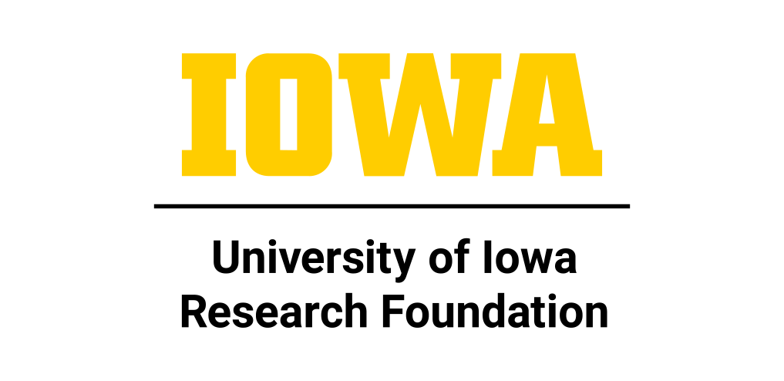
Researchers at the University of Iowa continue to develop innovative solutions to address the world’s most pressing issues, while entrusting their inventions to the UI Research Foundation (UIRF) for patenting and licensing into the commercial market. UI researchers have seen great success over the last year both in the lab and through commercial efforts. Companies licensing UI-invented technologies are making strides in developing products in areas traditionally associated with academic technology transfer at UI—human health care and engineering—but also in the fields of education and even some in the agricultural and animal health arenas.

While UIRF’s immediate focus is on protecting UI intellectual property and transferring it to companies for commercialization, this step is a critical one for the university’s overall economic development goals. By way of example: UI researcher Michael Schultz and his colleagues submitted their first invention to UIRF in 2009, describing their innovation for using radiopharmaceuticals to treat cancer. Eleven (and counting) invention disclosures and one license agreement between UIRF and Dr. Schultz’ start-up later, the company Perspective Therapeutics has 140 (and counting) employees, is actively hiring UI graduates, is proposing to build a production facility locally, is developing a discovery center in the research park, is sponsoring clinical trials at the hospital, and is planning collaborative research at the college of medicine. This is just one example of how UIRF’s activities align with the university’s economic development goals.

Revenue from the licensing agreements UIRF negotiates with our company partners is shared with our inventors and supports department, collegiate, and cross-campus research efforts. And as illustrated above, many licensing relationships also lead to sponsored research at the university. And in fact, the connection between research grants and inventions goes both ways—federal agencies, non-profit-foundations, and corporations usually include intellectual property provisions in their grants, and UIRF takes the lead in helping our researchers satisfy these requirements.


Protostudios (https://protostudios.uiowa.edu/) is a state-of-the-art, rapid-prototyping facility located in the MERGE co-working space in downtown Iowa City, Van Allen Hall and at UIHC. It works with UI researchers, researchers from other Iowa universities and healthcare institutions and community members to develop fully functional prototypes of product ideas, allowing innovators to test, redesign, and determine manufacturing paths and demonstrate usability to investors. Protostudios primary focus is on biomedical and electronics prototyping with access to 3D printers (plastics, metals, ceramics) milling, laser/wet jet cutter, printed circuit board fabrication, and consulting from on-staff industrial designers and engineers. Anatomical modeling of human organs prior to complex surgeries is developing into a key value add of Protostudios.

The creation of Protostudios was funded through a $1.5 million Strategic Infrastructure Fund grant from the Iowa Economic Development Authority, and the authority approved a $500,000 grant to outfit additional space for new equipment that expands the organization’s capabilities.


The UI Research Park (https://researchpark.uiowa.edu/) leases building sites and space to growing technology companies that require sustained research relationships with the university. The Park is home to a business incubator program that has nurtured over 100 UI start-ups and other new ventures since its founding. Incubator tenant companies can draw on both the research and business resources of the university, including access to UI libraries, hazardous waste management services, support for SBIR/STTR grants (Small Business Innovation Research/Small Business Technology Transfer federal grants), educational seminars, networking opportunities, and shipping/package handling.

The BioVentures Center (BVC) in the park contains wet laboratory modules that can be shared for life science companies and office/dry laboratory modules for engineering and technology-based companies. The BioVentures Center wet lab space is currently full and has a waiting list.

The Park is also home to three of the university’s specialized core facilities. These facilities provide technical support services critical to the growth of start-up companies as well as existing industry partners:
- Center for Biocatalysis and Bioprocessing operates a microbial fermentation facility and specializes in both upstream and downstream bioprocessing with expertise in process scale up for food products, biofuels, biopharmaceuticals, and other biotechnology products.
- University of Iowa Driving Safety Research Institute conducts research and development on driving safety for the government, military, and industry partners.
- State Hygienic Laboratory is the state’s environmental and public health laboratory, serving all ninety-nine Iowa counties as well as out-of-state clients by testing and tracking infectious diseases and illnesses.


UI Ventures (https://uiventures.uiowa.edu/) assists university faculty and staff in transforming their research into successful business endeavors so that their technologies can reach the population it was intended to help. As part of the Office of Innovation, UI Ventures supports cultural transformation on campus and provides access to capital and world-class talent to build successful companies around innovations originating from research at the university. As faculty develop technology, they are often left with an unknown question of “What’s next?” as their research evolves beyond basic principles and requires additional expertise and funding beyond what is available at the University. UI Ventures supports this transition through deployment of GAP funds to address specific business validation questions and utilizes a robust network of experts who have successfully started, scaled, and exited companies in the same areas as our faculty entrepreneurs. If faculty choose to start a new company, UI Ventures facilitates connections with industry-specific executives and funding resources to launch and grow their companies as well as serving as a liaison between the company and university services. UI Ventures routinely brings venture capitalists and successful entrepreneurs from around the country to campus so that faculty may directly engage with those who have direct experience. In addition, UI Ventures manages the TRI incubator, Nurse Innovators program, and operates the MADE program to encourage faculty and staff innovation and entrepreneurship throughout campus.
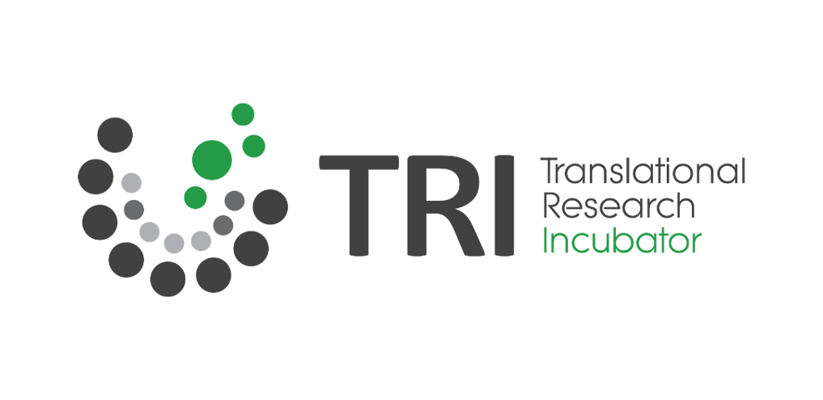
The Translational Research Incubator (TRI) (https://uiventures.uiowa.edu/translational-research-incubator) serves a critical role in launching medtech companies by providing 1) a physical location for the company in close proximity to clinical founders; and 2) shared lab equipment so companies can focus their limited resources on technology-specific development to maximize their funding. Much of the support for TRI goes to purchasing and maintaining equipment that can be shared among the company tenants with an in-kind contribution of at-cost facility space.

The TRI space, located in the Medical Laboratories building, can house up to four early-stage research-based biomedical or life science companies focused on commercializing technology developed at the University of Iowa. The space is ideal for small start-ups that need to conduct early-stage proof-of-concept experiments, often with SBIR/STTR funding, to attract the investment needed to expand operations at the UI Research Park and other locations. The TRI has proven successful in helping companies secure over $12 million in both federal (SBIR/STTR) and private grants. These companies have gone on to raise over $57 million in equity funding.

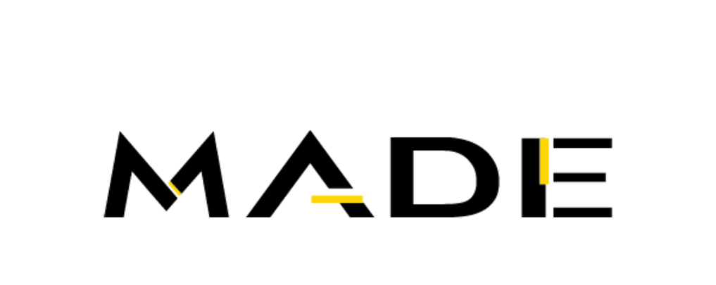
Iowa MADE (https://iowamade.org/) is a first of its kind program, in the nation, whose mission is to encourage and facilitate the UI community to bring innovative, need-based products to market with the goal of enhancing economic development at the university as an extension of research and scholarship.

MADE is a manufacturing and e-commerce initiative launched in FY18 with 3 objectives: 1) bring simple, low volume technology to market utilizing local Iowa manufacturing whenever possible; 2) contribute to a cultural transformation around innovation on campus; and 3) provide students with an opportunity to learn first-hand the tools necessary to bring a product to market. The program crosses several departments with products from Ophthalmology, Anesthesiology, Dentistry, Cardiothoracic Surgery, and General Surgery. Products are available for sale through the iowamade.org website and revenue is used to reimburse development costs to encourage continued support of innovation and development. All technologies remain available for licensing to an external company through UIRF.

An undergraduate student operations team maintains the FDA compliant quality system, manufacturing, product management, marketing, and sales. These students have the unique opportunity to gain in depth real-world experience and leadership skills on campus to complement their classroom education.

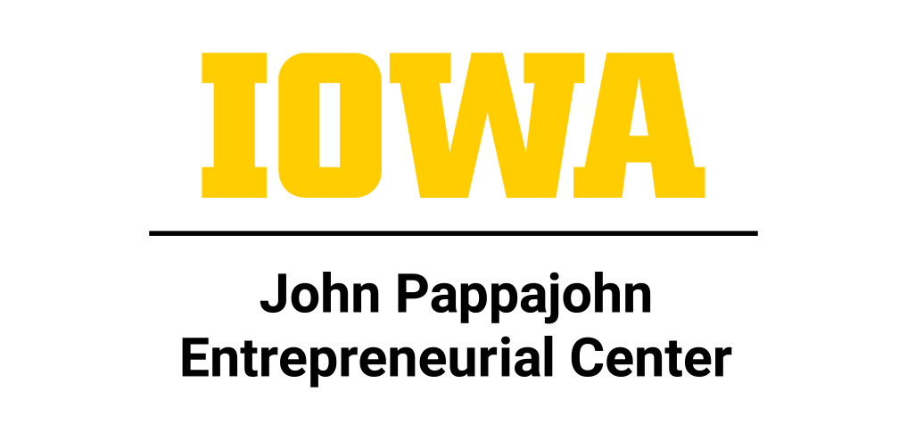
The John Pappajohn Entrepreneurial Center (Iowa JPEC) is an engine for entrepreneurship, innovation, and statewide economic growth. Ranked #15 in the nation by The Princeton Review, JPEC is recognized as one of the country’s premier entrepreneurship programs equipping students from every discipline with the mindset and skills to launch ventures, drive innovation, and lead organizations. Academic offerings span the BBA in Entrepreneurship, the BA in Enterprise Leadership (on-campus and online), and undergraduate and graduate certificates - including Entrepreneurial Management, Technological Entrepreneurship, and Innovation - reaching more than 2,000 students annually with applied, team-based, and capstone-driven learning. In addition, JPEC extends entrepreneurship education to the next generation, impacting 23,354 K–12 students across 37 states, including 15,079 students in the state of Iowa from 83 counties.

Beyond the classroom, Iowa JPEC offers one of the most comprehensive venture ecosystems in the nation. Students, faculty, and community members access resources ranging from business incubation and consulting projects to the NSF I-Corps program, gaining direct experience in building and scaling companies. Flagship initiatives such as Venture School, the Venture Mentoring Service, and Enterprise Internships connect entrepreneurs to world-class mentors, interns, and problem-solvers. The recently launched Hawkeye Ventures Seed Fund is set to expand this pipeline by providing early-stage capital and linking students, alumni, and investors in accelerating Iowa’s most promising start-ups.

JPEC’s impact extends across the state, powering Iowa’s economy through training, mentorship, and hands-on support for all entrepreneurs. Faculty and staff programs accelerate technology commercialization, while community businesses gain growth through consulting, accelerators, and statewide workshops. By uniting education, incubation, mentorship, and capital, Iowa JPEC fosters lifelong entrepreneurial learning, fuels job creation, and positions the University of Iowa as a national leader in innovation and economic vitality.


The University of Iowa Center for Advancement’s (UICA) (https://www.foriowa.org/) Corporate and Foundation Relations (CFR)drives economic development by connecting University of Iowa’s strengths with industry’s critical needs and solving business problems. Included but not limited to talent pipeline creation, access to faculty, cutting edge research and acting as a catalyst for organizations in achieving philanthropic goals.

CFR’s partnerships with the state’s economic development organizations and the University of Iowa’s office of Vice President for Research are levers that ensures the innovative research taking place at the University of Iowa is included in proposals for business attraction, retention and competitive advantage.

In addition to connecting companies with the university, the Center for Advancement is a key player in tapping UI’s extensive alumni base to support entrepreneurship and technology commercialization through monetary resources and, equally important, advice and expertise.

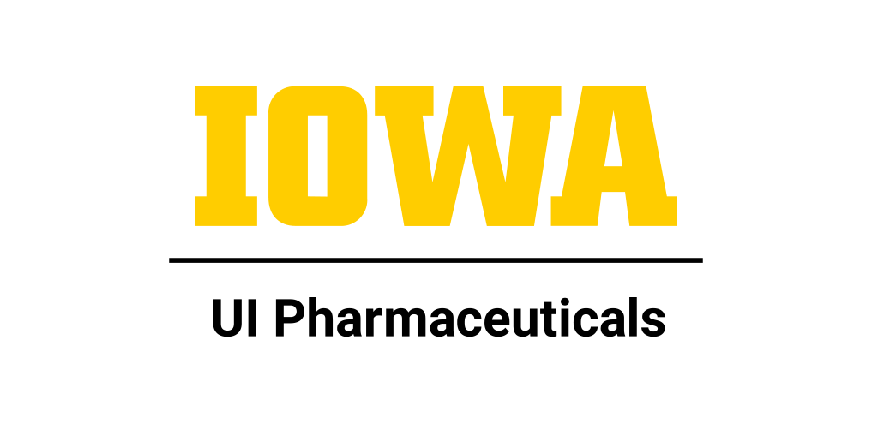
UI Pharmaceuticals (https://uip.pharmacy.uiowa.edu/) is a fee for service entity on the University of Iowa Campus that provides contract drug manufacturing (CDMO) services to academic, biotech, and pharmaceuticals clients. These services range from early-stage formulation development, analytical method support, clinical trial material manufacturing, to commercial product manufacture and support. It is organizationally structured as a division of the UI College of Pharmacy and employs approximately 95 pharmaceutical professionals. UI Pharmaceuticals has been operating for over 45 years and supports the manufacturing and testing of both clinical and commercial products. The seven departments that comprise the program are as follows:

- Sterile Manufacturing
- Non-Sterile Manufacturing
- Quality Assurance
- Analytical Services
- Preformulation and Formulation Development
- Business Development
- Engineering and Facilities

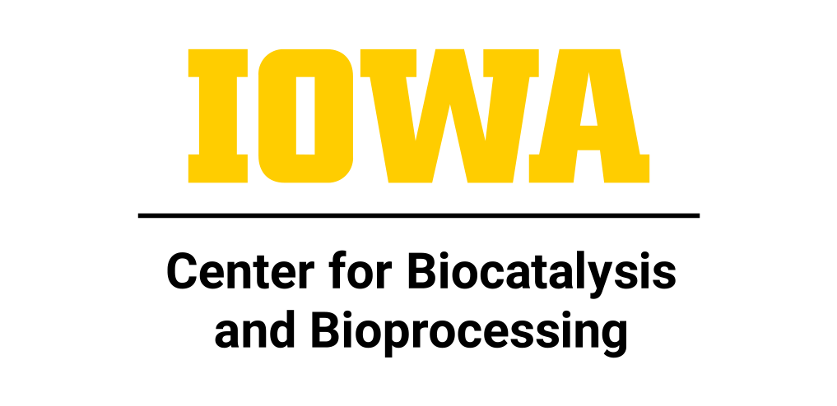
The Center for Biocatalysis and Bioprocessing (CBB) (https://cbb.research.uiowa.edu/) is an academic center at the UI focused on advancing biotechnology through the creation and dissemination of discoveries in the biocatalytic sciences.

As an internationally recognized contract development and manufacturing operation (CDMO), the CBB facility specialized in the optimization and scale-up of complex bioprocesses to produce pilot-scale, high valued bio-based chemicals. Most notably, the CBB’s facility fills a worldwide niche to produce recombinant proteins of commercial and research value.

A fraction of these proteins is produced under strict standards defined by the FDA, referred to as current good manufacturing practices (cGMP). The CBB’s cGMP suite operates under the 2008 FDA guidance for Phase I clinical studies, which means the products produced under this standard can be used to determine the safety and efficacy of putative therapeutics. The CBB’s cGMP operation is ideally suited for startup companies with limited budgets who need information for the Chemistry, Manufacturing, and Control (CMC) section of their Investigative New Drug (IND) applications required by the FDA before Phase I clinical trial testing can begin. The CBB operates the only facility in the State of Iowa that manufactures vaccines and therapeutic proteins for Phase I clinical trials in people.

Clients range from international corporations to virtual startups. In addition, the facility’s professional staff supports clients who are preparing SBIR/STTR grant applications and staff consults for companies preparing IND applications for the FDA.

The CBB bioprocessing facility is initiating a new effort designed to accelerate the translational path required to realize commercially viable products from laboratory discoveries. In the biotechnology sector, failure to demonstrate manufacturability is a major barrier to commercialization. The CBB’s expertise in both the development and scale-up of robust biomanufacturing processes is ideally suited to help startup companies to bridge this gap. Successful demonstration of manufacturability reduces the risk of the technology and increases its commercial value, thereby enhancing investment opportunities.

III. University of Iowa’s Economic Development Activities in FY24

- UI Research Park
  - The UI Research Park is home to 33 companies, employing over 3,700 total employees, 1,031 of those located on the park. Total payroll associated with Park companies is more than $3 million.
  - Companies residing on the Research Park, and in particular those residing in the BioVentures Center, have access to a variety of services, including: Shared laboratory equipment room; Executive board room and conference rooms; Multi-purpose room seating 70; Breakroom/vending area, atrium and lounge areas; Shipping/receiving area; High-speed wired & wireless internet; Emergency backup generator; Shared equipment room that includes: Autoclave, Laboratory glassware washer/dryer, RO/DI water system, Ice machine, -80° freezer; and the vast resources at the UI’s Carver College of Medicine via their core facilities.
- UI Ventures
  - UI Ventures currently supports 37companies including 8 that formed in FY24.
  - Faculty and staff founded companies raised over $91 million in equity funding in FY24.
  - In FY24, four UI faculty/staff companies were awarded $1.5 million in SBIR/STTR grants.
  - In FY23, 17 Innovation Fund awards were made to faculty and staff to aid the translation of their research towards commercial potential.
  - The Nurse Innovators program engaged >1,000 nurses with 29 projects in development including one at a Critical Access Hospital in Davis County.
  - Supported the second cohort of Innovation Leadership Fellows comprised of graduate and postgraduate students, medical students, and scientists.
  - UI Ventures continues to build a stronger economic development pipeline through programs that support business executive interactions, coaching and connections with investors, business strategy support, and other startup resources.
- Iowa MADE
  - MADE had 4 products on the market in FY24 and students continued to develop an additional 4 products originating from the Colleges of Medicine and Dentistry, and the UIHC Dept of Nursing.
  - MADE alumni continue to receive competitive job offers directly related to their work at MADE and are 100% employed upon graduation.
  - MADE utilizes suppliers in Iowa to support the state economy and presently 100% of part suppliers are Iowa companies.
- Protostudios
  - Protostudios worked with 44 clients across 72 unique design and production projects in FY24.
  - Employed 8 UI students providing them with hands-on experience in client interaction, project management, design, and a variety of technical skills.
- Iowa JPEC
JPEC Key Metrics & Programs
  - Impact Summary
  - Start-up Companies Served: 207 new business starts supported.
  - Program, Seminar & Workshop Participants: 4,170 Iowans engaged in entrepreneurial training.

  - Jobs Created: 171 new jobs generated through JPEC-supported ventures.
  - Client Support Hours: 18,300 hours of direct mentoring and consulting.
  - Total Clients Assisted: 754 individuals received one-on-one support.
  - Youth Impact: 15,079 K–12 students (264 schools from 175 school districts in 83 counties) inspired through entrepreneurship programs.
  - Seed Funding Awarded: $649,900 distributed to student and community start-ups.
  - Total Participants Across All Programs
(a, outreach, and youth): 32,460
- Seminar & Workshop Participants: 6,409
- Youth Impact (K-12): 23,354
- • Jacobson Institute: 18,628
- • DesignDash & UI Credit Programs: 4,726
- Event Participation:
- • Jacobson Institute Events: 2,122
- • Iowa JPEC Events: 2,048

Student Entrepreneurship
  - Academic Programs:2,994 students (2,170 unique) enrolled across the BA in Enterprise Leadership, BBA in Entrepreneurship, and entrepreneurship certificates; 337 MBA students completed advanced entrepreneurship coursework.

    - Bedell Student Incubator: A 10,000 sq. ft. campus hub with offices, coworking, and intensive mentoring; supported 60 teams in FY25, contributing to 91 jobs and impacting 1,752 students since inception in 2004.

    - Summer Startup Incubator: 12-week accelerator using Lean LaunchPad methodologies, daily lectures, and weekly pitch sessions advanced 11 team ventures of 14 students.
    - Business Competitions: $649,900 awarded through campus-wide pitch and business plan competitions to UI students, faculty and staff.
    - Jacobson Institute for Youth Entrepreneurship: Delivered BizInnovator curriculum in 348 schools nationwide, reaching 18,628 students.

    - Alumni-Student Mentoring Program: Alumni-Student Mentoring: 247 student–alumni mentor pairs enhanced students’ professional growth and entrepreneurial problem-solving skills.
    - Okoboji Entrepreneurial Institute: Week-long immersion in entrepreneurship via a partnership with Iowa Lakes Corridor Development and other Iowa universities and colleges; 6 students participated in FY25 for a total of 208 students since inception
    - Student Organizations: Entrepreneurial Honors Society Sigma Nu Tau supported 14 active members in FY25.

Statewide Entrepreneurship
    - Venture School: Lean LaunchPad-based training offered statewide; 67 startups made up of 86 entrepreneurs received 3,283 hours of mentoring in FY25. Locations included Mason City, Iowa City/Cedar Rapids, Des Moines, Dubuque, Quad Cities, and virtually.
    - UI Small Business Development Center (SBDC): Served 414 clients, 12 new businesses, across 5 counties (Cedar, Johnson, Iowa, Poweshiek, and Washington); resulting in $7.98M in equity raised, $15.5M sales growth, and creation of 48 jobs.
    - Institute for International Business (IIB): Partnered with 3 Iowa companies, across 3 counties (Johnson, Benton, and Linn), completing 3 consulting projects (4,560 hours) while providing 4 students with global business experience; providing strategic support in healthcare, consumer goods, and professional services.
    - Business Consulting Program: 61 projects across 19 industries and 14 counties; 8,200+ hours of faculty–student consulting; provided hands on support and one-on-one consulting.

    - Pappajohn Entrepreneurial Ventures Competition: Annual statewide competition awarding $100,000+ to promising Iowa start-ups; Sponsored by UI JPEC in partnership with Pappajohn entrepreneurial centers at ISU, UNI, Drake and NIACC as well as the IEDA.
    - NSF I-Corps Training Program: NSF I-Corps Training: Supported by a multi-year NSF I-corps federal grant and in a joint effort amongst the Office of the Vice President for Research and Economic Development, the UI Office of Innovation, UI Ventures, and IA JPEC. 5 cohorts trained 50 teams of 82 participants, with 1,000 hours of mentoring: resulting in 4 teams advancing to Nationals, securing $200,000 in federal grants.

Statewide Entrepreneurship
    - Regional Partnerships: Collaboration with multiple chambers of commerce, economic development groups, and community colleges across Iowa leveraging these networks to connect entrepreneurs with critical resources, mentorship, and funding opportunities.
    - Accelerator Partnerships: Engagement with the Global Insurance Accelerator, Goldman Sachs 10,000 Small Businesses, Iowa Startup Accelerator, and TechStars providing specialized support, access to capital, and national networks for early-stage ventures.
    - University Collaborations: Joint programming with ISU, UNI, Drake, NIACC, DMACC, Kirkwood, and others to expand entrepreneurship access, foster cross-campus innovation, and share research initiatives.

    - Hawkeye Ventures: Established to act as a conduit to connect students, faculty, alumni, and investors through seed funding, mentoring, and events.
    - National & Global Engagement: Active in GCEC, USASBE, NASVF, and InBIA; faculty and staff regularly present Iowa’s best practices on national and international stages ensuring JPEC’s programming remains at the forefront of entrepreneurial education and that its’ impact is felt beyond the borders of Iowa.
- UI Center for Advancement
  - Aligns corporate partner recruiting efforts/talent pipeline creation within State of Iowa. Including internships, early talent and experienced hires (Boomerangs)
  - Engage with economic development entities across the state- purchasing tables demonstrating the University of Iowa/Center for Advancement shows up for state, regional, local priorities.
  - Provide access to UI faculty and staff, research, labs, institutes promoting partnerships for critical business needs and problem-solving encouraging invitation to RFP’s and proposals
  - Generates engagement and funding to advance the University of Iowa in support of efforts that build a stronger community and access a state flagship university via scholarships, peer mentors, mental health services and wrap around programs
- UI Pharmaceuticals
  - In FY23 UI Pharmaceuticals worked with ~100 different clients to manufacture and testing ~90 individual lots of material, resulting in ~$17 million in total revenues UI Pharmaceuticals currently supports client programs across the United States as well as in Europe, Asia, Africa, and South America.
  - UI Pharmaceuticals made considerable progress in bringing its state-of-the-art sterile manufacturing facility online, targeting revenue generating batches in the third quarter of 2024.
- Center for Biocatalysis and Bioprocessing
  - The Center generated $3.2 million in annual revenue working with biopharma, commodity proteins and food products projects.
- UI Research Foundation
 | FY20 | FY21 | FY22 | FY23 | FY24
Disclosures | 95 | 101 | 103 | 72 | 87
Licenses + options | 37 | 47 | 48 | 47 | 29
Patent applications | 146 | 123 | 188 | 175 | 121
Issued patents | 76 | 86 | 80 | 58 | 69

Regents Innovation Funds Spent to Promote Economic Development in Iowa
- Protostudios: $125,681 for personnel and general expenses
- UI Research Park: $87,665 for BioVentures Center personnel, operating/general expenses
- UI Ventures and MADE: $781,358 for personnel, consultants, student interns, award and general expenses

The University of Iowa recognizes the important role it plays in the state’s economic development ecosystem. The university is committed to improving the quality of life in Iowa through a sustainable cycle of research and creative activity leading to job and wealth creation in the State. Realization of these goals make Iowa a healthier, more prosperous, and attractive place to live. The university will continue to ensure that Federal, State and philanthropic monies invested in research is leveraged to develop new economic opportunities for Iowans.

