Student Coding Homework Assignment Submission (Max 10 points)

1. Student Registration Information
- Full Name: Isaac Jacques
- Student ID: IJ24D
- Course Name: CIS4930
- Instructor Name: Dr Ahsan Abdullah
- Date of Submission (mm-dd-yyy): 02-21-2025

2. Assignment Overview (1 point)
- Assignment Title: Semester Project – Part 1
- Assignment Objectives:
  - Project Video: https://www.youtube.com/watch?v=olhFZn6-Nkw
  - Implement NER within a chosen domain using dictionary, rule or model.
  - Project Domain: "arts and literature"
  - 1. Persons (Authors, Poets, Artists, etc.)
    - Examples: Shakespeare, Hemingway, Virginia Woolf, Picasso, Emily Dickinson.
  - 2. Literary Works (Books, Poems, Plays, Novels, etc.)
    - Examples: "Moby Dick", "Hamlet", "The Great Gatsby", "The Catcher in the Rye".
  - 3. Artworks (Paintings, Sculptures, etc.)
    - Examples: "Starry Night", "The Thinker", "Guernica", "Mona Lisa".
  - 4. Art Movements or Styles
    - Examples: Surrealism, Impressionism, Baroque, Modernism, Realism.
  - 5. Organizations (Literary Societies, Art Institutions, Publishers, etc.)
    - Examples: The Royal Academy of Arts, Penguin Books, National Gallery, The New York Times (for literary articles).
  - 6. Places (Museums, Art Galleries, Libraries, Literary Locations, etc.)
    - Examples: The Louvre, The British Museum, The Globe Theatre, The Library of Alexandria.
  - 7. Events (Literary Awards, Art Exhibitions, Historical Events)
    - Examples: Booker Prize, Venice Biennale, The Harlem Renaissance, The Parisian Salon.
  - 8. Genres (Artistic, Literary, or Musical Genres)
    - Examples: Gothic, Science Fiction, Romance, Jazz, Classical Music.
  - 9. Characters (Fictional or Real-Life Figures)
    - Examples: Hamlet, Harry Potter, The Hunchback of Notre-Dame, Anne Frank.
  - 10. Quotes or Famous Lines
    - Examples: “To be, or not to be, that is the question.”, “It was the best of times, it was the worst of times.”
  - 11. Awards (Literary or Artistic Prizes)
    - Examples: Nobel Prize in Literature, Pulitzer Prize, Academy Awards (Oscars), Turner Prize.
  - 12. Periods (Literary or Artistic Time Periods)
    - Examples: The Romantic Era, The Renaissance, The Enlightenment, The Modernist Period.
  - 13. Techniques or Forms
    - Examples: Allegory, Metaphor, Sonnet, Free Verse, Watercolor, Collage.
  - 14. Movies or TV Adaptations
    - Examples: "The Lord of the Rings" (movie), "Pride and Prejudice" (film adaptation), "Sherlock Holmes" (TV series).

3. Code
- Code Implementation (2 points):
  - Main.py: This script helps automate training of NER models using spaCy. It scraps Wikipedia articles and automatically annotates topics. The script also trains and displays the model using some sample text. Topics are defined in entity_dict.json

# Example Python or C++ code for the assignment
import json
import os
import re
import wikipediaapi
import unicodedata
import nltk
from nltk.tokenize import sent_tokenize
import spacy
from spacy.tokens import DocBin
from spacy.training import Example
from spacy.cli.train import train
import random
from nltk.corpus import stopwords
from spacy import displacy
from datasets import load_dataset
import requests
from bs4 import BeautifulSoup

nltk.download('punkt')
stop_words = set(stopwords.words('english'))

# Default filename for storing the entity dictionary
FILENAME = "entity_dict.json"
ANNOTATIONS_FILE = "annotations.jsonl"

def load_dictionary(filename=FILENAME):
"""Load the entity dictionary from a JSON file."""
if os.path.exists(filename):
with open(filename, "r", encoding="utf-8") as f:
return json.load(f)
return {} # Return an empty dictionary if file doesn't exist

def save_dictionary(dictionary, filename=FILENAME):
"""Save the entity dictionary to a JSON file."""
with open(filename, "w", encoding="utf-8") as f:
json.dump(dictionary, f, indent=4, ensure_ascii=False)

def add_item(entity_type, new_items, filename=FILENAME):
"""Add new items to a specific entity category, avoiding duplicates."""
dictionary = load_dictionary(filename)

if entity_type not in dictionary:
dictionary[entity_type] = [] # Create category if it doesn't exist

# Add unique items
dictionary[entity_type].extend([item for item in new_items if item not in dictionary[entity_type]])

save_dictionary(dictionary) # Save changes
print(f"Added {len(new_items)} item(s) to '{entity_type}'.")

def search_item(item_name, filename=FILENAME):
"""Search for an item and return its entity category if found."""
dictionary = load_dictionary(filename)

for category, items in dictionary.items():
if item_name in items:
return f"'{item_name}' found in category: {category}"

return f"'{item_name}' not found in the dictionary."

def remove_item(entity_type, item_name, filename=FILENAME):
"""Remove an item from a specific entity category."""
dictionary = load_dictionary(filename)

if entity_type in dictionary and item_name in dictionary[entity_type]:
dictionary[entity_type].remove(item_name)
save_dictionary(dictionary)
print(f"Removed '{item_name}' from '{entity_type}'.")
else:
print(f"'{item_name}' not found in '{entity_type}'.")

def fetch_wikipedia_content(category, topic, output_dir="sources/wikipedia"):
# Normalize topic for filename
normalized_topic = normalize_topic(topic)
filename = os.path.join(output_dir, f"{normalized_topic}.txt")

# Check if file already exists
if os.path.exists(filename):
print(f"Skipping fetch: {filename} already exists.")
return filename

user_agent = "WikiBot/1.0 (contact: ij24d@fsu.edu)"
wiki_wiki = wikipediaapi.Wikipedia(user_agent=user_agent, language="en")
page = wiki_wiki.page(topic)

if not page.exists():
print(f"The topic '{topic}' does not exist on Wikipedia.")
return None

# Ensure output directory exists
os.makedirs(output_dir, exist_ok=True)

# Extracting main text content
content = page.text

# preprocess the content
content = normalize_text(content)
content = format_paragraphs(content)

# Tokenize into sentences
sentences = sent_tokenize(content)

# Writing to a file
os.makedirs(os.path.dirname(filename), exist_ok=True)
with open(filename, 'w', encoding='utf-8') as f:
f.write("\n".join(sentences))

print(f"Content for '{topic}' has been saved to {filename}.")
return page.fullurl

def sync_wikipedia(filename=FILENAME):
dictionary = load_dictionary(filename)
updated_dictionary = {category: [] for category in dictionary}

for category, items in dictionary.items():
print(f"Searching Wikipedia for {category}...")
for item in items:
print(f"Fetching: {item}")
result = fetch_wikipedia_content(category, item)

if result:
updated_dictionary[category].append(item)
else:
print(f"Removing '{item}' from '{category}' due to missing Wikipedia page.")

save_dictionary(updated_dictionary)
print("Sync complete. Dictionary updated.")

def normalize_topic(topic):
return re.sub(r'[<>:"/\\|?*]', '', topic.replace(" ", "_"))

def normalize_quote(text):
text = unicodedata.normalize("NFKC", text) # Normalize Unicode (NFKC fixes different forms)
text = text.replace("\u201c", '"').replace("\u201d", '"') # Fix curly double quotes
text = text.replace("\u2019", "'") # Fix apostrophe
text = text.replace("\u2026", "...") # Fix ellipses
return text

def normalize_text(text):
# Normalize Unicode characters
text = text.replace("\u2019", "'").replace("\u2018", "'") # Single quotes
text = text.replace("\u201C", '"').replace("\u201D", '"') # Double quotes
text = text.replace("\u2013", "-").replace("\u2014", "-") # Dashes
text = text.replace("\u2026", "...") # Ellipses

# Convert to ASCII and normalize spacing
text = unicodedata.normalize("NFKD", text).encode("ascii", "ignore").decode("ascii")
text = re.sub(r'\s+', ' ', text).strip()
text = text.replace(". . .", "...")
return text

def format_paragraphs(text):
# Merge broken lines into paragraphs
return "\n".join(re.split(r'\n{2,}', text))

def annotate_wikipedia(input_dir="sources/wikipedia", output_file=ANNOTATIONS_FILE, overwrite=True):
dictionary = load_dictionary()
annotations = []
all_entities = []
nlp = spacy.load("en_core_web_sm")

for category, entities in dictionary.items():
modified_entities = [re.sub(r'\s+', '.', str(entity)) for entity in entities if isinstance(entity, str)]
all_entities.extend(modified_entities)

# Collect all .txt files in the input directory
for entity_type, topics in dictionary.items():
print(f"Working on {entity_type} entities")
for topic in topics:
# if topic != "William Shakespeare":
# continue
normalized_topic = normalize_topic(topic)
filename = os.path.join(input_dir, f"{normalized_topic}.txt")

# Check if file for topic exists
if not os.path.exists(filename):
print(f"Skipping topic: {filename} does not exists.")
continue

with open(filename, "r", encoding="utf-8") as f:
print(f"Annotating {topic}")

topic_parts = [word for word in topic.split() if word.lower() not in stop_words]
topic_parts = [re.sub(r'\s+', '.', str(word)) for word in topic_parts if isinstance(word, str)]

pattern = r"\b(" + "|".join(sorted(all_entities + topic_parts, key=len, reverse=True)) + r")\b"
# print(f"{pattern}")

sentences = f.readlines()
for sentence in sentences:

#if not sentence.isascii(): # just skip this
# continue

entities = []
occupied_positions = set()
entity_counts = {}

# Use regex to find matches in the sentence
for match in re.finditer(pattern, sentence, re.IGNORECASE):
start, end = match.start(), match.end()
matched_text = match.group(0).lower()

# Skip short sentences where its mostly the entity w out any context
if (end - start) > len(sentence) / 2:
continue

# Ensure no overlapping entities
if any(pos in occupied_positions for pos in range(start, end)):
continue

entity_counts[matched_text] = entity_counts.get(matched_text, 0) + 1
# If any entity appears more than once, skip the sentence
if entity_counts[matched_text] > 1:
break

if matched_text in map(str.lower, [topic] + topic_parts):
entities.append([start, end, entity_type])
else:
for cat, items in dictionary.items():
if matched_text in map(str.lower, items):
entities.append([start, end, cat])
break
else:
print(f"Could not find category for matched text: {matched_text}")
continue

occupied_positions.update(range(start, end)) # Mark positions as used

doc = nlp(sentence.strip())
spacy_entities = [(ent.start_char, ent.end_char, ent.label_) for ent in doc.ents]

# If spaCy finds an entity that wasn't annotated, skip this sentence
for start, end, label in spacy_entities:
if not any(start == ent[0] and end == ent[1] for ent in entities):
#print(f"Skipping sentence due to missed entity: {sentence.strip()}")
break
else:
if entities:
annotations.append({
"text": sentence.strip(),
"entities": entities
})

# Save annotations in spaCy JSONL format
mode = "w" if overwrite else "a"
with open(output_file, mode, encoding="utf-8") as f:
for ann in annotations:
f.write(json.dumps(ann) + "\n")

print(f"Annotations saved to {output_file}.")

def serialize_data(input_file=ANNOTATIONS_FILE, split_ratio=0.8):
# Load a blank English model
nlp = spacy.blank("en")
# Create lists to store training and development examples
docs = []
# Load annotated data
with open(input_file, "r", encoding="utf-8") as f:
for line_num, line in enumerate(f, start=1):
data = json.loads(line.strip())
text = data["text"]
entities = data["entities"]

# Create a spaCy doc object
doc = nlp.make_doc(text)

# Add annotations
ents = []
seen_tokens = set()
for start, end, label in entities:
span = doc.char_span(start, end, label=label, alignment_mode="contract")

if span is None:
# print(f"Line {line_num}: Invalid span '{text[start:end]}' [{start}:{end}] in '{text}'")
continue # Skip invalid spans

# Prevent overlapping entities
if any(token.i in seen_tokens for token in span):
print(f"Line {line_num}: Overlapping entity '{span.text}' [{start}:{end}] in '{text}'")
continue

ents.append(span)
seen_tokens.update(token.i for token in span)

# Apply entity annotations
doc.ents = ents
docs.append(doc)

# Shuffle data and split into train and dev sets
random.shuffle(docs)
split_point = int(len(docs) * split_ratio)
train_docs = docs[:split_point]
dev_docs = docs[split_point:]

# Convert to spaCy's binary format
train_doc_bin = DocBin(docs=train_docs)
dev_doc_bin = DocBin(docs=dev_docs)

# Save the datasets
train_doc_bin.to_disk("train_data.spacy")
dev_doc_bin.to_disk("dev_data.spacy")

print(f"Training data saved as train_data.spacy ({len(train_docs)} examples)")
print(f"Development data saved as dev_data.spacy ({len(dev_docs)} examples)")

def display(filename="sample1.txt"):
nlp = spacy.load("./output/model-best")
text = None
with open(filename, "r", encoding="utf-8") as f:
text = f.read()
doc = nlp(text)

if text is not None:
displacy.serve(doc, style="ent", host="127.0.0.1")

if __name__ == "__main__":
while True:
print("\nNER Model Trainer")
print("1. Add item")
print("2. Search item")
print("3. Sync wikipedia")
print("4. Annotate wikipedia")
print("5. Serialize data")
print("6. Train Model")
print("7. Display Model")
print("9. Exit")

choice = input("Select an option: ")

if choice == "1":
entity_type = input("Enter entity category: ")
new_items = input("Enter new items (comma-separated): ").split(",")
add_item(entity_type.strip(), [item.strip() for item in new_items])

elif choice == "2":
item_name = input("Enter item name to search: ").strip()
print(search_item(item_name))

elif choice == "3":
sync_wikipedia()

elif choice == "4":
overwrite_flag = input("Do you want to overwrite existing annotations? (Y/N): ").strip().upper()
overwrite = overwrite_flag == "Y"
annotate_wikipedia(overwrite=overwrite)

elif choice == "5":
serialize_data()

elif choice == "6":
train("config.cfg", output_path="./output")

elif choice == "7":
display()

elif choice == "9":
print("Exiting...")
break

else:
print("Invalid choice. Please try again.")

4. Results Screenshot (1 point)
- Screenshots:
  - Main program
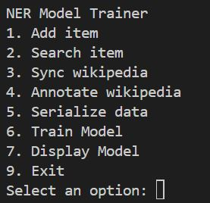
  - Training Latest Model
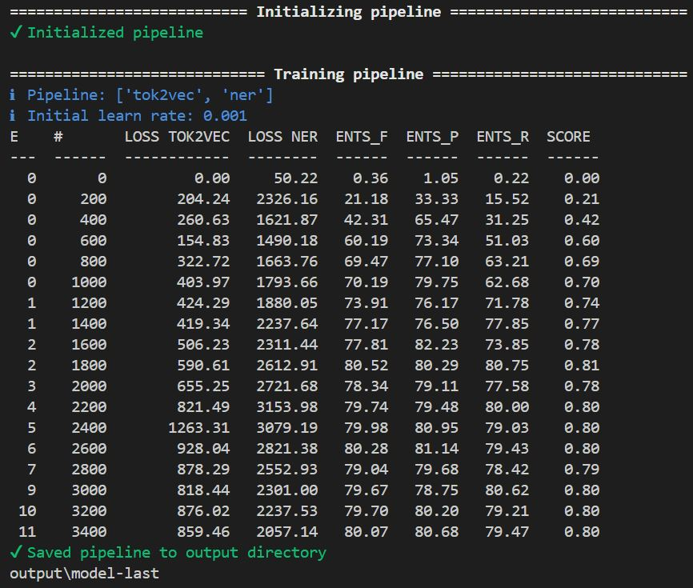
  - Using DisplayCe to test the model

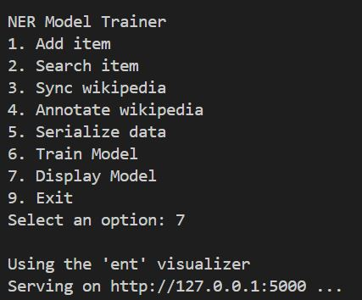
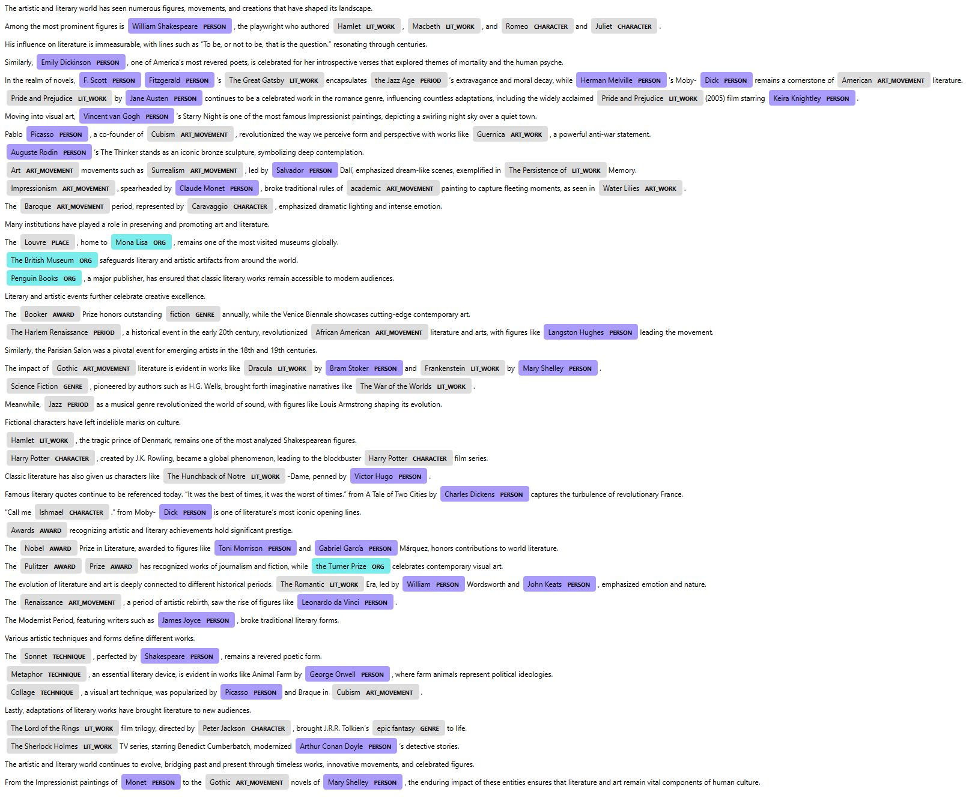

5. Data Generated (2 points)
- Data Output: (see files attached)
  - Input data: entity_dict.json, sample1.txt
  - Generated output data: annotations.json, train_data.spacy, dev_data.spacy, ./output

6. Analysis of Results (3 points)
- Analysis:
  - My approach was to create a list of relevant terms for each category and then gather a bunch of relevant text using the terms in context.
  - I used the wikipediaapi for scraping articles
  - I created a pipeline to normalize, format and tokenize the text
  - I wrote a process to programmatically annotate the text
    - At first my models had a very low score because I had too much low quality data.
  - I further refined the annotation process
    - Throwing out sentences that were too short
    - Throwing out sentences with non English characters
    - Using an existing spaCy model to check for entities I didnt’t recognize
      - i.e. If im using a sentence to label “William Shakespeare” as a person but it also mentions another person I don’t label then it’s a bad example

7. Conclusion (1 point)
- Summary:
  - I learned the importance of quality data over quantity.
  - I learned much about the process of annotating and training spacy models.
  - My next improvement would be to make an editor gui so I could manually refine annotations further.

8. Additional Comments (Optional) (bonus 1 point)
- Feedback/Comments:

Submission Checklist:
- Student Registration Information
- Assignment Overview
- Code
- Results Screenshot(s)
- Data Generated
- Analysis of Results
- Conclusion
- Additional Comments (if applicable)

