Assignment 2 Design Note
GitHub Issues API Gateway
Isaac Kim | CMPE 272 | September 6 2026
This project is a Fastify gateway for one GitHub repository. It supports issue and comment operations and records accepted webhook deliveries in SQLite.

1 - Architecture and Data Ownership
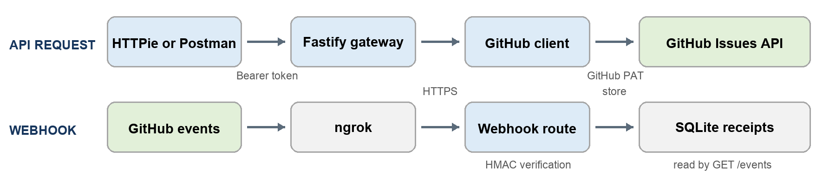
Figure 1 System context and data flows
Clients call the Fastify routes instead of GitHub directly. The gateway validates each request, checks the bearer token, and forwards issue and comment operations to GitHub. GET /healthz is public and only checks whether the server is running. GitHub remains the source of truth for issues and comments; SQLite stores only webhook receipts.

2 - Error Mapping and Pagination
All errors use the same JSON shape: code, message, and requestId. GitHub failures can also include upstreamStatus. The gateway does not return internal stack traces or GitHub response bodies.
Failure | Gateway response
Invalid input or GitHub 422 | 400
Invalid gateway token or GitHub 401 | 401
GitHub 403 or 404 | Same status
GitHub rate limit | 429 with Retry-After
GitHub timeout, network failure, or 5xx | 503
Unexpected application failure | 500

Pagination Strategy and Rate Limits
When GitHub rate limits the service, the client uses Retry-After or X-RateLimit-Reset to set a cooldown. Requests during that cooldown return 429. I did not automatically retry writes because GitHub may have completed a write before the timeout, which could create duplicates.
List routes pass page and per_page to GitHub, and issue lists also accept state and labels. The gateway returns GitHub's Link header so clients can request the next page.

3 - Webhook Deduplication and Integrity
The webhook route verifies GitHub's HMAC-SHA256 signature against the raw request body before parsing or saving anything. An invalid signature returns 401.
The route accepts issue, issue_comment, and ping events from the configured repository. Their payloads require different fields, so the OpenAPI request schema uses oneOf. For example, a comment event must include comment.id, while a ping does not use an issue action.
SQLite stores the delivery ID, event, action, repository, time, and related issue or comment ID. A unique constraint on (delivery_id, action) prevents redeliveries from creating duplicate rows. The route returns 204 after a new or duplicate delivery and 503 if storage fails.

4 - Security Tradeoffs
Connection | Credential and scope
Client to gateway | API_AUTH_TOKEN protects issue, comment, and event routes
Gateway to GitHub | GITHUB_TOKEN is limited to Issues read/write in one repository
GitHub to webhook | WEBHOOK_SECRET authenticates the exact payload bytes
Public to health check | No credential; process liveness only

All secrets come from environment variables. ngrok exposes the local webhook route, but the HMAC check still decides whether a request is trusted. Logs include request and delivery IDs without logging tokens, signatures, or request bodies. Docker runs as a non-root user and keeps SQLite data in a mounted volume.
The assignment targets one local instance and one repository. It uses one shared API token, and SQLite is not intended for multiple server instances. A larger deployment would need user accounts and a shared database.

