CMPE 272 Assignment 2 Screenshot Evidence
GitHub Issues API and Webhook Gateway
Isaac Kim
CMPE 272
Repository isaackimmi/cmpe-272-assignment-2
This document provides visual evidence that the gateway updates GitHub issues, handles pagination, receives signed webhooks through ngrok, and stores redeliveries idempotently.
Evidence included
- Issue update and comment behavior
- Issue-list pagination
- GitHub webhook delivery and redelivery
- SQLite receipt deduplication

Issue Lifecycle Evidence

Issue Closed Through the Gateway
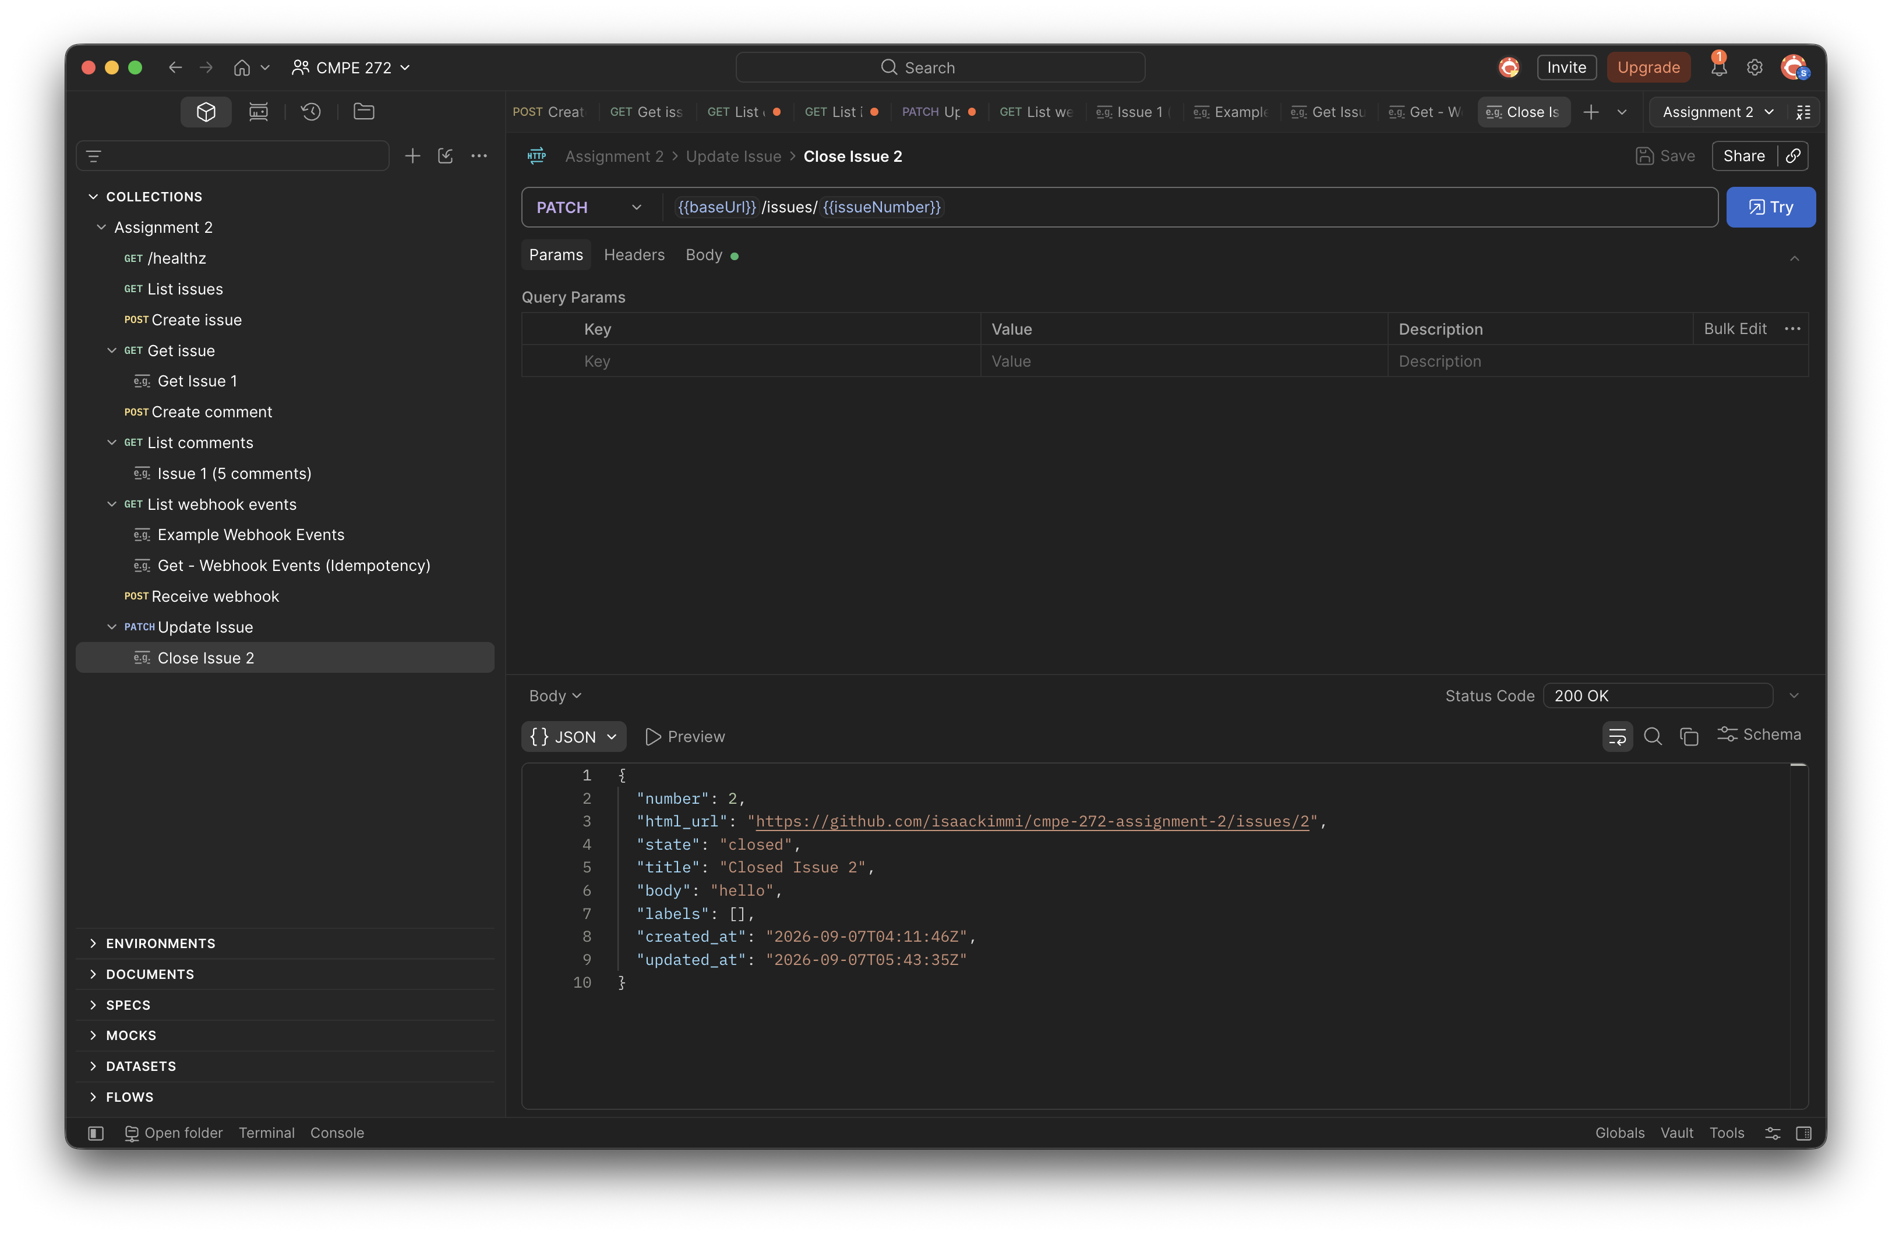
Figure 1. Postman returns 200 OK after PATCH /issues/2 and shows issue 2 in the closed state.

Closed State Confirmed on GitHub
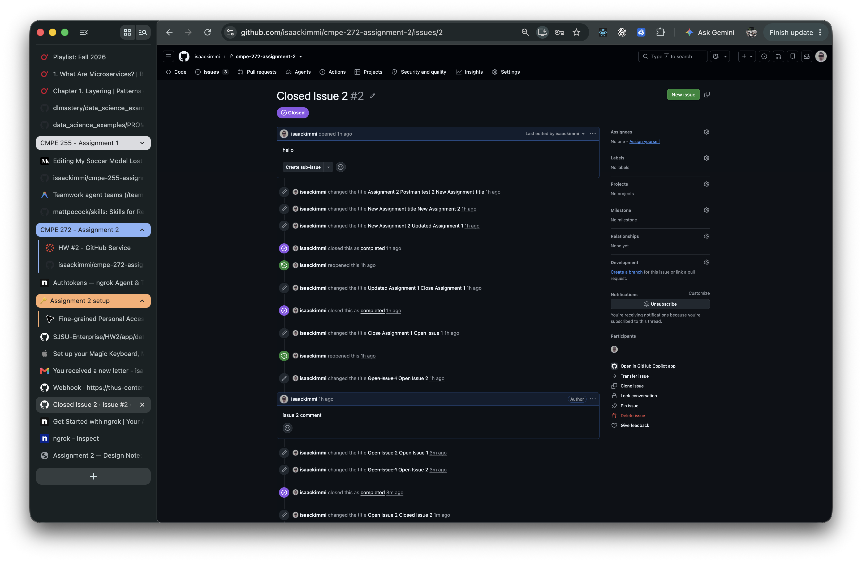
Figure 2. GitHub displays issue 2 as closed, confirming that the gateway updated the configured repository.

Issue Comments Stored on GitHub
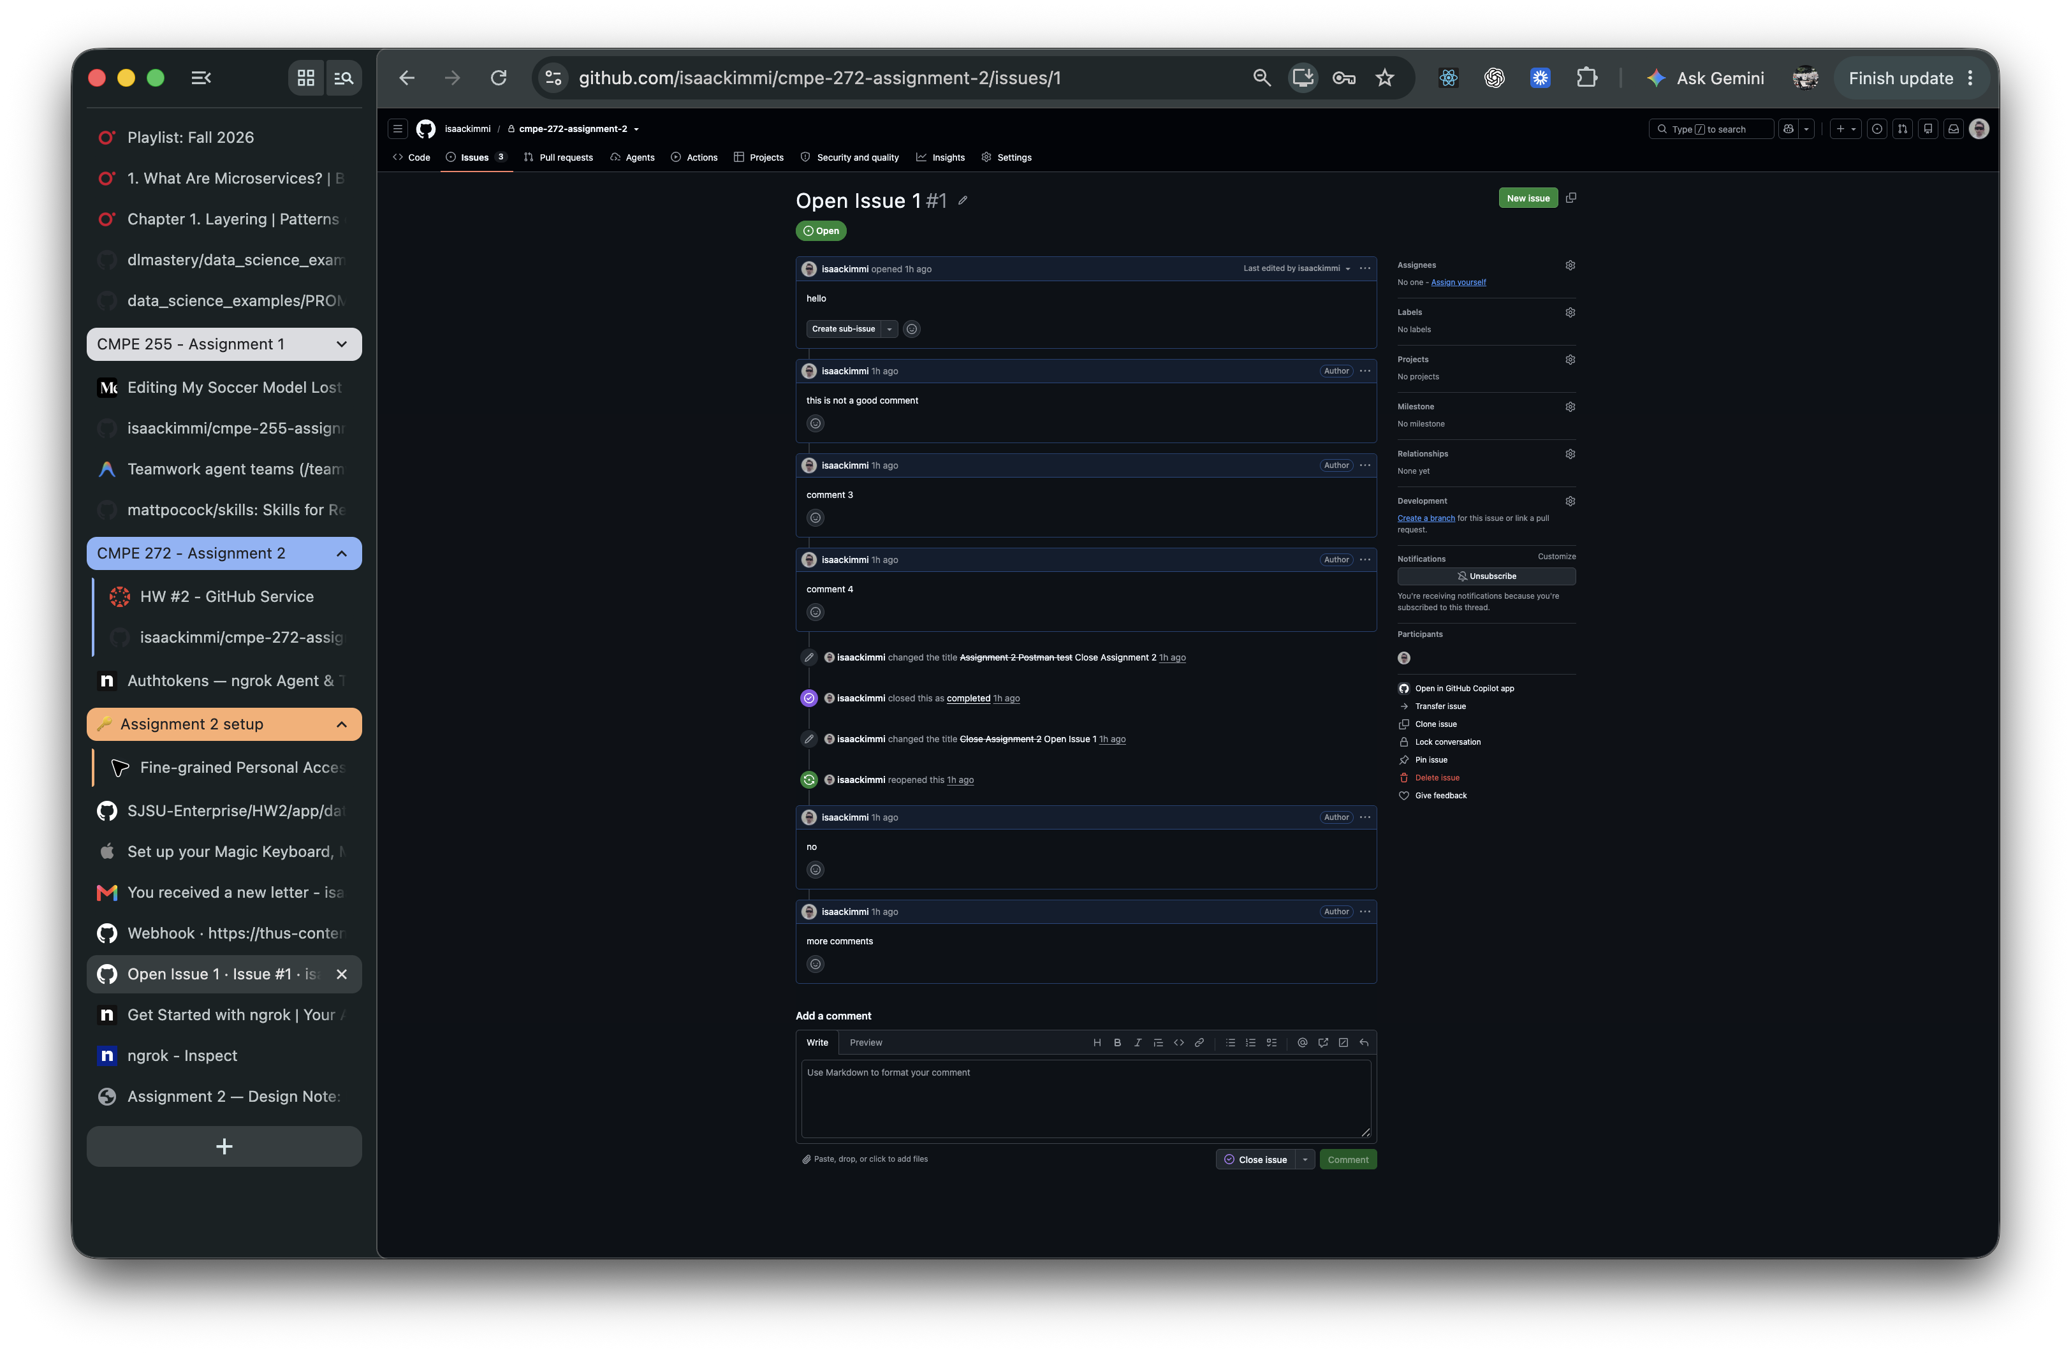
Figure 3. GitHub issue 1 shows five comments created while testing the issue comment routes.

Pagination Evidence

Three Issues Returned on Page One
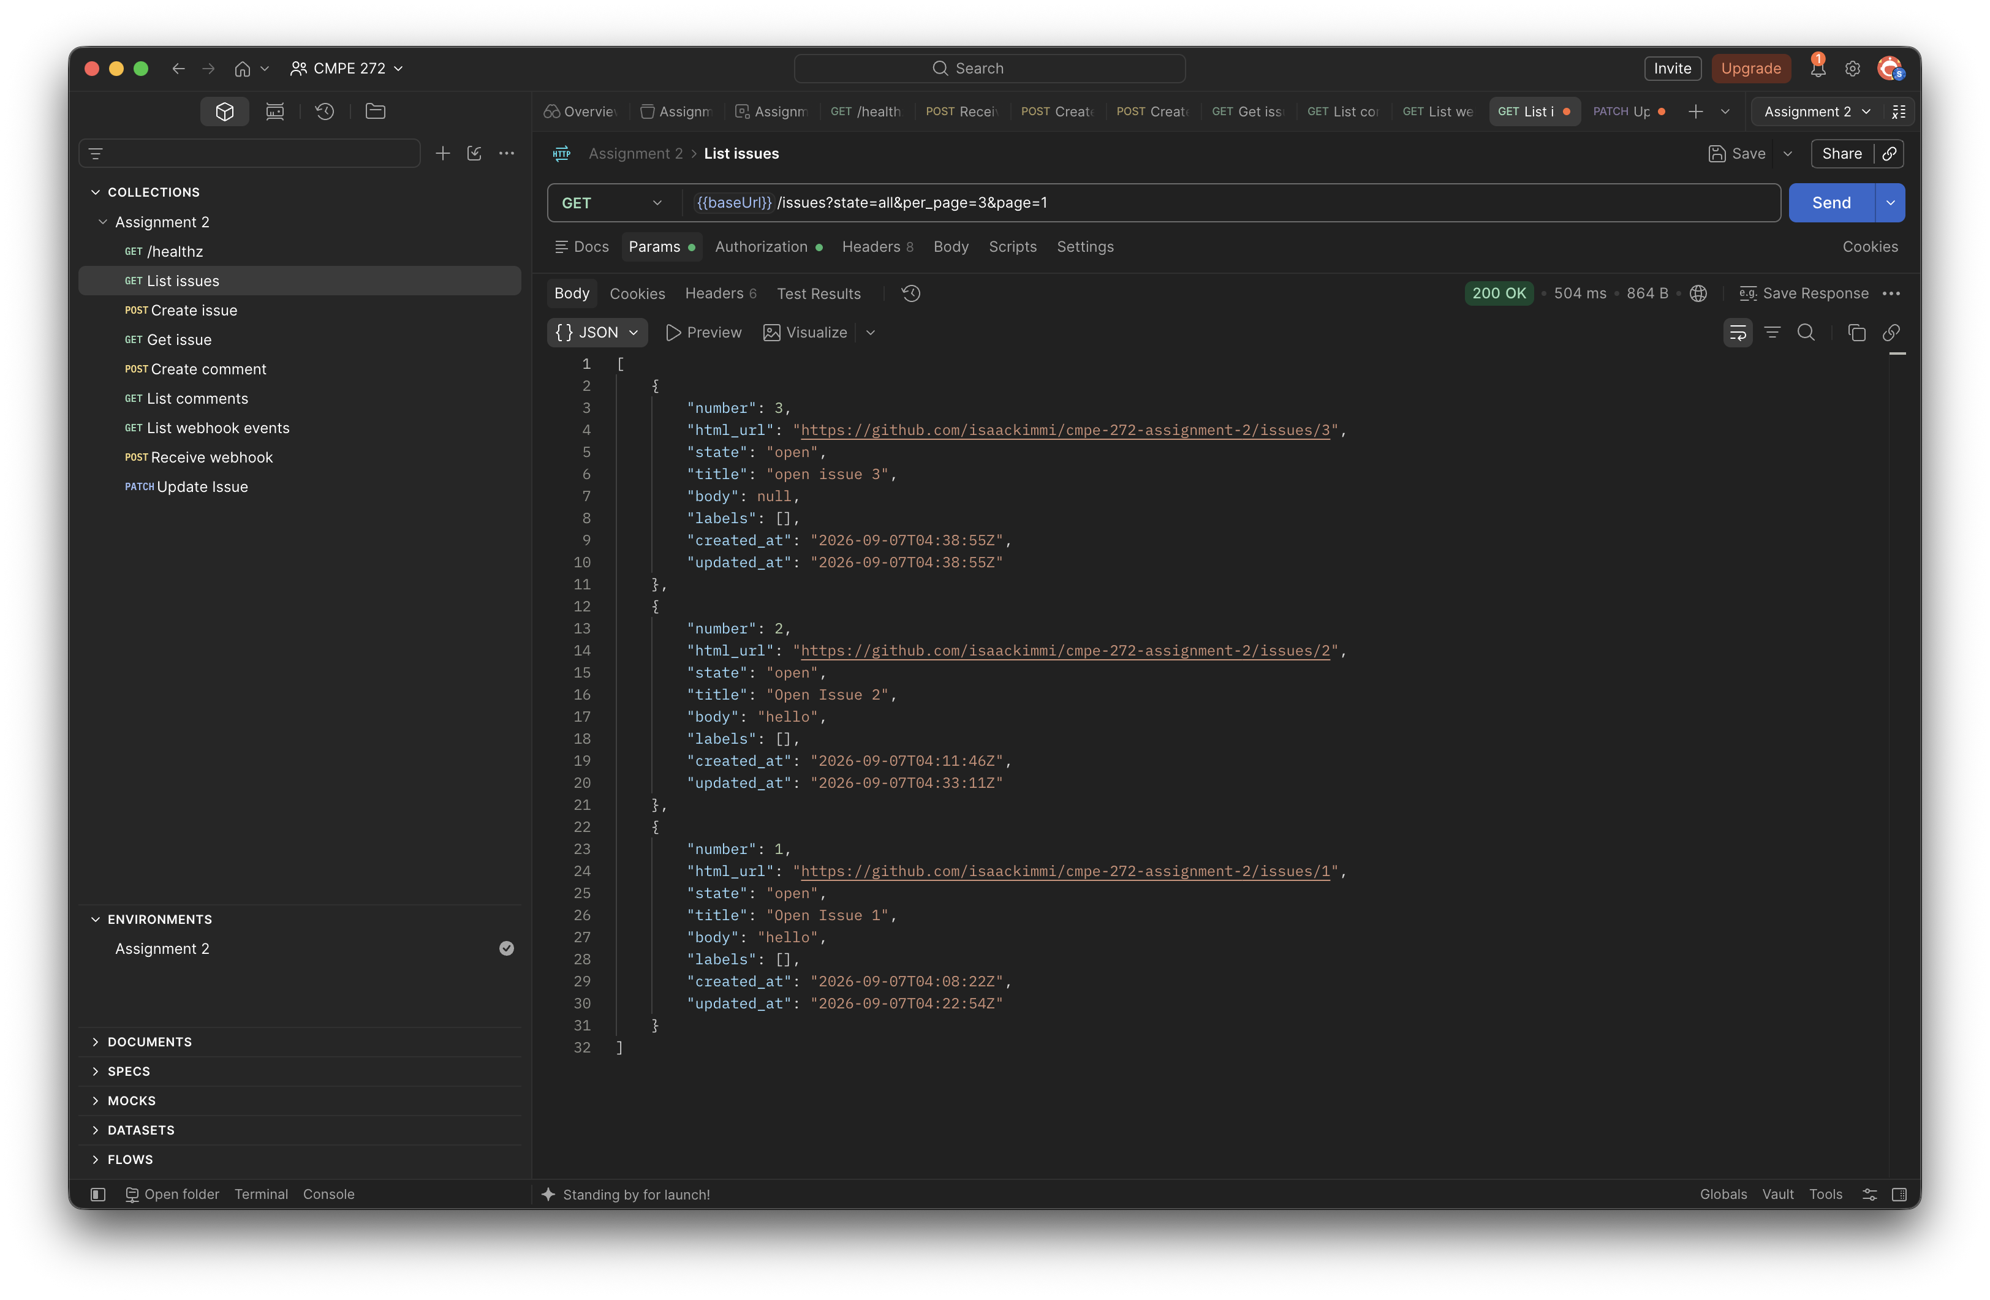
Figure 4. GET /issues with state=all, page=1, and per_page=3 returns three issue records.

Two Issues Returned on Page One
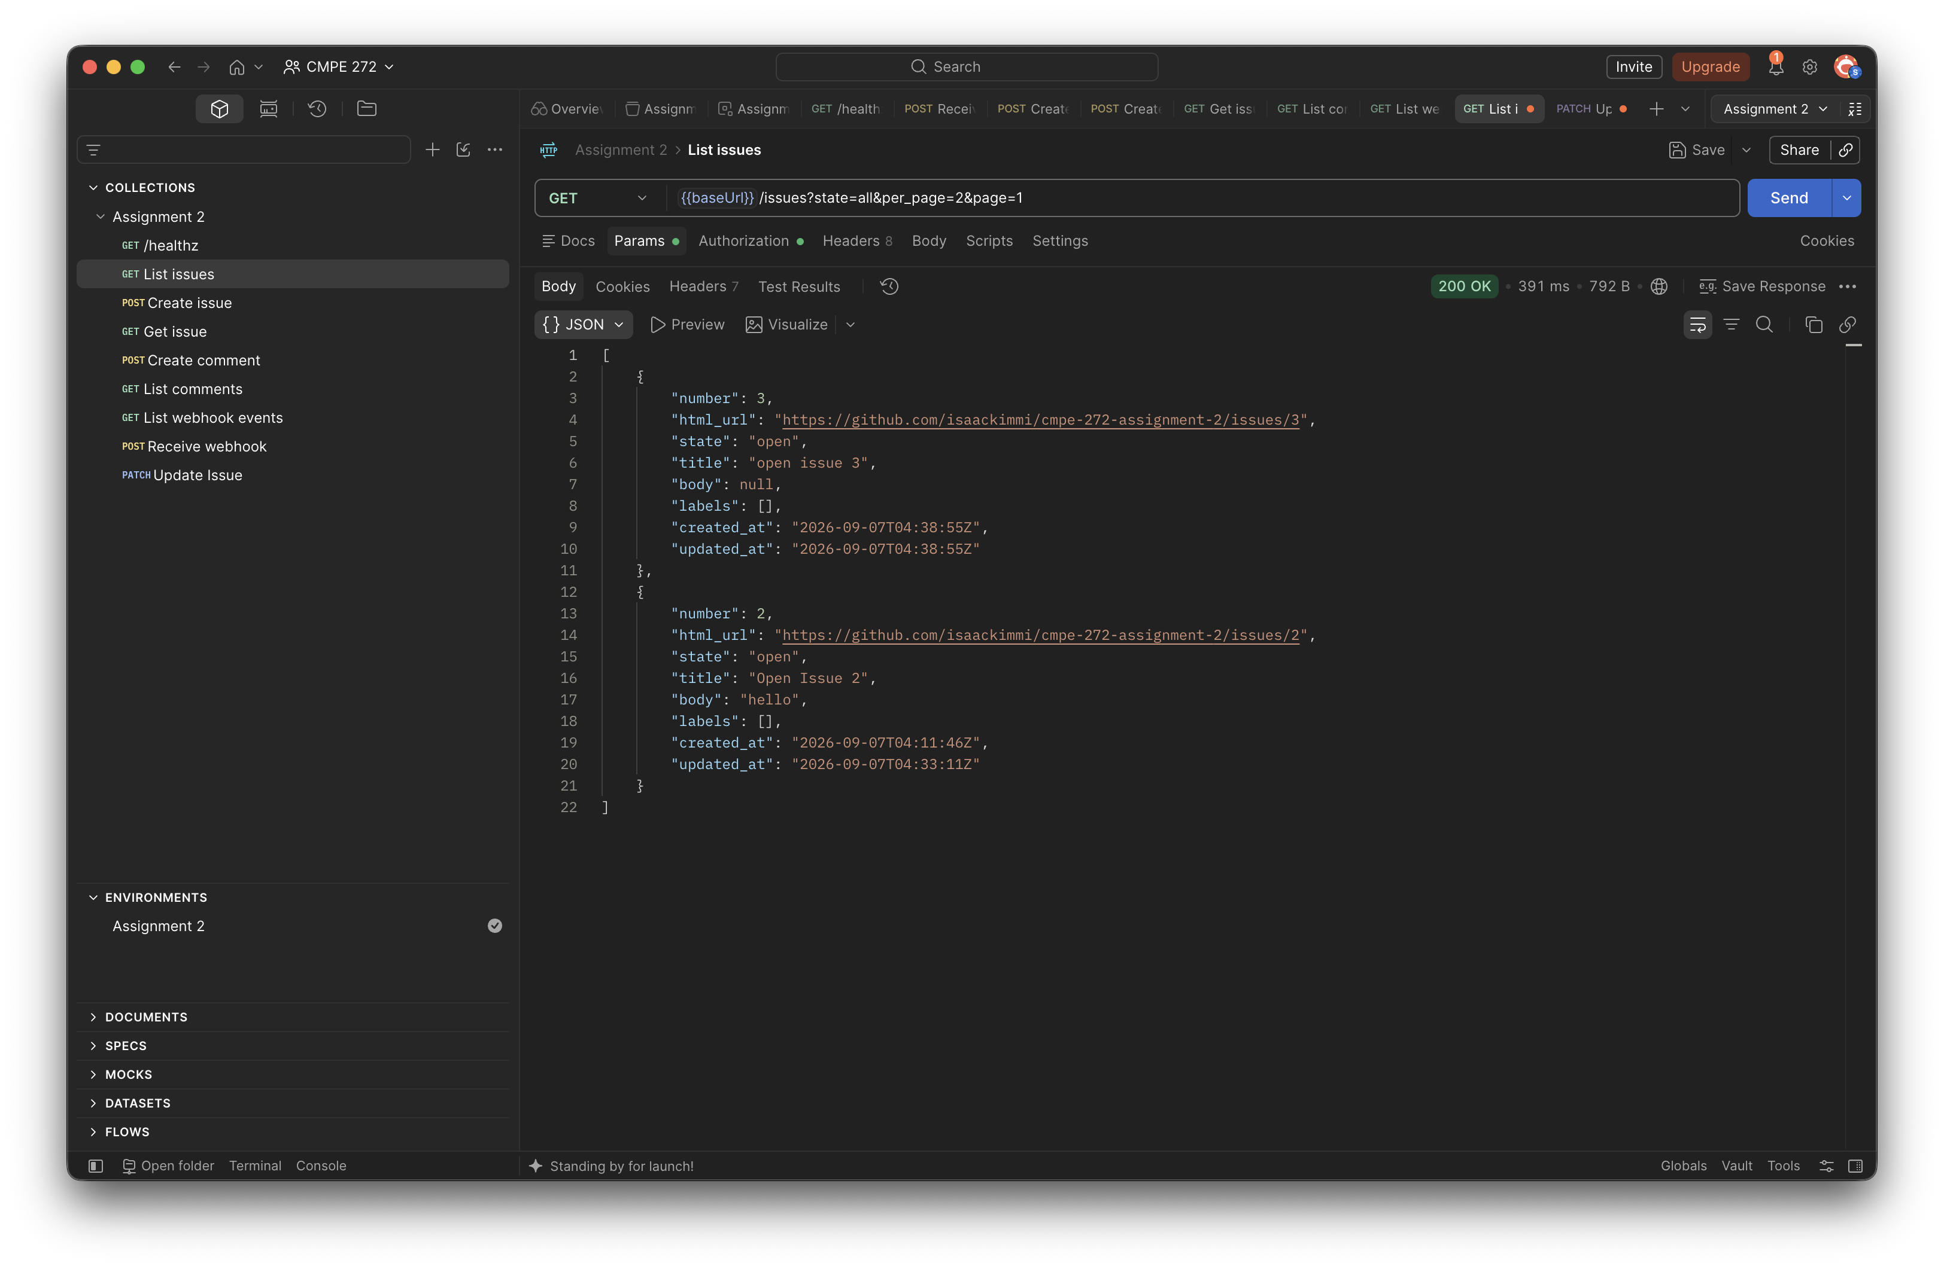
Figure 5. Changing per_page to 2 limits the first page to two issue records.

Issue List Across Two Pages
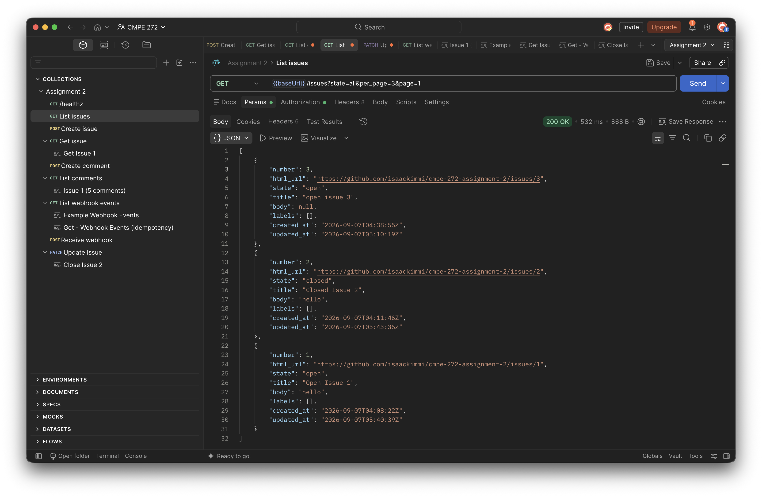
Figure 6. With per_page=3, the complete issue result set is divided across two pages.

Issue List Across Three Pages
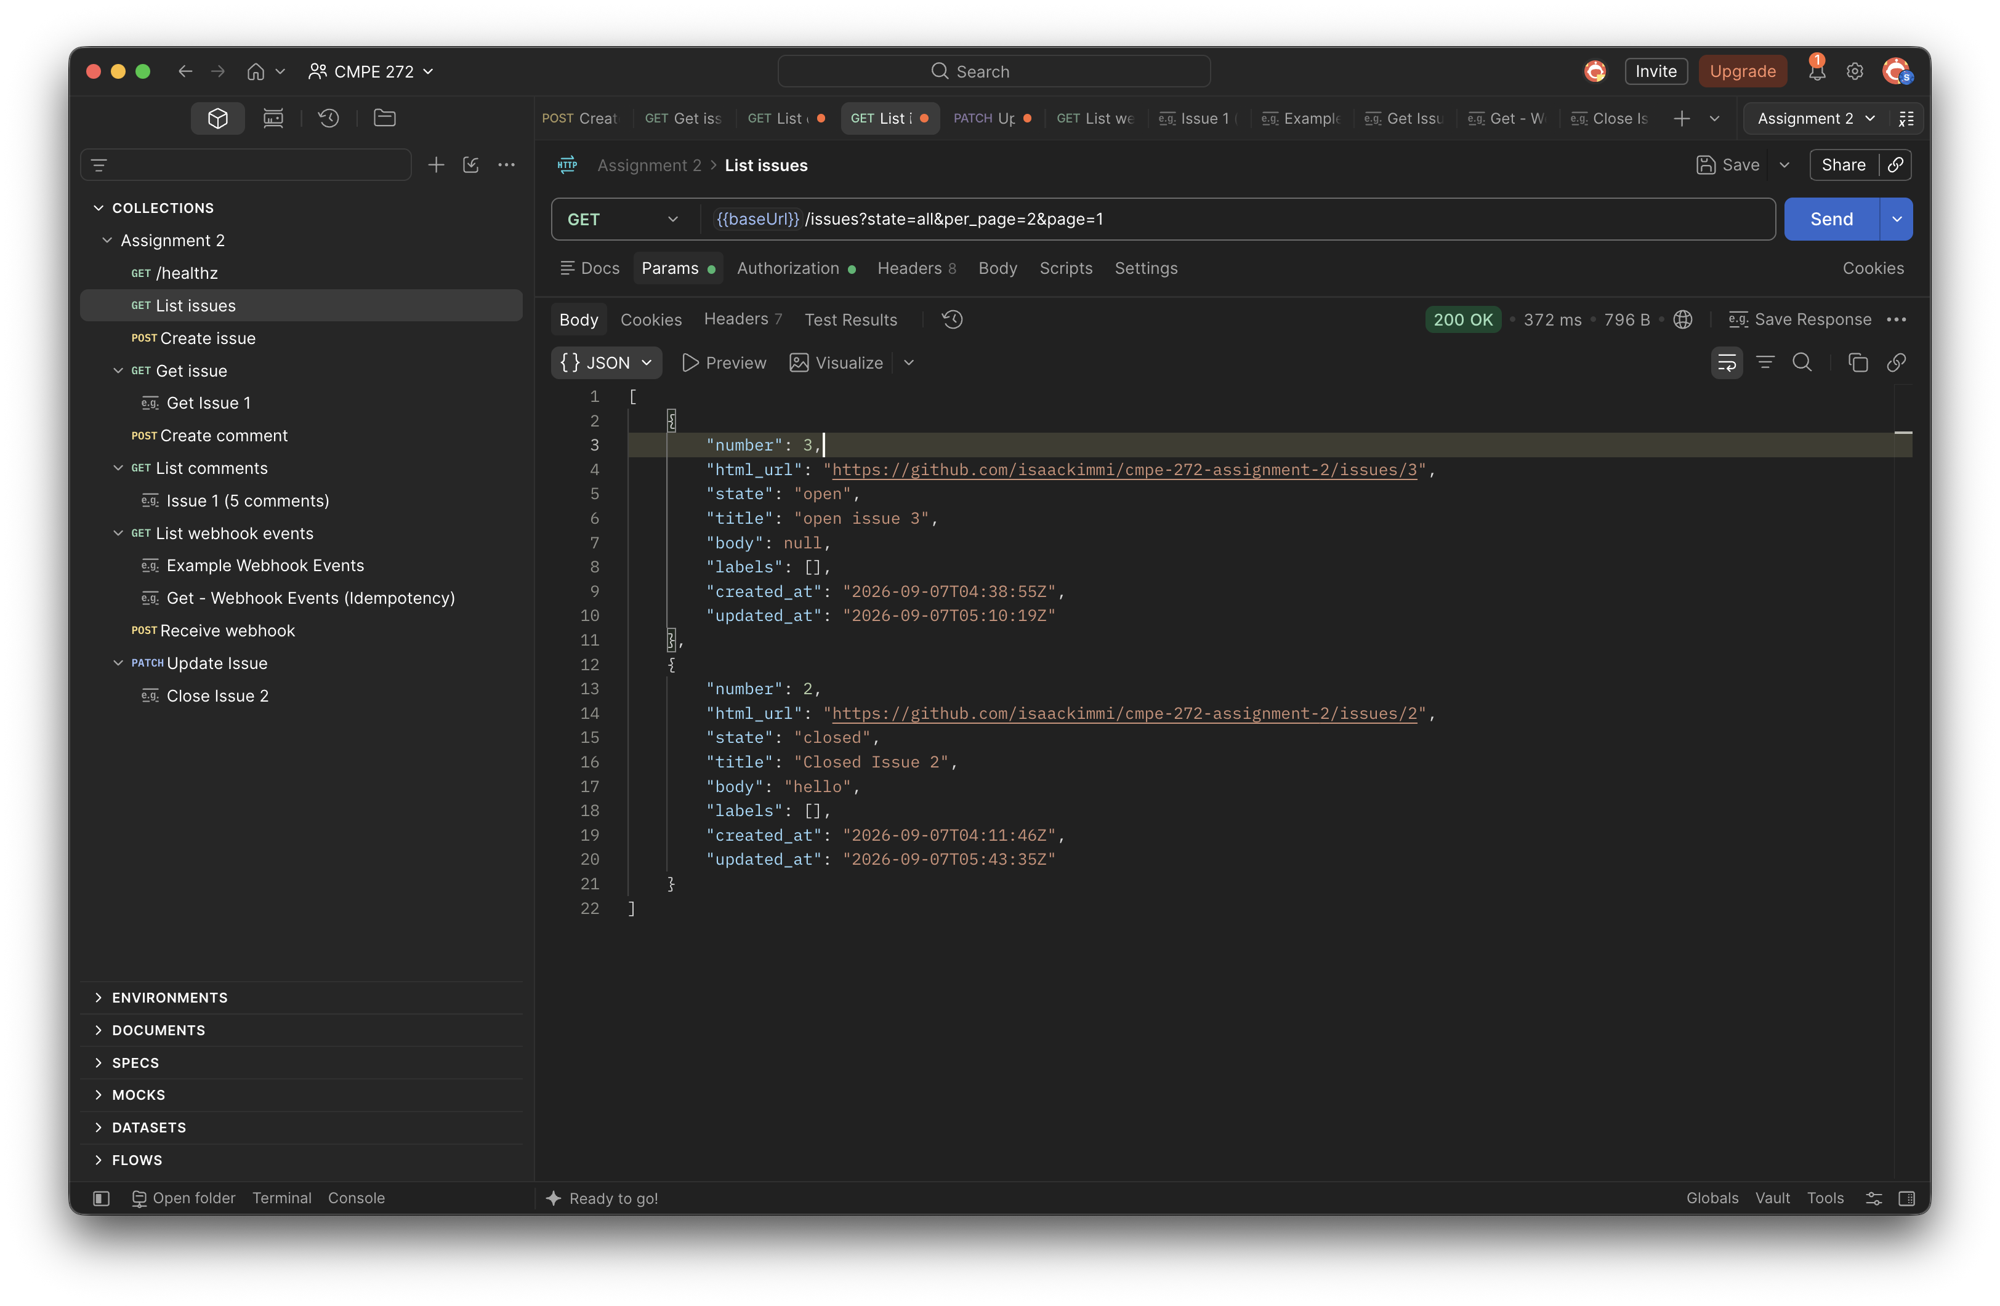
Figure 7. With per_page=2, the same result set is divided across three pages.

Webhook Evidence

Public Ngrok Tunnel
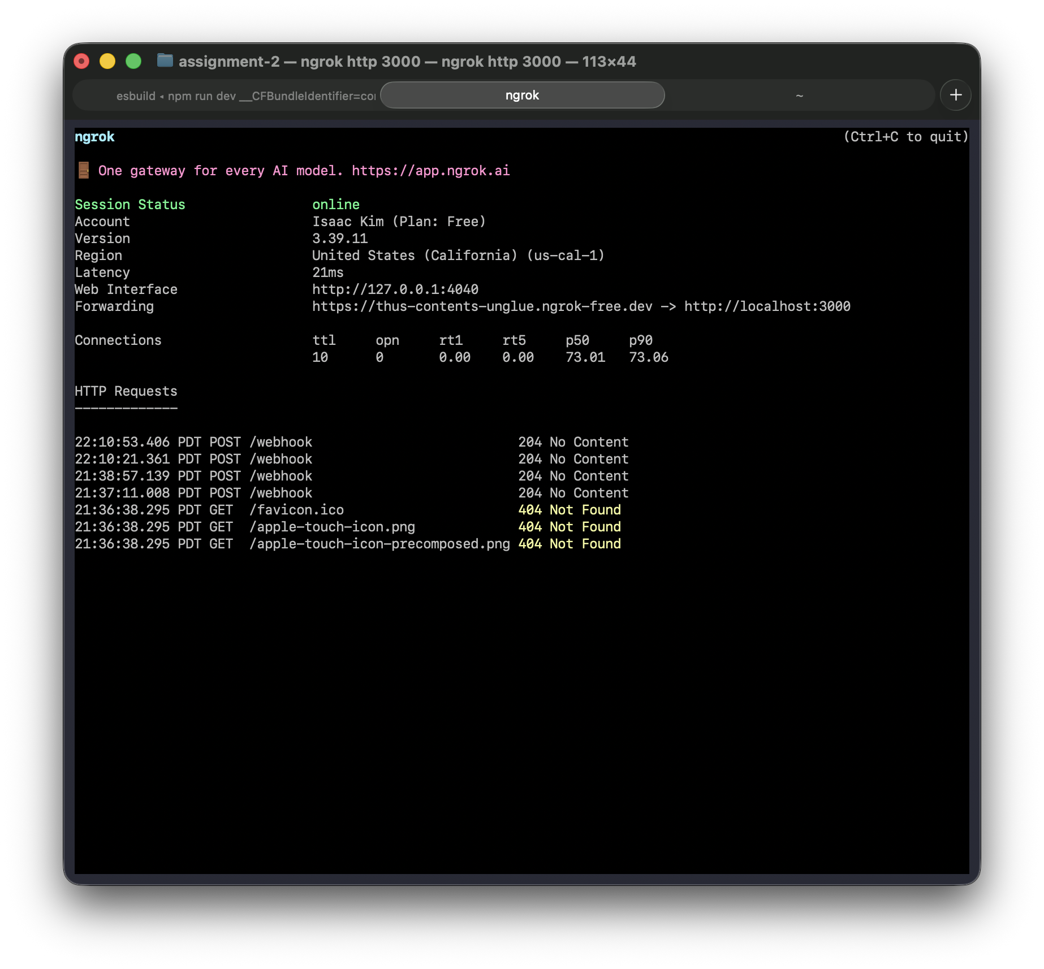
Figure 8. The ngrok tunnel forwards its public HTTPS address to localhost port 3000 and shows successful 204 webhook responses.

Webhook Requests Accepted
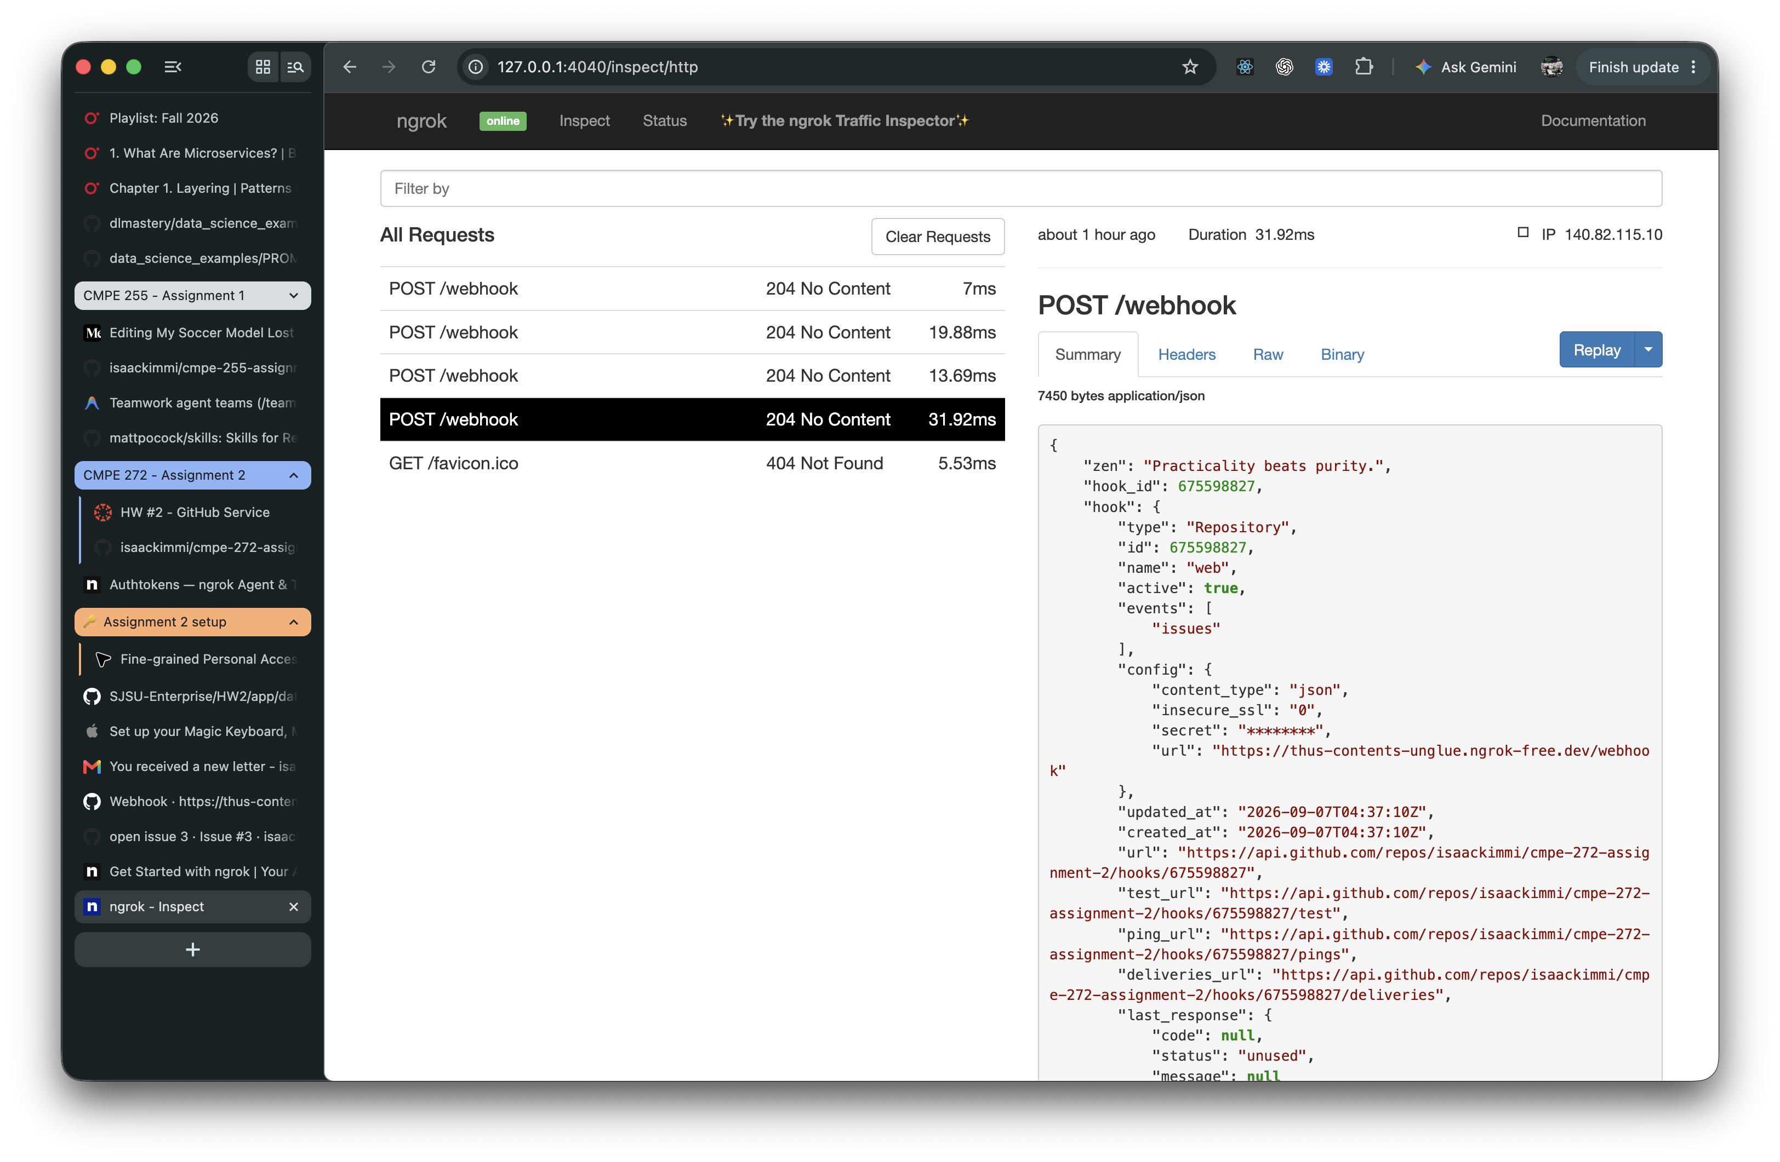
Figure 9. The ngrok inspector records GitHub POST /webhook requests that were accepted with 204 No Content.

GitHub Redelivery
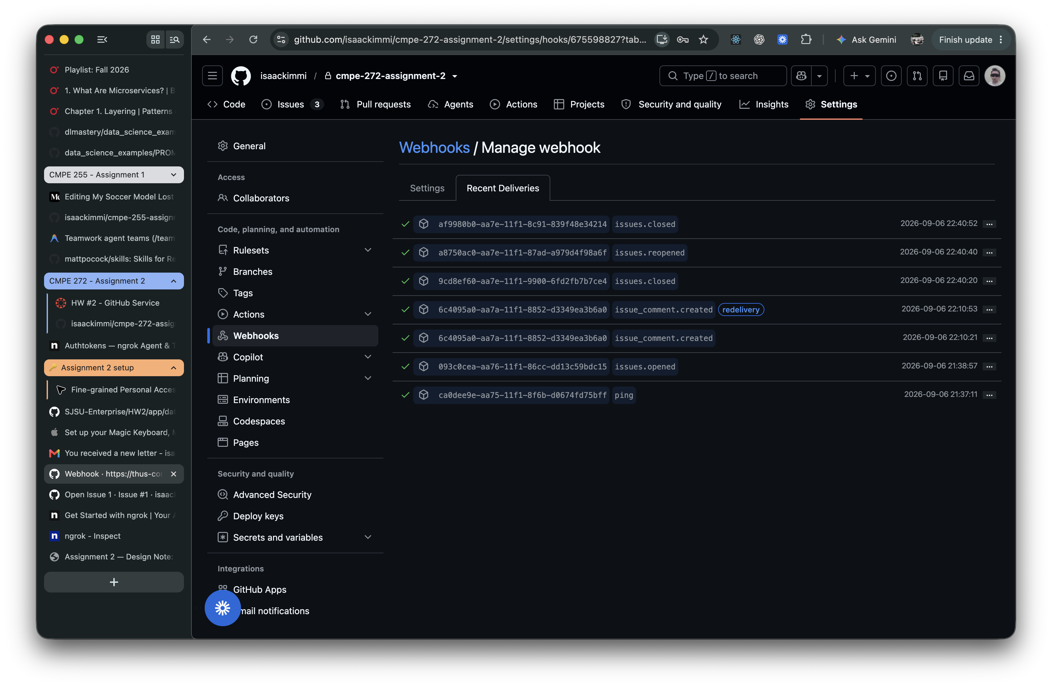
Figure 10. GitHub Recent Deliveries shows the original issue comment delivery and its redelivery using the same delivery ID.

Deduplicated Event Receipt
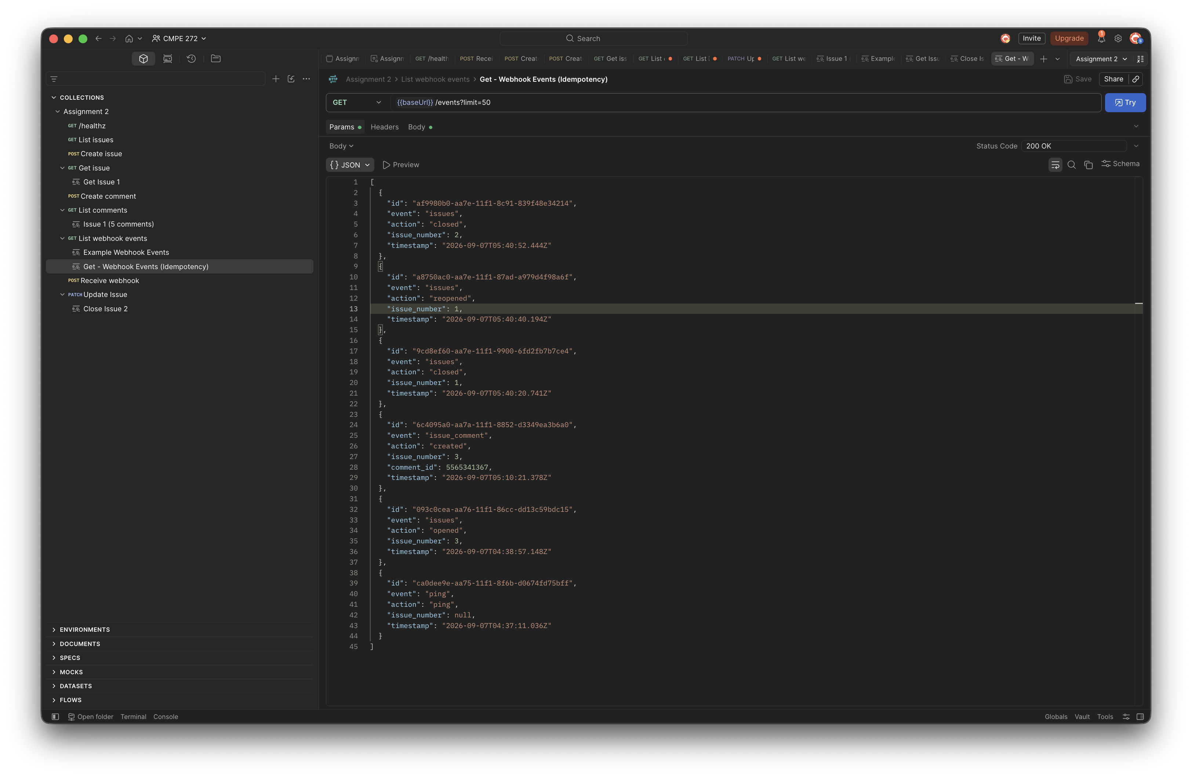
Figure 11. GET /events still contains one receipt for the redelivered issue comment, confirming idempotent storage.

