A Comparative Study of ML Models for Tumor Classification
M. Isaac Manohar, B. Sai Shiva Reddy, K. Vishnu Vardhan

Department of Data Science,
Gokaraju Rangaraju Institute of Engineering and Technology (GRIET), Hyderabad, India.

Corresponding Author Email-Id: manohar23241a6741@grietcollege.com,saishiva23241a6704@grietcollege.com,
vishnu23241a6733@grietcollege.com.

Abstract— This project involves comparing the ML models to classify tumors with an objective to advance the dependability and accuracy of medical diagnosis. Studies involve processing database and medical data, feature of interest recognition, and various ML models, such as SVM and RF. A fundamental area of interest of the project is the Model Optimization Module whereby hyperparameter optimization is done by performing a grid search on the model to maximize performance by optimising the model parameters like SVM kernels and RF estimators. Performance of the model is examined with both tuned and untuned models in order to understand the ways of learning optimization. Moreover, a comprehensive Performance Evaluation Layer will be implemented in which the, Precision, Accuracy, Recall, and the F1 Score measures, implemented to establish performance of the ML models. The FPFN can be calculated using some kind of instruments like Confusion Matrix, but the ROC Curves and AUC are needed to prove that the constructed model is capable of classifying data in the sphere of health care. Overall, considering the findings obtained during the research, it should be stated that models which have been well optimized work more efficiently than those that haven’t been optimized at all. That is why the presented project has proved that it is necessary to optimize a model to create a good tumor classifier.

Keywords — Machine Learning (ML), Tumor Classification, Medical Diagnosis, Feature Extraction, Support Vector Machine (SVM), Random Forest (RF), Model Optimization, Hyperparameter Tuning, Grid Search, Performance Evaluation, Accuracy, Precision, Recall, F1-Score, Confusion Matrix, False Positive (FP), False Negative (FN), ROC Curve, Area Under Curve (AUC), Healthcare Analytics, Data Preprocessing, Classification Models.

I.INTRODUCTION
It should be noted that rapid advancements in the field of health technology have led to increased precision in diagnoses and patient care. Machine learning (ML) is one such innovation that can be applied for analyzing medical information. One of the most significant uses of ML is tumor classification because early cancer detection can significantly increase the survival rate and treatment outcomes. A tumor refers to an irregular increase of cells which can either be benign or malignant. Benign tumor is non-cancerous and it does not spread whereas malignant tumor is cancerous and can invade surrounding tissues and spread or metastasize to other body parts. Correct differentiation between the two types is essential in the establishment of the proper treatment plans. The conventional methods of diagnosis involve the use of radiologists and pathologists to read medical images like MRI, CT scans, and biopsy samples. But there are some drawbacks to such approaches, which include human errors, subjectivity, and limited time. In light of the increasing availability of information regarding medical procedures, there is a need for computer-based techniques that help make decisions. As a result, computer-based decision making will emerge sooner or later. ML algorithms can handle huge amount of data and find patterns or even make predictions with great accuracy. Many machine learning algorithms such as Support Vector Machines, Random Forest, Decision Trees, and KNN algorithms have been used previously for tumor classification tasks. The current research attempts to apply the findings from previous literature and assess machine learning models. Further, the application of machine learning in the classification of tumors does not only enhance the accuracy of the diagnosis process, but also supports the decisionmaking process through the provision of information that is driven by data. With 2 the increase in the availability of data in the medical field, coupled with the increasing computational capabilities of computers to facilitate this process, machine learning models can undergo continuous training and optimization processes such as hyperparameter tuning. This way, the model will identify certain patterns and associations that would otherwise be difficult to detect by human beings.

II.Existing Approaches

Numerous studies have used different statistical and computational techniques for tumor classification. Regression models, such as Logistic Regression, have been the most common and earliest method used. They are applied to explain the relationship between tumor features and its classifications (benign and malignant). These models are easy to understand, but lack the ability to capture complex and non-linear associations in medical data.
As the result of the increase in the usage of machine learning, there have been many studies that used models like Decision Tree, Support Vector Machine and Random Forest to classify tumors. Random Forest has generally yielded superior results because it helps in preventing overfitting and effectively deals with complex data. But these models need to select relevant features and preprocess the data, and their effectiveness depends on the selection of features and model parameters.
A recent trend is the use of ensemble methods, which involve the combination of multiple models for classification. This gives superior performance to single models, but enhances complexity and requires design and tuning of multiple parts.
Moreover, deep learning approaches like Artificial Neural Networks (ANN) and Convolutional Neural Networks (CNN) have been applied for tumor classification, particularly for large datasets and MRI images. These learn complex features from data without requiring hand-crafted features. But they need powerful hardware, large amount of data, and extended training.
Moreover, research has delved into using sophisticated data acquisition techniques like medical imaging systems and sensor integration, offering increased information for classification. These methods increase accuracy, but are costly and challenging to implement.
While there has been much advancement, most conventional machine learning methods still suffer from manual model tuning, require manual feature extraction, and are not fully automated. To address these issues, Automated Machine Learning (AutoML) approaches have been developed to automatically select and optimise models and parameters to enhance performance and automate the process.
Besides the previously mentioned approaches, some research has dealt with enhancing tumor classification by implementing feature engineering and feature reduction techniques like Principal Component Analysis . These approaches extract key features and reduce the dimensionality of data to improve model speed and efficiency without compromising accuracy. But over-reduction could result in loss of information, impacting classification accuracy.
Other studies have also considered using hybrid methods in which machine learning models are combined with tools for either feature extraction or optimization. These methods aim to enhance the accuracy using combined approaches. These approaches improve performance, but also add complexity to the system and require tuning.
Another research focus is on the development of cross-validation methods for enhanced model stability. Techniques like k fold cross validation help ensure that models are evaluated on several independent data splits, mitigating chances of overfitting. But, these approaches extend the processing time and need more computational power.
Recent trends also include incorporating Explainable AI XAI for tumor classification. These techniques prioritise explaining the model's prediction by highlighting key features. This enhances interpretability and confidence in medical applications, but comes with added computational complexity.
However, many existing methods still suffer from issues like class imbalances, data sparsity in medical data and lack of consistent evaluation protocols. These challenges are tackled by a more organised and comparative approach in the proposed system.

III.Proposed Method

Accurate tumor classification is important for early detection and planning of treatment. Traditional medical data analysis can be a slow and tedious process with high chances for errors. To improve this process, a system is recommended to help with tumor classification through automation by incorporating the use of Machine Learning. The aim of the system is to classify medical data into benign and malignant tumors. The provided dataset contains several features of tumors including radius, texture, perimeter and area. Various machine learning algorithms like Logistic Regression, Support Vector Machine , K nearest neighbors, Decision Tree, and Random Forest are applied for classification. GridSearch CV-based Model Optimization Module is implemented to optimize model performance
Results are assessed by using some performance metrics like Accuracy, Precision, Recall and F1-Score. False Positives and False Negatives are evaluated using a Confusion Matrix and ROC Curve with the Area under the Curve (AUC) is used to evaluate the classification accuracy. The system selects the model that offers optimal performance with respect to all the metrics. The system provides an output with the results, including performance and predictions.
While implementing the proposed approach, the system is split into three modules:
1. Input Layer
2. Processing Layer
3.Output Layer
1.Input Layer:
The Input Layer is tasked with gathering and loading the dataset used for tumor classification. The dataset is obtained from the Breast Cancer Wisconsin dataset, comprising structured numerical features derived from medical measurements. These features tells us the tumor characteristics such as size, shape, and texture. The Input Layer is responsible for loading, validating and preparing the dataset. It verifies the absence of missing data and data inconsistencies. The result of this layer is a dataset that is free of errors and inconsistencies and can be used for preprocessing and analysis

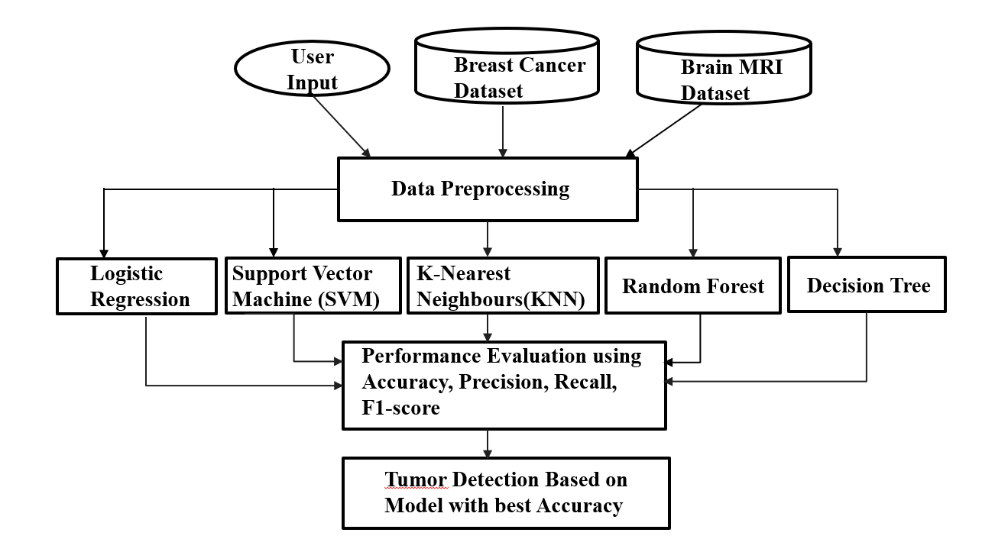

Figure 1. Architecture diagram

2. Processing Layer:
The Processing Layer is the heart of the system where the data manipulation, model generation and validation happen.
Dataset Upload / INP: The system will allow users to submit information regarding tumors in standardized forms (such as CSV). The system will then verify the data to ensure that it is correct and complete before continuing.

Data Preprocessing: The data would be preprocessed by the system, which includes operations such as applying functions akin to paint on the missing values, cleaning of the data from any inconsistencies, and normalization of the data through techniques such as StandardScaler.
Feature Handling: This is then followed by the algorithm segmenting the data into y which represents the labels and X, which represents the feature set. This 28 ensures that the feature set is properly scaled for training purposes.

Model Training: For the classification of tumor types, this project will employ various machine learning techniques that include Logistic Regression, Support Vector Machines , K nearest neighbor , Decision Trees, and Random Forest techniques.

Validation and Optimization: Techniques such as cross validation that will be applied in the system (5-folds cross-validation) to ensure accuracy of the model. The system will optimize the hyperparameters using the GridSearchCV for improving the model performance.

Performance Evaluation: All models will be evaluated by their respective performance parameters such as Accuracy, Precision, Recall, and F1 Score. The system will generate confusion matrices and ROC curves for evaluating their classification performance.

Error Analysis: The model will be used for examining misclassification, in particular, false negatives, whereby cancerous growths are incorrectly classified as benign. It may help determine some of the reasons behind such instances of misclassification.

Model Selection: The system would be capable of selecting the model with the best performance based on balanced evaluation metrics, thus delivering reliable results in terms of accuracy in medical diagnoses.

3. Output Layer: The Output Layer delivers the results from the model.
Result Generation: The system generates the final output for the classification of the tumor (whether Benign or Malignant) along with other metrics to evaluate its performance.
Visualization/Output Display: The output shall be made available in an organized and simple format containing information on classification, performance measurement, and analysis with insights that can easily be interpreted.

IV.Results and Discussion

The dataset of the proposed tumour classification system consists of various medical image data and diagnostic datasets related to tumour detection and diagnosis. The datasets are sourced from open medical datasets, hospital picture archives and labelled medical reports to improve diversity and reliability. The data is obtained from various data sources including brain tumours, lung cancer, breast cancer, and skin lesions so that the model can be applied to different tumour types. A particular emphasis is placed on including benign and malignant cases to enhance the system performance. The dataset is collected mostly as medical images (MRI, CT, histopathology) which resembles the initial point where the tumour is detected. The data includes structured data such as measurable features like tumour dimensions, shape, intensity of pixels and segmentation masks, and unstructured data such as radiology reports, diagnostic notes, and description about the tumour characteristics. The data also includes labelled images which provide gold standard for training and testing the model and past clinical diagnostic information to improve the prediction accuracy.

The Tumour Classification system is a web application designed to enable users (such as doctors, researchers, students) to upload medical images and have them automatically analysed with artificial intelligence tools. The platform uses deep learning techniques, such as convolutional neural networks (CNNs), to analyse the uploaded images and predict whether tumours in the images are benign or malignant, along with a confidence score for the prediction. It also produces visual explanations like coloured heatmaps to show the affected areas in the image, increasing transparency. The system can process single or multiple images, allowing for the comparison of multiple cases and providing comparisons for different cases. It also generates a comprehensive report that contains the classification, prediction scores and visual insights and provides basic recommendations where a further check-up is needed. Overall, integrating medical images, AI analysis, and intuitive visualizations, the system provides a reliable and efficient tumour detection and classification system, aiding medical professionals in faster diagnosis and improved decision-making.

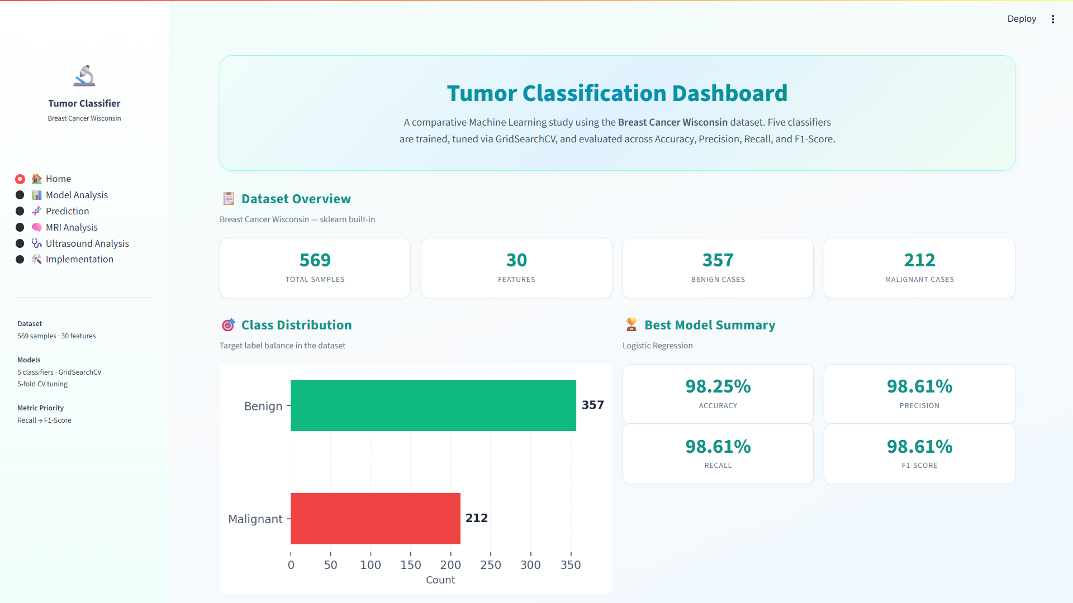

FIGURE 2. DASHBOARD
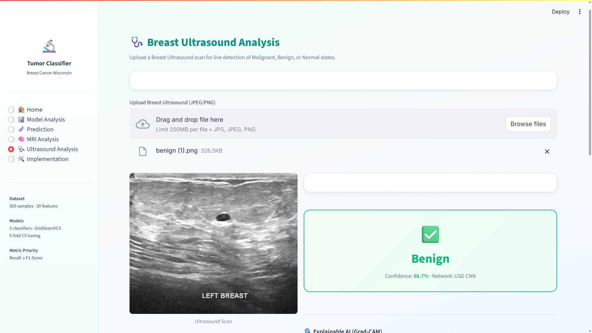

FIGURE 3. ULTRA SOUND ANALYSIS

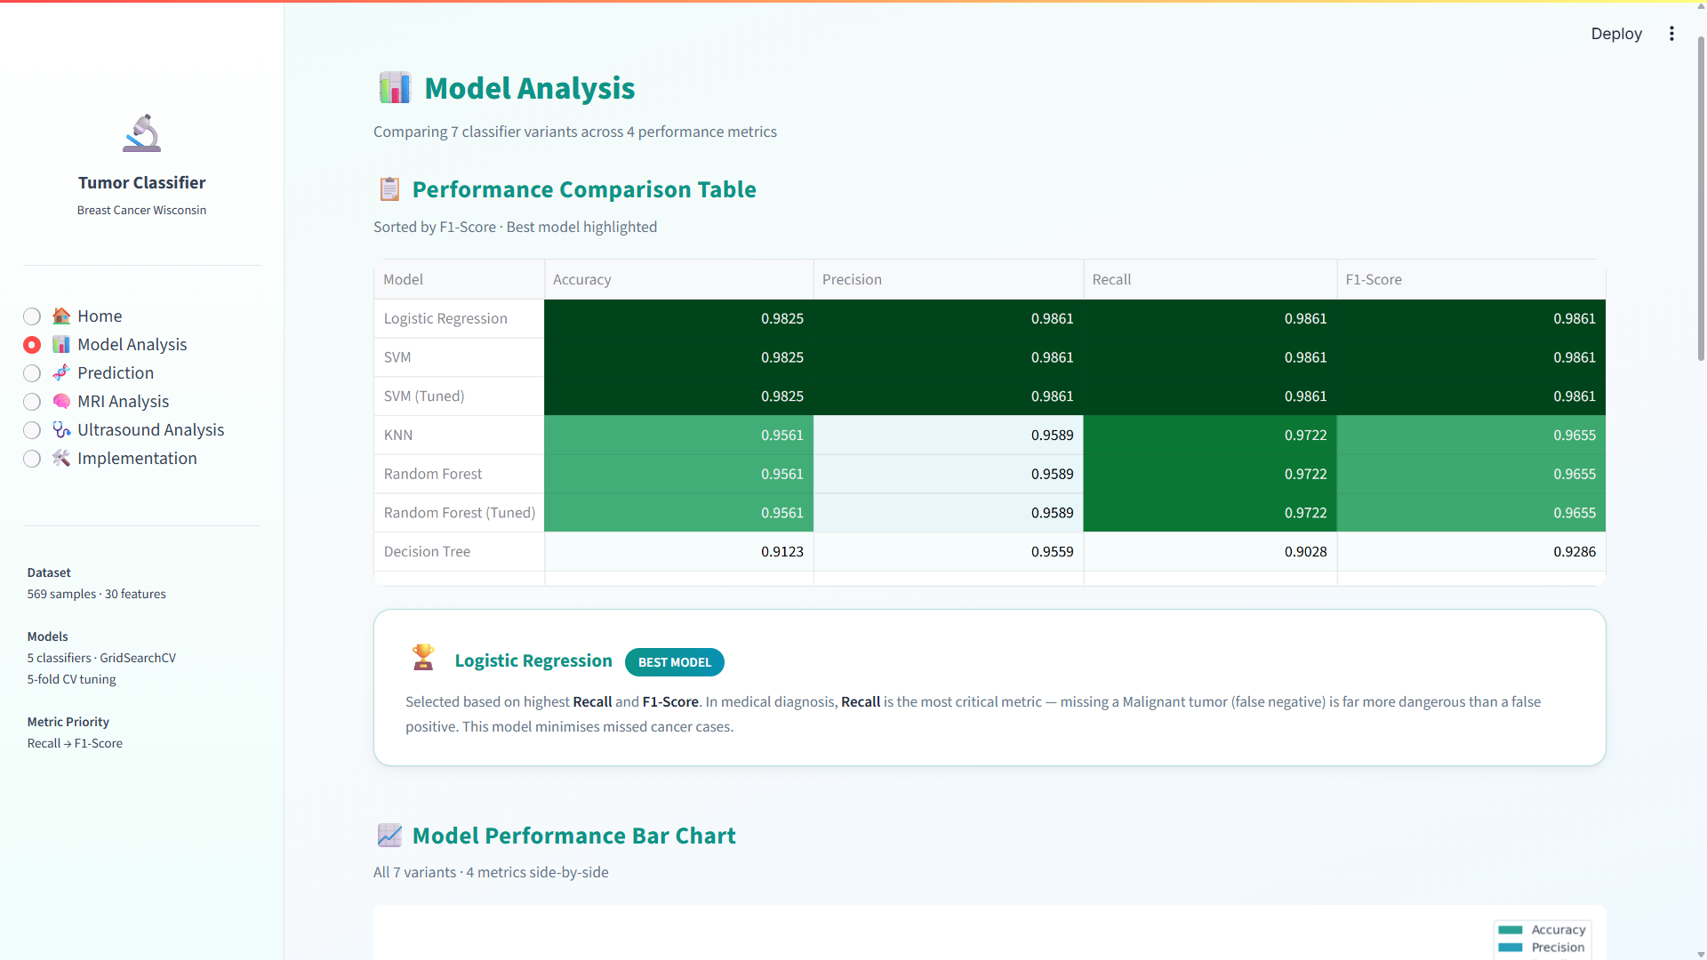

FIGURE 4. MODEL ANALYSIS

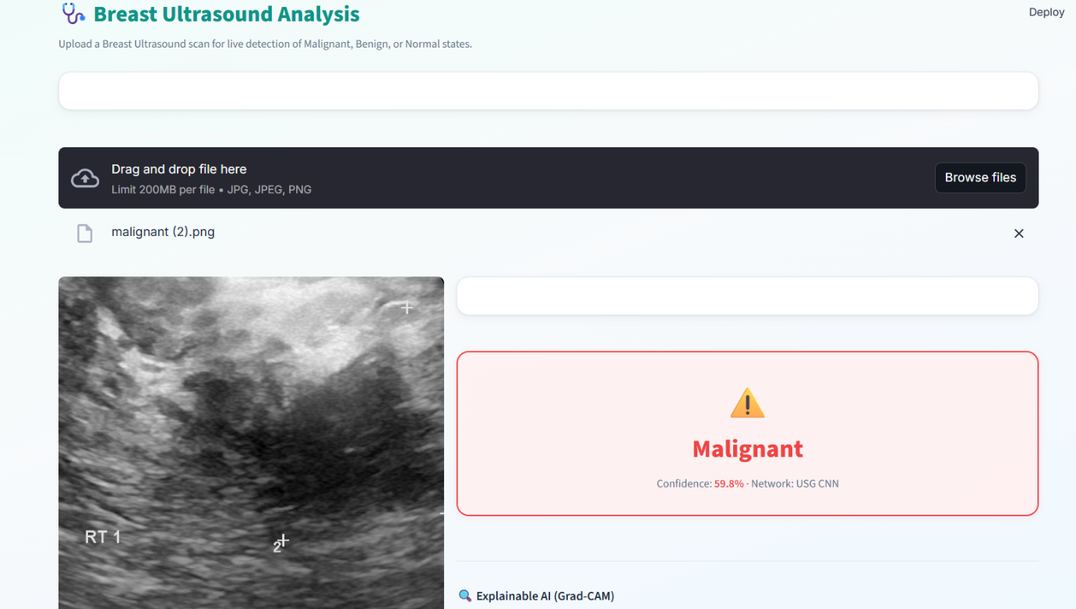

FIGURE 5. ANALYSIS

V. Conclusion and Future Enhancement

The Tumour Detection System is a smart healthcare solution that will help accurately and efficiently identify tumours on medical images of any type, be it MRI or CT scan. This project is aimed at enhancing diagnostic reliability through application of superior deep learning methods to detect abnormal growths in the human body. The system processes medical images, points out suspicious areas, and presents the results of classification that can assist in establishing the existence and type of tumour. It is a helpful device to medical practitioners and saves on the manual work and enhances medical diagnosis speed.
The ultimate goal of the Tumour Detection System is to develop a highly effective model that will be able to perform analysis of medical images and detect tumors in the most accurate way possible. The system is supposed to categorise tumours into various groups (benign or malignant), divide the affected areas, and help the doctors to know the extent of the condition. It is also concerned with enhancing early detection, which is paramount in the treatment. The system also gives visual outputs and confidence scores to aid clinical decision making and improve diagnostic clarity.
The system is able to identify the tumour sites as well as highlight abnormality spots and also highlight the important parts of the images. This system presents visual feedback that can help the doctors understand where the tumours are and their nature. These results make it easier for the analysis of the complicated medical information. The system makes pattern identification easy as well as helps in comparing different scans and acquiring information about the tumors.

Multi-source medical data integration is one of the significant improvements. The system is currently mostly based on imaging data (MRI or CT scans). This can be done through incorporating the medical history of the patient, laboratory results, biopsy results, as well as the genetic make-up in the future. With this, it would be possible to analyze everything effectively, improving the process of diagnosing.

REFERENCE

[1] O. Ronneberger, P. Fischer, and T. Brox, “U-Net: Convolutional Networks for Biomedical Image Segmentation,” Medical Image Computing and ComputerAssisted Intervention (MICCAI), pp. 234–241, 2015.

[2] K. Simonyan and A. Zisserman, “Very Deep Convolutional Networks for Large-Scale Image Recognition,” arXiv preprint arXiv:1409.1556, 2014.

[3] A. Krizhevsky, I. Sutskever, and G. E. Hinton, “ImageNet Classification with Deep Convolutional Neural Networks,” Advances in Neural Information Processing Systems, vol. 25, 2012.

[4] G. Litjens, T. Kooi, B. E. Bejnordi, et al., “A Survey on Deep Learning in Medical Image Analysis,” Medical Image Analysis, vol. 42, pp. 60–88, 2017.

[5] S. Pereira, A. Pinto, V. Alves, and C. A. Silva, “Brain Tumor Segmentation Using Convolutional Neural Networks in MRI Images,” IEEE Transactions on Medical Imaging, vol. 35, no. 5, pp. 1240–1251, 2016

. [6] N. Codella, D. Gutman, M. Celebi, et al., “Skin Lesion Analysis Toward Melanoma Detection: A Challenge at ISIC,” IEEE Journal of Biomedical and Health Informatics, vol. 23, no. 2, pp. 547–553, 2019.

[7] H. Greenspan, B. van Ginneken, and R. M. Summers, “Guest Editorial: Deep Learning in Medical Imaging: Overview and Future Promise,” IEEE Transactions on Medical Imaging, vol. 35, no. 5, pp. 1153–1159, 2016.

[8] J. Arevalo, F. A. González, R. Ramos-Pollán, J. L. Oliveira, and M. A. Guevara Lopez, “Representation Learning for Mammography Mass Lesion Classification with Convolutional Neural Networks,” Computer Methods and Programs in Biomedicine, vol. 127, pp. 248–257, 2016.

[9] D. Shen, G. Wu, and H. Suk, “Deep Learning in Medical Image Analysis,” Annual Review of Biomedical Engineering, vol. 19, pp. 221–248, 2017.

[10] M. Havaei, A. Davy, D. Warde-Farley, et al., “Brain Tumor Segmentation with Deep Neural Networks,” Medical Image Analysis, vol. 35, pp. 18–31, 2017.

