A Comparative Study of ML Models for Tumor Classification
M. Isaac Manohar(23241A6741) B. Sai Shiva Reddy(23241A6704) K. Vishnu Vardhan(23241A6733) Dr. Aruna Kumari
Department of Data Science Gokaraju Rangaraju Institute of Engineering and Technology (Associate Professor)

Introduction:
This project develops a machine learning framework for accurate tumor classification to support early cancer detection and clinical decision-making. It employs supervised models such as Logistic Regression, Support Vector Machine (SVM), K-Nearest Neighbors (KNN), Decision Tree, and Random Forest to analyze structured tumor data and classify tumors as benign or malignant. The system applies preprocessing techniques like normalization and stratified data splitting to ensure fair evaluation. Performance is measured using Accuracy, Precision, Recall, F1-Score, and ROC-AUC, along with confusion matrix analysis to detect critical errors. Interpretability methods further enhance transparency, enabling the identification of the most reliable model for practical healthcare applications.


Objectives:

To analyze tumor data and classify tumors as benign or malignant using Logistic Regression, SVM, KNN, Decision Tree, and Random Forest models.

To preprocess and standardize tumor features using normalization and stratified data splitting for consistent model training.

To evaluate model performance and identify misclassifications using Accuracy, Precision, Recall, F1-Score, ROC-AUC, and confusion matrix analysis.

To select the most reliable model and generate interpretable insights using feature importance and coefficient analysis.

Architecture Diagram:

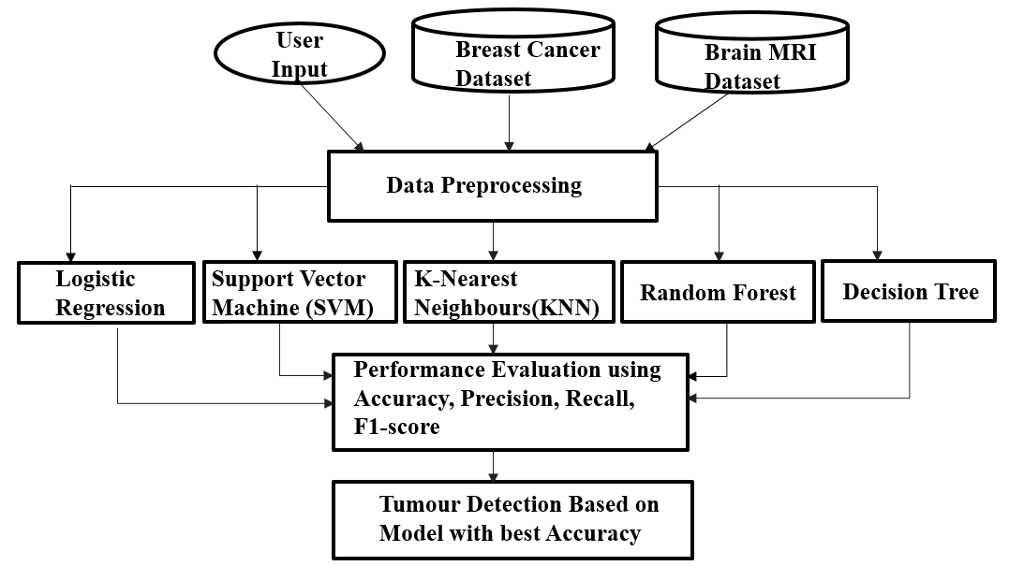

Results:

The system accurately classifies tumors using multiple machine learning models, with Logistic Regression and SVM achieving top performance (~98% accuracy) and balanced evaluation metrics.

The framework effectively minimizes critical errors such as false negatives and provides clear performance insights, supporting reliable and data-driven medical decision-making.
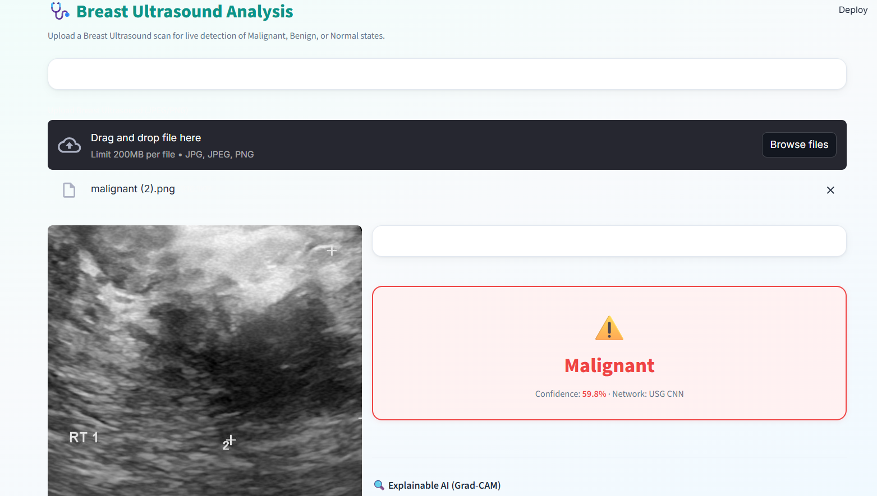

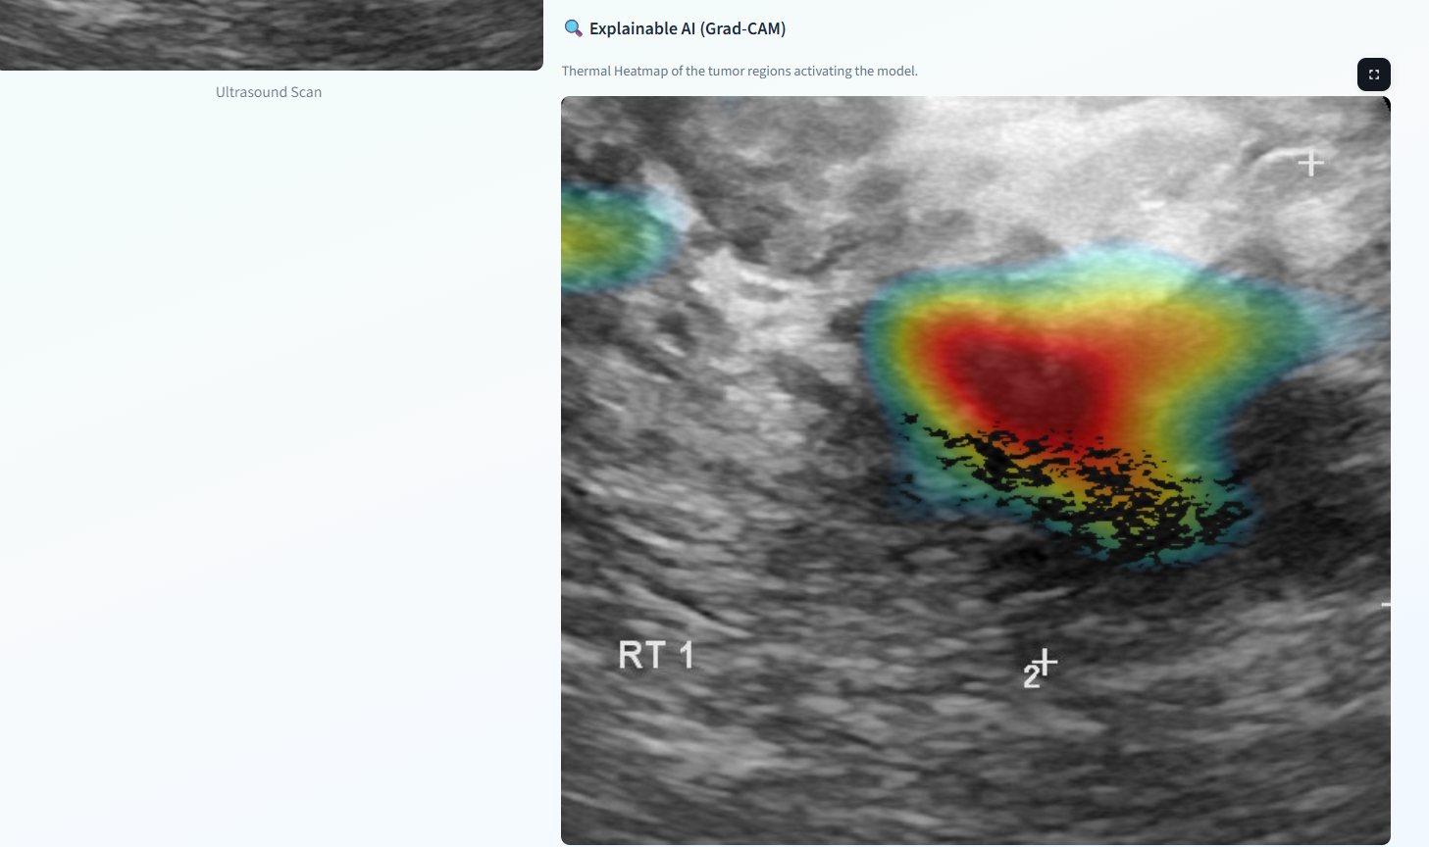

Conclusion:
Machine learning-based tumor classification helps improve early cancer detection and supports accurate medical decision-making. The system analyzes tumor data and classifies it into benign and malignant categories using ML models. It compares model performance, evaluates results using key metrics, and identifies the most reliable approach. The framework also analyzes misclassifications and provides interpretability through feature importance. Overall, this project shows that combining preprocessing, model comparison, and evaluation leads to accurate tumor classification, supporting better clinical decisions and improving healthcare outcomes. 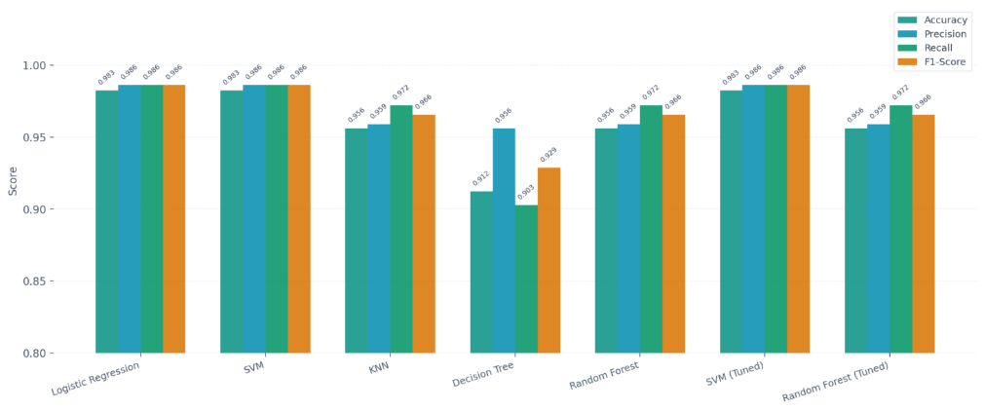
Future Enhancements:
- Developing a real-time web or mobile application for practical healthcare use
- Using larger and more diverse medical datasets to improve model accuracy
- Integrating advanced explainable AI techniques for better interpretability and trust
- Enhancing the system with real-time data integration and continuous model updates
Sustainability Goals:
- SDG 3: Good Health and Well-being
- SDG 9: Industry, Innovation, and Infrastructure

