**O**

**BJECTIVE**



To obtain knowledge in the field of business and information technology and apply the knowledge and skills to grow my future career and acquire relevant university diploma and degrees.

# EDUCATION

## **KCSE |** Nakeel High School

FROM 2016 – TO 2019

Started high school in 2016 and finished in 2019 with a C- grade.

## **DIPLOMA |** Jomo Kenyatta University of Agriculture and Technology

FROM 2021 – TO DATE

Enrolled for a Diploma in Business Information Technology in February 2021 expected to

graduate in the current year

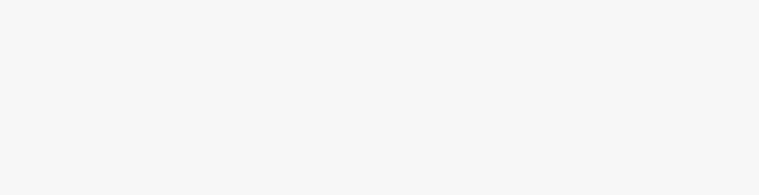

ISAAC

**MOBE**

Nairobi

+254 71935 9223

isaacmongechi@gmail.com

[https://www.linkedin.com](https://www.linkedin.com/in/)

[/](https://www.linkedin.com/in/)

[in](https://www.linkedin.com/in/)

[/](https://www.linkedin.com/in/)

isaac-mobe-950563210

http://github.com/isaacmobe



**PROJECTS**

## **SCHOOL|** projects

Worked on an online doctor appointment booking system for my final year project as a training opportunity for the field and to get a better understanding of the various technologies used in computer systems.

## **PERSONAL |** projects

I have worked on various personal portfolio websites to orient myself with different technologies like HTML, CSS, JAVASCRIPT, REACT and programming languages like PHP and PYTHON.Please visit my github to see some of my practical projects.

# SKILLS

|  |  |
| --- | --- |
| * Microsoft Office * Computer Literacy * Jetbrains IDES | * Frontend Development/desigN * 3D * Visual studio |

