GAFFER
FANTASY XI · SCOUTING DESK · MATCH ENGINE
Project Design & Build Document
A web app where you build a starting eleven from real, searchable footballers, then let Claude scout the side, conjure an opponent, and simulate the match. This document covers the full project end to end: vision, architecture, the real-player data layer, formations, features, the visual design system, the Claude integration, and a phased build plan.
Status: Working prototype built (see Section 2). This document defines v2.

Contents

1. Project Overview
GAFFER turns the daydream of “what if I picked the lineup” into a playable loop. The user assembles an XI on a tactics board, and an AI pundit does the rest — judging the side, inventing a worthy rival, and commentating a simulated match. It is built to show off practical, structured use of the Claude API inside a clean, characterful interface.

1.1 What changes in v2
- Real players only. Players are no longer free-text. Tapping a position opens a live search backed by a football data API; you pick from actual footballers and their real positions.
- Many more formations. The four-formation set expands to 16 (Section 5).
- Design-first. Every feature gets a deliberately designed screen, not just a results dump (Section 7).
- New features. Chemistry rating, formation recommender, tactical instructions, a live match ticker, and more (Section 6).

1.2 Design principles
- Real over fake — authentic player data anchors every AI judgement.
- One clear action per screen — build, scout, or play; never a wall of buttons.
- Structured AI — Claude always returns typed JSON the UI renders, never raw prose.
- Cheap by design — short, cached calls keep cost in fractions of a cent.

2. Current Prototype
The v1 prototype already implements the tactics board, formation switching, the three core Claude features, and the vintage matchday aesthetic v2 will build on. The screenshot below is the visual baseline for the redesign.
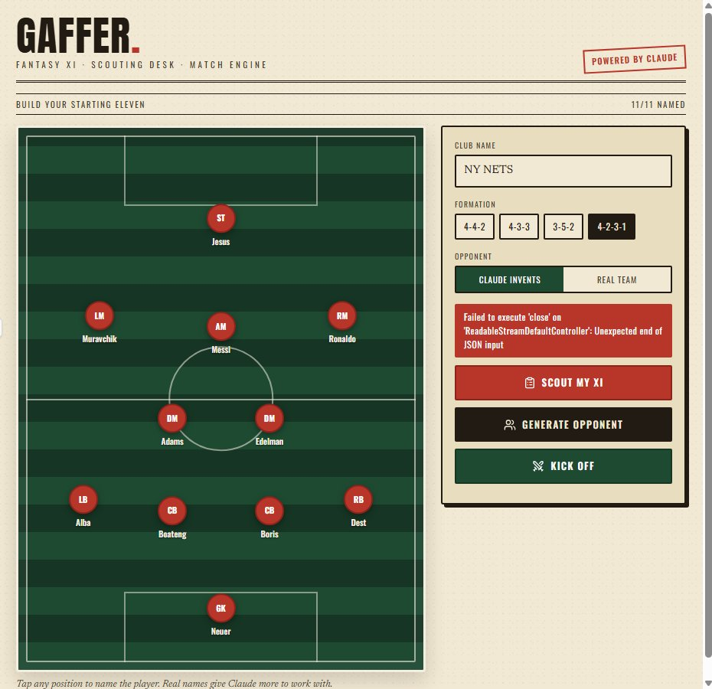
v1 prototype — tactics board, control panel, and the matchday-programme look.
Known bug visible above: the red “Unexpected end of JSON input” message. That is a truncated AI response — the JSON was cut off before closing, so parsing failed. Fully addressed in Section 8.4.

3. System Architecture
Three keys must never touch the browser: the Claude key, the football-API key, and any cache credentials. v2 introduces a thin backend that proxies both APIs, normalizes data, and caches aggressively. The browser only ever talks to your own server.

3.1 Components
Layer | Tech | Responsibility
Frontend | React + Vite | Tactics board, search UI, results screens, animations.
Backend proxy | Node/Express or serverless functions | Holds secrets; calls Claude + football API; validates and caches.
Data cache | SQLite or Redis (in-memory fine to start) | Stores player/team lookups and prompt-cacheable context.
Football API | TheSportsDB / API-Football | Real players, positions, clubs, crests, market values.
AI | Claude API (Sonnet) | Scout report, opponent generation, match simulation.

3.2 Request flow (player search)
- User types into a position slot; the input is debounced (~250 ms).
- Frontend calls your backend: GET /api/players/search?q=...&role=LW
- Backend checks cache, else queries the football API, normalizes the result, caches it.
- Frontend shows a dropdown of real players (photo, club, position badge).
- User picks one; the slot stores a structured player object, not a string.

4. Real-Player Data Layer
This is the headline v2 change. Below are the realistic options as of 2026, then a recommendation and the search UX.

4.1 API options
Source | Cost / limits | Player + position data | Best for
TheSportsDB | Free tier; $9/mo premium for higher limits & v2. CORS enabled. | searchplayers.php?p=Name returns name, position, club, photo. Crowd-sourced. | Hobby / fastest start. Recommended to begin.
API-Football (API-Sports) | Freemium; free tier ~100 requests/day. | Players search + per-team squads with structured positions, current rosters. | Accurate current squads, position filtering.
SportMonks | Mostly paid; free trial. | Detailed position + market value, very structured. | Richest data if budget allows.

4.2 Recommendation
Start on TheSportsDB — it is free, CORS-friendly, and its name search returns position and club, which is all the board needs. Wrap it behind your backend so you can swap to API-Football later for accurate current squads without touching the frontend. Normalize every source to one shape:
{ id, name, position, club, nationality, photoUrl, marketValue? }

4.3 The “search by position” reality
No free API offers a global “give me every left winger” query. Two practical patterns deliver the experience you want:
- Name autocomplete (primary): user types, results show each player’s real position. If it doesn’t match the slot’s role, show a gentle “plays as CM, you’re slotting them at LW” note but allow it — freedom is fun.
- Pre-indexed squads (optional): on first load, pull the squads of a handful of leagues into your cache; then you can offer a real “browse players by position” list filtered locally.

4.4 Caching
Player lookups rarely change within a session. Cache search results by query string and squads by team ID. This cuts football-API calls dramatically and keeps the search instant.

5. Formations (Expanded)
v2 ships 16 formations. Each is a list of slots with a role label and an (x, y) coordinate on the board; switching remaps existing picks by index where possible.
Formation | Shape / role split | Character
4-4-2 | Flat back four, four across mid, two strikers | Classic, balanced
4-4-2 Diamond | Diamond midfield, two strikers | Central overload
4-3-3 | Back four, midfield three, front three | Modern attacking
4-3-3 (False 9) | Front three with dropping striker | Possession, fluid
4-2-3-1 | Double pivot, band of three, lone striker | Control + width
4-1-4-1 | Single pivot, four ahead, lone striker | Compact, pressing
4-5-1 | Five across midfield, one up top | Defensive solidity
4-1-2-1-2 (Narrow) | Anchor, two CM, a 10, two ST | Narrow, direct
3-5-2 | Back three, wing-backs, two strikers | Wing-back energy
3-4-3 | Back three, flat four, front three | High, aggressive
3-4-1-2 | Back three, four, a 10, two ST | Creative hub
3-1-4-2 | Back three, anchor, four, two ST | Midfield control
5-3-2 | Back five, midfield three, two ST | Counter-attack
5-4-1 | Back five, four, lone striker | Ultra-defensive
4-4-1-1 | Back four, four, a 10 behind a 9 | Link play
3-2-4-1 | Back three, double pivot, four, one | Modern build-up

6. Features

6.1 Existing (carried over)

Scout my XI
Claude rates the side out of 10 and returns style, strengths, weaknesses, key player, and prospects. With real players, the verdict gets genuinely informed.

Generate opponent
Claude invents a balanced rival club with a full XI, formation, style, and main threat — calibrated to give a competitive match.

Simulate match
Claude plays out the game versus the generated opponent or a real team you choose, returning a scoreline, key events, man of the match, and a short report.

6.2 New features

Player search on click (core)
Tapping a slot opens an autocomplete of real players with crest, photo, club, and a position badge. Covered in Section 4.

Team chemistry & attribute radar
Claude (or a simple computed model) scores the side across Pace, Defense, Creativity, Physicality, and Experience, rendered as a radar chart. Updates live as you swap players.

Formation recommender
Given your eleven picks, Claude suggests the formation that best suits them and explains why — one tap to apply it.

Tactical instructions
A small panel of sliders — tempo, line height, pressing intensity, width — feeds the match simulation so your choices change the story and the scoreline.

Opponent difficulty dial
From “pub team” to “galácticos.” Sets how strong the generated rival is, passed into the opponent and sim prompts.

Live match ticker
Instead of dumping the result, reveal events minute-by-minute on an animated timeline with a rolling commentary feed — the single most delightful screen in the app.

Penalty shootout
If the simulation ends level, drop into a tap-to-take shootout mini-game, with Claude narrating each kick.

Galactico / budget mode
Each real player carries a market value from the API; build the best XI under a spending cap. Adds a strategy layer and a leaderboard hook.

Save & share
Export the finished lineup as a shareable matchday-programme card (image), or a link that reopens the board.

Tournament mode
Run your XI through a knockout bracket of generated or real teams, with Claude reporting each round.

7. GUI & Design System
The look is a vintage matchday programme: warm newsprint paper, ink black, a stamped red accent, deep pitch green, and a touch of gold. Display type is a condensed poster face (Anton), labels use Oswald, body copy a refined serif (Newsreader). This is the antidote to generic AI UI — it should feel printed.

7.1 Tokens
Token | Value | Use
Paper | #F2E9D4 | Background, cards
Ink | #211B14 | Text, borders, shadows
Stamp red | #B8352A | Primary actions, accents
Pitch green | #1F4A32 | Pitch, confirm actions, headings
Gold | #C98A2B | Tags, highlights

7.2 Per-feature screens
- Builder: the pitch is the hero. Slots are jersey discs; filled = red, empty = paper. Right rail holds club name, formation chips, opponent toggle, and the three actions. Search opens as a focused overlay near the tapped slot.
- Scout report: a big stamped rating, a style tag, then strengths (green ticks) and weaknesses (red marks), key player, and prospects. Reads like a scout’s index card.
- Opposition: an invented crest, the rival XI as a printed teamsheet, and a highlighted “main threat” line.
- Match: a scoreboard header, an animated event timeline, man of the match ribbon, and a short report — styled like a results page.
- Chemistry: a radar chart in ink-on-paper, with one-line callouts for the standout and weakest attribute.

7.3 Motion & polish
- Staggered reveal on page load; cards slide up in sequence.
- Slot fill animates (scale + ink-to-red) when a player is chosen.
- Match events type in one at a time on the ticker.
- Loading states use playful, on-theme messages, never spinners alone.

7.4 Responsive & accessible
- Below ~780px the board and rail stack; the board keeps its 3:4 ratio.
- All actions reachable by keyboard; search is a proper combobox with arrow-key navigation.
- Color is never the only signal — icons accompany ticks/marks and event types.

8. Claude Integration

8.1 Model & cost
Use Claude Sonnet (claude-sonnet-4-6) for scouting and simulation — the quality-to-cost sweet spot. The scout report alone runs fine on Haiku if you want it cheaper. Every action is one short call (a few hundred input tokens, capped output), so a full build–scout–simulate cycle costs a fraction of a cent. Cache the static system prompts (they’re fixed per feature) for a further ~90% off repeat input.

8.2 Structured output
Every feature prompts Claude to return only JSON against a fixed schema, then the UI renders it. Example schemas:
Scout: { overallRating, style, summary, strengths[], weaknesses[], keyPlayer, prospects }
Opponent: { teamName, formation, style, players[{role,name}], threat }
Match: { homeTeam, awayTeam, homeScore, awayScore, events[{minute,team,type,text}], manOfTheMatch, summary }

8.3 Prompt structure
- System: fixed persona + “respond with only valid JSON, no markdown.” Cacheable.
- User: the lineup (role: real player name), formation, tactical sliders, difficulty, and the exact JSON schema to fill.

8.4 Fixing the JSON truncation bug
The prototype’s error came from a response cut off before the JSON closed. Five-part fix:
- Raise max_tokens for the simulation on your own backend (you control it there) so the object always completes.
- Constrain the schema: cap events at 6–8 and ask for short text, so output stays small.
- Robust parsing: strip code fences and extract the first { to last } before JSON.parse.
- Retry on failure: if parsing fails, re-issue once with “return only valid JSON.”
- Avoid partial streams: for these structured calls, read the full response rather than parsing a stream mid-flight (the “ReadableStreamDefaultController” error is a half-consumed stream).

9. Build Roadmap
Phase | Goal | Deliverable
0 · Scaffold | Project + secrets | Vite React app, backend proxy, env keys, deploy target.
1 · Board | Build the XI | Pitch, 16 formations, slot interaction (done in v1).
2 · Real players | Search integration | Backend player search, autocomplete UI, position validation.
3 · AI core | The three features | Scout, opponent, sim with robust JSON + prompt caching.
4 · Polish + new | Design + features | Chemistry radar, tactics sliders, live ticker, difficulty dial.
5 · Persistence | Save & compete | Save/share cards, budget mode, tournament bracket.
6 · Ship | Deploy | Hosted app, monitoring, cost alerts.
Commit and push to GitHub after each phase so you always have a clean rollback point and a visible build history.

10. Stretch Goals
- Real fixtures: pull current squads so “real team” sims use actual rosters.
- Manager persona picker that sets commentary tone for the ticker.
- Multiplayer: two users submit XIs, Claude referees a head-to-head.
- Season mode with form, injuries, and a league table.

Appendix: Reference Endpoints
Player search (TheSportsDB):
GET https://www.thesportsdb.com/api/v1/json/{KEY}/searchplayers.php?p=Bukayo_Saka
Your backend search endpoint:
GET /api/players/search?q=saka&role=RW → [{ id, name, position, club, photoUrl }]
Claude call (server-side, your key):
POST https://api.anthropic.com/v1/messages
headers: x-api-key, anthropic-version: 2023-06-01 body: { model: "claude-sonnet-4-6", max_tokens, system, messages }

