STUDENT DETAILS
STUDENT NAME: ISAAC OMONDI OCHIENG
ADMISSION NUMBER: BSCCS/2024/52803
COURSE: COMPUTER SCIENCE
UNIT CODE: BIT3208
LECTURER NAME: MICHAEL NYORO
ACADEMIC YEAR: YEAR 3 SEMESTER 2

PROJECT DETAILS
PROJECT TITLE: CAR SELLING PLATFORM
SELECTED TECHNOLOGIES:
HTML, BOOTSTRAP, CSS,
MYSQL, JAVASCRIPT

GITHUB REPOSITORY LINK
https://github.com/isaacomosh/CAR_DEALERSHIP.git

Contents
Week 1: Local Environment Setup 3
Fig 1: Localhost running 3
Fig 2: Apache and MySQL Running 3
Fig 4: Hello World Test 4
Fig 5: Database Connection Test 4
Student reflection 5

Week 1: Local Environment Setup
Installation and Testing of Local Development Environment
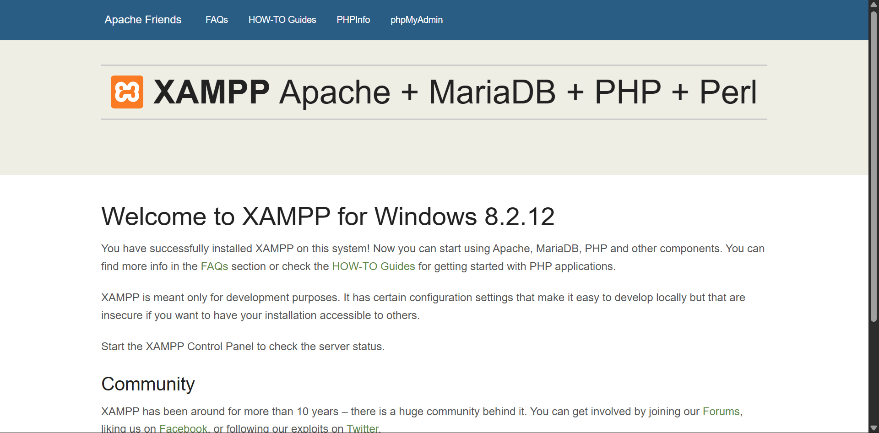

Fig 1: Localhost running
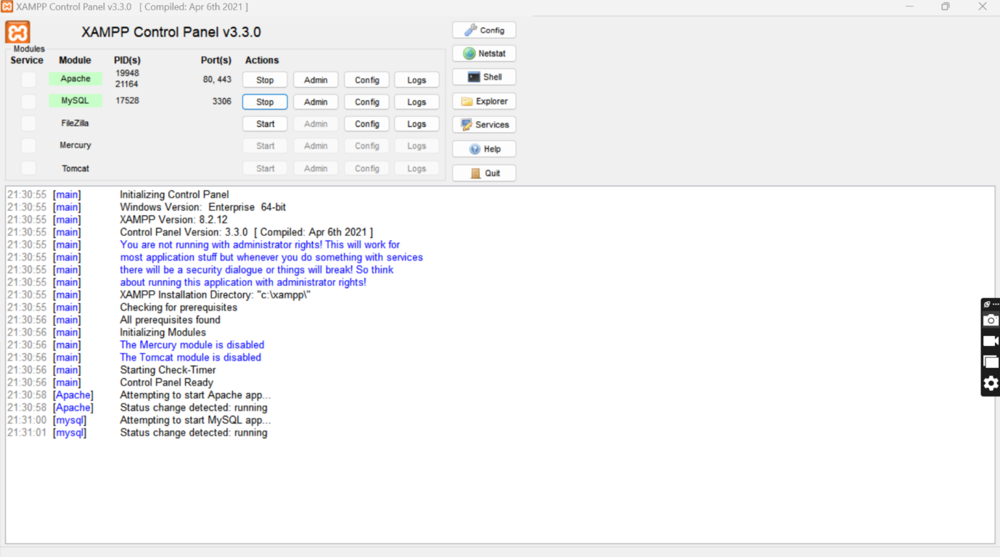

Fig 2: Apache and MySQL Running
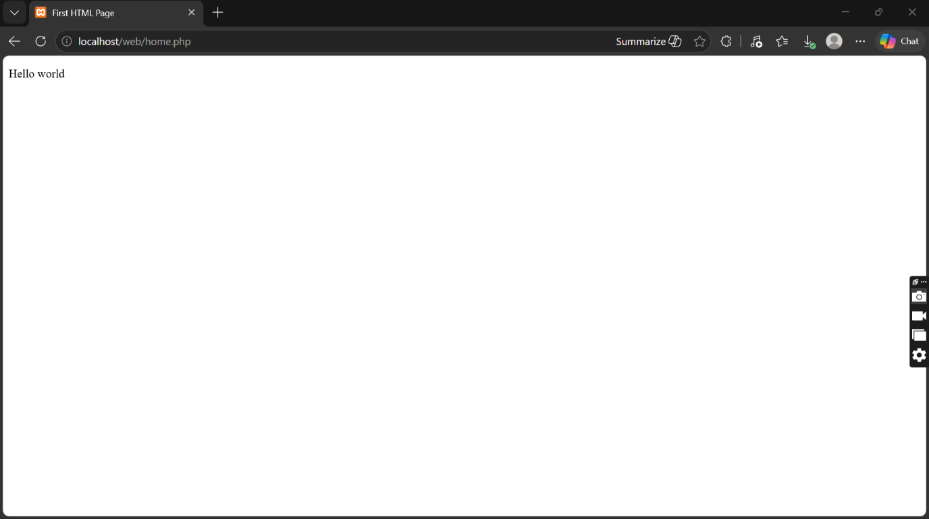

Fig 4: Hello World Test
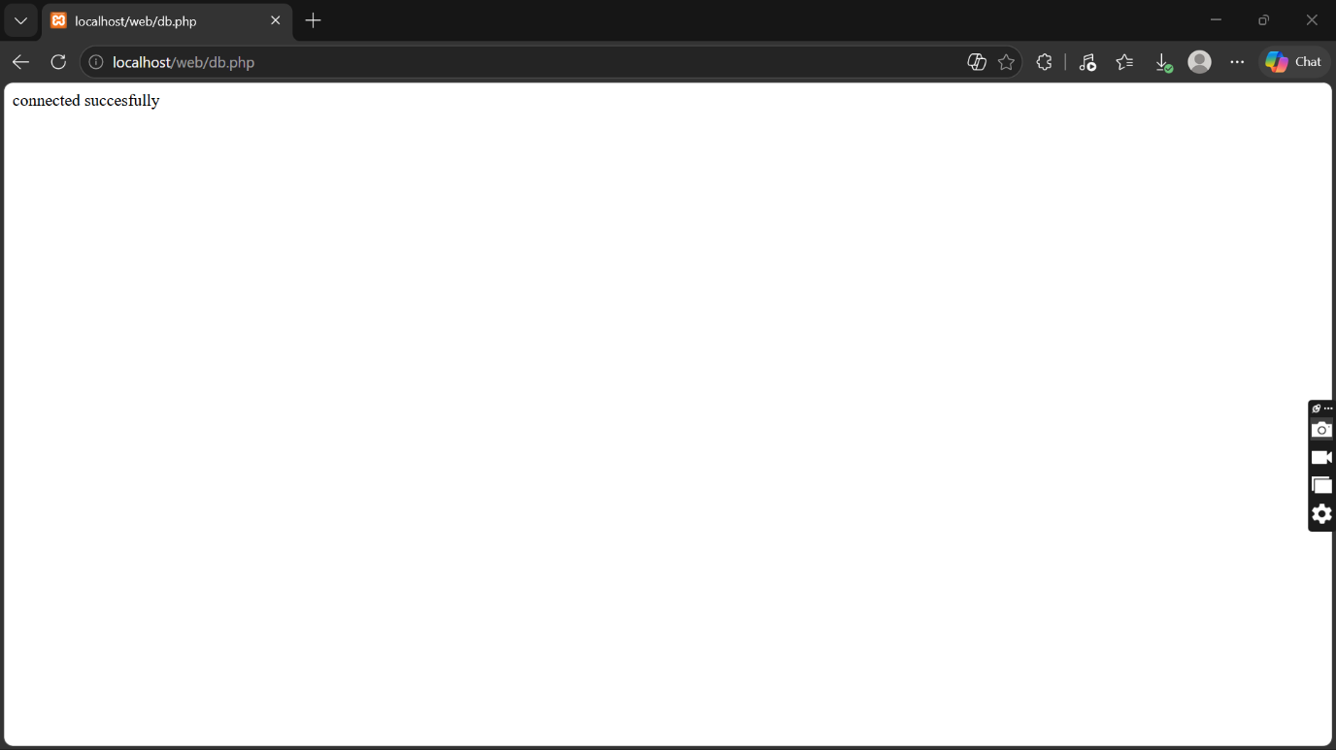

Fig 5: Database Connection Test

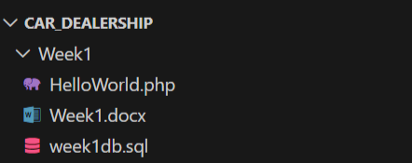
Fig 6: Folder Structure

Student reflection
I have learnt on how to configure database on XAMPP. I also learned how Apache and MySQL services work together to support web development and database management.
The technologies used during the practical included XAMPP, Apache Server, MySQL Database, PHP, HTML, and a web browser for testing localhost pages. These technologies helped me understand the interaction between the frontend, backend, and database systems in web development.
One of the challenges I encountered was configuring the server correctly and ensuring that Apache and MySQL services started successfully without port conflicts. At first, I also experienced difficulty connecting the database to the PHP page due to incorrect connection details. However, after troubleshooting and correcting the configuration settings, the connection became successful.

