STUDENT DETAILS

STUDENT NAME: ISAAC OMONDI OCHIENG

ADMISSION NUMBER: BSCCS/2024/52803

COURSE: COMPUTER SCIENCE

UNIT CODE: BIT3208

LECTURER NAME: MICHAEL NYORO

ACADEMIC YEAR: YEAR 3 SEMESTER

PROJECT DETAILS
PROJECT TITLE:LOGIN SYSTEM
SELECTED TECHNOLOGIES:
HTML, BOOTSTRAP, CSS,
MYSQL, JAVASCRIPT

GITHUB REPOSITORY LINK
https://github.com/isaacomosh/carsselling

TABLE OF CONTENTS
STUDENT DETAILS 1
STUDENT NAME: ISAAC OMONDI OCHIENG 1
ADMISSION NUMBER: BSCCS/2024/52803 1
COURSE: COMPUTER SCIENCE 1
UNIT CODE: BIT3208 1
LECTURER NAME: MICHAEL NYORO 1
ACADEMIC YEAR: YEAR 3 SEMESTER 1
PROJECT DETAILS 1
GITHUB REPOSITORY LINK 1
Week 1: Local Environment Setup 3
Fig 1: Installation of XAMPP 3
Fig 2: Apache and MySQL Running 4
Fig 4: Hello World Test 4
Fig 5: Database Connection Test 5
Student reflection 5
Week 2: Wireframes and GUI Design 7
Fig 1: Hand-drawn Wireframe 7
Fig 2: Dashboard Layout Design 8
Fig 3: Mobile View Mockup 8
Fig 4: Color Theme and Navigation Structure 9
GUI Prototype in Figma 10
Fig 5.1: Register page figma design 10
Fig 5.2: Login page figma design 10
Fig 5.3: Dashboard figma design 11
Week 3: JavaScript and PHP Basics 12
Frontend Interaction and Backend Foundations 12
Fig 1: JavaScript Form Validation 12
Fig 2: Password Strength Checker 13
Fig 3: PHP Syntax Practice 13
Fig 4: Database Connection Script 14
Fig 5: Dynamic User Input Handling 14
Student Reflection: 15
Week 4: Dynamic Backend Processing 16
Fig 1 Login form 16
Fig 2 Form validation 16
Fig 3 PHP processing code 17
Fig 4 Folder structure 17
Fig 5 Database connection 18
Fig 6 Session implementation 18
Fig 8 Contact Form 18
Fig 8 Register form 19
Student Reflection: 19

Week 1: Local Environment Setup
Installation and Testing of Local Development Environment

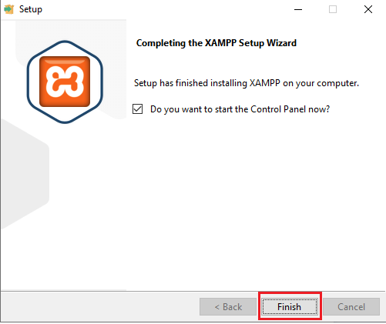
Fig 1: Installation of XAMPP 1

Fig 1: Installation of XAMPP

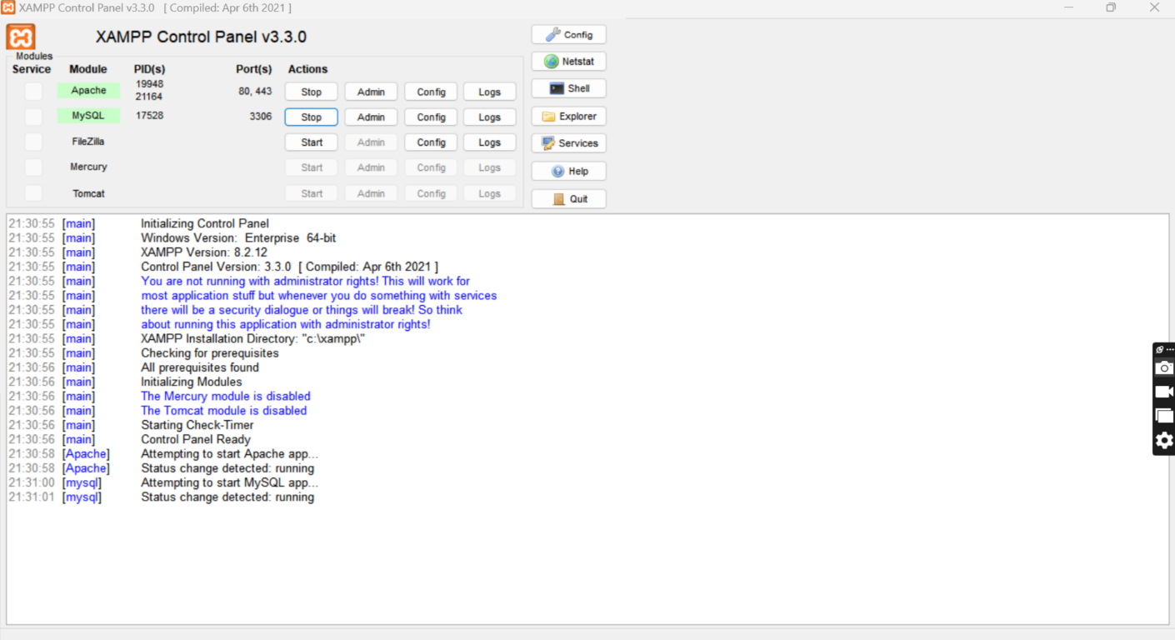

Fig 2: Apache and MySQL Running

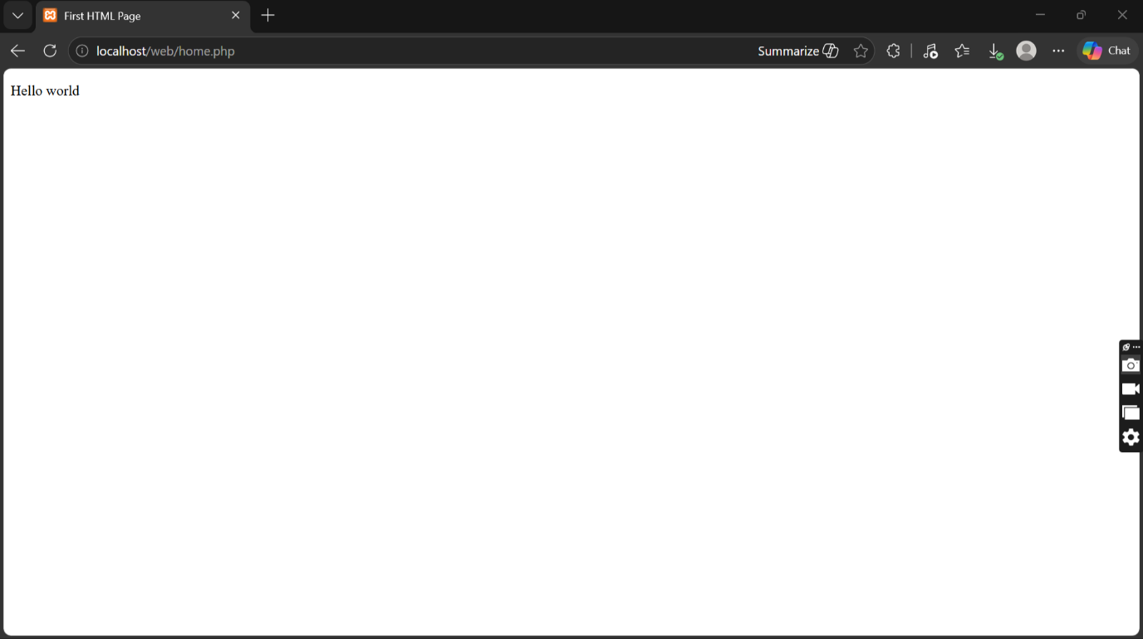

Fig 4: Hello World Test

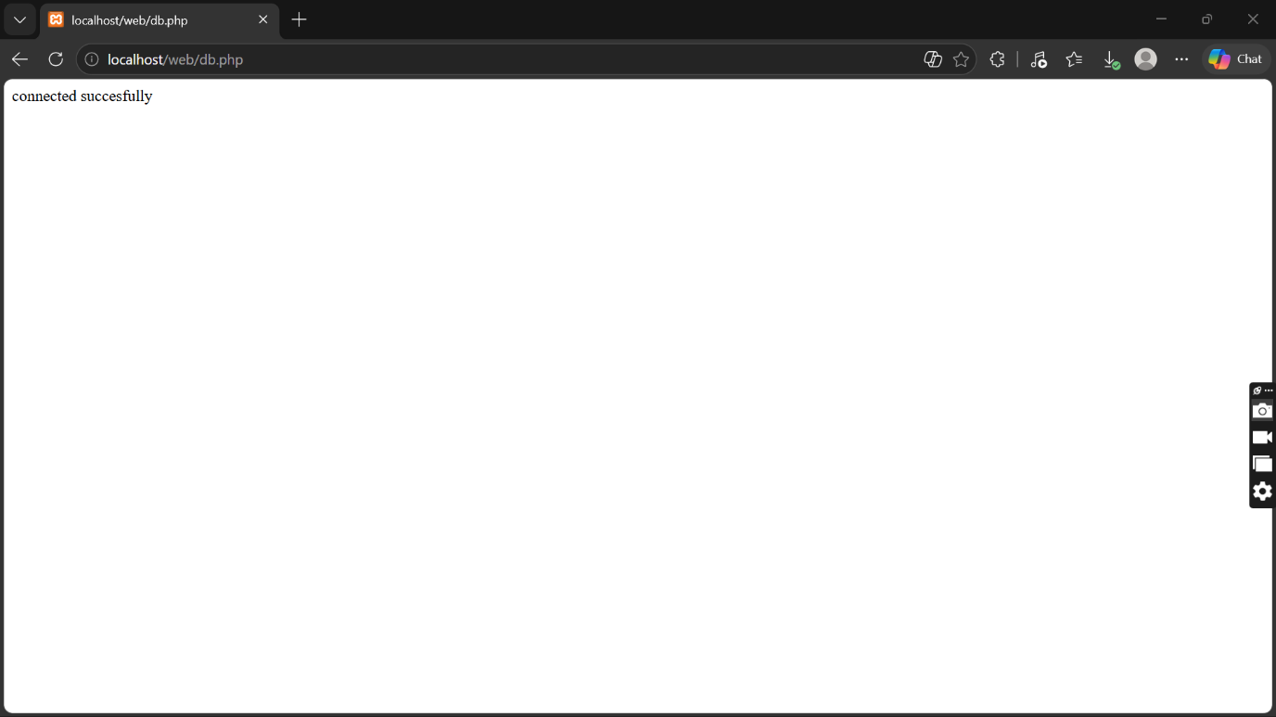

Fig 5: Database Connection Test

Student reflection
I have learnt on how to configure database on XAMPP. I also learned how Apache and MySQL services work together to support web development and database management.
The technologies used during the practical included XAMPP, Apache Server, MySQL Database, PHP, HTML, and a web browser for testing localhost pages. These technologies helped me understand the interaction between the frontend, backend, and database systems in web development.
One of the challenges I encountered was configuring the server correctly and ensuring that Apache and MySQL services started successfully without port conflicts. At first, I also experienced difficulty connecting the database to the PHP page due to incorrect connection details. However, after troubleshooting and correcting the configuration settings, the connection became successful.
The screenshots demonstrate the successful completion of each important step in the setup process. Figure 1 shows that the installation of the development environment was completed successfully. Figure 2 demonstrates that Apache and MySQL services were running properly from the control panel. Figure 3 confirms that the localhost server was working correctly in the browser. Figure 4 shows the successful execution of the first PHP or HTML “Hello World” page, proving that the web server could process files correctly. Finally, Figure 5 demonstrates a successful database connection between PHP and MySQL, confirming that the backend environment was functioning properly.

Week 2: Wireframes and GUI Design
User Interface Planning and System

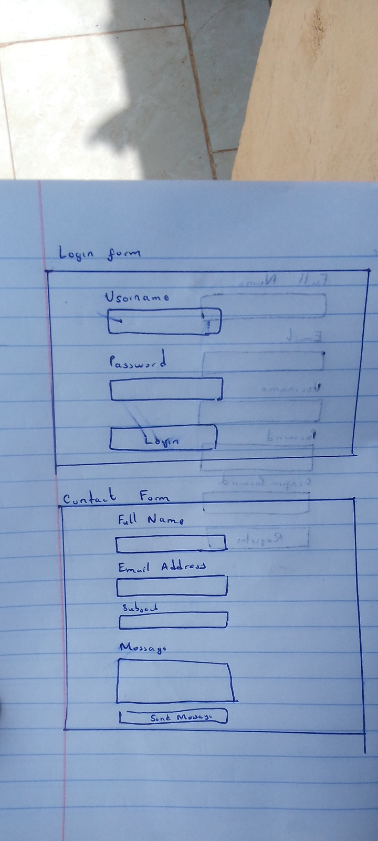

Fig 1: Hand-drawn Wireframe

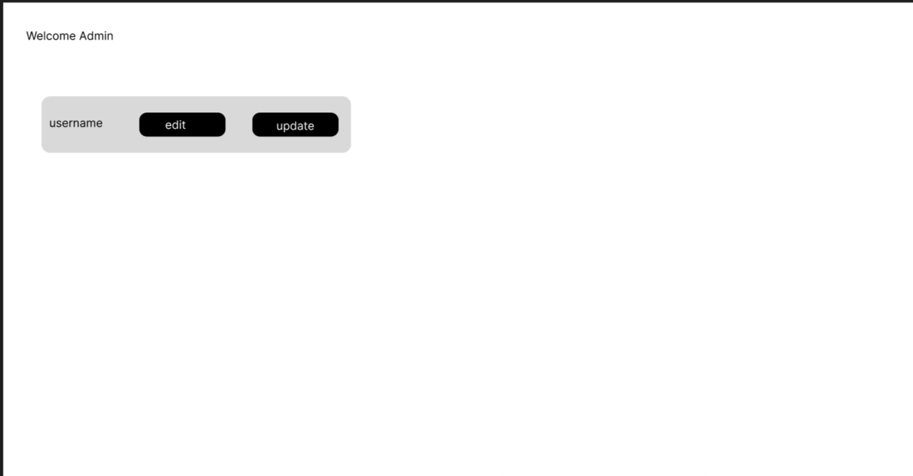

Fig 2: Dashboard Layout Design

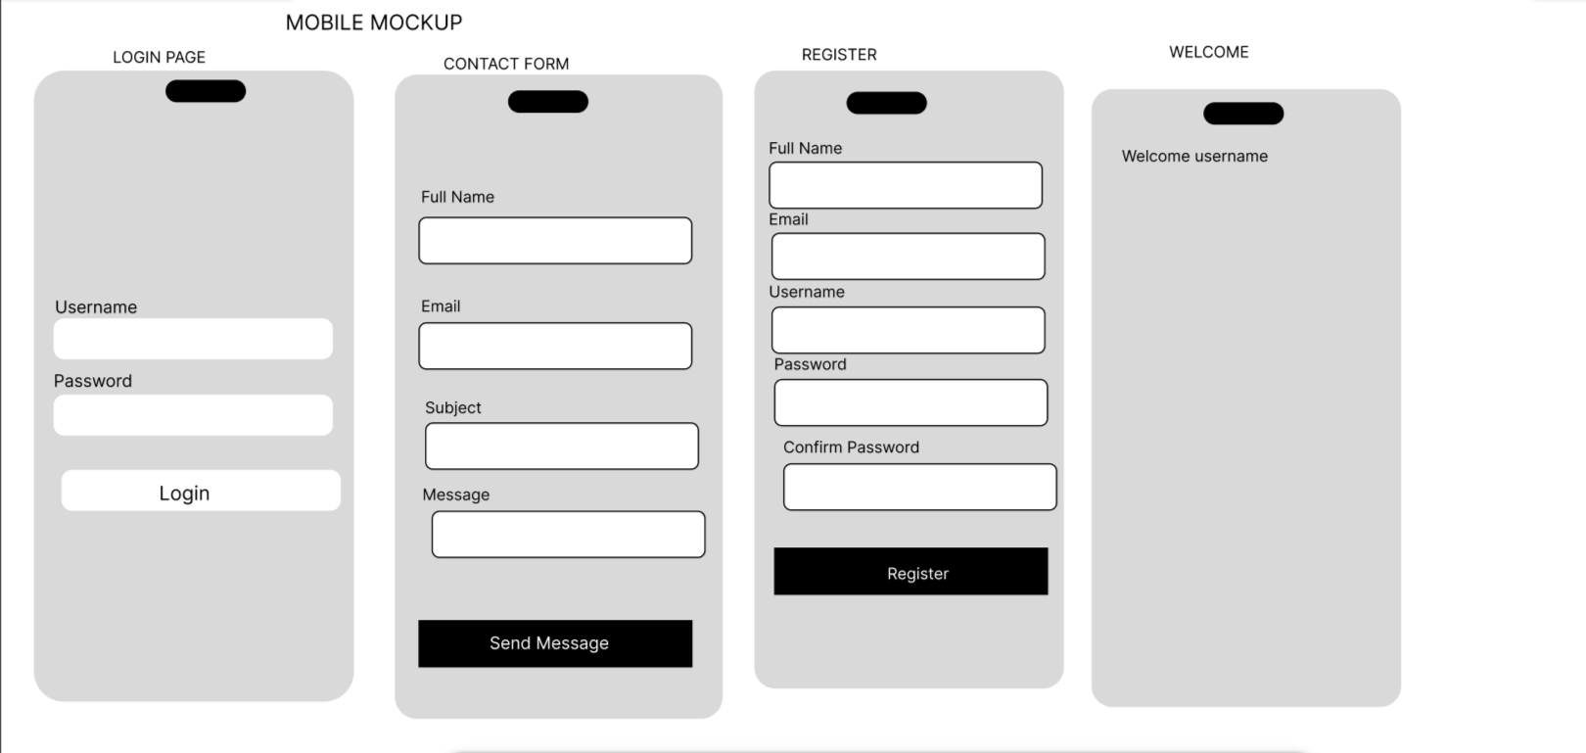

Fig 3: Mobile View Mockup

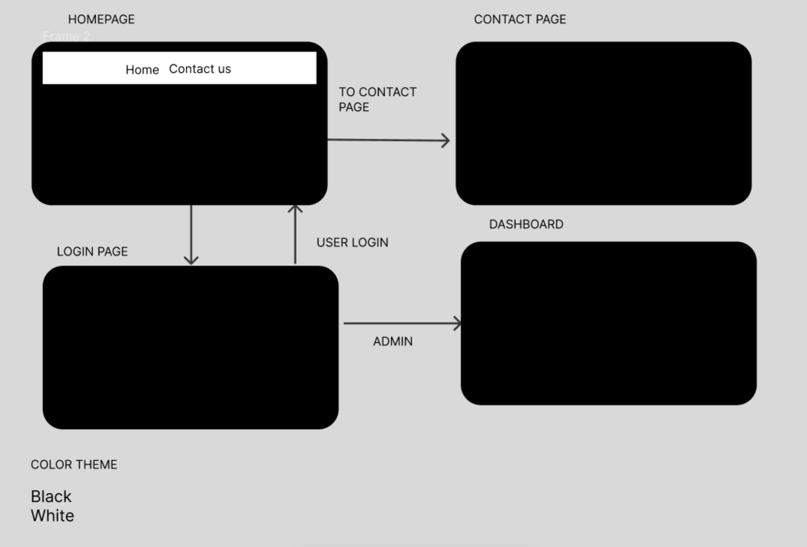

Fig 4: Color Theme and Navigation Structure

GUI Prototype in Figma
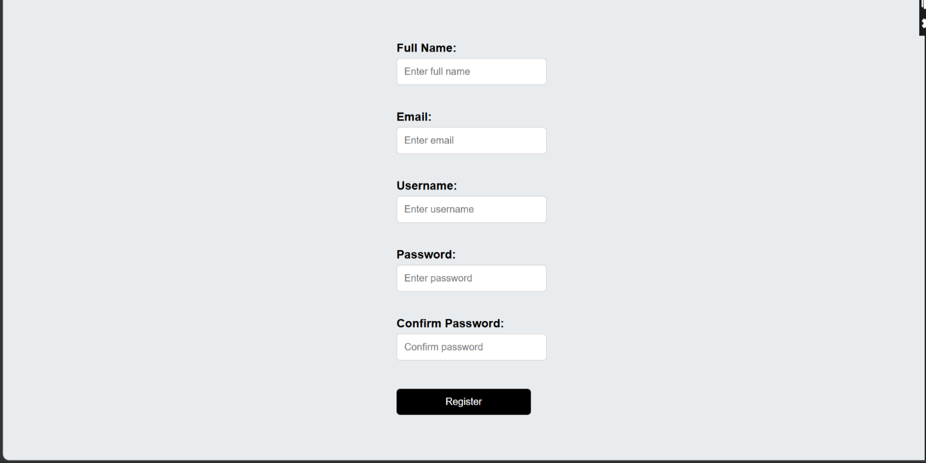

Fig 5.1: Register page figma design

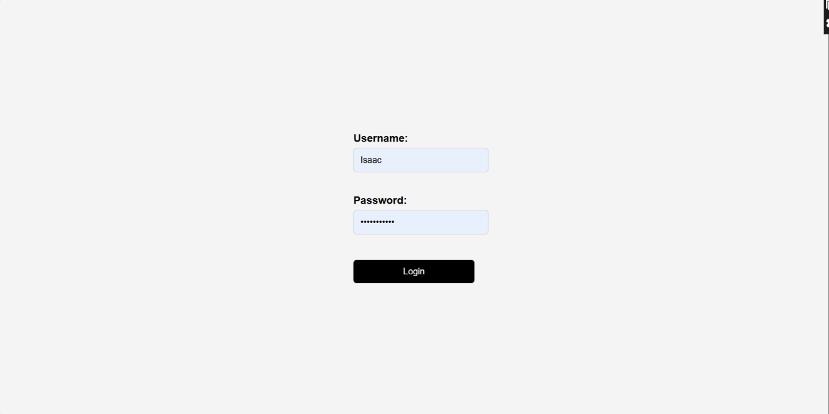

Fig 5.2: Login page figma design



Fig 5.3: Dashboard figma design
Student reflection
The system design was selected to create a simple and user-friendly experience for both customers and administrators. Fig 1 and Fig 5.1 5.2 5.3 focused on clean layouts for easier interaction during register login. Fig 2 was designed in a manner to improve accessibility and reduce navigation time between modules. Fig 3 ensured the system is responsive and usable on mobile devices. Fig 4 used black and white colors and organized navigation flow to improve readability and usability.

Week 3: JavaScript and PHP Basics

Frontend Interaction and Backend Foundations

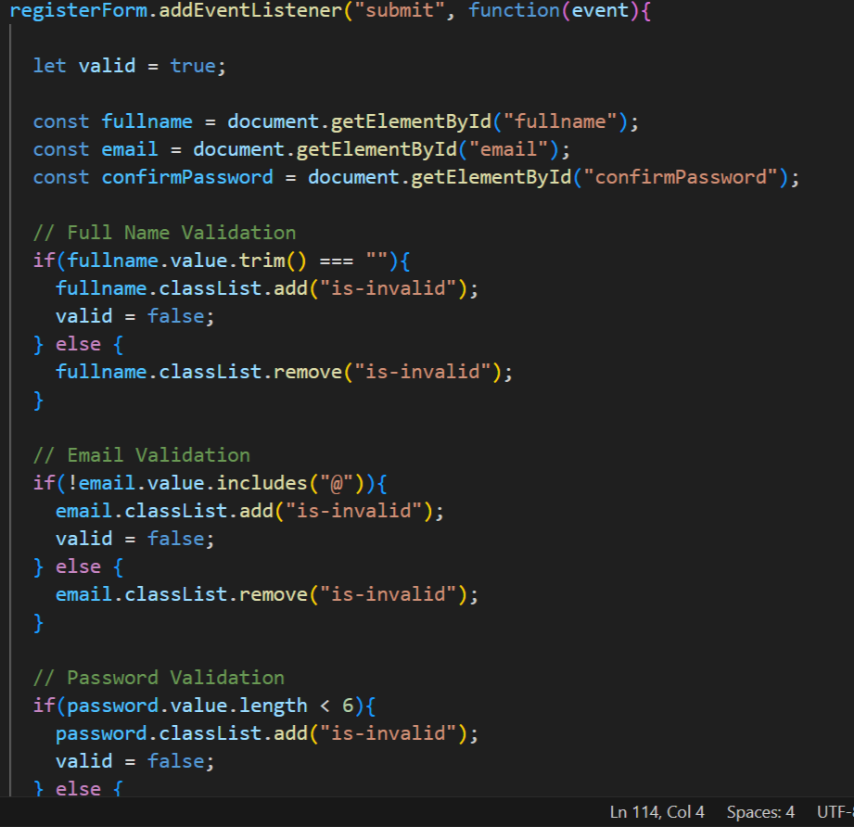

Fig 1: JavaScript Form Validation

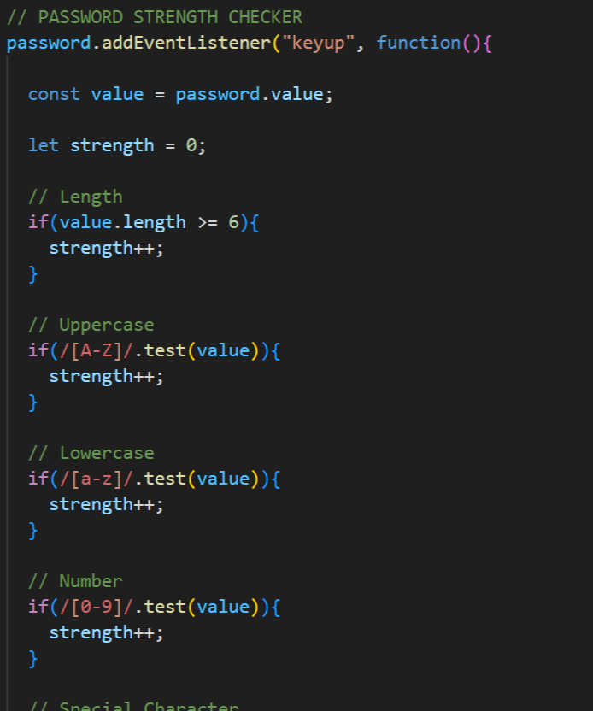

Fig 2: Password Strength Checker

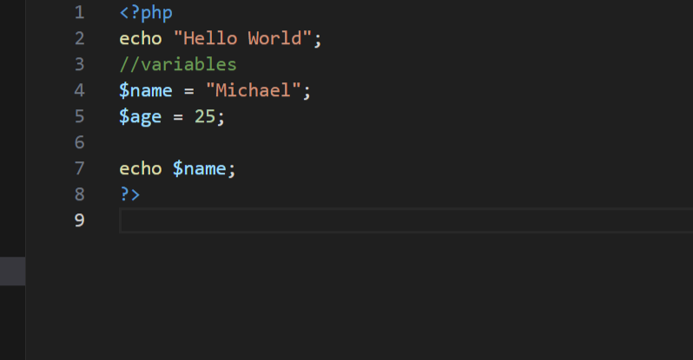

Fig 3: PHP Syntax Practice

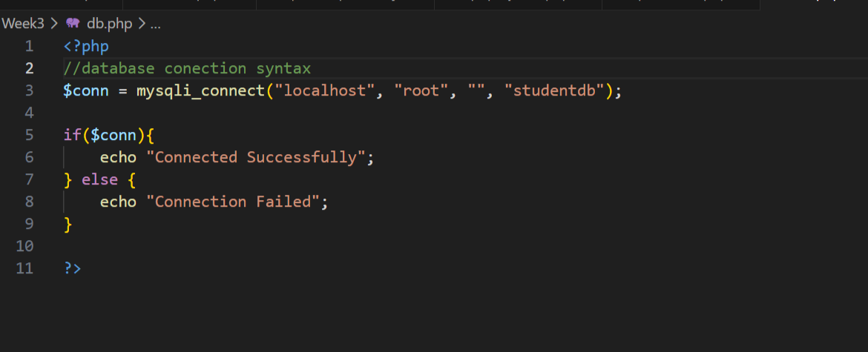

Fig 4: Database Connection Script

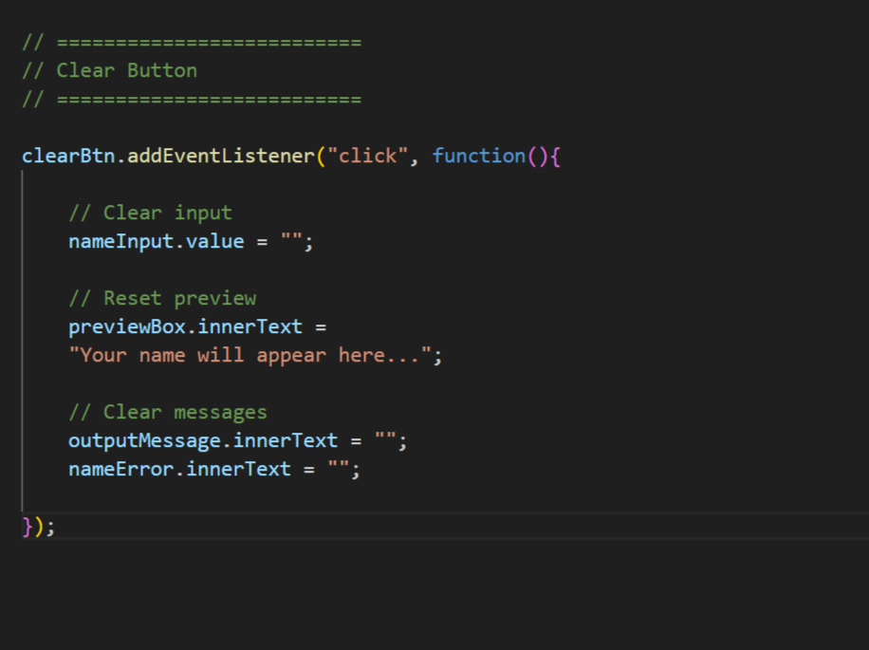

Fig 5: Dynamic User Input Handling

Student Reflection:
The frontend interacts using post and get http methods which are protocols for communication. Form validation ensures correct data is entered by the user in the input fields another thing it ensures the fields are not left empty, it also ensures that the correct data format is entered in the text fields / input fields. Databases connection ensures correct configuration with the correct database and tables to ensure data is correctly stored. So i have used php for database connection , html for the welcome home page and Java script for the form validation password strength checker ,dynamic input handling.

Week 4: Dynamic Backend Processing



Fig 1 Login form
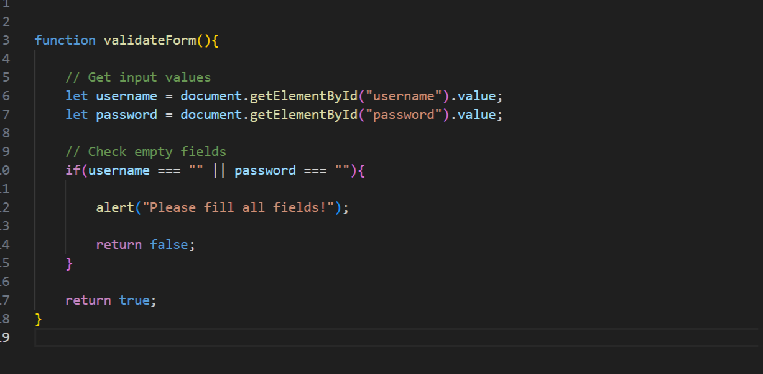

Fig 2 Form validation

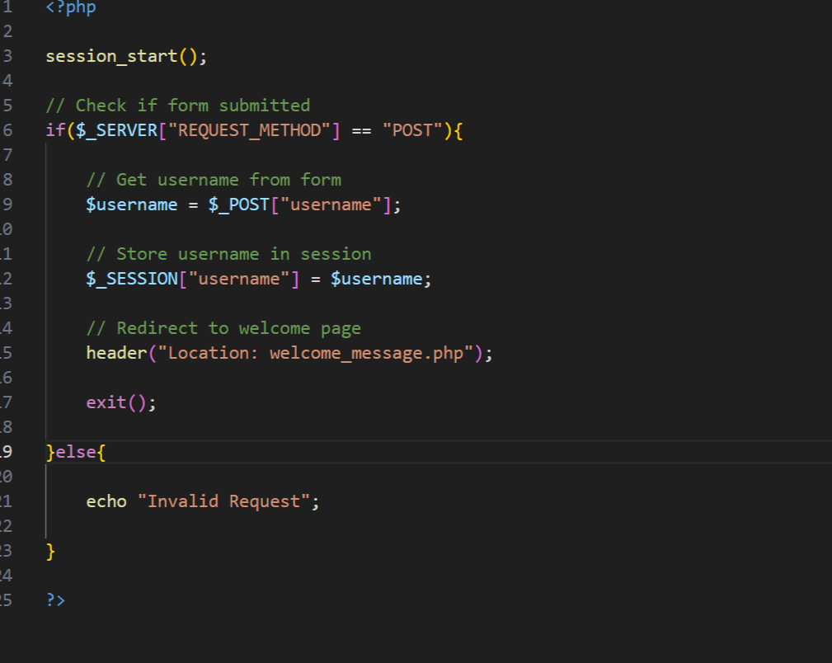
Fig 3 PHP processing code

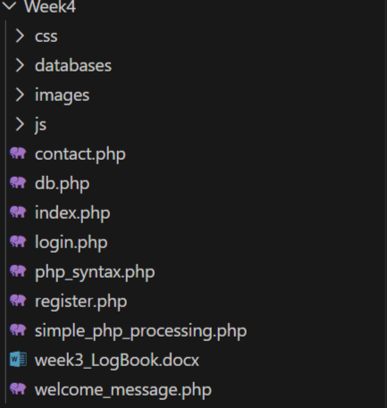
Fig 4 Folder structure


Fig 5 Database connection

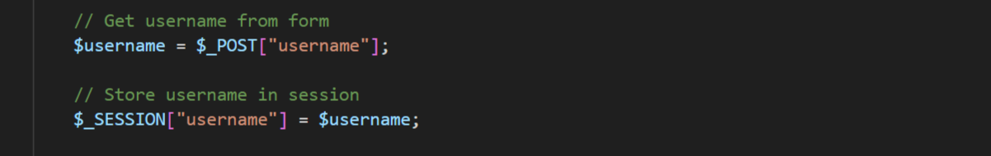

Fig 6 Session implementation

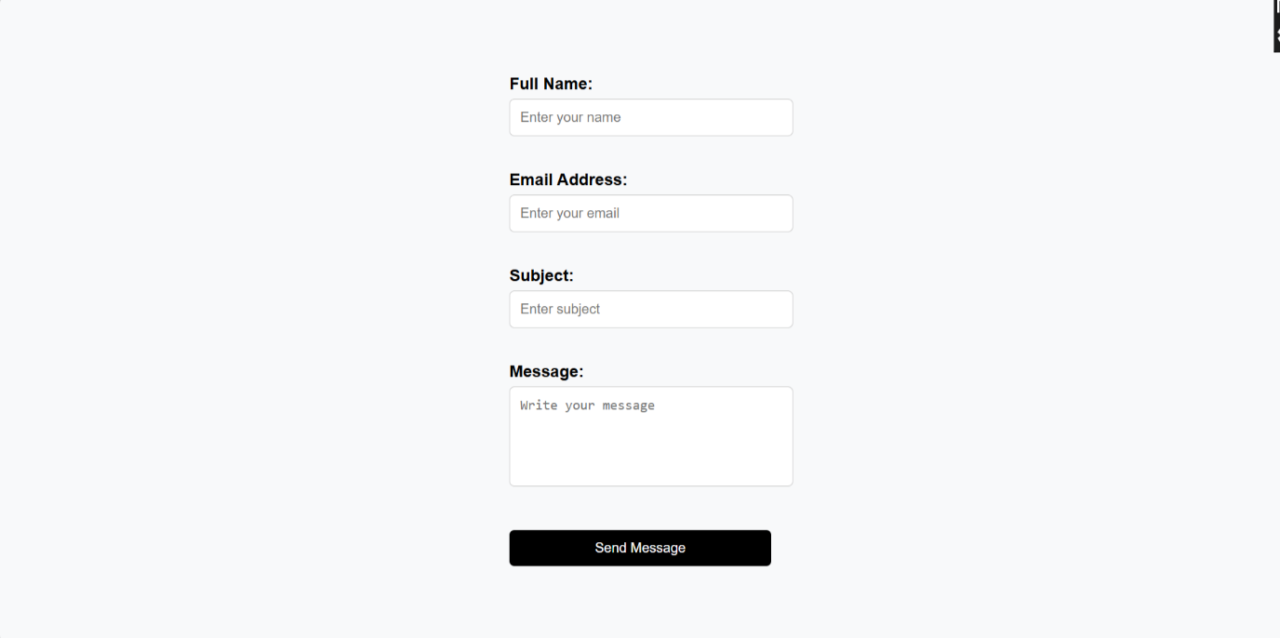

Fig 8 Contact Form



Fig 8 Register form

Student Reflection:
Form handling enable form validation and it ensures data is sent to the serve
r. Sessions can be implemented to show who is logged in at the time. Authentication system enables a user to access the system it can also give access to other pages in the system. The folder structure as in Fig 4 outlines a professional way of file handling and storage that makes retrieval and editing of files easier.

