STUDENT DETAILS

STUDENT NAME: ISAAC OMONDI OCHIENG

ADMISSION NUMBER: BSCCS/2024/52803

COURSE: COMPUTER SCIENCE

UNIT CODE: BIT3208

LECTURER NAME: MICHAEL NYORO

ACADEMIC YEAR: YEAR 3 SEMESTER

PROJECT DETAILS
PROJECT TITLE:LOGIN SYSTEM
SELECTED TECHNOLOGIES:
HTML, BOOTSTRAP, CSS,
MYSQL, JAVASCRIPT

GITHUB REPOSITORY LINK
https://github.com/isaacomosh/loginsystem

Table of Contents
STUDENT DETAILS 1
STUDENT NAME: ISAAC OMONDI OCHIENG 1
ADMISSION NUMBER: BSCCS/2024/52803 1
COURSE: COMPUTER SCIENCE 1
UNIT CODE: BIT3208 1
LECTURER NAME: MICHAEL NYORO 1
ACADEMIC YEAR: YEAR 3 SEMESTER 1
PROJECT DETAILS 1
GITHUB REPOSITORY LINK 1
Week 1: Local Environment Setup 11
Fig 1: Installation of XAMPP 11
Fig 2: Apache and MySQL Running 12
Fig 4: Hello World Test 12
Fig 5: Database Connection Test 13
Student reflection 13
Week 2: Wireframes and GUI Design 15
Fig 1: Hand-drawn Wireframe 15
Fig 2: Dashboard Layout Design 16
Fig 3: Mobile View Mockup 16
Fig 4: Color Theme and Navigation Structure 17
GUI Prototype in Figma 18
Fig 5.1: Register page figma design 18
Fig 5.2: Login page figma design 18
Fig 5.3: Dashboard figma design 19
Week 3: JavaScript and PHP Basics 20
Frontend Interaction and Backend Foundations 20
Fig 1: JavaScript Form Validation 20
Fig 2: Password Strength Checker 21
Fig 3: PHP Syntax Practice 21
Fig 4: Database Connection Script 22
Fig 5: Dynamic User Input Handling 22
Student Reflection: 23
Week 4: Dynamic Backend Processing 24
Fig 1 Login form 24
Fig 2 Form validation 24
Fig 3 PHP processing code 25
Fig 4 Folder structure 25
Fig 5 Database connection 26
Fig 6 Session implementation 26
Fig 8 Contact Form 26
Fig 8 Register form 27
Student Reflection: 27
Week 5: Database Components and CRUD Operations 28
Fig 1 Database creation query 28
Fig 2 Database creation success message 28
Table Creation 29
Fig 3 Users table creation query 29
CRUD Operations 29
Fig 4 Data insertion query on user table 29
Fig 5 Data reading query on user table 30
Fig 6 Update operation query on user table 30
Fig 7 Delete operation query on user table 31
Login database integration 31
Fig 8 Login database integration 31
Fig 9 Login database integration 32
Student Reflection: 32

Week 1: Local Environment Setup
Installation and Testing of Local Development Environment

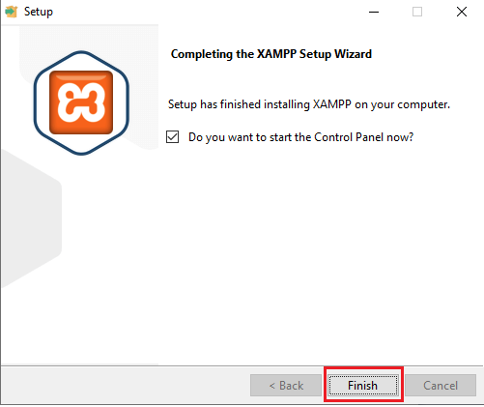

Fig 1: Installation of XAMPP

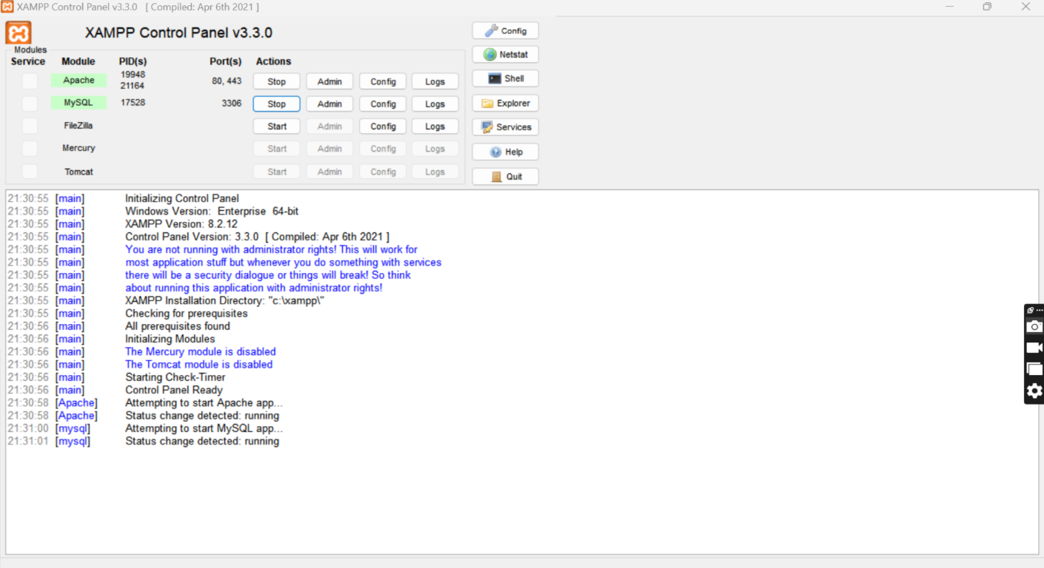

Fig 2: Apache and MySQL Running

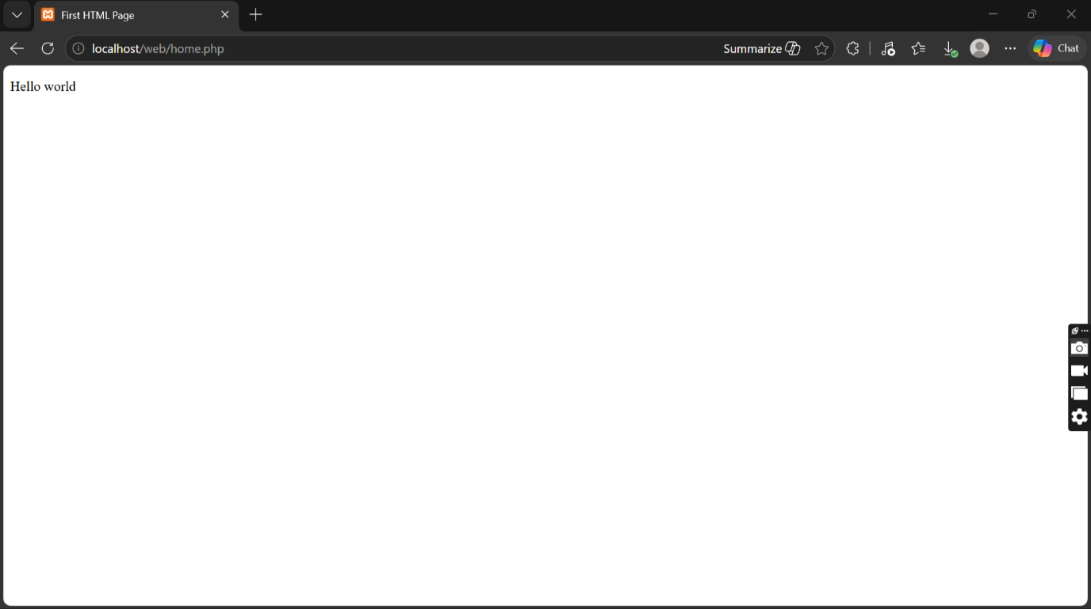

Fig 4: Hello World Test

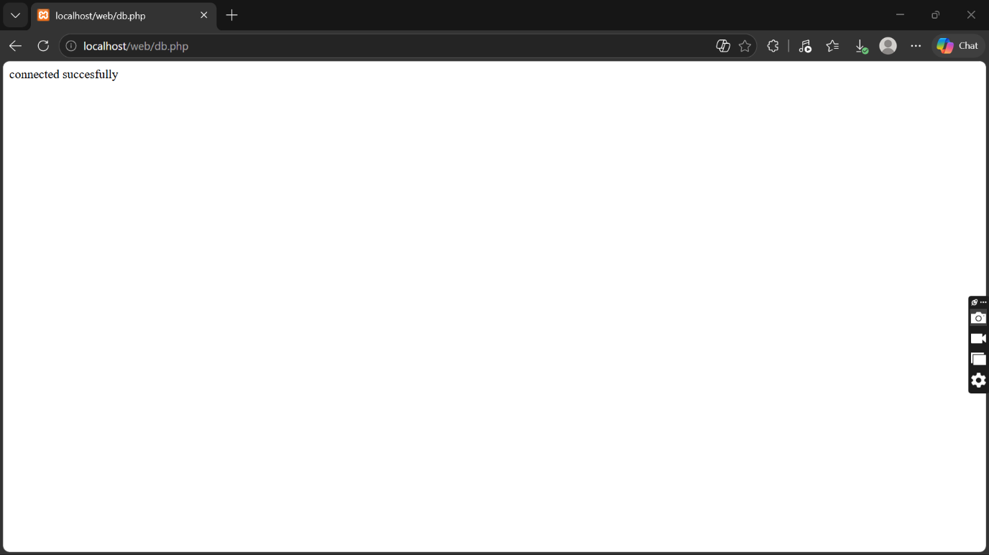

Fig 5: Database Connection Test

Student reflection
I have learnt on how to configure database on XAMPP. I also learned how Apache and MySQL services work together to support web development and database management.
The technologies used during the practical included XAMPP, Apache Server, MySQL Database, PHP, HTML, and a web browser for testing localhost pages. These technologies helped me understand the interaction between the frontend, backend, and database systems in web development.
One of the challenges I encountered was configuring the server correctly and ensuring that Apache and MySQL services started successfully without port conflicts. At first, I also experienced difficulty connecting the database to the PHP page due to incorrect connection details. However, after troubleshooting and correcting the configuration settings, the connection became successful.
The screenshots demonstrate the successful completion of each important step in the setup process. Figure 1 shows that the installation of the development environment was completed successfully. Figure 2 demonstrates that Apache and MySQL services were running properly from the control panel. Figure 3 confirms that the localhost server was working correctly in the browser. Figure 4 shows the successful execution of the first PHP or HTML “Hello World” page, proving that the web server could process files correctly. Finally, Figure 5 demonstrates a successful database connection between PHP and MySQL, confirming that the backend environment was functioning properly.

Week 2: Wireframes and GUI Design
User Interface Planning and System

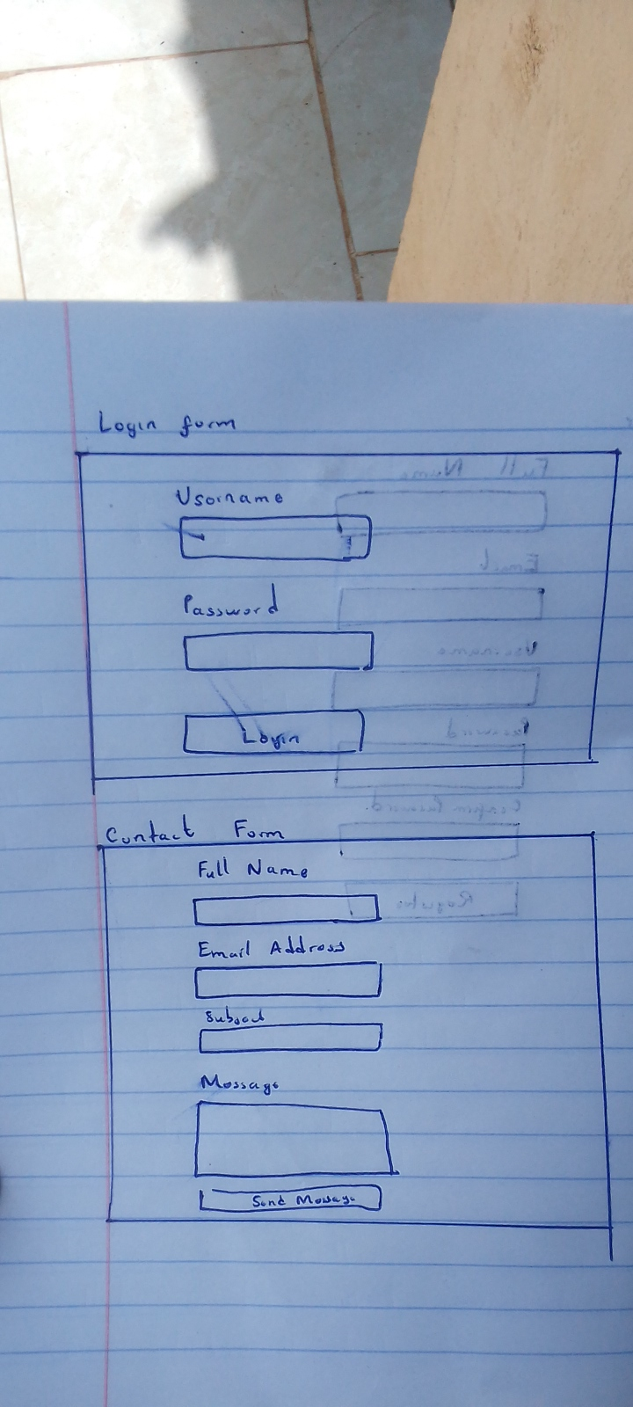

Fig 1: Hand-drawn Wireframe



Fig 2: Dashboard Layout Design

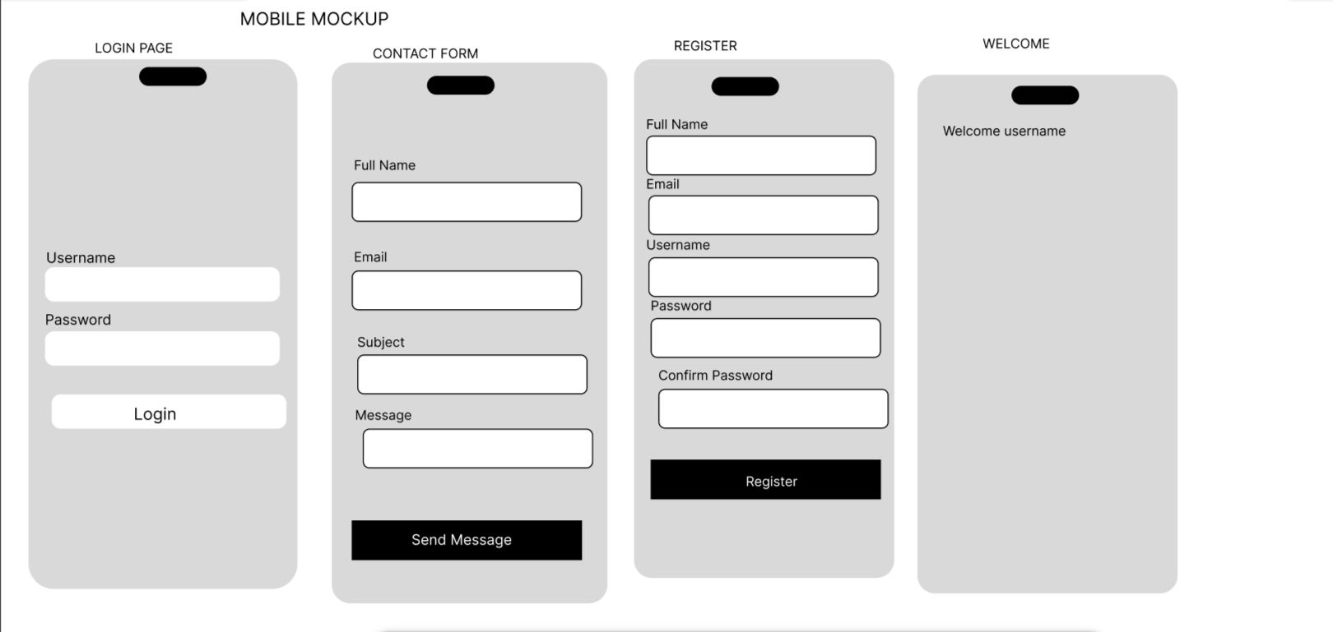

Fig 3: Mobile View Mockup

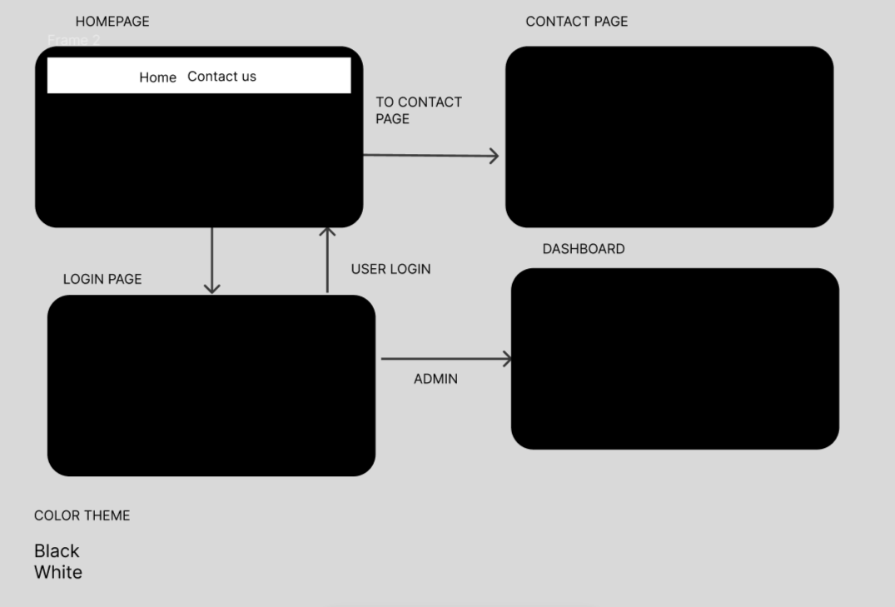

Fig 4: Color Theme and Navigation Structure

GUI Prototype in Figma
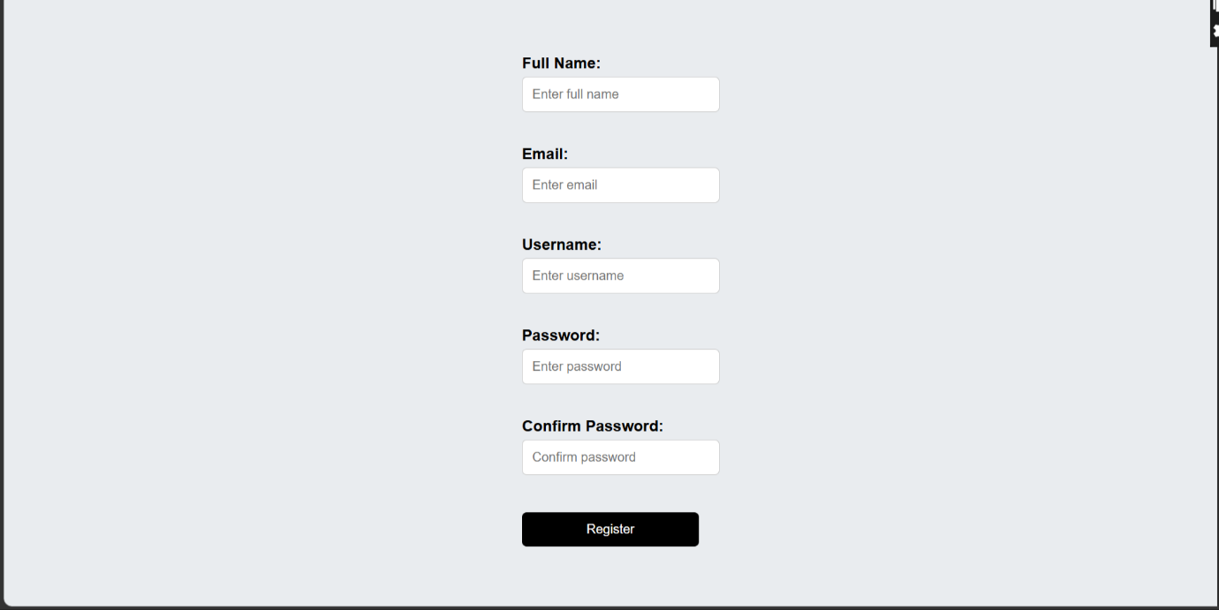

Fig 5.1: Register page figma design

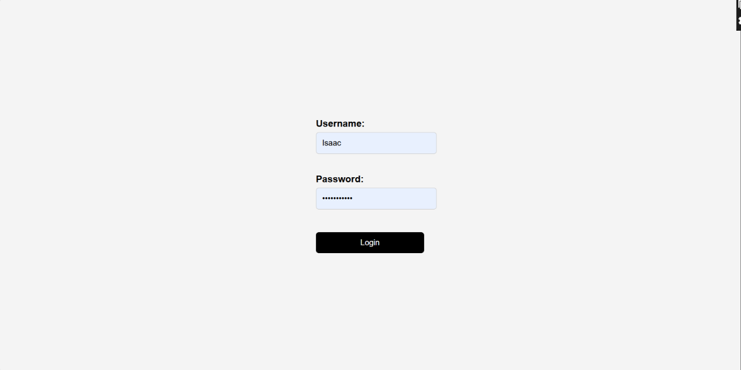

Fig 5.2: Login page figma design

Fig 5.3: Dashboard figma design
Student reflection
The system design was selected to create a simple and user-friendly experience for both customers and administrators. Fig 1 and Fig 5.1 5.2 5.3 focused on clean layouts for easier interaction during register login. Fig 2 was designed in a manner to improve accessibility and reduce navigation time between modules. Fig 3 ensured the system is responsive and usable on mobile devices. Fig 4 used black and white colors and organized navigation flow to improve readability and usability.

Week 3: JavaScript and PHP Basics

Frontend Interaction and Backend Foundations

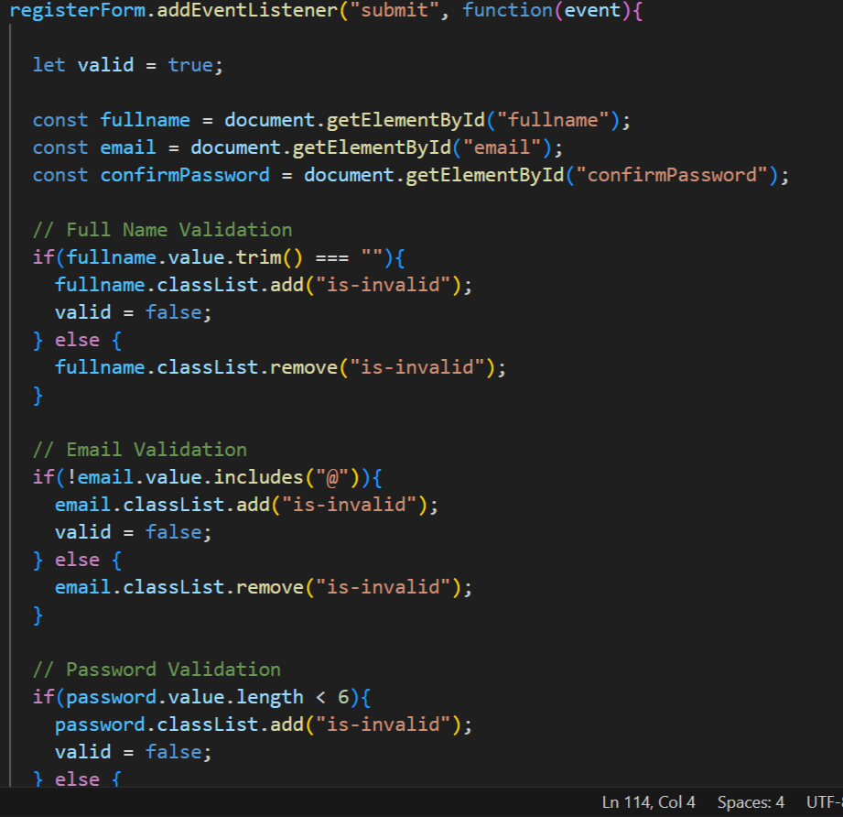

Fig 1: JavaScript Form Validation

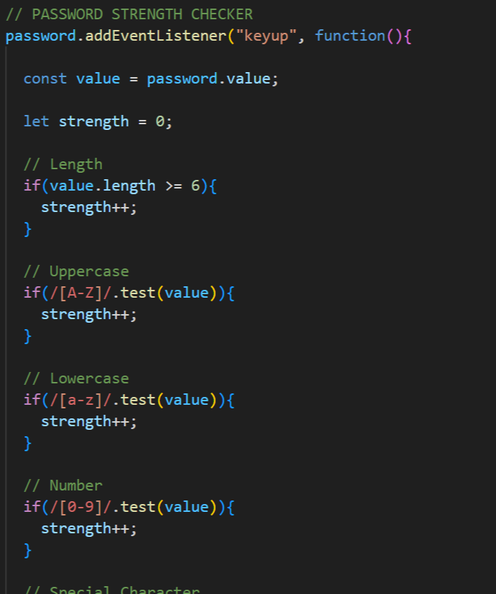

Fig 2: Password Strength Checker

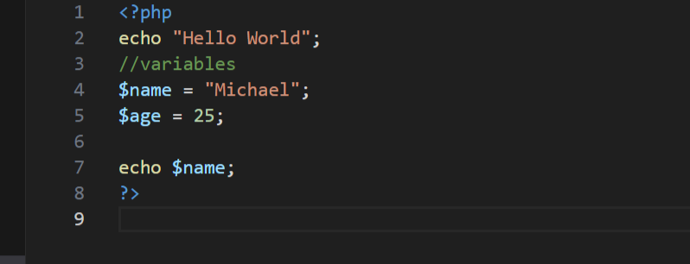

Fig 3: PHP Syntax Practice

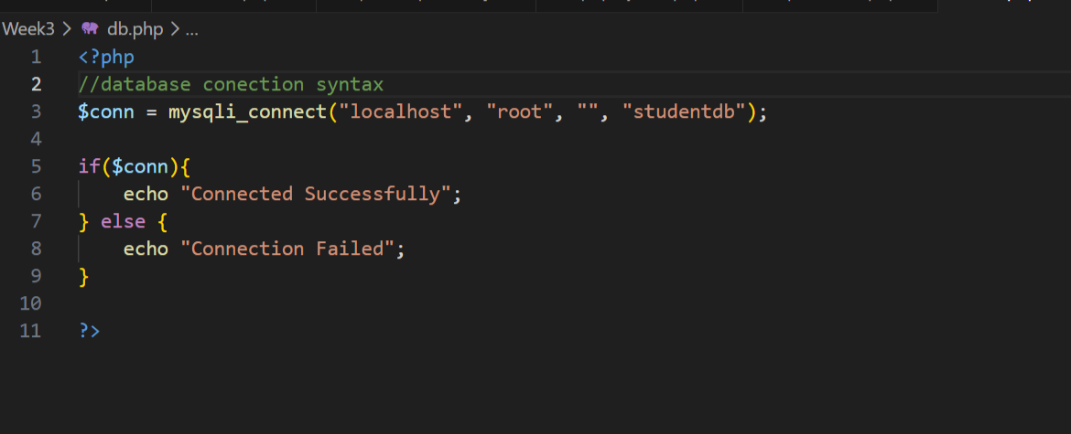

Fig 4: Database Connection Script

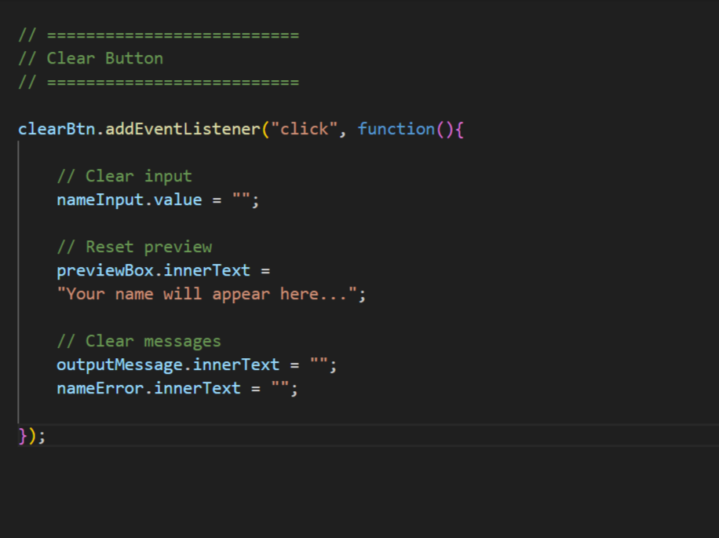

Fig 5: Dynamic User Input Handling

Student Reflection:
The frontend interacts using post and get http methods which are protocols for communication. Form validation ensures correct data is entered by the user in the input fields another thing it ensures the fields are not left empty, it also ensures that the correct data format is entered in the text fields / input fields. Databases connection ensures correct configuration with the correct database and tables to ensure data is correctly stored. So i have used php for database connection , html for the welcome home page and Java script for the form validation password strength checker ,dynamic input handling.

Week 4: Dynamic Backend Processing

Fig 1 Login form
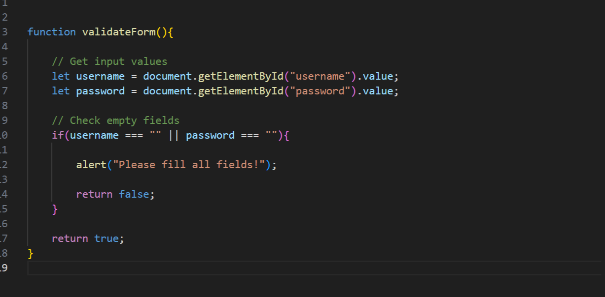

Fig 2 Form validation

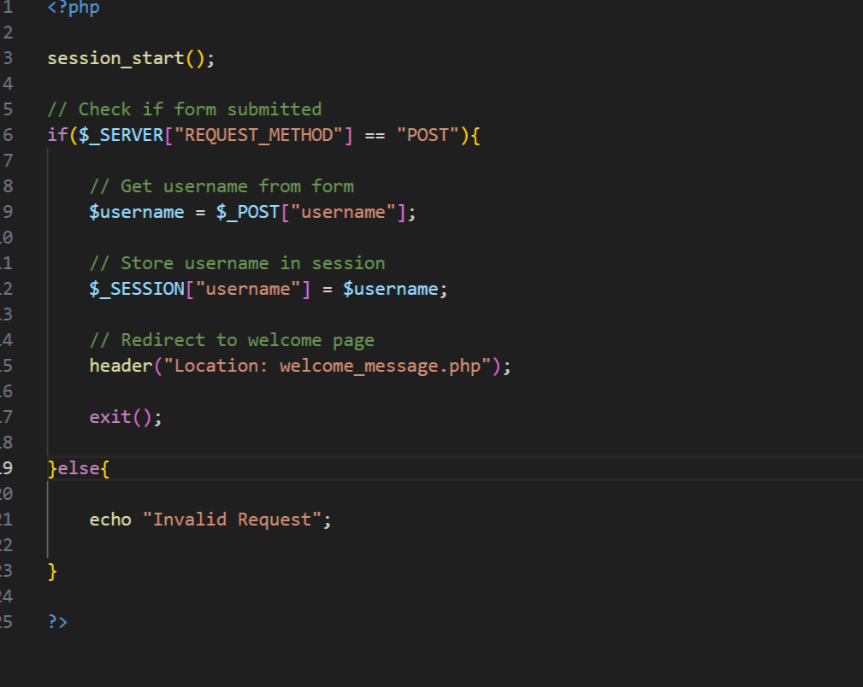
Fig 3 PHP processing code

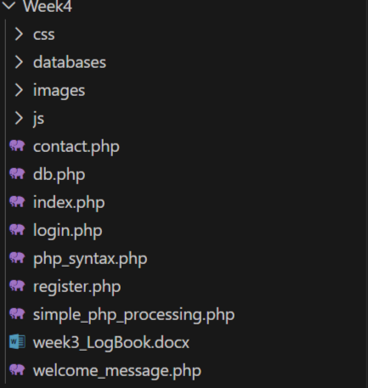
Fig 4 Folder structure


Fig 5 Database connection

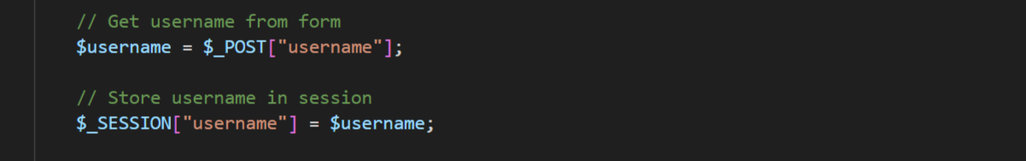

Fig 6 Session implementation

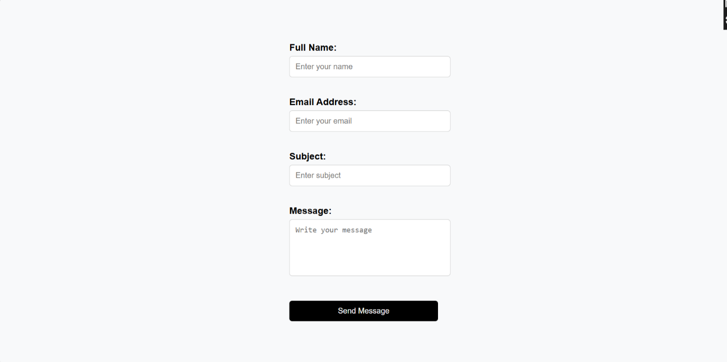

Fig 8 Contact Form

Fig 8 Register form

Student Reflection:
Form handling enable form validation and it ensures data is sent to the serve
r. Sessions can be implemented to show who is logged in at the time. Authentication system enables a user to access the system it can also give access to other pages in the system. The folder structure as in Fig 4 outlines a professional way of file handling and storage that makes retrieval and editing of files easier.

Week 5: Database Components and CRUD Operations
Database creation
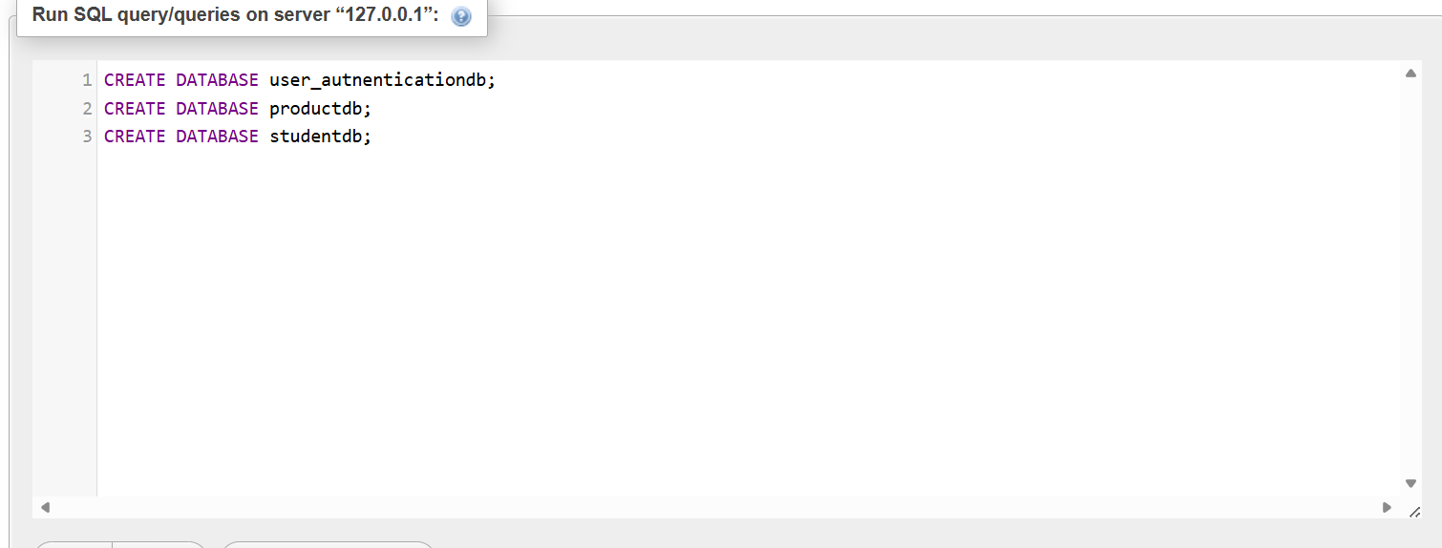

Fig 1 Database creation query
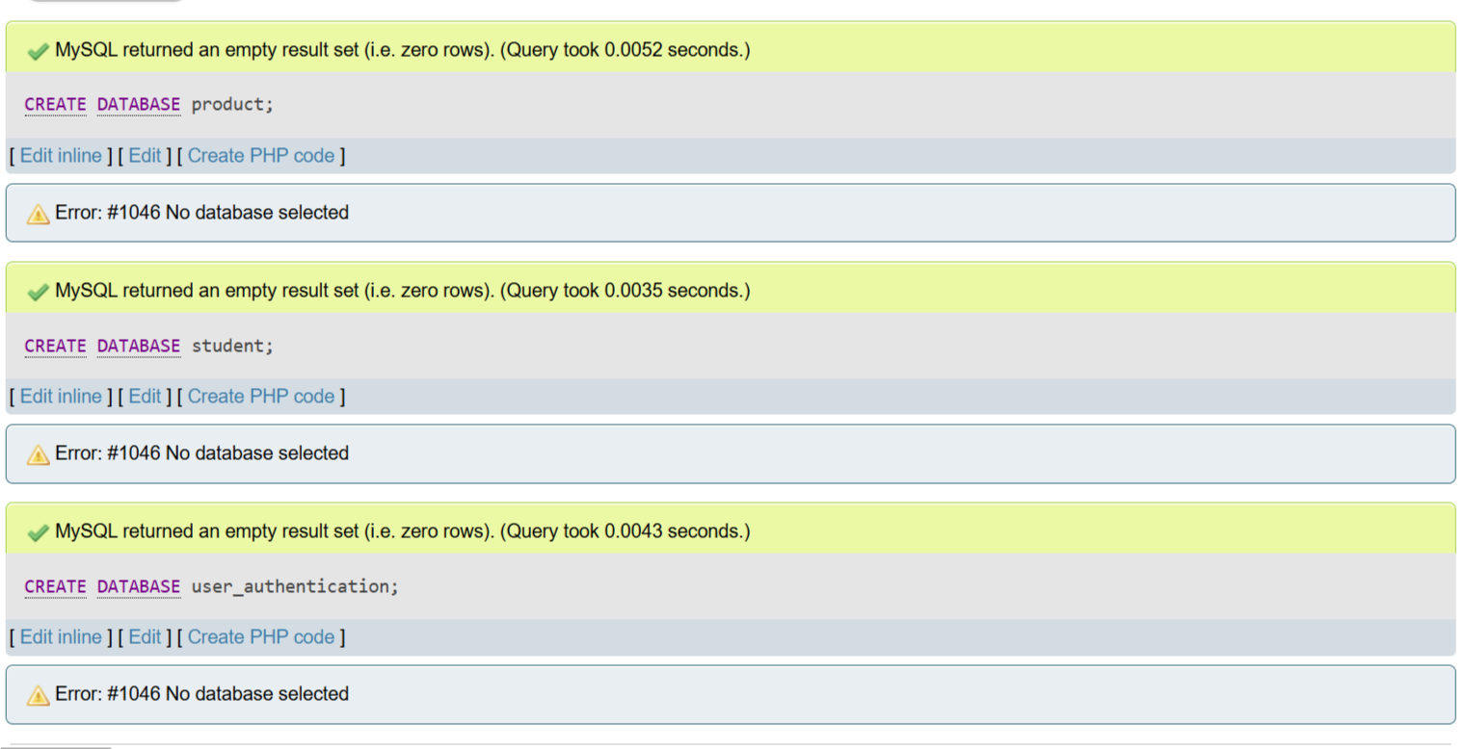

Fig 2 Database creation success message

Table Creation
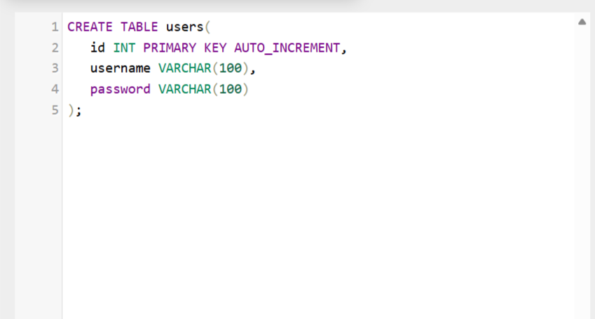

Fig 3 Users table creation query

CRUD Operations
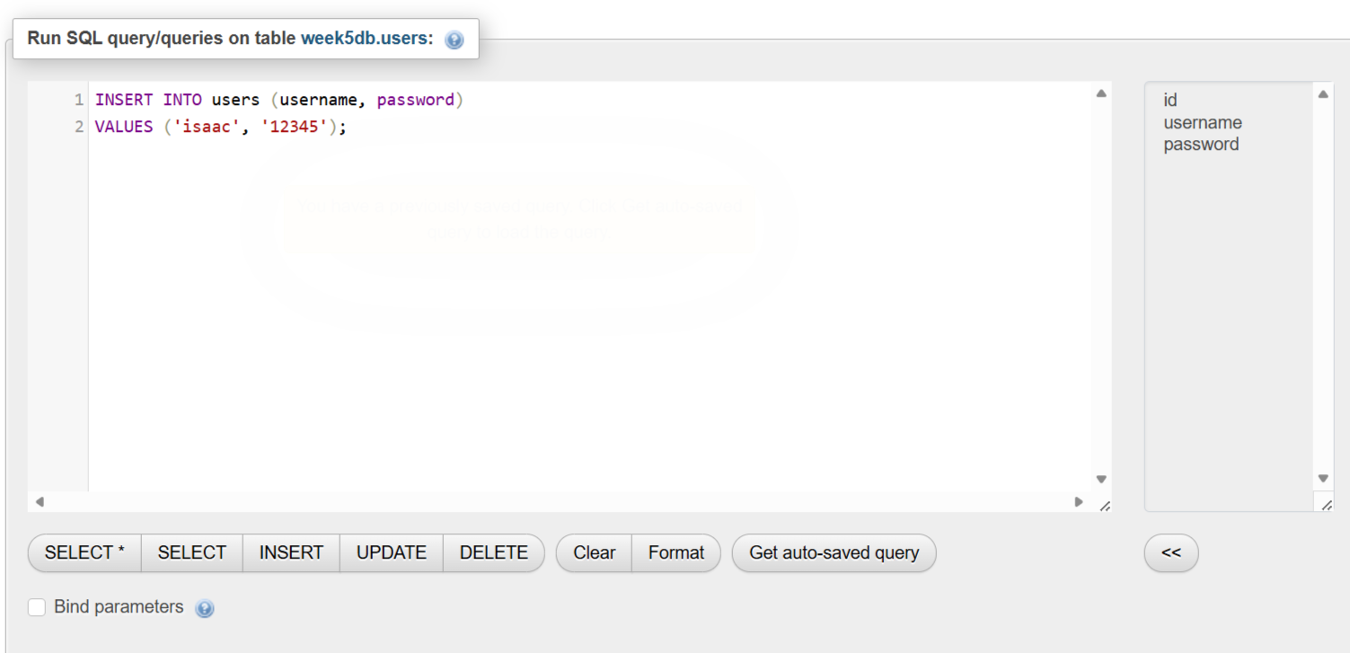

Fig 4 Data insertion query on user table

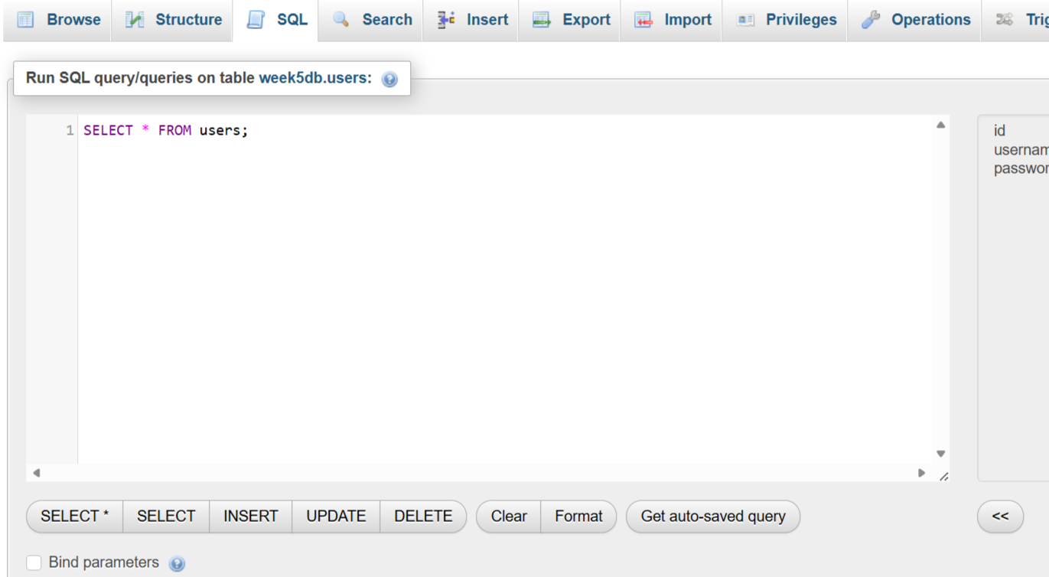

Fig 5 Data reading query on user table

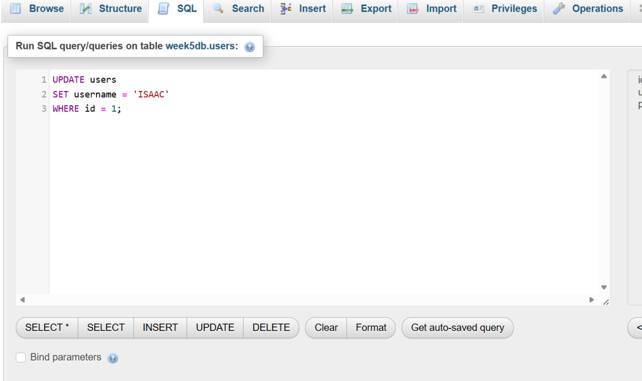

Fig 6 Update operation query on user table

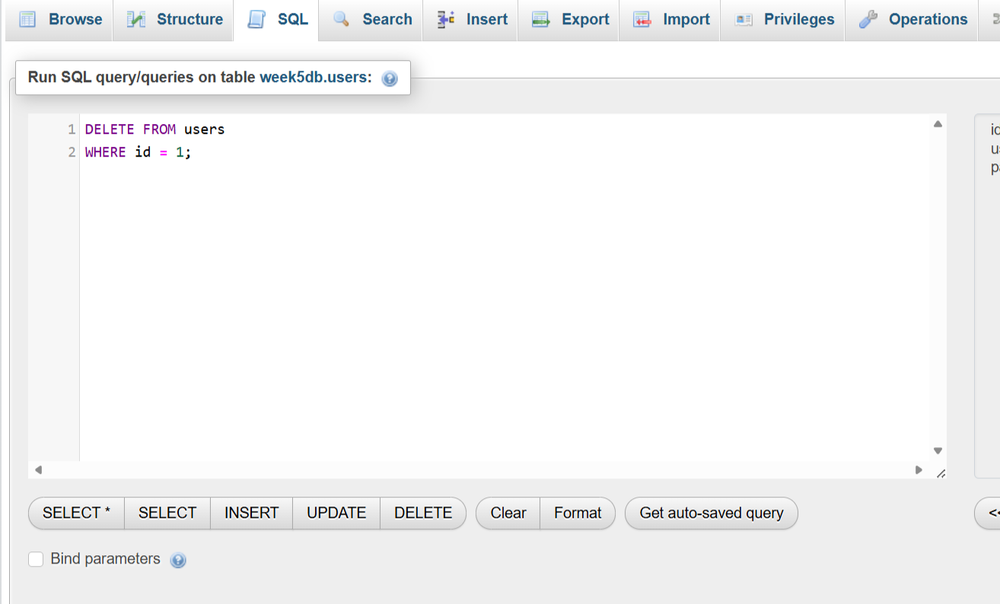

Fig 7 Delete operation query on user table

Login database integration
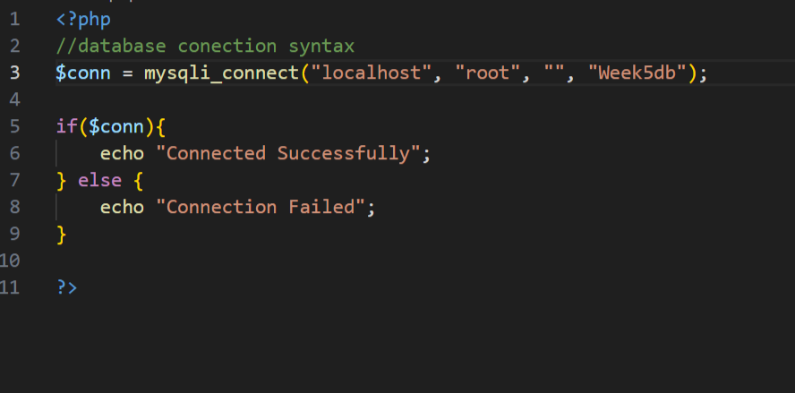

Fig 8 Login database integration

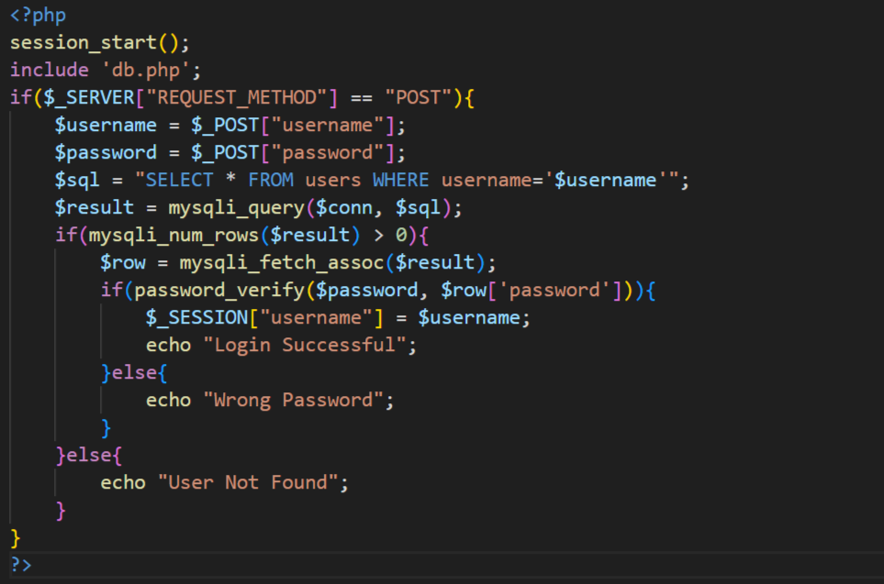

Fig 9 Login database integration

Student Reflection:
Crud operations enables a system to retrieve , add, update and delete records. This makes a system function dynamically. The database implementation enables data storage which can later be used for authentication and sessions .Integration with the authentication table shows how real world backend systems work .SQL queries makes it easy to create, add, insert, update and delete records efficiently. Fig 1 shows basic database creation sql query Fig 2 shows successful creation message by the XAMPP software Figure 4,5,6,7 shows the CRUD operations in database. Figures 8 and 9 shows integration to login system

