Isaac Sek

**CSS 490: Multimedia – HW 1**

1. How To Run: Go to URL to run on web, or install node.js
   1. <https://dashboard.heroku.com/apps/polar-springs-47298/settings>
   2. Or cd into root directory
   3. Run “npm install”
   4. Run “npm start”
2. Use Sample Code: No, developed all by myself
3. Screen shots for query results 33

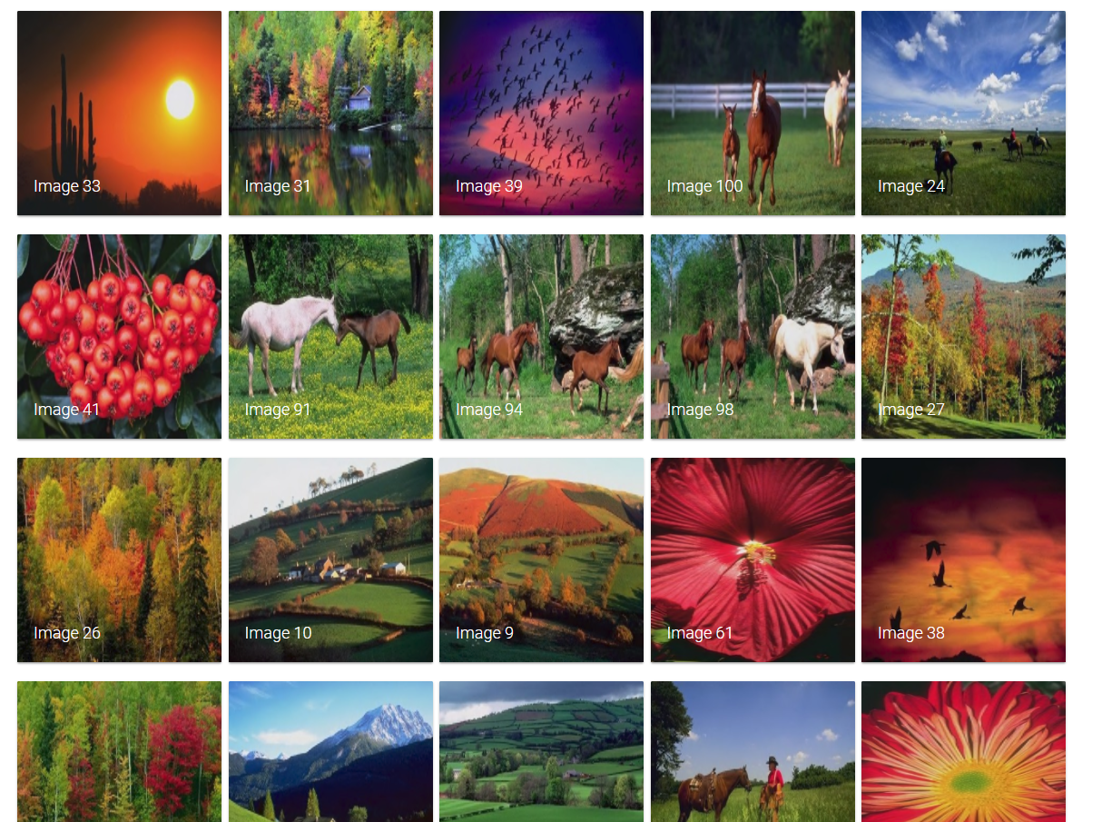

1. Screen shots for query results 93

